**Discrete Geometry: Some basic definitions, Ham-Sandwich theorem**

Discrete geometry or combinatorial geometry may be loosely defined as study of geometrical objects and properties that are discrete or combinatorial, either by their nature or by their representation.

**1. Polyhedra and polytopes**

A *polytope* is a geometric object with flat sides, which exists in any general number of dimensions. A polygon is a polytope in two dimensions, a polyhedron in three dimensions, and so on in higher dimensions (such as a 4-polytope in four dimensions). Some theories further generalize the idea to include such objects as unbounded polytopes (apeirotopes and tessellations), and abstract polytopes.

Examples of polyhedral:

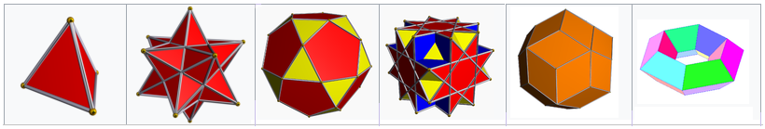

Regular tetrahedron, Small stellated dodecahedron, Icosidodecahedron, Great cubicuboctahedron, Rhombic triacontahedron, A toroidal polyhedron.

The following are some of the aspects of polytopes studied in discrete geometry:

* Polyhedral combinatorics
  + Polyhedral combinatorics is a branch of mathematics, within combinatorics and discrete geometry, that studies the problems of counting and describing the faces of convex polyhedra and higher-dimensional convex polytopes.
* Lattice polytopes
  + A **convex lattice polytope** (also called **Z-polyhedron** or **Z-polytope**) is a geometric object playing an important role in discrete geometry and combinatorial commutative algebra. It is a [polytope](https://en.wikipedia.org/wiki/Polytope) in a Euclidean space **R**n which is a [convex hull](https://en.wikipedia.org/wiki/Convex_hull) of finitely many points in the integer lattice **Z**n ⊂ **R**n.
* Ehrhart polynomials
* Pick's theorem
* Hirsch conjecture

**2. Packings, coverings and tilings**

Packings, coverings, and tilings are all ways of arranging uniform objects (typically circles, spheres, or tiles) in a regular way on a surface or manifold.

A *sphere packing* is an arrangement of non-overlapping spheres within a containing space. The spheres considered are usually all of identical size, and the space is usually three-dimensional Euclidean space. However, sphere packing problems can be generalised to consider unequal spheres, n-dimensional Euclidean space (where the problem becomes circle packing in two dimensions, or hypersphere packing in higher dimensions) or to non-Euclidean spaces such as hyperbolic space.

A tessellation of a flat surface is the tiling of a plane using one or more geometric shapes, called tiles, with no overlaps and no gaps. In mathematics, tessellations can be generalized to higher dimensions.

Specific topics in this area include:

* Circle packings
  + Circle packing is the study of the arrangement of circles (of equal or varying sizes) on a given surface such that no overlapping occurs and so that all circles touch one another.
  + Example: 
* Sphere packings
  + A sphere packing is an arrangement of non-overlapping spheres within a containing space. The spheres considered are usually all of identical size, and the space is usually three-dimensional Euclidean space. However, sphere packing problems can be generalised to consider unequal spheres, n-dimensional Euclidean space.
  + Example: 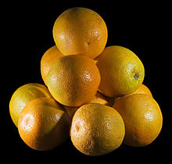
* Kepler conjecture
  + The Kepler conjecture, named after the 17th-century mathematician and astronomer Johannes Kepler, is a mathematical theorem about sphere packing in three-dimensional Euclidean space. It says that no arrangement of equally sized spheres filling space has a greater average density than that of the cubic close packing (face-centered cubic) and hexagonal close packing arrangements. The density of these arrangements is around 74.05%.
  + Example: 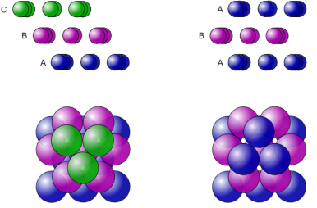
* Quasicrystals
  + A quasiperiodic crystal, or quasicrystal, is a structure that is ordered but not periodic. A quasicrystalline pattern can continuously fill all available space, but it lacks translational symmetry. While crystals, according to the classical crystallographic restriction theorem, can possess only two, three, four, and six-fold rotational symmetries, the Bragg diffraction pattern of quasicrystals shows sharp peaks with other symmetry orders, for instance five-fold.
  + Example: 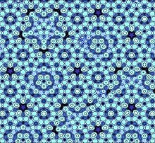
* Aperiodic tilings
* Periodic graph
* Finite subdivision rules

**3. Structural rigidity and flexibility**

Graphs are drawn as rods connected by rotating hinges. The cycle graph C4 drawn as a square can be tilted over by the blue force into a parallelogram, so it is a flexible graph. K3, drawn as a triangle, cannot be altered by any force that is applied to it, so it is a rigid graph.

Structural rigidity is a combinatorial theory for predicting the flexibility of ensembles formed by rigid bodies connected by flexible linkages or hinges.

Topics in this area include:

* Cauchy's theorem
* Flexible polyhedral

**4. Incidence structures**

Seven points are elements of seven lines in the Fano plane, an example of an incidence structure.

Incidence structures generalize planes (such as affine, projective, and Möbius planes) as can be seen from their axiomatic definitions. Incidence structures also generalize the higher-dimensional analogs and the finite structures are sometimes called finite geometries.

Formally, an incidence structure is a triple, C=(P, L, I), where P is a set of "points", L is a set of "lines" is the incidence relation. The elements of I are called flags. If . We say that point p "lies on" line *l*.

Topics in this area include:

* Configurations
  + In mathematics, specifically *projective geometry*, a configuration in the plane consists of a finite set of points, and a finite arrangement of lines, such that each point is incident to the same number of lines and each line is incident to the same number of points.
  + Example: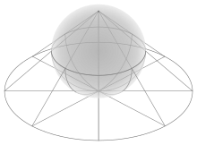 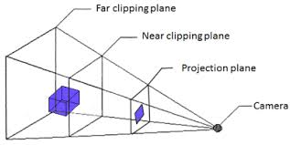
* Line arrangements
  + In geometry an arrangement of lines is the partition of the plane formed by a collection of lines. Bounds on the complexity of arrangements have been studied in discrete geometry, and computational geometers have found algorithms for the efficient construction of arrangements.
  + Example: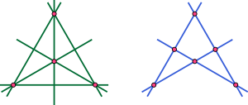
* Hyperplane arrangements
  + In geometry and combinatorics, an arrangement of hyperplanes is an arrangement of a finite set A of hyperplanes in a linear, affine, or projective space S. Questions about a hyperplane arrangement A generally concern geometrical, topological, or other properties of the complement, M(A), which is the set that remains when the hyperplanes are removed from the whole space. One may ask how these properties are related to the arrangement and its intersection semilattice. The intersection semilattice of A, written L(A), is the set of all subspaces that are obtained by intersecting some of the hyperplanes; among these subspaces are S itself, all the individual hyperplanes, all intersections of pairs of hyperplanes, etc.
  + Example: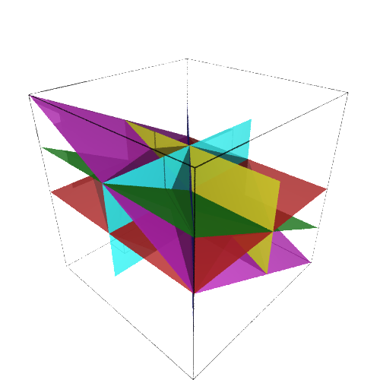
* Buildings
  + In mathematics, a building (also Tits building, Bruhat–Tits building, named after François Bruhat and Jacques Tits) is a combinatorial and geometric structure which simultaneously generalizes certain aspects of flag manifolds, finite projective planes, and Riemannian symmetric spaces. Initially introduced by Jacques Tits as a means to understand the structure of exceptional groups of Lie type, the theory has also been used to study the geometry and topology of homogeneous spaces of p-adic Lie groups and their discrete subgroups of symmetries, in the same way that trees have been used to study free groups.

**5. Oriented matroids**

An oriented matroid is a mathematical structure that abstracts the properties of directed graphs and of arrangements of vectors in a vector space over an ordered field (particularly for partially ordered vector spaces). In comparison, an ordinary (i.e., non-oriented) matroid abstracts the dependence properties that are common both to graphs, which are not necessarily directed, and to arrangements of vectors over fields, which are not necessarily ordered.

**6. Geometric graph theory**

A geometric graph is a graph in which the vertices or edges are associated with geometric objects. Examples include Euclidean graphs, the 1-skeleton of a polyhedron or polytope, intersection graphs, and visibility graphs.

Topics in this area include:

* Graph drawing
  + Graph drawing is an area of mathematics and computer science combining methods from geometric graph theory and information visualization to derive two-dimensional depictions of graphs arising from applications such as social network analysis, cartography, linguistics, and bioinformatics.
  + A drawing of a graph or network diagram is a pictorial representation of the vertices and edges of a graph. The arrangement of these vertices and edges within a drawing affects its understandability, usability, fabrication cost, and aesthetics. The problem gets worse if the graph changes over time by adding and deleting edges and the goal is to preserve the user's mental map.
  + Example: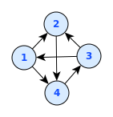
* Polyhedral graphs
  + In geometric graph theory, a branch of mathematics, a polyhedral graph is the undirected graph formed from the vertices and edges of a convex polyhedron. Alternatively, in purely graph-theoretic terms, the polyhedral graphs are the 3-vertex-connected planar graphs.
  + Example: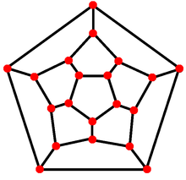
* Voronoi diagrams and Delaunay triangulations
  + In mathematics, a Voronoi diagram is a partitioning of a plane into regions based on distance to points in a specific subset of the plane. That set of points (called seeds, sites, or generators) is specified beforehand, and for each seed there is a corresponding region consisting of all points closer to that seed than to any other. These regions are called Voronoi cells. The Voronoi diagram of a set of points is dual to its Delaunay triangulation.
  + Example: 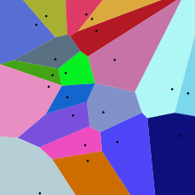

**7. Simplicial complexes**

A simplicial complex is a topological space of a certain kind, constructed by "gluing together" points, line segments, triangles, and their n-dimensional counterparts (see illustration). Simplicial complexes should not be confused with the more abstract notion of a simplicial set appearing in modern simplicial homotopy theory. The purely combinatorial counterpart to a simplicial complex is an abstract simplicial complex.

**8. Topological combinatorics**

The discipline of combinatorial topology used combinatorial concepts in topology and in the early 20th century this turned into the field of algebraic topology.

In 1978, the situation was reversed – methods from algebraic topology were used to solve a problem in combinatorics – when László Lovász proved the Kneser conjecture, thus beginning the new study of topological combinatorics. Lovász's proof used the Borsuk-Ulam theorem and this theorem retains a prominent role in this new field. This theorem has many equivalent versions and analogs and has been used in the study of fair division problems.

Topics in this area include:

* Sperner's lemma
  + Sperner's lemma states that every Sperner coloring of a triangulation of an n-dimensional simplex contains a cell colored with a complete set of colors.
  + Example: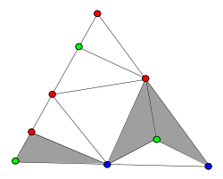
* Regular maps

**9. Lattices and discrete groups**

A discrete group is a group G equipped with the discrete topology. With this topology, G becomes a topological group. A discrete subgroup of a topological group G is a subgroup H whose relative topology is the discrete one. For example, the integers, Z, form a discrete subgroup of the reals, R (with the standard metric topology), but the rational numbers, Q, do not.

A lattice in a locally compact topological group is a discrete subgroup with the property that the quotient space has finite invariant measure. In the special case of subgroups of Rn, this amounts to the usual geometric notion of a lattice, and both the algebraic structure of lattices and the geometry of the totality of all lattices are relatively well understood. Deep results of Borel, Harish-Chandra, Mostow, Tamagawa, M. S. Raghunathan, Margulis, Zimmer obtained from the 1950s through the 1970s provided examples and generalized much of the theory to the setting of nilpotent Lie groups and semisimple algebraic groups over a local field. In the 1990s, Bass and Lubotzky initiated the study of tree lattices, which remains an active research area.

Topics in this area include:

* Reflection groups
* Triangle groups

**10. Digital geometry**

Digital geometry deals with discrete sets (usually discrete point sets) considered to be digitized models or images of objects of the 2D or 3D Euclidean space.

Simply put, digitizing is replacing an object by a discrete set of its points. The images we see on the TV screen, the raster display of a computer, or in newspapers are in fact digital images. Its main application areas are computer graphics and image analysis.

**11. Discrete differential geometry**

Discrete differential geometry is the study of discrete counterparts of notions in differential geometry. Instead of smooth curves and surfaces, there are polygons, meshes, and simplicial complexes. It is used in the study of computer graphics and topological combinatorics.

Topics in this area include:

* Discrete Laplace operator
* Discrete exterior calculus
* Discrete Morse theory
* Topological combinatorics
* Spectral shape analysis
* Abstract differential geometry
* Analysis on fractals

**Ham-Sandwich theorem:**

In mathematical measure theory, for every positive integer *n,* the **ham sandwich theorem** states that given *n* measurable "objects" in *n*-dimensional Euclidean space, it is possible to divide all of them in half (with respect to their measure, i.e. volume) with a single (*n* − 1) - dimensional [hyperplane](https://en.wikipedia.org/wiki/Hyperplane).

For example, we can find a straight line which divides two 2-dimensional shapes equally by its area.

Similarly we can find a hyper plane in 3-dimensional space that slices each of three solids in half by volume.

The ham sandwich theorem takes its name from the case when *n* = 3 and the three objects of any shape are a chunk of ham and two chunks of bread—notionally, a sandwich—which can then all be simultaneously bisected with a single cut (i.e., a plane). In two dimensions, the theorem is known as the **pancake theorem** because of having to cut two infinitesimally thin pancakes on a plate each in half with a single cut (i.e., a straight line).

Example: A ham-sandwich cut of eight red points and seven blue points in the plane.

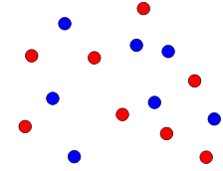 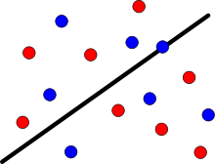

Exercise:

1. Does there exist a line which divides these 5 circles into two parts of equal area and perimeter? Justify your answer.

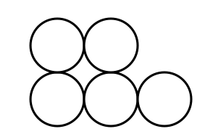

1. Does there exist a line which divides these 5 regions into parts of equal area? Justify your answer.

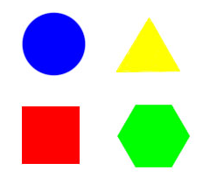

1. Does there exist a hyper plane which divides these 3 objects into two halves in volume? Justify your answer.

