Families with Children from China: British Columbia & Northwest Washington



FCCBC & NWWA CHINESE NEW YEARS 2004

Registration Form

Adults
Family Name | Given Name

Children (age as of January 8, 2004)
Family Name | Given Name | Age

Tickets

Before Dec. 5, 2003
Member / Guest |  | @ 20.00 ea.
Non Member |  | @ 25.00 ea.

Dec. 6, 2003 to Jan. 8, 2004
Member / Guest |  | @ 25.00 ea.
Non Member |  | @ 30.00 ea.

TOTAL:

❍ FCC Member
TO REGISTER:
Complete Registration Form and send it along with a cheque payable to FCC BC & NWWA in Canadian funds to:
FCC BC & NWWA CNY 2004
2730 Crescentview Drive
North Vancouver, B.C. V7R 2V1
You must be registered by January 8, 2004 as there will be no registration at the door. We encourage you to register early as seating is limited.
CONTACT INFORMATION:
Danielle Soulodre
Phone (604) 839-5862
Email: dsoulodre@shaw.ca

CHINESE NEW YEARS CELEBRATION 2004

- Lion Dance
- Entertainment (Dancing, Music)
- Lunch
- Children’s Activities
WHERE: Chinese Cultural Centre Hall
50 East Pender (Chinatown)
Vancouver
Parking available for $3 to $6 / day
(see map on reverse)

TIME: Saturday, January 17th, 2004
10:00 AM – 3:00 PM

COST:
Before December 5, 2003
FCC Members & Family Guests $20.00 ea.
Nonmembers $25.00 ea
Dec 6, 2003 to Jan. 8, 2003
FCC Members & Family Guests $25.00 ea.
Nonmembers $30.00 ea.
Children 18 and under are Free

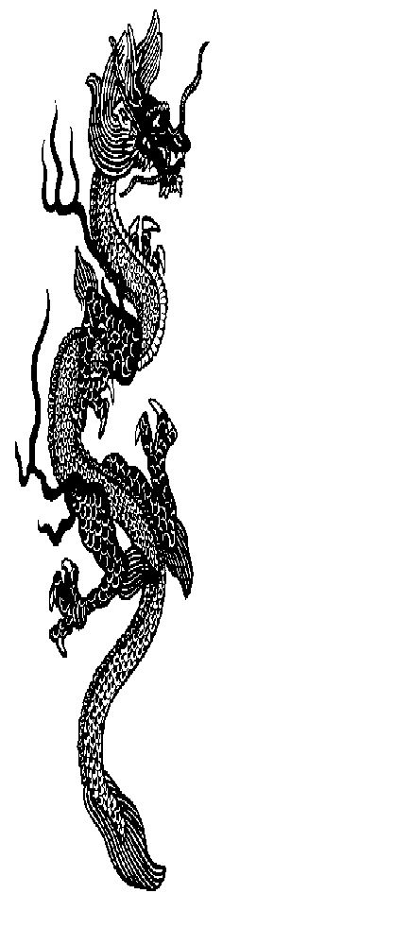
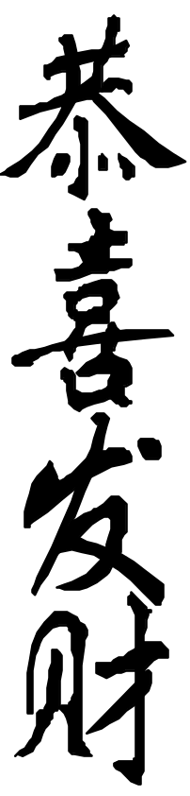
CHINESE NEW YEAR 2004
Year of the Monkey
FCC BC & NWWA

PENDER
KEEFER
HASTINGS
P
X
⬧
N
QUEBEC
CARRAL
Chinese Cultural Centre
50 East Powell
MAIN

