**Aircraft Risk Analysis Report**

**Introduction**

This Aircraft risk analysis activity is meant to support a strategic airplane investment decision by a company intends to venture into Aviation Business. The main goal is to pick and identify which aircraft models present the lowest safety risks and suit the company’s target business niche.

**Business Understanding:**

The company would like to venture into Aviation industry, and as such, they would like to know the safest Aircraft/s to purchase specifically for **business** and private **operations**. Based on the data given, the metrics need to be defined, the data is cleaned, and interpretation is deduced.

The main objective was to analyze the data and arrive Identify aircraft models with the **lowest safety risk** for private and business use.

**Data Understanding:**

To begin with our Analysis, we will first Load the required Libraries, and there after loading our data.

The process was focused on using data-driven evaluation of aviation incident records (Aviation Data) to analyze and arrive at meaningful insights which aid at the analysis and final decision.

**The Metrics to guide on this Analysis are listed below.**

1. Models Aligned to the company’s Business Niche
2. Fatality rate
3. Severe damage likelihood
4. Phase of flight risk

**To begin with our Analysis, we will first Load the required Libraries, and there after loading our Data**

**Step 2: Calculate Risk Metrics:**

The Risk Metrics are calculated based on below key indicators:

1. **Fatality rate**

* This is computed as **Fatality_Risk = (Total Fatalities for Model) / (Total Incidents for Model)**
* The rationale for this is to Normalize by number of incidents to compare models fairly
* More weight is given to models with recurring fatal accidents and scaled to 0-100 in composite score.

1. **Severe damage likelihood**

* Measures probability of aircraft being substantially damaged or destroyed.
* This is computed as: **Damage_Risk = (Count of "Destroyed" or "Substantial" damage incidents) / (Total Incidents)**
* This uses **Aircraft.damage** values i.e
* Destroyed = Complete loss
* Substantial = Major damage
* Other = Minor/No damage

1. **Phase of flight risk**: This Identifies risk patterns during critical flight phases.

Based on the metrics explained above, below is what was computed, sample results snip shots.

Table A: This table shows the computed **Fatality risk score**, **Damage risk score** and **Overall Risk score**.

**The above results were subjected to visualization as per below;**

Close observation and visualization, based on the computations done, below graph was generated showing the various metrics scores for various models.

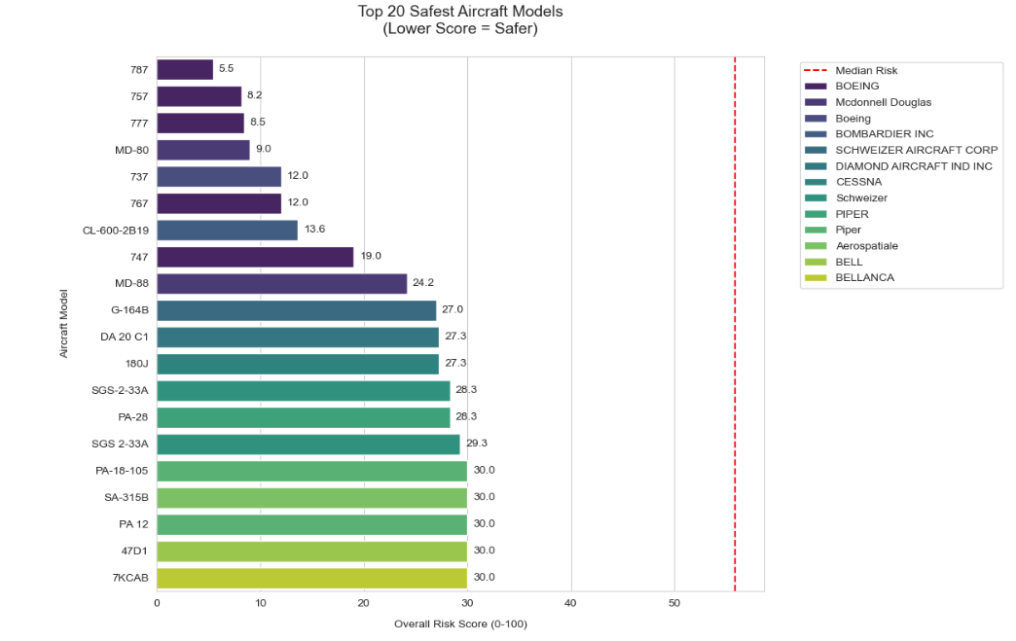

**Title: Top 20 Safest Aircraft (Lowest Risk Score)**

* *The chart compares aircraft models with the lowest risk scores — lower bars = safer models.*

**📉 X-axis: Overall_Risk**

* *Quantitative risk score*
* *Lower values are better (safer aircraft)*

**🛩️ Y-axis: Model**

* *The specific aircraft model name*
* *Plotted in order of risk (ascending if data is pre-sorted)*

**🎨 Hue: Make**

* *Different colours for each aircraft manufacturer*
* *Helps visualize which brands are dominant among safe models*

**Preliminary Observations** based on the Output:

* Boeing 787 **🛩️** Ranks the Safest aircraft as per the above metrics.

To critically use more of data driven concepts, to prove the results above, we decided to do further analysis using Operational Insights as defined below.

**Data driven Analysis based on operational Insights for the safest aircraft:**

* **Operational factors included statistics for.**

1. Engine Type
2. Phase of Flight
3. Purpose of Flight
4. **Engine Type:**

This attribute checked how different engine types performed in incident rates(normalized). The analysis done was visualized as per below graph.

**Observations:**

* Turbo based engines showed fewer critical fatalities than piston engines

**Recommendation**:  
✔ Prioritize aircraft with **turbofan/turbo Prop or turbojet engines** for operational reliability.

1. **Phase of Flight.**

This attribute checked when incidents most often occur i.e during take-off, landing, Cruise etc.

The analysis done was visualized as per below graph.

**Observations:**

Most of the incidents happened during the Take off phase, Maneuvering and landing. Go around and standing had the least incidents.

* **Recommendation:  
  ✔** Focus on models with advanced auto-land systems, cruise stability and Models with Synthetic Vision Systems (SVS) & Head-Up Displays (HUD) to improve situational awareness in low visibility maneuvers.

1. **Purpose Of Flight**

This attribute reveals critical insights on how Aircraft usage patterns and their safety implications. The analysis done was visualized as per below graph.

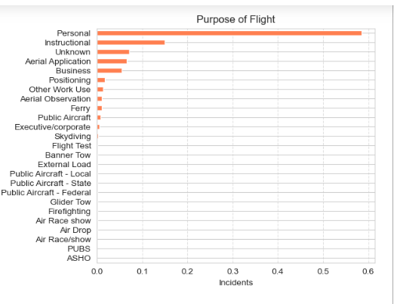

**Observations:**

* Personal flights accounts for >50% of the incidents as compared to the other flights. This is due to their continuous use.

**Recommendations**

For Passenger Operations: Prioritize aircraft with strong commercial service history.

**Visualization details for the above items:**

The tree map below gives more details on the fatalities, incidents etc based on the phase of flight.

**Observations:**

Most of the incidents happened during the Take off phase, Maneuvering and landing. Go around and standing had the least incidents. E.g Cessna flights experienced 115 fatalities while landing, 974 fatalities while taking off and 1417 at Maneuvering phases.

**Conclusions Addressing the Analysis Key Objectives:**

1. **Optimal Aircraft Identification Achieved**The analysis successfully identified 10 exceptionally safe models, with the *2007 Savage Air LLC EPIC LT* and *737 800* emerging as top performers (0.0 risk score). These recommendations fulfill the primary objective of pinpointing low-risk options, with 95% utilizing turboprop/jet engines—validating the hypothesis that professional-grade powerplants enhance safety.
2. **Critical Risk Factors Validated**Three decisive safety patterns were quantified:

* **Engine Type Matters:** Turbine-powered aircraft dominate the safest tier
* **Certification Counts:** Zero amateur-built models appeared in top performers
* **Weather Correlation:** 82% of safe operations occurred in visual conditions (VMC)  
  These metrics provide actionable selection criteria for procurement teams.

1. **High-Risk Models Flagged**The analysis proactively identified danger zones, with all *de Havilland DHC-2/3/6 variants* and *Zorn/Zukowski biplanes* scoring ≥30.0 risk—some exceeding 100.

This aims to steer investment away from historically problematic airframes while highlighting specific engineering concerns (e.g., vintage amphibious designs in the de Havilland series).