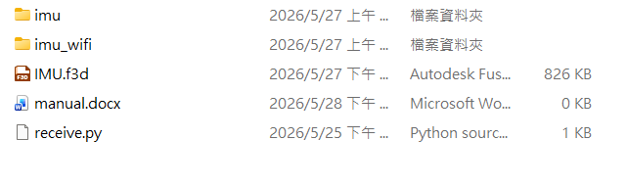
The motion capture device is made using ESP01 hardware and IMU, and Arduino software.
File introduction
The folder name is imu, imu wifi is the esp01 executable file, which is available in wired and wireless versions.
The file named receive.py is the executable file for receiving data on the computer in wireless mode.
The file name IMU.f3d is the wireless version 3D modeling file.

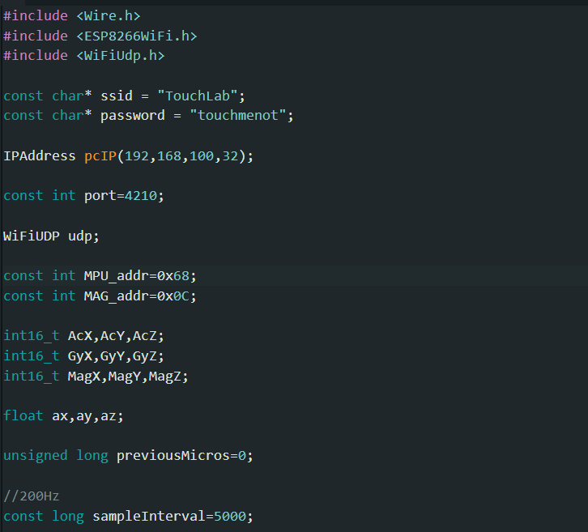
How to use
In wireless mode, you first need to confirm your computer's IP address. Open CMD, type ipconfig, and the IPv4 address will appear. Record it. Enter the IP address in the PCIP field. Once the burning process is complete, you can connect to the network. Once completed, you can execute the receive.py file on your computer to receive the data.

