Formatting Guides for Authors of ITA Papers
Anne Orther¹ and Ann Etherwen²
¹Department of Research, Big University, Hometown, UK
a.orther@middle.ac.uk
²Strategic Section, Company Inc, Statesville, USA
a.etherwen@companyinc.com

Abstract
This paper gives complete guidelines for authors submitting papers for the series of international conferences on Internet Technologies and Applications (ITA).

Keywords

ITA, Format, Author guide
1. Introduction
This document describes, and is written to conform to, author guidelines for the international conferences on Internet Technologies and Applications (ITA) series. This applies to all ITA papers and all ITA workshop papers to be published in ITA conference proceedings. It is prepared in Microsoft Word as a .doc document. Both initial submissions and final, camera-ready versions must conform to this layout and format. Microsoft Word terminology is used where appropriate in this document. Although formatting instructions may often appear daunting, the simplest approach is to use this template and insert headings and text into it as appropriate.
2. Format Guide
The following formatting rules must be followed strictly. This (.doc) document may be used as a template for papers prepared using Microsoft Word. Papers not conforming to these requirements may not be published in the conference proceedings.
2.1. General Format, Page Layout and Margins
Standard A4 (210mm x 297mm) portrait page set-up should be used. The left, right, top and bottom margins should be 30mm. Do not use any headers, footers or footnotes. No page numbers. Single column. All main text paragraphs, including the abstract, must be fully (left and right) justified. All text, including title, authors, headings, captions and body, will be Times New Roman font.
2.2. Title
The title is to be written in 20 pt. Times New Roman font, centred and using the bold and “Small Caps” formats. There should be 24 pt. (paragraph) spacing after the last line. Dominant title words should start in capitals, lesser ones in lower case, for example ‘Formatting Guides for Authors of ITA Papers. Only use commonly accepted abbreviations in the paper title; less familiar ones should be spelt out in full.
2.3. Authors
Author names are to be written in 13 pt. Times New Roman format, centred and followed by a 12pt. paragraph spacing. If necessary, use superscripts to link individual authors with institutions as shown above. Author affiliations are to be written in 12 pt. Times New Roman, centred, with email addresses, in 10 pt. Courier New, on the line following. email addresses can be combined as appropriate, {a.smith|b.jones}@bigcorp.com, for example. The last email address will have an 18 pt. (paragraph) spacing following.
2.4. Abstract
The Abstract section begins with the word, “Abstract” in 13 pt. Times New Roman, bold italics, “Small Caps” font with a 6pt. spacing following. The abstract must not exceed 150 words in length in 10 pt. Times New Roman italics. The text must be fully justified, with a 12 pt. paragraph spacing following the last line.
2.5. Keywords
The Keywords section begins with the word, “Keywords” in 13 pt. Times New Roman, bold italics, “Small Caps” font with a 6pt. spacing following. There may be up to five keywords (or short phrases) separated by commas and six spaces, in 10 pt. Times New Roman italics. An 18 pt. line spacing follows.
2.6. Section and sub-section headings
Section headings are numbered 1. Xxx, 2. Yyy, etc. in 14 pt. bold “Small Caps” Times New Roman font with a 6 pt. line spacing following.
Subsection headings are numbered 1.1. Aaa, 1.2. Bbb, etc. in 12 pt. bold Times New Roman font with a 6pt line spacing following.
2.6.1. Further Subsections
Further sub-sectioning, if required, is indicated using 1.1.1. Qqq, etc. headings with 11 pt. bold Times New Roman font with a 6pt line spacing following.
2.7. Text
Main-body text is to written in fully (left and right) justified 11 pt. Times New Roman font with a 6pt. (paragraph) line spacing following the last line of each paragraph, but a 12pt. (paragraph) line spacing following the last paragraph. Do not indent paragraphs.
2.8. Figures and Tables
Table 1. Heading and text fonts (Note, tables should not be split like this!).
Text | Alingnment | Font | Followed by:
Title | Centre | 20 pt. TNR, bold, small-caps | 24 pt. line sp.
Authors | Centre | 13 pt. TNR | 12 pt. line sp.
Addresses | Centre | 12 pt. TNR
emails | Centre | 11 pt. italic TNR | 18 pt. line sp. (last)
Abstract heading | Left | 13 pt. bold italic TNR, small caps | 6 pt. line sp.
Abstract text | Left | 10 pt. italic TNR | 12 pt. line sp.
Keywords heading | Left | 13 pt. bold italic TNR, small caps | 6 pt. line sp.
Keywords | Left, left, .. | 10 pt. italic TNR | 18 pt line sp.
Section headings | Left | 14 pt. bold TNR, small caps | 6 pt. line sp.
Sub-section heads | Left | 12 pt. bold TNR | 6 pt. line sp.
Sub-sub-sections | Left | 11 pt. bold TNR | 6 pt. line sp.
Body text | Full (left/right) | 11 pt. TNR | 12 pt line sp. (last)
Figures | Centre |  | 6 pt. line sp.
Figure captions | Centre | 11 pt. TNR | 12 pt. line sp.
References | Left | 10 pt. TNR (as shown) | 6 pt. line sp

All inserts, figures, diagrams, photographs and tables must be centre-aligned, clear and appropriate for black/white or greyscale reproduction. Splitting tables across pages, as has happened above, should be avoided wherever possible.
Figures (eg, Figure 1) must be numbered consecutively, 1, 2, etc., from start to finish of the paper, ignoring sections and subsections. Tables (eg, Table 1) are also numbered consecutively, 1, 2, etc., from start to finish of the paper, ignoring sections and subsections, and independently from figures
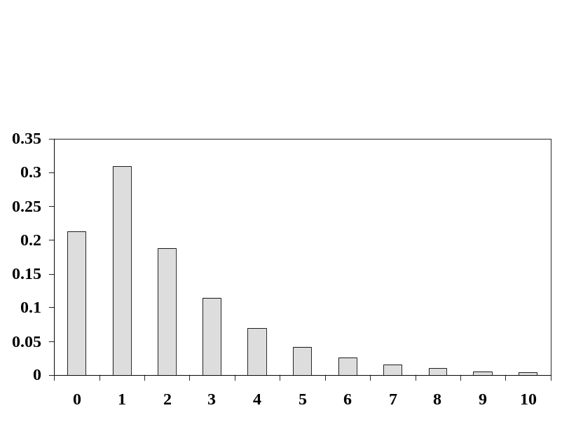
Figure 1. Diagrams, etc
All figures, tables, etc. must have a caption, centre-justified in 11 pt. Times New Roman. Captions precede tables but follow figures. Tables and figures must appear as close to their point of reference as satisfactory formatting of the final document permits.
2.9. Acknowledgements
An (unnumbered) acknowledgements section may be inserted if required. An example is given later in this template but this section is not essential. In particular, this section should acknowledge any sources of funding for the work. Such details should not appear on the front page of the paper.
2.10. References
References should be cited in the main text, in passing [1] or explicitly as in [2]. The full references should be given as below (essentially IEEE format), in the order in which they are cited, in 10 pt. Times New Roman, with a 6pt spacing between each.
3. Conclusions
Papers in this format must not exceed eight pages in length. This limit will not be extended by special arrangement. Papers are to be submitted via the EDAS conference management system as described on the ITA conference website. Papers for initial consideration must be submitted in Word.doc format. Final, camera-ready versions should take into account referees’ suggested amendments and must also be submitted in Word.doc format for editing into the final proceedings.
Acknowledgements
The authors would like to thank everyone, just everyone!
References
[1] Smith, A.B. & Jones, C.D. (2004) “Getting it Right”, ABC Transactions on XYZ, Vol. 10, No. 5, pp200-210.
[2] Brown, Bill & Black, Ben (1999) The Right Style, Really Useful Books, The Publishers.

