I first tried to install following the book and found that with newer MacOS they are no longer including PHP. I thought that was interesting, I included the message that I found below. There are work around but decided that would be something I would save for later.

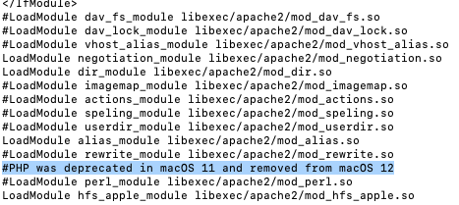

After I ran into that issue I followed instructions that you included in the Module and I had fewer issues. Below is my screenshot of my initial connection.

Below is a screenshot of my list of databases.

