Bellevue University

**Module 9**

**Milestone 1**

Ricardo Orlando, Monica Jones, Donnell Perkins

Database Development and Use – CSD310-307

Instructor: Tracy Shelanskey

Due: 05/04/2023

**Case Study 1 – Bacchus Winery**

**ERD**

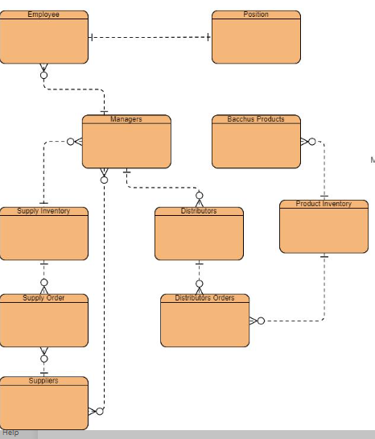

**Business Rules**

Business Rules for Bacchus Winery:

1. Bacchus has many suppliers
2. Suppliers deliver multiple days
3. Suppliers have several issues
4. Bacchus employees has one timesheet
5. Many suppliers have many supplies
6. A manager has many employees
7. The winery has one distribution manger
8. Distribution manager has many distributors
9. Employee has one position

Assumptions:

1. Bacchus has contracted suppliers.
2. Bacchus has several employees.
3. Bacchus has monthly orders.
4. Bacchus has monthly inventory