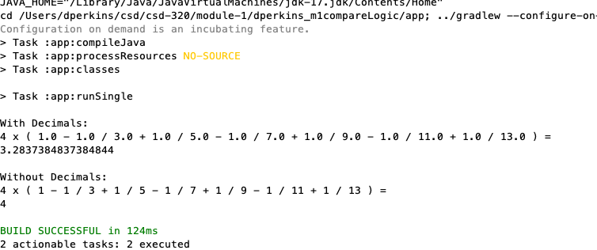

* The first result returns a value that is not truncated, and the second result returns a integer that has been truncated.
* To use more accurate data, you would use the result from the first one.