## A2V Tuner Guide

**1. Basic Form Structure**

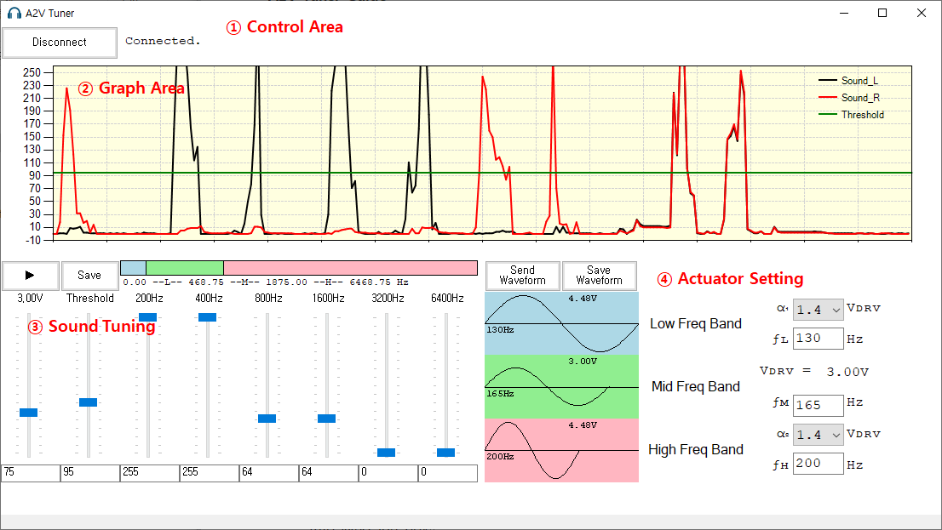

① Control Area

∙ Click the Connect button to connect to USB2UART Module. Other areas are enabled when it’s connected well.

② Graph Area

∙ Click the Play button to monitor the loudness of both sounds in real-time.

③ Sound Tuning Area

∙ Tuner is available in real-time. Actuator will be on when the loudness of sound goes over the threshold level. The loudness of sound depends on the values of equalizer in 0~6400Hz range. After the tuning work finish, click the Save button to record information to flash memory, or those will be lost when it reboots.

④ Actuator Setting

∙ 3-waveforms are testable. Set a frequency for each wave and amplitude (voltage) level ratio. And click Send Waveform button to write waveform information to DW7914. For a test to feel waveform, click the title area of each freq band. After the setting work finish, click the Save Waveform button to record waveform to flash memory.

**2. Hardware**

1) Block Diagram

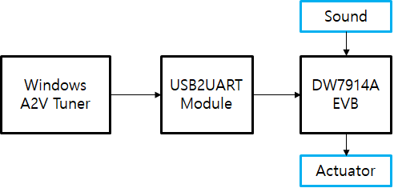

2) DW7914A EVB

- Interface Pin Map

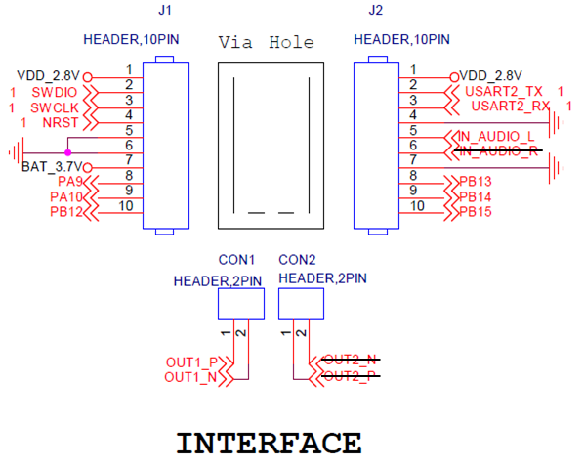

- Connection

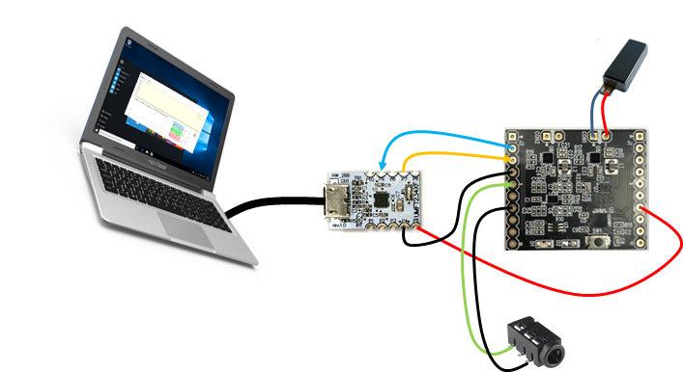

- Notice

Now Stereo Sound Input Channel is available through Audio_L and Audio_R.

Actuator works also stereo through CON1 and CON2.

The power input(BAT_3.7V) range is 2.7V~5.5V. Careful when power on. (no protection circuit yet)