**CSCI 415 – Assignment 2**

**Donovan Dobler and Ethan Gellerman**

* Proxy is written in C.

**To run:**

* Run PUTTY with tunneling options in effect:

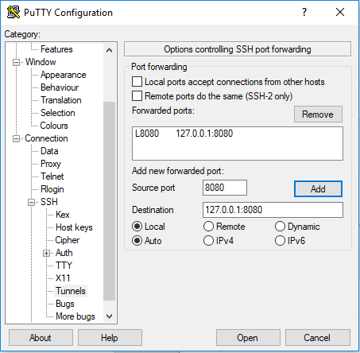

* Connect to lab computer:

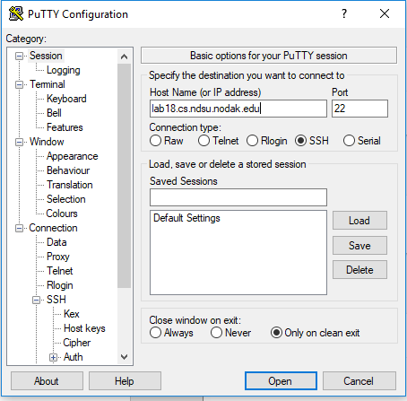

* Build proxy.c:



* Run proxy on correct port:



* Change proxy settings on internet browser:

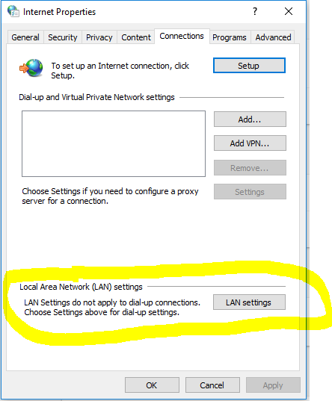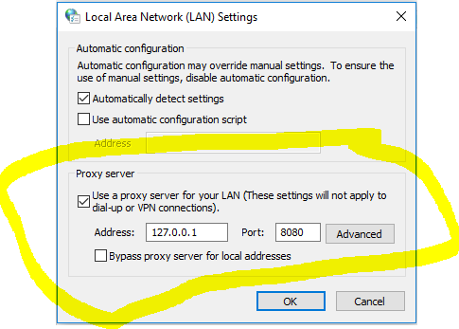

* Attempt accessing an http page in browser. If page displays in browser, proxy is configured correctly.

**Alternative method(after building proxy exe):**

* Create two putty sessions on the same lab computer, one to act as the server and the other as the client
* Run the following command on both sessions, with any open port you wish:



* Run the proxy on the server session using the same port:



* Use the curl command from the client to return a web address:

