**CSCI 415 – Assignment 2**

**Donovan Dobler and Ethan Gellerman**

**Source code walkthrough:**

Main method:

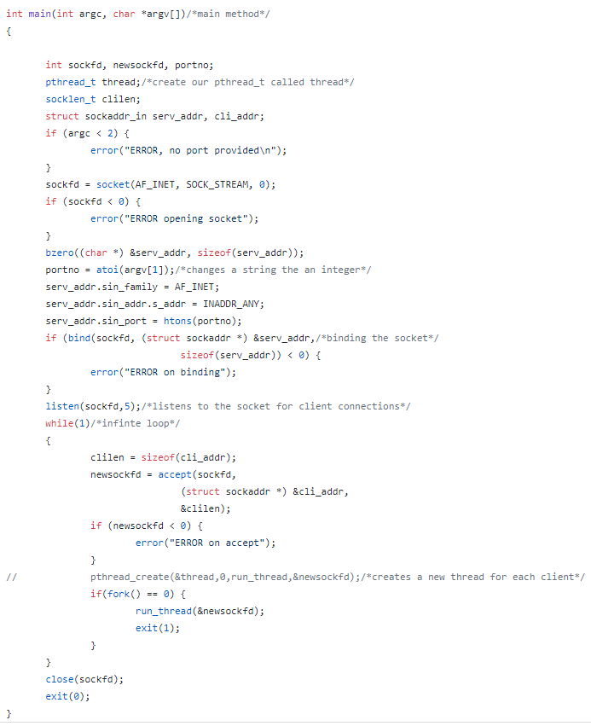

The port number is provided to this method at the terminal when the proxy is run. A socket is attempted to be initialized at this port on the host. After successful binding to the socket, the proxy listens for connections. If a request is detected, a new thread is created with the information provided by the client.

run_thread method:

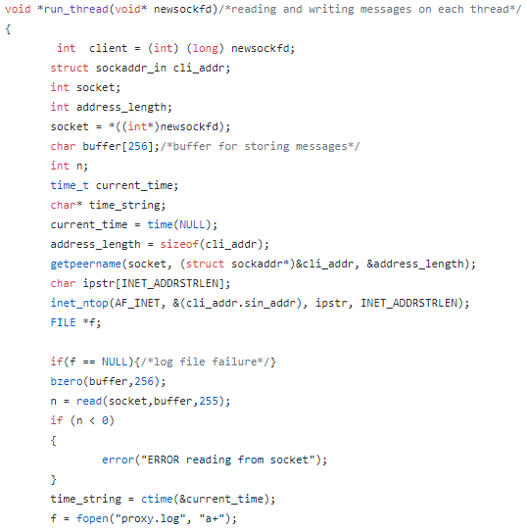

The thread is initialized, and a buffer is created for storing the HTTP request. The current time is checked for logging and a log file established for writing to.

run_thread method continued:

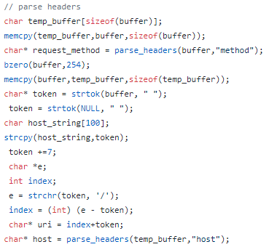

Each part of the header is sent to be parsed to get the correct format. That method is below:

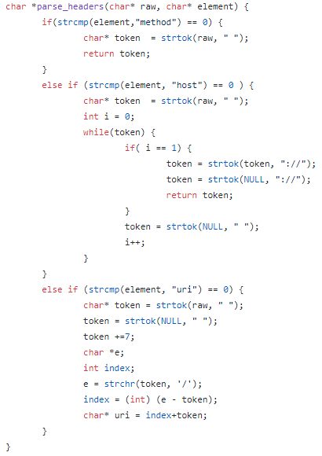

run_thread method continued:

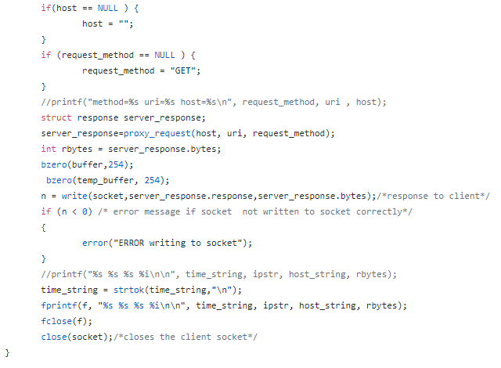

A new response structure is created to send to the client. The parsed header is sent to the server from the proxy. When a valid response is received, the bytes returned is captured and returned with the server response. The logging information is saved to the log file and printed to the console screen.

proxy_request method:

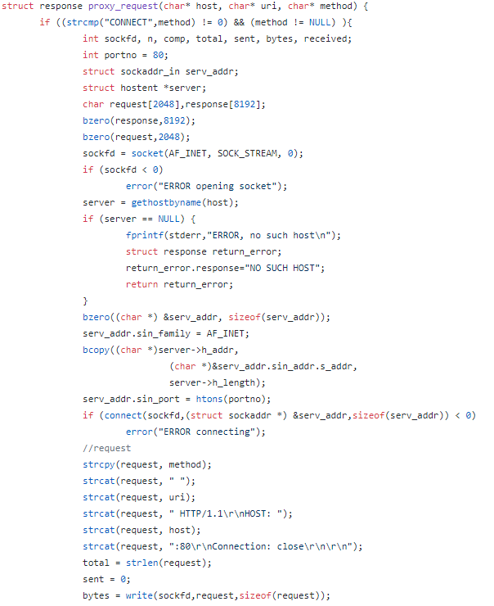

Sent from the thread method, each thread sends its request to the targeted server, if it is a valid http request. If the server is valid, the request is built and written to the socket.

proxy_request method continued:

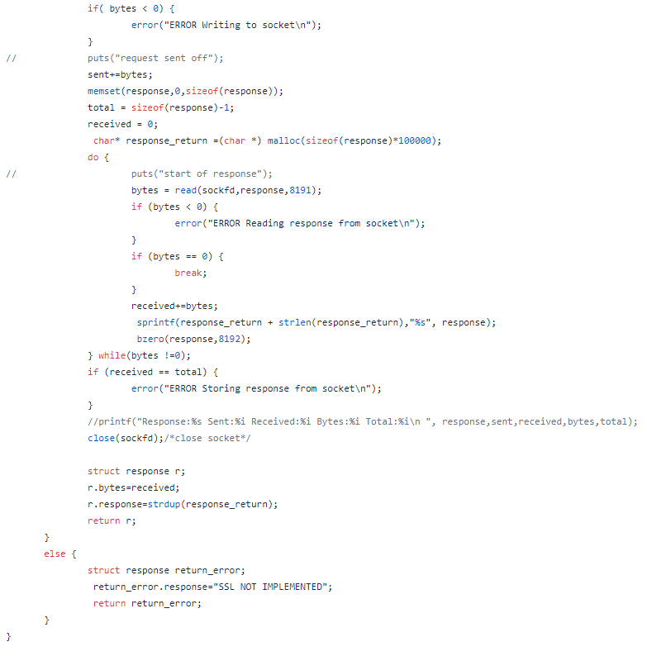

The response from the server is saved to memory and returned to the thread.

Header files, response structure, and error hander method:

