How Much Incorrect Retrieved Context Does It Take to Flip an LLM's Answer?
  - COMP 345 Midterm Report
Zane Braunstein and Donovan Sappet
October 30, 2026

1. Problem
People increasingly turn to AI chatbots for news. In 2026, 10% of people surveyed across 48 countries and territories used an AI chatbot such as ChatGPT, Perplexity, or Google Gemini for news each week, up from 7% a year earlier (Egan et al. 2026). Many of these chatbots look up documents and read them before answering a question, a design known as retrieval-augmented generation (RAG; Lewis et al. 2020). When the question is about news or policy, the documents a chatbot finds may be out of date or wrong. If those documents contain wrong information, the model may repeat that wrong information even when it already knows the correct answer. As this use continues to grow, it becomes more important to understand how incorrect facts in these documents affect the model’s answers.
This project is a stress test of how a retrieval-augmented LLM handles incorrect information in the documents it collects. We measure how much incorrect context an LLM needs to see before its answer flips to the wrong value, and we test whether the model’s hidden states can predict when the flip occurs.

1.1 Our Approach
We study a RAG system in which an open-weight LLM, Llama 3.1 8B Instruct, answers a question after reading passages of related text. Our text comes from 2,047 research publications by Rice University’s Baker Institute for Public Policy and the 747 PDF reports those publications link to, split into short passages. For each question we test, we choose 5 passages that state the correct answer. A retriever (all-MiniLM-L6-v2) scores how closely each passage matches the question and puts the 5 passages in order, from most to least similar. The ordered passages are then pasted ahead of the question into Llama’s prompt.
To test how wrong context changes the answer, we edit $m$ of the 5 passages to state a wrong (counterfactual) value, for $m=0$ to 5, choosing which passages to edit from a random order (Section 6.3). A script then checks whether Llama’s answer states the true value, the wrong value, both, or neither. We test Llama’s performance under three conditions, which differ only in the passages placed in the prompt. Condition 1 asks the question with no passages, to find out whether Llama already knows the answer. Condition 2 provides the 5 unedited passages. Condition 3 edits 1 to 5 of those passages. For every prompt, we also save Llama’s hidden states (the internal vectors the model computes at each of its 32 layers) and train simple classifiers—hereafter called probes—to predict from these vectors whether Llama’s answer will state the true value.
In our midterm sample of 20 facts, Llama’s answers flip in more than half of cases once 2 of the 5 passages are edited, stating the wrong value either alone or alongside the true value. This happens whether or not the model knew the fact beforehand. Which passage is edited also matters: an edit to the first passage lowers the share of correct answers more than four times as much as an edit to the last passage. A first set of probes, trained on 16 facts, does not yet predict the flip on facts outside its training set, but we expect the probes to improve once they are trained on the full set of about 100 facts (Section 7.6).
[TODO: Figure 1, the simple pipeline figure Shrish asked for: question + 5 passages → retriever orders them → edit m of them → Llama → answer and hidden states → scoring script and probes.]
Figure 1: Overview of one example, from the question and its 5 passages to the scored answer and the saved hidden states.

2. Hypothesis
We test Llama on facts split into two groups: parametric facts are those the model learned during pretraining and stores in its weights, and extractive facts are those the model has never seen, which it can learn only from the retrieved passages (Section 4.2). For each question, we give the model 5 passages that each state the correct answer and edit $m$ of them to state a wrong (counterfactual) value. For each prompt, we collect one greedy answer, which always takes the most likely next word, and 10 sampled answers, which choose each next word at random according to the model’s probabilities. We measure the model’s response as the true-answer rate—the fraction of its sampled answers that state the true value (Section 6.6). Because the true-answer rate is built from 10 sampled answers, it shows how confident the model is in the true value, not only which answer it gives most often.
We conjecture three key relationships between the model results and the input data:
- As $m$ increases, the model’s answers shift (flip) from the true value to the counterfactual one. We expect that for most facts the true-answer rate drops sharply over one or two values of $m$ rather than declining steadily.
- We expect extractive facts to flip at a lower $m$ than parametric facts, since the model has no stored answer to compare the passages against.
- We posit that a linear probe trained on the model’s hidden states can predict whether the model will side with its pretrained knowledge or the retrieved context, even among examples with the same $m$, where a classifier given only $m$ cannot tell them apart. We expect this information to be strongest in the middle layers, consistent with Zhao et al. (2024).

3. Related Approaches
It is well established that retrieval improves LLM accuracy and that irrelevant context can make answers worse (Shi et al. 2023; Liu et al. 2023; Cuconasu et al. 2024). Previous studies reach conflicting conclusions about how a model behaves when retrieved context directly contradicts what the model learned in pretraining. Longpre et al. (2021) found that QA models over-rely on memorized knowledge and ignore context that contradicts their memory. Xie et al. (2024) found the opposite for newer LLMs, which readily accept contradicting evidence when it is coherent, but still favor evidence that agrees with their memory when both are present. Wu et al. (2024, ClashEval) found that LLMs adopt incorrect retrieved content over their own correct prior knowledge over 60% of the time, and are more likely to do so when they are less confident in the prior answer.
Most of these studies measure only the model’s outputs. Zhao et al. (2024) extended this work by studying the model’s internal states when it is given conflicting context. The researchers trained logistic-regression probes on the hidden states (the residual stream) of Llama 3 8B and found that these hidden states signal a conflict between context and memory in the middle layers, peaking around layer 14 of 32. Zhao et al.’s probes could also predict, before the answer was generated, whether Llama would answer from the context or from its memory. However, their setup gives the model a single conflicting passage rather than varying how much of the context conflicts. It also compares that passage against the model’s own closed-book answer, so it does not separate facts the model knows from facts it does not.
Building on this research regarding how LLMs handle conflicts between retrieved context and their memory, and in particular on Zhao et al. (2024), we vary the amount of conflicting context as a controlled dose ($m=0$ to 5 of 5 passages) rather than using one conflict condition. We place the edited passages inside a full retrieval pipeline over real policy documents, rather than giving the model one prepared passage from a standard QA benchmark, so the text is written for real readers rather than built for testing. We compare facts the model knows (parametric) with facts it does not (extractive). We also test whether the probe can tell apart examples with the same number of wrong passages, for example two facts at $m=3$ where Llama keeps one and flips the other. A classifier given only $m$ cannot do this, so a probe with this ability would show that the hidden states carry information about the model’s choice beyond the input it was given.
Our initial results partly agree with Liu et al. (2023), who found that language models make the best use of information placed at the start or end of a long input, and the worst use of information in the middle. In our experiment, editing the first of the 5 passages lowers the share of correct answers far more than editing any other passage, but editing either of the last two passages has the smallest effect (Section 7.5). In other words, we observe a primacy effect (the first passage carries the most weight) but no recency effect (the last passages carry the least). In our setup, the first passage is also the passage most similar to the question, so part of this effect may come from how closely the passage matches the question rather than from its position.

4. Datasets

4.1 Corpus
Our corpus is the research published by Rice University’s Baker Institute for Public Policy. A web scraper collected every research page on the Baker Institute website, along with the text of the PDF reports those pages link to. The scraper takes its list of pages from the site’s public sitemap and sends one request per second. The site’s robots.txt file, which tells automated crawlers which parts of the site they may visit, disallows a separate /research-library section, so we did not collect that section.
The sitemap lists 4,271 pages. Of these, 2,054 are research publications; most of the rest are event pages (1,765) and expert and staff profiles (252). Our scraper collected 2,047 of the research pages, published between 2016 and 2026 (791 of them in 2024 or later), along with 747 PDF reports linked from 717 of those pages. A research page is often a summary of the full report, which is linked as a PDF: the median page has 855 words, while the median PDF has 3,890. In total, the pages hold 3.3 million words and the PDFs hold 4.4 million.
A single report can be thousands of words long and cover many topics, so the retriever and our search tools work with short passages rather than whole documents. Each document is split into passages of at least 120 words, so that each passage is long enough to state a fact along with its surrounding context, which is what we look for when choosing the 5 passages for each question (Section 4.3). To keep each passage’s context intact, each passage is built from full paragraphs, so a paragraph is never cut in half. As a result, most passages run a little over 120 words (median 139; Figure 2). The corpus has 50,852 passages. Of these, 87% are between 120 and 200 words, 10% are longer (usually one long paragraph or a table), and 4% are shorter (the last passage of a document, when fewer than 120 words are left).
All of these passages stay in the corpus, including the short and the long ones. Only the passages we choose for a fact (Section 4.3) have an upper limit of 200 words. The retriever reads only the first 256 tokens of a passage (about 200 words) and ignores the rest, so a passage of at most 200 words lets the retriever’s score cover the whole passage, including the sentence that states the fact. Of the 310 passages chosen for our 62 facts, 8 are longer (up to 288 words), because those facts had no shorter passage to use in their place. The 200-word limit matters only for the retriever. Llama reads every passage in full, so a longer passage can only change the order in which the retriever places the 5 passages, and Section 7.5 shows that this order matters.
A research page often repeats sentences from its own PDF (for example, its executive summary), so the same sentence can appear in two passages of the corpus. Section 4.3 explains how we handle these copies when choosing a fact’s passages.
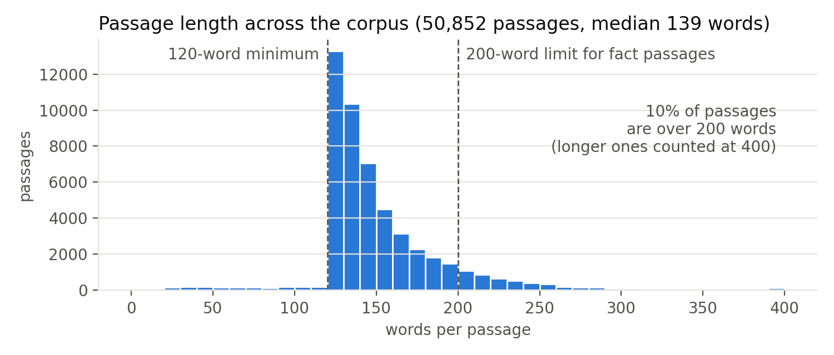
Figure 2: Passage length across the corpus. Passages over 400 words are counted at 400.

4.2 Facts
A fact in our study is a number, name, or date that answers a short question, such as the year NAFTA went into effect (1994). We use short answers for two reasons: each fact has one clear value, which is easy to replace with a single wrong value, and a script can check which of the two values the model’s answer states. Each fact has 3 differently worded versions of its question, so that a result does not depend on one phrasing (Section 6.3). We aim for about 100 facts in the final report. At the time of this report, 62 have been checked by hand, and this report tests a sample of 20 (Section 4.4).
Our second hypothesis (Section 2) compares how easily two kinds of facts flip, so each fact is assigned to one of the two groups below. Condition 1 (Section 6.1) decides the group by asking each question with no passages.
- Parametric facts are already known to the model from pretraining. We count a fact as parametric if the model answers all 3 wordings correctly with no passages. When an edited passage states a different value than the one the model learned, the model has to choose between its memory and its context.
- Extractive facts appear only in the corpus, so the model cannot answer these questions without the passages. We count a fact as extractive if the model does not answer any of the 3 wordings correctly with no passages. We prefer values from publications after Llama’s December 2023 training cutoff, which the model could not have seen during pretraining. Since the model has no stored answer to fall back on, these questions show how easily the model accepts wrong context when it has nothing to compare against.
A fact answered correctly for only one or two wordings fits neither group. We report these mixed facts separately (2 of the 20 facts in this report; Section 7.1).
For each fact, we wrote one plausible counterfactual value, close to the true value but wrong, such as 1996 instead of 1994 for NAFTA. We avoid obviously false values (such as 1776) because the model could reject such a value on its own, without weighing the edited passages against the unedited ones. A plausible value makes the model choose between two believable sources, as an outdated figure or a real error in a document would. For each fact, every edited passage states the same counterfactual value. This keeps the wrong passages in agreement with each other, and it lets one script pattern recognize the wrong answer. The number of edited passages, $m$, then measures how much support the wrong answer has. For instance, at $m=3$ the model sees three passages that say NAFTA took effect in 1996 and two that say 1994.
Because we choose every counterfactual value ourselves, each question has a known correct answer. The true value is whatever the unedited passages say, and the counterfactual value is the one we inserted. A script checks which of the two values the model’s answer states (Section 6.5), so scoring needs no human answer key and no LLM judge. Only answers that state both values, or neither value, are read and labelled by hand.

4.3 Passages for Each Fact
Each fact is paired with 5 corpus passages that state its true value. We choose these passages ourselves rather than letting the retriever search the corpus for them, so that we control exactly how many edited passages the model sees. If the retriever searched the whole corpus, it would decide how many of the edited passages reach the model, and $m$ would no longer be set by us (this setting is Condition 4, Section 6.4). With 5 passages per fact, the number of passages carrying the wrong value can be raised one step at a time from 0 to 5. This lets us measure the point at which the incorrect data starts to control the model’s answer, rather than only testing whether a single wrong passage changes the answer, as in Zhao et al. (2024).
The 5 passages must state the fact in 5 non-identical sentences, so that each passage is a separate statement of the fact rather than a repeat of another passage. Two passages can come from the same document, as long as the sentence stating the fact is worded differently in each. Most copies come from web pages that paste sentences from their own PDF reports. To find them, we compare the sentences that state the fact. If 90% of the words in the shorter sentence appear in the other sentence, in the same order, the two passages count as copies, and only one of them can be among the fact’s 5 passages. Our initial rule required the fact to appear in 5 different documents, but fewer Baker documents cover recent events, so that rule left very few extractive facts. Each chosen passage should also be at most 200 words (Section 4.1).

4.4 Finding Facts and the Midterm Sample
We found candidate facts for this report with three tools:
- A mining script finds subjects and values that sit close together in a sentence (for example, “NAFTA” and “1994”) and ranks the pairs by how many non-identical passages state them. Many values appear near a subject only because the value is common everywhere (for example, “2024” near “Mexico”), so the script keeps a pair only if the value appears near the subject at least 3 times as often as the value appears in the corpus overall.
- A search script lists every passage that matches a given pattern. We used this script to choose each fact’s 5 passages.
- An AI assistant (Claude) used these scripts to draft 95 candidate facts with their passages, of which we kept 51 after reading every passage.
As of this report, we have a total of 62 facts. Before a fact was used, we read its passages and confirmed both values, and a script checked that each edit changes every passage and that the counterfactual value does not already appear in the unedited passages.
Condition 1 (Section 6.1) assigns each fact to a group by asking Llama the question with no passages. To choose a sample for this report, we first ran Condition 1 on all 62 facts on a laptop CPU, using only the greedy answer. Llama answered all 3 wordings correctly for 43 facts, one or two wordings correctly for 10, and no wording correctly for the other 9. We chose 10 parametric facts that cover different kinds of values (years, months, percentages, dollar amounts) and 10 extractive facts: the 9 that Llama never answered correctly, and one (the 2025 tariff on Mexico and Canada) whose only correct-looking answer quoted an older tariff. The experiment then repeats Condition 1 on a Google Colab L4 GPU (Section 5.1), and the greedy answers from that run set each fact’s final group. In that run, all 10 parametric facts were again answered correctly for every wording, and 8 of the extractive facts were not answered correctly for any wording. The other 2 (the date of the Hamas attack and the 2025 tariff on Mexico and Canada) were answered correctly for one wording each, so we report them as mixed facts (Section 7.1).
Table 1: The 20 facts in the midterm sample. “Screen” is the number of question wordings (of 3) Llama answered correctly with no passages in the laptop screen used to pick the sample; “Run” is the same count in the GPU run, which sets the final group.
Picked as | Fact | True value | Counterfactual | Screen | Run | Final group
Parametric | Year NAFTA went into effect | 1994 | 1996 | 3 | 3 | Parametric
Parametric | Date the USMCA entered into force | July 1, 2020 | July 1, 2021 | 3 | 3 | Parametric
Parametric | Year of the U.S.-Mexico Water Treaty | 1944 | 1948 | 3 | 3 | Parametric
Parametric | Month Winter Storm Uri hit Texas | February 2021 | January 2021 | 3 | 3 | Parametric
Parametric | Year of Mexico’s energy reform | 2013 | 2016 | 3 | 3 | Parametric
Parametric | Month of Russia’s full-scale invasion of Ukraine | February 2022 | March 2022 | 3 | 3 | Parametric
Parametric | THC limit for hemp under U.S. law | 0.3% | 0.5% | 3 | 3 | Parametric
Parametric | 2017 tax law’s cap on the SALT deduction | $10,000 | $15,000 | 3 | 3 | Parametric
Parametric | 2017 tax law’s corporate tax rate | 21% | 23% | 3 | 3 | Parametric
Parametric | Year Hurricane Harvey flooded Houston | 2017 | 2018 | 3 | 3 | Parametric
Extractive | Start of the U.S.-Israeli strikes on Iran | February 28, 2026 | March 7, 2026 | 0 | 0 | Extractive
Extractive | President of Mexico from October 2024 | Claudia Sheinbaum | Xóchitl Gálvez | 0 | 0 | Extractive
Extractive | Date of the 2023 Hamas attack on Israel | October 7, 2023 | October 14, 2023 | 0 | 1 | Mixed
Extractive | Secretary of State in the second Trump administration | Marco Rubio | Bill Hagerty | 0 | 0 | Extractive
Extractive | Prime minister of Canada from 2025 | Mark Carney | Chrystia Freeland | 0 | 0 | Extractive
Extractive | Year Mexico became the top U.S. trading partner | 2023 | 2021 | 0 | 0 | Extractive
Extractive | Director of the Baker Institute | David M. Satterfield | Ryan C. Crocker | 0 | 0 | Extractive
Extractive | 2025 U.S. tariff on steel, aluminum, and copper | 50% | 40% | 0 | 0 | Extractive
Extractive | 2025 U.S. tariff on Mexico and Canada (fentanyl and migration) | 25% | 15% | 1 | 1 | Mixed
Extractive | Month Claudia Sheinbaum took office | October 2024 | December 2024 | 0 | 0 | Extractive

5. Models and Workflow

5.1 Pipeline
The system has three parts (Figure 3):
- The retriever, all-MiniLM-L6-v2, is a pretrained sentence-embedding model. It converts the question and each passage into a 384-dimensional vector and scores each passage by the cosine similarity between its vector and the question’s vector. In Conditions 2 and 3, the retriever does not search the whole corpus. Instead, it orders each fact’s 5 chosen passages, from most similar (Passage 1) to least similar (Passage 5), for the reason given in Section 4.3. The retriever is pretrained, and we do not train it further.
- The generator, Llama 3.1 8B Instruct, is an open-weight LLM with a training cutoff of December 2023. The ordered passages are pasted into a fixed prompt template ahead of the question, so Llama reads the passages as plain text. We ran Llama on a laptop CPU during development and run the experiments on a Google Colab L4 GPU.
- The probes are logistic regression classifiers trained on Llama’s hidden states (Section 5.4).
We use a small open-weight model for two reasons: a small model is likely easier to mislead with wrong context than the largest commercial LLMs, and the probes need direct access to the hidden states, which services offered only through an online API do not provide. If time permits, we will repeat the experiment with Llama 3.2 3B to see whether model size changes the flip point.
[Figure 3 from the proposal: Canva design DAHWOkhmehU, page 3. TODO: if its arrows say the question “retrieves” the passages, change them to show the retriever ordering the fact’s 5 passages.]
Figure 3: Data flow for one example. The retriever orders the fact’s 5 passages, and m of them are edited before they reach the frozen LLM. The generated answer is scored into a truth label, which is also the training target for the linear probes on the LLM’s hidden states. The 10 sampled answers per prompt give the true-answer rate.

5.2 Input
Each prompt contains a natural-language question about one fact and the $k=5$ passages that state the correct answer, in the order the retriever gives them, with $m$ of the passages edited to state the counterfactual value (Section 6.3 explains which passages are edited). Each combination of fact, question wording, and $m$ is one example, so 100 facts, 3 wordings, and 6 values of $m$ (0 to 5) give 1,800 examples in the full experiment. The midterm run uses the 20 facts in Table 1, which gives 360 examples, plus 60 closed-book prompts for Condition 1.

5.3 Output
For every prompt, the pipeline saves four outputs. The answers and their labels give the truth-support rate and the true-answer rate (Section 6.6), and the hidden states, paired with the greedy answer’s label, train the probes (Section 6.7):
- Llama’s greedy answer, in natural language.
- The scoring script’s label for that answer: true, counterfactual, both, or neither. The probes use a binary version of this label (1 for true, 0 otherwise).
- 10 sampled answers, each labelled by the same script, which give the true-answer rate.
- Llama’s hidden states for the prompt. Each of Llama’s 32 layers produces a 4096-dimensional vector for every prompt token. Llama reads text from left to right, so each token’s vector depends only on the tokens before that token. The final prompt token is therefore the only one that has seen the full question and all 5 passages, and we save its vector from each layer (one 32 × 4096 table of numbers per example).

5.4 Model Class
The pipeline uses three kinds of model, and only the third is trained by us:
- Embedding model: all-MiniLM-L6-v2 (pretrained, frozen), which orders the passages.
- LLM: Llama 3.1 8B Instruct (pretrained, frozen), which generates the answer.
- Linear probes: logistic regression with no hidden layers. Each probe takes one layer’s 4096-dimensional hidden-state vector $h$ from an example and outputs $p=σ(w⋅h+b)$, where $σ$ is the sigmoid function and $p$ is the predicted probability that the LLM’s answer for that example states the true value. Each probe has 4096 weights $w$ plus 1 bias $b$ (4097 parameters). We train one separate probe per layer (32 probes) and evaluate each probe on its own, so the output is a test accuracy for every layer. We do not combine the layers into one large probe, because that would hide which layer carries the information. With over 130,000 inputs and only about 1,400 training examples, one large probe would also overfit, fitting noise in the training examples that does not carry over to new facts.
The embedding model and LLM are not fine-tuned, and the prompt template (“Use the passages below to answer the question. Passage 1: … Passage 5: … Question: … Answer:”) is the same in every condition, so any change in the answer comes from the passages or from the question wording (Section 4.2). The only learned parameters are the probe weights.
Because Llama 3.1 Instruct is a chat model, we send the filled-in template as a single message from the user. Llama’s chat format also adds a short system message with the current date (“Today Date: …”). The default date, 26 July 2024, made Llama describe 2026 events as hypothetical, so we fix the date to 26 October 2026 in every condition.
Each prompt produces one greedy answer and 10 sampled answers. The greedy answer always takes the most likely next word, so the same prompt always gives the same answer, and this answer sets the prompt’s label. The sampled answers are drawn at temperature 1 with no top-k or top-p cutoff, which means each next word is drawn from the model’s own, unchanged probabilities. Every answer can be up to 192 tokens long (a token being a word or part of a word). We first allowed 32 tokens and then 64, but answers that state both values often name the second value later, after token 64, so a low cap can cut an answer off before the second value appears and give the answer the wrong label. In a test of 50 answers allowed 512 tokens, every label was settled by token 128, and 96% of the answers ended on their own before token 192.

6. Experiments to Test the Hypothesis

6.1 Condition 1: Closed-Book Baseline
Llama answers each question with no passages. This condition tells us what Llama knows before it sees any context. The greedy answers for the 3 wordings place each fact in a group (Section 4.2): parametric if all 3 are correct, extractive if no wording is answered correctly, and mixed otherwise.

6.2 Condition 2: Clean RAG ($m=0$)
Llama receives the fact’s 5 passages with no edits, in the order the retriever gives them (Section 5.1). This condition checks that the passages are enough for Llama to answer correctly, so that any drop in Condition 3 comes from the edits rather than from passages that fail to answer the question.

6.3 Condition 3: Counterfactual Dose ($m=1$ to 5)
Condition 3 uses the same 5 passages as Condition 2, but $m$ of them are edited to state the counterfactual value, for $m=1$ to 5. Raising $m$ from 1 to 5 raises the share of wrong passages from 1 in 5 to all 5.
Which passages are edited matters as well as how many, because language models use information unevenly across a long input (Liu et al. 2023). If we always edited the same slots, the effect of position would be mixed into the effect of $m$. For each fact and wording, we therefore draw one random order of the 5 slots with a fixed random seed, and at each $m$ we edit the first $m$ slots of that order. For instance, if the order for one wording is 2, 5, 1, 4, 3, then $m=1$ edits Passage 2, $m=2$ edits Passages 2 and 5, and $m=3$ adds Passage 1. Because each set of edited slots contains the set before it, every step from $m$ to $m+1$ adds exactly one wrong passage, and the change in the answer at that step measures the effect of that one passage (Section 7.5). Our initial plan drew a separate random set of slots for every $m$, but then the NAFTA curve dropped and recovered depending on whether Passage 1 happened to be edited at a given $m$.
As described in Section 4.2, each fact is asked in 3 wordings, and each wording gets its own random order of slots. If the answer flips at the same $m$ for all 3 wordings, the flip comes from the edited passages rather than from one phrasing of the question.

6.4 Condition 4: Corpus-Level Edits (if time permits)
Instead of editing the 5 passages directly, we edit $n$ of the $N$ mentions of a fact across the whole corpus (for example, a fact mentioned 30 times, flipped 1, 5, 10, … 30 times) and let the retriever choose the passages. This setup is closer to how wrong information appears in the sources a real RAG system searches. However, the amount of wrong context the model sees then depends on which passages the retriever picks, which adds a second variable to the experiment, so we treat Condition 4 as a follow-up to Condition 3.

6.5 Scoring the Answers
Every metric in Section 6.6 starts from a script that labels each answer by searching the answer’s text for the fact’s two values. For each fact, we write a short list of text patterns for the true value and a second list for the counterfactual value. Each pattern covers the forms an answer might use. For instance, the patterns for “October 2024” also match “Oct. 2024” and “October 1, 2024”, and a pattern for 1994 matches 1994 only as a whole number, not as part of 19940. The script first removes commas from the answer, so that “$10,000” and “$10000” match the same pattern, and then checks which lists match, ignoring capitalization.
The script gives each answer one of four labels:
- True: only the true value appears.
- Counterfactual: only the counterfactual value appears.
- “Both”: both values appear.
- Neither: neither value appears.
Because the script looks only for the two values, it cannot tell which value an answer settles on when both appear, or what an answer with neither value says. We read and label these answers by hand. The script also flags likely refusals by looking for phrases such as “no information” or “cannot”, which we check by hand (Section 8).

6.6 Evaluation Metrics
Each metric below answers one part of our hypotheses (Section 2).
- Truth-support rate: the share of greedy answers labelled true, at each value of $m$. We expected few answers to state both values, but in Condition 3, 81 of the 300 greedy answers do (Section 8). Many of these give one value and mention the other as a disagreement. The script labels these answers “both”, and until we label them by hand, a “both” answer does not count toward the truth-support rate. To check the script’s accuracy, we will also hand-check a random 50 of its other labels.
- True-answer rate: a single greedy answer per prompt can only show a step from true to counterfactual, so the greedy answer cannot tell a sudden flip from a gradual one. For each prompt, we therefore score the 10 sampled answers with the same script and record the share labelled true. This share estimates how likely the model is to give the true answer, and unlike the probes, the estimate comes directly from the model’s own answers. We also record the counterfactual rate and the “both” rate, which are the shares of sampled answers labelled counterfactual and “both”.
- Sigmoid fit: for each fact, we fit the curve $r(m)=\frac{1}{1+exp(s(m−m_{0}))}$ to its true-answer rate across $m=0$ to 5. Here $m_{0}$ is the midpoint of the curve (where the fact’s true-answer rate crosses 50%) and $s$ is the slope. A large $s$ means the true-answer rate drops at a threshold, and a small $s$ means the rate declines gradually, so the spread of $s$ across facts tests our first hypothesis, which predicts a sharp drop.
- Flip point: the smallest $m$ at which the truth-support rate drops below 50%, reported separately for the parametric and extractive groups. Comparing the two flip points tests our second hypothesis.
- Probe accuracy and AUC: each layer’s probe is scored on facts it was not trained on. The AUC (area under the ROC curve) is the chance that the probe gives a randomly chosen true answer a higher score than a randomly chosen other answer, so 0.5 is chance and 1.0 is a perfect ranking. As a baseline, we train a logistic regression whose only input is $m$. This baseline must give the same prediction for every example with the same $m$. If a probe beats the baseline, for example by separating two facts at $m=3$ where the model keeps the true value for one and flips on the other, then the hidden states hold information about the model’s choice beyond how much wrong context it was given (such as how confident the model is in the fact). To test this directly, we also compute the within-$m$ AUC: the AUC within each value of $m$, averaged over $m$. The $m$-only baseline scores exactly 0.5 on this measure, so any probe above 0.5 is using something other than $m$. This tests our third hypothesis.
- Control probe: a probe trained on the $m=0$ prompts to predict whether a fact is parametric or extractive. This control shows how much of the probes’ signal comes from simply encoding whether the model knows the fact.
- Retrieval recall (Condition 4 only): how often the edited passages are among the passages the retriever returns.

6.7 Probe Training: Loss Function and Optimizer
Each example gives one training pair (hidden state, truth label) for each layer’s probe. The input is the saved hidden-state vector from that layer, and the target is the example’s binary truth label (1 if the greedy answer is labelled true, 0 otherwise). We split the examples by fact (80% of facts for training, 20% for testing), so all 18 examples for a given fact land on the same side of the split and the probe cannot score well by memorizing individual facts. Since the label is binary, we use binary cross-entropy loss and optimize with Adam.
We plot each probe’s test AUC against its layer number (Figure 9). Layers where the probe performs near chance do not yet carry information about which answer the model will give, and the layer where the AUC rises suggests where in the model the choice between memory and context takes shape. Because the hidden states are recorded before any answer is written, the best-performing probe could also be used to flag RAG answers that are likely following bad context before the answer is generated. Each probe’s output $p$ is its estimate—read from that layer’s hidden state—of the probability that the LLM’s answer will state the true value. Because $p$ is a number between 0 and 1 rather than a yes or no, averaging $p$ over the examples at each $m$ shows how far the model’s internal state moves away from the true value as wrong context is added, even at values of $m$ where the generated answer has not flipped yet.
For the midterm report, we ran Conditions 1 to 3 for the 20 sample facts on a Colab L4 GPU (420 prompts, with hidden states saved for all 360 RAG prompts) and trained a pilot set of probes on these hidden states (Section 7.6). A single 80/20 split of 20 facts would leave only 4 facts for testing, so the pilot uses 5-fold cross-validation: we divide the facts into 5 groups of 4, and each group serves as the test set once.

7. Results
All numbers in this section come from a single run on a Colab L4 GPU. The run covers Conditions 1 to 3 for the 20 facts in Table 1: 60 closed-book prompts (20 facts × 3 wordings) and 360 RAG prompts (20 facts × 3 wordings × 6 values of $m$). Each prompt has one greedy answer and 10 sampled answers. Two rates from Section 6.6 appear throughout:
- The truth-support rate is the share of greedy answers that state only the true value.
- The true-answer rate is the share of the 10 sampled answers that state only the true value, averaged over prompts.
Until the hand labels are done, a “both” answer counts as not true for either rate (Section 8). The tables and figures are produced by crag.analyze and crag.figures in our repository.

7.1 Condition 1: Closed-Book Baseline
All 10 facts chosen as parametric were answered correctly for every wording, so all 10 remain in the parametric group. Of the 10 facts chosen as extractive, 8 were not answered correctly for any wording. The other 2 were answered correctly for one wording out of three. For instance, when asked about the 2023 attack on Israel, Llama first said it had no information about the war and then gave the correct date, October 7, 2023. When asked about the 2025 tariff on Mexico and Canada, the one correct-looking answer gave the right rate (25%) but attributed the rate to a different tariff from 2020. Under our grouping rule (Section 4.2), both facts fall in neither group, so we report them separately as mixed facts. The extractive group below therefore has 8 facts.
Only one greedy answer with no passages gave the counterfactual value. Asked who directs the Baker Institute, Llama named Ryan Crocker, the value we use as that fact’s counterfactual. The answer itself does not say why, but we chose Crocker to be a plausible counterfactual: like the true director, David Satterfield, Crocker is a former U.S. ambassador to Lebanon. A model that does not know the answer can reach for the same kind of name, which suggests our counterfactual values are as believable as we intended.

7.2 Condition 2: Clean RAG ($m=0$)
With the 5 unedited passages, all 60 greedy answers state the true value, in both groups. In 57 of the 60 prompts, all 10 sampled answers also state the true value. In the other 3 prompts, 9 of the 10 do, so 597 of the 600 sampled answers are correct, a true-answer rate of 99.5%. The passages are therefore enough for Llama to answer every fact, including the 8 extractive facts it could not answer closed-book, so any drop in either rate in Condition 3 comes from the edits.

7.3 Condition 3: Counterfactual Dose ($m=1$ to 5)
As a concrete example, consider the question “In what year did NAFTA go into effect?” (true value 1994, counterfactual 1996). With no edits, all 10 sampled answers say 1994. At $m=1$ the edited passage is Passage 2, and the greedy answer still gives 1994, citing Passage 1, while noting that Passage 2 says 1996; 7 of 10 sampled answers give only 1994. At $m=3$ the edit reaches Passage 1, and the greedy answer becomes “According to Passage 1, … NAFTA went into effect on January 1, 1996.” Two unedited passages (Passages 4 and 5) still state 1994, but the answer mentions only Passage 5 and claims that Passage 4 also says 1996. The answer then explains 1994 away as the year NAFTA was signed. At $m=5$ every answer says 1996.
Across all 20 facts, Table 2 and Figure 4 show the same three stages as the NAFTA example: the true value holds at small $m$, answers name both values in the middle, and the counterfactual value replaces the true value at large $m$. The true-answer rate falls from 99% at $m=0$ to 64% at $m=1$ and 40% at $m=2$. The counterfactual rate rises slowly at first (6% at $m=1$, 13% at $m=2$) and becomes the most common answer only at $m=4$ (61%). At $m=2$ and $m=3$, the most common sampled answer names both values (46% and 47% of sampled answers). Therefore, Llama rarely switches straight from one value to the other. As more passages are edited, Llama usually first reports that the passages disagree, and only later gives the counterfactual value alone (Section 7.5 shows which passages decide the switch). Every Condition 3 answer stated at least one of the two values, and no answer was a refusal.
Table 2: Condition 3 results for all 20 facts (60 prompts at each m). Label counts are for greedy answers; the three rates are over sampled answers.
$m$ | true | both | cf | Truth-support | True-answer rate | Counterfactual rate | “Both” rate
0 | 60 | 0 | 0 | 100% | 99% | 0% | 0%
1 | 36 | 20 | 4 | 60% | 64% | 6% | 30%
2 | 28 | 24 | 8 | 47% | 40% | 13% | 46%
3 | 14 | 20 | 26 | 23% | 21% | 31% | 47%
4 | 6 | 17 | 37 | 10% | 8% | 61% | 31%
5 | 0 | 0 | 60 | 0% | 0% | 98% | 1%
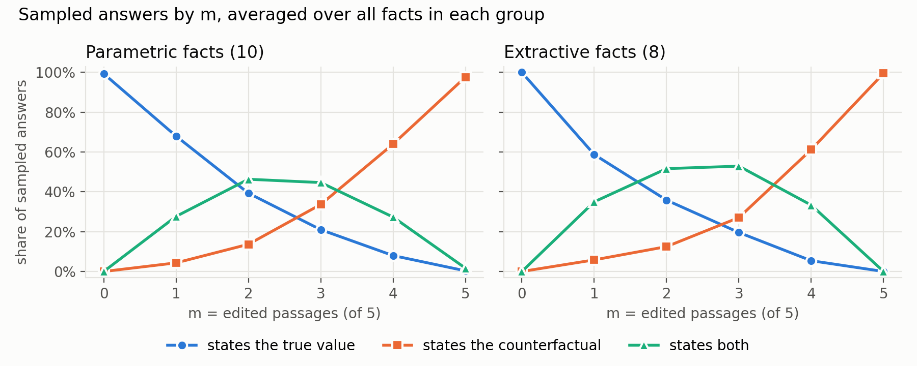
Figure 4: Share of sampled answers that state the true value, the counterfactual value, or both, against the number of edited passages m, averaged over all facts in each group. Left: the 10 parametric facts. Right: the 8 extractive facts.
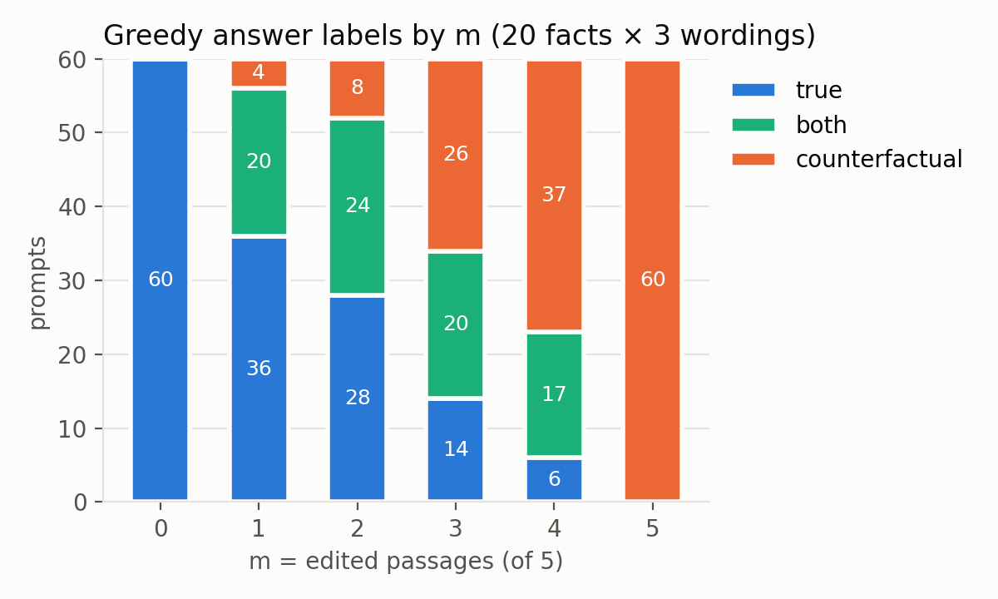
Figure 5: Labels of the greedy answers at each m, for all 20 facts and 3 wordings.
The flip point is $m=2$ for both groups: the truth-support rate is 57% (parametric) and 58% (extractive) at $m=1$, and 47% and 38% at $m=2$. The true-answer rate gives the same flip point. The two groups’ curves are nearly identical (Figure 4). Extractive facts have a slightly lower true-answer rate at $m=1$ (59% against 68%), but with 8 and 10 facts this difference is within the spread between individual facts. In this sample, Llama does not keep the true value for more edited passages on facts it already knows than on facts it learned only from the passages, so our second hypothesis is not supported.

7.4 Sigmoid Fits: A Threshold or a Gradual Decline?
Our first hypothesis predicts that the true-answer rate drops sharply over one or two values of $m$. The slope $s$ of each fitted sigmoid (Section 6.6) measures how sharply the rate falls, but $s$ is hard to read on its own, so we convert $s$ to a width: the number of edited passages the fitted curve needs to fall from a 90% to a 10% true-answer rate. The width equals $2ln9/s≈4.4/s$. A width of 1 or less means the fact flips within a single added passage, and a width of 2 or less matches the drop over one or two values of $m$ that our first hypothesis predicts.
Fitted to all 18 RAG prompts of each fact (3 wordings together), as planned in Section 6.6, the curves look gradual. The median slope is $s=1.5$ for parametric facts and 1.7 for extractive facts, a median width of 3.0 and 2.5 passages. Only 6 of the 20 facts have a width of 2 or less, and only 3 have a width of 1 or less (the U.S. corporate tax rate, the year Mexico became the top U.S. trading partner, and the U.S. secretary of state).
The pooled fit, however, averages away sudden drops that appear when each wording is plotted on its own (Figure 6). Each wording has its own random order of edited slots, so Passage 1 is edited at a different $m$ for each wording, and each wording drops at a different point. Averaging three sudden drops at different points produces a smooth curve. We therefore also fit each of the 60 fact-wording pairs (one fact asked in one wording, 6 prompts each) on its own. The median width is then 1.4 passages: 38 of the 60 pairs have a width of 2 or less, and 28 flip within one passage. In 45 of the 60 pairs, a single added passage lowers the true-answer rate by 50 percentage points or more. In 30 of the 60 pairs, the largest drop happens at the step that edits Passage 1, compared with the 12 we would expect if every passage mattered equally. For a single question, the answer therefore usually changes in one step, and where that step falls depends largely on when Passage 1 is edited. In the fits by wording, the extractive facts drop more abruptly (median width 0.7, against 1.6 for parametric facts), but with these few facts we treat this difference as a question for the full run.
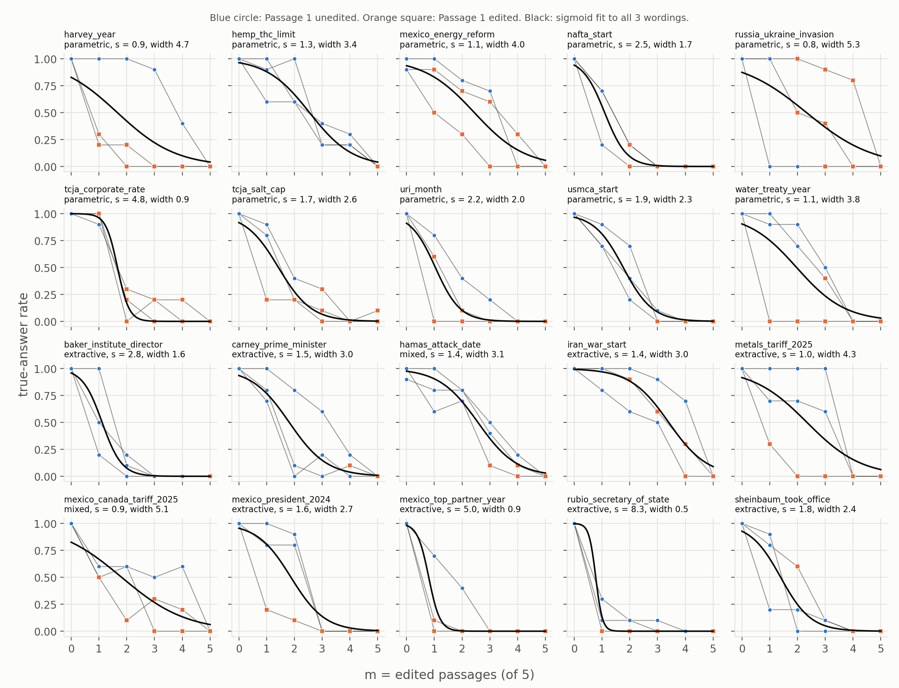
Figure 6: True-answer rate of every fact. Each thin line is one question wording; circles mark prompts where Passage 1 is unedited and squares mark prompts where Passage 1 is edited. The black curve is the sigmoid fitted to all 3 wordings together.

7.5 Which Passage Matters
Which passage is edited changes the answer about as much as how many passages are edited. Going from $m=0$ to $m=5$, the true-answer rate falls from 99% to 0%, so each added edit lowers the rate by about 20 percentage points on average. Because the edited slots are nested (Section 6.3), every step from $m$ to $m+1$ edits exactly one more passage, so the drop at that step measures the effect of that one passage. Averaged over all steps, editing Passage 1 lowers the true-answer rate by 41 percentage points, Passages 2 and 3 by about 20, and Passages 4 and 5 by about 10 (Figure 7). The gap between editing Passage 1 and editing Passage 5 (about 32 points) is therefore larger than the average effect of one more edited passage. Table 3 shows the same pattern at $m=1$: when the one edited passage is Passage 1, only 36% of sampled answers state the true value, but when it is Passage 5, 88% still do.
Figure 8 shows the effect of Passage 1 in another way, by splitting the prompts at each $m$ by whether Passage 1 is edited. At every $m$ from 1 to 4, prompts with an edited Passage 1 have a lower true-answer rate. With 3 of 5 passages edited, for instance, Llama gives the true value in 12 of 24 greedy answers when Passage 1 is unedited, but in only 2 of 36 when Passage 1 is edited. The greedy answers also name Passage 1 first far more than any other passage: of the 228 answers that name a passage, 167 start with Passage 1.
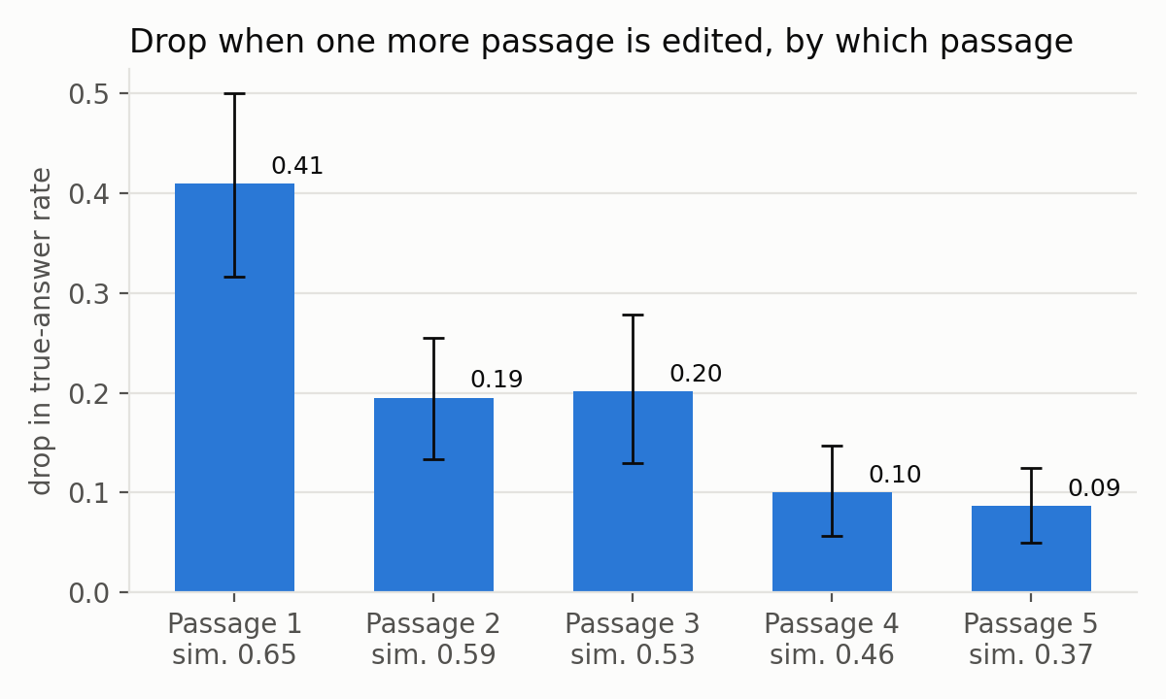
Figure 7: Average drop in the true-answer rate when one more passage is edited, by which passage the step edits (60 steps each). Error bars are 95% intervals from resampling facts. “sim.” is the passage’s average retriever similarity to the question.
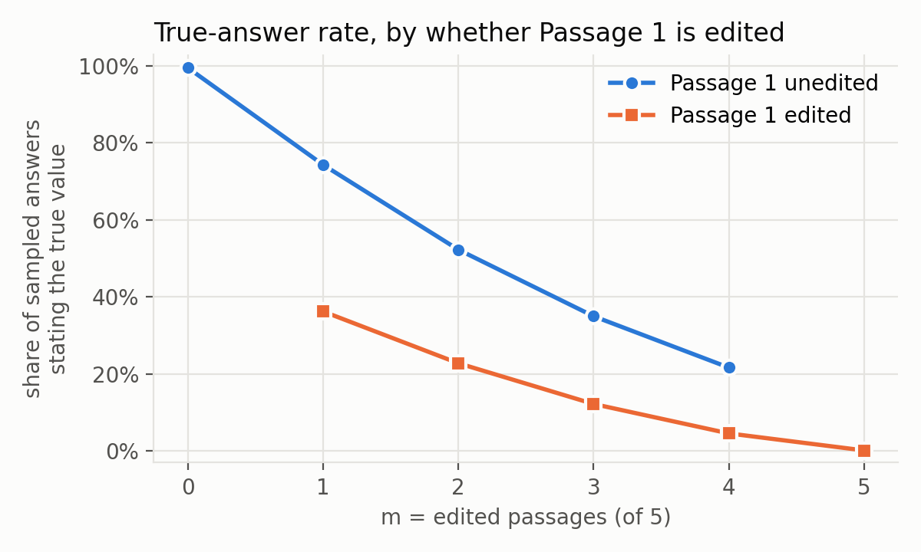
Figure 8: True-answer rate against m, split by whether Passage 1 is edited.
There are two possible explanations for this pattern, and our design cannot separate them yet. The first is position: language models use information at the start of a long input more than information in the middle (Liu et al. 2023). The second is similarity: the retriever places the passage most similar to the question in slot 1 (average similarity 0.65, against 0.37 for slot 5), so Passage 1 is also the passage that answers the question most directly. Most wordings fit both explanations, since the first passage is also the most similar one. A single wording, however, gives some evidence for similarity. For “When did Russia’s full-scale invasion of Ukraine begin?”, Passage 1 is edited from $m=1$, yet 80% or more of the sampled answers stay correct up to $m=4$, and the greedy answer cites Passage 3 at every $m$, including $m=0$. Passage 3 is the only passage that uses the question’s own phrase, “full-scale invasion,” and Passage 3 is not edited until $m=5$. Llama appears to follow the passage whose sentence best matches the question, and that passage is usually, but not always, Passage 1. Shuffling the passage order while keeping the same edits would separate the two explanations (Section 9).
Table 3: True-answer rate at m = 1, by which slot holds the one edited passage.
Edited slot | Prompts | Greedy answers true | True-answer rate | “Both” rate
1 | 16 | 5 | 36% | 56%
2 | 17 | 10 | 74% | 22%
3 | 10 | 7 | 59% | 31%
4 | 8 | 6 | 80% | 14%
5 | 9 | 8 | 88% | 12%

7.6 Probe Pilot
We trained the 32 layer probes described in Sections 5.4 and 6.7 on the hidden states of the 360 RAG prompts, using the 5-fold split by fact from Section 6.7. The target is 1 when the greedy answer is labelled true (144 of the 360 prompts) and 0 otherwise, so “both” answers count as 0 until they are labelled by hand. Every prompt is predicted by a probe that never saw its fact. Each probe is trained with Adam for 500 full-batch steps (learning rate 0.01, weight decay 0.01). Before training, each of the 4096 inputs is rescaled to mean 0 and standard deviation 1 on the training facts, so that no single input dominates because of its scale.
The probes do not beat the baseline that sees only $m$. The $m$-only baseline reaches 80% accuracy and an AUC of 0.88 on the held-out facts (AUC is defined in Section 6.6). The best layer probes reach an AUC of only 0.59 (layers 23 and 24), and many layers are close to 0.5 (Figure 9). Within prompts that share the same $m$, where the $m$-only baseline is at chance by construction, the best probes reach 0.62 to 0.63 (layers 3, 23, and 24). With only 20 facts, we do not treat this as evidence that the hidden states predict the flip, so the pilot does not support our third hypothesis yet.
The reason appears to be that the fact itself dominates the hidden state. At layer 16, where the average hidden-state vector has length 9.7, editing all 5 passages moves the final token’s vector by only 0.6 on average, while asking the same question in another wording moves the vector by 2.7 and switching to another fact moves the vector by 4.1. A probe trained on 16 facts therefore learns mostly what separates those facts from each other, and that does not carry over to new facts. As a check that the information is present at all, we also split the prompts at random, so that every test fact also appears in training. We do not use this split for results, because a probe can then score well by recognizing facts it has already seen. With this split, the late-layer probes reach an AUC of 0.88. The hidden states therefore do carry the outcome, but in a way that our 16 training facts are too few to separate from the facts themselves.
The control probe, in contrast, performs well. Trained on the clean prompts ($m=0$) to predict whether a fact is parametric or extractive, the control probe reaches 89% accuracy on held-out facts at layer 12, where always guessing the larger group would give 56%. The hidden states therefore separate facts Llama knows from facts it does not. However, most of our extractive facts concern events from 2023 onward, so the control probe may partly be detecting recent topics rather than the model’s knowledge itself.
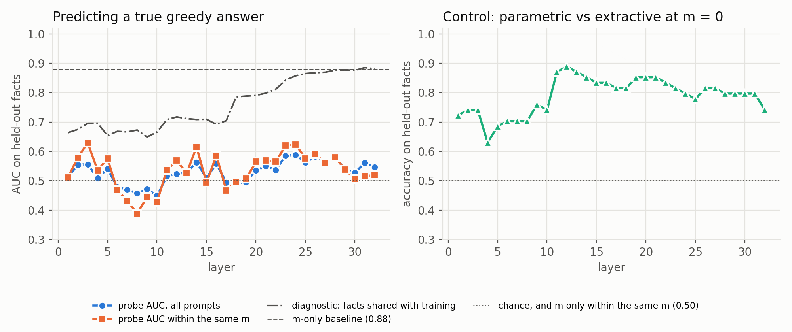
Figure 9: Probe pilot. Left: AUC on held-out facts for predicting a true greedy answer, for all prompts and within prompts that share the same m, with the m-only baseline. The dash-dot line is the diagnostic split that shares facts between training and test. Right: accuracy of the m = 0 control probe that predicts parametric vs extractive.

8. Failure Analysis
The rates in Section 7 show how often Llama loses the true value, but not how its answers go wrong. To see this, we sort every greedy answer that does not state only the true value (the value in the unedited passages) into one of four failure types:
- Adopted counterfactual: the answer states the counterfactual value.
- Mixed answer: the answer mentions both values without picking one.
- Other wrong answer: the answer states a value that is neither the true nor the counterfactual one.
- Refusal: the model declines to answer.
A mixed answer is different from a mixed fact (Section 4.2). A mixed fact is a fact Llama knows for only some wordings, while a mixed answer is a single answer that names both values.
We also note cases where the corpus itself disagrees about a fact (for example, different figures from different years or from authors with different viewpoints), since these natural conflicts could mix with the counterfactual values we insert.
Table 4: Failure types of the greedy answers, before hand labelling. “Mixed answer” is every answer the script labelled “both”.
$m$ | Adopted counterfactual | Mixed answer | Other wrong answer | Refusal
closed-book | 1 | 0 | 11 | 16
0 | 0 | 0 | 0 | 0
1 | 4 | 20 | 0 | 0
2 | 8 | 24 | 0 | 0
3 | 26 | 20 | 0 | 0
4 | 37 | 17 | 0 | 0
5 | 60 | 0 | 0 | 0
With passages, Llama’s wrong answers fall into only two types, adopted counterfactual and mixed answer. With passages, Llama never refused and never gave a third value. Without passages, the 28 wrong closed-book answers are refusals (16, all for extractive or mixed facts) or other wrong answers (11), plus the one counterfactual answer from Section 7.1.
Mixed answers are the most common failure at $m=1$ and 2 and stay common until $m=4$: 81 of the 300 Condition 3 greedy answers state both values. Many of these answers follow one passage and then report the other value as a disagreement. For example, at $m=1$ for NAFTA, the answer gives 1994 “according to Passage 1” and then notes that “Passage 2 mentions that NAFTA was implemented in January 1996, which is incorrect.” The script cannot tell which value such an answer settles on, so we will label the 81 mixed greedy answers by hand, along with a random 50 of the script’s other labels to check the script’s accuracy.
Llama also sometimes names the wrong passage. Asked who has been Canada’s prime minister since 2025 (Mark Carney) at $m=4$, one answer says “According to Passage 3” but quotes the true value, which only the unedited Passage 2 states. The NAFTA answer at $m=3$ (Section 7.3) makes the same kind of mistake. For this reason we use the passage citations only as a rough signal and measure position effects from the edited slots instead (Section 7.5).
While checking facts by hand, we found such disagreements in the corpus. For instance, some passages date the Gulf War as “1990-91” rather than giving a single year, and one passage dates the start of Russia’s invasion of Ukraine to February 22, 2022, two days before the date most sources give. In both cases, we left the disagreeing passages out of the fact’s 5 passages. The Gulf War fact uses only passages that give 1991 alone, and the Ukraine fact does not use the passage that gives February 22. Neither case affects the results in this report, since the Gulf War fact is not among the 20 sampled facts and the Ukraine question asks only for the month.

9. Discussion and Limitations
The overall goal is to find how much wrong context it takes to override what a model knows, how that amount changes when the model already knows the fact, and what the model’s hidden states reveal about its choice between memory and context.
The midterm results partly support our first hypothesis and do not support our second. For a single question wording, the true-answer rate usually falls in one step, as the first hypothesis predicts, but the step at which it falls depends largely on when Passage 1 is edited, and averaging over wordings turns these steps into a gradual curve. Llama flips at $m=2$ whether or not it knew the fact beforehand, so in this sample its pretraining does not make it keep the true value longer. So far, the results suggest that Llama does not weigh its memory against the passages so much as weigh the passages against each other. Llama mostly follows one passage, usually Passage 1, which is both the first passage and the one most similar to the question, and it reports the other value as a disagreement. The probe pilot does not yet support our third hypothesis: trained on 16 facts, the probes predict the flip on new facts no better than the $m$-only baseline, because differences between facts dominate the hidden states. The full set of about 100 facts gives 80 training facts instead of 16, which is the first thing to try before changing the probe design. The control probe does separate known from unknown facts (89% accuracy at layer 12), so the hidden states do encode whether Llama knows a fact, which is the distinction behind our second hypothesis.
These results have several limitations. First, position and similarity are confounded. Passage 1 is always the passage the retriever rates most similar to the question, so we cannot yet say whether Llama favors that passage for being first or for matching the question best. Second, the sample is small: 20 facts instead of about 100, with only 8 extractive facts, so the differences between the two groups are within the spread between individual facts. Third, the scoring script matches fixed text patterns, so the 81 greedy answers that state both values still need hand labels, and until then these answers count as not true. Fourth, the GPU and the laptop CPU give slightly different answers to the same prompt, so every number in this report comes from one GPU run. Finally, an edit that replaces a year can also change a range that contains that year. For instance, for the year Enrique Peña Nieto became president of Mexico (2012, counterfactual 2013; not among this report’s 20 facts), three passages give his term as “2012-2018”, which the edit turns into a five-year term, “2013-2018”. Llama could notice this mismatch, which may make some edited passages easier to reject than others. Before the full run, we will search the edited passages for ranges like this one and replace any affected passage with one that states the year on its own.
Before the final report, we plan to:
- check more facts by hand, especially extractive facts, to reach about 100;
- label the mixed answers by hand and check a random 50 of the script’s labels;
- run the full experiment (1,800 RAG examples) on the GPU;
- retrain the probes on the full set, which gives about 80 training facts instead of 16;
- add a control that shuffles the passage order while keeping the same edits, to separate the effect of position from the effect of similarity;
- run Condition 4 (corpus-level edits) if time permits.

References
Cuconasu, F., Trappolini, G., Siciliano, F., Filice, S., Campagnano, C., Maarek, Y., Tonellotto, N., and Silvestri, F. (2024). The Power of Noise: Redefining Retrieval for RAG Systems. ACM SIGIR Conference on Research and Development in Information Retrieval (SIGIR). arXiv:2401.14887.
Egan, J., Robertson, C. T., Ross Arguedas, A., Newman, N., Nielsen, R. K., Mukherjee, M., and Fletcher, R. (2026). Reuters Institute Digital News Report 2026. Reuters Institute for the Study of Journalism. doi:10.60625/risj-4vgf-s811.
Lewis, P., Perez, E., Piktus, A., Petroni, F., Karpukhin, V., Goyal, N., Küttler, H., Lewis, M., Yih, W., Rocktäschel, T., Riedel, S., and Kiela, D. (2020). Retrieval-Augmented Generation for Knowledge-Intensive NLP Tasks. Advances in Neural Information Processing Systems (NeurIPS). arXiv:2005.11401.
Liu, N. F., Lin, K., Hewitt, J., Paranjape, A., Bevilacqua, M., Petroni, F., and Liang, P. (2023). Lost in the Middle: How Language Models Use Long Contexts. Transactions of the Association for Computational Linguistics (2024). arXiv:2307.03172.
Longpre, S., Perisetla, K., Chen, A., Ramesh, N., DuBois, C., and Singh, S. (2021). Entity-Based Knowledge Conflicts in Question Answering. Conference on Empirical Methods in Natural Language Processing (EMNLP). arXiv:2109.05052.
Shi, F., Chen, X., Misra, K., Scales, N., Dohan, D., Chi, E., Schärli, N., and Zhou, D. (2023). Large Language Models Can Be Easily Distracted by Irrelevant Context. International Conference on Machine Learning (ICML). arXiv:2302.00093.
Wu, K., Wu, E., and Zou, J. (2024). ClashEval: Quantifying the Tug-of-War between an LLM’s Internal Prior and External Evidence. NeurIPS 2024 Datasets and Benchmarks Track. arXiv:2404.10198.
Xie, J., Zhang, K., Chen, J., Lou, R., and Su, Y. (2024). Adaptive Chameleon or Stubborn Sloth: Revealing the Behavior of Large Language Models in Knowledge Conflicts. International Conference on Learning Representations (ICLR). arXiv:2305.13300.
Zhao, Y., Du, X., Hong, G., Gema, A. P., Devoto, A., Wang, H., He, X., Wong, K.-F., and Minervini, P. (2024). Analysing the Residual Stream of Language Models Under Knowledge Conflicts. NeurIPS 2024 Workshop on Foundation Model Interventions. arXiv:2410.16090.

