Software Engineering – Github acess

**Steps:**

1. Plan project
2. Decide on what to build with
3. Start building
4. Integrate components

**Plan Project:**

The project consists of 3 components, retrieving data from github, storing the data in a useable format and then converting the data into a graphical representation. Retrieving the data from github in a Json format is relatively simple and can be done in most languages with relative ease, and the D3js library that was recommended uses json as an input, which would make it easier to integrate as I would not need to switch data types.

When deciding on what to use to build the project I originally started out using java, as that was the language I was most familiar with and most comfortable using, and I believe I almost found a way to retrieve the json data from the github API, which I have included below, however as I continued using this, I found that java was increasingly difficult to complete the project in, and as I looked towards creating the visualisation of the data I found it to be too difficult to use. I attempted to use D3js which was recommended to us in java using a library that required javafx, however I decided this was too complex a way of doing it and that these were not the right frameworks for doing the project in.

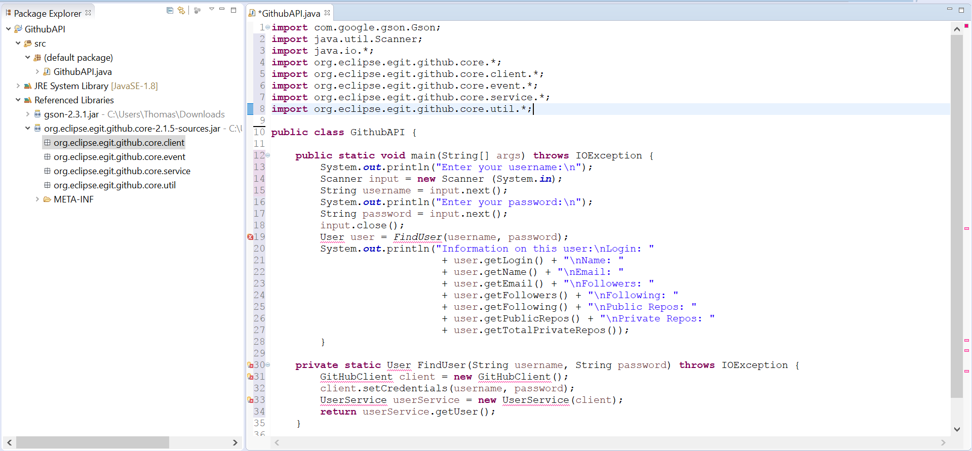

I then moved towards using javascript for the visualisation of the data using D3js, however I had very little experience with javascript and so again decided that it made no sense to try using a framework that I was unfamiliar with.

I eventually settled on python, as I had done some work in it before and found it generally easy to use and any material that could be repurposed for it was easily readable and comprehensible. Using this it was much easier to build a much more compact project that could both retrieve the data and visualise the data in the same program.