Don Pathirage
ECE 4363

Project 1

This project focuses on analyzing Fisher’s Iris dataset which contains four features (petal width, length and sepal width, length) describing three species of flowers. The batch perceptron and least-squares algorithms will be used to model a classifier for the data.

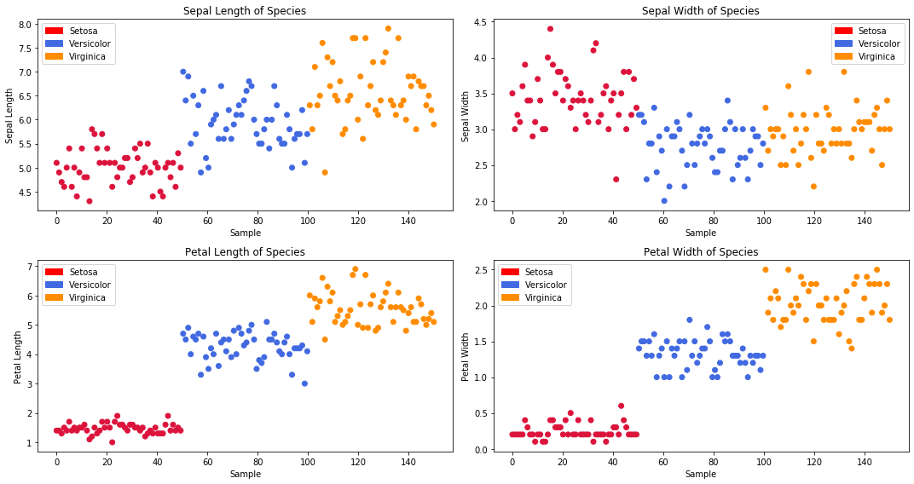

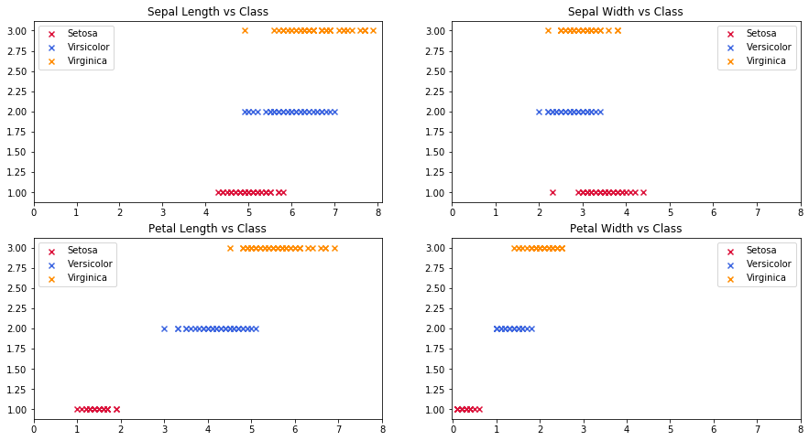

Looking over the data and the set of features provided for the three types of flowers, I expect the Setosa class to be more separable than Versicolor and Virginica as there is more overlap between the latter. Furthermore, petal length and petal width will likely perform better as features for classifying this dataset given their distinctness for each species.

Statistics

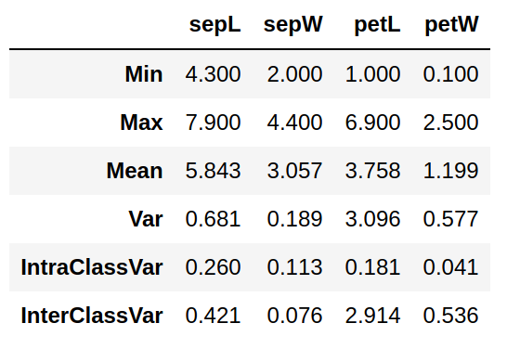

The between class variance vs within class variance for petal length and petal width are relatively high, making them better candidate-features for separating the three classes.

Correlation Matrix

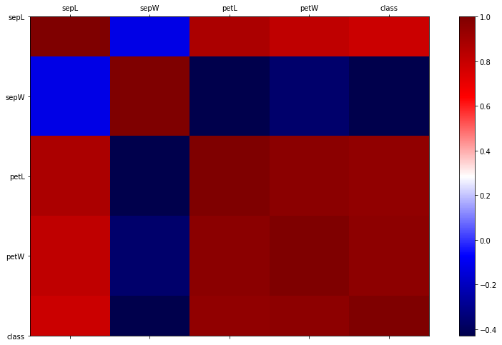

The correlation matrix visualizes the strength and direction of linear relationships between features. Here, blue represents negative correlation and red represents positive correlation. If there is a strong correlation between a pair of non-distinct features it would be best to select one or the other as using both may be redundant in classifying the data. The more independent features will have a larger affect on class separability.

Classifiers
1. ----------Setosa vs Versi+Virgi for All Features----------

Batch Perceptron converged in 8 epochs
Batch Perceptron Weights:
[[ 0.0932]
[ 0.3213]
[-0.5331]
[ 0.064 ]]
Number of Batch Perceptron Misclassifications: 0

Least-Squares Weights:
[[ 0.15588383]
[ 0.46008261]
[-0.50955521]
[-0.73593198]]
Number of Least-Squares Misclassifications: 0
2. ----------Setosa vs Versi+Virgi for Features 3 and 4----------

Batch Perceptron converged in 8 epochs
Batch Perceptron Weights:
[[-0.0541]
[-0.0941]
[ 0.198 ]]
Number of Batch Perceptron Misclassifications: 0

Least-Squares Weights:
[[-0.5026581 ]
[ 0.01966852]
[ 1.53206671]]
Number of Least-Squares Misclassifications: 1
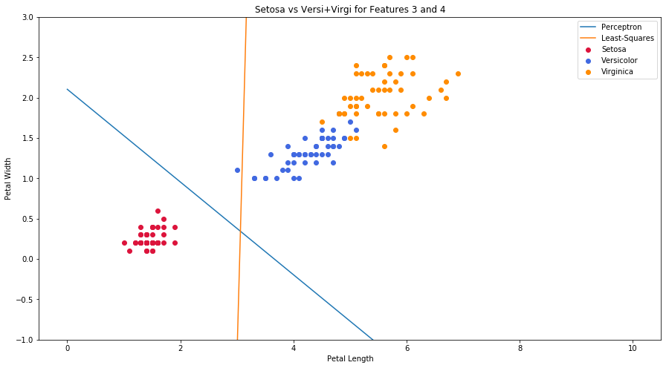
Setosa is linearly separable from the other classes and perceptron converged as expected, LS is not guaranteed to converge.
3. ----------Virgi vs Versi+Setosa for All Features----------

Batch Perceptron did NOT converge after 2000 epochs
Batch Perceptron Weights:
[[ -79.11]
[ -84.18]
[ 171.16]
[-141.5 ]]
Number of Batch Perceptron Misclassifications: 11

Least-Squares Weights:
[[-0.32048244]
[ 0.65144114]
[ 0.58633228]
[-2.65575702]]
Number of Least-Squares Misclassifications: 15

4. ----------Virgi vs Versi+Setosa for Features 3 and 4----------

Batch Perceptron did NOT converge after 1000 epochs
Batch Perceptron Weights:
[[ 0.1891]
[ 0.5598]
[-1.829 ]]
Number of Batch Perceptron Misclassifications: 6

Least-Squares Weights:
[[-0.14601222]
[ 1.28051055]
[-1.32037839]]
Number of Least-Squares Misclassifications: 8
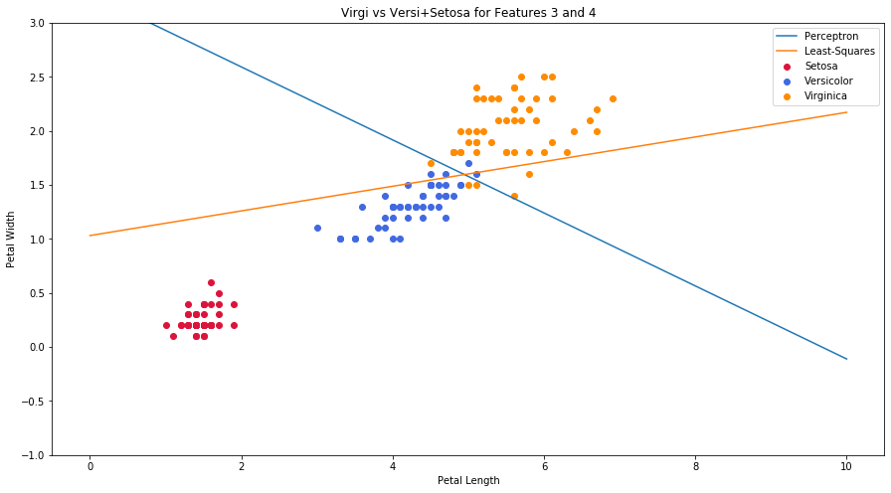
5. ----------Setosa vs Versi vs Virgi for Features 3 and 4 with Multi-Class Least-Squares----------

Multi-Class Least-Squares Weights:
[[-0.25132905 0.32433516 -0.07300611]
[ 0.00983426 -0.65008953 0.64025527]
[ 1.26603335 -0.10584416 -0.16018919]]
Number of Least-Squares Misclassifications: 34

