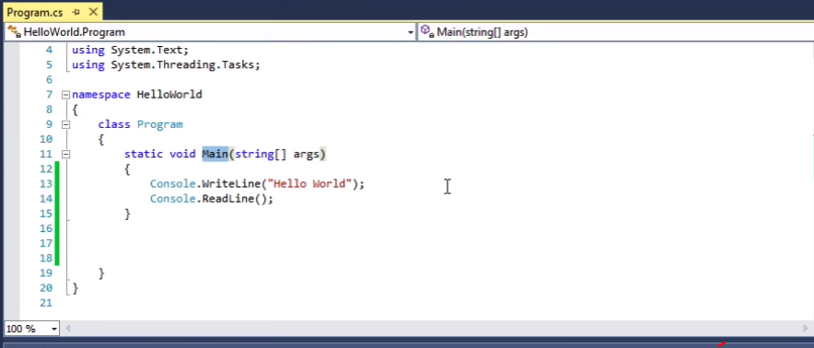

{} – inside opening and closing curly brace are known as your code black;

static void Main(string{} args) = name of block of code Main

Entire code black is a method.

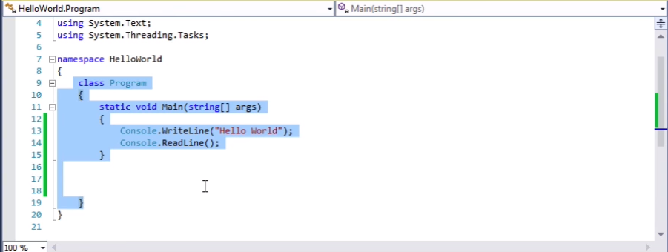

Class contains an organization of many blocks of methods.

WriteLine, ReadLine is a method in a class name console

“.” Is a method accessor

() hold passing argument values to methods.

; completes a thought in c# can be used multiple lines.

Whitespace doesn’t matter.

Indentation is automatically added by default. This makes it easier to read.

Colors designates types of code. Assist in readability of code.

Solution Explorer is our main navigation.

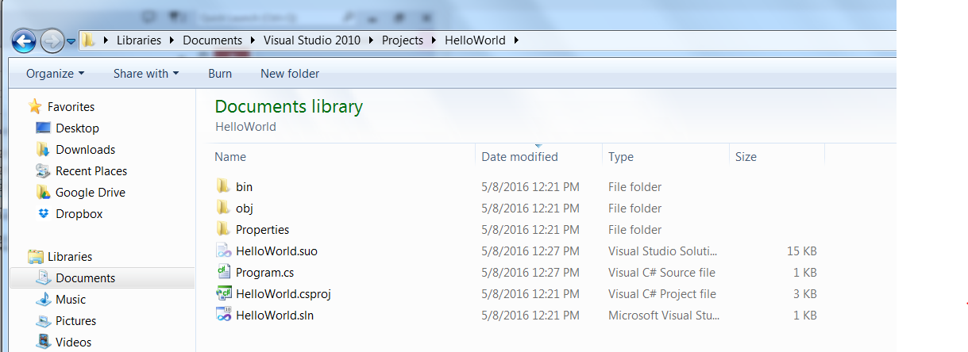

Debug files

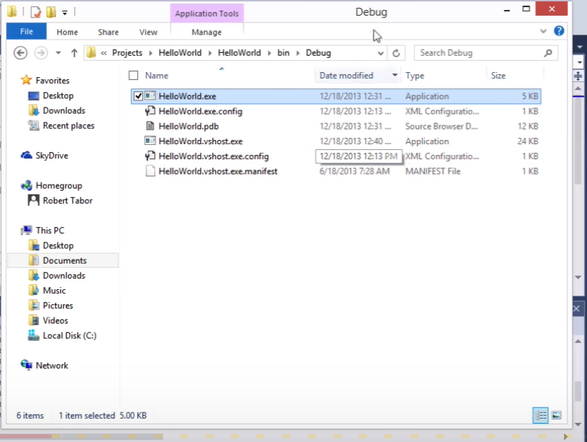

Can run without visual studio.

This is not a realese version. You can creat this by

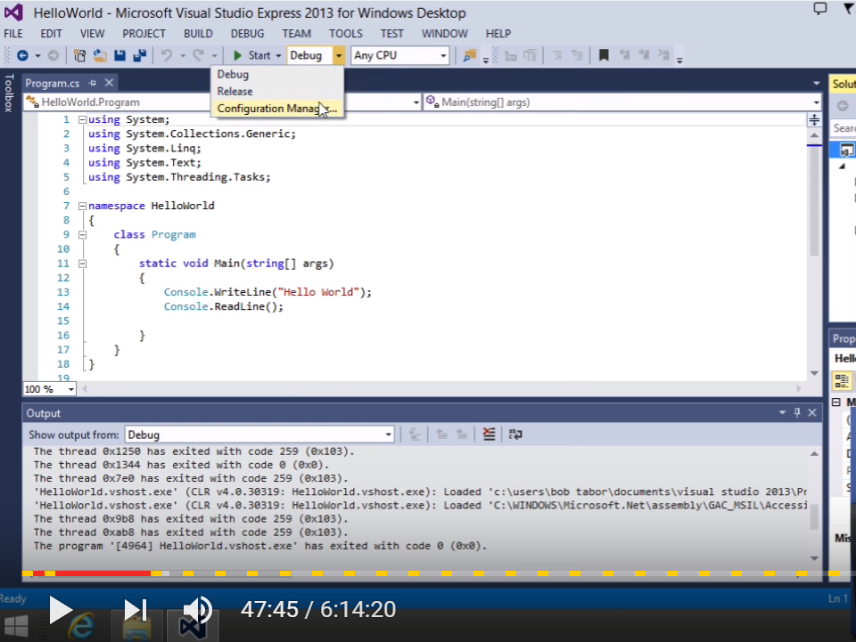

Using the above drop down. Configuration option is for advanced releases out of our scope. (multiple projects)

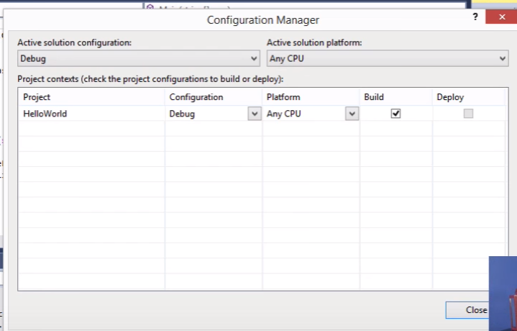

After code is test and ready for other users, which will package without debug process code only needed for visual studio. Not optimized.–

1 Choose release for stand alone version:

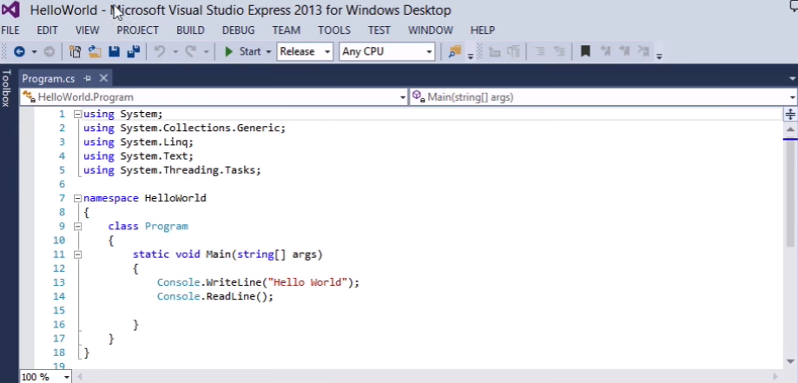

Click on build -

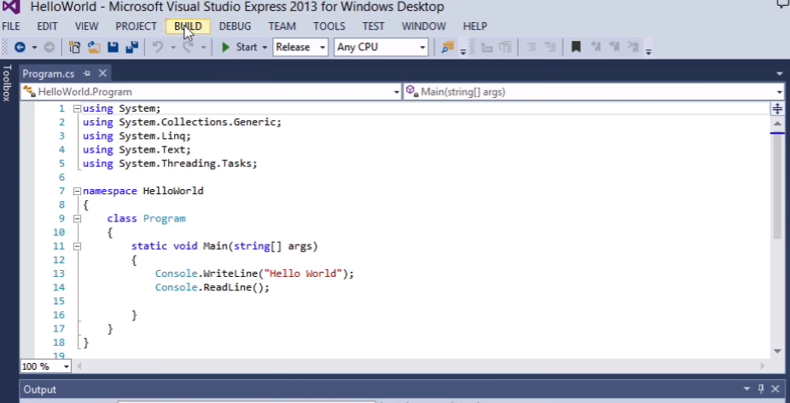

Bottom corner will show build succeed. Then look in file manager and you will see:

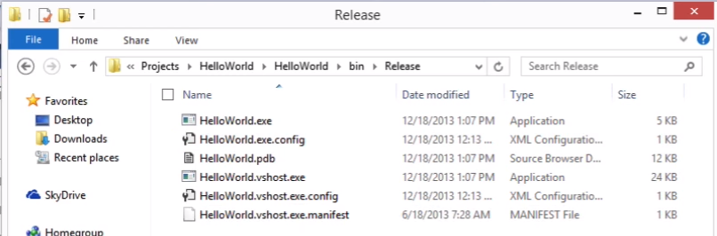

Output is identical for simple versions of programs. When you get further into more complex code you will see a dramatic difference.

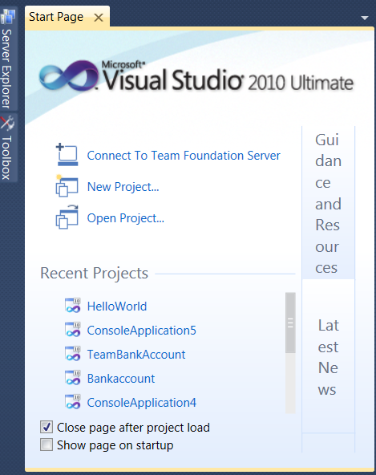Quick overview of visual studio IDE:

How to open projects from start menu –

a) You may click on recent projects in lower left corner.

b) open projects under Start

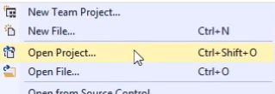c) File open project: (Or shortcut)

d) Recent Projects and solutions- 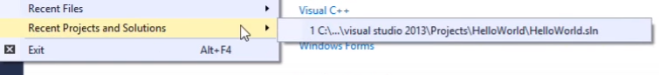

Window Auto hide feature

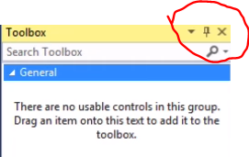

Toolbox and property window are not really used for console applications. (use for web can pull graphic drop down from tool box into main window, then move it around)

**How to set breakpoints** put mouse in row all the way to the left gray column and click to create: then run start in debug option and the following will appear. 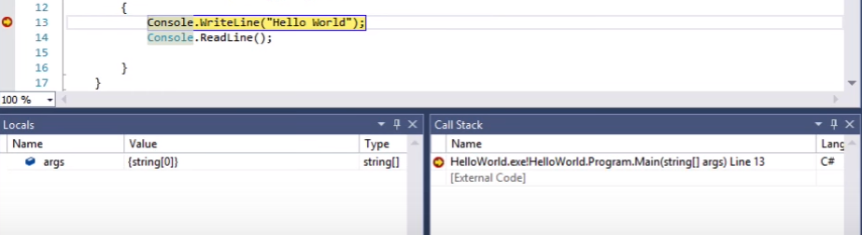

The line in yellow will be the very next line of to be executed.

How to go through code step by step use shortcut or these buttons: (step intoF11, step over F10, step out)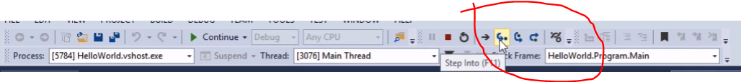

Press F10 or step over button and it moves down:

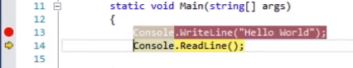

**To remove break point can be done in 3 ways**:

1 Click on red dot

2. F9 on keyboard when line is selected.

3. Menu item debug, toggle breakpoint as shown below:

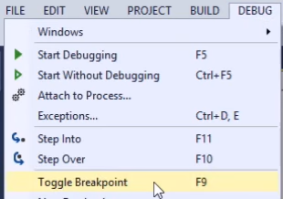

**Comment** are denoted by // . They are not compiled and are for programmers to specify functionality or often used in debugging. 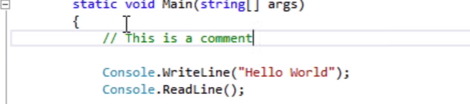

You can hilight code and use to bar button as follows to comment multiple lines of code.

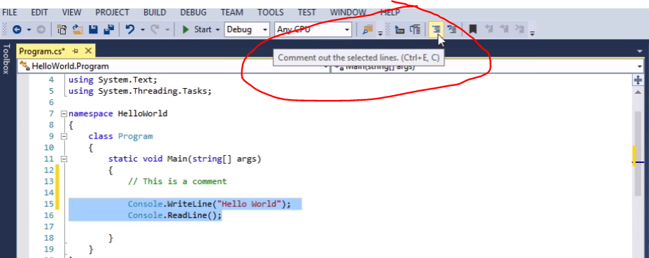

To can use the same process to uncomment code using button just to the right.

To do a multiline comment you can use /* text */ as shown below.

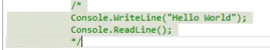

Itellisense – autofills available option as you type.

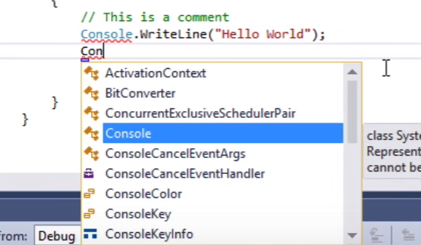

If you enter spacebar word will complete. If enter next delimiter is will complete. Also give you a breif window of what comes next.

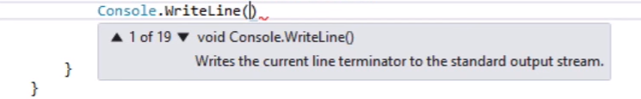

Also give information when you hover over a line as in the following example. 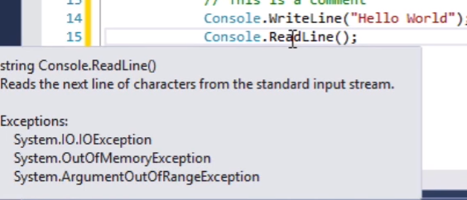

Customizing your visual studio to your preferences:

1 Choose tool menu, options. Text editer, then chooseC#:

Check box with line numbering.

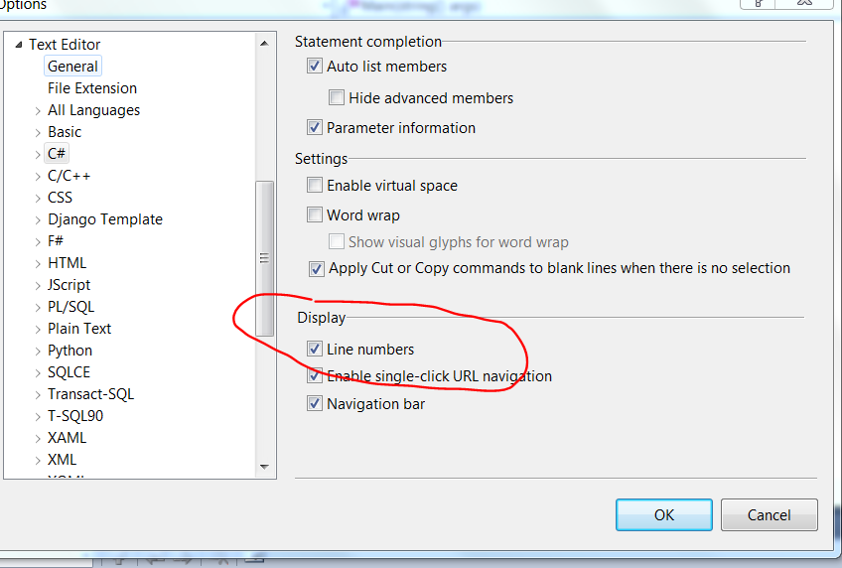

You can change how colors appear on your screen by choosing tool menu, environment, fonts and colors. Choose different settings.

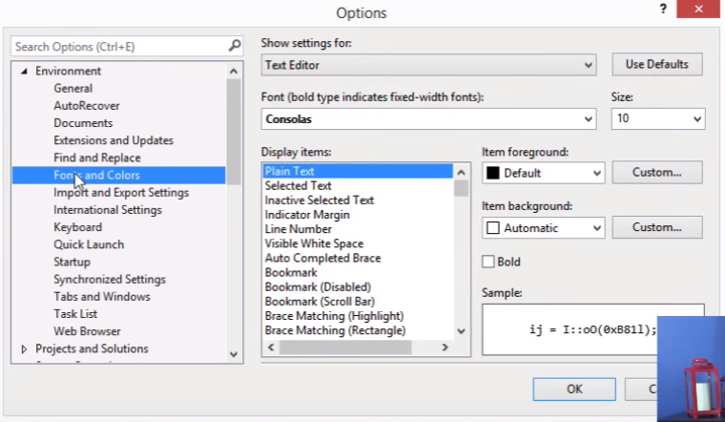

Code roll-up feature. By clicking on the  the code will collapse as shown below.

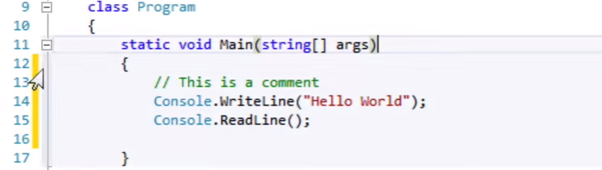

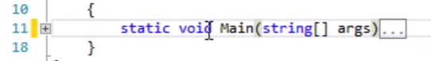

Yellow vertical strip designates the lines of code that have not been saved. When you hit save, the line will turn green indicating the lines have been recently saved.