Gunslinger Documentation
Get it right the first time, every time with Gunslinger!

What is it?
Gunslinger combines the concept of data providers and templates, making it easy to use configuration to generate whole new sections of your code base.

What can it do?
Gunslinger uses a combination of configuration and templates to create file output based on metadata provided by any number of Data Providers.
Example: A SQL Data Provider would return metadata for all of the tables in a given database.

The case for code generation
Imagine starting a project and being 80% done on the first day! Generated code can give us stable, working, testable code with the press of a button. In a scenario where a code base has very predictable elements and a template has been refined, generated code can absolutely provide 100% complete and working code. Generated code may not provide all of the bells and whistles that we might want for a finished product, but it can provide a working starting point that can then be customized to deliver value more quickly and reliably.

Templating
Gunslinger uses Handlebars.Net to render templates. Handlebars source is available on Github and the package is available on NuGet. Handlebars has a good pedigree, being an enhancement on the mustache template engine written for .Net. It is blisteringly fast and quite easy to use.

Data Providers
Gunslinger comes with three Data Providers that provide metadata for the following sources:
- SQL Server Database – the most common use case
- Swagger Endpoint – connect to an API with greater ease
- Class Library (DLL) – the sky is the limit with this new alpha feature
It is relatively easy to wire up a new Data Provider, though you may never need to do so.
A Data Provider class can be created for pretty much any data source that has a consistent rule set. Here are some examples of data sources for which a provider could be easily created:
- JSON file source
- XML file source

Operate with a scalpel
You don't have to run every generator that is used in your project at once because each time that Gunslinger is run it references a single JSON Configuration file that can configure as many or as few Data Providers and Templates as needed. In this way, we can group related processes or isolate distinct processes.

Run it with PowerShell!
Run Gunslinger however you want by creating PowerShell scripts that run Gunslinger once, or several times in succession.
Running Gunslinger 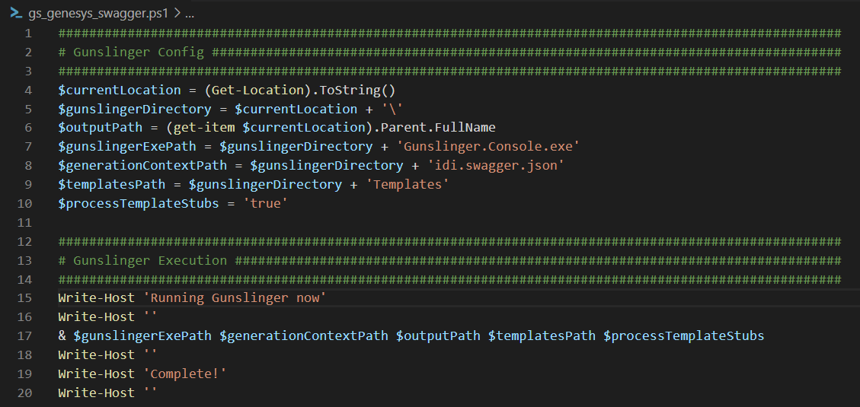
Any errors that come up will display in the PowerShell window. When errors occur, they are often issues with accessibility to the requested data source.

JSON Configuration

OutputDirectory
Data Type: string
Indicates the root path for the output for the current context.
Example: C:\Projects\GunslingerOutput\

ProcessTemplateStubs
Data Type: boolean
Indicates whether or not to run templates that have been designated as “stubs” via the IsStub property.

TemplateDirectory
Data Type: string
Indicates the root location of the templates that will be used for this context.

ExcludeTheseEntities
Data Type: string array
Indicates entities that should be ignored in this context. This is useful when there are entities that are unwanted in the output.

ExcludeTheseTemplates
Data Type: string array
Indicates templates that should be ignored in this context. This is useful when you don’t want to create a new configuration file, but also want to skip some templates.

IncludeTheseEntitiesOnly
Data Type: string array
Indicates that all entities other than the ones listed here should be ignored in this context. This is useful when you know that changes have been made to an entity or a small group of entities and you don’t want to process output for any others.

IncludeTheseTemplatesOnly
Data Type: string array
Indicates that all templates other than the ones listed here should be ignored in this context. This is useful when you don’t want to create a new configuration file, but also want to skip some templates.

Resources
Data Type: Resource Array

Resource

Source
Data Type: string

Destination
Data Type: string
Used for copying files or folders from a source to a destination. Useful for making sure that certain artifacts that might change are included in the output.

DataProviders
Data Type: DataProvider array

DataProvider

Name
Data Type: string
This value needs to be unique within the current configuration document. It is used to reference the data provider from within the template configuration.

TypeName
Data Type: string
Used to reference the actual C# type in the compiled source. Currently available values are:
- SQLModelDataProvider
- SwaggerDataProvider
- ReflectionDataProvider (alpha)
- ReflectionMethodInfoDataProvider (alpha)

UseLocalDataSource
Data Type: boolean
Indicates to use the “LocalDataSource” property.

LocalDataSource
Data Type: string
An alternate string used to connect to a local resource. Only active when the “UseLocalDataSource” property is set to true. Use this when there is limited connectivity to a production data source or when you want to manually modify a test version of a data source.

DataSource
Data Type: string
The string used to connect to the resource. When using SQLModelDataProvider this will be a connection string, with the SwaggerDataProvider it will be a URL.

OpenDataSourceUrlInDefaultBrowser
Data Type: boolean
This allows us to mitigate issues with authorization on some endpoints by opening the data source URL in a browser window. A particular endpoint that was used early on while developing Gunslinger required a user to authorize by visiting the page in a browser before the endpoint will allow us to pull data from that application context. This helps speed up the resolution of that issue.

NonSpecifiedPropertiesAreNullable
Data Type: boolean
Indicates whether or not to treat all properties that aren’t specified as required to be treated as if they were nullable. This is only relevant within the SwaggerDataProvider and is not the standard way that Swagger treats properties. This option is here to provide the ability to allow the SwaggerDataProvider to behave in a non-standard way because, for better or worse, some endpoints are configured this way and Gunslinger needed to accommodate that. Templates
Data Type: Template array

Template

Type
Data Type: TemplateType enum

TemplateType
Setup – indicates that only one file will be output. Information about every model will be provided to the template.
Model – indicates that one file per model will be output.

Name
Data Type: string
Mostly just an identifier for the user who configures the template, but also used in reporting an error finding the template file.

Namespace
Data Type: string
Available for use inside the template. The intended use is to designate the output file’s namespace.

IsStub
Data Type: boolean
Designates a template as a “stub”, or a file that should be used by the developer to extend a generated base class. When the “ProcessTemplateStubs” value is true a template with this value will get run, when the “ProcessTemplateStubs” value is false it will not.

InputRelativePath
Data Type: string
The file path of the template. This is relative to the “TemplateDirectory” value provided.
Example: SwaggerModel.txt
Example: SwaggerTemplates\\SwaggerModel.txt

OutputRelativePath
Data Type: string
The file path for the files output by this template. This is relative to the “OutputDirectory” value provided.
There are two special template strings can be used inside this string, they are {schema} and {entityName}. Schema is only relevant for the SQLModelDataProvider.
Example: \\{entityName}.cs
Example: Data\\{schema}\\Models\\{entityName}.cs

Language
Data Type: Language enum

Language
csharp
sql
javascript
html
This value helps the metadata property factories determine how to translate data types from the data source type system to the type system in the destination language. Set this value to reflect the language of the output file type.

RunOnce
Data Type: Boolean
No longer in use. Ignore this or remove the reference. It is being removed in favor of the “Type” designation.

DataProviderName
Data Type: string
Indicates the source Data Provider that the metadata for running the template will come from.

Imports
Data Type: string array
Available for use inside the template. The intended use is to assign the imports used in the file that is output. It is not uncommon for some models to need imports that other models don’t need. Every import for the entire batch of files will need to be included here for the output code to compile. This may result in some files having more imports than needed.

Template Example
There are some good template examples in the source code in the Tests project.
Here are some for quick reference.
Simple Model
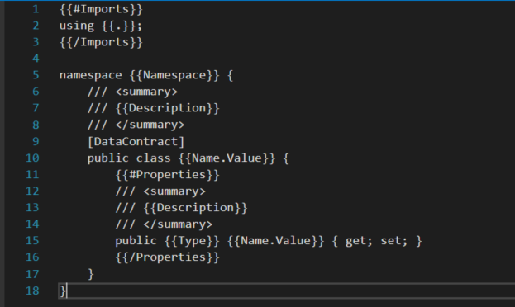
Slightly more complex
