**ONE-6290 - JIRA Ticket**

* This project intends to use the weather widget to see what the temperature will be like in the area for the upcoming days and to see if there is rain in the forecast. I envisioned this of being more of a high level 3 to 7 day forecast for the location that listed the high/low temp in a layout

**EXAMPLE of ONE-6290**

* **At the top right of the WO will be a weather icon. If a user hovers over the icon, a hover over pop-up will appear with the current week’s forecast.**

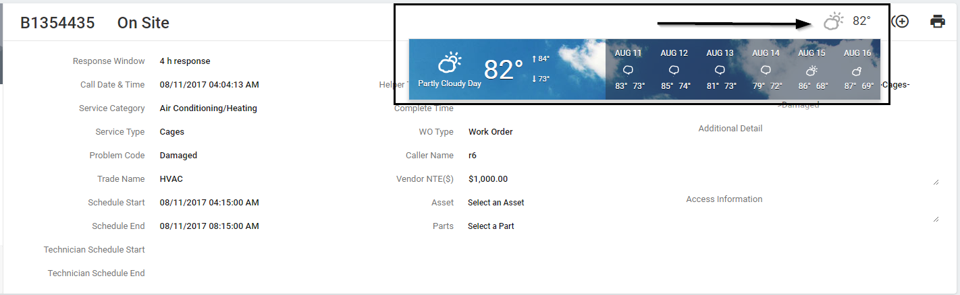

**ONE-6670 - JIRA Ticket**

Due to the request from affiliates, they would like some way to save their daily searches they make in our portal

**Example of ONE-6670**

* **Improved the Affiliates' Work Management module and added the "Save Search Filter" feature to allow the affiliates to save their daily searches.**

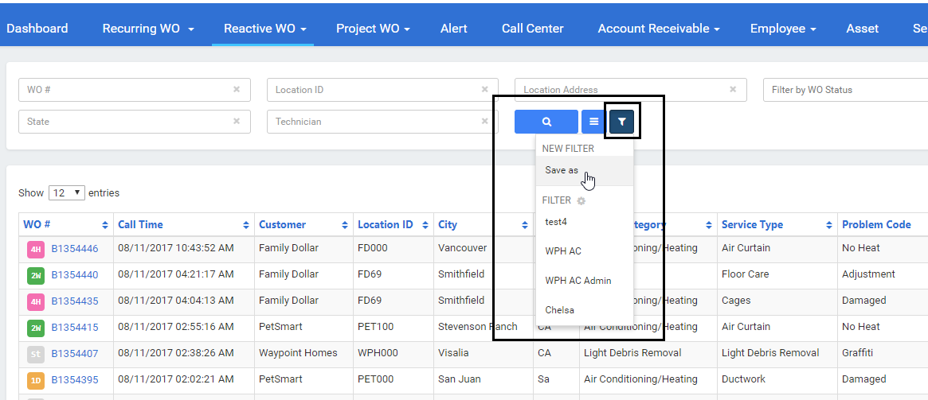

This project came from Operations department and they would like to show affiliates their aging work orders. The widget can look identical to the one that currently exists on our internal portal (Open WO by aging)

**Example of ONE-5284**

* + **Add Widget to show breakdown of aging reactive WOs.**

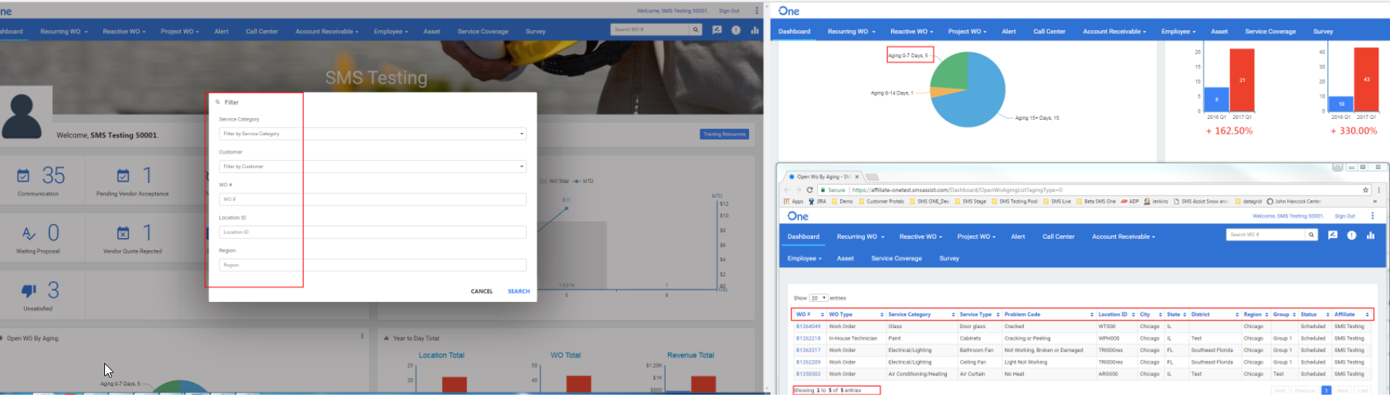

**EXAMPLE of ONE-5329**

* **SMSU: Affiliate Quick Tour: The quick tour will highlight the basic functionalities for the affiliate portal. The quick tour will also provide affiliate training videos and guides.**

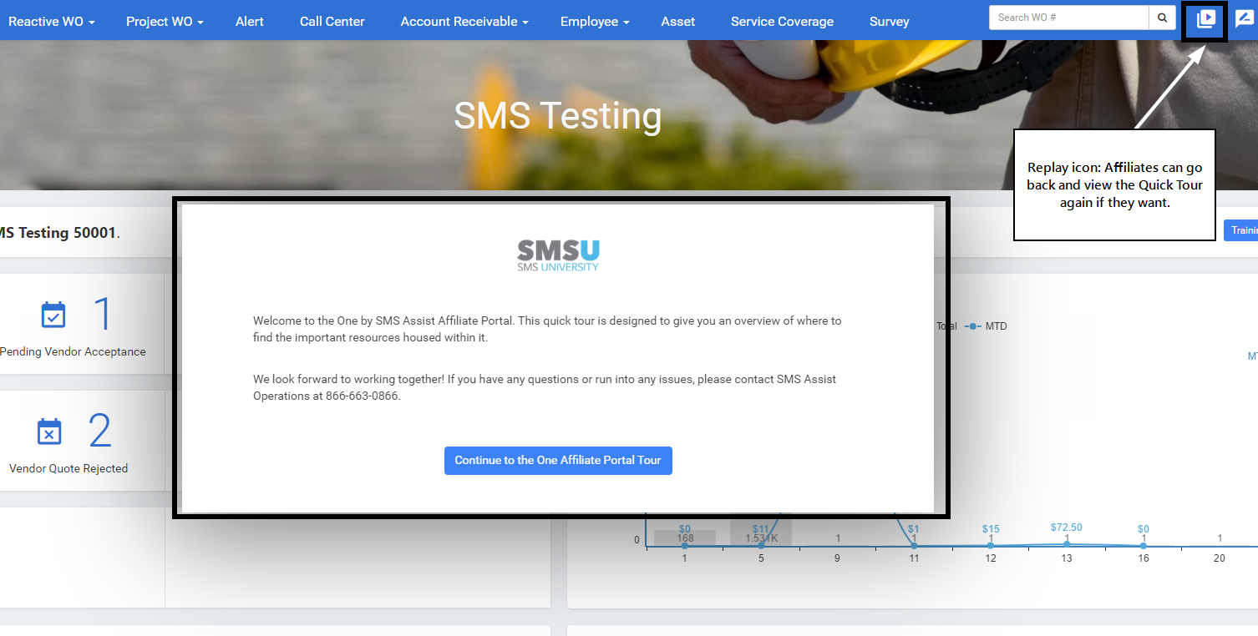

* **SMSU: Affiliate Quick Tour: The tour will show the affiliate how to download the mobile application.**

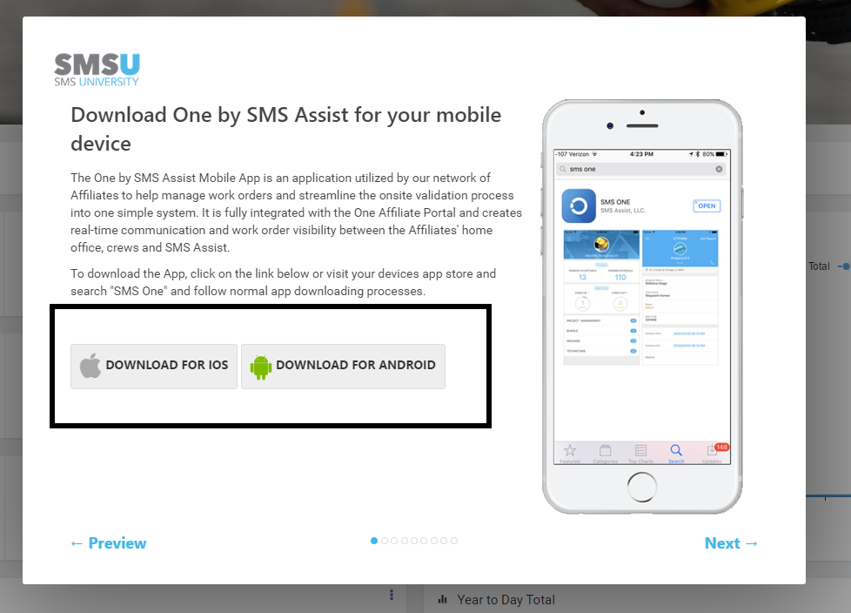

* **SMSU: Affiliate Quick Tour: Show the affiliate how to accept and Schedule Work Orders.**

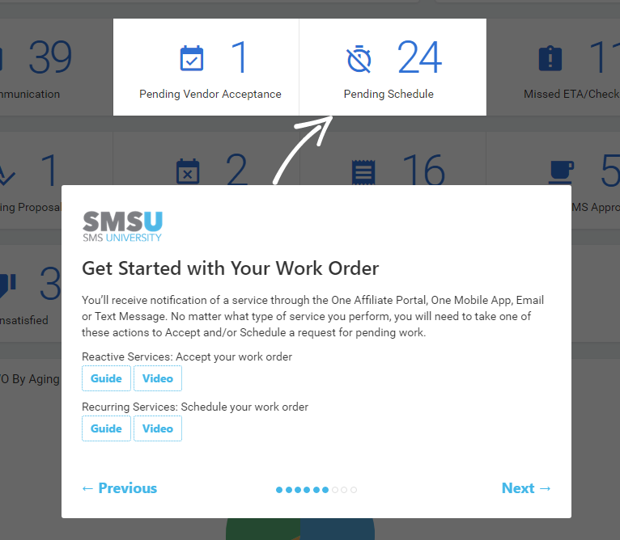

* **SMSU: Affiliate Quick Tour: How to download the application, check-in, and check-out of Work Orders through the mobile application.**

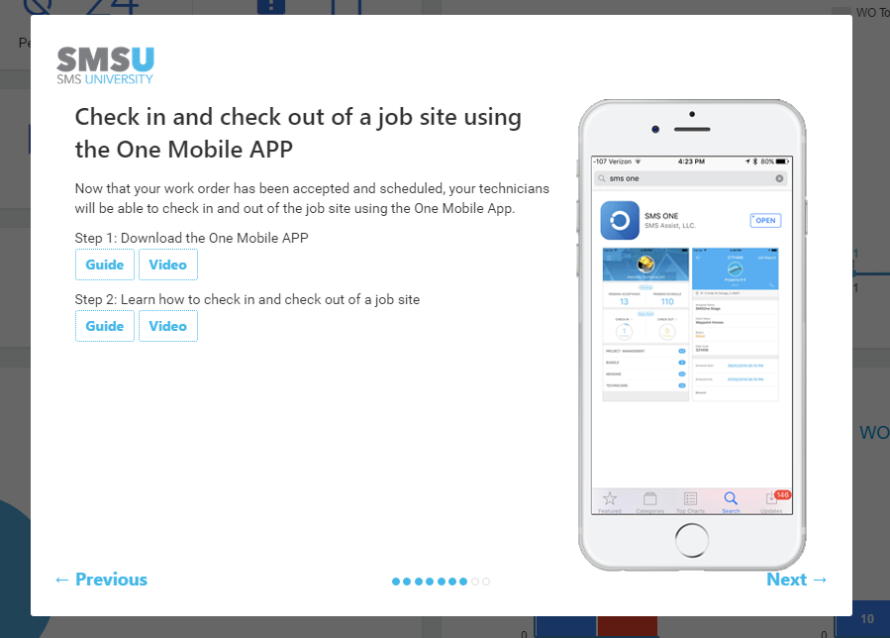

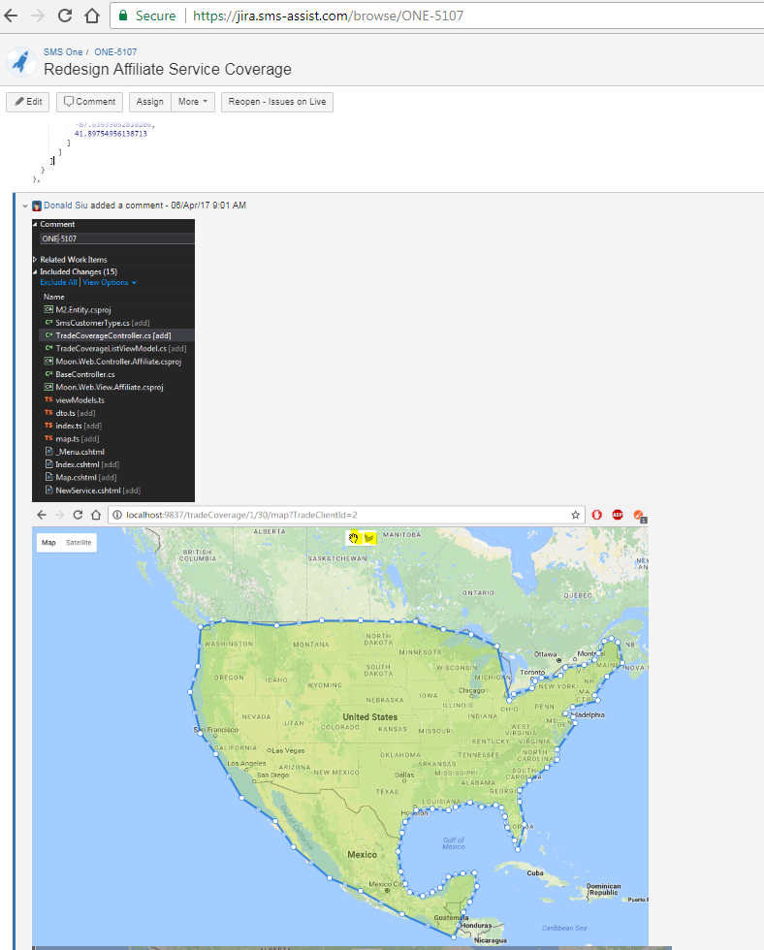

**EXAMPLE of ONE-5107**

* **The ARM's (Affiliate Relationship Management) team wants to use their version of Trades instead of our current Service Category > Service Type. The Trades would be a translation table based on Service Category > Service Type > Problem Code.**

