Eat-Da-Burger Activity

Begin listening on port 3000, shows default DB

user@user-097ifju MINGW64 ~/Documents/Bootcamp/eat-da-burger (master)
$ node server.js
connected as id 10
{ burgers:
[ RowDataPacket {
id: 1,
burger_name: 'Macho Burger',
devoured: 0,
date: 2017-09-28T18:07:01.000Z },
RowDataPacket {
id: 2,
burger_name: 'Quiona Vegetarian Burger',
devoured: 0,
date: 2017-09-28T18:07:01.000Z },
RowDataPacket {
id: 3,
burger_name: 'Texas Bacon Burger',
devoured: 0,
date: 2017-09-28T18:07:01.000Z },
RowDataPacket {
id: 4,
burger_name: 'Double Cheeseburger',
devoured: 0,
date: 2017-09-28T18:07:01.000Z },
RowDataPacket {
id: 5,
burger_name: 'Big Mac Hamburger',
devoured: 0,
date: 2017-09-28T18:07:01.000Z } ] }

Ran on localhost:3000

Main screen displays in /burgers, shows default burgers defined in the database:

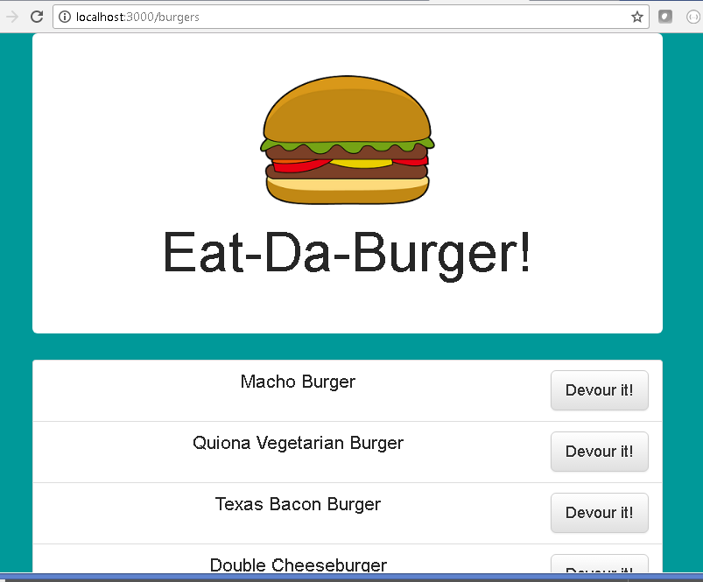
Click the Devour it! Button for Macho Burger and Macho Burger is moved to the field below:

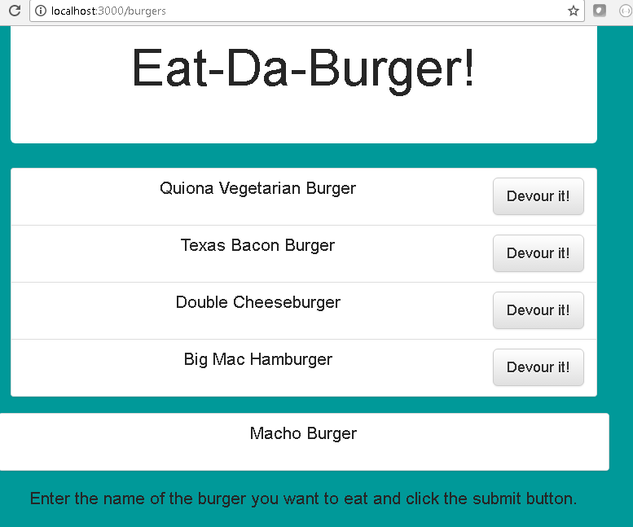
Click the Devour it! button for the next item and it appends to the list. Now the Quiona Vegetarian Burger displays.

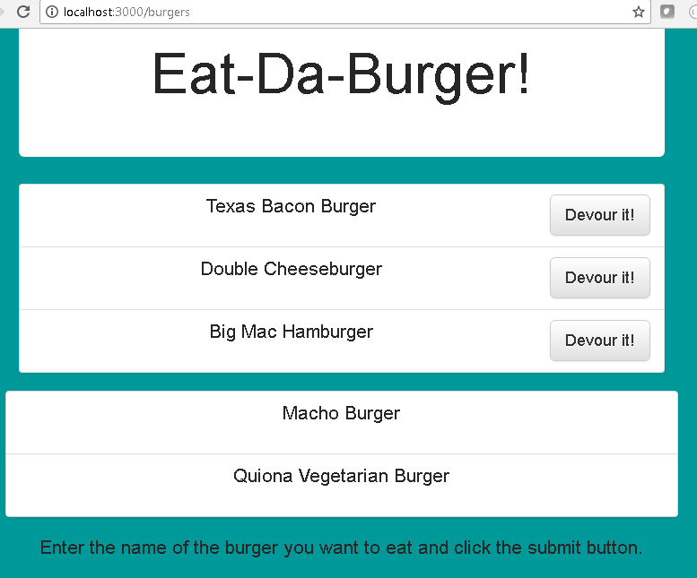

In the bottom field, entered the name of a new burger, LLBean Burger, and clicked Add Burger.

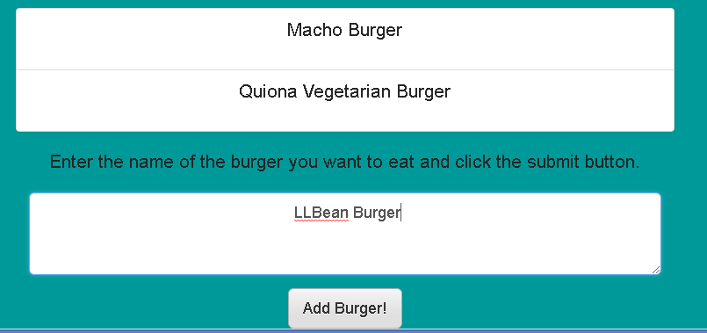
Result: LLBean Burger is added to the end of the list of burgers to devour.

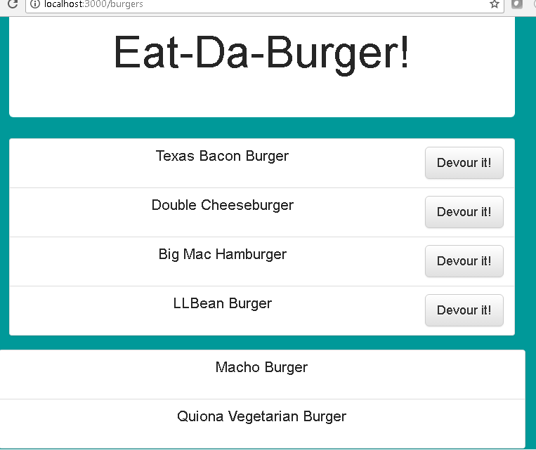
When all burgers are eaten, all appear in the list:

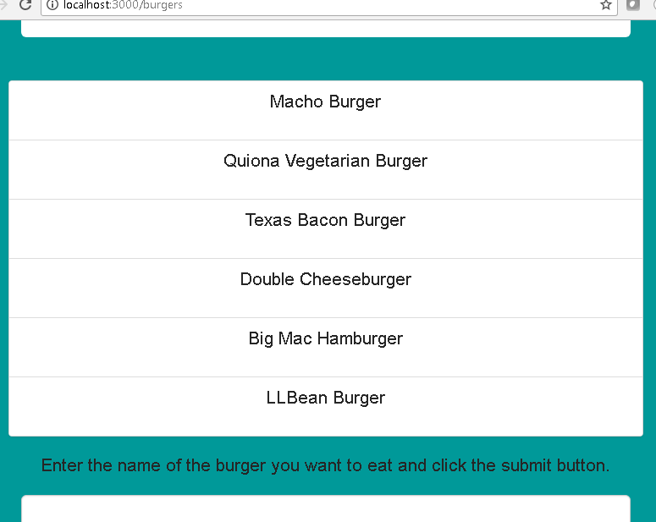

Rerun node server.js, shows DB updated”

user@user-097ifju MINGW64 ~/Documents/Bootcamp/eat-d
$ node server.js
connected as id 11
{ burgers:
[ RowDataPacket {
id: 1,
burger_name: 'Macho Burger',
devoured: 1,
date: 2017-09-28T18:30:36.000Z },
RowDataPacket {
id: 2,
burger_name: 'Quiona Vegetarian Burger',
devoured: 1,
date: 2017-09-28T18:32:31.000Z },
RowDataPacket {
id: 3,
burger_name: 'Texas Bacon Burger',
devoured: 1,
date: 2017-09-28T18:35:25.000Z },
RowDataPacket {
id: 4,
burger_name: 'Double Cheeseburger',
devoured: 1,
date: 2017-09-28T18:35:27.000Z },
RowDataPacket {
id: 5,
burger_name: 'Big Mac Hamburger',
devoured: 1,
date: 2017-09-28T18:35:28.000Z },
RowDataPacket {
id: 6,
burger_name: ' LLBean Burger',
devoured: 1,
date: 2017-09-28T18:35:29.000Z } ] }

