User Interface Design Specification

Kimchi - Ginger

Document Status: DRAFT

Owners:

Don Spangler
Simon Alibert

Susan Jasinski

Contents

Functional Requirements 3
Guidelines 3
Widgets 3
Typography and Common Action Labels 3
1 Overall Layout 5
1.1 Design approach 5
1.2 Icons 7
2 Administration 8
2.1 Design approach 8
2.2 Administration Tasks 11
2.3 Icons 12
3 Blueprint Fonts and Colors 14

Functional Requirements
This user interface design document describes additions and changes to the Kimchi console to support virtualization management. This document focuses on updates to the layout, visual design and interaction of the existing console elements. These elements include: reorganizing page content, adding search/filtering function, sorting function, touch gestures, page responsiveness, and mobile responsiveness. Additional items and interactions, including new features and functions, will be specified in follow-on specification documents.

The purpose of this feature is to provide users with a consistent and intuitive interface that allows them to navigate to necessary tasks and see relevant information.

Guidelines

Widgets
This design references Bootstrap visual design and interactions. Any departure from this widget set will be specified as part of this design document, the design blueprints or in the prototype. If not specified, it is assumed and expected that Bootstrap specifications and interactions will be followed.

Typography and Common Action Labels
We will make an effort to include font specification in our designs; as a general rule of thumb, Kimchi follows the following patterns:

- Header 1 bold: Helvetica Neue Light 27px
- Header 1 light: Helvetica Neue Bold 27px
- Header 2 bold: Helvetica Neue Bold 22px
- Header 3 bold: Helvetica Neue Bold 17px
- Header 3 medium: Helvetica Neue Medium 17px
- Header 3 light: Helvetica Neue Light 17px
- Header 4 medium: Helvetica Neue Medium 14px

Banner / Header
- Content + unselected tabs content Header 3 medium #FFFFFF (white)
- Selected tabs content Header 3 bold #FFFFFF (white)
Header 3 bold #222222 (dark grey)
- Tabs counter content Header 4 medium #FFFFFF (white)
Header 4 medium #222222 (dark grey)

Panels
- Panel Titles Header 1 bold #444444 (grey)
- General / Enabled content Header 3 medium #222222 (dark grey)
- Disabled content Header 3 medium #999999 (light grey)
- Links – normal state
- Links – hover state
- Links – visited state
- Links – disabled state
- Sub-Content and Table-Column Header 3 light #222222 (dark grey)
content (e.g. %, GB)
- Table headers Header 3 light #222222 (dark grey)
- Button content Header 3 medium #FFFFFF (white)
Header 3 medium #444444 (grey)
- Disabled Button content Header 3 medium #999999 (light grey)
- Field content Header 3 medium #222222 (white)
- Disabled Field content Header 3 medium #999999 (light grey)
- Context Menu content Header 3 medium #FFFFFF (white)
- Disabled Context menu content Header 3 medium #999999 (light grey)
- Host Utilization Rates Header 1 light #222222 (dark grey)
- Guest Utilization Rates Header 2 bold #222222 (dark grey)
- Inline messages for gathering Header 3 medium #444444 (grey)
data or no data available

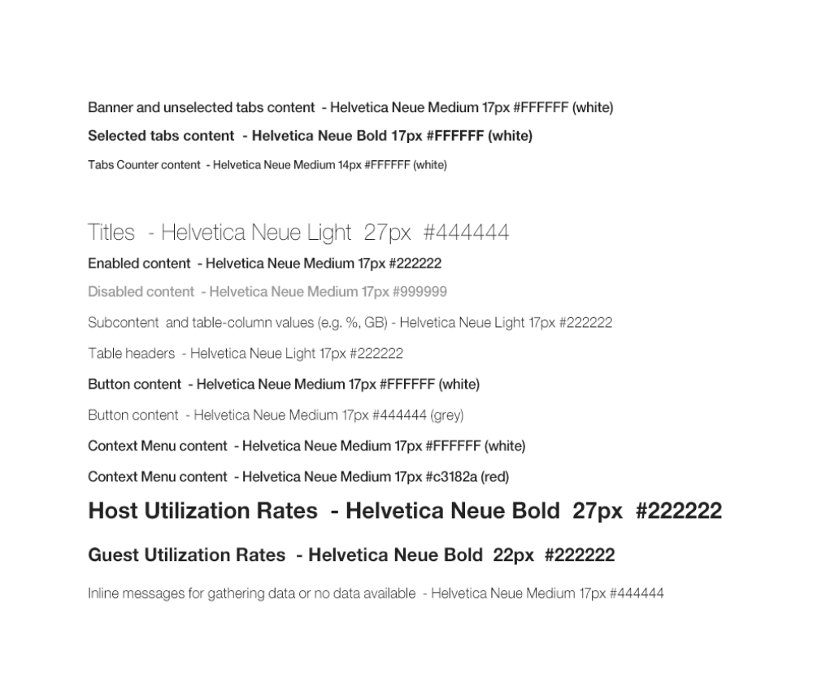

Overall Layout

Design approach
The overall console layout is made up of five different areas:

- Banner – Provides product name and access to peer hosts, user info, and hep topics actions such as log out.
- Tabs –This section provides a space for the host names and tabs, including a digit counter for the number of resources displayed in each tab
- Panel Level Actions – Provides a space for panel level actions such as add a resource as well as future actions such as Print and Export
- Filter and Sorting – Optional area for filter field, sort button and toggle button for gallery or table view.
- Content area – Displays main content area

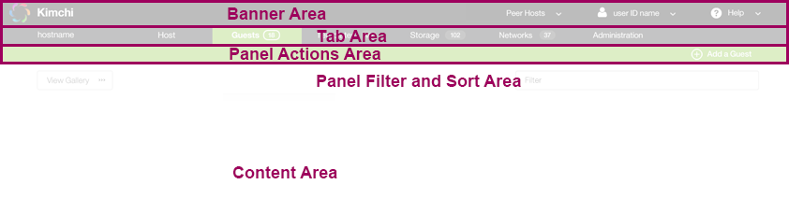
Figure 1.1-1; Example of basic console layout

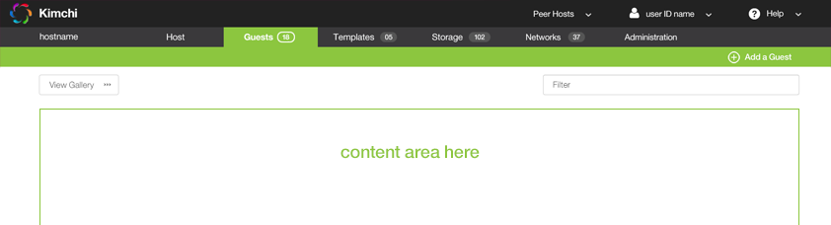
Figure 1.1-2: High fidelity example of basic layout with doc pod expanded

Application logo and name stick to the left side of the banner, and do not move when the screen is resized. It has no actions.

Peer Host drop down stick to the right side of the banner when the screen is resized. When on option is clicked, a new browser tab is opened with the new peer host login.

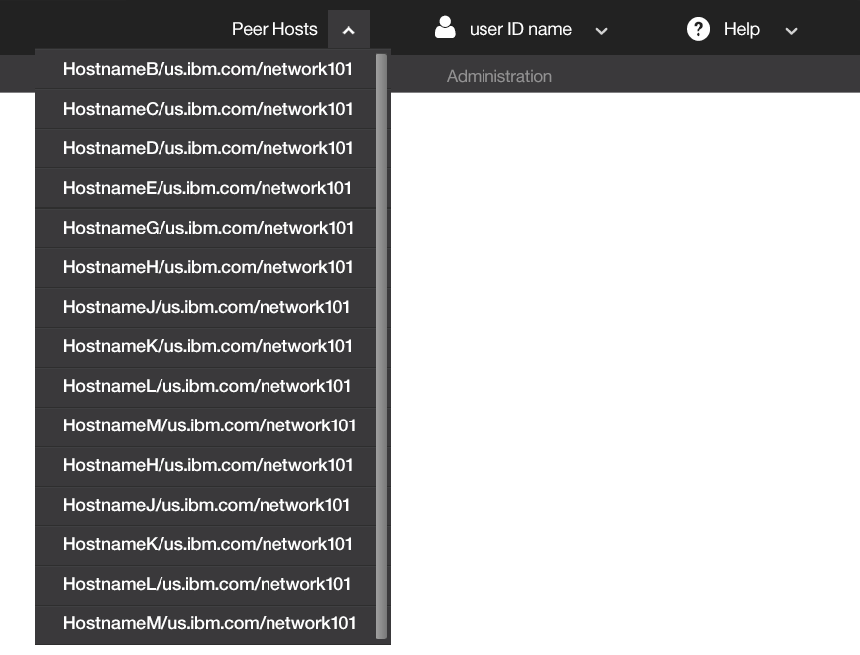
Figure 1.1-3: Example of Peer Host context menu

[user ID] drop down sticks to the right side of the banner when the screen is resized. Single-clicking the [user id name] and chevron causes a context menu to display with the Log Off action.

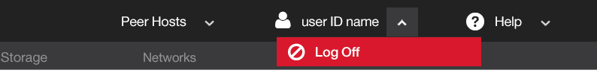
Figure 1.1-4: Example of User ID context menu

Help drop down sticks to the right side of the banner when the screen is resized. Single-clicking the Help and chevron causes a context menu to display listing all help topics available for the application. (Right now, each topic is for a tab/panel in Kimchi).

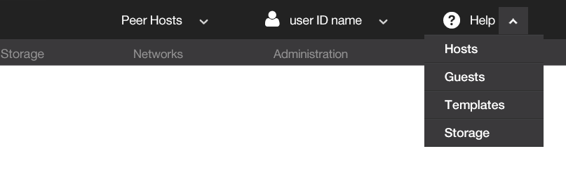
Figure 1.1-5: Example of Help context menu

Icons

Icon | hex value | size | Font | Character Name | Behavior
 | -- | 42px | -- | kimchi.png | --
 | #FFFFFF | 26px | Font Awesome | user | --
 | #FFFFFF | 26px | Font Awesome | help-circled | --
 | #CCCCCC | 13px | Font Awesome | down-open | - Single-click (or single tap) causes context menu to open
 | #AAAAAA | 13px | Font Awesome | up-open | - Single-click (or single tap) causes context menu to close
 | #FFFFFF | 24px | Font Awesome | block | --
 | #FFFFFF | 24px | Entypo | Plus-circled | --

Administration

Design approach
Tab color is red, and each panel option can be expanded and collapsed.
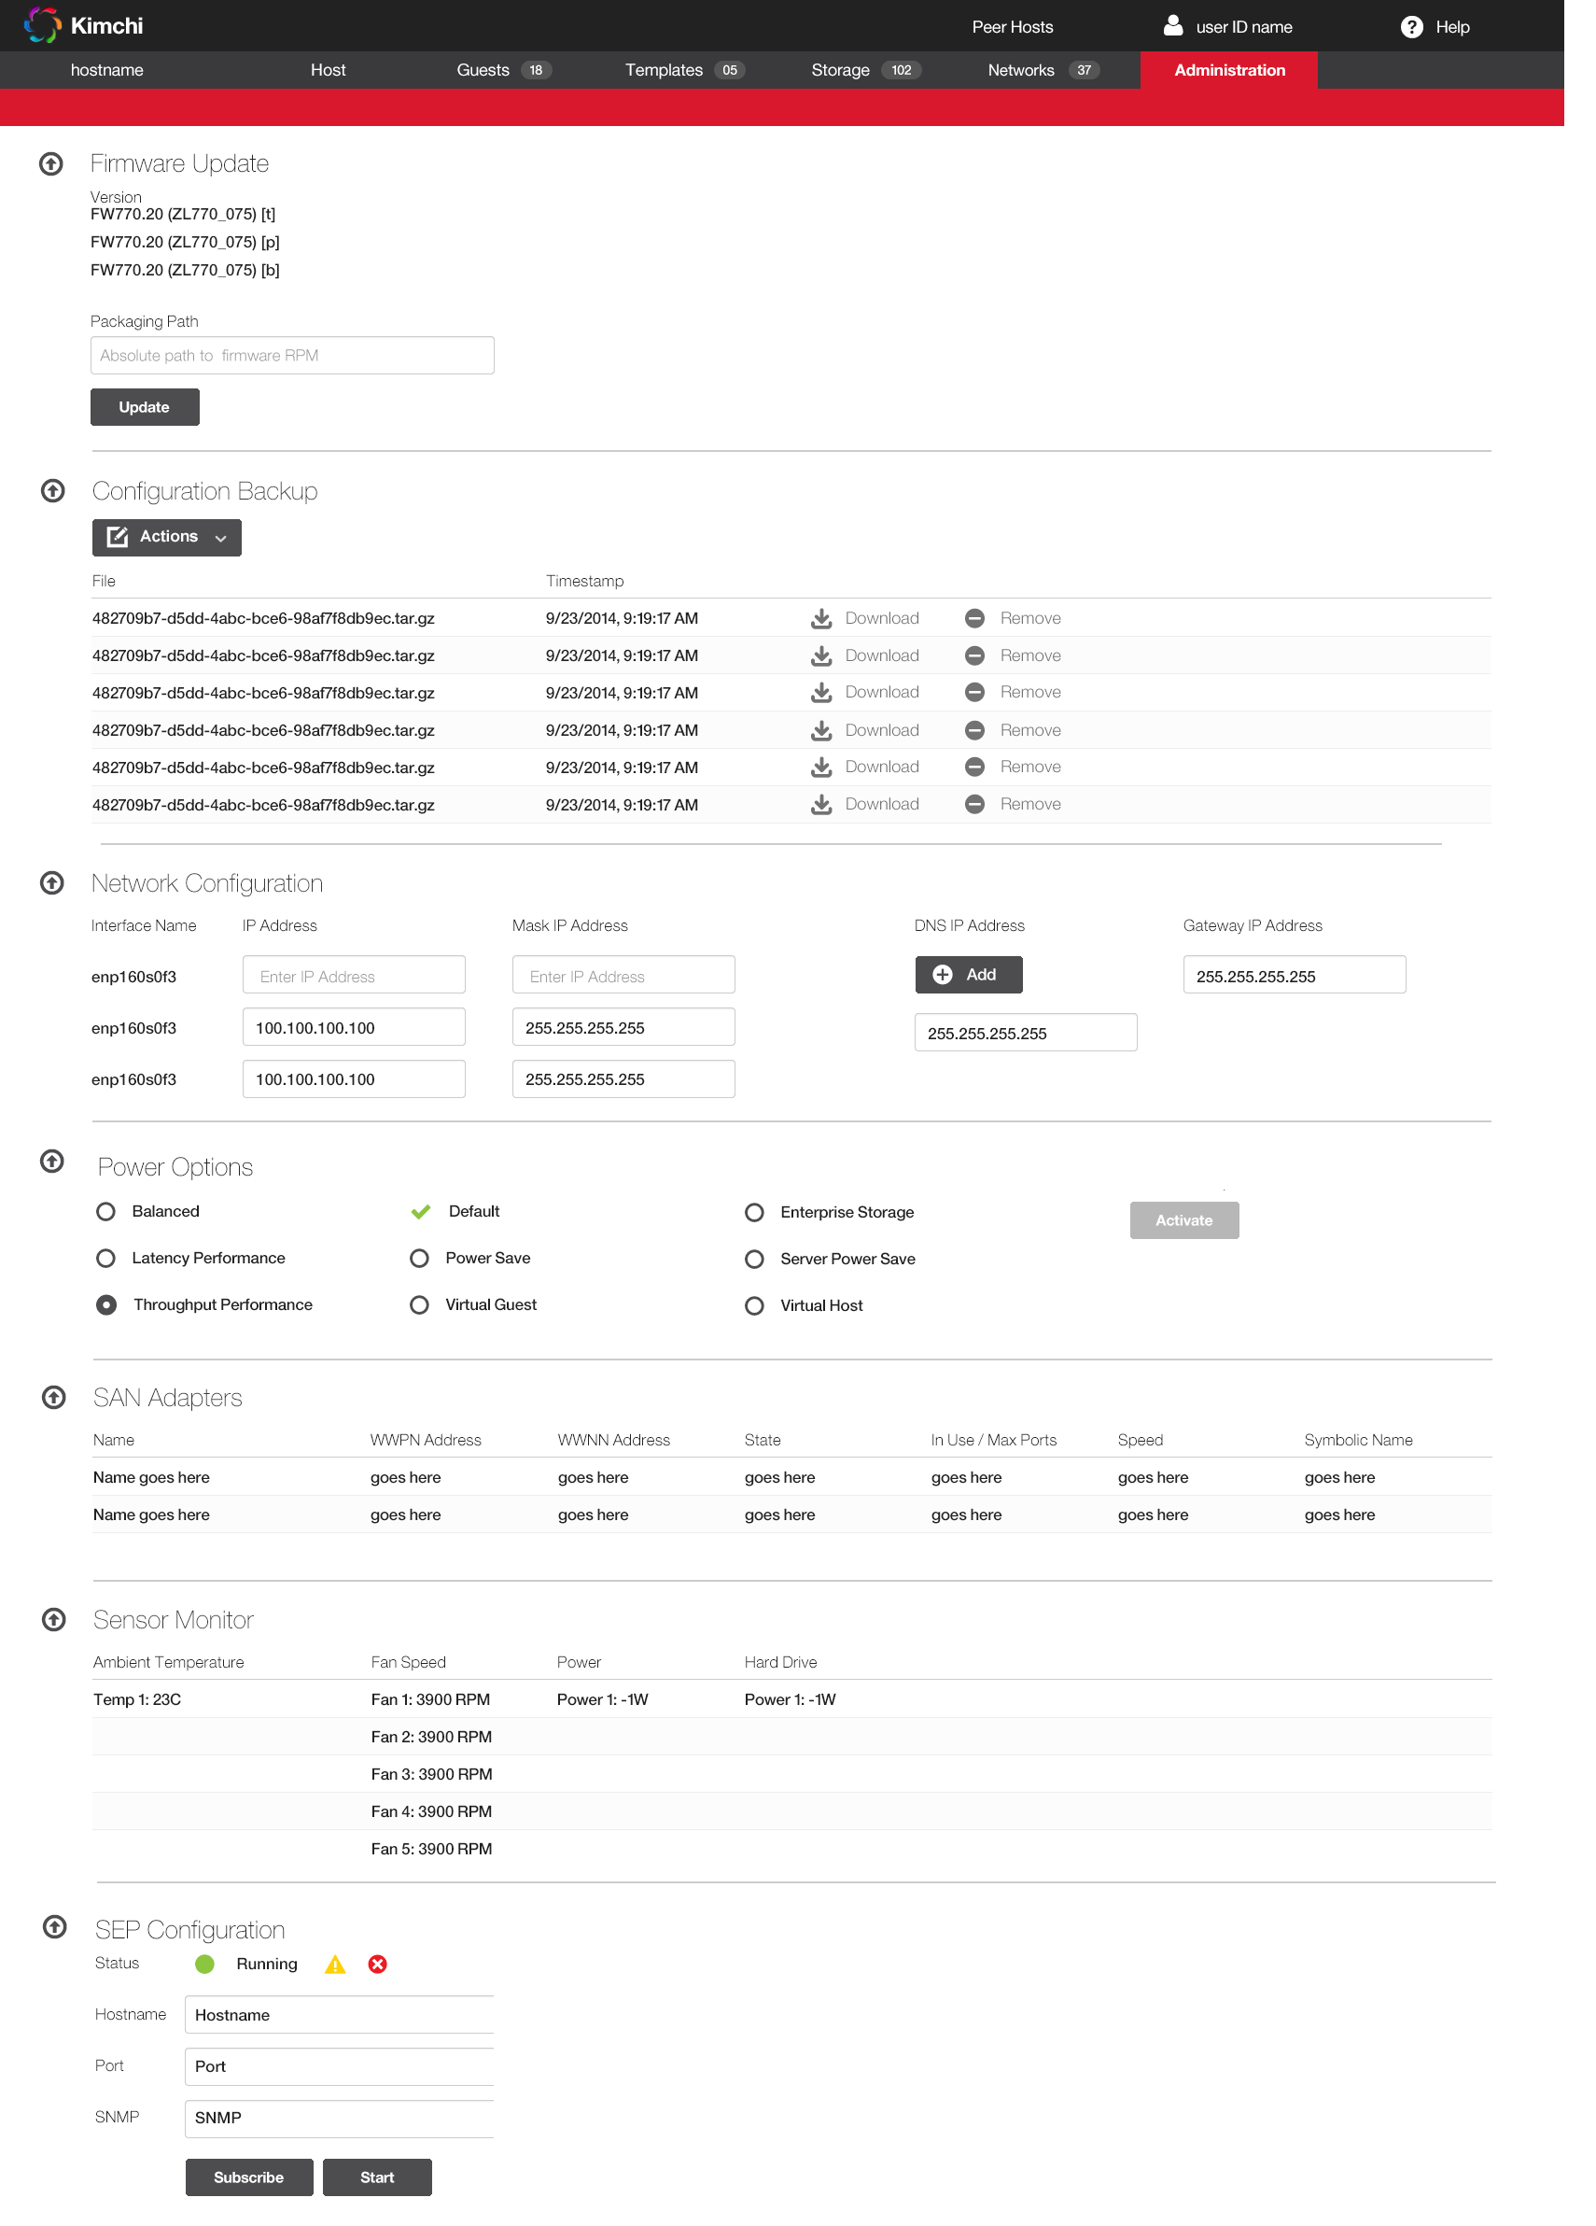
Figure 2.1-1: High fidelity example of Administration panel layout – all sections expanded

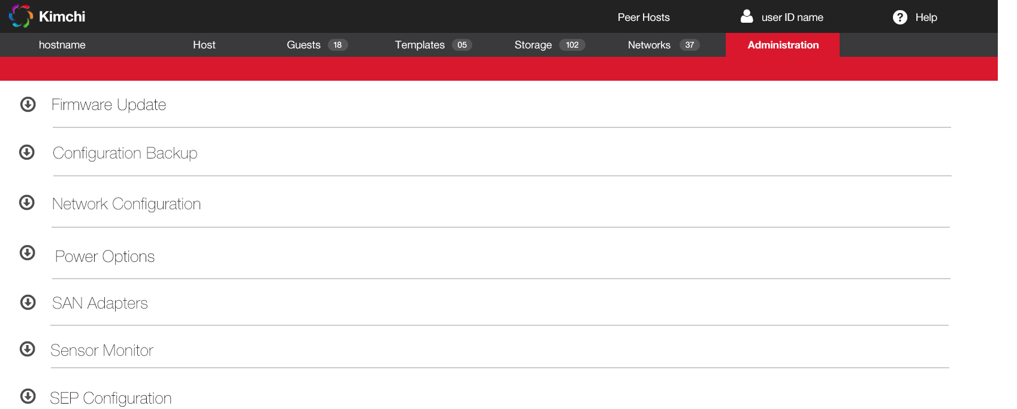

Figure 2.1-1: High fidelity example of Administration panel layout – all sections collapsed

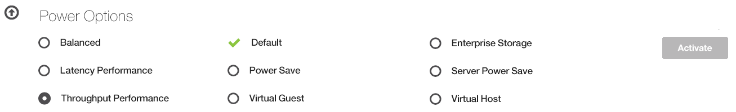
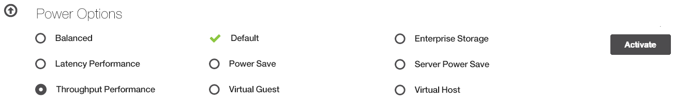

Figure 8.1-2: Example of Power options – Activation button is disabled when no radio button is selected (top) and enabled when a radio button is selected (bottom)



Figure 8.1-2: Example of Configuration Backup – file properties appear inline when the actions context menu

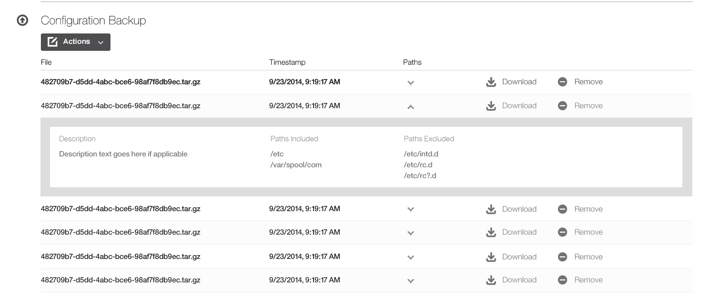

Figure 8.1-2: High fidelity example of Configuration Backup section layout with Paths content open inline – semi-table view

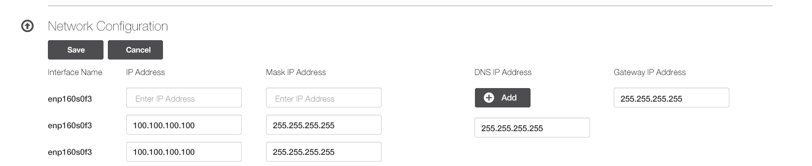

Figure 2.1-2: Example of Network Configuration option – Save and Cancel buttons appear when changes are made to a field in this section, and the panel becomes modal. After either the saved or canceled button is clicked the buttons disappear and the panel is no longer modal again.

Administration Tasks

The following Administration panel tasks do not have a task window, message window or alert message associate with them:
- SEP Configuration > Start …
- Configuration Backup > Download …
- Configuration Backup > Remove …
- Configuration Backup > Generate Default Backup …
- Configuration Backup > New Custom Backup …

Firmware > Update …

Figure 2.2-1: Example of Firmware task for updating host firmware

SEP Configuration > Subscribe …

Figure 2.2-1: Example of SEP Configuration task for subscribing

Power Option > Activate …

Figure 2.2-1: Example of Network Configuration task for adding a DNS IP Address

Configuration Backup > Batch Delete …

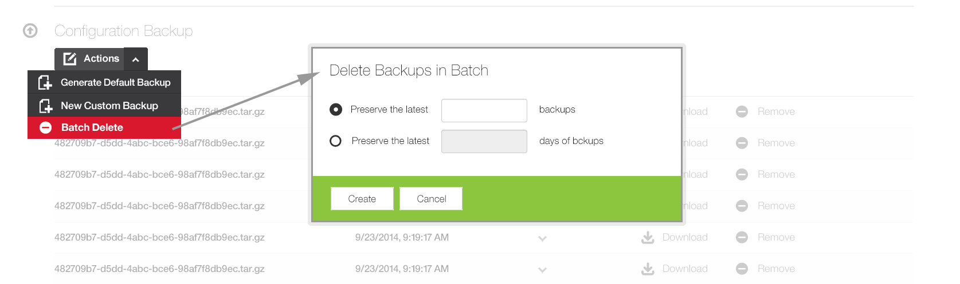

Figure 2.2-1: Example of Configuration Backup task for deleting a batch of configuration backups at one time

Network Configuration > DNS IP Address > Add …

Figure 2.2-1: Example of Network Configuration task for adding a DNS IP Address

Icons

Icon | hex value | size | Font | Character Name | Behavior
 | #FFFFFF | 24px |  |  | Delete
 | #FFFFFF | 24px |  |  | New Custom Backup / Generate Default Backup
 | #777777 | 20px |  |  | Actions button
 | #FFFFFF | 25px | Entypo | plus-circled | Add
 | #8cc63f | 24px | Font Awesome | ccw | Activated
 | #FFFFFF | 24px |  |  | Selected
 | #FFFFFF | 24px |  |  | Unselected
 | #555555 | 48px |  |  | Expand
 | #555555 | 48px |  |  | Collapse
 | #CCCCCC | 13px | Font Awesome | down-open | - Single-click (or single tap) causes context menu to open
 | #AAAAAA | 13px | Font Awesome | up-open | - Single-click (or single tap) causes context menu to close

Blueprint Fonts and Colors

Global Fonts and Colors …
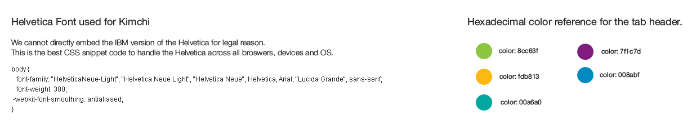
Global Header …

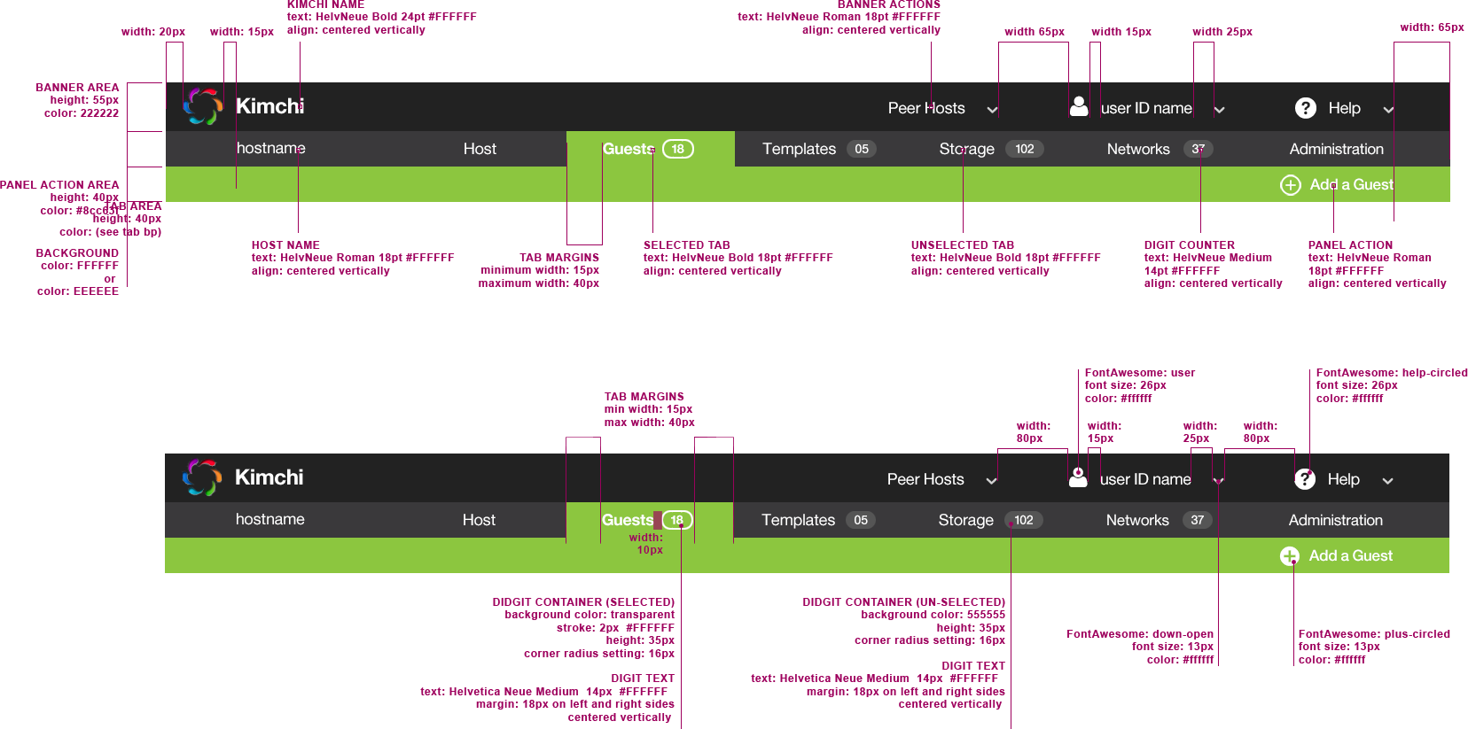

Global Margins …

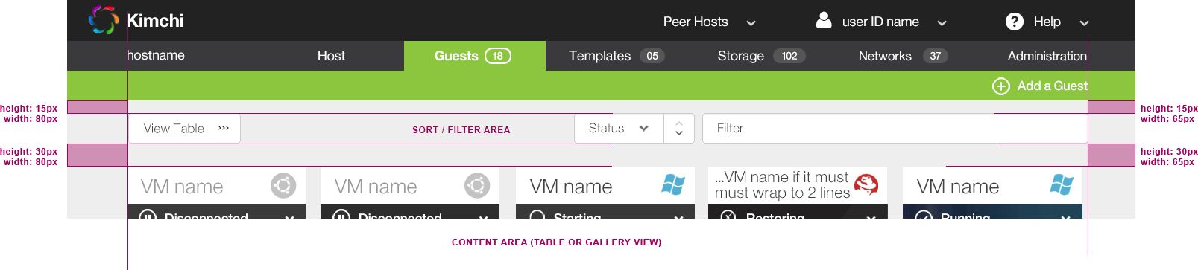

Global Filters and Table Filters …

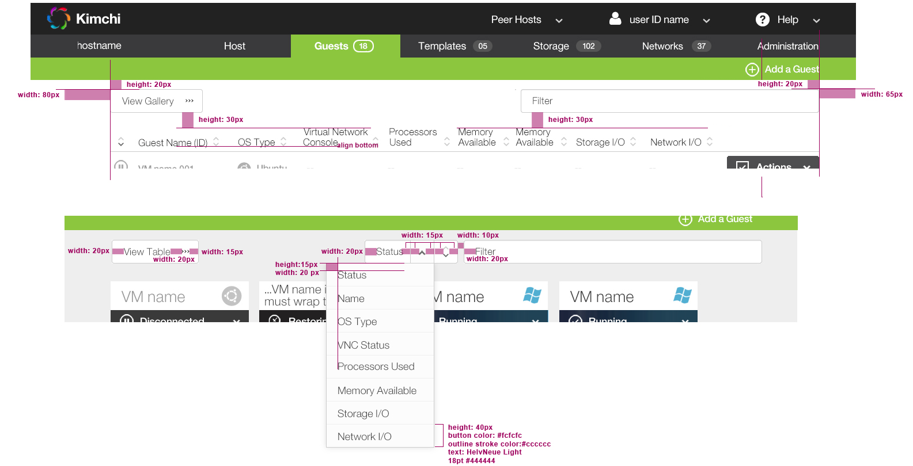

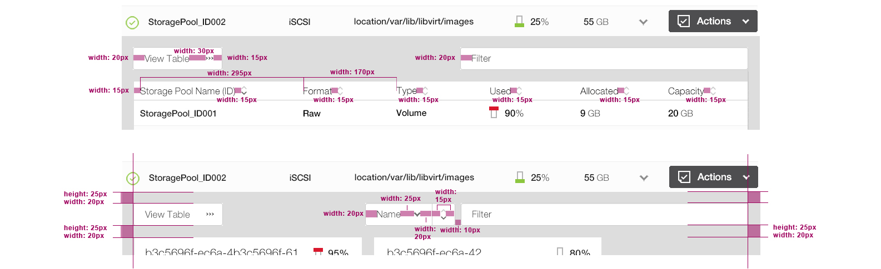

Global Context Menu …

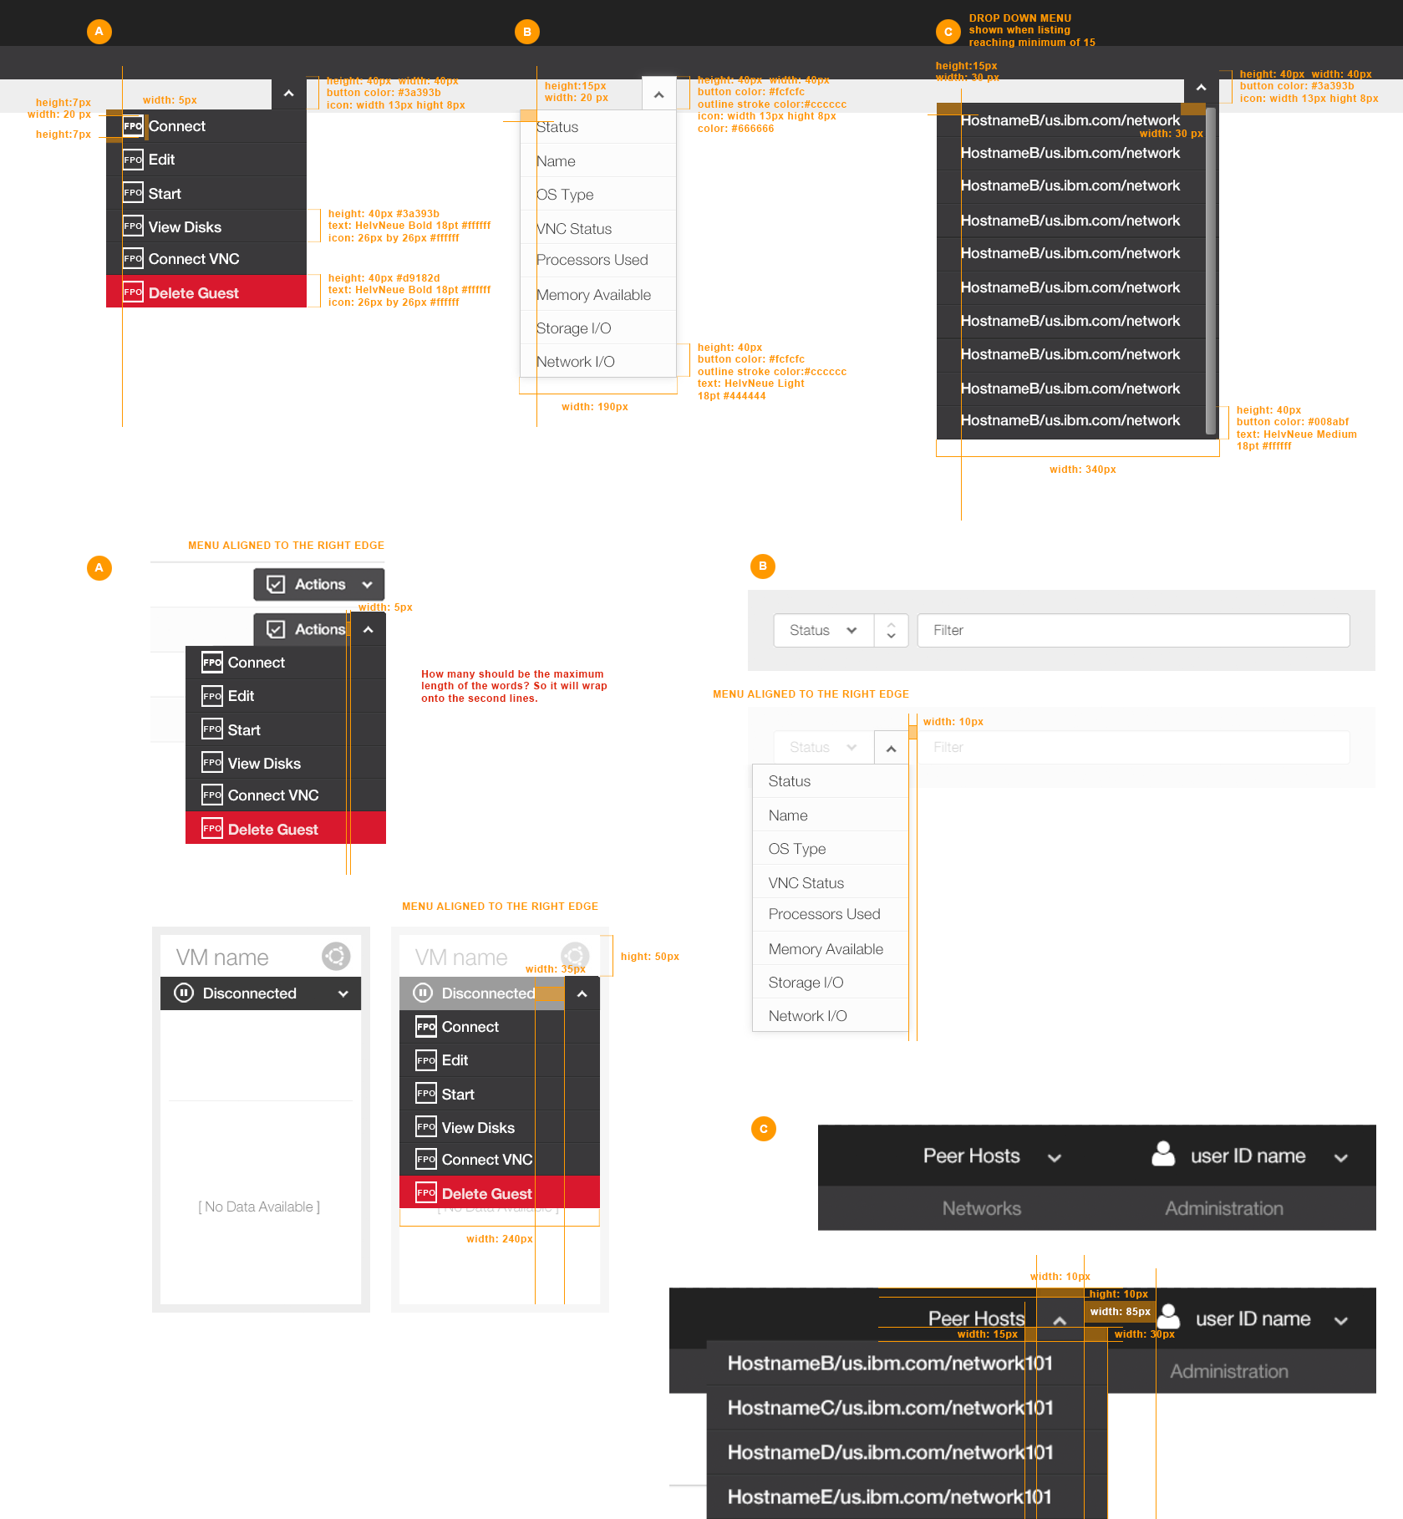

Global Buttons …

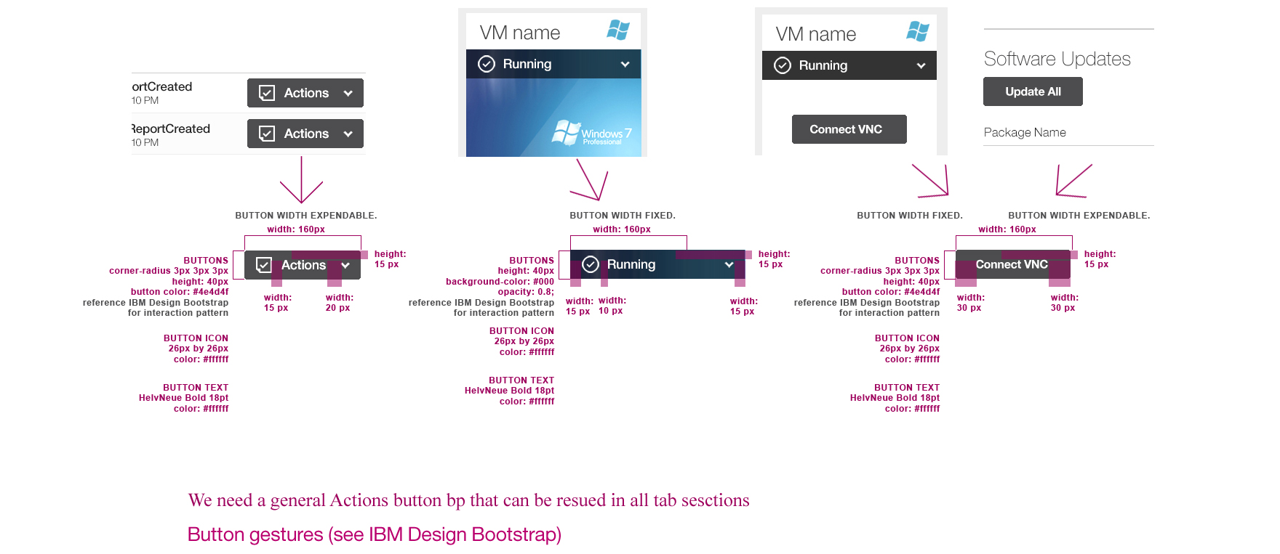

Global Tables …

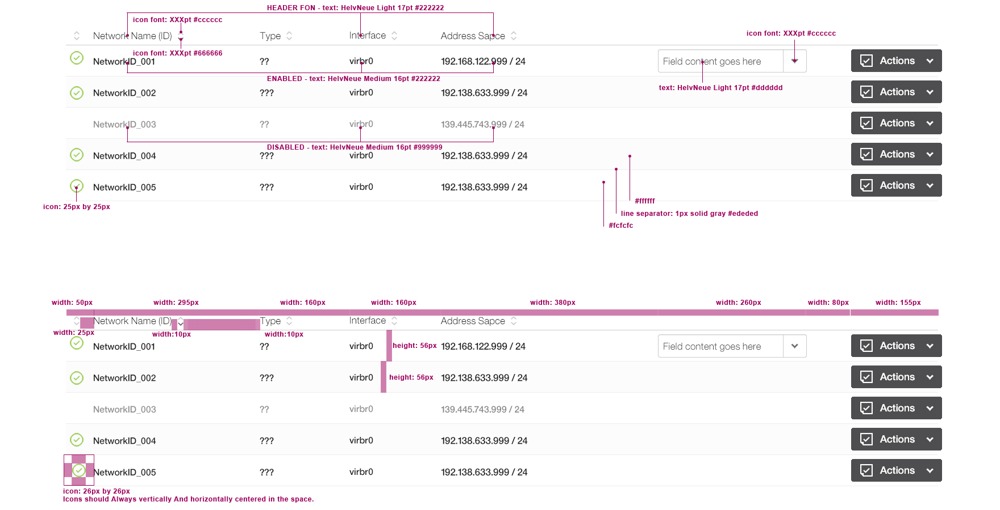

Global Gallery Cards …

