Assignment 9

Presentation of Results

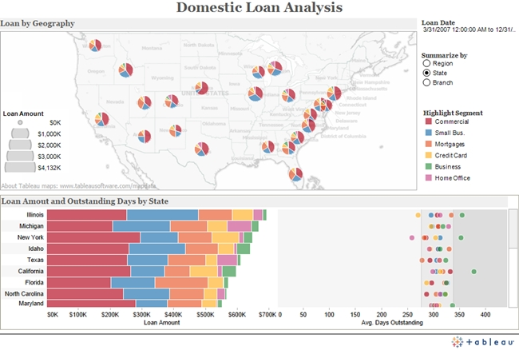

http://media.wiley.com/Lux/07/410907.image0.jpg

This visualization is interesting in the fact of its complexity. There is quite a bit of data being shown here, with several different graphing methods. The horizontally stacked bar chart at the bottom, and then the physical map that includes smaller pie charts really seem to clutter and overcomplicate the visualization. The information displayed is still valuable and could be improved by simply reducing some of the graphs included. The consistency of colors is definitely a positive for this visualization.

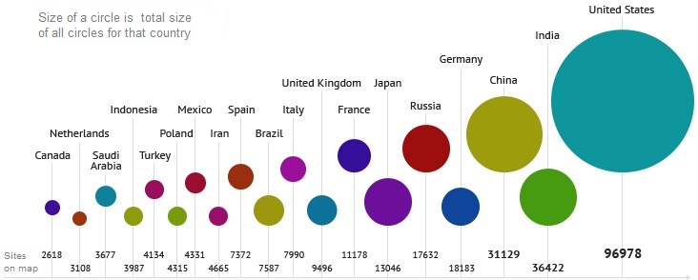

<http://internet-map.net/Content/info/info-eng.jpg>

This next visualization is quite simple, but conveys a clear and explicit message. A quick look at the visualization will provide a solid understanding. The two main goals data visualization are to make the data look aesthetically pleasing and to effectively and accurately represent the data. This visualization accomplishes both of these goals. The scale appears to be fitting for the data. It’s easy to identify each country and its corresponding number of sites shown. The light line that attaches the dataset with its actual statistic is very helpful. The only minor improvement I would suggest is to, make the explanatory text in the bottom left corner a little larger and maybe move it to a more central area such as top and center of graph.

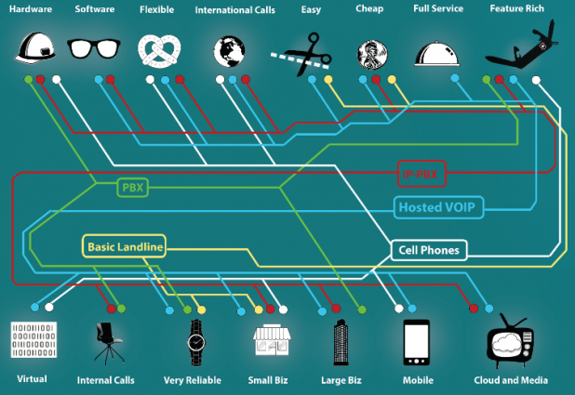

<http://blog.visual.ly/wp-content/uploads/2013/09/label-diagram-618x425.png>

This visualization is immediately breaking an important rule in the fact that it is not clear or easy to understand with just a glance. There can be some text involved to explain a visualization, but it should not confuse people. The colors and use of icons make sense which is one positive from this graphic. The concept of being “very reliable” is represented by an image of a watch, “mobile” is accompanied by an image of a cellphone. It’s nice to see some real world representation, but the overall message or purpose of the graphic is unclear. There are too many lines and images, with not enough explanation or actual data. It would take an advanced data scientist a few hours to analyze and understand the full scope of this data visualization.