PARTNERS UPDATE | COMMUNITY AND ECONOMIC DEVELOPMENT
Where Does Southeastern LIHTC Build, and What Does It Build?
How much the credit builds across the Southeast, where it lands, what kind of housing it produces, and how the newest developments differ from the long-run record.

Since 2008 the Low-Income Housing Tax Credit has financed about 240,000 units in roughly 2,700 developments¹ across the six Southeastern states. Where they landed departs from the national pattern. Nationally the credit concentrates in large metros; in the Southeast it reaches micropolitan and rural areas more fully and builds most intensively in mid-sized markets rather than the largest.
Behind those units is a flow of federal tax-credit authority. Across the developments that record an allocation amount, Southeastern projects placed in service from 1987 through 2024 were awarded about 2.66 billion dollars in annual credit, roughly 12 percent of the 21.5 billion dollars recorded nationally. Each annual award is claimed for ten years, putting the regional total on the order of 27 billion dollars in ten-year credit value. These totals cover only the records that report an amount, about six in ten regionally, so they understate the full flow.

Florida and Georgia lead by volume, but less populous states lead per resident
Florida and Georgia together account for more than half the region's units, followed by Tennessee, Louisiana, Mississippi, and Alabama. Counting by population reorders that ranking. Measured as units per 100,000 residents, Mississippi and Louisiana stand highest, at 698 and 648. Florida, despite the largest total, sits at 335 because of its large population, and Alabama is lowest on both counts, at 210. A state can lead on volume and trail on production per resident, and the two readings answer different questions.
Table 1. LIHTC production and project characteristics, Southeastern states, 2008-2024.
State | Projects | Units | Low-income units | Units / 100k | Avg. size | 9% credit | New constr. | In QCT
Florida | 656 | 72,237 | 69,926 | 335 | 110 | 45% | 52% | 48%
Georgia | 751 | 66,896 | 64,353 | 625 | 89 | 35% | 59% | 35%
Tennessee | 433 | 40,149 | 39,999 | 581 | 93 | 50% | 50% | 39%
Louisiana | 424 | 30,163 | 25,944 | 648 | 71 | 28% | 54% | 47%
Mississippi | 309 | 20,684 | 20,325 | 698 | 67 | 74% | 47% | 40%
Alabama | 162 | 10,570 | 10,527 | 210 | 65 | 65% | 61% | 29%
Southeastern total | 2,735 | 240,699 | 231,074 | 465 | 88 | 47% | 54% | 40%
Source: HUD National LIHTC Database, authors' calculations.

The credit reaches micropolitan areas more intensively than metros, unlike the national pattern
Nationally the credit concentrates in metropolitan areas, at about 529 units per 100,000 residents against 394 in micropolitan areas and 241 in rural counties outside any core-based statistical area. The Southeast departs from that pattern. Micropolitan areas keep pace with metros, at roughly 479 and 457 units per 100,000, so the region's micropolitan rate edges above its metropolitan one². Rural counties record 366, below both, but well above the national rural rate of 241. Credit-financed housing reaches the region's smaller cities and towns, and its rural counties, more fully than the national pattern.
Figure 1. LIHTC units per 100,000 residents by place type, United States, 2008-2024.
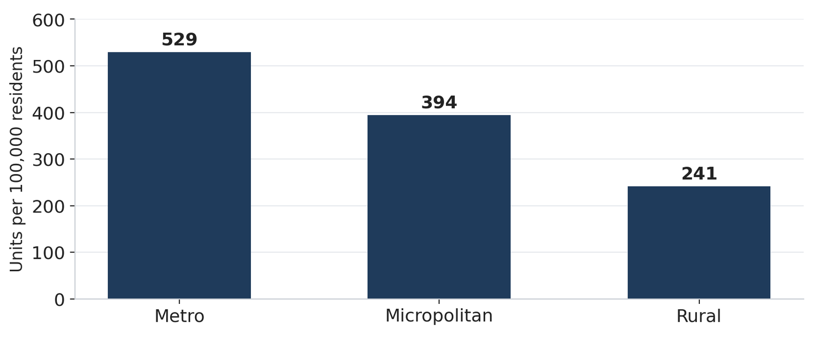
Source: HUD National LIHTC Database, 2020 Census, authors' calculations.
Figure 2. LIHTC units per 100,000 residents by place type, Southeast and United States, 2008-2024.
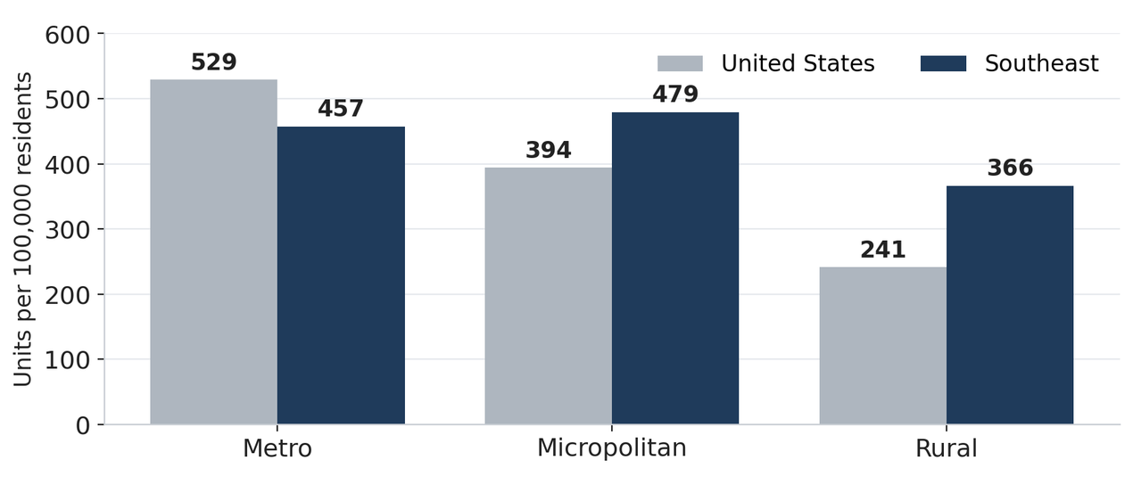
Source: HUD National LIHTC Database, 2020 Census, authors' calculations.

Among metros, the largest markets lead per resident, but mid-sized markets lead per renter
Affordable homes for the lowest-income renters are in short supply across the region: nationally only about 35 affordable and available rental homes exist for every 100 extremely low-income renter households, and no Southeastern state or metropolitan area has an adequate supply³. Ranking the region's metropolitan areas by renter households, the population the credit serves, orders the largest rental markets first: the Miami, Atlanta, Tampa, and Orlando areas lead on renter households, followed by the Nashville and New Orleans areas. Measuring production against that base two ways, units per 100,000 residents and units per 1,000 renter households, reorders them⁴. On a per-renter-household basis, the base closer to rental demand, mid-sized markets lead: ranked by units per 1,000 renter households, the New Orleans area leads at 72.3, the Nashville area at 57.0, and the Knoxville area at 54.6, while the largest renter markets fall near the middle, Miami at 32.3 and Tampa about 25.7. Atlanta is the exception among the large markets, at 43.4, and Birmingham records the lowest rate, at 8.8.
Three mid-sized markets, not the largest ones, produce most intensively. Ranked by units per 1,000 renter households, the New Orleans area leads at about 72, followed by the Nashville area at about 57 and the Knoxville area at about 55, roughly double the rates of the large Florida metros. The New Orleans figure reflects concentrated post-Katrina rebuilding; the Nashville figure coincides with rapid population growth over the period. By contrast, the four largest rental markets fall near the middle of the distribution: Miami records about 32 units per 1,000 renter households and Tampa about 26. Atlanta is the exception among the large markets, ranking fourth on intensity at about 43. The Birmingham area records the lowest rate, under 9, less than a fifth of the leading rate.
Production intensity varies about eightfold across these metros per renter household, and about tenfold per resident, from the Birmingham area to the New Orleans area. For practitioners, the ranking separates two considerations that unit totals combine: where renter households are concentrated, and where production is most intensive relative to that base.
Figure 3a. Metropolitan areas ranked by renter households: LIHTC units per 100,000 residents and per 1,000 renter households, Southeastern states, 2008-2024.
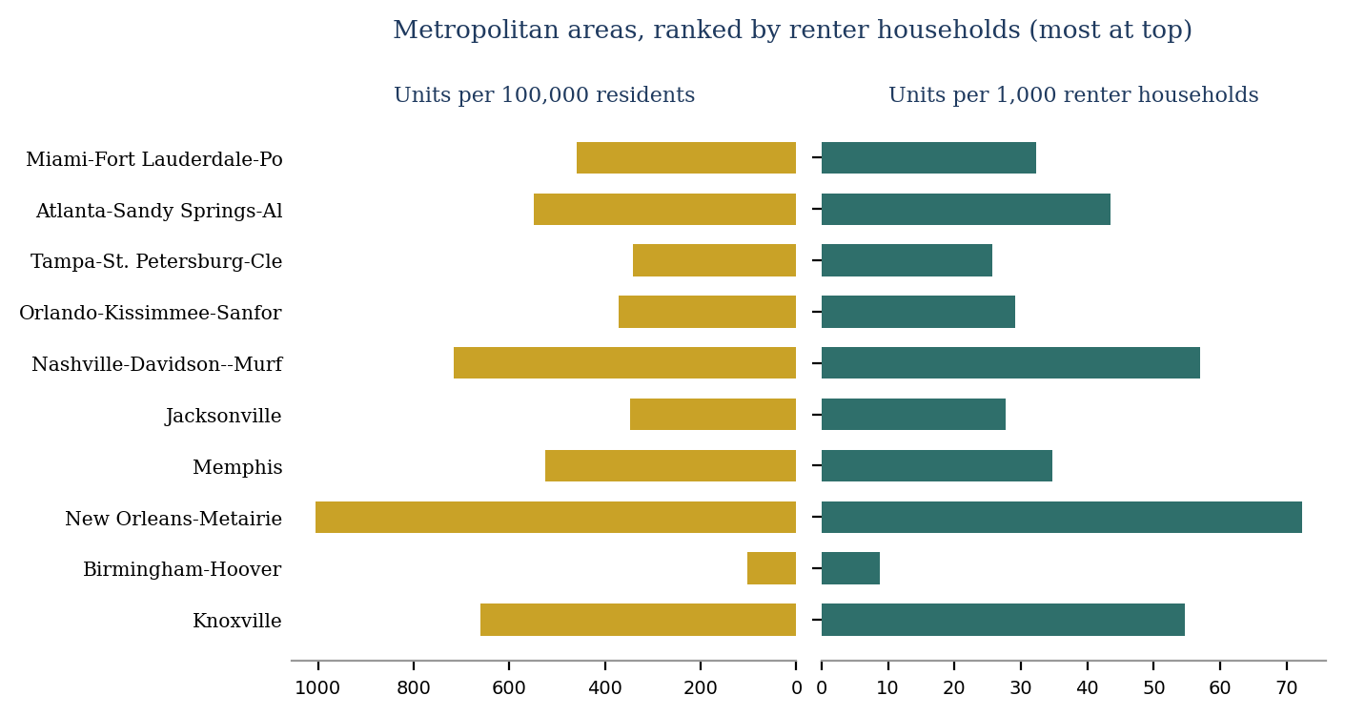
Source: HUD National LIHTC Database, 2020 Census, authors' calculations.

Small markets often reach renters as intensively as the metros do
The same reading applied to the region's micropolitan areas, ranked by renter households, shows comparable agreement between the two denominators, with a few larger exceptions. Tupelo and Meridian, Mississippi, and LaGrange, Georgia, rank near the top on renter households. The two per-capita measures again order the areas similarly, so the micropolitan parity noted earlier holds under either denominator⁴. The renter-based measure mainly sharpens where production is dense relative to the renter base.
Several small markets produce at rates that rival or exceed the region's metros. LaGrange records about 847 units per 100,000 residents and Key West about 968, both above every metro except New Orleans, consistent with the micropolitan parity described earlier. The tourism-oriented areas of Key West and Sevierville record high rates per renter household, near 60 units per 1,000, above what their per-resident rates alone would indicate, because a large share of their housing is renter-occupied and the resident base is small. Tupelo and Sevierville also rank near the top on the renter measure.
The spread among micropolitan areas is narrower than among metros but remains wide, about sevenfold on the per-resident measure and fourfold per renter household. Albertville, Alabama, records the lowest rate, about 15 units per 1,000 renter households. For practitioners, the pattern indicates that the region's strongest per-capita production extends beyond its cities: a set of small Mississippi, Georgia, and Tennessee markets reaches its renters as intensively as the metros do, and in several cases more so.
Figure 3b. Micropolitan areas ranked by renter households: LIHTC units per 100,000 residents and per 1,000 renter households, Southeastern states, 2008-2024.
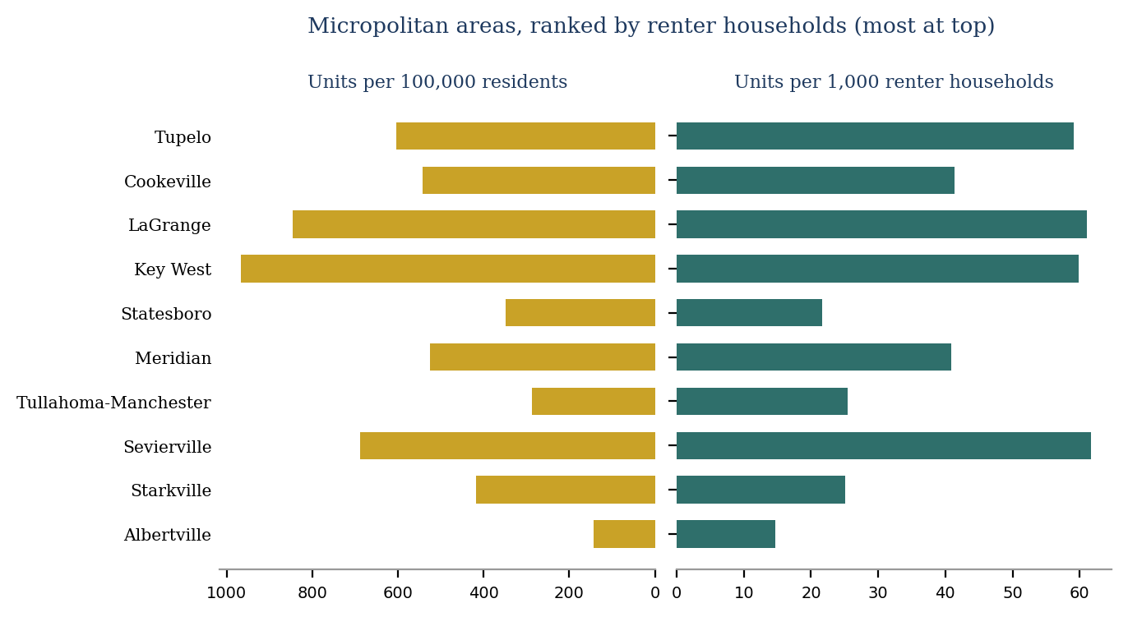
Source: HUD National LIHTC Database, 2020 Census, authors' calculations.

Gulf Coast disaster recovery still shapes the region's production geography
Part of why Mississippi and Louisiana lead on production per resident traces to a single policy episode. After Hurricanes Katrina and Rita in 2005, the Gulf Opportunity Zone Act raised housing-credit authority in the hardest-hit areas of Alabama, Louisiana, and Mississippi. For 2006 through 2008 it added up to $18.00 for each resident of the affected zone, against a normal state ceiling near $1.90 per resident. It also designated the zone a Difficult Development Area, which further raised the credit available there. Developments carrying the Gulf Opportunity Zone designation account for about 13,700 total units in Louisiana and 9,200 in Mississippi. Two decades later, per-resident rates in several of the region's Gulf Coast markets remain above the regional average.
HUD records the designation on each affected development, so the episode can be read directly. Across Alabama, Louisiana, and Mississippi the designated developments carry 26,118 total units, all placed in service between 2006 and 2010. They account for 78 percent of the three states' production in the 2008 peak. Annual production in those states averaged about 4,400 units from 2000 to 2005, about 9,600 from 2007 to 2009, and about 3,200 from 2011 to 2016, so output settled below its pre-designation level once the window closed. No units carry the designation after 2010, so what persists is the accumulated stock rather than continuing production.
Figure 4. Total units placed in service in Alabama, Louisiana, and Mississippi, by Gulf Opportunity Zone designation, 2000-2024.

Source: HUD National LIHTC Database, authors' calculations. Counts are total units, matching the other production figures. Designated units are those HUD codes as being in a metropolitan or non-metropolitan Gulf Opportunity Zone difficult development area. Units appear in the year placed in service, which lags allocation. The window is 2000 to 2024 rather than the 2008 to 2024 window used elsewhere for production, because the episode requires a pre-designation baseline. The figure covers the three states of the Katrina Gulf Opportunity Zone. Florida holds a further 9,858 designated total units under the Wilma zone, which received the difficult development area treatment but not the per-resident credit ceiling increase, and is excluded on that basis; see the note.

Mostly family housing, though less so in the newest cohort
Family housing is the larger share in the region and the nation, but the regional tilt is stronger: about 77 percent of Southeastern units are family housing against 62 percent nationally, with a correspondingly smaller elderly share, near 12 against 27 percent.
Figure 5. Target population of LIHTC units, Southeast and United States, 1987-2024.
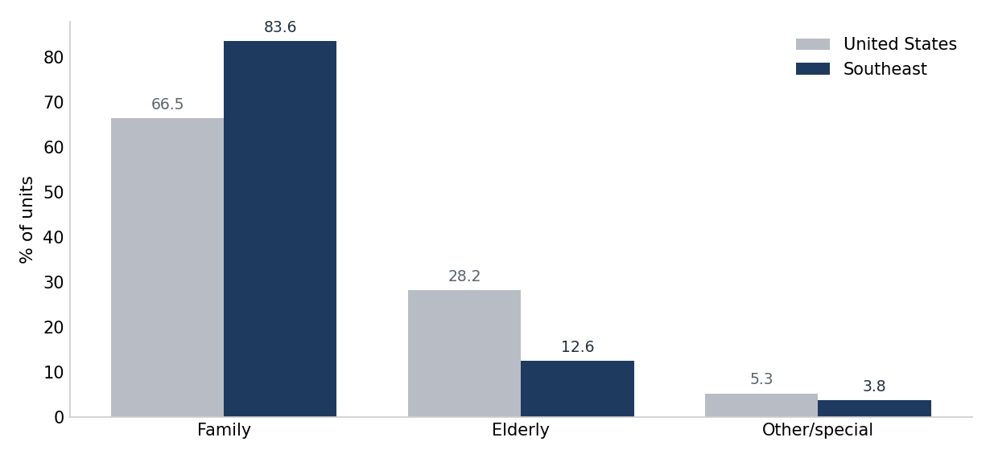
Source: HUD National LIHTC Database, authors' calculations.
That reading pools nearly four decades, and the family tilt is a feature of the accumulated stock rather than a fixed regional trait. Family housing carried 74 to 85 percent of Southeastern units in every cohort placed in service through 2015-2019, above the national share throughout. In the 2020-2024 cohort it falls to 56 percent, below the national 60 percent for the first time in the series. The elderly share rises to 19 percent, and other targeted populations, including developments serving disabled and homeless residents, reach 25 percent of regional units against 17 percent nationally. On these three categories the regional and national shares are closer in the 2020-2024 cohort than in any earlier cohort.
Figure 6. Target population by placed-in-service cohort, share of units reporting a target population, Southeast and United States, 1987-2024.

Source: HUD National LIHTC Database, authors' calculations. Units in developments that record no target population are excluded; the target-population fields began with the 2003 properties, so the excluded share is largest in the earliest cohorts. Shares are of income-restricted units in developments that record the characteristic; the excluded share is given above. Comparisons between the region and the nation assume that non-reporting is unrelated to the characteristic being measured. Panel scales differ; read each panel against its own axis.

Sixty percent of area median income dominates, with income averaging rising in the newest cohort
On depth of affordability, almost all units in developments that record an income ceiling sit at the lower 50 or 60 percent of area median income thresholds that set the deepest rents, in the region as in the nation. The 60 percent ceiling carries 92 percent of reporting units in the region against 89 percent nationally, and income averaging, which blends deeper and shallower units, remains a small and recent share at 6 percent regionally. Developments that record no ceiling are excluded from the figure rather than shown as a category, and the note reports how large that group is.
Figure 7. Income ceiling of LIHTC units, share of units reporting a ceiling, Southeast and United States, 1987-2024.

Source: HUD National LIHTC Database, authors' calculations.
The cohort view shows how recently income averaging arrived. Income averaging accounts for 25 percent of reporting units placed in service in the region in 2020-2024, ahead of the 21 percent national share, having been unavailable before 2018. The 60 percent ceiling absorbs the shift, falling from 91 percent of reporting units in 2015-2019 to 75 percent in 2020-2024, close to the national 75 percent. The 50 percent ceiling, consistently the smaller of the two deep-rent options in the region, falls below 1 percent of reporting units in the newest cohort against 4 percent nationally.
Figure 8. Income ceiling by placed-in-service cohort, share of units reporting a ceiling, Southeast and United States, 1987-2024.

Source: HUD National LIHTC Database, authors' calculations. Units with no recorded ceiling are excluded: 73.1 percent of Southeastern units in the 1987-1994 cohort, 51.3 percent in 2010-2014, and 3.4 percent in 2020-2024, against 70.3, 23.3, and 6.5 percent nationally. The field began with the 2006 properties. Shares are of income-restricted units in developments that record the characteristic; the excluded share is given above. Comparisons between the region and the nation assume that non-reporting is unrelated to the characteristic being measured. Panel scales differ; read each panel against its own axis.

Mostly new construction, in wider swings than the pooled figure shows
New construction carries roughly six to seven in ten units that record a construction type in each place type, rising to about seven in ten in metropolitan areas, with acquisition and rehabilitation, the program's preservation side, making up most of the rest. The mix moves modestly across markets: new construction is 73 percent of recording units in metropolitan areas, 62 percent in micropolitan areas, and 64 percent in rural counties.
Figure 9. Construction type by place type, share of units recording a type, Southeast, 1987-2024.

Source: HUD National LIHTC Database, authors' calculations. Shares are of income-restricted units in developments that record a construction type. Units with no recorded type are excluded: 13.9 percent in metropolitan areas, 6.3 percent in micropolitan areas, and 8.2 percent in rural counties. Place type is assigned by county under the OMB March 2020 delineation; records without 2020 county geography, 11.4 percent of regional income-restricted units, are excluded from this figure.
Stability across place types does not carry over to stability across time. Regional new construction rose to 87 percent of reporting units in the 2000-2004 cohort, fell to 52 percent in 2015-2019 as acquisition and rehabilitation climbed to 46 percent, and returned to 64 percent in 2020-2024. The national series turns in the same direction in the most recent cohort, to 68 percent. Across cohorts the regional new-construction share spans about 35 percentage points.
Figure 10. Construction type by placed-in-service cohort, share of units recording a type, Southeast and United States, 1987-2024.

Source: HUD National LIHTC Database, authors' calculations. Units with no recorded construction type are excluded; the excluded share runs from 4.1 to 26.0 percent of regional units across cohorts and 8.0 to 19.0 percent nationally. Shares are of income-restricted units in developments that record the characteristic; the excluded share is given above. Comparisons between the region and the nation assume that non-reporting is unrelated to the characteristic being measured. Panel scales differ; read each panel against its own axis.
Which places lead depends on the measure: ranked by units, Southeastern production concentrates in the large states and metros; measured per resident or per renter household, it spreads to smaller ones. The accumulated stock is mostly family housing at a 60 percent ceiling and newly built, though recent developments carry a narrower family share and more income averaging. The companion updates build on these measures, turning to how the developments are financed and how the terms of the deal have changed; as the 2025 law takes effect, its regional imprint will register first against them.
Data and methods
Figures are from the HUD National LIHTC Database, with population denominators from the 2020 Census. Production and geographic figures cover projects placed in service 2008 to 2024 in the six Southeastern states; the composition figures are cumulative, 1987 to 2024. Production and geographic figures count total units in credit-financed developments, matching the unrestricted population denominators they are set against. Composition figures count income-restricted units, because the characteristics measured are properties of restricted units. Table 1 reports both counts, with the income-restricted total in the low-income units column, taken from HUD's reconciled low-income unit field. Place type is assigned to each project by its county using the OMB March 2020 delineation: a county in a Metropolitan Statistical Area is metropolitan, one in a Micropolitan Statistical Area is micropolitan, and one in neither is rural. Metropolitan and micropolitan areas are ranked by total units, with per-resident rates shown alongside. The Gulf Opportunity Zone discussion draws on the Gulf Opportunity Zone Act of 2005⁵ and published estimates of credit-financed reconstruction. Each composition characteristic is shown twice: a pooled figure covering 1987 to 2024 and a cohort figure grouping projects into a 1987-1994 band and five-year placed-in-service bands thereafter. All three composition characteristics, target population, income ceiling, and construction type, are computed on a reporting base. Conventions common to the series: figures count income-restricted units unless stated otherwise; records coded 8888 or 9999 in the placed-in-service field, 2,765 records and 225,252 units nationally, are excluded from all year-based figures, and only 254 of those records fall in the region, so the exclusion bears more on the national series than the regional one; Puerto Rico and other territories, 0.69 percent of national units, are excluded from the national series, so that the place-type numerators cover the same universe as the population denominators, which are drawn from the fifty states and the District of Columbia and contain no territories; and any characteristic with material non-reporting is shown on a reporting base, with the excluded share given in the figure note. Regional-to-national comparisons on a reporting base assume non-reporting is unrelated to the characteristic measured, which this file cannot test, and completeness differs by geography: among regional income-restricted units, 61 percent record a target population, 51 percent an income ceiling, and 88 percent a construction type, against 58, 66, and 88 percent nationally. Place type is assigned from the March 2020 delineation for every project regardless of when it was placed in service, so a county that gained metropolitan status during the period is treated as metropolitan throughout; HUD's own metro field, measured at placed in service, will differ. Records without 2020 county geography, 11.4 percent of regional income-restricted units, are excluded from the place-type figures on both the numerator and the denominator side, for the same reason: a record with no county can be given neither a place type nor a population, so counting it on one side without the other would misstate the rate. Per-resident rates divide a 2008-2024 production flow by 2020 Census population, so rates for states that grew quickly across the window are understated relative to states that grew slowly. Within Figures 6, 8, and 10 the panels carry separate vertical scales, so panels should be read against their own axes rather than against each other. Figures 5 through 10 are native charts with their data embedded, editable in place.
By Donta Council, Community and Economic Development, Federal Reserve Bank of Atlanta.
The views expressed here are the author's and not necessarily those of the Federal Reserve Bank of Atlanta or the Federal Reserve System. Any remaining errors are the author's responsibility.
Notes
1. Production and geographic figures cover projects placed in service 2008 to 2024; composition figures are cumulative, 1987 to 2024. Data are from the U.S. Department of Housing and Urban Development, Low-Income Housing Tax Credit Property Database (projects placed in service through 2024), https://www.huduser.gov/portal/datasets/lihtc.html. For background on how the credit works and whom it serves, see Scally, Gold, and DuBois, The Low-Income Housing Tax Credit: How It Works and Who It Serves, Urban Institute, 2018.
2. A core-based statistical area (CBSA) is a county or group of counties defined by the U.S. Office of Management and Budget around an urban core: metropolitan areas have a core of at least 50,000 residents, micropolitan areas 10,000 to 50,000, and counties in neither are treated here as rural. Place type follows the March 2020 delineation, OMB Bulletin No. 20-01 (March 6, 2020), used for consistency with the population denominators; OMB Bulletin No. 23-01 has since superseded it. Population denominators are from the U.S. Census Bureau, 2020 Census resident population totals.
3. National and state estimates of affordable and available rental homes per 100 extremely low-income renter households are from National Low Income Housing Coalition, The Gap: A Shortage of Affordable Homes (2026), https://nlihc.org/gap, which draws on the American Community Survey and its Public Use Microdata Sample. Extremely low-income renters are those with incomes at or below the federal poverty guideline or 30 percent of area median income, whichever is greater. Florida, for example, records about 26 affordable and available homes per 100 such renters, and the Orlando area, at 13, is among the lowest of the fifty largest metropolitan areas.
4. Across the ten metropolitan areas the two per-capita measures are almost perfectly rank-ordered (Spearman rank correlation 1.00; linear correlation 0.99); across the ten micropolitan areas the agreement is high but weaker (Spearman 0.92; linear 0.91). Appendix Table A1 reports the coefficients and the ranked values.
5. The Gulf Opportunity Zone Act of 2005 (Pub. L. 109-135, codified at Internal Revenue Code section 1400N(c)) carried two housing-credit provisions. Under section 1400N(c)(1), the housing-credit ceiling of each state with territory in the Katrina Gulf Opportunity Zone rose for calendar years 2006 through 2008 by up to $18.00 per resident in the zone, against a regular ceiling near $1.90; under section 1400N(c)(3), the Gulf Opportunity, Rita, and Wilma zones were treated as difficult development areas, for credit amounts allocated from 2006 through 2008 and for property placed in service through December 31, 2010. Texas and Florida instead received a flat $3,500,000 ceiling addition for 2006 alone under section 1400N(c)(2). Figure 4 therefore covers Alabama, Louisiana, and Mississippi, the states that received the per-resident increase; unit counts use the HUD database's Gulf Opportunity Zone difficult development area codes. For how the affected states used this authority, see U.S. Government Accountability Office, Gulf Opportunity Zone: States Are Allocating Federal Tax Incentives to Finance Low-Income Housing and a Wide Range of Private Facilities, GAO-08-913, July 16, 2008.
PARTNERS UPDATE | COMMUNITY AND ECONOMIC DEVELOPMENT
How Are Southeastern LIHTC Deals Financed?
The shift toward the bond-financed credit, where bond authority binds, and what the 2025 tax law changes.

How a Southeastern LIHTC deal is financed has changed over the program's history. The program's two credits, a competitive 9 percent credit and a 4 percent credit tied to tax-exempt bonds, have traded places over time as the bond-financed path has grown. That path now concentrates in Florida and Georgia, the two states with the largest bond-financed volume in the region. Whether either state is bond-cap-constrained is a separate question the HUD data cannot answer; state ceiling records would be needed to establish it, and Georgia's 2024 statewide allocation shows an unused ceiling balance. The public money layered around the credit is thinner here than nationally, about 1,160 dollars per income-restricted unit against roughly 2,378. A 2025 tax law lowers the bond-financing test and raises the 9 percent credit ceiling. This update follows the money: the bond, where it binds, and the subsidy layered alongside the credit.

The bond does double duty, and the region has shifted toward it
The 4 percent credit is claimed when a development is financed with tax-exempt private-activity bonds, which do double duty: they supply the permanent debt and, by covering a required share of cost, they trigger the credit. The deeper 9 percent credit is awarded through annual state competitions¹. Over the program's history the competitive 9 percent share, dominant early on, has given ground as the bond-financed 4 percent share has climbed, and the two cross in the mid-2010s; nationally the 4 percent credit reaches close to two-thirds of single-credit units by the 2020-2024 cohort. The Southeast follows that path through 2015-2019, but its 2020-2024 cohort shows a sharp rebound in the 9 percent share, driven almost entirely by a surge of Georgia developments recorded as competitive 9 percent. That surge runs counter to both the national trend and the region's own trajectory, and we have not been able to verify it against Georgia's allocation records, so we flag it rather than read it as a genuine reversal.
Figure 1 rests only on developments that carry a usable single-credit code; records coded as using both credits, as TCEP only, or with a blank credit field are set aside. That coverage is uneven across the region (Figure 1b). Florida's line reflects nearly all of its production and Mississippi's most of it, but Georgia's credit field is blank for roughly three-quarters of its developments and Louisiana's for about half. Georgia's coverage sits near zero through 2014 and fills in only in the two most recent cohorts, so the region's single-credit series is effectively Alabama, Florida, Mississippi, and Tennessee in the early years, with Georgia entering late. The movement in Georgia's recent share therefore coincides with its reporting filling in, and the state-level lines should be read with each cell's coverage in view.
Figure 1. Credit composition over time (single-credit basis), Southeast and United States.
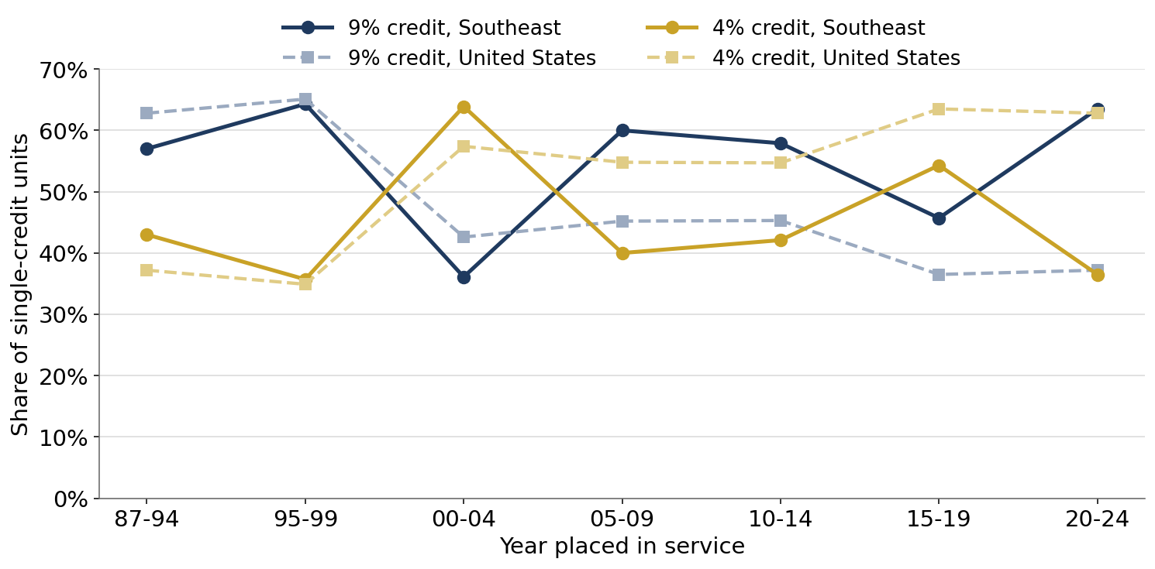
Source: HUD National LIHTC Database, authors' calculations. Shares are of single-credit units (competitive 9 percent or bond-financed 4 percent); developments coded as both or as unknown are excluded. The Southeast's 2020-2024 cohort includes a large number of Georgia developments recorded as competitive 9 percent, which drives the recent uptick in the region's 9 percent share; this pattern runs against the national trend and has not been independently verified.
Figure 1b. Single-credit coverage rate by state and cohort, Southeast.
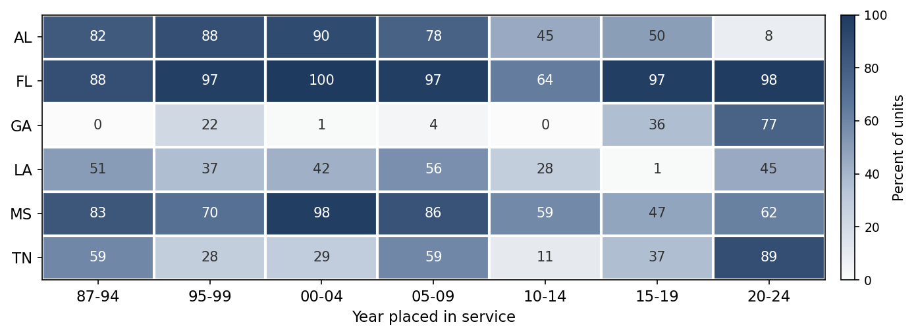
Cells show the share of each state's income-restricted units carrying a usable single-credit code (competitive 9 percent or bond-financed 4 percent); the remainder are coded as using both credits, as TCEP only, or with a blank credit field, and do not enter Figure 1. “n/a” marks a state-cohort with no recorded units. Source: HUD National LIHTC Database, authors' calculations.
The single-credit line also sets aside developments that draw on both credits at once. These twinned deals pair the 9 percent credit, usually on the rehabilitation scope, with the 4 percent bond credit on acquisition, and they are overwhelmingly a preservation tool: two-thirds of their units are acquisition and rehabilitation, against roughly a third of single-credit units (Figure 1c). Their use is concentrated, Tennessee records two-fifths of its units as twinned and Mississippi and Alabama a fifth or more, while Florida, Georgia, and Louisiana barely use the structure. The states that twin credits most are, in principle, the most practiced at the resyndication that keeps expiring properties affordable, a thread this series returns to when affordability expiration is in view.
Figure 1c. Double-credit (twinned) use and what it builds, Southeast.
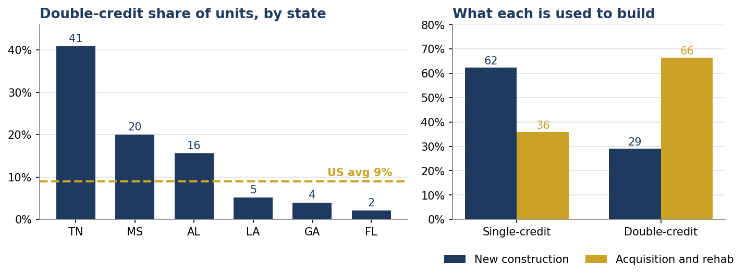
Double-credit developments are those recorded with the credit field coded as using both the 9 percent and 4 percent credits. As with single-credit coverage, the wide state variation reflects agency reporting practice as well as financing structure; the states that rarely record twinning are largely the same ones that leave the credit field blank most often. The one-time 2010-2014 Tax Credit Exchange Program is excluded. Source: HUD National LIHTC Database, authors' calculations.
Beyond the two credits, the region's other public and sponsorship channels move over the same period, and most have held or receded rather than grown. Each panel tracks one mechanism, the nation in gray and the region in navy. Any additional public source holds in the low double digits nationally but has thinned in the region, from about 29 percent of early units to 6 percent recently; HOME participation rose through the 2010-2014 cohort and has since eased; and USDA Rural Development, a mainstay of the program's first decade, falls to low single digits. The one channel rising is nonprofit sponsorship, which reaches about one in five regional units in the recent cohorts².
Figure 2. Financing mechanisms over time, Southeast and United States.
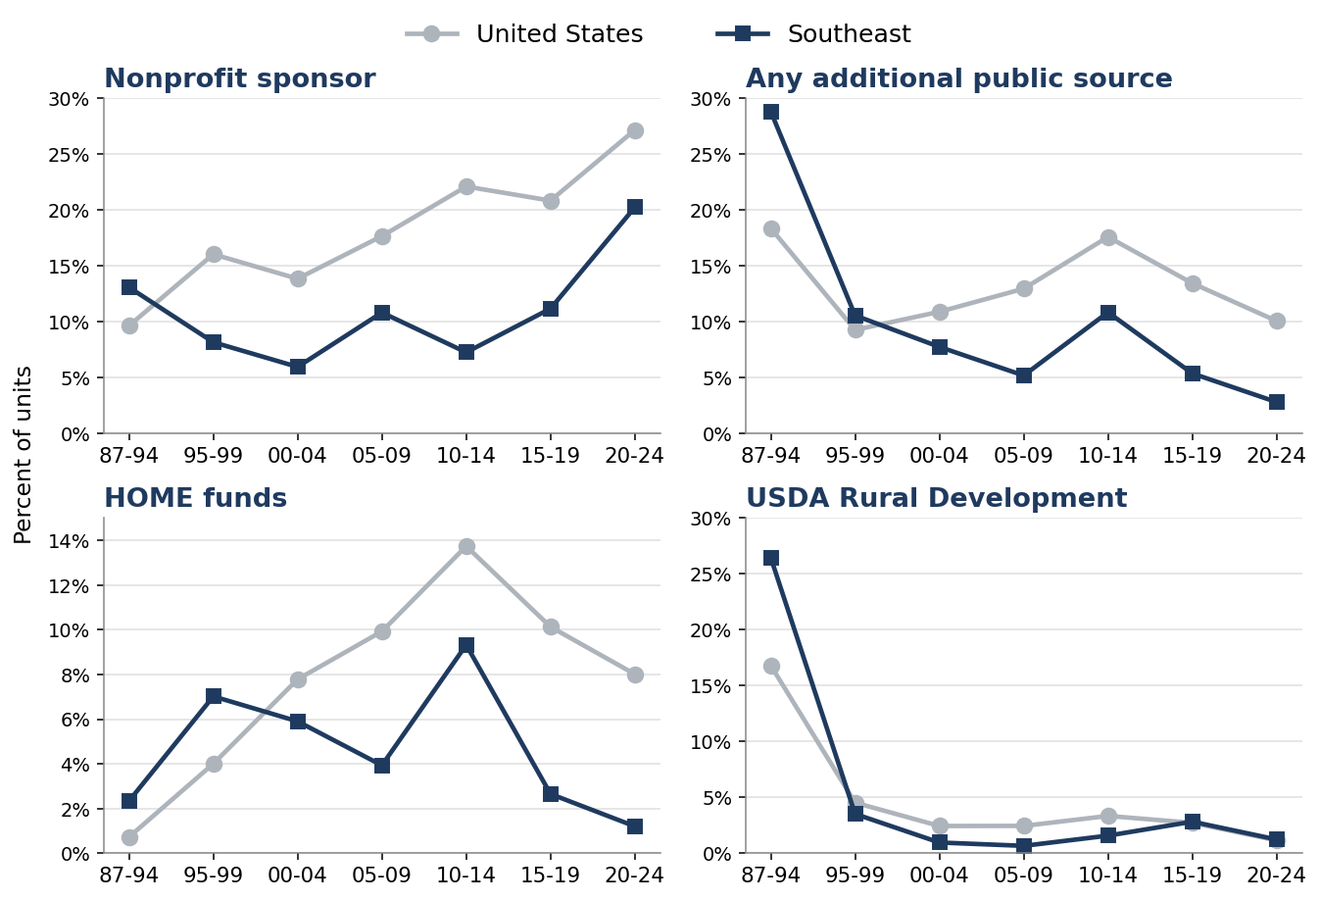
Source: HUD National LIHTC Database, authors' calculations.

The 4 percent credit concentrates where bond authority binds, in Florida and Georgia
Reliance on the bond is uneven. In recent units the 4 percent share runs highest in Mississippi, Tennessee, and Florida, near 67, 62, and 54 percent, and lowest in Georgia and Alabama, near 21 and 10 percent. The state range on this measure spans more than 50 percentage points.
Figure 3. Recent credit mix by state, share of units 2015-2024, Southeast.
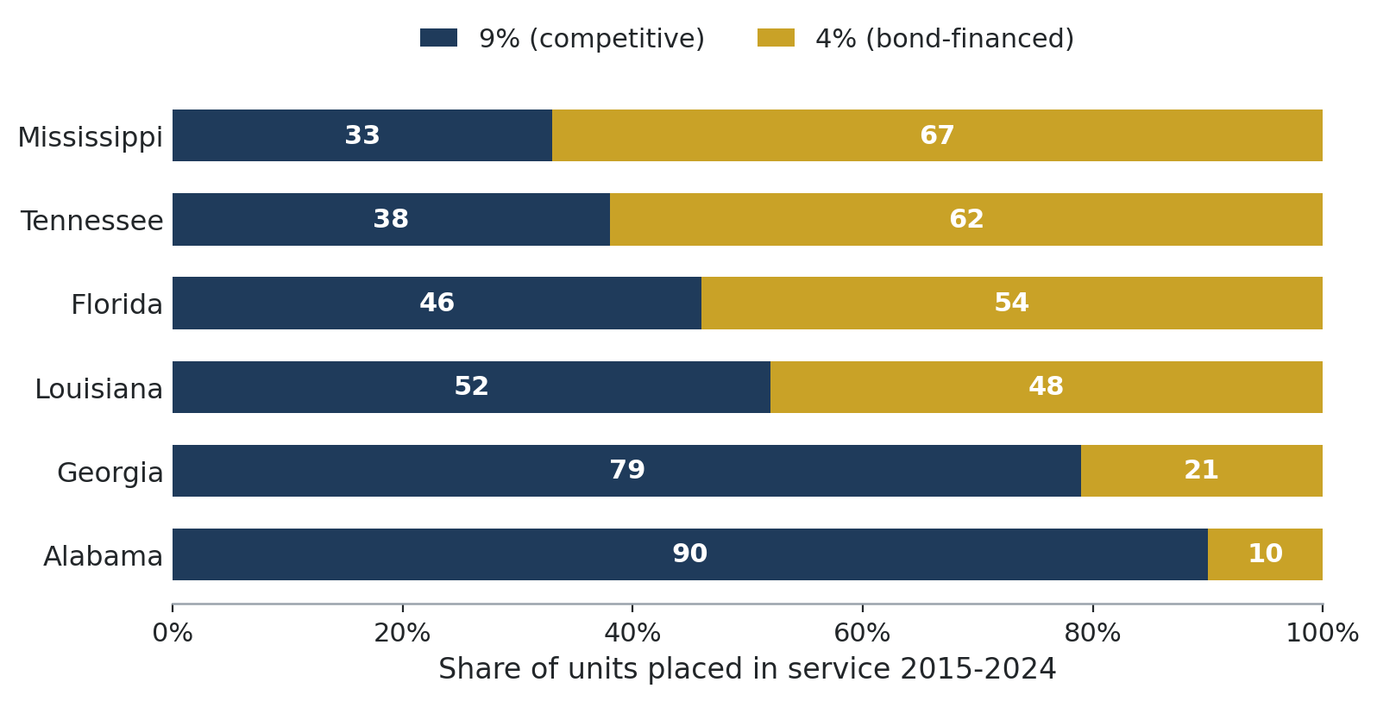
Source: HUD National LIHTC Database, authors' calculations.
Bond authority explains part of that split. The 2024 cap is set at 125 dollars per resident, with a 378 million dollar small-state floor that Mississippi sits at. Florida and Georgia, the region's two largest programs, press against their 2024 caps of about 2.83 and 1.38 billion dollars, while Tennessee, Alabama, Louisiana, and Mississippi sit below caps near 891, 639, 572, and 378 million with authority unused. Because the same private-activity bonds also fund other public purposes, an active 4 percent program in the constrained states competes for a capped resource rather than drawing on a free one³.
Figure 4. Private-activity bond cap and posture by state, Southeast, 2024.
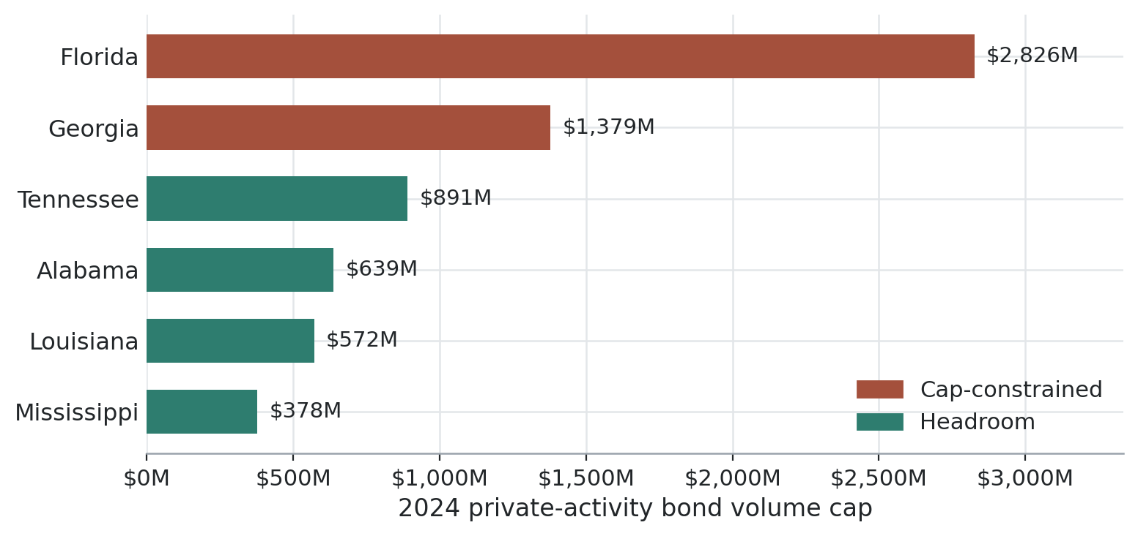
Source: IRS Rev. Proc. 2023-34 and Census Bureau population estimates for the cap; HUD National LIHTC Database for bond-financed production; authors' calculations.
Traced over time, each state's 4 percent share climbs steepest where the program is largest, and the timing differs: some states moved onto the bond path early, others only recently. The regional shift toward the bond is the sum of these uneven state paths, not a single uniform trend. In the most recent cohorts the 4 percent share reaches about 67 percent in Mississippi and 62 percent in Tennessee, near 54 percent in Florida and 48 percent in Louisiana, but only about 21 percent in Georgia and 10 percent in Alabama.⁴
Figure 5. Share of production using the 4 percent credit, by state over time.
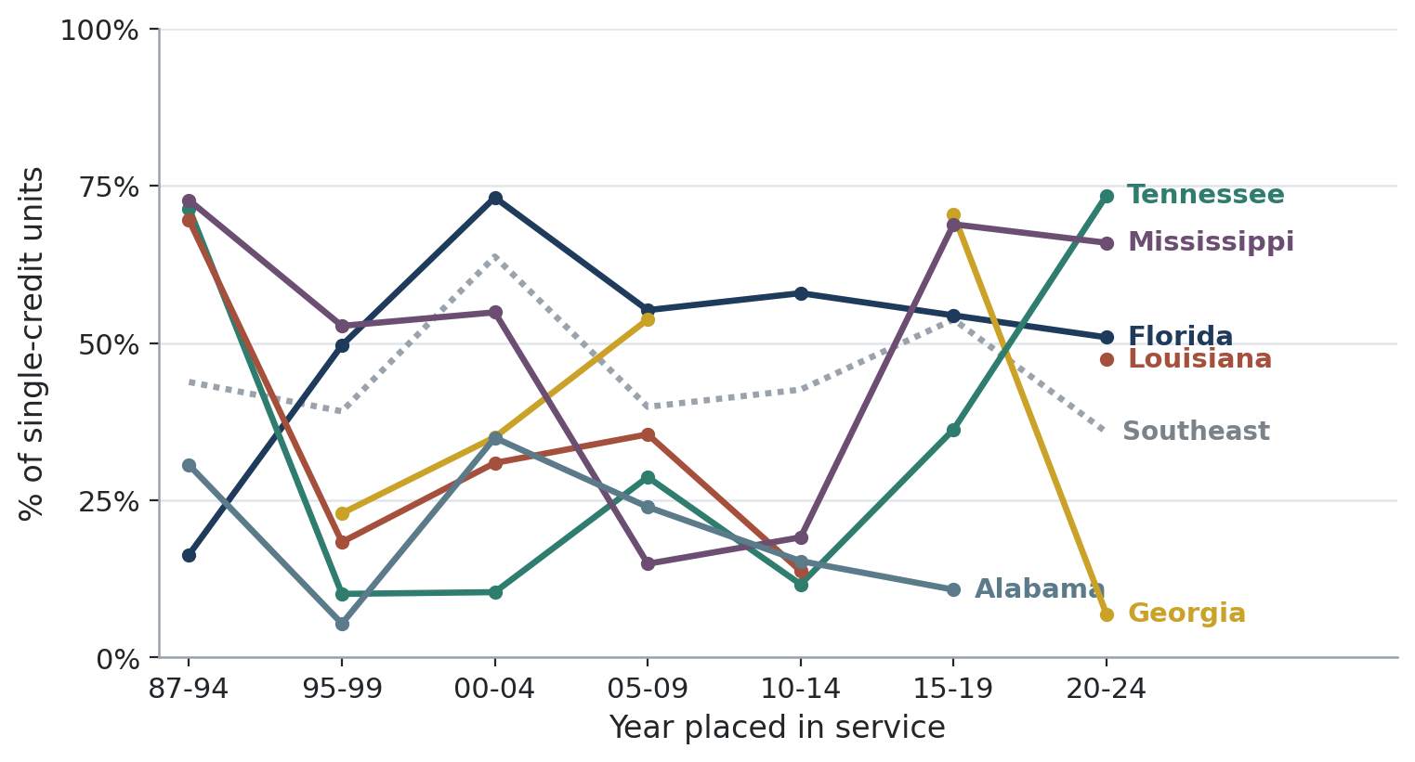
Note: Alabama's series ends at 2015-2019; too few 2020-2024 placements carry a single-credit code to report.
Source: HUD National LIHTC Database, authors' calculations.

The 2025 law eases the bond test and lifts the 9 percent credit
The 2025 tax law makes two changes that bear directly on this financing⁵. It lowers the bond-financing test, the share of cost that tax-exempt bonds must cover to unlock the 4 percent credit, from 50 to 25 percent of aggregate basis for developments placed in service in tax years beginning after 2025, where the qualifying bonds are part of an issue dated after 2025 that finances at least 5 percent of aggregate basis, and it makes permanent an increase of about 12 percent in the 9 percent credit ceiling beginning in 2026. Splitting recent single-credit production shows where each change acts: about 63 percent is 9 percent credit, which the higher ceiling lifts; about 13 percent is 4 percent production in the bond-constrained states, which the lower test eases by letting a smaller bond cover the required share; and about 23 percent is 4 percent production where bond authority is not yet binding, which neither change reaches directly. The largest near-term effects point back toward Florida and Georgia.
The financing story is one of growing reliance on the bond and on the credit itself. As production has tilted toward the 4 percent path, it has concentrated where private-activity bond authority is scarcest, which makes the 2025 law’s easing of the bond test most consequential in Florida and Georgia, where the cap binds hardest. Each turn to the bond also raises the complexity of assembling a deal, complexity that surfaces as longer timelines from allocation to placement, the subject of the companion update on how deals have changed.
Data and methods
Figures are from the HUD National LIHTC Database for the six Southeastern states. Credit composition uses the credit-type field, where the 9 percent credit is the competitive credit and the 4 percent credit is the bond-financed credit; credit type is reported unevenly across states and early years, so single-credit shares rest on thin reporting bases for some states. The 2025-law decomposition splits recent single-credit units into 9 percent, 4 percent in the bond-constrained states of Florida and Georgia, and 4 percent elsewhere. Bond cap figures are authors’ calculations from IRS Rev. Proc. 2023-34 and Census Bureau population estimates, not from the HUD database. Cohorts are placed-in-service bands, a 1987-1994 band and five-year bands thereafter. Conventions common to the series: figures count income-restricted units unless stated otherwise; records coded 8888 or 9999 in the placed-in-service field, 2,765 records and 225,252 units nationally, are excluded from all year-based figures, and only 254 of those records fall in the region, so the exclusion bears more on the national series than the regional one; Puerto Rico and other territories, 0.69 percent of national units, are excluded from the national series, so that the place-type numerators cover the same universe as the population denominators, which are drawn from the fifty states and the District of Columbia and contain no territories; and any characteristic with material non-reporting is shown on a reporting base, with the excluded share given in the figure note. Regional-to-national comparisons on a reporting base assume non-reporting is unrelated to the characteristic measured, which this file cannot test, and completeness differs by geography: among regional income-restricted units, 61 percent record a target population, 51 percent an income ceiling, and 88 percent a construction type, against 58, 66, and 88 percent nationally.
By Donta Council, Community and Economic Development, Federal Reserve Bank of Atlanta.
The views expressed here are the author’s and not necessarily those of the Federal Reserve Bank of Atlanta or the Federal Reserve System. Any remaining errors are the author’s responsibility.
Notes
1. On how the two credits work and how states allocate them, see Keightley (2025) and Scally, Gold, and DuBois (2018).
2. The nonprofit-sponsorship field is a one-sided flag, recorded for about a fifth of records, that identifies nonprofit sponsors without consistently identifying for-profit ones. It supports the trend shown here but cannot support a nonprofit-versus-for-profit comparison.
3. Private-activity bond volume cap for 2024 is the greater of $125 per resident or $378,230,000 per state, set by IRS Rev. Proc. 2023-34 and applied to Census Bureau resident-population estimates released December 2023. The cap figures are authors' calculations from those sources, not from the HUD database. The used-versus-unused posture compares the cap to bond-financed production from the HUD National LIHTC Database.
4. Credit type is reported unevenly across states and early years, so single-credit shares rest on thin reporting bases for some states.
5. The One Big Beautiful Bill Act lowered the bond-financing test for the 4 percent credit from 50 to 25 percent for developments placed in service after December 31, 2025, and made permanent an increase of about 12 percent in the 9 percent credit ceiling beginning in calendar year 2026.
Sources
1. Mark P. Keightley, An Introduction to the Low-Income Housing Tax Credit, CRS Report RS22389, Congressional Research Service, updated July 11, 2025, https://www.congress.gov/crs-product/RS22389.
2. Corianne Payton Scally, Amanda Gold, and Nicole DuBois, The Low-Income Housing Tax Credit: How It Works and Who It Serves, Urban Institute, July 2018, https://www.urban.org/research/publication/low-income-housing-tax-credit-how-it-works-and-who-it-serves.
3. Internal Revenue Service, Rev. Proc. 2023-34, inflation-adjusted private-activity bond volume cap for calendar year 2024.
4. One Big Beautiful Bill Act, Pub. L. 119-21, enacted July 4, 2025.
5. U.S. Department of Housing and Urban Development, Office of Policy Development and Research, Low-Income Housing Tax Credit (LIHTC) Property Database, https://www.huduser.gov/portal/datasets/lihtc.html.
PARTNERS UPDATE | COMMUNITY AND ECONOMIC DEVELOPMENT
How Are Southeastern LIHTC Deals Subsidized?
The public subsidy layered around the credit: which programs carry it, how much reaches each unit, and how thin it runs against the nation.
Beyond the two credits and the bonds, Southeastern LIHTC deals draw on a short list of other public sources, and that layer is thinner here than nationally. The region records about 1,160 dollars of non-credit public money per income-restricted unit against roughly 2,378 for the nation, close to half. This update follows that outside subsidy: which programs deliver it, how often it appears in a deal, and how much reaches each unit.

Developments lean on a short list of other public sources
Figure 1 shows how often each outside source appears in a deal. HOME and USDA Rural Development are the region's two largest sources, present in about 5 and 4 percent of units, while CDBG, common nationally at about 1.6 percent, barely registers here. The region fills the gap around the credit from a shorter list of programs.
Figure 1. Incidence of additional public sources, Southeast and United States.
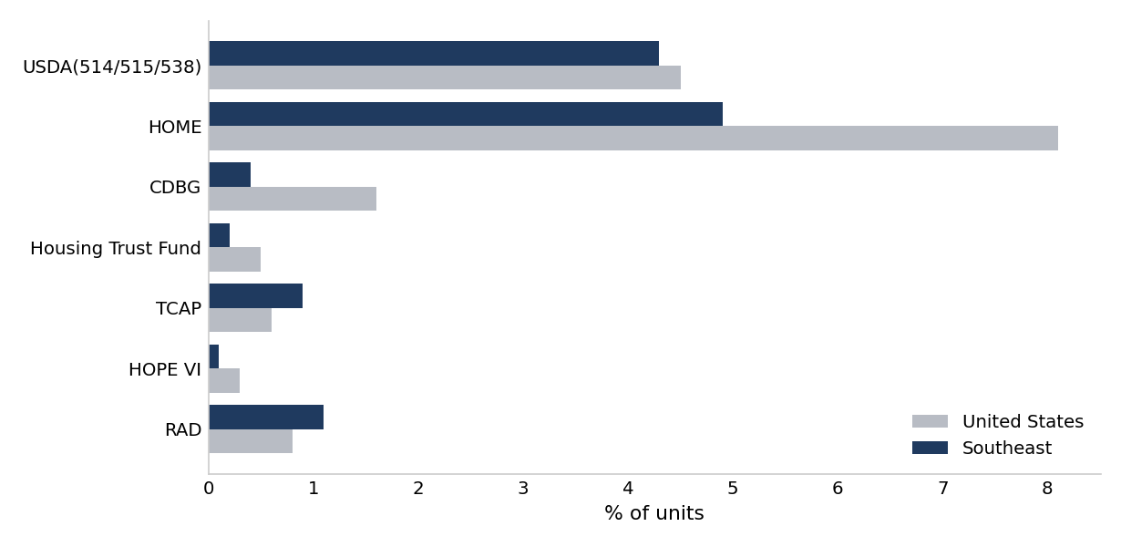
Source: HUD National LIHTC Database, authors' calculations.
The number of outside public sources layered into a development has also fallen over time. The regional average has dropped from about 0.32 sources per development in the earliest cohorts to near 0.11 recently, slipping below the national figure along the way. Recent Southeastern developments draw on fewer outside public programs than they once did, and fewer than a comparable national deal, narrowing the public layer well before the dollar comparisons that follow.
Figure 2. Average additional public sources per development over time, Southeast and United States.
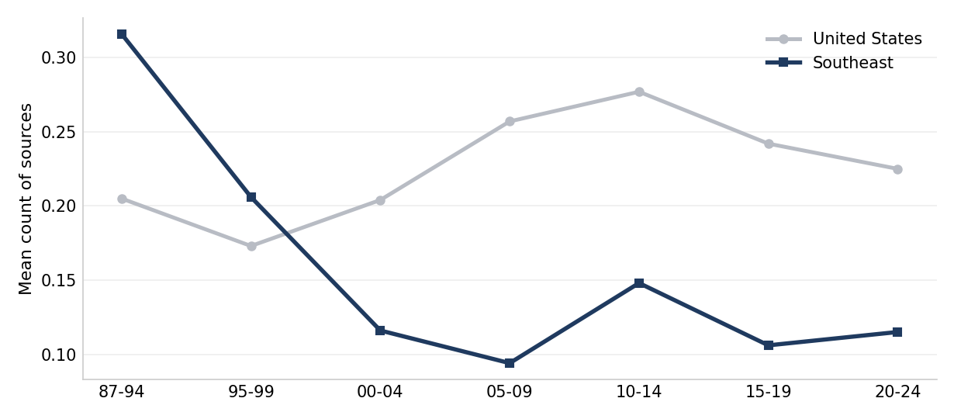
Source: HUD National LIHTC Database, authors' calculations.
Where dollar amounts are recorded, the same few programs carry the totals, and the regional bars sit below the national ones source for source. The chart counts only programs that report dollars, so it understates the full subsidy, but the regional shortfall it shows is consistent with the per-unit gap that follows.
Figure 3. Recorded dollars by additional public source, Southeast and United States, 1987-2024.
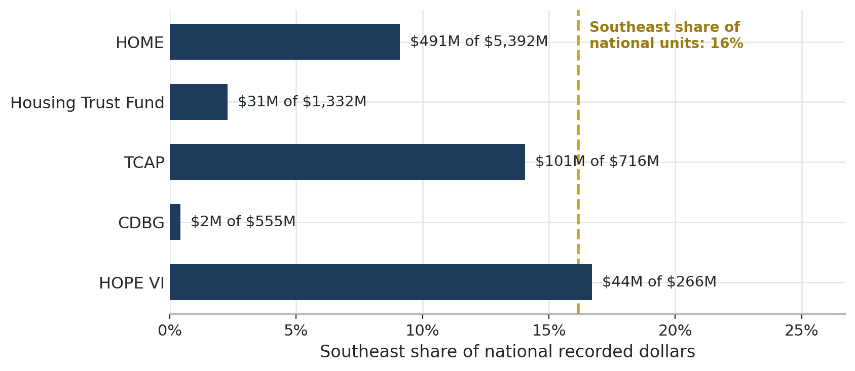
Source: HUD National LIHTC Database, authors' calculations.
Summed to a single figure, the region records about 1,160 dollars of non-credit public money per income-restricted unit against roughly 2,378 nationally, close to half. The figure counts public programs only, not philanthropy or other private capital, and is a lower bound because USDA and RAD record participation without dollar amounts. The gap between the regional and national figures is about 1,218 dollars per income-restricted unit.
Because these amounts are pooled across placed-in-service years 1987 to 2024, a constant-dollar version deflates each recorded dollar to 2024 by the year the development opened. On that basis the regional figure is about 1,700 dollars per income-restricted unit and the national figure about 3,200, and the regional rate stands at just over half the national rate rather than just under. The constant-dollar adjustment raises both levels and tightens the regional share without changing the finding.
Figure 4. Non-credit public subsidy per income-restricted unit, Southeast and United States, 1987-2024.
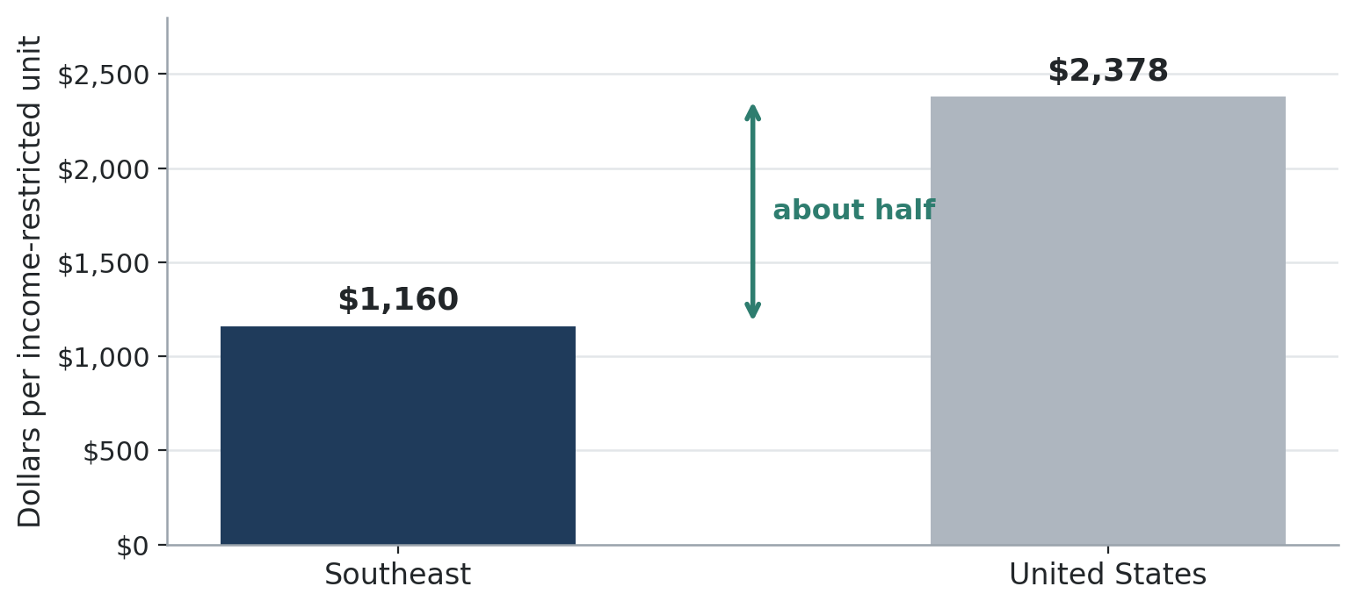
Source: HUD National LIHTC Database, authors' calculations.
USDA Rural Development, one of the region's two main outside sources, has receded over the program's history, persisting most in Mississippi. USDA participation and the average count of outside sources per development decline over the same period. USDA-backed developments fell from roughly a quarter of regional units in the program's first decade to low single digits recently, while Mississippi has kept the highest rate in the region.
Figure 5. USDA Rural Development participation over time, Southeast and United States.
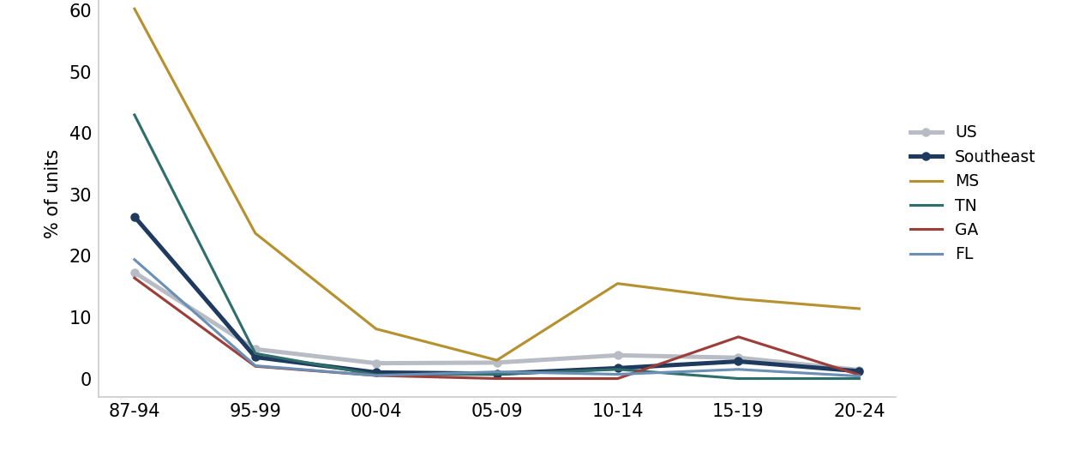
Source: HUD National LIHTC Database, authors' calculations.
Non-credit public money in the region runs at about half the national rate per income-restricted unit, is carried by a short list of programs, mainly HOME and USDA Rural Development, and the average count of sources per development has fallen over the period. These figures cover public programs that record dollar amounts and understate total outside support, because USDA and RAD record participation without amounts.
Data and methods
Figures are from the HUD National LIHTC Database for the six Southeastern states. The dollars-per-unit figure sums the recorded amounts of the HOME, CDBG, Housing Trust Fund, TCAP, and HOPE VI programs and divides by income-restricted units, for projects with a valid placed-in-service year 1987 to 2024; it counts public programs only, not philanthropy or other private capital, and is a lower bound, because USDA Rural Development and RAD record participation without dollar amounts. The dollars-per-unit figure is reported in nominal dollars and, alongside it, in constant 2024 dollars: each recorded amount is deflated to 2024 by the annual CPI-U matched to the placed-in-service year, with the deflator formed as the 2024 index over the record-year index, so that dollars of different vintages are made comparable before summing. Because the regional and national figures are deflated the same way, their ratio is governed by the timing of spending rather than by the choice of index; a construction cost index would be the alternative where the interest is real building capacity rather than general purchasing power. The additional-public category in the HUD data collapses nine programs; in the Southeast it is carried mainly by HOME and USDA Section 515, with CDBG near-absent. The average count of additional public sources per development sums the recorded soft-funding flags per project, by allocation cohort. Cohorts here are five-year allocation bands beginning with a 1987-1994 band, while the dollars-per-unit figure filters on placed-in-service year. This update moves among three units of analysis: incidence as a percent of income-restricted units, the count of sources per development, and dollars per income-restricted unit. Conventions common to the series: figures count income-restricted units unless stated otherwise; records coded 8888 or 9999 in the placed-in-service field, 2,765 records and 225,252 units nationally, are excluded from all year-based figures, and only 254 of those records fall in the region, so the exclusion bears more on the national series than the regional one; Puerto Rico and other territories, 0.69 percent of national units, are excluded from the national series, so that the place-type numerators cover the same universe as the population denominators, which are drawn from the fifty states and the District of Columbia and contain no territories; and any characteristic with material non-reporting is shown on a reporting base, with the excluded share given in the figure note. Regional-to-national comparisons on a reporting base assume non-reporting is unrelated to the characteristic measured, which this file cannot test, and completeness differs by geography: among regional income-restricted units, 61 percent record a target population, 51 percent an income ceiling, and 88 percent a construction type, against 58, 66, and 88 percent nationally.
By Donta Council, Community and Economic Development, Federal Reserve Bank of Atlanta.
The views expressed here are the author's and not necessarily those of the Federal Reserve Bank of Atlanta or the Federal Reserve System. Any remaining errors are the author's responsibility.
Sources
1. U.S. Department of Housing and Urban Development, Office of Policy Development and Research, Low-Income Housing Tax Credit (LIHTC) Property Database, https://www.huduser.gov/portal/datasets/lihtc.html.
2. U.S. Department of Housing and Urban Development, HOME Investment Partnerships Program, https://www.hud.gov/program_offices/comm_planning/home.
3. U.S. Department of Agriculture, Rural Development, Multifamily Housing Direct Loans (Section 515 Rural Rental Housing), https://www.rd.usda.gov/programs-services/multifamily-housing-programs.
4. U.S. Department of Housing and Urban Development, Community Development Block Grant Program, https://www.hud.gov/program_offices/comm_planning/cdbg.
5. Corianne Payton Scally, Amanda Gold, and Nicole DuBois, The Low-Income Housing Tax Credit: How It Works and Who It Serves, Urban Institute, July 2018, https://www.urban.org/research/publication/low-income-housing-tax-credit-how-it-works-and-who-it-serves.
PARTNERS UPDATE | COMMUNITY AND ECONOMIC DEVELOPMENT
How Has Southeastern LIHTC Changed, and Where Do Deals Land?
Larger deals, longer timelines from allocation to occupancy, and a siting pattern that has shifted toward basis-boost tracts.

Three changes have reshaped how Southeastern LIHTC deals come together. Developments have grown larger, from a median of 28 income-restricted units in the 1987-1994 allocation cohort to 73 in 2020-2024 in the region, against 24 rising to 60 nationally. Deals also take longer to open, with the regional interval from allocation to occupancy rising toward 1.8 to 2.0 years, up from well under one. And the share of units sited in Qualified Census Tracts, which carry a basis boost, has risen. This update traces those three trends.

Deals have grown larger
Median income-restricted units per development have climbed across allocation cohorts in the region and the nation, with the regional line above the national one for most of the program's history, rising from 28 in the earliest cohort to 73 in the most recent. The regional median has close to tripled over the period.
Figure 1. Median development size over time, Southeast and United States.
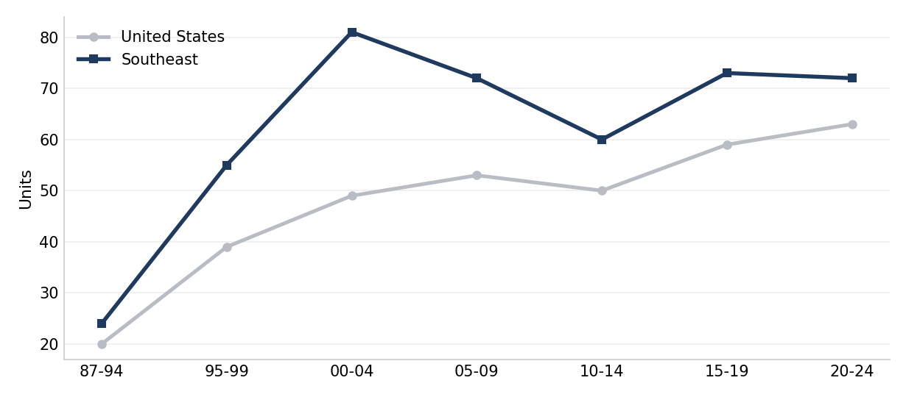
Source: HUD National LIHTC Database, authors' calculations.

Development size by place type and state
Development size follows the urban-to-rural gradient and runs larger in the region than the nation at every place type: a median of 80 income-restricted units in metropolitan areas, 45 in micropolitan areas, and 36 in rural counties, against 56, 38, and 27 nationally. The regional-to-national gap is widest in metropolitan areas, at about 23 units.
Figure 2. Median development size by place type, Southeast and United States, 1987-2024.
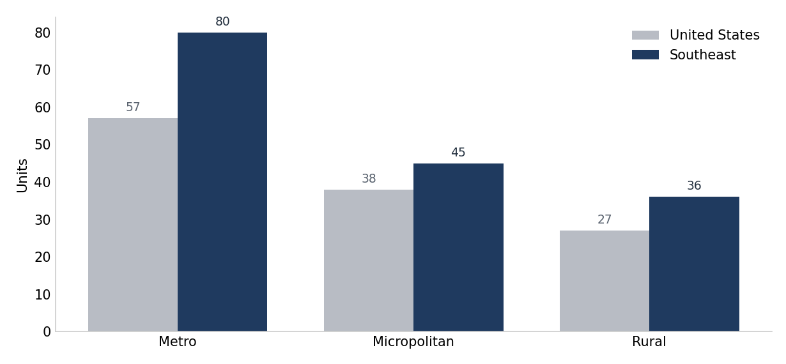
Source: HUD National LIHTC Database, authors' calculations.
The same pattern holds across states. For allocations from 2015 to 2024, Florida records the largest developments at a median of 96 income-restricted units, while Louisiana and Mississippi record the smallest at 41 and 46, and the others fall in between against a national median of 60.
Figure 3. Median development size by state, Southeastern states.
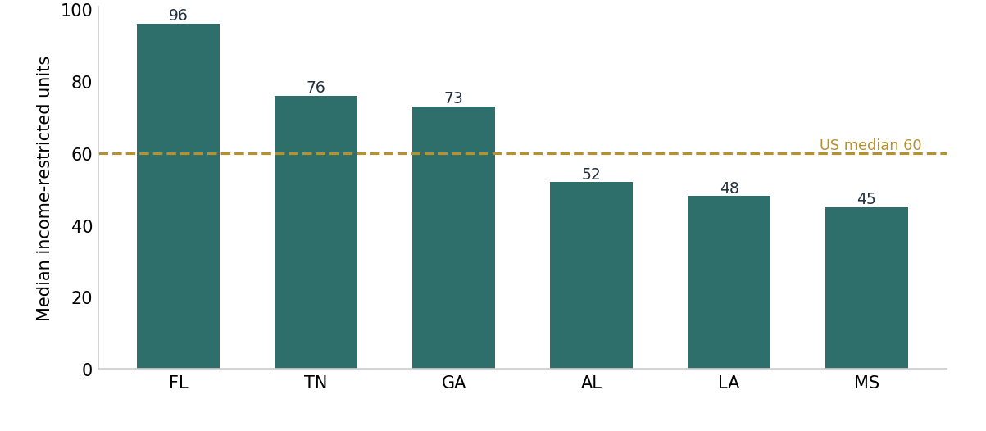
Source: HUD National LIHTC Database, authors' calculations.

Deals take longer to open than they once did
The interval between a credit allocation and the day a development opens has lengthened across cohorts. The regional average, lower than the national one early on, now sits above it, near 1.8 to 2.0 years for recent allocations against well under one in the program's first decade. The regional average moved from below the national average in the earliest cohorts to above it in the most recent.
Figure 4. Mean lag from allocation to placed in service, by allocation period, Southeast and United States.
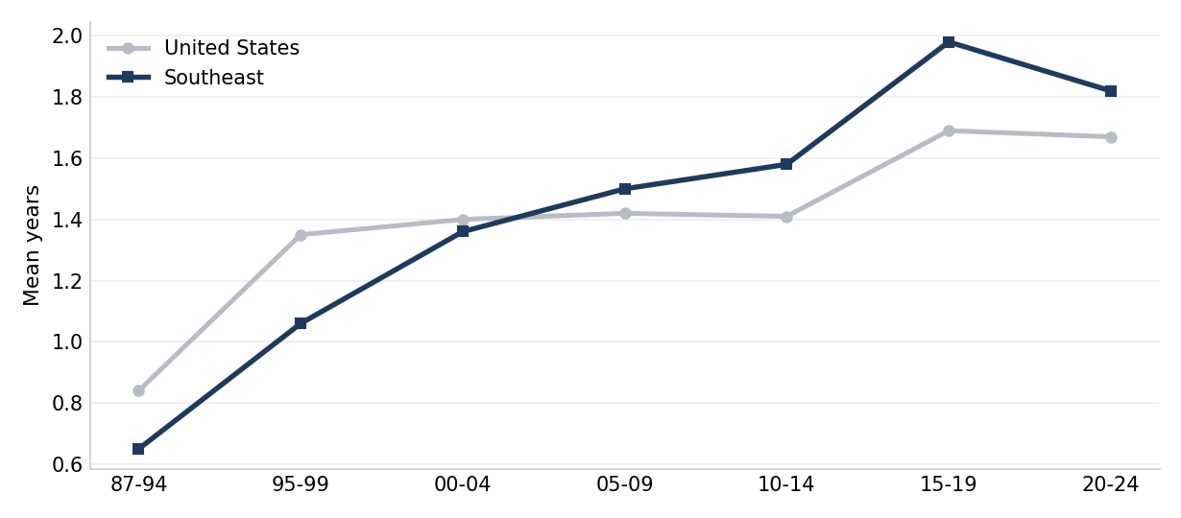
Source: HUD National LIHTC Database, authors' calculations.
The same lengthening shows in the distribution: the share of regional developments opening within the allocation year has shrunk cohort by cohort, from more than half in the earliest period to about one in ten recently, while the three-or-more-year band has grown to roughly a quarter. The slow path is a shift in the whole distribution, not a few outliers.
Figure 5. Distribution of the allocation-to-placement lag, Southeast.
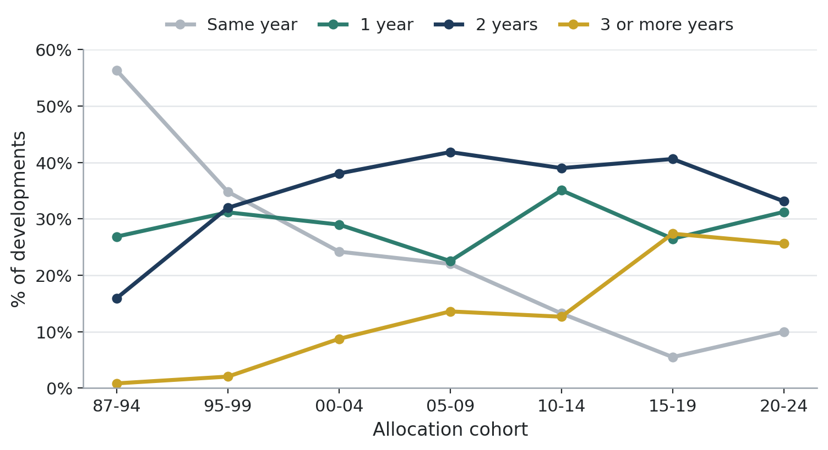
Source: HUD National LIHTC Database, authors' calculations.
Because recent allocations have had less time to place, a completeness-adjusted view restricts each cohort to allocations with at least two years to open. Even then the share placed within two years falls, from near universal in the early cohorts to about seven in ten regionally for the most recent, so the slowdown is real rather than an artifact of incomplete recent data.
Figure 6. Share of allocations placed in service within two years, by period, Southeast and United States.
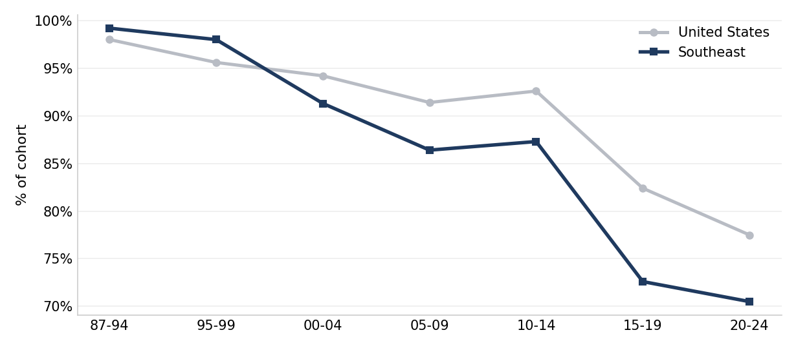
Source: HUD National LIHTC Database, authors' calculations.
Across states, the recent average interval runs from about 1.5 years in Tennessee and Alabama to over 2 in Florida, with the regional average near 1.8. The states with the longest intervals are also those with the largest programs and the highest 4 percent shares.
Figure 7. Mean lag from allocation to placed in service by Southeastern state, allocations 2010-2019.
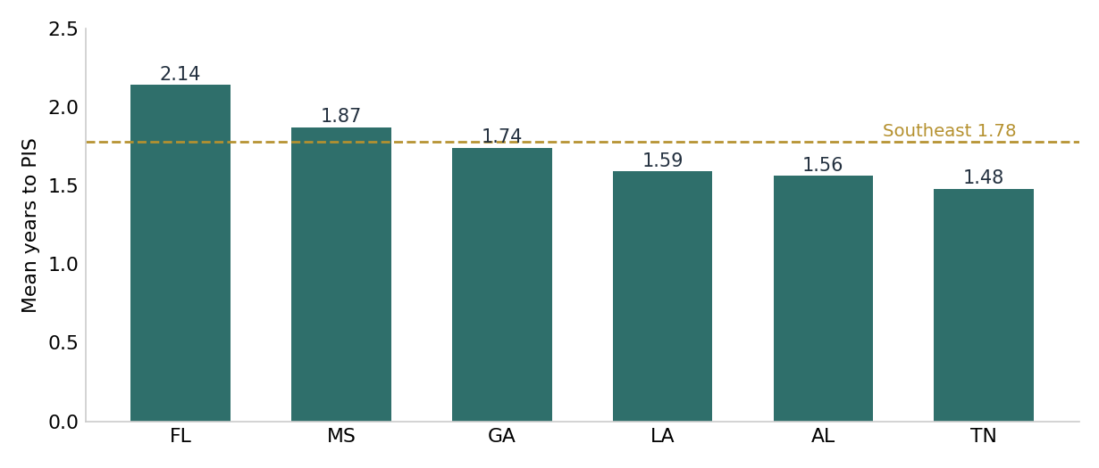
Source: HUD National LIHTC Database, authors' calculations.

Siting has shifted toward moderate-income and higher-minority tracts
Where deals land has also moved.¹ By tract income the region's units concentrate in moderate-income neighborhoods, about 43 percent against 34 percent nationally, with a smaller share in the lowest-income tracts, 21 against 24 percent. The regional credit reaches moderate-income areas more than the national pattern does.
Figure 8. Share of LIHTC income-restricted units by tract income level, Southeast and United States.
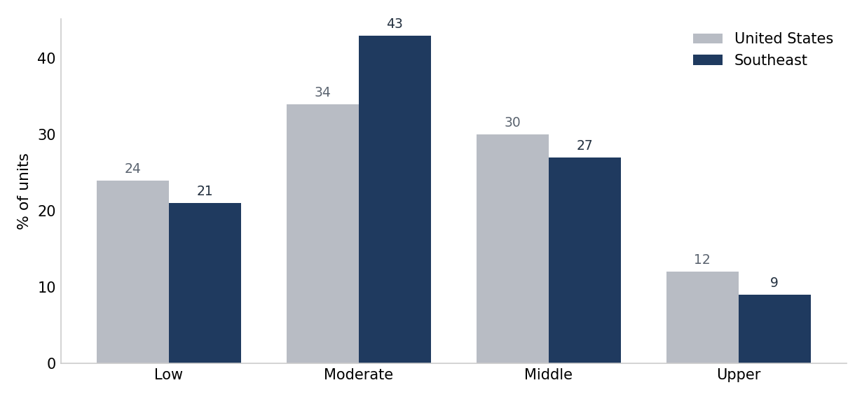
Source: HUD National LIHTC Database, 2020 Census, authors' calculations.
By tract racial composition the regional units shift toward the higher-minority categories, with near 39 percent in tracts where most residents are people of color against 33 percent nationally. Where the credit lands differs from the national pattern on both readings, income and racial composition.
Figure 9. Share of LIHTC income-restricted units by tract minority share, Southeast and United States.
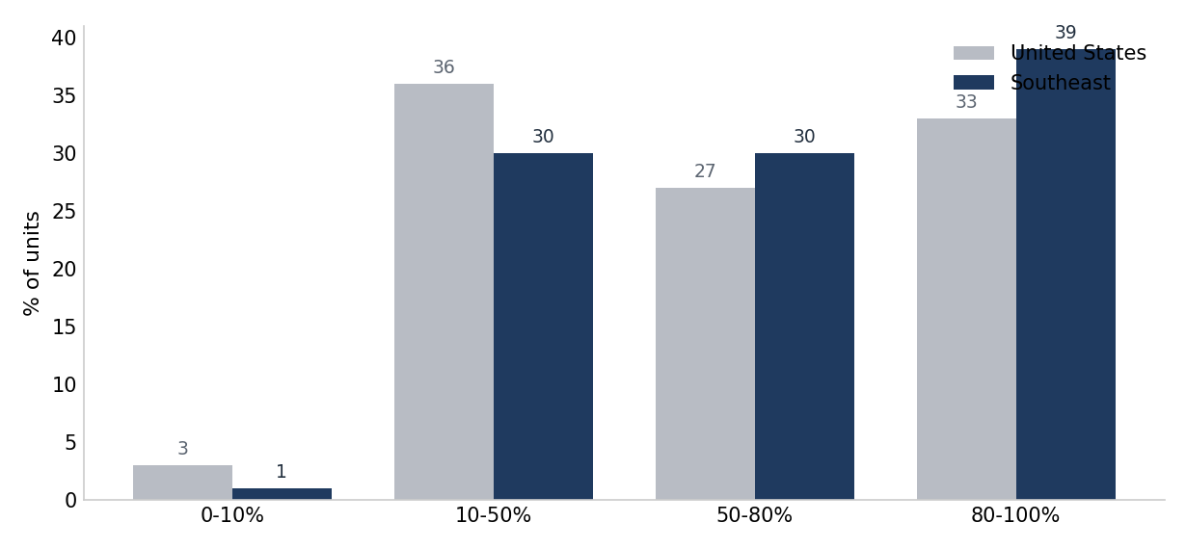
Source: HUD National LIHTC Database, 2020 Census, authors' calculations.
The Qualified Census Tract designation raises the eligible basis, and so the credit a development can claim, in qualifying higher-poverty or lower-income areas. The share of units sited in these tracts has risen over time, and the bond-financed 4 percent credit now exceeds the competitive 9 percent credit on this measure, a reversal from the program's earlier years that ties the siting trend back to the bond-financed path.
Figure 10. Share of units sited in Qualified Census Tracts over time, Southeast and United States.
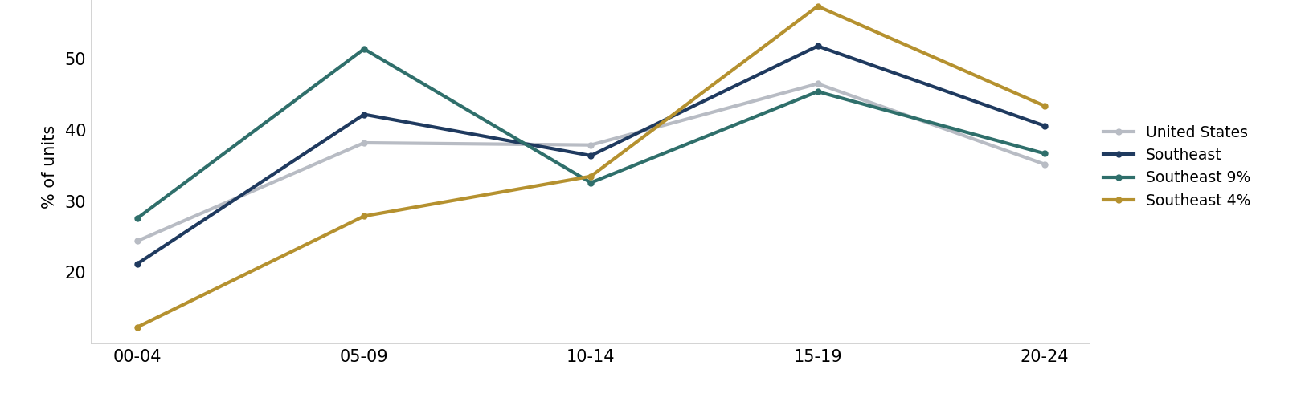
Source: HUD National LIHTC Database, authors' calculations.
The three measures move over the same period: median development size rises, the allocation-to-placement interval lengthens, and the share of units sited in Qualified Census Tracts increases. Whether and how these trends are related is beyond what the HUD database alone can establish.

The 9 percent and 4 percent credits build different housing
The clearest split is between the two forms of the credit. Developments financed with the competitive 9 percent credit are more often new construction, 86 against 73 percent of units recording a type, and more often sited in Qualified Census Tracts, 28 against 23 percent, while the bond-linked 4 percent credit carries a higher family share, 82 against 73 percent, and relatively more preservation. They also run smaller, a median of 54 units against 76 for the 4 percent credit, in line with the size gradient in Figures 2 and 3. The two credits are associated with different development profiles on each of these measures.
Figure 11. Profile of 9 percent and 4 percent developments, Southeast, 1987-2024.
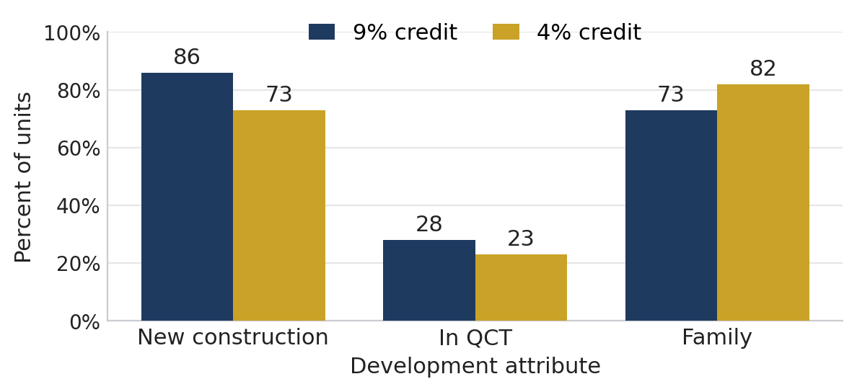
Source: HUD National LIHTC Database, authors' calculations.
Data and methods
Figures are from the HUD National LIHTC Database for the six Southeastern states. Development size is the count of income-restricted units per development, by allocation cohort. The allocation-to-placement interval is the number of years between credit allocation and placed in service, by allocation cohort; the completeness-adjusted share restricts each cohort to allocations with at least two years to place. Tract income and racial composition come from a tract-level join and count income-restricted units, with the higher-minority category defined as tracts where people of color are at least 80 percent of residents, and the Qualified Census Tract series begins in 2000, when that designation becomes reliable. Development size is the count of income-restricted units per development, reported as a median because the size distribution is right-skewed, while the allocation-to-placement interval is reported as a mean because it is bounded and roughly symmetric. Cohorts are five-year allocation bands beginning with a 1987-1994 band, and recent means allocations from 2015 to 2024. Conventions common to the series: figures count income-restricted units unless stated otherwise; records coded 8888 or 9999 in the placed-in-service field, 2,765 records and 225,252 units nationally, are excluded from all year-based figures, and only 254 of those records fall in the region, so the exclusion bears more on the national series than the regional one; Puerto Rico and other territories, 0.69 percent of national units, are excluded from the national series, so that the place-type numerators cover the same universe as the population denominators, which are drawn from the fifty states and the District of Columbia and contain no territories; and any characteristic with material non-reporting is shown on a reporting base, with the excluded share given in the figure note. Regional-to-national comparisons on a reporting base assume non-reporting is unrelated to the characteristic measured, which this file cannot test, and completeness differs by geography: among regional income-restricted units, 61 percent record a target population, 51 percent an income ceiling, and 88 percent a construction type, against 58, 66, and 88 percent nationally.
By Donta Council, Community and Economic Development, Federal Reserve Bank of Atlanta.
The views expressed here are the author's and not necessarily those of the Federal Reserve Bank of Atlanta or the Federal Reserve System. Any remaining errors are the author's responsibility.
Notes
1. The Qualified Census Tract basis boost is set in Internal Revenue Code section 42(d)(5)(B). On siting patterns and the fair-housing context, see Ellen, Horn, and O'Regan (2016) and Texas Department of Housing and Community Affairs v. Inclusive Communities Project, Inc. (2015).
Sources
1. U.S. Department of Housing and Urban Development, Office of Policy Development and Research, Low-Income Housing Tax Credit (LIHTC) Property Database, https://www.huduser.gov/portal/datasets/lihtc.html.
2. Ingrid G. Ellen, Keren M. Horn, and Katherine M. O'Regan, Poverty Concentration and the Low Income Housing Tax Credit: Effects of Siting and Tenant Composition, Journal of Housing Economics 34, December 2016, 49-59.
3. U.S. Department of Housing and Urban Development, Qualified Census Tracts and Difficult Development Areas, https://www.huduser.gov/portal/datasets/qct.html.
4. Texas Department of Housing and Community Affairs v. Inclusive Communities Project, Inc., 576 U.S. 519 (2015).
5. U.S. Census Bureau, American Community Survey five-year estimates, census tract level.

Appendix. Two per-capita measures of production
This appendix supports the metropolitan and micropolitan rankings in Figures 3a and 3b. For each area it reports production measured two ways, units per 100,000 residents and units per 1,000 renter households, and the correlation between the two measures. The high correlation indicates that the ranking of areas is not sensitive to the choice of denominator.
Correlation between the two measures. Metropolitan areas: Spearman rank correlation 1.00, linear (Pearson) correlation 0.99. Micropolitan areas: Spearman 0.92, linear 0.91. Coefficients are computed across the ten areas in each panel.
Table A1. LIHTC production per resident and per renter household, top ten Southeastern metropolitan and micropolitan areas by renter households, 2008-2024.
Metropolitan area (ranked by renter households) | Units per 100,000 residents | Units per 1,000 renter households
Miami-Fort Lauderdale | 459 | 32.3
Atlanta-Sandy Springs | 549 | 43.4
Tampa-St. Petersburg-C | 343 | 25.7
Orlando-Kissimmee-Sanf | 371 | 29.2
Nashville-Davidson--Mu | 716 | 57.0
Jacksonville | 347 | 27.7
Memphis | 525 | 34.7
New Orleans-Metairie | 1004 | 72.3
Birmingham-Hoover | 103 | 8.8
Knoxville | 661 | 54.6

Micropolitan area (ranked by renter households) | Units per 100,000 residents | Units per 1,000 renter households
Tupelo | 603 | 59.1
Cookeville | 543 | 41.4
LaGrange | 846 | 61.0
Key West | 968 | 59.8
Statesboro | 348 | 21.7
Meridian | 525 | 40.9
Tullahoma-Manchester | 288 | 25.4
Sevierville | 689 | 61.7
Starkville | 418 | 25.1
Albertville | 143 | 14.7
Source: HUD National LIHTC Database, 2020 Census, ACS 2016-2020 5-year; authors' calculations. Areas ranked by renter households; rates use Southeast-state counties only.

PARTNERS UPDATE | COMMUNITY AND ECONOMIC DEVELOPMENT
When Does Southeastern LIHTC Affordability Expire, and Where?
How many income-restricted units reach the end of their scheduled affordability period over the next two decades, which states carry the wave, and where it lands on the ground.

The Sixth District's earliest Low-Income Housing Tax Credit units have begun aging out of their affordability requirements, but the near-term wave is smaller, and lands differently, than a simple thirty-year count suggests. About 235,000 income-restricted units reach scheduled expiration over the two decades from 2025 through 2044. Georgia carries the largest share, about 95,000 units, followed by Tennessee, Louisiana, Alabama, and Mississippi. Florida, the region's largest producer, contributes almost none of the near-term wave: its state-mandated 50-year affordability period defers most of its expirations to the 2040s and 2050s. The near-term wave concentrates in the metropolitan counties of Atlanta, Memphis, Nashville, and New Orleans.
That last point drives the regional total, and it is where a thirty-year rule of thumb goes wrong. Affordability lasts at least thirty years under federal law, but several states require longer, and Florida requires fifty. The HUD LIHTC Database rarely records the elected term, so a computation that defaults every record to thirty years counts Florida's units as expiring in the 2020s and 2030s when most are restricted into the 2040s, 2050s, and beyond. Under that default the region's twenty-year total would read about 384,000 units with Florida ranked first at roughly 148,000; correcting for Florida's fifty-year mandate cuts the twenty-year total to about 235,000 and moves Florida to last in the near term. The University of Florida's Shimberg Center, which tracks the state's assisted stock directly, reaches the same conclusion, describing Florida's path as a slope rather than a cliff. The authoritative per-property expiration year is carried in the National Housing Preservation Database's scheduled-expiration field, which encodes each state's terms; the figures here apply Florida's fifty-year rule to its post-1995 developments and the federal thirty-year minimum elsewhere, using any longer elected term where the HUD record reports one.
This is the first view of the wave assembled for the six Sixth District states as a unit, from the HUD LIHTC Database, and reported at the county level. It builds on work that maps the same terrain in parts: the National Housing Preservation Database and PolicyMap map expirations nationally; the Federal Reserve Bank of Chicago examined the Seventh District; the Shimberg Center maintains a mapped Florida inventory; and a metropolitan Atlanta preservation map is maintained by HouseATL with the Atlanta Regional Commission and Enterprise Community Partners. The contribution here is the consistent six-state comparison and its link to the production, financing, and siting findings in the rest of this series.

The near-term wave crests in the late 2030s, and Florida's arrives two decades later
The region placed most of its non-Florida credit stock in the two decades after 1995, and those units reach their thirtieth year across the 2025 to 2044 window. Annual scheduled expirations in the five states other than Florida rise from about 11,000 income-restricted units in 2025 to a peak near 17,600 in the late 2030s, then ease, and the cumulative total reaches about 235,000 by 2044. Florida's wave is a separate event: because its developments carry fifty-year terms, they begin reaching expiration only around 2045, and about 92,000 Florida units come due in the decade from 2045 to 2054. The two-decade offset between Florida and its neighbors is a product of affordability-term policy, not of when the units were built.
Figure 1. Income-restricted units reaching scheduled expiration each year, Sixth District, 2025-2054, Florida shown separately.
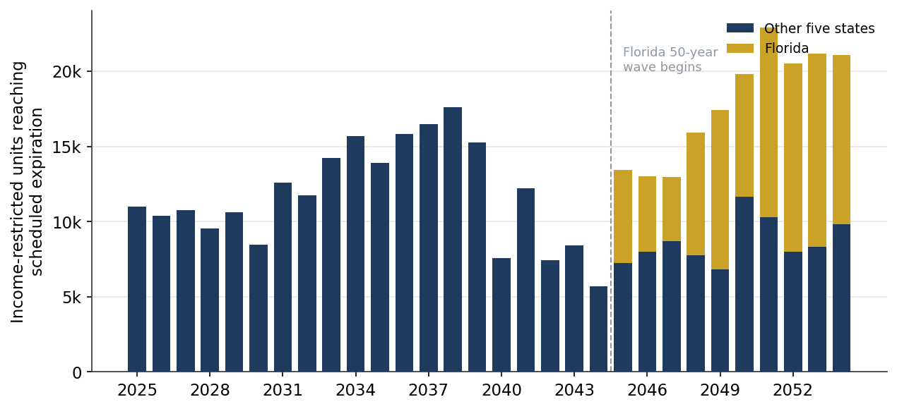
Source: HUD National LIHTC Database, authors' calculations.

Georgia carries most of the near-term wave
Georgia accounts for about 95,000 income-restricted units reaching scheduled expiration between 2025 and 2044, the largest share in the region. Tennessee (about 44,000), Louisiana (about 39,000), Alabama (about 29,000), and Mississippi (about 28,000) follow. Florida, despite building the most units of any state in the region, contributes almost nothing to the near-term total because of its fifty-year restrictions. The ranking reflects both production volume and state affordability-term policy: the near-term exposure sits with the states that built heavily under the federal minimum term.
Figure 2. Income-restricted units reaching scheduled expiration by state, Sixth District, 2025-2044.
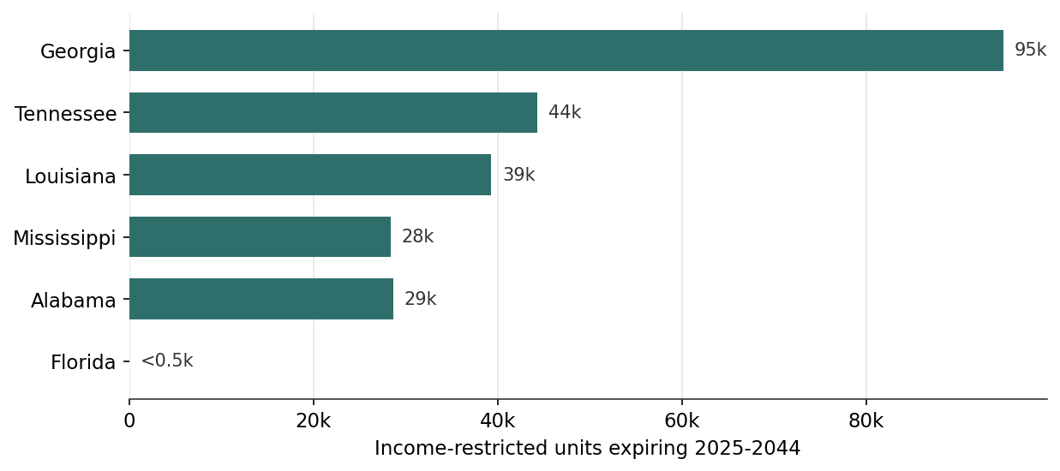
Source: HUD National LIHTC Database, authors' calculations.

About half the region's still-restricted stock reaches expiration within twenty years
Measured against the units still under a scheduled restriction at the start of 2025, about 46 percent reach scheduled expiration by 2044, with the curve crossing the halfway mark near 2043. This is a lower share than a thirty-year default implies, again because Florida's fifty-year units remain restricted throughout the window. The near-term exposure is real and concentrated, but it is a smaller and more geographically focused share of the regional stock than a simple count suggests.
Figure 3. Cumulative share of the 2025 active affordable stock reaching scheduled expiration, Sixth District.
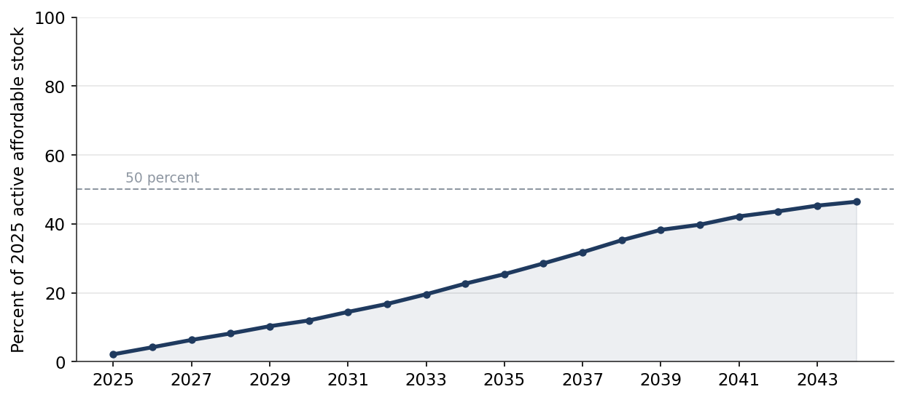
Source: HUD National LIHTC Database, authors' calculations.

The near-term wave concentrates in Atlanta, Memphis, Nashville, and New Orleans
The heaviest county totals sit in the region's largest non-Florida rental markets: Fulton and DeKalb counties in metropolitan Atlanta, Shelby County around Memphis, Davidson County around Nashville, and Jefferson and Orleans parishes around New Orleans each face several thousand income-restricted units reaching scheduled expiration in the window. Florida's counties are nearly empty on the near-term map, a direct visual signature of the state's fifty-year mandate. About 28 percent of the twenty-year total sits in Qualified Census Tracts, the higher-need neighborhoods where siting has concentrated over the program's history (see Update 4).
Figure 4. Income-restricted units reaching scheduled expiration by county, Sixth District, 2025-2044.
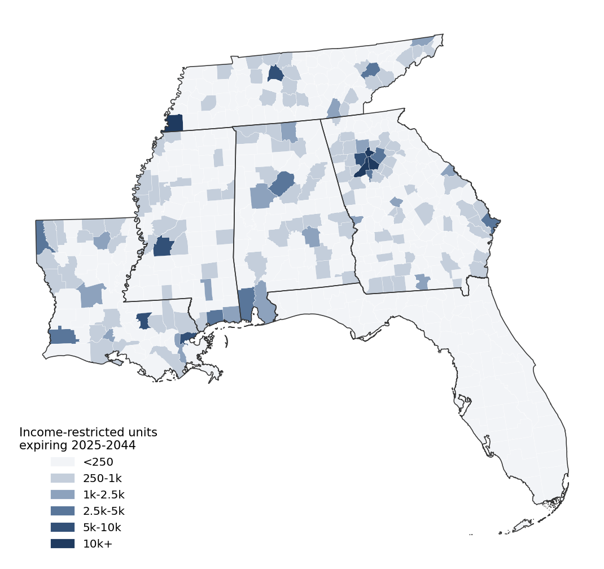
Source: HUD National LIHTC Database, authors' calculations.

Preservation pathways: where bankers and philanthropy fit
Which of these units stay affordable depends less on the expiration date than on who owns the property and what else supports it. Sorting the near-term expiring stock on those two characteristics separates it into three preservation pathways, shown in Figure 5, and each points to a different kind of capital. About 9 percent, roughly 22,000 units, is nonprofit-sponsored, where mission owners are the most likely to preserve and where the need is recapitalization: bank permanent debt paired with philanthropic or community-development gap capital for rehabilitation. About 13 percent, roughly 31,000 units, is for-profit-owned but carries a layered federal subsidy or project-based rental assistance, so other affordability restrictions provide a backstop and refinancing becomes a matter of coordinating several funders alongside the state agency. The remaining 78 percent, roughly 183,000 units, is for-profit-owned with only the tax credit, the segment where market forces alone determine the outcome and where outside capital has the most to change.
Within that market-risk segment, market strength identifies the most urgent cases. Pairing each property with five-year rent growth in its county, a standard signal of the pressure to convert, about 20,000 county-identified market-risk units sit in strong markets where county rents rose more than 30 percent over five years. These are the highest conversion risk and the clearest preservation priority, and roughly 18,000 of them are in larger properties at a scale that supports conventional debt and four-percent bond resyndication, the natural reach of bank preservation lending. A further 38,000 units sit in moderately strengthening markets, and about 109,000, mostly in softer or thin rural markets, face less immediate conversion pressure but more risk of physical deterioration without recapitalization. Size sorts the opportunity again within each tier: the small properties under 50 units, difficult to finance conventionally, are the natural target for catalytic and program-related investment capital, community development financial institutions, and acquisition funds that aggregate small deals, while about 28 percent of the market-risk units sit in Qualified Census Tracts, aligning bank Community Reinvestment Act activity with the neighborhoods where the loss would fall hardest.
Two caveats apply. The market-strength measure uses a public county rent index that covers the region's metropolitan and mid-size counties but not its thinnest rural markets, so those uncovered counties are grouped with the softer markets, where conversion pressure is in fact low. And the HUD nonprofit-sponsor flag undercounts mission ownership and records the original sponsor rather than the current owner, so the market-risk total is an upper bound.
Figure 5. Near-term expiring income-restricted units by preservation pathway, and the market-risk segment by market strength and development size, Sixth District, 2025-2044.
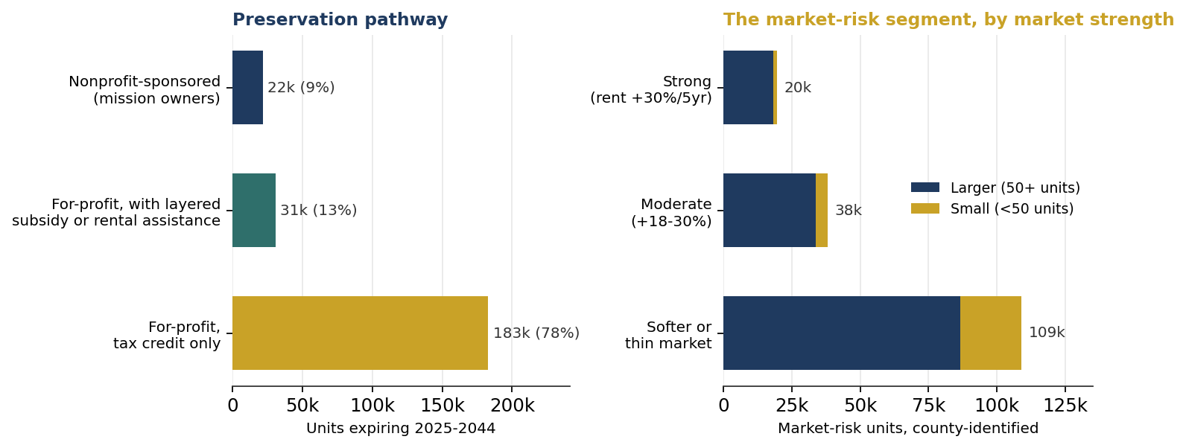
Source: HUD National LIHTC Database, Zillow Observed Rent Index, authors' calculations.

What this means for partners
Scheduled expiration is not the same as lost affordability. Former LIHTC units often remain below market rents for a period, and many are preserved through new tax-credit awards, other public subsidies, or nonprofit and public ownership. But the volume and timing set the preservation agenda, and the corrected picture sharpens it in three ways. First, the near-term wave is smaller and more concentrated than a headline thirty-year count implies, about 235,000 units rather than 384,000, and it sits mainly in Georgia, Tennessee, and the Gulf metros, so preservation capital and monitoring reach the most units by focusing there over the next fifteen years. Second, Florida is a policy lesson rather than a near-term problem: its fifty-year affordability mandate has deferred a wave of roughly 92,000 units to the 2040s and 2050s, the clearest evidence in the region that longer terms move the timing of loss by decades, and a model other states weighing their Qualified Allocation Plans can study. Third, the counts here remain a scheduled baseline. They do not capture early exits through the qualified contract process, which the HUD data cannot see and which would pull some units out sooner; pairing the National Housing Preservation Database's status field with the scheduled terms used here would complete the local picture.

Data and methods
Universe: HUD National LIHTC Database, developments in the six Sixth District states (Alabama, Florida, Georgia, Louisiana, Mississippi, and Tennessee), all placement years from 1987 through 2024. Units are income-restricted units (the LI_UNITR field). Scheduled expiration is the year placed in service plus the affordability period.
The affordability period is the federal thirty-year minimum, with two adjustments. Where a record reports a longer elected term, that term is used. And because Florida requires a fifty-year affordability period, Florida developments placed in service in 1995 or later, when the fifty-year rule was in effect, are assigned fifty years, while the small number of earlier Florida developments retain the thirty-year minimum. This correction matters because the HUD affordability-years field is unreported for nearly all records, so a uniform thirty-year assumption would count Florida's fifty-year units as near-term expirations; that uniform assumption yields a twenty-year total near 384,000 units and ranks Florida first, and is reported here only as an upper bound. The authoritative per-property expiration year is the scheduled-expiration field in the National Housing Preservation Database, which encodes each state's terms directly and which the Shimberg Center uses for Florida.
The region's active stock at the start of 2025 is defined as units whose scheduled expiration falls in 2025 or later. The county map aggregates income-restricted units by 2020 county FIPS code; units in records without a usable county code are omitted from the map but retained in the state and regional totals. Limitation: these are scheduled expirations. HUD data does not record early exits through a qualified contract, foreclosure, or another route, nor whether a unit stays affordable after its restriction ends. The counts are a scheduled baseline computed from the HUD source used throughout this series, corrected for Florida's mandated term.

PARTNERS UPDATE | COMMUNITY AND ECONOMIC DEVELOPMENT
Who Can Buy the Southeast's Housing Credits, and What Would a CRA Change Do to the Pool?
How many banks can buy the tax credits behind a Sixth District deal, which counties would lose their only local buyer under the 2026 CRA proposal, and where that leaves new production and preservation.

The credits behind a Low-Income Housing Tax Credit deal are bought by investors, and in the Southeast as nationally, banks supply about 80 percent of that investor capital, driven by the Community Reinvestment Act. A 2026 proposal from the Office of the Comptroller of the Currency and the Federal Deposit Insurance Corporation would remove the CRA investment test from banks with 1.649 billion to 10 billion dollars in assets, the tier that supplies much of the marginal demand outside the largest metros. Using bank branch presence in a county as a proxy for where a bank can earn CRA credit, this update scores every Sixth District county by how many investment-test banks could buy a deal there. The proposal thins that buyer pool across the region and removes it entirely from 46 mostly rural counties.
Across the region's counties, the number of investment-test banks with a local branch falls from a median of three to two, and from a mean of 5.4 to 3.9, a reduction of about 28 percent in local buyer competition. Most existing affordable units are insulated: 72 percent sit in metropolitan counties with eleven or more investment-test banks, which keep their large-bank buyers, so the pricing effect on the current stock is modest, as national commentary expects. The exposure is concentrated where the region is thinnest. Forty-six counties would lose their only local investment-test bank, and another 66 already have none, leaving 112 of the region's roughly 530 counties, about one in five, with no locally present CRA-motivated buyer for a housing-credit deal.
This is the district-specific, deal-level version of a national debate. The CohnReznick and Novogradac market surveys establish that banks supply about 80 percent of LIHTC investor capital and that the geography of CRA has produced a two-tier pricing market, urban markets priced well above rural ones. What has not been mapped is where the Sixth District's own deals sit on that gradient and which counties would cross from one buyer to none under the proposal. This update supplies that, joining the HUD LIHTC Database to current FDIC institution and branch data.

Most housing-credit units sit where bank competition is deep
The region's affordable units are concentrated where buyers compete. About 72 percent of active income-restricted units sit in counties with eleven or more investment-test banks present, the large metropolitan markets, and only about 1 percent sit in the counties that would lose their only local buyer. That concentration is itself a product of the two-tier market: capital has flowed to the places where banks compete for it, and thinly to the places where they do not. It also means the near-term pricing effect on the existing stock is limited, because the units are where the buyers remain.
Figure 1. Active income-restricted units by the number of investment-test banks present in the county, Sixth District.
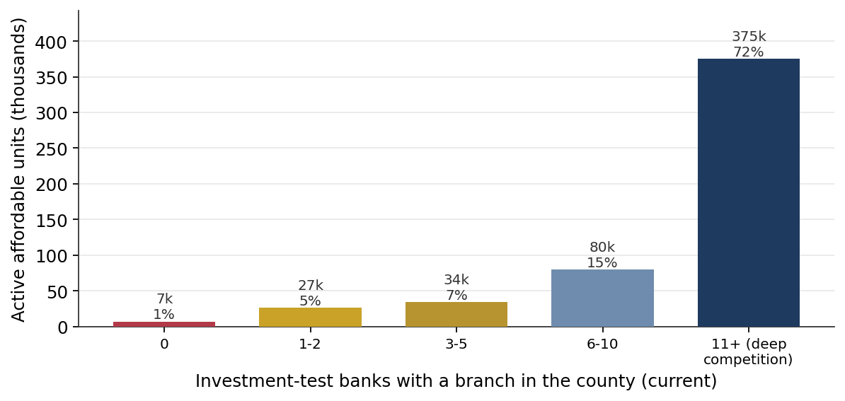
Source: HUD National LIHTC Database, FDIC institution and branch data, authors' calculations.

The proposal thins the buyer pool across the region
Counting the banks large enough to face the CRA investment test, and mapping where they have branches, gives a picture of buyer competition county by county. The metropolitan counties carry deep competition, with dozens of investment-test banks; the rural counties carry one or two, or none. Raising the large-bank threshold to 10 billion dollars removes the test from the mid-size tier and thins that competition everywhere, cutting the typical county from three investment-test banks to two.
Figure 2. Investment-test banks with a branch in the county, Sixth District, current.
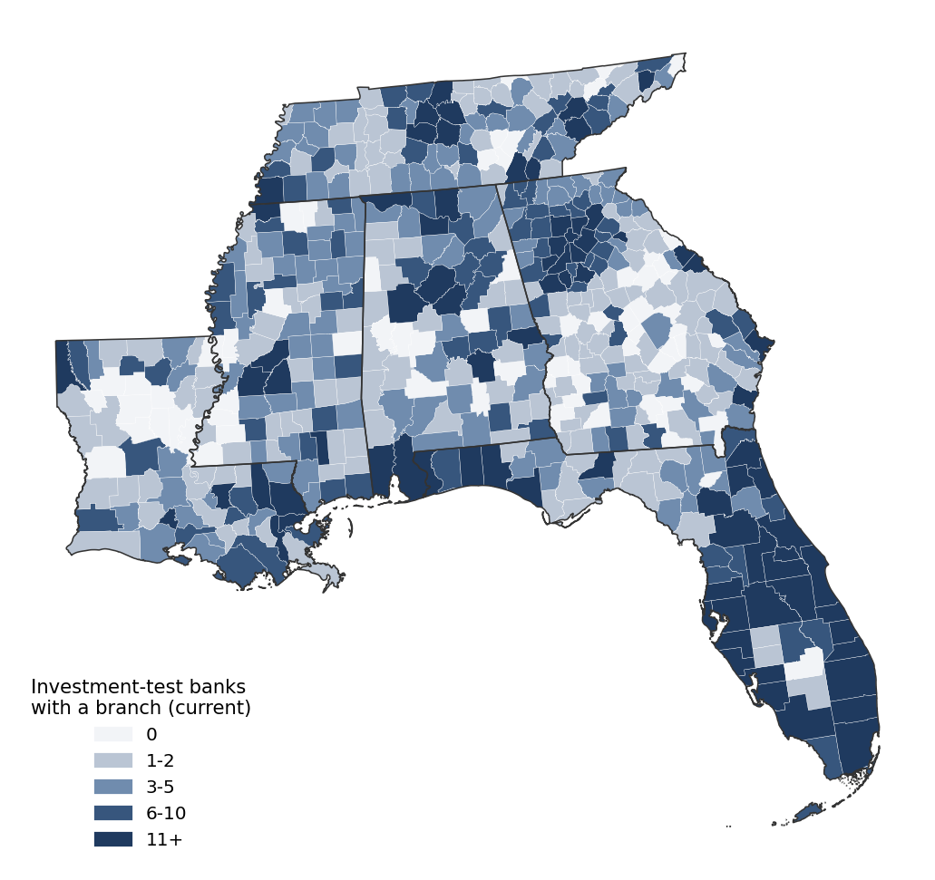
Source: HUD National LIHTC Database, FDIC institution and branch data, authors' calculations.

Forty-six counties would lose their only local investment-test buyer
The sharpest effect is at the thin end. In 46 Sixth District counties, the only banks large enough to face the investment test today are in the 1.649-billion-to-10-billion-dollar tier, so raising the threshold removes all of them and leaves the county with no locally present investment-test bank. A further 66 counties already have none. Together, 112 counties, about one in five in the region, would have no local CRA-motivated buyer for a housing-credit deal. These counties hold few existing units, about 7,000, but they are where a new 9-percent rural deal, or the resyndication of an expiring rural property from the preservation wave in Update 5, would have no local buyer and would depend on out-of-area or non-CRA capital.
Figure 3. Sixth District counties by local investment-test bank status after the proposed rule.
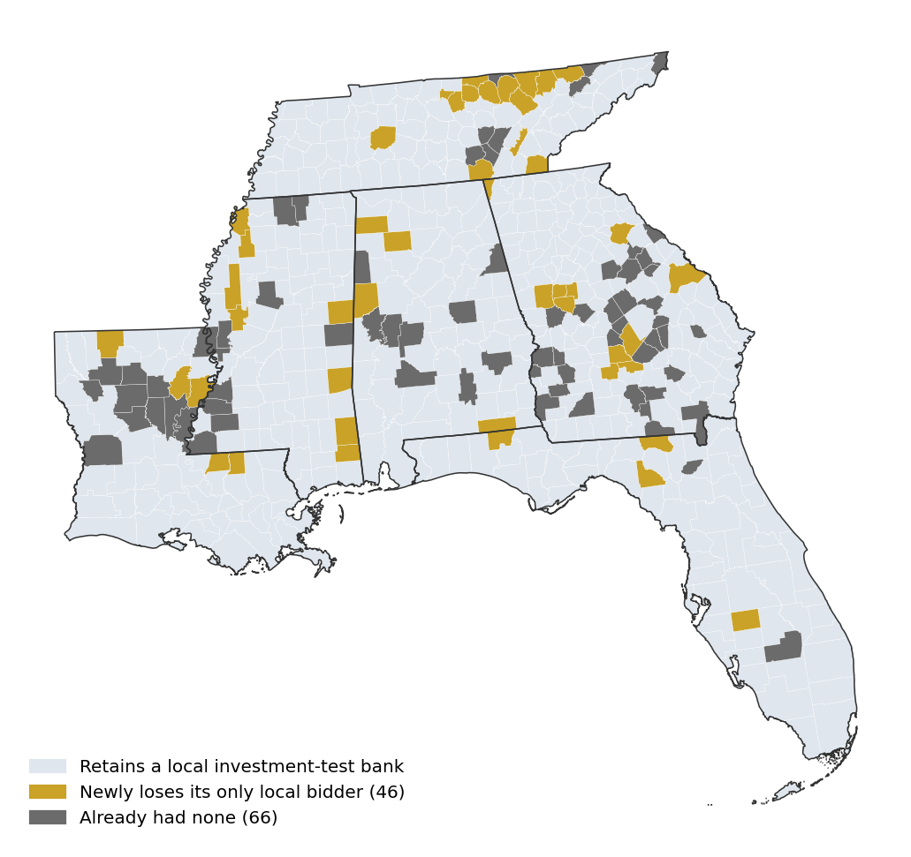
Source: HUD National LIHTC Database, FDIC institution and branch data, authors' calculations.

The banks at risk are the region's mid-size regionals
The banks that would lose the investment test are the region's mid-size regional institutions, not the money-center investors that write the largest checks. Fifty-three banks headquartered in the six states hold between 1.649 billion and 10 billion dollars in assets, led by Florida and Tennessee with fourteen each, and 45 of them are supervised by the OCC or the FDIC and therefore directly covered by this proposal. The 17 Sixth District banks above 10 billion dollars keep the test. Nationally the pattern is the same: 524 banks sit in the affected tier, about 411 of them OCC- or FDIC-supervised, while only about 161 large banks above 10 billion dollars retain the investment test. One provision of the proposal runs the other way, allowing a bank to earn community-development credit outside its assessment areas once it has met needs inside them, which could send larger investors toward the same thin markets that are losing local bidders.
Figure 4. Banks headquartered in each Sixth District state with 1.649 billion to 10 billion dollars in assets, the tier that would lose the CRA investment test.
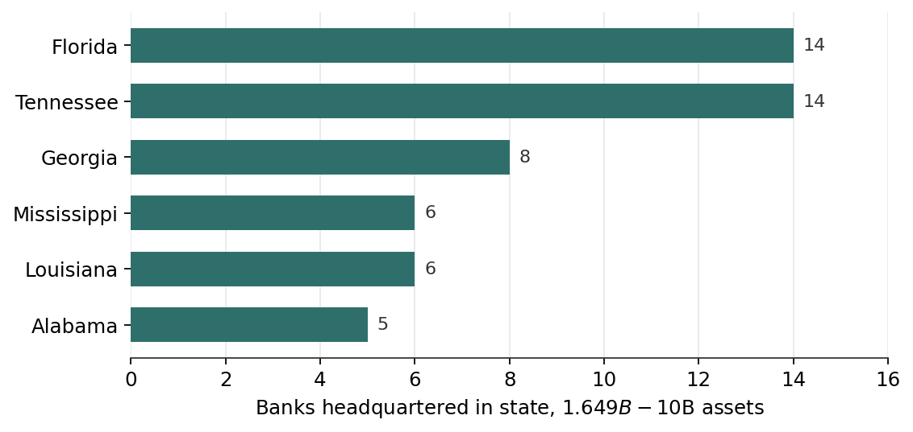
Source: HUD National LIHTC Database, FDIC institution and branch data, authors' calculations.
Table 1. Banks headquartered in each Sixth District state, by asset tier.
State | Community  (< $1.649B) | At-risk  ($1.649B-$10B) | Large  (> $10B) | At-risk  assets ($B) | Median  size ($B)
Florida | 62 | 14 | 7 | 55.4 | 3.25
Tennessee | 92 | 14 | 3 | 39.1 | 2.27
Georgia | 113 | 8 | 1 | 31.5 | 3.44
Louisiana | 97 | 6 | 1 | 27.4 | 3.85
Mississippi | 48 | 6 | 3 | 24.4 | 3.19
Alabama | 86 | 5 | 2 | 15.0 | 2.94
Sixth District | 498 | 53 | 17 | 192.9 | 3.22
Source: FDIC institution data, authors' calculations. Community banks (under 1.649 billion dollars) never faced the CRA investment test; at-risk banks (1.649 to 10 billion) would lose it under the proposal; large banks (over 10 billion) keep it. Assets and median size are for the at-risk tier.

The pattern is national, and the Southeast is more exposed than average
The same phenomenon appears across the country. Nationally, 443 counties would lose their only local investment-test bank, and 816, about one in four counties with any bank branch, would have none. The losses concentrate in the rural Great Plains, Midwest, and Appalachia: Illinois, Texas, Kentucky, Nebraska, and Iowa each contain 30 to 42 such counties. As in the Sixth District, the national unit exposure is small, about 1.7 percent of income-restricted units in counties that would have no local buyer, because the credit concentrates in metropolitan markets everywhere.
The Sixth District's place in that national picture is the reason to watch it closely. The region holds about 17 percent of the nation's income-restricted units, and a higher share of them, 2.7 percent against the national 1.7 percent, sit in counties that would have no local investment-test buyer. That gap reflects the region's greater rural and micropolitan reach documented in Update 1: the Southeast builds more affordable housing in thin markets than the nation does, so a rule that thins those markets' buyer pools reaches more of the region's stock. The district-level concern is one instance of a national rural pattern, and the region carries more of that exposure than the national average.
Figure 5. Counties by local investment-test bank status after the proposed rule, contiguous United States.
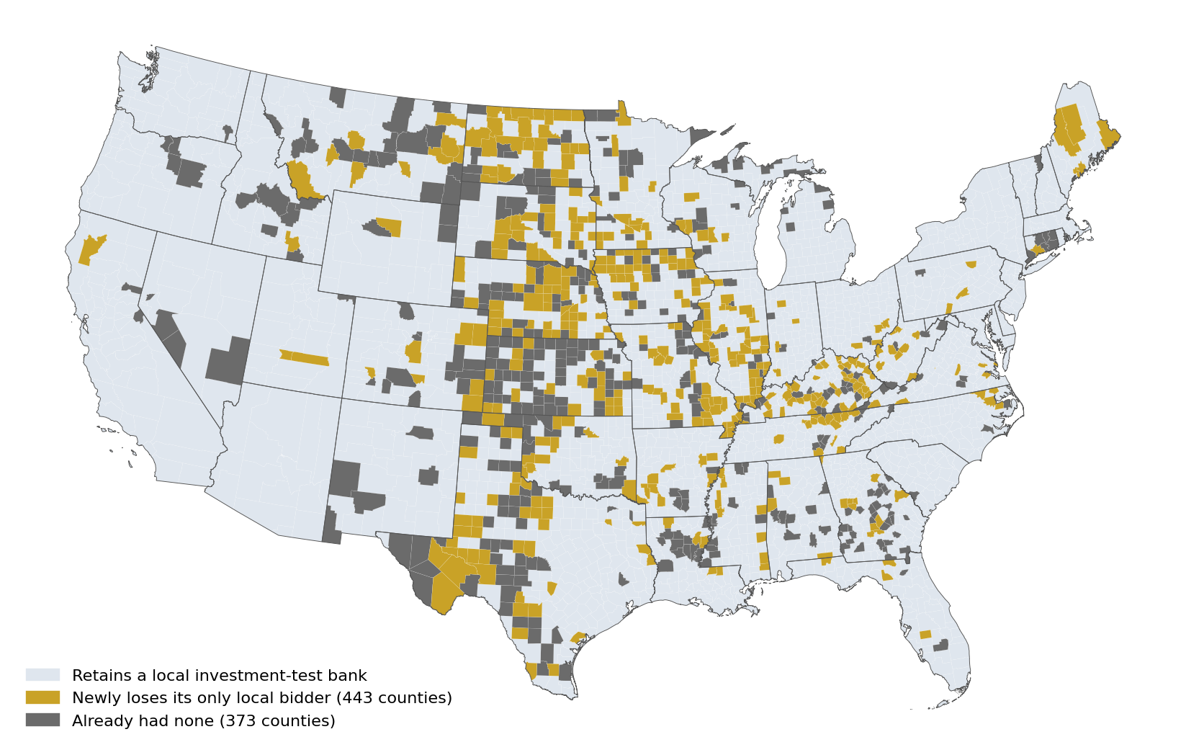
Source: HUD National LIHTC Database, FDIC institution and branch data, authors' calculations.
Table 2. Most exposed counties nationally: no local investment-test buyer and the largest income-restricted stock.
County | State | Bank status | Income-restricted units
Burke | GA | Newly lost | 612
Montgomery | KS | Newly lost | 562
Tunica | MS | Newly lost | 516
Sunflower | MS | Newly lost | 504
Vernon | LA | Already none | 470
Whitley | KY | Newly lost | 458
Lee | AR | Already none | 446
Miami | KS | Newly lost | 414
Phillips | AR | Newly lost | 379
Ben Hill | GA | Newly lost | 377
Dunklin | MO | Newly lost | 373
Pike | OH | Newly lost | 372
Grayson | KY | Already none | 367
Mitchell | GA | Already none | 344
Sagadahoc | ME | Newly lost | 321
Source: HUD National LIHTC Database, FDIC institution and branch data, authors' calculations. Units are total placed income-restricted units; national expiration timing is not computed. Connecticut is excluded (see methods).

The double bind: expiring rural properties with no local buyer
The two preceding analyses meet on the ground in a small set of rural properties. Overlaying the counties that would lose their only local investment-test bank on the near-term expiration map from Update 5 identifies the developments that face both an expiring affordability restriction and no locally present bank to buy the credits that would resyndicate them. In the 46 counties that newly lose their only local bidder, 88 developments holding about 3,490 income-restricted units reach scheduled expiration between 2025 and 2044. Across all 112 counties that would have no local investment-test bank, the figure is 182 developments and about 6,900 units.
These are small rural properties, most under 100 units, clustered in the Mississippi Delta, rural East Tennessee, and central and eastern Georgia. They include developments such as Shady Lane in Robinsonville and Beechlane in Belzoni, Mississippi; LaFollette Estates in East Tennessee; and Bridgecreek in Fitzgerald and Burkestone Place in Waynesboro, Georgia. Each reaches the end of its restriction in a county where, after the proposal, no bank large enough to face the CRA investment test operates a branch. Preserving them would require a buyer from outside the county, a mission-driven owner, or the out-of-assessment-area investment the proposal would newly permit, and their small scale places most of them in the catalytic-capital and community-development-finance segment identified in Update 5 rather than the bank-financeable one.
Figure 6. Developments reaching scheduled expiration in 2025-2044 located in counties that would have no local investment-test bank, Sixth District.
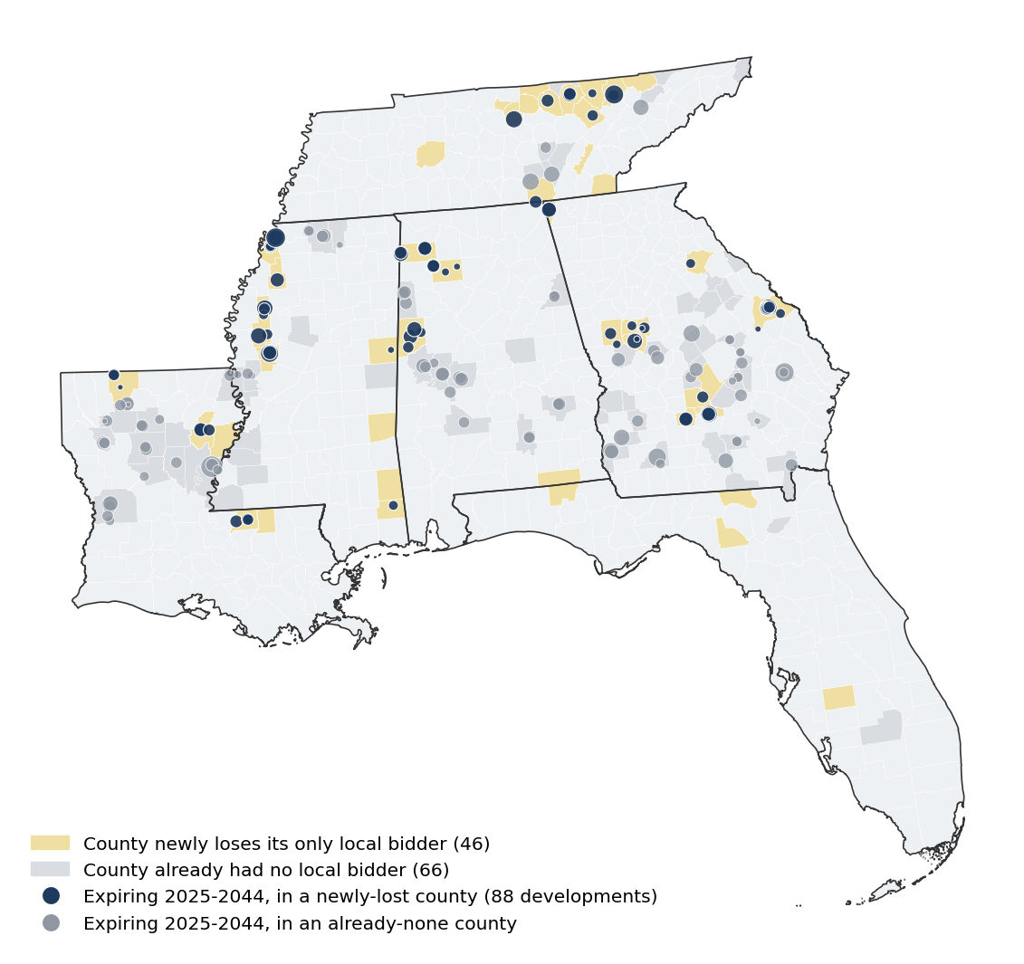
Source: HUD National LIHTC Database, FDIC institution and branch data, authors' calculations.
Table 3. Most exposed Sixth District counties: no local investment-test buyer and the largest near-term expiring stock.
County | State | Bank status | Expiring units | Developments
Tunica | MS | Newly lost | 437 | 11
Burke | GA | Newly lost | 379 | 10
Winston | AL | Newly lost | 236 | 7
Franklin | AL | Newly lost | 233 | 5
Ben Hill | GA | Newly lost | 223 | 4
Vernon | LA | Already none | 222 | 6
Sunflower | MS | Newly lost | 219 | 5
Concordia | LA | Already none | 214 | 4
Hale | AL | Already none | 183 | 5
Bienville | LA | Already none | 175 | 7
Humphreys | MS | Newly lost | 174 | 3
Pickens | AL | Newly lost | 166 | 4
Source: HUD National LIHTC Database, FDIC institution and branch data, authors' calculations. Units reach scheduled expiration, 2025-2044. The full set of 73 such counties appears in Table 4.

What this means for partners
The proposal does not ban bank investment in housing credits; it removes the primary CRA reason for a large group of mid-size banks to make it. The corrected picture sharpens the concern in three ways. First, the near-term effect on the existing stock and on national pricing is modest, because most units sit in metropolitan counties that keep their large-bank buyers. Second, the real exposure is prospective and rural: 112 Sixth District counties would have no locally present investment-test buyer, so new production and the preservation of thin-market stock in those places would depend on capital from outside the county. Third, the region's own geography raises the stakes, because the Southeast reaches rural and micropolitan markets more fully than the nation does, as Update 1 showed, and those are the markets with the thinnest buyer pools. The out-of-assessment-area provision is the offset to watch, and the comment period is where the housing sector can make the rural-buyer concern part of the record.

Data and methods
Bank data are drawn from current FDIC institution data, for asset size, and FDIC branch-location data, for geography. A bank is treated as an investment-test bank if its total assets exceed the current large-bank threshold of 1.649 billion dollars; under the proposal that threshold rises to 10 billion dollars. A bank's assessment area is proxied by the counties in which it operates a branch, the standard approach in this literature; actual assessment areas may extend to surrounding counties, so the county counts are a conservative measure of coverage. A county is counted as losing its only local bidder when it has at least one investment-test bank today and all of them fall in the 1.649-billion-to-10-billion-dollar tier. The proposal is supervised by the OCC and the FDIC and was not joined by the Federal Reserve, so Fed-supervised banks, about 113 of the 524 in the affected tier nationally, are not directly covered.
LIHTC exposure uses the HUD National LIHTC Database for the six Sixth District states, with the Florida fifty-year affordability correction described in Update 5, and joins developments to counties by 2020 county FIPS code. Branch presence is a proxy for the ability to earn CRA credit, not a guarantee that a given bank will invest in a given county; large banks satisfy their obligations across many markets, and the proposed out-of-assessment-area provision would further loosen the link between branch geography and investment. The bank figures reflect FDIC data current as of retrieval.
Table 4. All no-buyer Sixth District counties with near-term expiring stock, 2025-2044.
County | State | Bank status | Expiring units | Developments
Tunica | MS | Newly lost | 437 | 11
Burke | GA | Newly lost | 379 | 10
Winston | AL | Newly lost | 236 | 7
Franklin | AL | Newly lost | 233 | 5
Ben Hill | GA | Newly lost | 223 | 4
Vernon | LA | Already none | 222 | 6
Sunflower | MS | Newly lost | 219 | 5
Concordia | LA | Already none | 214 | 4
Hale | AL | Already none | 183 | 5
Bienville | LA | Already none | 175 | 7
Humphreys | MS | Newly lost | 174 | 3
Pickens | AL | Newly lost | 166 | 4
Turner | GA | Newly lost | 166 | 4
Franklin | LA | Newly lost | 162 | 4
Perry | AL | Already none | 153 | 4
Marshall | MS | Already none | 147 | 4
Lamar | AL | Already none | 144 | 4
Jackson | LA | Already none | 128 | 4
Campbell | TN | Newly lost | 120 | 2
Early | GA | Already none | 115 | 2
Evans | GA | Already none | 112 | 2
Red River | LA | Already none | 112 | 3
East Feliciana | LA | Newly lost | 104 | 3
Mitchell | GA | Already none | 104 | 2
Bullock | AL | Already none | 104 | 3
Dade | GA | Newly lost | 103 | 2
Upson | GA | Newly lost | 97 | 3
Johnson | GA | Already none | 90 | 4
Fentress | TN | Newly lost | 90 | 2
Greene | AL | Already none | 88 | 2
Crawford | GA | Already none | 87 | 2
Smith | TN | Newly lost | 72 | 1
Crenshaw | AL | Already none | 72 | 2
Wilkinson | GA | Already none | 72 | 1
Grundy | TN | Already none | 72 | 1
Claiborne | LA | Newly lost | 72 | 3
Winn | LA | Already none | 72 | 2
Calhoun | GA | Already none | 66 | 1
Sequatchie | TN | Already none | 64 | 1
Wheeler | GA | Already none | 64 | 3
Grainger | TN | Already none | 64 | 1
Lanier | GA | Already none | 58 | 1
Cleburne | AL | Already none | 56 | 2
Meriwether | GA | Newly lost | 54 | 2
Atkinson | GA | Already none | 51 | 2
Quitman | MS | Newly lost | 50 | 1
Bleckley | GA | Already none | 48 | 1
Talbot | GA | Already none | 48 | 1
Sharkey | MS | Already none | 47 | 2
Lamar | GA | Newly lost | 42 | 2
Overton | TN | Newly lost | 41 | 1
Marion | TN | Newly lost | 40 | 1
Telfair | GA | Already none | 39 | 1
Charlton | GA | Already none | 39 | 1
Treutlen | GA | Already none | 36 | 1
Terrell | GA | Already none | 36 | 1
Wilcox | GA | Newly lost | 36 | 1
Van Buren | TN | Already none | 32 | 1
Morgan | TN | Newly lost | 32 | 1
LaSalle | LA | Already none | 32 | 1
East Carroll | LA | Already none | 32 | 1
Wilcox | AL | Already none | 32 | 1
Pulaski | GA | Already none | 32 | 1
Pike | GA | Newly lost | 24 | 1
Oglethorpe | GA | Newly lost | 24 | 1
George | MS | Newly lost | 24 | 1
Grant | LA | Already none | 24 | 1
Scott | TN | Newly lost | 20 | 1
Issaquena | MS | Already none | 16 | 1
Benton | MS | Already none | 12 | 1
Noxubee | MS | Newly lost | 12 | 1
Bacon | GA | Already none | 11 | 1
Catahoula | LA | Already none | 10 | 1
Source: HUD National LIHTC Database, FDIC institution and branch data, authors' calculations.

