PARTNERS UPDATE | COMMUNITY AND ECONOMIC DEVELOPMENT
Where Does Southeastern LIHTC Build, and What Does It Build?
How much the credit builds across the Southeast, where it lands, what kind of housing it produces, and how the newest developments differ from the long-run record.

Since 2008 the Low-Income Housing Tax Credit has financed about 240,000 units in roughly 2,700 developments¹ across the six Southeastern states. Where they landed departs from the national pattern. Nationally the credit concentrates in large metros; in the Southeast it reaches micropolitan and rural areas more fully and builds most intensively in mid-sized markets rather than the largest.
Behind those units is a flow of federal tax-credit authority. Across the developments that record an allocation amount, Southeastern projects placed in service from 1987 through 2024 were awarded about 2.66 billion dollars in annual credit, roughly 12 percent of the 21.5 billion dollars recorded nationally. Each annual award is claimed for ten years, putting the regional total on the order of 27 billion dollars in ten-year credit value. These totals cover only the records that report an amount, about six in ten regionally, so they understate the full flow.

Florida and Georgia lead by volume, but less populous states lead per resident
Florida and Georgia together account for more than half the region's units, followed by Tennessee, Louisiana, Mississippi, and Alabama. Counting by population reorders that ranking. Measured as units per 100,000 residents, Mississippi and Louisiana stand highest, at 698 and 648. Florida, despite the largest total, sits at 335 because of its large population, and Alabama is lowest on both counts, at 210. A state can lead on volume and trail on production per resident, and the two readings answer different questions.
Table 1. LIHTC production and project characteristics, Southeastern states, 2008-2024.
State | Projects | Units | Low-income units | Units / 100k | Avg. size | 9% credit | New constr. | In QCT
Florida | 656 | 72,237 | 69,926 | 335 | 110 | 45% | 52% | 48%
Georgia | 751 | 66,896 | 64,353 | 625 | 89 | 35% | 59% | 35%
Tennessee | 433 | 40,149 | 39,999 | 581 | 93 | 50% | 50% | 39%
Louisiana | 424 | 30,163 | 25,944 | 648 | 71 | 28% | 54% | 47%
Mississippi | 309 | 20,684 | 20,325 | 698 | 67 | 74% | 47% | 40%
Alabama | 162 | 10,570 | 10,527 | 210 | 65 | 65% | 61% | 29%
Southeastern total | 2,735 | 240,699 | 231,074 | 465 | 88 | 47% | 54% | 40%
Source: HUD National LIHTC Database, authors' calculations.

The credit reaches micropolitan areas more intensively than metros, unlike the national pattern
Nationally the credit concentrates in metropolitan areas, at about 529 units per 100,000 residents against 394 in micropolitan areas and 241 in rural counties outside any core-based statistical area. The Southeast departs from that pattern. Micropolitan areas keep pace with metros, at roughly 479 and 457 units per 100,000, so the region's micropolitan rate edges above its metropolitan one². Rural counties record 366, below both, but well above the national rural rate of 241. Credit-financed housing reaches the region's smaller cities and towns, and its rural counties, more fully than the national pattern.
Figure 1. LIHTC units per 100,000 residents by place type, United States, 2008-2024.
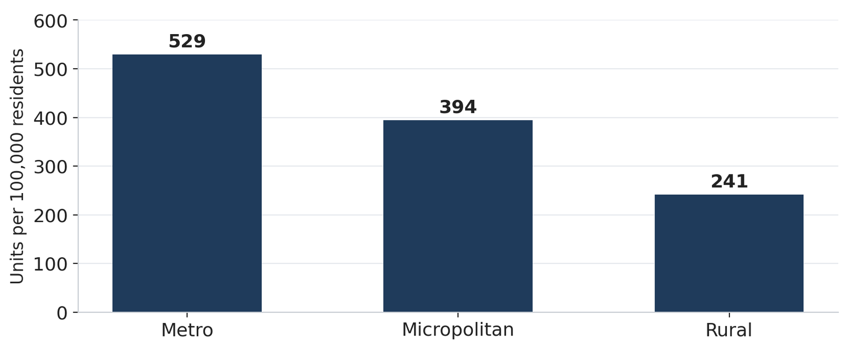
Source: HUD National LIHTC Database, 2020 Census, authors' calculations.
Figure 2. LIHTC units per 100,000 residents by place type, Southeast and United States, 2008-2024.
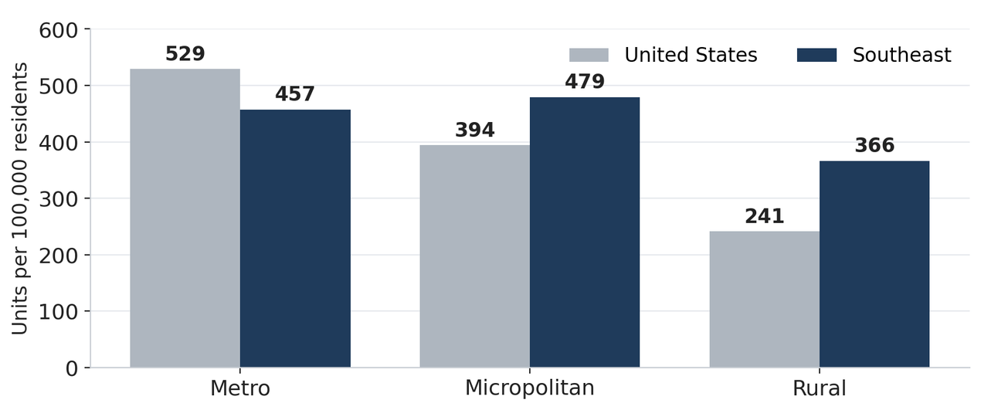
Source: HUD National LIHTC Database, 2020 Census, authors' calculations.

Among metros, the largest markets lead per resident, but mid-sized markets lead per renter
Affordable homes for the lowest-income renters are in short supply across the region: nationally only about 35 affordable and available rental homes exist for every 100 extremely low-income renter households, and no Southeastern state or metropolitan area has an adequate supply³. Ranking the region's metropolitan areas by renter households, the population the credit serves, orders the largest rental markets first: the Miami, Atlanta, Tampa, and Orlando areas lead on renter households, followed by the Nashville and New Orleans areas. Measuring production against that base two ways, units per 100,000 residents and units per 1,000 renter households, reorders them⁴. On a per-renter-household basis, the base closer to rental demand, mid-sized markets lead: ranked by units per 1,000 renter households, the New Orleans area leads at 72.3, the Nashville area at 57.0, and the Knoxville area at 54.6, while the largest renter markets fall near the middle, Miami at 32.3 and Tampa about 25.7. Atlanta is the exception among the large markets, at 43.4, and Birmingham records the lowest rate, at 8.8.
Three mid-sized markets, not the largest ones, produce most intensively. Ranked by units per 1,000 renter households, the New Orleans area leads at about 72, followed by the Nashville area at about 57 and the Knoxville area at about 55, roughly double the rates of the large Florida metros. The New Orleans figure reflects concentrated post-Katrina rebuilding; the Nashville figure coincides with rapid population growth over the period. By contrast, the four largest rental markets fall near the middle of the distribution: Miami records about 32 units per 1,000 renter households and Tampa about 26. Atlanta is the exception among the large markets, ranking fourth on intensity at about 43. The Birmingham area records the lowest rate, under 9, less than a fifth of the leading rate.
Production intensity varies about eightfold across these metros per renter household, and about tenfold per resident, from the Birmingham area to the New Orleans area. For practitioners, the ranking separates two considerations that unit totals combine: where renter households are concentrated, and where production is most intensive relative to that base.
Figure 3a. Metropolitan areas ranked by renter households: LIHTC units per 100,000 residents and per 1,000 renter households, Southeastern states, 2008-2024.
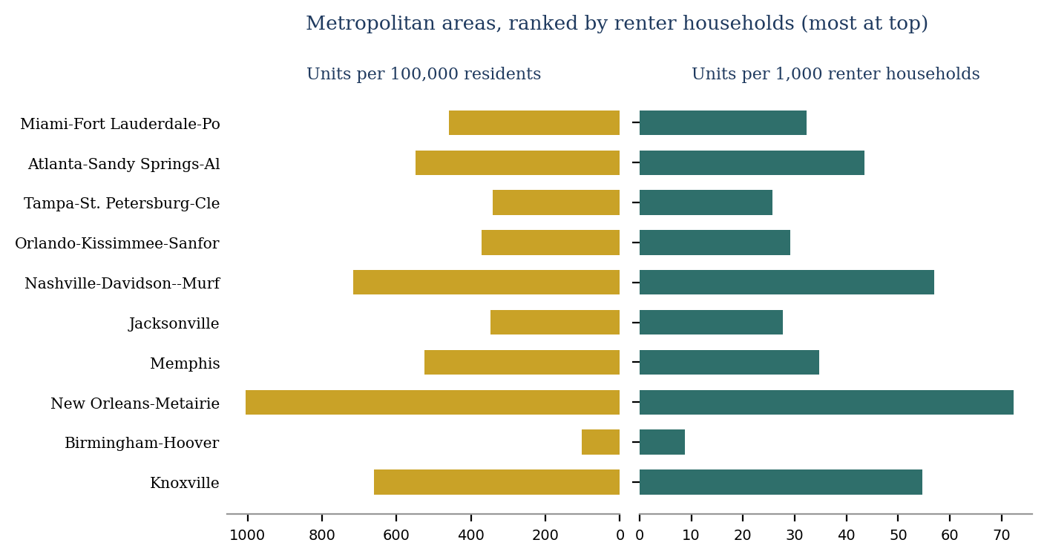
Source: HUD National LIHTC Database, 2020 Census, authors' calculations.

Small markets often reach renters as intensively as the metros do
The same reading applied to the region's micropolitan areas, ranked by renter households, shows comparable agreement between the two denominators, with a few larger exceptions. Tupelo and Meridian, Mississippi, and LaGrange, Georgia, rank near the top on renter households. The two per-capita measures again order the areas similarly, so the micropolitan parity noted earlier holds under either denominator⁴. The renter-based measure mainly sharpens where production is dense relative to the renter base.
Several small markets produce at rates that rival or exceed the region's metros. LaGrange records about 847 units per 100,000 residents and Key West about 968, both above every metro except New Orleans, consistent with the micropolitan parity described earlier. The tourism-oriented areas of Key West and Sevierville record high rates per renter household, near 60 units per 1,000, above what their per-resident rates alone would indicate, because a large share of their housing is renter-occupied and the resident base is small. Tupelo and Sevierville also rank near the top on the renter measure.
The spread among micropolitan areas is narrower than among metros but remains wide, about sevenfold on the per-resident measure and fourfold per renter household. Albertville, Alabama, records the lowest rate, about 15 units per 1,000 renter households. For practitioners, the pattern indicates that the region's strongest per-capita production extends beyond its cities: a set of small Mississippi, Georgia, and Tennessee markets reaches its renters as intensively as the metros do, and in several cases more so.
Figure 3b. Micropolitan areas ranked by renter households: LIHTC units per 100,000 residents and per 1,000 renter households, Southeastern states, 2008-2024.
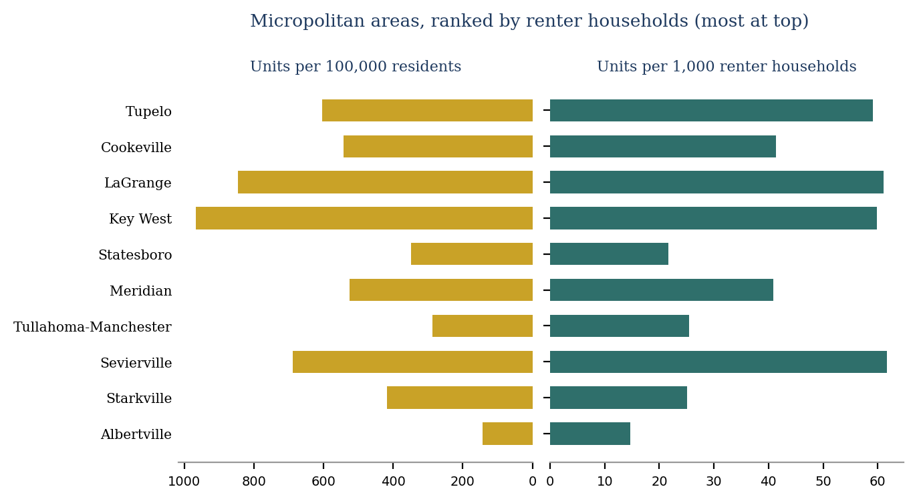
Source: HUD National LIHTC Database, 2020 Census, authors' calculations.

Gulf Coast disaster recovery still shapes the region's production geography
Part of why Mississippi and Louisiana lead on production per resident traces to a single policy episode. After Hurricanes Katrina and Rita in 2005, the Gulf Opportunity Zone Act raised housing-credit authority in the hardest-hit areas of Alabama, Louisiana, and Mississippi. For 2006 through 2008 it added up to $18.00 for each resident of the affected zone, against a normal state ceiling near $1.90 per resident. It also designated the zone a Difficult Development Area, which further raised the credit available there. Developments carrying the Gulf Opportunity Zone designation account for about 13,700 total units in Louisiana and 9,200 in Mississippi. Two decades later, per-resident rates in several of the region's Gulf Coast markets remain above the regional average.
HUD records the designation on each affected development, so the episode can be read directly. Across Alabama, Louisiana, and Mississippi the designated developments carry 26,118 total units, all placed in service between 2006 and 2010. They account for 78 percent of the three states' production in the 2008 peak. Annual production in those states averaged about 4,400 units from 2000 to 2005, about 9,600 from 2007 to 2009, and about 3,200 from 2011 to 2016, so output settled below its pre-designation level once the window closed. No units carry the designation after 2010, so what persists is the accumulated stock rather than continuing production.
Figure 4. Total units placed in service in Alabama, Louisiana, and Mississippi, by Gulf Opportunity Zone designation, 2000-2024.

Source: HUD National LIHTC Database, authors' calculations. Counts are total units, matching the other production figures. Designated units are those HUD codes as being in a metropolitan or non-metropolitan Gulf Opportunity Zone difficult development area. Units appear in the year placed in service, which lags allocation. The window is 2000 to 2024 rather than the 2008 to 2024 window used elsewhere for production, because the episode requires a pre-designation baseline. The figure covers the three states of the Katrina Gulf Opportunity Zone. Florida holds a further 9,858 designated total units under the Wilma zone, which received the difficult development area treatment but not the per-resident credit ceiling increase, and is excluded on that basis; see the note.

Mostly family housing, though less so in the newest cohort
Family housing is the larger share in the region and the nation, but the regional tilt is stronger: about 77 percent of Southeastern units are family housing against 62 percent nationally, with a correspondingly smaller elderly share, near 12 against 27 percent.
Figure 5. Target population of LIHTC units, Southeast and United States, 1987-2024.
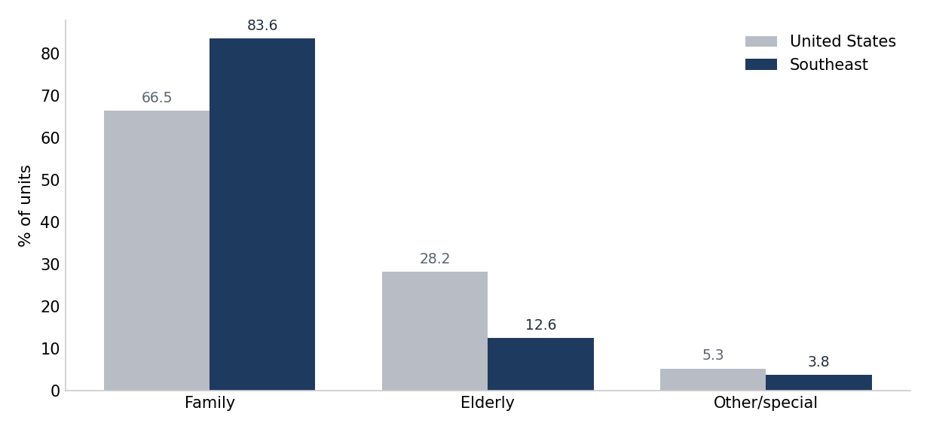
Source: HUD National LIHTC Database, authors' calculations.
That reading pools nearly four decades, and the family tilt is a feature of the accumulated stock rather than a fixed regional trait. Family housing carried 74 to 85 percent of Southeastern units in every cohort placed in service through 2015-2019, above the national share throughout. In the 2020-2024 cohort it falls to 56 percent, below the national 60 percent for the first time in the series. The elderly share rises to 19 percent, and other targeted populations, including developments serving disabled and homeless residents, reach 25 percent of regional units against 17 percent nationally. On these three categories the regional and national shares are closer in the 2020-2024 cohort than in any earlier cohort.
Figure 6. Target population by placed-in-service cohort, share of units reporting a target population, Southeast and United States, 1987-2024.

Source: HUD National LIHTC Database, authors' calculations. Units in developments that record no target population are excluded; the target-population fields began with the 2003 properties, so the excluded share is largest in the earliest cohorts. Shares are of income-restricted units in developments that record the characteristic; the excluded share is given above. Comparisons between the region and the nation assume that non-reporting is unrelated to the characteristic being measured. Panel scales differ; read each panel against its own axis.

Sixty percent of area median income dominates, with income averaging rising in the newest cohort
On depth of affordability, almost all units in developments that record an income ceiling sit at the lower 50 or 60 percent of area median income thresholds that set the deepest rents, in the region as in the nation. The 60 percent ceiling carries 92 percent of reporting units in the region against 89 percent nationally, and income averaging, which blends deeper and shallower units, remains a small and recent share at 6 percent regionally. Developments that record no ceiling are excluded from the figure rather than shown as a category, and the note reports how large that group is.
Figure 7. Income ceiling of LIHTC units, share of units reporting a ceiling, Southeast and United States, 1987-2024.

Source: HUD National LIHTC Database, authors' calculations.
The cohort view shows how recently income averaging arrived. Income averaging accounts for 25 percent of reporting units placed in service in the region in 2020-2024, ahead of the 21 percent national share, having been unavailable before 2018. The 60 percent ceiling absorbs the shift, falling from 91 percent of reporting units in 2015-2019 to 75 percent in 2020-2024, close to the national 75 percent. The 50 percent ceiling, consistently the smaller of the two deep-rent options in the region, falls below 1 percent of reporting units in the newest cohort against 4 percent nationally.
Figure 8. Income ceiling by placed-in-service cohort, share of units reporting a ceiling, Southeast and United States, 1987-2024.

Source: HUD National LIHTC Database, authors' calculations. Units with no recorded ceiling are excluded: 73.1 percent of Southeastern units in the 1987-1994 cohort, 51.3 percent in 2010-2014, and 3.4 percent in 2020-2024, against 70.3, 23.3, and 6.5 percent nationally. The field began with the 2006 properties. Shares are of income-restricted units in developments that record the characteristic; the excluded share is given above. Comparisons between the region and the nation assume that non-reporting is unrelated to the characteristic being measured. Panel scales differ; read each panel against its own axis.

Mostly new construction, in wider swings than the pooled figure shows
New construction carries roughly six to seven in ten units that record a construction type in each place type, rising to about seven in ten in metropolitan areas, with acquisition and rehabilitation, the program's preservation side, making up most of the rest. The mix moves modestly across markets: new construction is 73 percent of recording units in metropolitan areas, 62 percent in micropolitan areas, and 64 percent in rural counties.
Figure 9. Construction type by place type, share of units recording a type, Southeast, 1987-2024.

Source: HUD National LIHTC Database, authors' calculations. Shares are of income-restricted units in developments that record a construction type. Units with no recorded type are excluded: 13.9 percent in metropolitan areas, 6.3 percent in micropolitan areas, and 8.2 percent in rural counties. Place type is assigned by county under the OMB March 2020 delineation; records without 2020 county geography, 11.4 percent of regional income-restricted units, are excluded from this figure.
Stability across place types does not carry over to stability across time. Regional new construction rose to 87 percent of reporting units in the 2000-2004 cohort, fell to 52 percent in 2015-2019 as acquisition and rehabilitation climbed to 46 percent, and returned to 64 percent in 2020-2024. The national series turns in the same direction in the most recent cohort, to 68 percent. Across cohorts the regional new-construction share spans about 35 percentage points.
Figure 10. Construction type by placed-in-service cohort, share of units recording a type, Southeast and United States, 1987-2024.

Source: HUD National LIHTC Database, authors' calculations. Units with no recorded construction type are excluded; the excluded share runs from 4.1 to 26.0 percent of regional units across cohorts and 8.0 to 19.0 percent nationally. Shares are of income-restricted units in developments that record the characteristic; the excluded share is given above. Comparisons between the region and the nation assume that non-reporting is unrelated to the characteristic being measured. Panel scales differ; read each panel against its own axis.
Which places lead depends on the measure: ranked by units, Southeastern production concentrates in the large states and metros; measured per resident or per renter household, it spreads to smaller ones. The accumulated stock is mostly family housing at a 60 percent ceiling and newly built, though recent developments carry a narrower family share and more income averaging. The companion updates build on these measures, turning to how the developments are financed and how the terms of the deal have changed; as the 2025 law takes effect, its regional imprint will register first against them.
Data and methods
Figures are from the HUD National LIHTC Database, with population denominators from the 2020 Census. Production and geographic figures cover projects placed in service 2008 to 2024 in the six Southeastern states; the composition figures are cumulative, 1987 to 2024. Production and geographic figures count total units in credit-financed developments, matching the unrestricted population denominators they are set against. Composition figures count income-restricted units, because the characteristics measured are properties of restricted units. Table 1 reports both counts, with the income-restricted total in the low-income units column, taken from HUD's reconciled low-income unit field. Place type is assigned to each project by its county using the OMB March 2020 delineation: a county in a Metropolitan Statistical Area is metropolitan, one in a Micropolitan Statistical Area is micropolitan, and one in neither is rural. Metropolitan and micropolitan areas are ranked by total units, with per-resident rates shown alongside. The Gulf Opportunity Zone discussion draws on the Gulf Opportunity Zone Act of 2005⁵ and published estimates of credit-financed reconstruction. Each composition characteristic is shown twice: a pooled figure covering 1987 to 2024 and a cohort figure grouping projects into a 1987-1994 band and five-year placed-in-service bands thereafter. All three composition characteristics, target population, income ceiling, and construction type, are computed on a reporting base. Conventions common to the series: figures count income-restricted units unless stated otherwise; records coded 8888 or 9999 in the placed-in-service field, 2,765 records and 225,252 units nationally, are excluded from all year-based figures, and only 254 of those records fall in the region, so the exclusion bears more on the national series than the regional one; Puerto Rico and other territories, 0.69 percent of national units, are excluded from the national series, so that the place-type numerators cover the same universe as the population denominators, which are drawn from the fifty states and the District of Columbia and contain no territories; and any characteristic with material non-reporting is shown on a reporting base, with the excluded share given in the figure note. Regional-to-national comparisons on a reporting base assume non-reporting is unrelated to the characteristic measured, which this file cannot test, and completeness differs by geography: among regional income-restricted units, 61 percent record a target population, 51 percent an income ceiling, and 88 percent a construction type, against 58, 66, and 88 percent nationally. Place type is assigned from the March 2020 delineation for every project regardless of when it was placed in service, so a county that gained metropolitan status during the period is treated as metropolitan throughout; HUD's own metro field, measured at placed in service, will differ. Records without 2020 county geography, 11.4 percent of regional income-restricted units, are excluded from the place-type figures on both the numerator and the denominator side, for the same reason: a record with no county can be given neither a place type nor a population, so counting it on one side without the other would misstate the rate. Per-resident rates divide a 2008-2024 production flow by 2020 Census population, so rates for states that grew quickly across the window are understated relative to states that grew slowly. Within Figures 6, 8, and 10 the panels carry separate vertical scales, so panels should be read against their own axes rather than against each other. Figures 5 through 10 are native charts with their data embedded, editable in place.
By Donta Council, Community and Economic Development, Federal Reserve Bank of Atlanta.
The views expressed here are the author's and not necessarily those of the Federal Reserve Bank of Atlanta or the Federal Reserve System. Any remaining errors are the author's responsibility.
Notes
1. Production and geographic figures cover projects placed in service 2008 to 2024; composition figures are cumulative, 1987 to 2024. Data are from the U.S. Department of Housing and Urban Development, Low-Income Housing Tax Credit Property Database (projects placed in service through 2024), https://www.huduser.gov/portal/datasets/lihtc.html. For background on how the credit works and whom it serves, see Scally, Gold, and DuBois, The Low-Income Housing Tax Credit: How It Works and Who It Serves, Urban Institute, 2018.
2. A core-based statistical area (CBSA) is a county or group of counties defined by the U.S. Office of Management and Budget around an urban core: metropolitan areas have a core of at least 50,000 residents, micropolitan areas 10,000 to 50,000, and counties in neither are treated here as rural. Place type follows the March 2020 delineation, OMB Bulletin No. 20-01 (March 6, 2020), used for consistency with the population denominators; OMB Bulletin No. 23-01 has since superseded it. Population denominators are from the U.S. Census Bureau, 2020 Census resident population totals.
3. National and state estimates of affordable and available rental homes per 100 extremely low-income renter households are from National Low Income Housing Coalition, The Gap: A Shortage of Affordable Homes (2026), https://nlihc.org/gap, which draws on the American Community Survey and its Public Use Microdata Sample. Extremely low-income renters are those with incomes at or below the federal poverty guideline or 30 percent of area median income, whichever is greater. Florida, for example, records about 26 affordable and available homes per 100 such renters, and the Orlando area, at 13, is among the lowest of the fifty largest metropolitan areas.
4. Across the ten metropolitan areas the two per-capita measures are almost perfectly rank-ordered (Spearman rank correlation 1.00; linear correlation 0.99); across the ten micropolitan areas the agreement is high but weaker (Spearman 0.92; linear 0.91). Appendix Table A1 reports the coefficients and the ranked values.
5. The Gulf Opportunity Zone Act of 2005 (Pub. L. 109-135, codified at Internal Revenue Code section 1400N(c)) carried two housing-credit provisions. Under section 1400N(c)(1), the housing-credit ceiling of each state with territory in the Katrina Gulf Opportunity Zone rose for calendar years 2006 through 2008 by up to $18.00 per resident in the zone, against a regular ceiling near $1.90; under section 1400N(c)(3), the Gulf Opportunity, Rita, and Wilma zones were treated as difficult development areas, for credit amounts allocated from 2006 through 2008 and for property placed in service through December 31, 2010. Texas and Florida instead received a flat $3,500,000 ceiling addition for 2006 alone under section 1400N(c)(2). Figure 4 therefore covers Alabama, Louisiana, and Mississippi, the states that received the per-resident increase; unit counts use the HUD database's Gulf Opportunity Zone difficult development area codes. For how the affected states used this authority, see U.S. Government Accountability Office, Gulf Opportunity Zone: States Are Allocating Federal Tax Incentives to Finance Low-Income Housing and a Wide Range of Private Facilities, GAO-08-913, July 16, 2008.

