Paying for Protection: Risk Perceptions, Household Balance Sheets, and Disaster Mitigation Behavior

Dontá Council
Federal Reserve Bank of Atlanta

Author Note
Dontá Council, Federal Reserve Bank of Atlanta. Correspondence concerning this article should be addressed to Dontá Council, Federal Reserve Bank of Atlanta, 1000 Peachtree Street NE, Atlanta, GA 30309. Email: [INSERT AUTHOR EMAIL BEFORE SUBMISSION]. ORCID: [INSERT ORCID iD BEFORE SUBMISSION].
The views expressed in this paper are those of the author and do not necessarily reflect those of the Federal Reserve Bank of Atlanta or the Federal Reserve System. Any errors are the author's own.
Funding. This research received no specific grant from any funding agency in the public, commercial, or not-for-profit sectors.
Conflict of interest. The author declares no conflict of interest.
Ethics statement. This study analyzes de-identified secondary survey data that are publicly available and therefore does not constitute human subjects research requiring institutional review board approval.
Data availability statement. The data analyzed in this study are publicly available from the Board of Governors of the Federal Reserve System, Survey of Household Economics and Decisionmaking, at https://www.federalreserve.gov/consumerscommunities/shed_data.htm (dataset DOI: 10.17016/datasets.002). A replication package containing the prepared analysis dataset in Stata format and documented code reproducing every table and figure is available from the author and will be deposited in a public repository upon acceptance.
Use of artificial intelligence. The author used a large language model (Claude, Anthropic) as a drafting and editing aid during manuscript preparation and to translate analysis code between Python and Stata. All research questions, data decisions, model specifications, and interpretations are the author's own. The author verified the reported estimates against the underlying data and each citation against its published source, and takes full responsibility for the content of this manuscript.

Abstract
Households increasingly bear the cost of protecting themselves against disasters, yet research on who acts has centered on risk perception rather than on the resources that action requires. This study tests whether the form of household resources, and not only their amount, governs protective behavior: a lump-sum investment such as hardening a property should depend on assets, while insurance, paid as a recurring premium, should depend on income. Using four pooled waves of the Federal Reserve Board's Survey of Household Economics and Decisionmaking (2021 to 2024; 47,236 observations of 32,585 adults), survey-weighted logistic regression, respondent fixed-effects, and random-intercept cross-lagged panel models relate three mitigation behaviors to perceived risk, disaster experience, and four dimensions of economic position. Assets predicted property improvement and insurance purchase along a cost gradient, while across households income predicted only insurance. Perceived risk and disaster experience predicted all three behaviors, and perceived risk and mitigation moved together within households across waves, but changes in perceived risk did not precede changes in mitigation. Financially strained and indebted households reported more mitigation, not less. Because the capacity to self-protect is distributed along the lines of wealth, risk communication alone is unlikely to close gaps in household mitigation.
Keywords: disaster mitigation, risk perception, household finance, protection motivation theory, hazard adaptation, panel data

Paying for Protection: Risk Perceptions, Household Balance Sheets, and Disaster Mitigation Behavior
In the United States, the financial burden of weather-related disasters has shifted increasingly onto households themselves. The National Oceanic and Atmospheric Administration recorded 27 separate billion-dollar disasters in 2024, with total damages near 182.7 billion dollars, part of a cumulative toll exceeding 2.9 trillion dollars across more than 400 such events since 1980 (NOAA National Centers for Environmental Information, 2025). As these losses have mounted, the public programs that once absorbed much of the risk have come under strain, and a growing share of the responsibility for loss reduction now rests with individual households, who must decide 1) whether to insure, 2) whether to harden their property, and 3) whether to relocate (Kousky, 2019; Michel-Kerjan, 2010). These private decisions determine the size of aggregate losses and, just as consequentially, their distribution, since disasters and the assistance that follows them tend to widen existing wealth gaps along lines of race, education, and homeownership (Howell & Elliott, 2019). Understanding what enables a household to act, and what holds it back, is therefore central both to disaster policy and to the equity concerns that animate community and economic development.
A long line of research has asked whether perceived risk drives protective behavior, and the record is mixed enough to have earned a name. Reviews of the natural-hazards literature repeatedly find the association between perceived risk and protective action weak or inconsistent, a regularity that Wachinger et al. (2013) termed the risk perception paradox (see also Bubeck et al., 2012). The leading reconciliation holds that perceived threat translates into action only when households also believe that an effective response is available and that they can afford it, the condition that the dominant behavioral theories label coping appraisal (Grothmann & Reusswig, 2006; Lindell & Perry, 2012; Rogers, 1975). Affordability is an economic quantity, which places household economic position at the center of any adequate account of protective behavior.
Economic research on protective investment reinforces this view while complicating it. Household insurance choices depart from the predictions of expected-utility theory in both directions, with modest risks overinsured through the purchase of low deductibles priced well above expected value (Sydnor, 2010) and catastrophic risks left uninsured by many homeowners facing premiums many times the expected loss (Kousky & Cooke, 2012). Beliefs about rare events decay with time since the last event (Gallagher, 2014), and insurance and physical risk reduction undertaken in advance behave as complements rather than substitutes (Botzen et al., 2019). Underlying all of this, a large fraction of American households cannot absorb even a modest unexpected expense (Lusardi et al., 2011). That fact suggests a sharper question than the paradox alone, because affordability is not a single quantity. Income arrives as a flow across a period. Assets are a stock available for conversion at a moment. Protective investments differ in which of the two they require.
This study turns that distinction into a test. If the binding constraint were simply cost, income and assets should both rise with the expense of a behavior, since both are money. If the constraint is instead the form that resources take, the two should separate by financing structure, with assets governing the responses that convert holdings into protection and income governing the response met from a recurring premium. Four pooled waves of the Survey of Household Economics and Decisionmaking (SHED), a nationally representative survey conducted annually by the Board of Governors of the Federal Reserve System, permit that test. The SHED pairs items on disaster experience and forward-looking risk perception with an unusually detailed battery of household financial measures, allowing threat appraisal and four dimensions of economic position, namely subjective economic well-being, income, assets, and debt, to be modeled jointly across three behaviors that differ in cost: investigating other places to live, improving one's property to reduce risk, and purchasing additional insurance. Across 47,236 observations of 32,585 adults the prediction holds, and the separation is sharp. A second contribution follows from the panel structure of the survey. A random-intercept cross-lagged panel model separates stable between-household differences from within-person change, locates most of the perception and mitigation association in the former, and finds no evidence that a change in perception precedes a change in mitigation, which bears directly on risk communication, a policy instrument premised on moving a household's perception over time. Both components of threat appraisal also predict mitigation with economic capacity fully specified, a result that sits against the weak associations reported in much of the earlier literature.
Literature Review
The Rising Private Burden of Disaster Risk
The economic case for studying household mitigation begins with the scale and incidence of disaster losses. Insured and uninsured losses from weather-related disasters have risen sharply over recent decades, driven by a combination of climatic change and the accumulation of population and capital in exposed areas (Kousky, 2019; NOAA National Centers for Environmental Information, 2025). Public risk-bearing institutions have not kept pace. The National Flood Insurance Program, the principal federal vehicle for residential flood risk, has operated at a structural deficit and covers only a fraction of exposed properties, leaving most households to finance their own recovery or to rely on limited and often delayed federal assistance (Michel-Kerjan, 2010). The result is a steady transfer of risk-bearing to households, whose private decisions about insurance and physical mitigation increasingly determine both the magnitude of losses and the speed of recovery.
These private decisions also shape the distribution of wealth. Using nationally representative longitudinal data linked to county hazard damages, Howell and Elliott (2019) showed that as local hazard damages rise, so does wealth inequality, with white, more educated, and homeowning households accumulating wealth after disasters while others lose ground, and with federal assistance amplifying rather than offsetting these gaps. This finding situates household mitigation squarely within community and economic development. If the capacity to mitigate is itself distributed unequally, then private protective behavior becomes a channel through which disasters reproduce and widen existing disparities, and policies that overlook the economic preconditions of mitigation risk entrenching them.
Risk Perception and the Limits of the Motivational Hypothesis
The study of how people perceive hazards is rooted in the psychometric tradition established by Slovic (1987), which demonstrated that lay risk judgments are systematic and are shaped by qualitative features of a hazard such as dread and controllability rather than by expected losses alone. Risk perception thus came to occupy a central place in models of protective behavior, under what is sometimes called the motivational hypothesis: that higher perceived risk should motivate greater protective action. The accumulated evidence, however, has not borne out a strong version of this hypothesis. Reviewing the flood literature, Bubeck et al. (2012) found that a positive association between risk perception and mitigation behavior is rarely observed and is often absent altogether. Synthesizing across hazards, Wachinger et al. (2013) described a risk perception paradox in which households with high perceived risk, and even direct hazard experience, frequently fail to act, and they identified personal experience and trust in authorities, rather than abstract risk estimates, as the strongest correlates of perception. A meta-analysis of adaptation behavior similarly placed efficacy beliefs and social norms ahead of experience and knowledge as predictors of adaptive behavior (van Valkengoed & Steg, 2019). The collective message of this literature is that perceived risk is a necessary but insufficient condition for protective action, and that its predictive power depends on what else is brought into the analysis.
Protection Motivation Theory and Models of Protective Action
Protection motivation theory, introduced by Rogers (1975), supplies the most widely used framework for specifying those additional conditions. The theory holds that protective behavior is the joint product of threat appraisal, which combines the perceived probability and severity of a hazard, and coping appraisal, which combines the perceived efficacy of an available response, the perceived ability to perform it, and its cost. The defining prediction of the theory is conditional: high threat appraisal motivates protective action only when coping appraisal is favorable, that is, when an effective response is judged both feasible and affordable. When coping appraisal is unfavorable, households may turn to non-protective responses such as denial or fatalism, the belief that a hazard lies beyond one's control and that protective effort is therefore futile. Grothmann and Reusswig (2006) brought this structure directly into household flood mitigation, showing in a survey of flood-prone residents that a socio-psychological model incorporating coping appraisal outperformed a purely socioeconomic model and that coping appraisal distinguished households that acted from those that did not. The Protective Action Decision Model of Lindell and Perry (2012) reaches a convergent conclusion from the hazards-response tradition, positing that threat perceptions, perceptions of the protective action itself, and stakeholder perceptions jointly govern behavior, and that situational facilitators and impediments, including resource constraints, condition whether intention becomes action. Across these frameworks, the cost and feasibility of the protective response are not incidental controls but core determinants, which is precisely where household economic position enters.
Recent evidence clarifies where the theory holds and where it does not. Synthesizing 35 empirical studies published between 2017 and 2024, Ni et al. (2025) report that risk perception generally promotes household preparedness, and that perceived response efficacy does so as well, but that the direction and magnitude of these effects vary with the hazard, the specific behavior, and the resources available to the household. Two findings from national survey data bear more directly on the present design. Miao and Zhang (2023), drawing on a national survey of U.S. households, extend protection motivation theory by showing that perceived coping efficacy mediates the influence of prior experience and other drivers on preparedness, which places the coping half of the appraisal on the causal path rather than beside it. Qiu et al. (2023), analyzing 4,559 respondents to the 2021 National Household Survey, find that households caring for older, disabled, or young members and those with low capacity report lower preparedness overall, and that response efficacy matters most for the low-capacity group. A third study anticipates the present argument from a different direction. Grover et al. (2022), surveying households in four coastal communities, measured a broad set of risk-perception constructs and related them to three classes of flood hazard adjustment: emergency preparedness, nonstructural mitigation, and structural mitigation. Their risk-perception scales were significantly correlated only with nonstructural mitigation, the least resource-intensive of the three. Perception predicted the adjustments that cost little and failed to predict the ones that cost a great deal, which is the pattern a capacity constraint would produce, though their design could not test that interpretation because it did not measure household resources. All three studies measure coping capacity through perceived efficacy rather than through the resources a household actually holds. That is the measurement gap this study addresses: whether the capacity that governs costly mitigation is what households believe they can do, or what their balance sheets permit them to fund.
The Economics of Household Protective Investment
Economic research on insurance and risk reduction supplies both a theory of the protective decision and a set of stylized facts that any account must accommodate. Under expected-utility theory, a risk-averse household should insure fully against actuarially fair catastrophic risk, yet observed insurance choices depart from that benchmark in both directions. Studying homeowners' deductible decisions, Sydnor (2010) found that most customers purchase low deductibles at prices significantly above expected value, implying a level of risk aversion over modest stakes that a standard model can rationalize only with implausibly large risk parameters. Against catastrophic hazards the departure runs the other way, and many homeowners decline disaster coverage altogether. Kousky and Cooke (2012) show that this second pattern need not be irrational. Because catastrophe losses are fat-tailed and correlated across policies, solvency-constrained insurers must charge premiums many times the expected loss, and a homeowner facing a binding budget constraint may rationally forgo coverage at that price. Affordability, and not behavioral bias alone, is therefore part of the standard explanation for why catastrophic risk goes uninsured. Belief formation about rare hazards is a central part of the explanation. Gallagher (2014) showed that flood insurance take-up spikes in the year after a regional flood and then decays steadily toward baseline, a dynamic most consistent with Bayesian learning subject to forgetting and incomplete information, and one that gives the availability of recent experience a powerful role in protective decisions. This learning dynamic implies that disaster experience should be a strong and proximate predictor of mitigation, while perceived future risk may operate more weakly or anticipatorily, an implication the present design is well positioned to test. Recent work reinforces both the centrality and the fallibility of beliefs in these markets. Bakkensen and Barrage (2022), surveying coastal households door to door in Rhode Island, found significant underestimation of flood risk and sorting into exposed locations on the basis of risk beliefs and amenity values, with belief heterogeneity generating home prices that exceed fundamentals by an estimated 6% to 13% in their benchmark area, while Bradt et al. (2021) documented that voluntary flood insurance purchase reflects adverse selection on private risk information. Both findings imply that households act on subjective assessments of risk that may diverge from objective hazard, which makes the measurement of perceived risk, as distinct from realized experience, analytically important.
A second economic insight concerns the relationship between insurance and physical risk reduction. The naive moral-hazard intuition holds that insurance should crowd out private prevention, since insured households bear less of the residual loss. Botzen et al. (2019), studying New York City homeowners after Hurricane Sandy, found the opposite for measures undertaken in advance of a threat: insurance and loss-reduction investments behaved as complements rather than substitutes, with insured households more, not less, likely to harden their property. This complementarity matters for the present study because it predicts that the same households, and the same resources, may drive both insurance purchase and property improvement, rather than these behaviors trading off. A third insight concerns the public-private margin. Federal disaster assistance is partial and uncertain, and the National Flood Insurance Program has left a substantial share of at-risk homes uninsured over four decades of operation (Michel-Kerjan, 2010). Anticipation of that assistance can also displace private coverage, a mechanism sometimes called charity hazard. Kousky et al. (2018) provide the direct evidence, finding that receiving an individual assistance grant reduces the quantity of insurance purchased the following year by roughly 4,000 to 5,000 dollars, about 3% of mean coverage in their sample (see also Kousky, 2019). Together these results frame household mitigation as an investment decision made under uncertainty, behavioral bias, and binding public-private interactions, in which the household's own resources are decisive.
Economic Position, Financial Fragility, and Coping Capacity
If protective action is an investment, then the household balance sheet determines who can make it. A substantial household-finance literature documents that a large share of American households are financially fragile, lacking the liquidity to absorb a modest shock. Lusardi et al. (2011) found that nearly half of respondents could not, or probably could not, come up with 2,000 dollars within a month, with fragility concentrated among the less educated, the unemployed, families with children, and those who had suffered wealth losses, but extending well into the middle class. The Federal Reserve's own SHED reports document a parallel fragility, with a substantial minority of adults unable to cover a 400 dollar emergency expense with cash (Board of Governors of the Federal Reserve System, 2024a). This fragility is not evenly distributed. Black and Hispanic households hold substantially less wealth and liquidity than White households at comparable income levels. The hazards literature links this durable gap to the widening of wealth inequality after disasters (Howell & Elliott, 2019). The capacity to convert resources into protective action is therefore patterned by race and ethnicity through the level of assets a household holds, not by income alone; whether the asset gradient itself differs by group is examined directly below. These measures of liquidity and balance-sheet capacity correspond directly to the cost component of coping appraisal: a household that cannot find 400 dollars for an emergency is unlikely to finance a structural mitigation measure, regardless of how it perceives its risk. Income, by contrast, is a flow that may be only loosely connected to the stock of resources a household can deploy on short notice, which motivates measuring economic position along several dimensions rather than collapsing it into income.
Two recent studies approach this stock-and-flow distinction from the administrative side and reach compatible conclusions. Mulder and Liao (2024) isolate the causal effect of home equity on flood insurance demand by exploiting house-price movements over the 2000s boom and bust, and find that take-up follows house prices with an elasticity near 0.3, concluding that leveraged households with little equity are less likely to insure. Their preferred mechanism is risk shifting rather than affordability, since mortgage default operates as a high-deductible substitute for formal coverage, though they also document a liquidity channel in which home equity helps constrained households avoid lapsing on coverage after an income shock. Fitzmaurice et al. (2026) draw the distinction more directly still. Simulating the financial position of North Carolina mortgage borrowers across seven floods from 1996 to 2019, they classify credit-constrained borrowers as collateral constrained when negative equity prevents further secured borrowing and as income constrained when monthly cashflow cannot service an additional payment. Among borrowers exposed to flooding, 32% could not finance repairs, of whom 89% were collateral constrained and 35% income constrained. Both studies examine the financing of recovery after damage occurs, and both rely on administrative records of mortgages, insurance policies, and property values. Whether the same distinction governs the decision to protect a home before a disaster, across behaviors that differ in what they cost and in how they are paid for, remains open, and answering it requires household-level measures of both threat appraisal and economic position.
The vulnerability tradition in hazards research reaches a complementary conclusion from a community perspective. Cutter et al. (2003) developed the widely used Social Vulnerability Index, showing that susceptibility to hazard losses is structured by socioeconomic status, race, age, housing, and related characteristics, and that these factors shape both exposure and the capacity to prepare and recover. Read alongside the evidence that disasters widen wealth gaps (Howell & Elliott, 2019), this literature implies that the households most exposed to disaster risk are often those least equipped, financially, to mitigate it. The present study operationalizes this insight by distinguishing assets and debt from income and subjective well-being, allowing a direct test of which dimensions of economic position enable or constrain protective action, and for which behaviors.
The Present Study
Measuring coping capacity explicitly, through four dimensions of economic position, permits a direct test of whether perceived risk predicts mitigation once affordability is held constant, the condition that protection motivation theory and the economic accounts both identify as decisive. A second contribution comes from comparing three behaviors that differ in cost and in how they are paid for, which converts the affordability claim into a prediction about which financial dimension should govern which response. The third is design. Respondent fixed-effects, first-difference, multilevel, and random-intercept cross-lagged panel models address the confounding from stable household characteristics that has long clouded the perception-behavior question, and the random-intercept specification separates the between-household differences that a conventional cross-lagged model would misread as within-person influence (Hamaker et al., 2015). The feedback mechanism proposed by Bubeck et al. (2012), whereby prior mitigation lowers subsequent perceived risk, is a within-person claim, and evaluating it requires exactly the lead-lag evidence that reduced-form designs cannot supply.
Conceptual Framework and Hypotheses
Each mitigation behavior is a protective investment whose adoption depends on threat appraisal and on the household's capacity to bear the cost of the response. Threat appraisal is measured by direct disaster experience, which the learning literature identifies as a proximate and powerful input (Gallagher, 2014), and by forward-looking risk perception, the household's anticipatory assessment of future exposure. Coping capacity is measured by four dimensions of economic position, shown schematically in Figure 1: subjective economic well-being, which captures the household's overall sense of its financial standing; income; assets; and debt. What separates income from assets is temporal, and that distinction organizes the analysis. Income is a flow, arriving in increments across a period. Assets are a stock, available for conversion at a moment. Hardening a property requires a lumpy outlay that cannot wait for the next several paychecks to accumulate, so the resources that fund it must already exist in convertible form, which is the margin the financial-fragility literature identifies as binding for a large share of households (Lusardi et al., 2011). Insurance is paid for differently. A premium is a recurring obligation met out of earnings, within reach of a household whose flow is adequate even when its stock is thin. Debt enters as obligations that may constrain protective action or may accompany the financial engagement of exposed households. The framework therefore yields a falsifiable asymmetry: assets should govern the behaviors that convert holdings into protection, and income should govern the behavior that earnings finance directly.
Whether threat appraisal predicts mitigation across behaviors that differ in cost, and whether realized experience is the stronger of its two signals, is the first question this study addresses. The second asks which dimension of household economic position governs the capacity to act, and specifically whether the predicted asymmetry appears, with assets governing the responses that draw on holdings and income governing the premium-financed one. The third asks whether these relationships hold within individuals over time, once every stable characteristic is differenced out, and how perceived risk and mitigation are ordered in time.
The framework yields five hypotheses. Consistent with the threat-appraisal component of protection motivation theory, forward-looking risk perception is expected to be positively associated with all three mitigation behaviors (H1). Direct disaster experience, which informs both perceived probability and severity and operates through the learning channel, is expected to be positively associated with all three behaviors and to be the strongest of the threat-appraisal predictors (H2). Drawing on the distinction between income flow and balance-sheet capacity, income is expected to be a weak independent predictor once the other dimensions of economic position are included (H3). Drawing on the role of liquidity in financing protective investment and on the complementarity of insurance and physical mitigation (Botzen et al., 2019), assets are expected to be positively associated with the two resource-intensive responses, improving property and purchasing insurance (H4). Finally, drawing on the vulnerability and financial-fragility literatures, weaker subjective economic well-being and higher debt are expected to be associated with a tilt toward lower-cost adaptation, including investigating relocation, reflecting constrained coping capacity (H5). Table 1 summarizes these five hypotheses and the appraisal component to which each corresponds.

Figure 1
Conceptual Framework: Threat Appraisal, Coping Capacity, and Household Mitigation Behavior
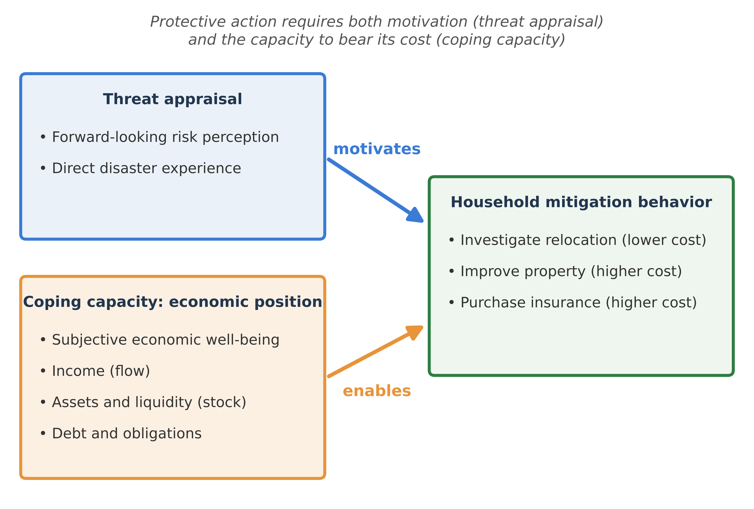
Note. The framework integrates protection motivation theory with the household-finance account of coping capacity. Protective action is modeled as the joint product of threat appraisal, comprising forward-looking risk perception and direct disaster experience, and coping capacity, measured by four dimensions of household economic position. Coping capacity conditions whether threat appraisal translates into action, because acting on perceived risk requires the resources to bear the cost of the response.

Table 1
Summary of Study Hypotheses
Hypothesis | Prediction
H1 | Higher forward-looking risk perception is positively associated with all three mitigation behaviors.
H2 | Disaster experience is positively associated with all three behaviors and is the strongest of the threat-appraisal predictors.
H3 | Income is a weak independent predictor once the other dimensions of economic position are included.
H4 | Assets are positively associated with the two resource-intensive responses, improving property and purchasing insurance.
H5 | Weaker subjective economic well-being and higher debt are associated with a tilt toward lower-cost adaptation, such as investigating relocation, reflecting constrained coping capacity.
Note. Hypotheses follow from protection motivation theory and the household-finance and vulnerability literatures developed in the introduction. H1 and H2 concern threat appraisal; H3 through H5 concern coping capacity.
Data and Methods
Data
Data come from the Survey of Household Economics and Decisionmaking (SHED), conducted annually each fall by the Board of Governors of the Federal Reserve System (Board of Governors of the Federal Reserve System, 2024a). The SHED is a nationally representative survey of adults that measures economic well-being and identifies risks to household finances, with modules on income, employment, banking and credit, housing, education, and retirement. A module on disruptions from natural disasters and severe weather has been fielded since the 2021 wave, and it includes items on disaster experience, forward-looking risk perception, and protective behaviors. The present analysis pools the 2021, 2022, 2023, and 2024 waves, yielding a combined sample of 47,236 respondent-waves (11,874 in 2021; 11,667 in 2022; 11,400 in 2023; and 12,295 in 2024). These observations correspond to 32,585 unique respondents, because a subset was recontacted in consecutive waves; the survey provides a respondent identifier that permits linkage across adjacent years and motivates clustering the pooled standard errors by respondent. The unit of analysis is the adult respondent, who reports on household finances and behavior, and the analytic sample includes both homeowners and renters. Cross-sectional analyses apply the survey population weight provided in the public-use files, which calibrates the sample to the U.S. adult population. The within-person, cross-lagged, and multilevel models are estimated unweighted, since they target relationships within respondents or within states rather than population totals. Appendix Table A1 lists every variable used in the analysis, its definition and coding, and its source in the SHED public-use files.
Because the analyses apply the survey population weight, the sample mirrors the U.S. adult population. The mean respondent age was 48 years, ranging from 18 to 100, and 51% of adults were women. By race and ethnicity, approximately 62% identified as White, 17% as Hispanic, 12% as Black, and the remaining 9% as Asian, multiracial, or another group. About 35% held a bachelor's degree or higher, 27% had completed some college, and roughly 9% had not finished high school. Roughly 73% of respondents were homeowners, and family income was spread across the four harmonized brackets, with about 35% of adults in the highest and 24% in the lowest. Table 2 reports the mean, standard deviation, minimum, and maximum of every variable used in the analysis.
Table 2
Descriptive Statistics for Analysis Variables
Variable | Mean | SD | Min | Max
Investigate relocation (0/1) | 0.13 | 0.33 | 0 | 1
Improve property (0/1) | 0.16 | 0.37 | 0 | 1
Purchase insurance (0/1) | 0.05 | 0.22 | 0 | 1
Five-year risk perception (1-5) | 3.38 | 0.82 | 1 | 5
Disaster experience (0/1) | 0.14 | 0.35 | 0 | 1
Subjective economic well-being (z) | -0.01 | 1.01 | -2.56 | 1.98
Income (z) | -0.05 | 1.03 | -1.55 | 1.07
Assets (z) | -0.09 | 1.05 | -3.34 | 0.73
Debt (z) | 0.01 | 1.00 | -0.81 | 2.81
Homeowner (0/1) | 0.73 | 0.45 | 0 | 1
Age (years) | 48.38 | 17.79 | 18 | 100
Note. N = 47,236 respondent-waves, pooled across the 2021 to 2024 Survey of Household Economics and Decisionmaking (SHED). Means and standard deviations are weighted by the survey population weight; minimum and maximum reflect the observed range. Binary variables are coded 0 or 1. The economic-position indices are standardized to a mean of zero and unit variance, so their means are near zero by construction and their minima and maxima express the observed range in standard-deviation units. Age is reported in years.
Measures
Outcome Variables
Three binary mitigation behaviors are examined, each drawn from a SHED item asking whether, in the past year, the respondent undertook the action at least partly because of the threat of natural disasters or severe weather. The behaviors are investigating other places to live, improving one's property to reduce risk, and purchasing additional insurance. In the pooled sample, 12.8% of adults reported investigating other places to live, 16.1% reported improving their property, and 5.1% reported purchasing additional insurance.
Threat-Appraisal Variables
Forward-looking risk perception is measured by a five-point item asking whether, five years from now, the respondent expects the chance of experiencing a natural disaster or severe weather event to be higher or lower than it is now. The item was reverse-coded so that higher values indicate greater perceived future risk, ranging from 1 (much lower) to 5 (much higher). It serves as the principal indicator of forward-looking threat appraisal. Direct disaster experience is a binary indicator equal to one if the respondent reported that natural disasters or severe weather affected the household in the past year through income loss, property damage, temporary evacuation, longer-term displacement, or another impact. In the pooled sample, 14.4% of adults reported a disaster impact in the prior year, and the mean of the reverse-coded perception item was 3.38. The forward-looking perception item appears in all four waves and was answered in all 47,236 observations, and the disaster-experience measure is likewise defined for all 47,236: in 28,229 observations the respondent was administered the impact battery directly, while in the remaining 19,007 the respondent was screened out because they reported no qualifying disaster, are coded as unexposed. The disaster-experience items were administered to all respondents in the 2021 and 2022 waves, whereas in 2023 and 2024 they followed a screening question, so that respondents who indicated no qualifying disaster were not shown the impact items and are coded as not having experienced one. This coding is substantively appropriate, because a respondent who reported no disaster could not have experienced an impact, and it preserves the unexposed comparison group that identifies the experience association. Because the perception item, the economic items, the outcomes, and the demographic measures contain no item nonresponse, the analytic sample for every pooled model comprises all respondents with a valid value on each variable entered, so the reported N of 47,236 is the count of complete responses rather than an inflated total.
Economic Position Indices
Four indices operationalize household economic position, each constructed identically across all four waves from items asked of all respondents. Subjective economic well-being is the standardized mean of two items, a four-point Likert assessment of how well the household is managing financially and a five-point Likert assessment of its financial situation relative to 12 months earlier (α = .61). The income index is the harmonized four-category measure of family income. The assets index is an additive composite of four binary indicators of financial holdings and liquidity: whether the household has set aside three months of emergency savings, whether it holds a checking, savings, or money market account, whether it could cover an unexpected 400 dollar expense by some means, and whether it holds at least one credit card. The last item measures access to credit rather than an owned asset, and its inclusion is deliberate. The quantity the framework requires is not net worth but resources a household can convert into protection at the moment an outlay falls due, and an available credit line is such a resource in a way that an illiquid holding is not. Excluding it would define capacity by ownership rather than by convertibility, which is the distinction the stock-and-flow argument rests on. Card access and card burden are also kept separate: holding a card enters the assets index, while carrying an unpaid balance enters the debt index. Debt enters as an additive composite of three binary indicators of obligation and borrowing reliance: whether the household carried an unpaid credit card balance in the past year (asked of cardholders, so households without a card are coded as carrying none), whether it holds student loan debt, and whether it would meet an unexpected 400 dollar expense by putting it on a credit card and paying it off over time. The asset and debt indices are formative composites of distinct holdings rather than reflective scales, so their internal-consistency coefficients (.63 and .45 respectively) are reported in Table 3 for transparency rather than as evidence of unidimensionality. All four indices were standardized for analysis. Because the underlying SHED items are categorical or binary rather than continuous dollar amounts, none of the four indices carries a nominal monetary value. Income is recorded in harmonized brackets rather than as a dollar figure, and the asset and debt items record whether a household holds a given resource or obligation rather than how much. Standardization therefore expresses each household's economic position relative to the pooled distribution, with a mean of zero and a standard deviation of one, so that a value locates a household relative to others rather than denoting a quantity of money. The indices capture relative position rather than dollar magnitude. To give these positional measures a concrete referent, Figure 2 reports both the aggregate movement of the standardized indices and the share of households holding each underlying resource and obligation across the four waves, conveying what a shift in position represents when no dollar figure is attached.

Table 3
Construction of Household Economic-Position Indices
Index | Component indicators | α
Subjective economic well-being | Managing financially (4-point); financial situation vs. 12 months ago (5-point); standardized mean | .61
Income | Family income, four harmonized categories | n/a
Assets | Has 3-month emergency savings; has bank account; could cover a 400 dollar emergency expense; has at least one credit card; additive composite | .63
Debt | Carried unpaid credit card balance; holds student loan debt; would finance a 400 dollar emergency on credit over time; additive composite | .45
Note. All indices were standardized prior to analysis. The assets and debt indices are formative composites of distinct holdings; internal-consistency coefficients are reported for transparency. SHED 2021 through 2024 public-use data.

Figure 2
Aggregate Household Economic Position Across Survey Waves, 2021 to 2024
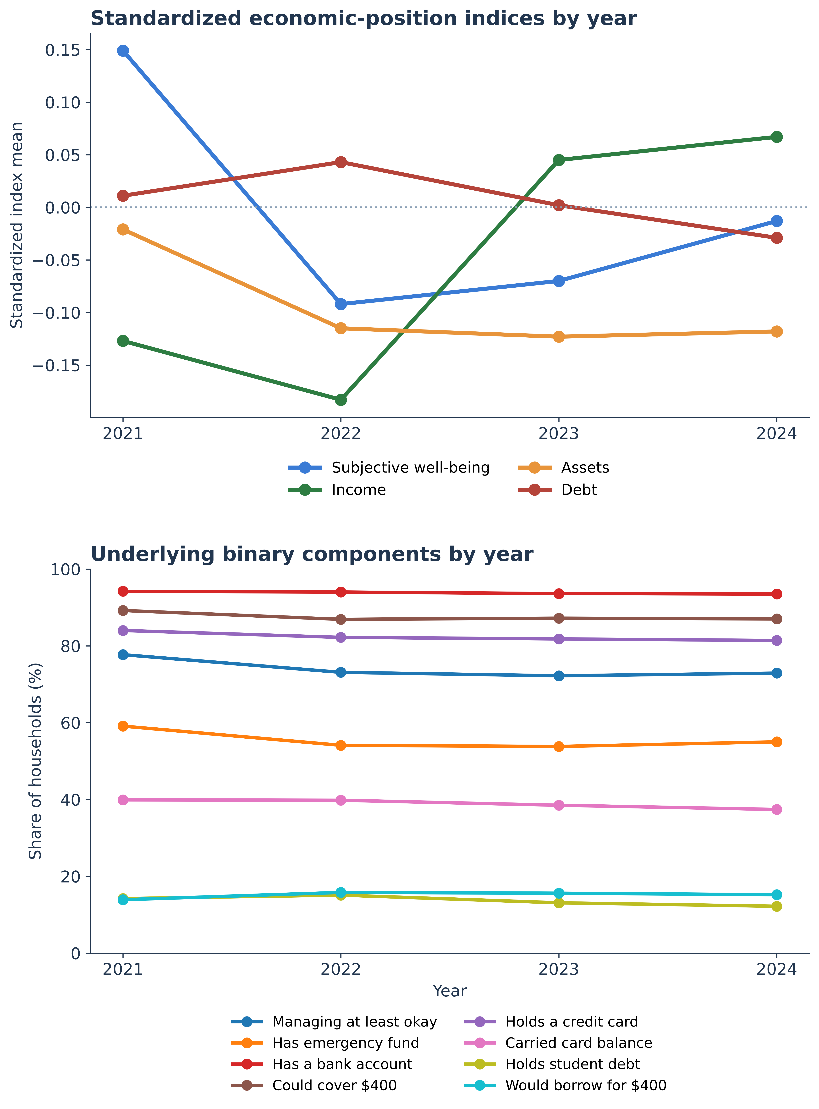
Note. Because the economic-position indices carry no nominal dollar value, the top panel reports the weighted mean of each standardized index by wave, expressed in standard-deviation units relative to the pooled mean of zero, so the lines show how aggregate position shifts over time rather than any quantity of money. The bottom panel reports the weighted share of households reporting each underlying resource or obligation by wave, which gives the positional measures a concrete referent. Together the panels convey what a change in position represents when no dollar figure is attached.
Covariates and the Income Specification
All models adjust for respondent race and ethnicity, gender, educational attainment, age, homeownership, housing type, and employment status, together with survey-year fixed effects that absorb wave-specific shocks such as the disaster activity of a given year. Race and ethnicity are included because the literature reviewed above documents large racial and ethnic gaps in wealth, liquidity, and post-disaster wealth trajectories (Howell & Elliott, 2019), so the categories are needed both to keep those gaps from being attributed to the economic indices and to test whether the asset gradient differs across groups; the five categories are those provided in the SHED public-use files. Family income enters the models a single time, as the income dimension of economic position. Because the harmonized family-income measure also serves as the income-category control, entering it both as a focal construct and as a separate covariate would introduce redundant and collinear terms. To verify that the single-entry specification raises no multicollinearity concern, variance inflation factors were computed for all continuous and binary predictors. All values were well below conventional thresholds, ranging from 1.03 to 1.63, with income at 1.43, which confirms that the four economic constructs can be entered jointly without instability. Income is therefore retained as one of the four economic constructs and is not duplicated as a demographic control.
Analytic Strategy
Because each outcome is binary, survey-weighted logistic regression was used to estimate the association between each predictor and the odds of each mitigation behavior in the pooled cross-section. Estimates apply the population weight, normalized to the analytic sample size. Because a subset of respondents was recontacted across waves, so that the pooled sample contains repeated observations of the same individuals, standard errors are clustered by respondent, which accounts for the within-person correlation that simple robust standard errors would ignore. Two specifications were estimated for each outcome across the full 2021 to 2024 period. The full specification includes the five-year risk-perception item together with disaster experience, the four economic indices, and the covariate block. The experience specification omits the perception item and is otherwise identical, providing a robustness check that shows whether the experience and economic associations are stable when perceived risk, which could be subject to feedback from prior mitigation, is excluded. Results are reported as odds ratios with 95% confidence intervals, where an odds ratio above one indicates that higher values of the predictor are associated with greater odds of the behavior.
To address the cross-sectional limitations of the pooled models, respondent fixed-effects models were estimated using conditional logistic regression across all three consecutive-wave panel transitions the data support, from 2021 to 2022, from 2022 to 2023, and from 2023 to 2024. These transitions link respondents observed in both adjacent waves (3,752, 3,870, and 4,018 recontacted respondents, respectively). Conditional logistic regression conditions on the respondent, so it identifies the effect of within-person change in the time-varying predictors, namely perceived risk, disaster experience, and the four economic indices, while differencing out every stable individual characteristic, whether observed or unobserved, including location, baseline disposition, and time-invariant demographics. The estimates are based on respondents whose behavior changed between waves, and they address an important source of confounding in the pooled associations, since they are not driven by fixed between-person differences, although time-varying confounders and reverse causation within the interval remain possible.
Four additional specifications probe the robustness of the pooled findings and the dynamics behind them. First, geographic fixed effects were added to the pooled models, in the form of indicators for each of the 51 states or, alternatively, the nine census divisions, which absorb stable place-level confounders such as baseline hazard exposure and state insurance regulation. Second, first-difference linear probability models were estimated on each panel transition by differencing the binary outcome and the time-varying predictors across waves, which yields interpretable percentage-point effects of within-person change and provides a linear analogue to the conditional logit. Third, multilevel logistic models with a random intercept for state were estimated to accommodate the clustering of households within states and to quantify the between-state variation in baseline mitigation that the fixed-effects models absorb. Fourth, a random-intercept cross-lagged panel model was estimated on the 1,885 respondents observed in each of the 2022, 2023, and 2024 waves to examine the temporal ordering of perceived risk and behavior. The model requires at least three waves per respondent, and requiring all four waves would shrink the balanced panel to 989 respondents; the three most recent consecutive waves therefore maximize the sample available for the lead-lag test, and the four-wave panel is estimated as a sensitivity check. This model separates stable, trait-like differences between households, captured by a random intercept for each variable, from the within-person dynamics that remain, and it estimates the within-person cross-lagged paths from earlier perceived risk to later behavior and from earlier behavior to later perceived risk (Hamaker et al., 2015). Following that specification, the random intercepts are uncorrelated with the first-wave within-person components. It improves on a conventional cross-lagged model, which can mistake stable between-person differences for within-person influence when stability is trait-like. The binary behaviors were treated as continuous for estimation, a linear-probability approximation within the structural model that keeps the random-intercept decomposition tractable and is common in applied panel work; the cross-lagged paths were constrained to be time-invariant. Because the outcomes are binary, this treatment is an approximation, and a categorical-threshold specification estimated by weighted least squares with a mean- and variance-adjusted statistic would be the orthodox alternative. That estimator is left to future work, and the qualitative conclusion drawn here, that the perceived-risk and mitigation association is concentrated between households and that neither variable leads the other within households, rests on the sign and significance of the cross-lagged paths rather than on their precise magnitudes.
Statistical Software
All analyses except the random-intercept cross-lagged panel model were conducted in Stata release 14.2 (StataCorp, 2015). Survey-weighted estimation and respondent-clustered standard errors used the svy suite with svyset; the pooled models were estimated with svy: logit and the adjusted predicted probabilities with margins. The within-person fixed-effects models used clogit, the first-difference models used regress with robust standard errors on differenced variables, and the multilevel models used melogit with a random intercept for state. The random-intercept cross-lagged panel model was estimated by maximum likelihood in Python (version 3.13) using the semopy package (version 2.3.11; Igolkina & Meshcheryakov, 2020), with the lagged paths constrained equal across waves. That model was fit outside Stata because it specifies eight latent variables against six observed variables, a configuration Stata's sem command declines to estimate under its identification rule that the number of latent variables not exceed the number of observed variables. The replication package supplies a Stata-executable equivalent in which the random intercepts are represented by the person-specific means, so that the between-person association is the correlation of those means and the cross-lagged paths are estimated on the person-centered scores. Index construction and diagnostics used egen, alpha, pca, and estat vif. Every Stata command used is part of official Stata, so no user-written Stata packages are required to reproduce the analysis; the optional estout package was used only to export formatted tables. A complete replication package accompanies the article, containing the pooled analysis dataset in Stata format, a turnkey do-file that reproduces every table and figure and rebuilds the dataset from the public-use SHED files when they are supplied, and a Python script that estimates the random-intercept cross-lagged panel model.
Results
Table 3 summarizes the construction of the four economic-position indices. Table 4 reports weighted descriptive statistics for the mitigation behaviors and threat-appraisal measures across the four waves. The prevalence of each behavior was relatively stable over time, with property improvement the most common response in every wave, rising from 14.3% in 2021 to 18.5% in 2023, and insurance purchase the least common at roughly 5% throughout. Reported disaster experience ranged from 13.1% to 16.0% across waves, tracking the underlying disaster activity of each year, and mean perceived future risk was stable at approximately 3.4 on the five-point scale. The sample also exhibited the financial fragility that motivates the asset measures: roughly 12% of adults reported that they could not cover an unexpected 400 dollar expense by any means, about 45% lacked three months of emergency savings, and about 39% carried an unpaid credit card balance, while roughly 73% were homeowners. Table 5 presents the pooled survey-weighted logistic regression results, and Table 6 presents the within-person fixed-effects results. Figure 3 plots the weighted prevalence of each behavior and of disaster experience across the four waves. The analysis takes the three research questions in sequence. The pooled models in Table 5 answer the first question, on threat appraisal, and the second, on which dimension of economic position governs the capacity to act. The within-person, difference-based, and multilevel models in Tables 6 through 8, together with the geographic fixed-effects models and the cross-lagged estimates in Table 9, answer the third, on whether the relationships hold within individuals and how perceived risk and mitigation are ordered in time.

Table 4
Weighted Prevalence of Mitigation Behaviors and Threat-Appraisal Measures, by Survey Wave
Measure | 2021 | 2022 | 2023 | 2024
Investigated other places to live | 12.2% | 12.1% | 13.3% | 13.6%
Improved property to reduce risk | 14.3% | 14.0% | 18.5% | 17.7%
Purchased additional insurance | 5.3% | 5.1% | 5.3% | 4.7%
Disaster impact in prior year | 16.0% | 13.3% | 13.1% | 15.2%
Five-year risk perception (1 to 5 mean) | 3.41 | 3.36 | 3.37 | 3.36
Unweighted N | 11,874 | 11,667 | 11,400 | 12,295
Note. Percentages and means are weighted using the SHED population weight. The risk-perception item is reverse-coded so that higher values indicate greater perceived future risk. SHED 2021 through 2024 public-use data.

Figure 3
Weighted Prevalence of Mitigation Behaviors and Disaster Experience, 2021 to 2024
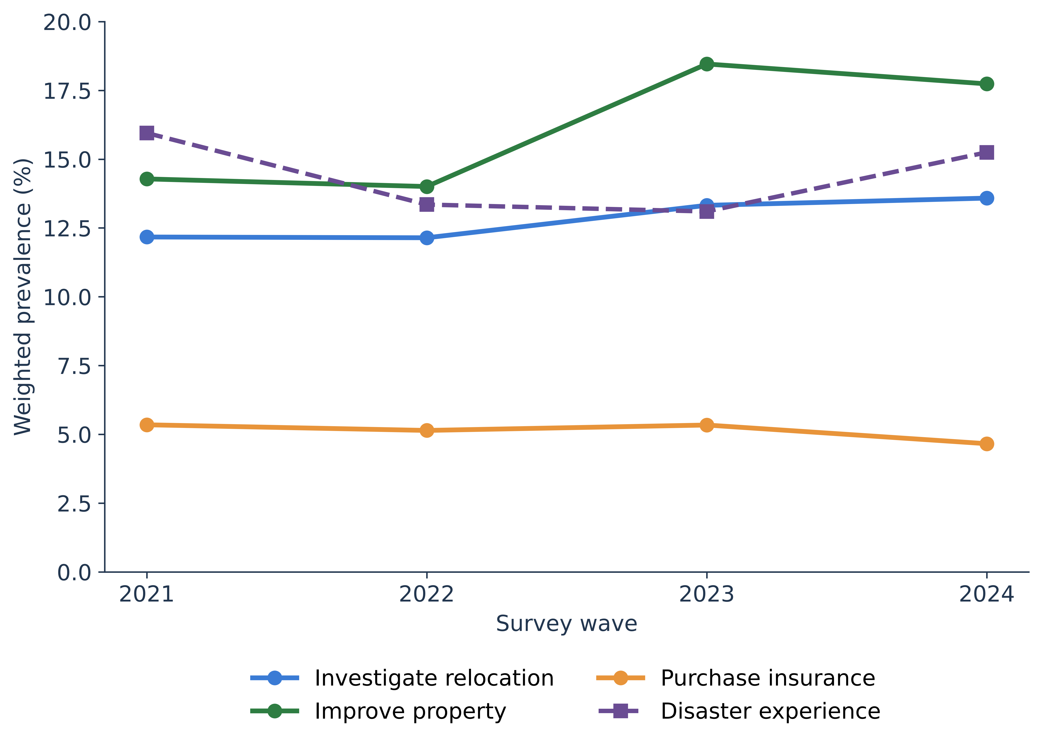
Note. Weighted prevalence of each mitigation behavior and of reported prior-year disaster experience across the four survey waves, using the SHED population weight. Property improvement is the most common response in every wave and additional insurance the least, and the series are broadly stable across the period.
Threat Appraisal in the Pooled Models
The first research question, whether threat appraisal predicts mitigation across behaviors and whether experience is the stronger signal, is answered here, in the pooled models of Table 5. It generated two hypotheses: that higher forward-looking risk perception would predict all three behaviors (H1), and that direct disaster experience would predict all three and be the strongest of the threat-appraisal predictors (H2). Both were supported, H2 with a qualification about scale noted below. In the full specification, each one-point increase in perceived future risk was associated with 58% higher odds of investigating other places to live, 55% higher odds of improving property, and 53% higher odds of purchasing additional insurance, each significant at the .001 level. Because perception is measured on a five-point scale, the gap between a household at the bottom and one at the top corresponds to a several-fold difference in the odds of mitigation, and in predicted-probability terms the adjusted probability of improving property rose from roughly 7% at the bottom of the scale to roughly 26% at the top. Disaster experience showed the largest associations of any predictor in the model. Households reporting a prior-year impact had roughly two and a half times the odds of investigating relocation, nearly four times the odds of improving property, and three times the odds of purchasing insurance. The adjusted probability of property improvement rose from roughly 13% among those reporting no impact to roughly 35% among those reporting one. The comparison between the two threat-appraisal measures depends on scale, because experience is binary while perception is scored per point on a five-point item. Across the full perception scale, the change in adjusted probability (from about 5% to 22% for investigating relocation and from 2% to 9% for purchasing insurance) is as large as or larger than the experience contrast for those two behaviors (from 11% to 23% and from 4% to 11%), whereas experience dominates for improving property (13% to 35%, against 7% to 26%). Experience is therefore the stronger signal for the costly physical response, which is consistent with the learning account of protective investment, in which a recent and salient event updates beliefs and prompts action more forcefully than an abstract forward-looking estimate (Gallagher, 2014). The economic associations were essentially unchanged in the experience specification in Panel B, and the experience odds ratios rose modestly (to 2.91, 4.45, and 3.49), as expected when the correlated perception item is removed. The broader significance of this block is that perceived risk remained a strong predictor after coping capacity was fully specified. Earlier work repeatedly found the perception-behavior link to be weak or absent, a regularity termed the risk perception paradox (Bubeck et al., 2012; Wachinger et al., 2013). The contrast cannot be attributed to the affordability controls, because the perception odds ratios were essentially the same when the four economic indices were omitted (1.58, 1.56, and 1.55). It more likely reflects differences in sample size, hazard coverage, and the forward-looking framing of the perception item. Figure 4 displays the full set of pooled odds ratios with their respondent-clustered confidence intervals, and Figure 5 plots the adjusted probabilities across the perception and assets scales.

Table 5
Pooled Survey-Weighted Logistic Regression Odds Ratios for Three Disaster-Mitigation Behaviors, SHED 2021 to 2024
Panel A. Full specification (2021 to 2024)
Predictor | Investigate  relocation | Improve  property | Purchase  insurance
Five-year risk perception | 1.58***  [1.51, 1.65] | 1.55***  [1.49, 1.62] | 1.53***  [1.44, 1.63]
Disaster experience | 2.53***  [2.34, 2.74] | 3.96***  [3.68, 4.25] | 3.03***  [2.73, 3.38]
Subjective economic well-being | 0.87***  [0.83, 0.90] | 0.94**  [0.91, 0.98] | 0.99  [0.93, 1.05]
Income | 1.04  [0.99, 1.09] | 1.03  [0.99, 1.08] | 1.14***  [1.07, 1.22]
Assets | 1.05  [1.00, 1.10] | 1.22***  [1.16, 1.27] | 1.29***  [1.19, 1.39]
Debt | 1.11***  [1.07, 1.15] | 1.09***  [1.05, 1.13] | 1.14***  [1.09, 1.20]
Homeowner | 0.59***  [0.54, 0.66] | 2.04***  [1.82, 2.30] | 0.70***  [0.60, 0.81]
Age | 0.79***  [0.76, 0.82] | 1.09***  [1.05, 1.13] | 0.98  [0.91, 1.04]
Female | 0.93  [0.87, 1.01] | 0.85***  [0.80, 0.91] | 0.90*  [0.82, 1.00]
Black | 1.45***  [1.30, 1.62] | 1.39***  [1.25, 1.55] | 1.84***  [1.59, 2.12]
Hispanic | 1.41***  [1.27, 1.55] | 1.31***  [1.18, 1.44] | 1.24**  [1.07, 1.44]
Bachelor’s degree or higher | 1.17  [0.99, 1.39] | 0.95  [0.82, 1.11] | 0.86  [0.66, 1.11]
Observations | 47,236 | 47,236 | 47,236
McFadden pseudo-R² | 0.090 | 0.115 | 0.071

Panel B. Experience specification, perception excluded (2021 to 2024)
Predictor | Investigate  relocation | Improve  property | Purchase  insurance
Disaster experience | 2.91***  [2.69, 3.14] | 4.45***  [4.15, 4.77] | 3.49***  [3.14, 3.87]
Subjective economic well-being | 0.87***  [0.83, 0.90] | 0.94**  [0.91, 0.98] | 0.99  [0.93, 1.05]
Income | 1.04  [0.99, 1.09] | 1.03  [0.99, 1.07] | 1.14***  [1.07, 1.22]
Assets | 1.07**  [1.02, 1.12] | 1.23***  [1.18, 1.29] | 1.31***  [1.21, 1.41]
Debt | 1.12***  [1.08, 1.16] | 1.10***  [1.06, 1.13] | 1.15***  [1.10, 1.21]
Homeowner | 0.59***  [0.54, 0.66] | 2.01***  [1.79, 2.26] | 0.69***  [0.60, 0.81]
Age | 0.78***  [0.74, 0.81] | 1.07**  [1.03, 1.11] | 0.96  [0.90, 1.02]
Female | 0.95  [0.89, 1.03] | 0.87***  [0.81, 0.93] | 0.92  [0.83, 1.02]
Black | 1.41***  [1.27, 1.57] | 1.38***  [1.24, 1.54] | 1.82***  [1.57, 2.10]
Hispanic | 1.44***  [1.30, 1.59] | 1.35***  [1.22, 1.49] | 1.28***  [1.11, 1.49]
Bachelor’s degree or higher | 1.29**  [1.10, 1.53] | 1.04  [0.89, 1.21] | 0.94  [0.73, 1.21]
Observations | 47,236 | 47,236 | 47,236
McFadden pseudo-R² | 0.072 | 0.099 | 0.057
Note. Cell entries are odds ratios with 95% confidence intervals in brackets, from survey-weighted logistic regression applying the SHED population weight, with standard errors clustered by respondent. All models include survey-year fixed effects and adjust for race and ethnicity, gender, education, age, homeownership, housing type, and employment. Continuous predictors (subjective economic well-being, income, assets, debt, age) are standardized; risk perception is scored 1 to 5 with higher values indicating greater perceived future risk. Reference categories are White and male; education enters as four categories (less than high school, high school, some college, and a bachelor's degree or higher) with less than high school as the reference, and the table reports the bachelor's-or-higher contrast. * p < .05. ** p < .01. *** p < .001.

Figure 4
Pooled Full-Model Odds Ratios With Respondent-Clustered 95% Confidence Intervals
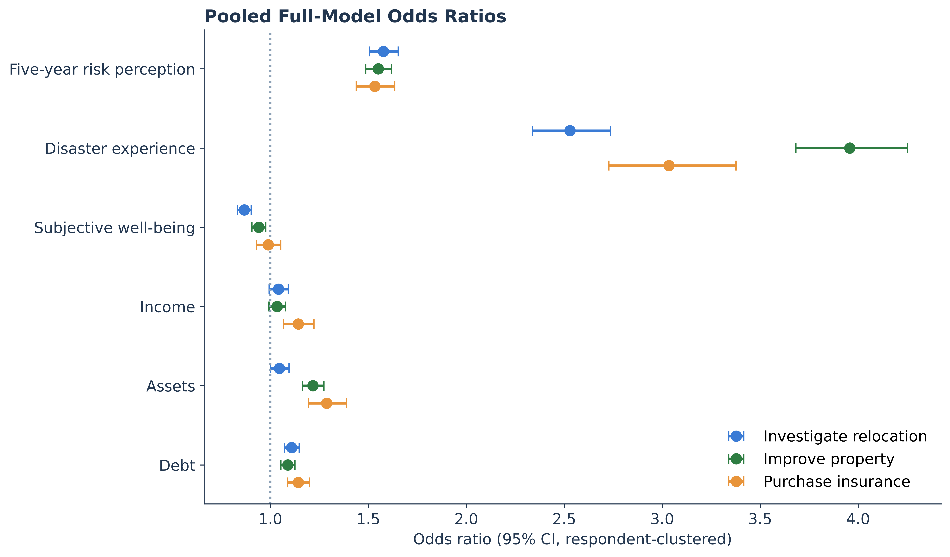
Note. Odds ratios from the full pooled specification (Table 5, Panel A) for all three behaviors, with 95% confidence intervals based on standard errors clustered by respondent. Values to the right of one indicate higher odds of the behavior. Disaster experience and risk perception lie well above one for every behavior, assets rise for the two resource-intensive responses, and income lies near one.
Economic Position in the Pooled Models
The two financial dimensions divide the three behaviors along the line the framework predicted. H3 held that income would be a weak independent predictor once the other economic dimensions were included, and H4 that assets would be positively associated with the two resource-intensive responses, improving property and purchasing insurance. Both were borne out, and where each mattered is more informative than either result taken alone. Income was weak for two of the three behaviors. With standard errors clustered by respondent, the income coefficient was statistically indistinguishable from zero for investigating relocation and for improving property, the two responses most often presumed to track financial capacity, and income reached significance only for insurance purchase, where a one standard deviation increase raised the odds by about 14%. Assets ran the other way, along a graded pattern. A one standard deviation increase in the assets index was associated with roughly 22% higher odds of improving property and 29% higher odds of purchasing insurance, the two costly responses, but only about 5% higher odds of investigating relocation, an association that falls just short of conventional significance for the least costly response. Read together, the two gradients trace how each behavior is financed. Insurance is the response met from a recurring premium, and it is the only response income predicts. Property improvement is a lumpy conversion of holdings into protection, and it is where assets dominate while income disappears. An account resting on cost alone would have income and assets rise together with expense, since both are money; they do not. What distinguishes the households that harden their property is holding resources already in convertible form, which is why a single figure of earnings misstates capacity for every behavior except the one earnings actually pay for.

Figure 5
Adjusted Predicted Probabilities of Mitigation by Perceived Risk and by Assets
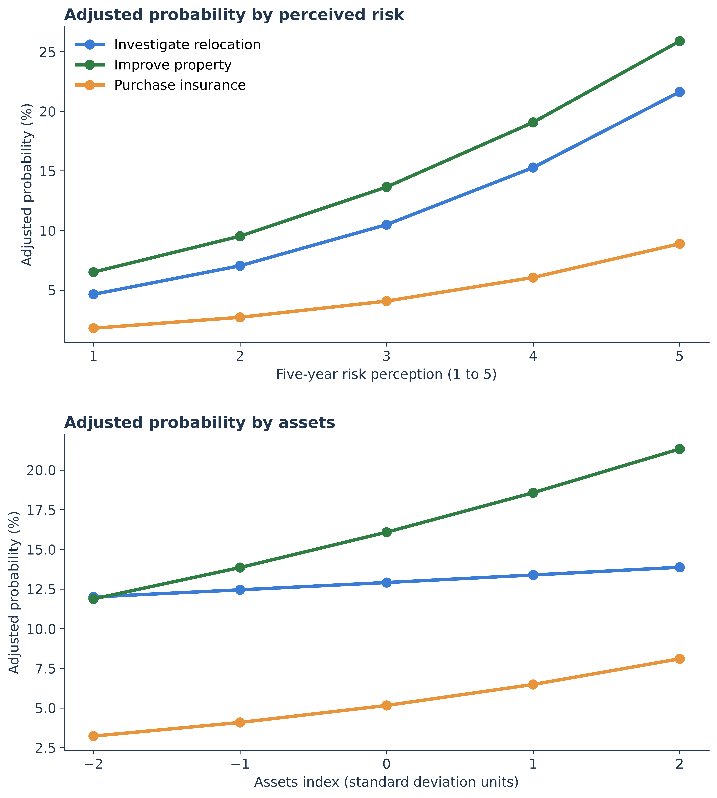
Note. Model-implied probabilities of each behavior across the five-year risk-perception scale (top) and across the standardized assets index (bottom), holding the remaining covariates at their observed values and averaging with the population weight. The probability of improving property rises from roughly 7% at the bottom of the perception scale to roughly 26% at the top.
H5 anticipated that weaker subjective economic well-being and higher debt would tilt households toward lower-cost adaptation, reflecting constrained coping capacity. It was partly supported for well-being and not supported for debt. Weaker subjective economic well-being was associated with greater odds of investigating relocation and, more weakly, of improving property, and was not associated with insurance purchase. The gradient (0.87, 0.94, and 0.99) tilts toward the lower-cost response, but the property association shows that strain does not simply divert households away from costly mitigation. Debt ran counter to the hypothesis: rather than concentrating in the lower-cost responses, it was positively associated with all three behaviors. One exploratory reading of this unexpected result is that debt here operates less as a pure constraint than as a marker of households that are financially engaged and materially exposed, carrying obligations and taking protective action at the same time. This interpretation is post hoc and would need direct testing, for example with measures of debt burden and its composition that the SHED does not provide. The within-person result reported below, that increases in debt predicted greater odds of investigating relocation, the lowest-cost response, in two of the three panel transitions, is consistent with this interpretation, since relocation inquiry is the option most available to a pressed household. Taken together, the economic results revise the simple expectation that only comfortable households mitigate: the asset side of the balance sheet most clearly distinguishes households that undertake costly mitigation, while financial strain accompanies engagement in mitigation rather than withdrawal from it.
Demographic Covariates
Several covariate associations merit comment. Homeownership was strongly associated with property improvement, with homeowners having roughly twice the odds of renters, as expected for a behavior that requires control over the dwelling, while homeowners had lower odds of investigating relocation and of purchasing additional insurance. Black and Hispanic respondents had higher odds of mitigation across behaviors than White respondents, and women had somewhat lower odds than men of improving property and purchasing insurance. Older age was associated with modestly higher odds of property improvement. These patterns held with survey-year fixed effects in place.
Within-Person Fixed-Effects Models
The third research question, whether the relationships hold within individuals once stable confounders are removed, is answered by the panel analysis that begins here. A central concern with the pooled associations is that they might reflect stable differences between households rather than the operation of threat appraisal itself, since households in hazardous places or with particular dispositions might both perceive more risk and mitigate more. The respondent fixed-effects models in Table 6 address this directly by conditioning on the individual, so that the estimates describe how within-person changes in the predictors relate to within-person changes in behavior, net of every stable characteristic. The threat-appraisal results survived this more demanding test. Increases in perceived future risk were associated with significantly greater odds of investigating relocation and of improving property in all three transitions, and of purchasing insurance in the 2021 to 2022 and 2022 to 2023 transitions. The onset of disaster experience was associated with significantly greater odds of investigating relocation and improving property in all three transitions, with odds ratios for property improvement above two in each, and with greater odds of purchasing insurance in the 2021 to 2022 transition. Because these associations cannot be produced by fixed between-household differences, they materially strengthen the reading of H1 and H2: the link between threat appraisal and mitigation is not an artifact of who lives where or of stable traits, but tracks change within the same person over time. This is the strongest evidence in the analysis that the contemporaneous perception-behavior relationship, so often found weak in cross-sectional work, is not an artifact of stable differences between households. It concerns co-movement within a person across a wave, not temporal precedence; the random-intercept cross-lagged model reported below examines whether change in one variable leads change in the other, and reaches a more qualified conclusion. Figure 6 contrasts the pooled and within-person estimates side by side.

Table 6
Respondent Fixed-Effects (Conditional Logit) Odds Ratios Across Three Consecutive-Wave Panel Transitions
Panel A. 2021 to 2022 transition
Within-person predictor | Investigate  relocation | Improve  property | Purchase  insurance
Five-year risk perception | 1.73***  [1.36, 2.21] | 1.52**  [1.18, 1.96] | 1.92***  [1.32, 2.80]
Disaster experience | 1.75**  [1.16, 2.63] | 2.76***  [1.85, 4.13] | 1.85*  [1.06, 3.22]
Subjective economic well-being | 1.01  [0.83, 1.23] | 0.89  [0.72, 1.09] | 1.05  [0.79, 1.41]
Income | 1.28  [0.99, 1.65] | 1.47*  [1.09, 1.98] | 1.24  [0.79, 1.94]
Assets | 1.31  [0.96, 1.79] | 1.30  [0.94, 1.80] | 1.89*  [1.06, 3.38]
Debt | 1.30*  [1.01, 1.67] | 1.12  [0.84, 1.49] | 1.19  [0.75, 1.89]
Discordant respondents | 474 | 493 | 226

Panel B. 2022 to 2023 transition
Within-person predictor | Investigate  relocation | Improve  property | Purchase  insurance
Five-year risk perception | 1.35**  [1.10, 1.64] | 1.31**  [1.07, 1.60] | 1.48**  [1.10, 1.99]
Disaster experience | 1.75**  [1.18, 2.60] | 2.22***  [1.53, 3.22] | 1.58  [0.92, 2.73]
Subjective economic well-being | 0.95  [0.79, 1.15] | 0.98  [0.81, 1.19] | 0.93  [0.69, 1.25]
Income | 1.13  [0.88, 1.46] | 1.31*  [1.02, 1.68] | 1.08  [0.78, 1.50]
Assets | 1.31  [0.99, 1.74] | 1.35*  [1.02, 1.81] | 1.31  [0.87, 1.99]
Debt | 0.95  [0.75, 1.21] | 1.05  [0.83, 1.33] | 0.93  [0.62, 1.39]
Discordant respondents | 517 | 591 | 251

Panel C. 2023 to 2024 transition
Within-person predictor | Investigate  relocation | Improve  property | Purchase  insurance
Five-year risk perception | 1.32**  [1.10, 1.57] | 1.57***  [1.30, 1.90] | 1.33  [1.00, 1.78]
Disaster experience | 2.53***  [1.70, 3.78] | 2.15***  [1.53, 3.01] | 1.29  [0.75, 2.22]
Subjective economic well-being | 0.98  [0.81, 1.18] | 0.88  [0.73, 1.06] | 0.69*  [0.48, 0.99]
Income | 1.00  [0.74, 1.34] | 0.95  [0.72, 1.27] | 0.68  [0.40, 1.14]
Assets | 1.06  [0.81, 1.38] | 1.51**  [1.16, 1.97] | 1.68*  [1.10, 2.58]
Debt | 1.37**  [1.08, 1.73] | 1.11  [0.88, 1.41] | 0.87  [0.60, 1.28]
Discordant respondents | 556 | 690 | 232
Note. Cell entries are odds ratios with 95% confidence intervals in brackets, from conditional (respondent fixed-effects) logistic regression. Each model conditions on the respondent and includes a period indicator, so coefficients reflect within-person change in the time-varying predictors and all stable individual characteristics are differenced out. Estimation uses respondents observed in both waves of a transition; identification rests on the discordant respondents, defined as those whose behavior changed between the two waves, since respondents whose behavior was identical in both waves contribute no information and are dropped. Continuous predictors are standardized; risk perception is scored 1 to 5 with higher values indicating greater perceived future risk. * p < .05. ** p < .01. *** p < .001.

Figure 6
Pooled Versus Within-Person Fixed-Effects Estimates, 2023 to 2024
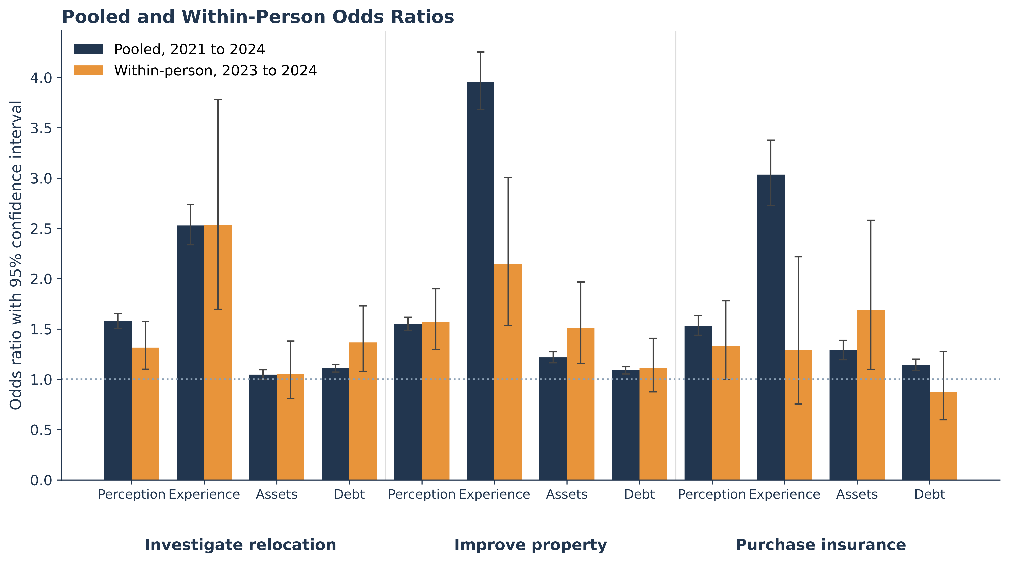
Note. Pooled odds ratios (Table 5, Panel A) beside within-person conditional-logit odds ratios for the 2023 to 2024 transition (Table 6, Panel C), each with its 95% confidence interval. Within-person estimates rest only on respondents whose behavior changed between waves and are correspondingly less precise. Perceived risk and disaster experience remain above one for investigating relocation and improving property after all stable individual characteristics are differenced out; for purchasing insurance, the within-person intervals include one in this transition.
The economic constructs were also informative within individuals, though with smaller and more selective associations, as expected given that fixed-effects estimates rely only on respondents whose behavior changed between waves. Increases in assets were associated with greater odds of improving property in the 2022 to 2023 and 2023 to 2024 transitions and of purchasing insurance in the 2021 to 2022 and 2023 to 2024 transitions, and every assets odds ratio for the two resource-intensive responses exceeded one, mirroring within individuals the cross-sectional finding that assets matter most for resource-intensive responses and lending further support to H4. Income behaved differently within individuals than across them. Increases in income were associated with greater odds of improving property in the 2021 to 2022 and 2022 to 2023 transitions, a pattern the pooled models do not show; a household whose earnings rise may find a lumpy outlay easier to meet at the margin, even though income levels do not distinguish which households harden their property. The result qualifies the pooled income finding and is reported here rather than explained away. The convergence of the within-person and pooled results for the focal predictors indicates that the main findings are not artifacts of cross-sectional confounding, and it is this convergence across designs, rather than any single specification, that underwrites the conclusions.
Extended Specifications and Robustness
The remaining specifications, summarized in Tables 7 through 9, probe whether the pooled findings depend on particular modeling choices and recover the dynamics behind them. Adding fixed effects for each of the 51 states left the focal estimates essentially unchanged, with perceived risk and disaster experience remaining strong positive predictors of every behavior and the experience associations attenuating only slightly because exposure is geographically clustered; census-division fixed effects produced the same pattern (estimates in the replication package). The implication is that the threat-appraisal results are not generated by stable differences across places in hazard exposure or insurance regulation, because they hold when households are compared only with others in the same state, which removes a broad class of confounders that a cross-state comparison would leave open.
The first-difference linear probability models in Table 7 re-express the within-person results in percentage points, which makes their magnitude tangible. In the 2023 to 2024 transition, a one-point rise in perceived future risk was associated with a 3.8 percentage-point increase in the probability of improving property, with smaller but significant increases for the other behaviors, while the onset of disaster experience was associated with increases of roughly 8 to 10 percentage points for investigating relocation and improving property. The 2021 to 2022 transition shows the same pattern, with a one-point rise in perceived risk associated with increases of 4.1, 2.7, and 2.4 percentage points across the three behaviors and the onset of disaster experience with an increase of 9.6 percentage points in property improvement. That a linear estimator with a different functional form reproduces the conditional-logit pattern indicates the within-person results are not an artifact of the logistic specification, and the percentage-point magnitudes show the effects to be substantively large relative to base rates that sit near 13 to 18% for investigating relocation and improving property.

Table 7
First-Difference Linear Probability Models of Within-Person Change in Mitigation, by Panel Transition
Panel A. 2021 to 2022 transition
Change in predictor | Investigate  relocation | Improve  property | Purchase  insurance
Five-year risk perception | +4.1***  [+2.4, +5.8] | +2.7**  [+1.1, +4.3] | +2.4***  [+1.2, +3.6]
Disaster experience | +4.8**  [+1.5, +8.2] | +9.6***  [+6.0, +13.2] | +3.2*  [+0.6, +5.7]
Subjective economic well-being | +0.2  [-1.2, +1.6] | -0.5  [-1.9, +0.9] | +0.3  [-0.6, +1.3]
Income | +1.5  [-0.2, +3.3] | +1.7*  [+0.2, +3.3] | +0.0  [-1.0, +1.1]
Assets | +1.5  [-0.4, +3.5] | +1.4  [-0.5, +3.2] | +1.5*  [+0.3, +2.6]
Debt | +2.3*  [+0.3, +4.3] | +1.2  [-0.7, +3.0] | +0.9  [-0.3, +2.1]
Observations | 3,752 | 3,752 | 3,752

Panel B. 2022 to 2023 transition
Change in predictor | Investigate  relocation | Improve  property | Purchase  insurance
Five-year risk perception | +2.7**  [+0.9, +4.4] | +2.2**  [+0.6, +3.9] | +1.7**  [+0.5, +2.8]
Disaster experience | +5.5**  [+1.9, +9.0] | +8.6***  [+4.6, +12.5] | +2.3  [-0.3, +4.9]
Subjective economic well-being | -0.4  [-1.9, +1.1] | -0.1  [-1.6, +1.4] | -0.2  [-1.2, +0.7]
Income | +0.8  [-0.8, +2.4] | +1.7  [-0.1, +3.4] | +0.4  [-0.9, +1.7]
Assets | +1.9*  [+0.1, +3.6] | +1.5  [-0.3, +3.3] | +0.9  [-0.3, +2.1]
Debt | -0.3  [-2.0, +1.5] | +0.2  [-1.7, +2.0] | -0.2  [-1.3, +0.9]
Observations | 3,870 | 3,870 | 3,870

Panel C. 2023 to 2024 transition
Change in predictor | Investigate  relocation | Improve  property | Purchase  insurance
Five-year risk perception | +2.3**  [+0.7, +3.9] | +3.8***  [+2.3, +5.3] | +1.2*  [+0.1, +2.2]
Disaster experience | +8.2***  [+4.8, +11.7] | +9.9***  [+5.9, +14.0] | +2.0  [-0.5, +4.6]
Subjective economic well-being | -0.3  [-1.9, +1.2] | -1.1  [-2.7, +0.4] | -0.8  [-1.7, +0.0]
Income | -0.1  [-2.5, +2.3] | -0.5  [-2.9, +2.0] | -0.7  [-2.2, +0.7]
Assets | +0.8  [-1.1, +2.8] | +3.5***  [+1.5, +5.5] | +1.6*  [+0.3, +2.9]
Debt | +2.4*  [+0.4, +4.3] | +0.6  [-1.3, +2.6] | -0.8  [-2.1, +0.4]
Observations | 4,018 | 4,018 | 4,018
Note. Cell entries are coefficients in percentage points with 95% confidence intervals in brackets, from ordinary least squares regression of the wave-to-wave change in the binary behavior on the change in each predictor, with robust standard errors. First differencing removes all stable individual characteristics. Risk perception is the 1 to 5 item; the economic indices are standardized. * p < .05. ** p < .01. *** p < .001.
The multilevel models in Table 8 place a random intercept on state to accommodate the clustering of households within states. The focal odds ratios closely tracked the pooled estimates, with the experience associations slightly smaller, as in the state fixed-effects models, and the between-state standard deviation of the random intercept was modest, 0.25 to 0.26 on the log-odds scale. The substantive reading is that, once household characteristics are accounted for, states differ only modestly in baseline mitigation, so the action in these data is at the household level rather than the place level: the predictors that carry the relationship are the ones households hold, not fixed features of where they live. Figure 7 ranks the states by their weighted rate of any mitigation.

Table 8
Multilevel Logistic Regression Odds Ratios With a Random Intercept for State, SHED 2021 to 2024
Predictor | Investigate  relocation | Improve  property | Purchase  insurance
Five-year risk perception | 1.62***  [1.56, 1.68] | 1.52***  [1.47, 1.58] | 1.51***  [1.43, 1.59]
Disaster experience | 2.42***  [2.26, 2.60] | 3.70***  [3.47, 3.94] | 2.79***  [2.54, 3.07]
Subjective economic well-being | 0.86***  [0.83, 0.89] | 0.94***  [0.91, 0.97] | 0.99  [0.94, 1.04]
Income | 1.02  [0.98, 1.06] | 1.03  [0.99, 1.06] | 1.13***  [1.07, 1.20]
Assets | 1.03  [0.99, 1.07] | 1.18***  [1.14, 1.23] | 1.25***  [1.17, 1.33]
Debt | 1.09***  [1.06, 1.12] | 1.10***  [1.07, 1.13] | 1.14***  [1.09, 1.18]
State random-intercept SD | 0.26 | 0.25 | 0.26
Observations | 47,236 | 47,236 | 47,236
Note. Cell entries are odds ratios with 95% confidence intervals in brackets, from multilevel logistic regression with a random intercept for state (51 states including the District of Columbia), estimated by maximum likelihood with adaptive Gauss-Hermite quadrature. All models include the same fixed-effect covariates and survey-year fixed effects as Table 5 and are unweighted. The random-intercept standard deviation is on the log-odds scale. * p < .05. ** p < .01. *** p < .001.

Figure 7
Any Disaster Mitigation by State, Pooled 2021 to 2024
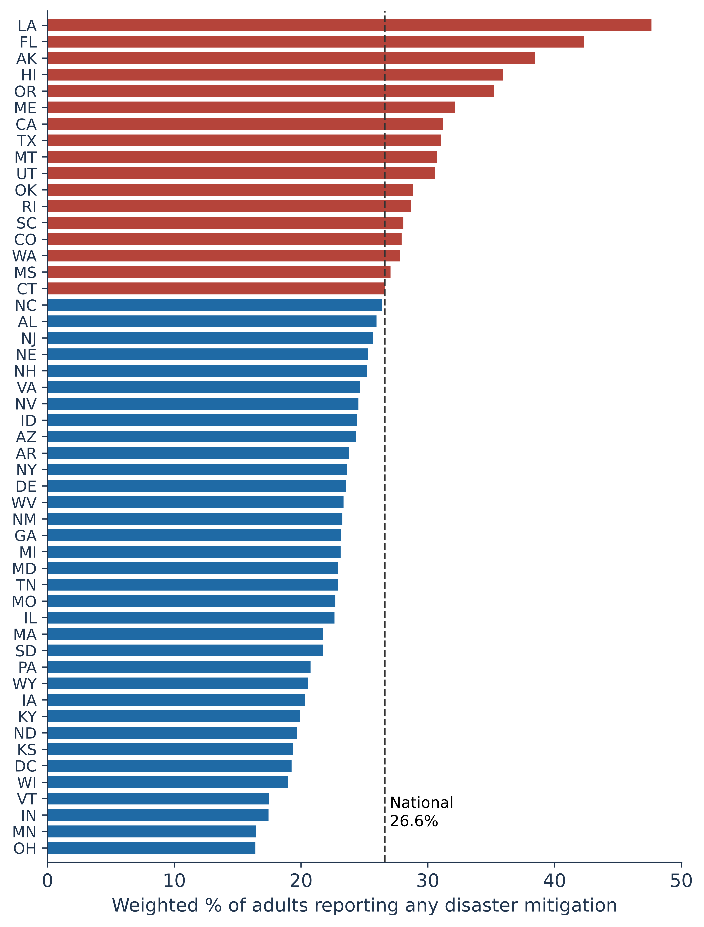
Note. Weighted share of adults reporting any of the three mitigation behaviors, by state, pooled across waves. Bars above the national rate are shaded differently from those below it. High-exposure coastal states rank highest, a face-validity check on the self-reported behaviors.
The random-intercept cross-lagged panel model in Table 9 separates stable between-household differences from within-person change, and it places most of the perception-mitigation association in the former. Households that were stably more worried were also stably more likely to mitigate, with the correlation between the stable components of perceived risk and behavior positive and significant for all three behaviors (r = .30 for investigating relocation, .24 for improving property, and .33 for purchasing insurance). The within-person cross-lagged paths were small and statistically insignificant in both directions; the two property paths came closest (p = .078 and .067) and both were negative. Earlier perceived risk did not predict later mitigation once stable differences were removed, and earlier mitigation did not predict later perceived risk. Within waves, the within-person components were weakly and positively correlated (standardized covariances of .02 to .09), significantly so in two of the three waves for investigating relocation, which is consistent with the contemporaneous co-movement the fixed-effects models detect. Estimating the model on the 989 respondents observed in all four waves yielded the same pattern. The stable components remained positively and significantly correlated for every behavior (r = .30, .16, and .34), and earlier perceived risk did not predict later mitigation for any behavior. One reverse path reached significance in the four-wave panel: investigating relocation was followed by higher perceived risk (b = .14, p = .009). Its sign is positive, the opposite of the feedback mechanism in which mitigation lowers later perceived risk (Bubeck et al., 2012), and it is one of six reverse-path tests across the two panels, so it is reported rather than interpreted. Three waves of binary outcomes limit the power available for lead-lag tests, so these null paths establish the absence of detectable within-person dynamics and not the absence of any. The result does not conflict with the fixed-effects estimates, which capture contemporaneous within-person association; the random-intercept model poses the more demanding question of whether change in one variable precedes change in the other. A conventional cross-lagged specification would have registered these between-household differences as within-person influence, the hazard that motivated the random-intercept approach (Hamaker et al., 2015). Where the association sits determines what can be done with it, since the margin that risk communication acts on is the within-person one.

Table 9
Random-Intercept Cross-Lagged Panel Model of Perceived Risk and Mitigation, 2022 to 2024
Parameter | Relocation | Property | Insurance
Between-person correlation of stable components (r) | .30*** | .24*** | .33***
Within-person: prior perception to later mitigation | .011 | -.026 | -.005
Within-person: prior mitigation to later perception | .034 | -.115 | -.033
Observations | 1,885 | 1,885 | 1,885
Note. Estimates from a random-intercept cross-lagged panel model (Hamaker et al., 2015) fit to the 1,885 respondents observed in each wave from 2022 to 2024. The random intercepts are uncorrelated with the first-wave within-person components. The first row reports the standardized correlation between the stable, between-person components of perceived risk and the behavior. The second and third rows report unstandardized within-person cross-lagged path coefficients, constrained to be time-invariant; none is statistically significant. The binary behaviors were treated as continuous for estimation, and model fit was good (comparative fit index of .998 or higher; root mean square error of approximation of .019 or lower). A four-wave version fit to the 989 respondents observed in every wave from 2021 to 2024 is reported in the text. * p < .05. ** p < .01. *** p < .001.
Measurement and Inference Robustness
Three further checks address the construction of the economic indices and the structure of the data. First, because the pooled sample contains repeated observations of recontacted respondents, all pooled models reported in Table 5 use standard errors clustered by respondent. Clustering left the point estimates unchanged and the principal conclusions intact. Its only consequence for inference was that income ceased to be statistically significant for investigating relocation (p = .035 with model-based standard errors, .087 with clustering); income was not significant for improving property under either approach.
Second, the economic indices were reconstructed in two alternative ways to test their sensitivity to the equal-weighting of items, with results reported in Table 10. Replacing each additive index with the first principal component of its items, and separately removing one indicator from the assets and debt composites, left the substantive pattern unchanged, although dropping emergency savings, the strongest single liquidity item, reduced the assets odds ratios for improving property and purchasing insurance to 1.10 and 1.16. Across all three constructions, assets remained a strong and significant predictor of the two resource-intensive responses, improving property and purchasing insurance, and debt remained positive and significant for every behavior. The small association between assets and investigating relocation, the lowest-cost behavior, was not statistically significant under any of the three constructions, a pattern consistent with the expectation that liquidity matters least for the least costly response.

Table 10
Robustness of the Assets and Debt Associations to Alternative Index Constructions
Index construction | Assets (OR) | Debt (OR)
Panel A. Investigate relocation
Equal-weight | 1.05 | 1.11***
First principal component | 1.03 | 1.10***
Leave-one-out | 0.99 | 1.10***
Panel B. Improve property
Equal-weight | 1.22*** | 1.09***
First principal component | 1.19*** | 1.08***
Leave-one-out | 1.10*** | 1.07***
Panel C. Purchase insurance
Equal-weight | 1.29*** | 1.14***
First principal component | 1.25*** | 1.12***
Leave-one-out | 1.16*** | 1.10***
Note. Each entry is the odds ratio for the assets or debt index from the full pooled model (Table 5, Panel A) with the index constructed three ways: the equal-weighted standardized sum used in the main analysis, the first standardized principal component of the index items, and a leave-one-out version dropping the emergency-savings item from assets and the student-loan item from debt. The first principal component accounted for 50% of the variance in the assets items and 48% in the debt items. All models include the full covariate set and survey-year fixed effects, with standard errors clustered by respondent. * p < .05. ** p < .01. *** p < .001.
Third, because the within-person models rely on recontacted respondents, selective panel attrition could in principle bias them. Comparing respondents who were recontacted in the following wave with those who were not, retention was roughly 32% to 35% and was related to age, with younger respondents more likely to be retained, and weakly to homeownership, with homeowners slightly less likely to be retained. Critically, the recontacted and non-recontacted groups were well balanced on the focal predictors and on the outcomes, with standardized mean differences for risk perception, disaster experience, and each of the three behaviors below roughly 0.06 in absolute value. Because the conditional logit further differences out stable individual characteristics, attrition related to age or homeownership is unlikely to bias the within-person estimates of the focal relationships, although attrition related to unobserved within-person change cannot be entirely ruled out.
A final check addresses the wave difference in how disaster experience was measured. Restricting the pooled models to the 28,229 observations in which respondents were directly administered the disaster-experience items, rather than screened out by the 2023 and 2024 gate, left the focal estimates substantively unchanged. Risk perception and disaster experience remained strong and significant for every behavior, and the four economic associations retained their sign and approximate magnitude. Two significance results changed in this smaller sample: the well-being association with improving property weakened to 0.96 and lost significance, and the assets association with investigating relocation rose to 1.08 and became significant. To make the stability concrete, the disaster-experience odds ratio for property improvement moved only from 3.96 in the full sample to 3.78 in the directly-asked subsample, for investigating relocation from 2.53 to 2.18, and for purchasing insurance from 3.03 to 2.73, while the risk-perception odds ratios were similarly stable, near 1.5 to 1.6 in both samples. The experience association is therefore not an artifact of coding screened-out respondents as unexposed. A further check probes whether the asset gradient itself varies by race and ethnicity, since the capacity to convert resources into protection is unequally distributed and the framework locates that capacity in the balance sheet. Interacting the assets index with the five-category race and ethnicity measure, a joint test of the interaction terms was not significant for either resource-intensive behavior, improving property or purchasing insurance. The association between assets and costly mitigation is therefore statistically similar across racial and ethnic groups; what differs across groups is the level of assets a household holds, not the rate at which assets translate into protection. This pattern is what the distributional argument requires. If assets gate costly mitigation at a common rate, then the well-documented racial gaps in wealth and liquidity pass through directly into gaps in the capacity to protect, without any need for the mechanism itself to differ by group.
Two further checks concern the number of tests and the revision of the assets index. Because the pooled models estimate eighteen focal associations, three behaviors by six predictors, the p-values were adjusted for multiple comparisons using both the Holm step-down procedure and the Benjamini-Yekutieli false discovery rate, which remains valid under arbitrary dependence among tests. Every association significant at the .05 level remained significant under both adjustments, and every null association remained null. The assets index used throughout adds credit-card access to the three liquidity indicators of an earlier specification, namely emergency savings, a bank account, and the capacity to cover a 400 dollar expense, a revision that raised internal consistency from .51 to .63 and that rests on the convertibility argument set out in the Measures section. Re-estimating the pooled models with the three-item index produced assets odds ratios of 1.05, 1.25, and 1.28 for investigating relocation, improving property, and purchasing insurance, against 1.05, 1.22, and 1.29 with four items, and left every other focal estimate within .04 of its reported value. The one difference in inference concerns the smallest association: assets predicted investigating relocation at p = .027 with three items and at p = .051 with four, so the claim that liquidity matters least for the least costly response rests on the size of that association rather than on its crossing a significance threshold.

Discussion
Households mitigate when they perceive risk and when they have lived through a disaster, and whether that motivation becomes action depends on the form their resources take.
Income failed here because it is the wrong temporal object for the expense in question. A flow arriving in increments does not fund an outlay that must be made at once, and property improvement is an outlay of exactly that kind. Assets were the economic dimension most clearly associated with it and with insurance purchase, the two resource-intensive responses, in the pooled models and within individuals over time, while across households income mattered only for insurance, the response met from a recurring premium. Within households, rising income did accompany property improvement in two of the three panel transitions, so the flow is not irrelevant at the margin, but income levels do not distinguish which households protect themselves. That division carries the theoretical weight of the study. The cost component of coping appraisal turns on whether a household holds resources in the form the expense demands, which is the convertible margin the household-finance literature identifies as binding for a large share of households (Lusardi et al., 2011). Protection motivation theory anticipates that affordability governs the coping half of the appraisal; these results specify which financial dimension does that work for which kind of protection. The pattern also bears on the economics of disaster insurance. Assets predicted insurance purchase and property improvement together, matching the finding of Botzen et al. (2019) that coverage and physical risk reduction undertaken in advance of a threat behave as complements. The same balance-sheet capacity funds both forms of protection, which leaves little room for a moral-hazard account in which coverage displaces prevention. Read alongside the administrative evidence, the finding is convergent rather than isolated. Fitzmaurice et al. (2026) separate collateral constraints from income constraints when households finance repairs after a flood, and find collateral binding far more often than cashflow; the present results locate the same asymmetry earlier in the sequence, in the decision to protect a home before damage occurs. Mulder and Liao (2024) likewise tie insurance demand to home equity, though they attribute the relationship principally to risk shifting through the default option rather than to affordability. These accounts are not rivals. Their mechanism operates on leveraged homeowners deciding what to insure; the present mechanism operates on the broader population of households deciding what they can fund. That two different data traditions, administrative records and a nationally representative survey, converge on the priority of stocks over flows is the stronger form of the claim.
Private mitigation may convert exposure into liability for households without assets and into an ordinary purchase for households that hold them. Two results describe that division. Weaker subjective economic well-being was associated with greater engagement in mitigation, and higher debt was positively associated with all three behaviors. The financially strained households in this sample were more likely to report protective action, not less, and the within-person estimates show increases in debt accompanying greater odds of investigating relocation in two of the three panel transitions, the lowest-cost response and the one most available to a constrained household. Strain and exposure travel together, since the households that face disaster risk also face the financial pressures disasters create, and the vulnerability tradition in hazards research has long held that exposure and limited coping capacity coincide (Cutter et al., 2003). What the debt result suggests, though these data cannot confirm it, is a mechanism by which that coincidence reproduces itself. A household that protects itself by borrowing has purchased safety against a future obligation. A household that protects itself from savings has reallocated a stock it already held. Both appear in these data as mitigation, and the two transactions leave the households in different positions when the next shock arrives. Disasters and the assistance that follows them already widen wealth gaps along lines of race, education, and homeownership (Howell & Elliott, 2019), and a mitigation system financed privately distributes its costs along those same lines. Public assistance offsets this unevenly at best. Examining federal aid relative to damage across hurricanes in the Southeast and Mid-Atlantic, Waters et al. (2024) document disparities in aid-to-damage ratios, with poorer counties and communities of color receiving less assistance to invest in mitigation even as they face greater exposure. Households that cannot fund protection from their own balance sheets are therefore not reliably backstopped by the programs designed to help them, which places more weight on the balance sheet itself.
The random-intercept model changes the target of the policy inference. Separating stable between-household differences from within-person change places the perceived-risk and mitigation relationship largely between households: those persistently more worried are persistently more likely to act, significantly so for all three behaviors, and a four-wave check returns the same pattern. Within households, the fixed-effects models show perceived risk and mitigation changing together across adjacent waves, but in the cross-lagged model neither predicted the other at the next wave. A reduced-form cross-lagged model that ignored the stable component would have read those between-household differences as within-person influence (Hamaker et al., 2015), and the three-wave panel with binary outcomes has limited power for the lead-lag question, so the finding is best stated as an absence of detectable within-person dynamics. That households act on subjective assessments capable of diverging from objective hazard is consistent with evidence that coastal residents underestimate flood risk and sort on their beliefs (Bakkensen & Barrage, 2022), and the role of private risk information in the insurance decision echoes the adverse selection documented in voluntary flood insurance markets (Bradt et al., 2021). Risk communication rests on the premise that moving a household's perception moves its behavior, a within-person claim about sequence. These estimates show perception and mitigation changing together within households but find no evidence that a change in perception comes first.
Limitations
Several limitations qualify these conclusions. First, the fixed-effects models reduce the threat of confounding from stable traits but do not establish causation, since time-varying confounders and reverse causation within the wave interval remain possible. They also identify effects only from respondents whose behavior changed between waves, so they speak to the margin of behavioral change and not to the full population. Because each transition spans only two adjacent waves, these models cannot capture longer dynamics. Second, the mitigation items are self-reported and binary, capturing whether an action was taken but not its scale or effectiveness. Third, both threat-appraisal measures are self-reported, and the analysis contains no external, objective measure of hazard exposure, so perceived risk and reported experience cannot be benchmarked against realized county-level risk; the state rankings in Figure 7, in which high-exposure coastal states rank highest, offer only a coarse face-validity check. Merging a county-level hazard-loss series such as the Spatial Hazard Events and Losses Database for the United States would allow perceived risk to be separated from realized exposure and is the most valuable single extension of this design. Relatedly, the disaster-experience measure aggregates several distinct impacts into a single indicator and does not distinguish hazard types, which may matter for which mitigation response a household selects. Fourth, the asset and debt indices are formative composites assembled from a small set of binary indicators, and their modest internal-consistency coefficients reflect that they combine distinct holdings rather than measure a single latent trait. Fifth, gender enters only as a control. Because the behaviors are reported for the household while gender is an attribute of the individual respondent, the design cannot separate gendered decision-making within households, and no sex- or gender-disaggregated analysis is reported. Finally, the public-use files do not include the design information needed for full survey variance estimation, so pooled standard errors rely on weighted estimation clustered by respondent rather than a complete design-based variance, and the panel and multilevel models are unweighted.
Implications and Conclusion
Raising perceived risk will accomplish little for the households that lack the resources to act on it. Communication strategies retain their value, since perceived risk predicts mitigation in a recent national sample and moves with it within individuals from one wave to the next, but the asset results identify liquidity and balance-sheet position as what separates the households that undertake costly mitigation, and the strain results show many of the most engaged households already under financial pressure. Programs that pair risk information with direct support for the cost of acting, whether through 1) grants, 2) low-cost financing, or 3) subsidized insurance, reach the households for whom perceived risk would otherwise not translate into protective action. Federal disaster assistance is partial, uncertain, and can crowd out private coverage (Kousky et al., 2018; Michel-Kerjan, 2010), and the capacity to self-protect is distributed along the same lines as wealth (Cutter et al., 2003; Howell & Elliott, 2019), so such support functions as distributional policy whether or not it is designed as such. This study models threat appraisal and four dimensions of coping capacity jointly, across three behaviors that differ in how they are financed, on a single large and recent nationally representative footing, and corroborates the cross-sectional associations with within-person, multilevel, and difference-based estimators. The distinction it draws between stock and flow goes beyond a refinement of measurement. It determines which households a mitigation policy can reach, and which it may leave to borrow.

References
Bakkensen, L. A., & Barrage, L. (2022). Going underwater? Flood risk belief heterogeneity and coastal home price dynamics. The Review of Financial Studies, 35(8), 3666–3709. https://doi.org/10.1093/rfs/hhab122
Board of Governors of the Federal Reserve System. (2024a). Economic well-being of U.S. households in 2023. https://www.federalreserve.gov/publications/2024-economic-well-being-of-us-households-in-2023-preface.htm
Board of Governors of the Federal Reserve System. (2024b). Survey of Household Economics and Decisionmaking [Data set]. https://doi.org/10.17016/datasets.002
Botzen, W. J. W., Kunreuther, H., & Michel-Kerjan, E. (2019). Protecting against disaster risks: Why insurance and prevention may be complements. Journal of Risk and Uncertainty, 59(2), 151–169. https://doi.org/10.1007/s11166-019-09312-6
Bradt, J. T., Kousky, C., & Wing, O. E. J. (2021). Voluntary purchases and adverse selection in the market for flood insurance. Journal of Environmental Economics and Management, 110, 102515. https://doi.org/10.1016/j.jeem.2021.102515
Bubeck, P., Botzen, W. J. W., & Aerts, J. C. J. H. (2012). A review of risk perceptions and other factors that influence flood mitigation behavior. Risk Analysis, 32(9), 1481–1495. https://doi.org/10.1111/j.1539-6924.2011.01783.x
Cutter, S. L., Boruff, B. J., & Shirley, W. L. (2003). Social vulnerability to environmental hazards. Social Science Quarterly, 84(2), 242–261. https://doi.org/10.1111/1540-6237.8402002
Fitzmaurice, K. P., Garcia, H. M., Sebastian, A., Thomson, H., Zeff, H. B., & Characklis, G. W. (2026). Flood risks to the financial stability of residential mortgage borrowers: An integrated modeling approach. Natural Hazards and Earth System Sciences, 26(1), 675–701. https://doi.org/10.5194/nhess-26-675-2026
Gallagher, J. (2014). Learning about an infrequent event: Evidence from flood insurance take-up in the United States. American Economic Journal: Applied Economics, 6(3), 206–233. https://doi.org/10.1257/app.6.3.206
Grothmann, T., & Reusswig, F. (2006). People at risk of flooding: Why some residents take precautionary action while others do not. Natural Hazards, 38(1–2), 101–120. https://doi.org/10.1007/s11069-005-8604-6
Grover, H., Lindell, M. K., Brody, S. D., & Highfield, W. E. (2022). Correlates of flood hazard adjustment adoption in four coastal communities. International Journal of Disaster Risk Reduction, 68, 102728. https://doi.org/10.1016/j.ijdrr.2021.102728
Hamaker, E. L., Kuiper, R. M., & Grasman, R. P. P. P. (2015). A critique of the cross-lagged panel model. Psychological Methods, 20(1), 102–116. https://doi.org/10.1037/a0038889
Howell, J., & Elliott, J. R. (2019). Damages done: The longitudinal impacts of natural hazards on wealth inequality in the United States. Social Problems, 66(3), 448–467. https://doi.org/10.1093/socpro/spy016
Igolkina, A. A., & Meshcheryakov, G. (2020). semopy: A Python package for structural equation modeling. Structural Equation Modeling: A Multidisciplinary Journal, 27(6), 952–963. https://doi.org/10.1080/10705511.2019.1704289
Kousky, C. (2019). The role of natural disaster insurance in recovery and risk reduction. Annual Review of Resource Economics, 11, 399–418. https://doi.org/10.1146/annurev-resource-100518-094028
Kousky, C., & Cooke, R. (2012). Explaining the failure to insure catastrophic risks. The Geneva Papers on Risk and Insurance: Issues and Practice, 37(2), 206–227. https://doi.org/10.1057/gpp.2012.14
Kousky, C., Michel-Kerjan, E. O., & Raschky, P. A. (2018). Does federal disaster assistance crowd out flood insurance? Journal of Environmental Economics and Management, 87, 150–164. https://doi.org/10.1016/j.jeem.2017.05.010
Lindell, M. K., & Perry, R. W. (2012). The protective action decision model: Theoretical modifications and additional evidence. Risk Analysis, 32(4), 616–632. https://doi.org/10.1111/j.1539-6924.2011.01647.x
Lusardi, A., Schneider, D., & Tufano, P. (2011). Financially fragile households: Evidence and implications. Brookings Papers on Economic Activity, 2011(1), 83–134. https://doi.org/10.1353/eca.2011.0002
Miao, Q., & Zhang, F. (2023). Drivers of household preparedness for natural hazards: The mediating role of perceived coping efficacy. Natural Hazards Review, 24(2), 04023010. https://doi.org/10.1061/NHREFO.NHENG-1620
Michel-Kerjan, E. O. (2010). Catastrophe economics: The National Flood Insurance Program. Journal of Economic Perspectives, 24(4), 165–186. https://doi.org/10.1257/jep.24.4.165
Mulder, P., & Liao, Y. (2024). What's at stake? Understanding the role of home equity in flood insurance demand (OFR Working Paper No. 24-06). Office of Financial Research, U.S. Department of the Treasury. https://www.financialresearch.gov/working-papers/2024/07/24/understanding-the-role-of-home-equity-in-flood-insurance-demand/
Ni, M., Xia, L., Wang, X., Wei, Y., Han, X., Liu, Y., & Pan, S. (2025). Psychological influences and implications for household disaster preparedness: A systematic review. Frontiers in Public Health, 13, 1457406. https://doi.org/10.3389/fpubh.2025.1457406
NOAA National Centers for Environmental Information. (2025). U.S. billion-dollar weather and climate disasters. https://www.ncei.noaa.gov/access/billions/
Qiu, D., Lv, B., Cui, Y., & Zhan, Z. (2023). The role of response efficacy and self-efficacy in disaster preparedness actions for vulnerable households. Natural Hazards and Earth System Sciences, 23(12), 3789–3803. https://doi.org/10.5194/nhess-23-3789-2023
Rogers, R. W. (1975). A protection motivation theory of fear appeals and attitude change. The Journal of Psychology, 91(1), 93–114. https://doi.org/10.1080/00223980.1975.9915803
Slovic, P. (1987). Perception of risk. Science, 236(4799), 280–285. https://doi.org/10.1126/science.3563507
StataCorp. (2015). Stata statistical software: Release 14. StataCorp LP.
Sydnor, J. (2010). (Over)insuring modest risks. American Economic Journal: Applied Economics, 2(4), 177–199. https://doi.org/10.1257/app.2.4.177
van Valkengoed, A. M., & Steg, L. (2019). Meta-analyses of factors motivating climate change adaptation behaviour. Nature Climate Change, 9(2), 158–163. https://doi.org/10.1038/s41558-018-0371-y
Wachinger, G., Renn, O., Begg, C., & Kuhlicke, C. (2013). The risk perception paradox: Implications for governance and communication of natural hazards. Risk Analysis, 33(6), 1049–1065. https://doi.org/10.1111/j.1539-6924.2012.01942.x
Waters, L., Best, K., Miao, Q., Davlasheridze, M., & Reilly, A. C. (2024). Under-reported and under-served: Disparities in US disaster federal aid-to-damage ratios after hurricanes. International Journal of Disaster Risk Reduction, 106, 104430. https://doi.org/10.1016/j.ijdrr.2024.104430

Appendix
Table A1
Variable Definitions and Sources
Variable | Description and coding | Source
Mitigation behaviors (dependent variables)
Investigate relocation | Binary; 1 if the respondent investigated other places to live to reduce disaster risk in the prior year | SHED ND4_a
Improve property | Binary; 1 if the respondent made property improvements to reduce disaster risk in the prior year | SHED ND4_b
Purchase insurance | Binary; 1 if the respondent purchased additional insurance against disaster risk in the prior year | SHED ND4_c
Threat appraisal
Risk perception | Five-point item on whether the chance of a disaster five years from now is higher or lower than now, reverse-coded so that 5 indicates much higher perceived future risk | SHED ND2 (reverse-coded)
Disaster experience | Binary; 1 if any prior-year disaster impact was reported, namely income loss, property damage, temporary evacuation, longer-term displacement, or another impact | SHED ND1_a to ND1_e (derived)
Economic position (standardized indices)
Subjective economic well-being | Standardized mean of two items: how well the household is managing financially (4-point) and its financial situation relative to 12 months earlier (5-point) | SHED B2, B3 (derived)
Income | Family income in four harmonized categories, standardized | SHED inc_4cat_50k (standardized)
Assets | Standardized additive composite of four binary indicators: has three months of emergency savings, holds a bank account, could cover an unexpected 400 dollar expense, and holds at least one credit card | SHED EF1, BK1, EF3_h, C2A (derived)
Debt | Standardized additive composite of three binary indicators: carried an unpaid credit card balance, holds student loan debt, and would finance an unexpected 400 dollar expense on credit | SHED C4A, SL1, EF3_b (derived)
Demographic covariates
Race and ethnicity | Five categories (White, Black, Hispanic, and others); White is the reference category | SHED race_5cat
Gender | Male or female; male is the reference category | SHED ppgender
Education | Four categories (less than high school, high school, some college, bachelor's degree or higher); less than high school is the reference category | SHED ppeducat
Age | Respondent age in years, standardized | SHED ppage (standardized)
Homeowner | Binary; 1 if the respondent owns the residence, 0 if renting or another arrangement | SHED pprent (derived)
Housing type | Categorical type of dwelling | SHED pphouse4
Employment | Categorical employment status | SHED ppemploy
Survey year | Indicators for the 2021 through 2024 waves, entered as fixed effects | SHED survey wave
Survey design and weights
Population weight | Cross-sectional weight calibrating the sample to the U.S. adult population | SHED weight_pop
Respondent identifier | Links recontacted respondents across waves and serves as the clustering unit for pooled standard errors | SHED shedid
State | State of residence, 51 categories including the District of Columbia | SHED ppstaten
Note. All variables are drawn from the Federal Reserve Board's Survey of Household Economics and Decisionmaking (SHED) public-use files for 2021 through 2024 (Board of Governors of the Federal Reserve System, 2024b). Items marked derived are constructed from the listed SHED items as described in the Measures section. The economic indices and age are standardized to a mean of zero and unit variance. SHED item names follow the public-use codebooks. The disaster-experience items were asked of all respondents in 2021 and 2022 and followed a screening question in 2023 and 2024.

