­­

Design Specification

For

Item Tracker

Prepared by:

Group Name: Group 27

|  |  |
| --- | --- |
| Donald Taylor | tayloriii.2@wright.edu |
| Jacob Manser | manser.2@wright.edu |
| Mohammad Aljagthmi | aljagthmi.4@wright.edu |
| Ryan Ly | ly.13@wright.edu |

For:

Project Sponsor *CEG 4980 Administration*

|  |  |
| --- | --- |
| Buck, Erik | erik.buck@wright.edu |
|  |  |
|  |  |

Document Tracking Information:

Document Version 0.1

Date 2018.11.16

Final Approval Date *2018.12.05*

Final Appoval By:

|  |  |
| --- | --- |
| Donald Taylor | tayloriii.2@wright.edu |
| Jacob Manser | manser.2@wright.edu |
| Mohammad Aljagthmi | aljagthmi.4@wright.edu |
| Ryan Ly | ly.13@wright.edu |

Table of Contents

1. Executive Summary 1

1.1 Purpose of this document 1

1.2 Design Scope 1

1.3 Intended Audience and Document Overview 2

1.4 Definitions, Acronymns, and Abbreviations 2

1.5 Document Conventions 2

1.6 References and Acknowledgments 3

1.7 Historical Introduction 3

1.8 Market Analysis and Relevant Art 3

1.9 Alternative Approaches 7

1.10 Impact of Success 13

2 Context of Design Solution 14

2.1 Design Objectives 14

2.2 Design Assumptions 14

2.3 Design Requirements 15

2.4 Design Constraints 16

2.5 Design Standards 17

2.6 Design Functionality 17

2.7 User Characteristics 19

2.8 Operating Environment 19

2.9 User Documentation 19

3 Technical Approach 20

3.1 Hardware 20

3.2 Software 20

3.2.1 Software Overview 20

3.2.2 Software Flow Diagram 22

3.2.3 Software Block Diagram 23

3.2.4 Mobile Application User Flow Diagrams 24

4 Appendix: Test and Evaluation Master Plan and Report 29

5 Appendix: Résumés of Team Members 40

# 1. Executive Summary

This document outlines the proposed system design for a tracking device that will be referred to as the Item Tracker which will be designed to accommodate to the Institute of Electrical and Electronics Engineer (IEEE) 802.11 Standard. This document is based on the System Design Document template.

## Purpose of this document

The purpose of this document is to describe how the Item Tracker is to be constructed and how it will function. The document will present an issue that many people face and will introduce our device that will be able to amend or lessen the extent of said issue. The document will also explain how this device is marketable to our current consumer environment. The document will inform the reader of what the project team is and is not responsible for and what the user is responsible for, the design objectives for our product, any assumptions we have, any requirement and constraints the team must keep in mind, how our device will function, the characteristic of the usability of our device and how the operating environment of the device is to be constructed. It will detail how this device will be produce on a hardware and software level and will.

The Item Tracker attaches to objects. The items location will be tracked via the use of Wi-Fi Positioning Systems (WPS) and each item will be stored on an online database that the user will be able to access through a mobile application on any Android device.

The Item Tracker will primarily use a clients’ Wi-Fi to track the Items location via Wi-Fi Positioning Systems (WPS). The Item Tracker will be compatible with a mobile application exclusive to Android device that have at least the Android 4.4 operating system (OS). The application will be programmed using Java with the aid of Android Studio. The database will be programmed using Firebase due to its tools that are compatible with Android devices.

## Design Scope

The benefits of using our device will be the ability to locate at least one item per Item Tracker that a client desires to know the location of. The user will be able to view the location of the linked item by utilizing a mobile application that we will create that will be compatible on any device running Android 4.4 or later. The range of the devices tracking capability will be limited by the range of the connection to the user’s Wi-Fi network since the device tracking the location via Wi-Fi Positioning Systems (WPS) and will be unable to locate the item if it is outside that range. The devices shape will be similar to that of a United States 0.25 coin in order to fit onto most object with little difficulty or obstructions. The device will be powered by replaceable cell battery that will not be provided alongside the Item Tracker, and that the user will have to periodically replace. The user should not expose the Item Tracker to any extreme temperature (less than 32 oF or exceeding 150 oF) for a prolonged amount of time. The device shall withstand non-toxic liquid spills of 8 fl. oz. or less and be able to function after falling 3 ft. from non-accelerated gravity. The information of each tracked object will be stored on an online database which the user can access via an email login. The user will receive notifications via email concerning the application and the tracked items.

## Intended Audience and Document Overview

Project sponsors (anyone who will be funding the project) should be expected to read all of section 3 as well as section 4 in that order. Project clients and users are expected to read section sections 2.1, 3.2-3.4, and 3.6-9. Project managers should read all sections of the document. Marketing staff should read all of section 2 and 3.2-3.9. Technical writers should real all of section 3 and 4.

## Definitions, Acronymns, and Abbreviations

IEEE – Institute of Electrical and Electronics Engineers

SPI – Society of the Plastics Industry

ANSI – American National Standards Institute

LED – Light Emitting Diode

ISO – International Organization for Standardization

FIPS – Federal Information Processing Standards

NEMA – National Electrical Manufacturers Association

FCC – Federal Communications Commission

RFC – Request For Comments

UL – Underwriters Laboratories

## Document Conventions

N/A

## References and Acknowledgments

1. Anonymous, “ Tile's Competitors, Revenue, Number of Employees, Funding and Acquisitions,” *Owler: Competitive Intelligence to Outsmart Your Competition*. [Online]. Available: https://www.owler.com/company/thetileapp. [Accessed: 17-Nov-2018].
2. Anonymous, “United States (USA) GDP - Gross Domestic Product 2016,” *countryeconomy.com*, 20-Oct-2017. [Online]. Available: https://countryeconomy.com/gdp/usa?year=2016. [Accessed: 17-Nov-2018].
3. D. Munro, “U.S. Healthcare Hits $3 Trillion,” *Forbes*, 31-Jan-2012. [Online]. Available: https://www.forbes.com/sites/danmunro/2012/01/19/u-s-healthcare-hits-3-trillion/#2afedb263da8. [Accessed: 17-Nov-2018].
4. K. Perez, “The Human and Economic Costs of Medical Errors,” *Maximizing Reimbursement Starts with Patient Access | HFMA*, 21-Jun-2016. [Online]. Available: https://www.hfma.org/Content.aspx?id=48695. [Accessed: 17-Nov-2018].
5. lady ada, “Overview,” *Overview*, 24-Apr-2015. [Online]. Available: https://learn.adafruit.com/adafruit-huzzah-esp8266-breakout/overview. [Accessed: 28-Nov-2018].
6. Office of the Actuary, “National Healthcare Expenditure Projections 2017-26,” *CMS*, 14-Feb-2018. [Online]. Available: https://www.cms.gov/Research-Statistics-Data-and-Systems/Statistics-Trends-and-Reports/NationalHealthExpendData/Downloads/NHEProjSlides.pdf. [Accessed: 17-Nov-2018].
7. R. Sipherd, "The third-leading cause of death in America most doctors don't want you to know about", *CNBC*, 2018. [Online]. Available: https://www.cnbc.com/2018/02/22/medical-errors-third-leading-cause-of-death-in-america.html. [Accessed: 18- Nov- 2018].

## Historical Introduction

“Medical mistakes are now the third leading cause of death in the United States. A recent Johns Hopkins study claims that more than 250,000 to as many as 440,000 people die from medial errors. Medical error is one that is caused by inadequately skilled staff, error in judgement or care, a system defect or a preventable adverse effect. This includes computer breakdowns, mix-ups with the dose or types of medications administered and further complications.”[3]

## Market Analysis and Relevant Art

The NHE, or National Healthcare Expenditure, was 17.9% of the GDP, or Gross Domestic Product, in 2016 with an expected growth percentage of 5.5% per year for the next 10 years. The GDP was listed as $18,707,200M, making the NHE $3,348,589M. [3]

Medical errors cost the industry $20,800 million dollars annually. Adding to this the additional quality adjusted life years of those who are lost due to these errors at $75,000 - $100,000, with 10 years lost life, the QALYs for these deaths makes up an additional $187,500M - $250,000M.[2]

We intend to market our product towards relieving these errors starting with more accurate prescription monitoring. There are systems in place to electronically monitor prescriptions but nothing that links the physical items together. Our product sets out to rectify that.

As far as mobile device statistics, Apple’s iOS currently maintains a higher share of the market for smartphone device sales in the US but trails Android by a much greater margin worldwide. In selecting to develop the application against Android, we ensure access to a larger part of the global market for our product.

A close up of a map

Description generated with very high confidence

A close up of a map

Description generated with very high confidence

The top five options on the market which have similar features to our Tracker are listed in the table below. They differ in many ways and no single option contains the same features as our product. These options are marketed more towards the home user with a limited consideration for more industrial marketing.

|  |  |  |  |  |
| --- | --- | --- | --- | --- |
| Rank | Company | Total Funding ($ M) | Revenue ($M) | Retail Cost ($) |
| 1 | A close up of a sign  Description generated with high confidence | 124.8 | 89.8 | 14.99 |
| 2 |  | 61.6 | 12 | 25-35 |
| 3 | A picture containing clipart  Description generated with high confidence | -- | 7 | 25-35 |
| 4 |  | .002 | 5 | 20 |
| 5 | A close up of a logo  Description generated with high confidence | 23 | 3 | 49.99 |

We fully intend to market our product to hospitals as our primary market with further considerations for elderly care centers, pharmacies, and the parent consumer markets as we expand our share. Only in reaching for our final market share shall we endure heavy competition but by that point, we will have a reputation for success in the medical industry which will allow us to convey a great deal of goodwill as well as endorsements that will give us the leverage we would need to stand out in that heavily competitive market.

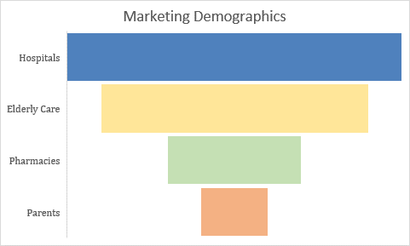

## Alternative Approaches

Hardware/software design choice to be made (include its identification within your system architecture):

Controller - Size

|  |  |  |  |  |
| --- | --- | --- | --- | --- |
|  | Design Options for Microcontroller | | | |
| Criteria | Raspberry Pi Zero W | Arduino MKR WiFi 1010 | Adafruit Feather M0 WiFi – ATSAMD21 + ATWINC1500 | Adafruit HUZZAH ESP8266 breakout |
| Constraint 10 | 5 mm | ####  We know it is well under 2 cm | 8 mm | 5 mm |
| Constraint 20 | 30.5 mm | 25 mm | 22.8 mm | 25 mm |
| Constraint 30 | 66 mm | 61.5 mm | 53.65 mm | 38 mm |
| Constraint 40 | 9.3 g | 32 g | 6 g | 5 g |

Controller – Wi-Fi Compatibility

|  |  |  |  |  |
| --- | --- | --- | --- | --- |
|  | Design Options for Microcontroller | | | |
| Criteria | Raspberry Pi Zero W | Arduino MKR WiFi 1010 | Adafruit Feather M0 WiFi – ATSAMD21 + ATWINC1500 | Adafruit HUZZAH ESP8266 breakout |
| Requirement 1.0 | ####  Commercial products adhere to IEEE 802.11 | ####  Commercial products adhere to IEEE 802.11 | ####  Commercial products adhere to IEEE 802.11 | ####  Commercial products adhere to IEEE 802.11 |
| Requirement 2.0 | ####  Depends on SW development | ####  Depends on SW development | ####  Depends on SW development | ####  Depends on SW development |
| Requirement 3.0 | ####  Comms via Wi-Fi | ####  Comms via Wi-Fi | ####  Comms via Wi-Fi | ####  Comms via Wi-Fi |
| Constraint 70 | ####  Commercial products adhere to IEEE 802.11 | ####  Commercial products adhere to IEEE 802.11 | ####  Commercial products adhere to IEEE 802.11 | ####  Commercial products adhere to IEEE 802.11 |
| Standard 10 | ####  Commercial products adhere to IEEE 802.11 | ####  Commercial products adhere to IEEE 802.11 | ####  Commercial products adhere to IEEE 802.11 | ####  Commercial products adhere to IEEE 802.11 |

Controller - Controller

|  |  |  |  |  |
| --- | --- | --- | --- | --- |
|  | Design Options for Microcontroller | | | |
| Criteria | Raspberry Pi Zero W | Arduino MKR WiFi 1010 | Adafruit Feather M0 WiFi – ATSAMD21 + ATWINC1500 | Adafruit HUZZAH ESP8266 breakout |
| Constraint 60 | #### | #### | #### | #### |
| Constraint 160 | ####  Depends on Ryan’s performance | ####  Depends on Ryan’s performance | ####  Depends on Ryan’s performance | ####  Depends on Ryan’s performance |
| Constraint 180 | #### | #### | #### | #### |
| Standard 40 | #### | #### | #### | #### |
| Standard 90 | ####  Depends on Ryan’s performance | ####  Depends on Ryan’s performance | ####  Depends on Ryan’s performance | ####  Depends on Ryan’s performance |
| Standard 100 | #### | #### | #### | #### |

Lighting – Size/Power consumption

|  |  |  |  |  |
| --- | --- | --- | --- | --- |
|  | Design Options for Microcontroller | | | |
| Criteria | Raspberry Pi Zero W | Arduino MKR WiFi 1010 | Adafruit Feather M0 WiFi – ATSAMD21 + ATWINC1500 | Adafruit HUZZAH ESP8266 breakout |
| Constraint 60 | ####  Does not have integrated LED | ####  Does not have integrated LED | ####  Does not have integrated LED | ####  Has integrated LED |

We chose to use the Adafruit HUZZAH ESP8266 breakout because it fits the size constraints while having the required Wi-Fi and microcontroller functionality. Wiring constraints and Wi-Fi usage are dependent on other parts of the design.

Power Source - Size

|  |  |  |  |  |  |
| --- | --- | --- | --- | --- | --- |
|  | Design Trades for Power Source | | | | |
| Criteria | 4 AAA Batteries in Series | 3.7V 1100 mAh LiPo Battery pack | Solar cells | 2 3V button cell batteries in series | Hamster wheel and hamster |
| Constraint 10 | 178 mm | 49 mm | 145 mm | 24.5 mm | 342.9 mm |
| Constraint 20 | 10.5 mm | 30 mm | 145 mm | 24.5 mm | 304.8 mm |
| Constraint 30 | 10.5 mm | 7mm | 2.5 | 10 mm | 127 mm |
| Constraint 40 | 46 g | 23 g | 80 g | ~25 g | 997.903 g |
| Standard 40 | #### | #### | #### | #### | #### |

Power Source – Voltage output

|  |  |  |  |  |  |
| --- | --- | --- | --- | --- | --- |
|  | Design Trades for Power Source | | | | |
| Criteria | 4 AAA Batteries in Series | 3.7V 1100mAh LiPo Battery pack | Solar cells | 2 3V button cell batteries in series | Hamster wheel and hamster |
| Voltage Output | 6V | 3.7V | 6V | 6V | To Be Determined |

We chose to use the 3.7V 1100 mAh battery pack implementation because it is the smallest choice that can supply the required voltage to the microcontroller and last longer than 7 days on one charge. In fact, this battery implementation is estimated to last approximately 30 days on one charge.

Case – Damage resistance

|  |  |  |  |
| --- | --- | --- | --- |
|  | Design Trades for Case | | |
| Criteria | Tupperware | Wrap plastic cling wrap | Wrap in Aluminum foil |
| Requirement 18.0 | #### | #### | #### |
| Requirement 19.0 | #### | #### | #### |
| Requirement 20.0 | #### | #### | #### |
| Requirement 21.0 | #### | #### | #### |
| Allows Wi-Fi Through | #### | #### | #### |

We chose to use plastic cling wrap because it is the most form fitting external material that a Wi-Fi signal can still pass through.

Attachment Method – Secure attachment

|  |  |  |  |
| --- | --- | --- | --- |
|  | Design Trades for Attachment Method | | |
| Criteria | Rubber Bands | Hook-and-Loop Fasteners | Epoxy |
| Requirement 4.0 | #### | #### | #### |
| Standard 20 | #### | #### | #### |

Attachment Method – Removable

|  |  |  |  |
| --- | --- | --- | --- |
|  | Design Trades for Attachment Method | | |
| Criteria | Rubber Bands | Hook-and-Loop Fasteners | Epoxy |
| Requirement 4.1 | #### | #### | #### |

Attachment Method – Capable of reattachment

|  |  |  |  |
| --- | --- | --- | --- |
|  | Design Trades for Attachment Method | | |
| Criteria | Rubber Bands | Hook-and-Loop Fasteners | Epoxy |
| Requirement 4.2 | #### | #### | #### |

We chose to use the hook-and-loop fasteners (Velcro ©) because it can be removable and reusable. We chose hook-and-loop fasteners over rubber bands because it is faster to remove and reattach with hook-and-loop fasteners than with rubber bands. Rubber bands also have the added disadvantage of adding extra strain and stress on the tracker’s external case.

GUI – Programming Language

|  |  |  |  |  |  |
| --- | --- | --- | --- | --- | --- |
|  | Design Options | | | | |
| Criteria | Option 1  Java | Option 2  C++ | Option 3  Swift | Option 4  Python | Option 5  JRuby |
| Requirement 3.0 | Used for mobile app development | Used for mobile app development | Used for mobile app development | Used for mobile app development | Used for mobile app development |
| Requirement 7.0 | Is Multi-Platform | Is Multi-Platform | Is IOS exclusive | Is Multi-Platform | Can be used on Android devices |
| Familiarity with language | All team members have experience | Some team members have experience | No experience | Some team member have little experience | No experience |
| Has Wi-Fi Tracking Library Tools | Yes | Yes | Yes | Yes | No |
| Portable | Yes | No | No | Yes | Yes |
| Database API Tools | Yes | No | Yes | Yes | Yes |

We chose to use Java due to the reason for this is mainly group familiarity with the language as well as it has all of the tools that we need to complete the application.

GUI – Platform for Delivery

|  |  |  |
| --- | --- | --- |
|  | Design Options | |
| Criteria | Device Local | Remote Server |
| Constraint 190 | ### | #### |
| Time to Develop | Low | High |
| Complexity | Low | High |

We have chosen to develop a device local application in order to minimize the time required to develop as well as the complexity.

Database - Language

|  |  |  |  |  |
| --- | --- | --- | --- | --- |
|  | Design Options | | | |
| Criteria | Postgres | SQL | MySQL(Room) | Firebase |
| Requirement 7.0 | No | No | Yes | Yes |
| Constraint 190 | Free | $1800 per core | Free | Free |
| Hardware Profile Requirements | High | High | Low | Low |
| Additional Tools Included | No | No | No | Yes |

We have chosen Firebase as it meets all requirements that we have for a database, as well as, includes a number of useful additional tools in Android that will prove useful in the development process.

Background Services – API

|  |  |  |  |
| --- | --- | --- | --- |
|  | Design Options | | |
| Criteria | Celery[Redis] | Lettuce[Dory] | WorkManager[Firebase] |
| Requirement 7.0 | No | Yes | Yes |
| Hardware Profile Requirements | High | Low | Low |
| Runs without Application in Memory | Yes | Yes | Yes |

We have chosen to use the java library of WorkManager as it allows us to have asynchronous tasking for Firebase database loading and monitoring per the software block diagram without the need for the application to be running.

OS Communication – API

|  |  |  |  |
| --- | --- | --- | --- |
|  | Design Options | | |
| Criteria | Kotlin | Java | Firebase |
| Requirement 7.0 | Yes | Yes | Yes |
| Team Familiarity | None | All | Some |
| Ease of Interface | Medium | Medium | Easy |

We chose Firebase as it offers an easy to use API and is already incorporated into the project in other ways so we have no need to learn additional tools or methods.

OS Communication – Communication to External Services

|  |  |  |  |
| --- | --- | --- | --- |
|  | Design Options | | |
| Criteria | Kotlin | Java | Firebase |
| Requirement 7.0 | Yes | Yes | Yes |
| Team Familiarity | None | All | Some |
| Ease of Interface | Medium | Medium | Easy |

We chose Firebase as it offers an easy to use API and is already incorporated into the project in other ways so we have no need to learn additional tools or methods.

Tracker - API

|  |  |  |  |
| --- | --- | --- | --- |
|  | Design Options | | |
| Criteria | Arduino 1.8.7 | Javascript | Python |
| Compatible with Adafruit HUZZAH ESP8266 breakout | #### | #### | #### |
| Compatible with Raspberry Pi Zero W | #### | #### | #### |
| Compatible with Arduino MKR WiFi 1010 | #### | #### | #### |
| Compatible with Adafruit Feather M0 WiFi – ATSAMD21 + ATWINC1500 | #### | #### | #### |

We chose Arduino 1.8.7 to interface with the Tracker as it is the only option which is compatible with the microcontroller.

Tracker – Communication Methodology Protocol

|  |  |  |  |  |  |
| --- | --- | --- | --- | --- | --- |
|  | Design Options | | | | |
| Criteria | TCP | UDP | HTTP | FTP | SSH |
| Requirement 1.0 | Yes | Yes | Yes | Yes | Yes |
| Requirement 3.0 | Yes | Yes | Yes | Yes | Yes |
| Constraint 70 | Yes | Yes | Yes | Yes | Yes |
| Standard 10 | Yes | Yes | Yes | Yes | Yes |
| Complexity | Requires listener for two way communication | One way communication | Limited by ports, requires webserver and web-browser decoding | Port Listener | Port listener, requires authentication |

We chose UDP as our data transmission protocol as it fulfills all of our needs for simple, intermittent communication.

Tracker – Structure of Data Transmitted

|  |  |  |  |
| --- | --- | --- | --- |
|  | Design Options | | |
| Criteria | JSON | String | Custom Object |
| Requirement 1.0 | Yes | Yes | No |
| Ease of Parsing | Easy | Medium | Easy |
| Compatible with Chosen Protocol | Yes | Yes | No |

We have chosen to structure the data in JSON as it offers the most flexibility as a payload which will be easily parsed into the database once received by the listeners.

## Impact of Success

The success of this product will save lives, ease worries, and allow our medical professionals to stand assured that they can pay greater attention to those things that really require their attention. With our system, the margin for prescription drug administration errors will be little to nothing as we will automate not only the schedule for the drug, but which bottle the pills are located within, giving everyone involved the peace of mind that they are following the doctor’s orders to the letter. In further expansions, our Item Tracker will be built in to a prescription bottle cap allow for more specialized use and reusability. As this is an entirely untapped market, we will set ourselves up to create a need where there previously was none allowing us the sole market share. The possibilities are endless.

# Context of Design Solution

## Design Objectives

**Objective 1**: Tracker syncs location with application. The Tracker records and monitors the location of objects that it is linked to via the application.

**Objective 2**: Tracker can be reattached to a new object. The Tracker can connect to new objects should the user desire.

**Objective 3**: Tracker has configurable alerts from an application. The Tracker has an application that allows the user to configure some elements describing what object the Tracker is attached to. The application also allows the user to set alert notification for the object.

**Objective 4**: Tracker has LED light to display alerts. The Tracker comes equipped with an LED light that can be configured to turn on in conjunction with an alert.

**Objective 5**: Tracker has replaceable power source. The Tracker has batteries as a replaceable power source which can be replaced at a specific time when it is needed.

**Objective 6**: Tracker is resistant. The Tracker is water, pressure, and weather resistant.

## Design Assumptions

**Assumption 1:** The user will have access to the IOS App Store or the Google Play Store to acquire the necessary app.

**Assumption 2:** The user has object(s) that they wish to track.

**Assumption 3:** The user has a device (i.e. an Apple or Android smart phone or tablet) that can access the internet in order to interact with the app.

**Assumption 4:** There will be an existing IEEE 802.11 standard Wi-Fi router for the Tracker to use.

**Assumption 5:** The user has a place of residence.

**Assumption 6:** There will be no outside parties/entities that will tamper with the tracker.

**Assumption 7:** The user supplies batteries that are compatible with the device.

**Assumption 8:** The user can hear the alarm function.

**Assumption 9:** The user can see the LED Alert Light.

**Assumption 10:** The user will not attach the device to anything below 32 oF.

**Assumption 11:** The user will not attach the device to an object that will be submerged in water.

**Assumption 12:** The user has working household power.

**Assumption 13:** The user will not expose the device to temperatures above 150oF.

**Assumption 14:** The user does have anything in the house that will obstruct the Wi-Fi signal.

**Assumption 15:** The user has their internet and network discovery settings turned on for their Wi-Fi.

**Assumption 16:** The user will not subject the Tracker to accelerated gravity.

**Assumption 17:** The user will not expose the Tracker to radiation.

**Assumption 18:** The user can operate a smart phone.

**Assumption 19:** The user can operate a smart phone application.

## Design Requirements

**Objective 1**: Tracker syncs location with application.

**Objective 2**: Tracker can be reattached to a new object.

**Objective 3**: Tracker has configurable alerts from an application.

**Objective 4**: Tracker has LED light to display alerts.

**Objective 5**: Tracker has replaceable power source.

**Objective 6**: Tracker is resistant.

|  |  |  |
| --- | --- | --- |
| Req No. | Obj No. | Requirement |
| 1.0 | 1 | Device shall comply with IEEE 802.11 communication standard |
| 2.0 | 1 | Device shall use an open source positioning system over Wi-Fi |
| 3.0 | 1 | Device shall communicate with a mobile application |
| 4.0 | 2 | Device shall adhere to surfaces that meet SPI standards A-3, B-1, B-2, B-3, C-1, C-2, C-3 for molded plastic with Velcro© pads |
| 5.0 | 4 | Device shall contain an attached LED light that conforms to ANSI C82.16-2015 standard |
| 6.0 | 1 | Device shall include a mobile application |
| 7.0 | 3 | Mobile application shall be usable on a mobile device running Android 4.4 or newer |
| 8.0 | 3 | Mobile application shall email the user provided email address when battery voltage drops below 80% of factory listed voltage |
| 9.0 | 3 | Mobile application shall allow the user to configure a visual alarm for an input date and time |
| 10.0 | 3 | Mobile application shall allow the user to configure an audible tone of at least 60dB for an input date and time |
| 11.0 | 3 | Mobile application shall allow the user to configure the LED light to turn on for an input date and time |
| 12.0 | 3 | Mobile application shall allow the user to see location information for the device |
| 13.0 | 3 | Mobile application shall allow the user to define a custom name for the device |
| 14.0 | 3 | Mobile application shall store user defined email |
| 15.0 | 3 | Mobile application shall store user defined wi-fi network credentials |
| 16.0 | 5 | Device shall provide the user access to the battery through a folding panel |
| 17.0 | 5 | Device shall accept a replacement battery of the same form factor |
| 18.0 | 6 | Device shall function in temperatures above 32­­­­0F |
| 19.0 | 6 | Device shall function in temperatures not exceeding 1500F |
| 20.0 | 6 | Device shall function if exposed to 8 fl oz of water |
| 21.0 | 6 | Device shall function following a 3 ft exposure to unaccelerated gravity |

## Design Constraints

|  |  |
| --- | --- |
| Const No. | Constraints |
| 10 | Device height shall not exceed 45 cm |
| 20 | Device depth shall not exceed 45 cm |
| 30 | Device width shall not exceed 60 cm |
| 40 | Device weight shall not exceed 20 kg |
| 50 | Device power supply shall not exceed 10 Ah |
| 60 | Device shall comply with UL60335 |
| 70 | Device shall comply with one or more of the standards under IEEE 802.11 |
| 80 | Mobile application shall be compatible with Android 4.4 or newer |
| 90 | Mobile application audible tone shall not exceed 80dB |
| 100 | Device LED shall not exceed 60 lumens in brightness |
| 110 | Device LED shall have a minimum brightness of 15 lumens |
| 120 | Mobile application shall comply with ISO/IEC 29179:2012 standard |
| 130 | Mobile application shall comply with ISO 9241 standard |
| 140 | Mobile application shall comply with ISO 25062 standard |
| 150 | Device user input stored data shall be encrypted by a means which complies with FIPS 180-4 standard for secure hash algorithms |
| 160 | Device wiring shall comply with ANSI/NEMA WD 6-2016 |
| 170 | Device Wi-Fi antenna shall be FCC certified |
| 180 | Device data transmission shall meet RFC 1042 standard for IP datagrams |
| 190 | Device total cost shall not exceed $250.00 |

Definitions:

Width: The longest dimension of the device. The x dimension of the x, y, z plane

Height: The dimension perpendicular to the surface which the device is placed relative to the width. The y dimension of the x, y, z plane.

Depth: The dimension perpendicular to both height and width. The z dimension of the x, y, z plane.

## Design Standards

|  |  |
| --- | --- |
| Stand. No. | Standard |
| 10 | The wireless fidelity connectivity (WiFi) connection shall conform to IEEE 802.11 standard. |
| 20 | The molded plastic surface textures represented will adhere to SPI standards A-3, B-1, B-2, B-3, C-1, C-2, and C-3. |
| 30 | The LED used will comply to LED production standard ANSI C82.16-2015. |
| 40 | The tracker’s will conform to the home appliance safety standard UL 60335. |
| 50 | The mobile application will conform to ISO/IEC 29179:2012 standard for user interface design. |
| 60 | The mobile application’s hardware and software will interact in a system that will comply with ISO 9241 standard. |
| 70 | The mobile application’s usability will be tested with ISO 25062 standard. |
| 80 | The user’s inputted stored data will use encryption standard FIPS 180-4. |
| 90 | The tracker device’s wiring will conform to ANSI/NEMA WD 6-2016 standard. |
| 100 | The device’s data transmission for IP datagrams will comply with RFC 1042 standard. |

## Design Functionality

1. Wi-Fi (Requirement - 1.0 - 3.0)

The Tracker shall include a built-in antenna for IEEE 802.11 standard Wi-Fi communication protocols (UDP) to facilitate the positioning and tracking functionality. The Wi-Fi functionality will also be used to transmit the Trackers collected data to the mobile application for processing.

1. Mobile Application (Requirement – 6.0 – 15.0)

The Tracker shall include a mobile application to allow the user to access the various features of the tracker device from a mobile device. The mobile application consists of four main functional parts the GUI, Database, Background Services, and OS Communication.

* The GUI serves to collect and deliver user data consisting of username, password, network credentials, and tracker configuration data (configured alerts or device naming) to the database for insert, update, or deletion. The GUI component will also handle the display of location data correlated by the Tracker as a point in a graphical representation of the space as built by the user.
* The Database will handle the collection of location data, user data, and tracker configuration data, sending the requested information to the requestor.
* The Background Services component will serve as a listener for data transmitted by the Trackers, as well as, the initiator of alarms or emails required by the device. The location and battery status data will be collected and packaged for storage in the database by the Background Services as they will run continually in the background of the mobile device.
* The OS Communication module will use Android Services to initiate alerts and emails to the user regarding user configured alerts and battery status update emails.

1. Wi-Fi positioning (Requirement – 2.0)

Using open source tools, such as Redpin, the Tracker will construct a Wi-Fi fingerprint for its location with room level accuracy. This system functions based on symbols, instead of geographic coordinates, to represent mappings of location. The position is calculated based on the signal strength of the tracker from adjacent wireless devices and the stored information of these devices to create a network of positions of reference. The system works based on two major components, a network sniffer to locate objects and a location database with algorithms to locate stored objects.

1. Application communication (Requirement – 3.0, 9.0, 11.0, 12.0)

The included smart device application will allow the user to uniquely identify each Tracker on their network. With this application, the user will be able to register Trackers and set notifications and/or alarms for the individual Trackers which will activate the LED at the specified date/time. The user can also use the application to query the current location of any registered Tracker on the network.

1. Surface adhesion (Requirement – 4.0)

The Tracker shall be able to attach to the surface of various objects and remain attached until the user removes it. While on the object, the Tracker will remain in contact with the object to ensure that the tracker’s application can obtain accurate data of the object being tracked. The Tracker must also be able to be removed from the object by the user. The Tracker, when not attached to an object to track, shall be able to be attached to an object that the user chooses to track.

1. Notification/alarm (Requirement – 9.0 - 11.0)

The device will be able to notify the user of is location via audible alarm from the mobile device and/or LED light activation from the Tracker to alert the user as a reminder to locate the object that the Tracker is attached to.

1. User Input (Requirement – 8.0, 13.0)

The mobile application will require the user to register once, allowing the application to capture a user provided email, username, and password for authentication to access their personal list of Tracker devices. Each Tracker can be configured with a user defined name, via the mobile application, for more accurate identification by the user for the purposes of location and alarms.

1. Replaceable power source (Requirement – 16.0, 17.0)

The Tracker will be able to accept a battery as a power source. The Tracker’s battery compartment shall also be accessible with aid of a tool (screwdriver) to remove the spent power source and subsequently replace it with a new power source. The battery compartment shall also be able to be closed and sealed for completeness of installation of a new power source.

1. Minor damage resistance (Requirement – 18.0 - 21.0)

The Tracker’s hardware will be encased in a housing to protect the device from damage. The housing will be designed around the Tracker to ensure the least amount of movement of the device while inside of the housing. The housing will be able to open and close for minor maintenance by the user. When closed, the Tracker’s housing will be sealed to prevent the entering of outside particles and fluids into the housing. In addition, the housing will have a rubberized external coating to enhance the shock absorbing quality of the casing to further protect the Tracker’s hardware.

## User Characteristics

We predict that the typical user of the item tracker will be a homeowner that has a sufficient income to pay house bills and is familiar in the use of Android smartphones and Wi-Fi. The minimum technical prowess of the consumer is that they need to be familiar with using a touch screen device, battery powered devices, and using devices that use Wi-Fi to connect to a network.

## Operating Environment

The item tracker works optimally when it is stationary and in a dry environment that is between 32oF and 150oF. However, we have designed the protective casing to be resistant to damage from dropping, crushing, and water spillage.

The item tracker will not work optimally where the Wi-Fi signal can be obstructed or blocked. This includes being near or around water-filled tanks, being covered in metal, or being surrounded in concrete.

## User Documentation

1. <https://learn.adafruit.com/adafruit-huzzah-esp8266-breakout/using-arduino-ide>
2. User Manual – (in software)

# Technical Approach

This section describes the technical approach we decided to take to achieve the requirements we specified and to stay within the standards and constraints of our project.

## Hardware

The item tracker requires a microcontroller. Tradeoffs for this hardware component include controller’s size, weight, and familiarity of use. The four top choices for this component are the Raspberry Pi Zero W, the Arduino MKR WiFi 1010, the Adafruit Feather M0 WiFi – ATSAMD21 + ATWINC1500, and the Adafruit HUZZAH ESP8266 breakout. In terms of size and weight, the Raspberry Pi Zero W, the Arduino MKR WiFi 1010, and the Adafruit Feather M0 WiFi – ATSAMD21 + ATWINC1500 failed Constraint 30 leaving only the Adafruit HUZZAH ESP8266 breakout as the only contender left. All of the choices passed the weight constraint and only the Raspberry Pi Zero W failed Constraint 20. Our group is familiar with use with Arduino programming and Raspberry Pi programming. With all of this considered, out group has chosen the Adafruit HUZZAH ESP8266 breakout to be our microcontroller to be implemented.

The item tracker requires a 3V power source. Due to size and familiarity, our group has chosen to use a 3.7V 1100mAh battery pack our power source. We decided on this from the choices of using alkaline batteries, button cell batteries, and solar cell panels. We made our decision based on output voltage and battery life. Every choice passed the output voltage test but only the 3.7V 1100mAh battery pack passed the battery life test. We calculated that the 3.7V 1100mAh battery pack will last approximately 30 days on one charge.

The item tracker requires a method of attachment. We have chosen hook-and-loop fasteners because of their familiarity and effectiveness for the job.

The item tracker will require wires for the prototyping and final implementation. We have chosen to use 22-gauge wires due to familiarity and ease of obtaining.

## Software

### Software Overview

Our software design is meant to divide the responsibilities of the application into logical blocks to maximize both the battery life of the device and minimize the footprint of the application on the mobile device. The database implementation will take advantage of available libraries for cloud storage and mobile multi-processing. These libraries will also allow us to interact with the database by wrapping the database schema into objects that can be manipulated in the same way as java classes which will minimize the need to extensive database knowledge and principles.

The engine of the application will consist of background listeners that will process events sent by the application, as well as, those events transmitted by the devices hardware. These events will trigger database update actions for UDP payloads consisting of device status information for processing. The alert functionality will utilize the same features as the Android operating system for calendar or alarm alerts to ensure that the alerts are conducted even if the device is asleep.

### Software Flow Diagram

A close up of text on a white background

Description generated with very high confidence

The focal point of the application is the database. Using this cloud storage medium, with an object-oriented API, the background services will maintain an intermittent connection with Tracker to receive current state data and update the entries in the database for use by the GUI for user interaction. Using this model, there is minimal risk to data corruption and stale data due to race conditions as the database library includes features to compensate for these issues.

### Software Block Diagram

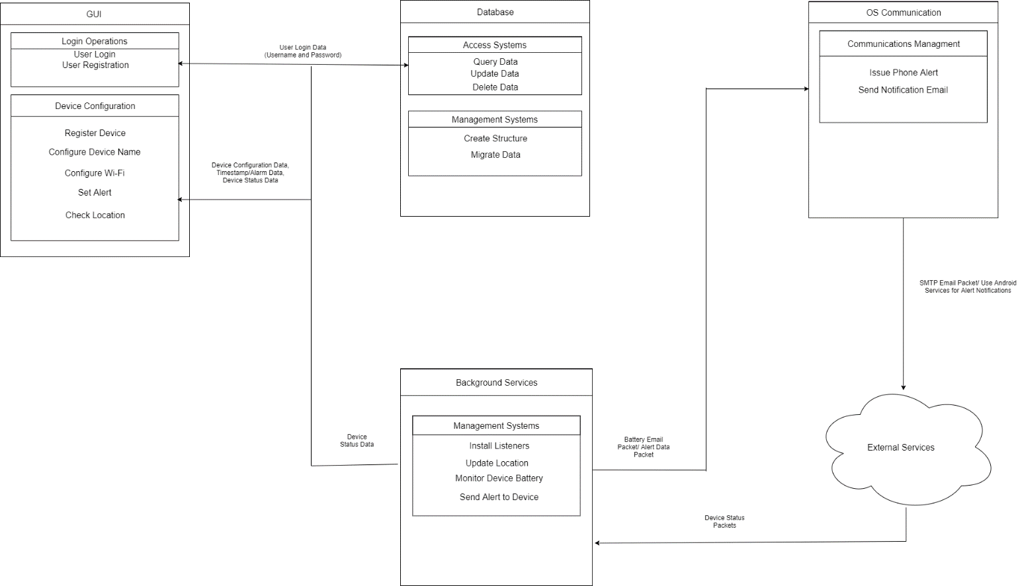

Software functional block definitions

1. GUI – The graphical user interface application designed to allow the user to access and edit data stored in the database. This functional block contains two subsystems:
   1. Login Operations – controls the user access to the application or registration if no user data is found.
   2. Device Configuration – controls configuration, addition, and display of Tracker information from and to the database for the GUI.
2. Database – The storage paradigm for Tracker statistics and configurations. This functional block contains two subsystems:
   1. Access Systems – runs queries against the stored data and returns, updates, or deletes that data according to user defined or system requested inputs.
   2. Managements Systems – controls the database modules construction or migration.
3. Background Services – The subsystems that will need to be launched when the device is started to handle the intermittent communication with the Trackers. This functional block contains one subsystem:
   1. Management Systems – controls the initial setup and controls the behaviors for the listening routes required for intermittent reporting of data by the Tracker.
4. OS Communications – The subsystem to interact with the OS features that allow for external communications from the device. This functional block contains one subsystem:
   1. Communication Management – Issues the mobile alerts, notifications, or email to the user.
5. External Services – Functional unit used to describe external communication means and hardware to interact with the IoT. Data will be packaged JSON embedded in UDP protocol.

### Mobile Application User Flow Diagrams

The following section represents how the user will interact with the application for the various features listed in the GUI logical module. The data transmitted between the different logical modules listed will consist of API schema objects as sent and received from the Firebase database application.

User Login Procedure

A screenshot of a cell phone

Description generated with very high confidence

Device Configuration Procedure

A close up of a logo

Description generated with very high confidence

Device Registration Diagram

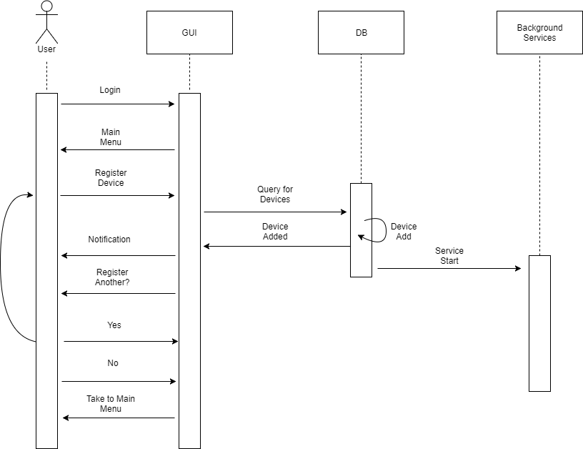

Alert Configuration Diagram

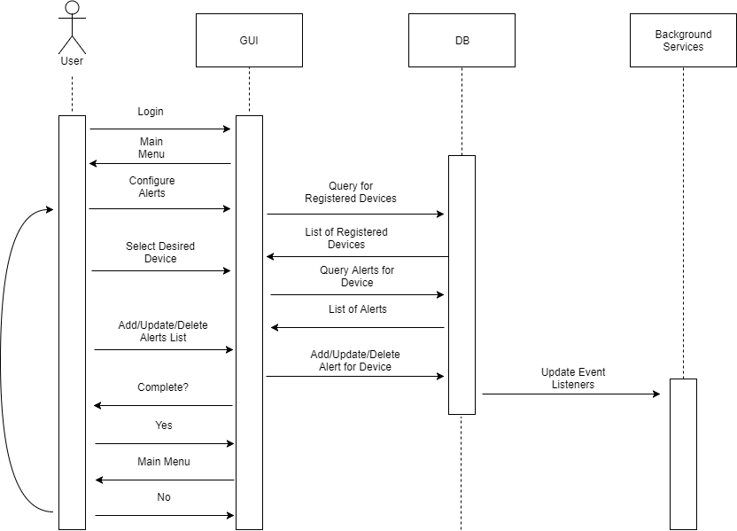

User Request Device Location

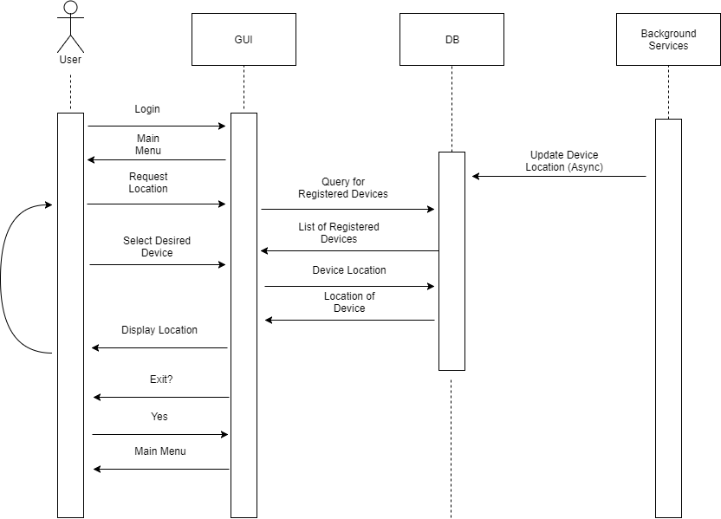

# Appendix: Test and Evaluation Master Plan and Report

**Definition of terms:**

*Test*: the act of inspecting or measuring a particular property or capability of the system.

*Evaluation*: the act of analyzing the results of a test to determine if a particular design requirement, constraint, or standard is satisfied.

*Threshold*: the minimal performance level for the design to satisfy a particular requirement, constraint, or standard.

*Objective*: the performance level goal, that is better than the performance Threshold value.

**Summary Tables of Test Plan**

|  |  |  |  |  |
| --- | --- | --- | --- | --- |
| Requirement | Test Method | Evaluation Method | Threshold | Objective |
| 1.0 | Demonstration | Test Adafruit HUZZAH ESP8266 Connection to Wi-Fi network | Adafruit HUZZAH ESP8266 able to connect | Adafruit HUZZAH ESP8266 able to connect |
| 2.0 | Demonstration | Test location Software | Within 6 ft of target. | Within 3 ft of target. |
| 3.0 | Demonstration | Test wireless sockets | Tracker and device send messages with 70% receive rate. | Tracker and device send messages with 90% receive rate. |
| 4.0 | Demonstration | Test attachment method to various surfaces. | Attaches to 4 out of 7 SPI std surfaces. | Attaches to 7 out of 7 SPI std surfaces. |
| 5.0 | Inspection | Adafruit HUZZAH ESP8266 has built-in LED that conforms to ANSI C82.16.16-2015 std. | Adafruit HUZZAH ESP8266 breakout has LED with no defects. | Adafruit HUZZAH ESP8266 breakout has LED with no defects. |
| 6.0 | Inspection | Test in tandem with Requirement 3.0. | Has application. | Has application. |
| 7.0 | Demonstration |  |  |  |
| 8.0 | Demonstration | Drain battery to test Battery check protocol. | Email received 10 seconds late. | Email received 2 seconds late. |
| 9.0 | Demonstration | Test User Input and Database. | Alarm triggers 10 seconds late. | Alarm triggers 2 seconds late. |
| 10.0 | Demonstration | Test User Input and Database. | Alarm triggers 10 seconds late and sound is 40 – 60 dB. | Alarm triggers 2 seconds late and sound is 60 dB. |
| 11.0 | Demonstration | Test User Input and Database. | LED triggers 10 seconds late. | LED triggers 2 seconds late. |
| 12.0 | Demonstration | Test in tandem with Requirement 2.0. | Database holds information 5 data packets late. | Database holds information 1 data packet late. |
| 13.0 | Demonstration | Test User Input and Database. | Database holds user defined name. | Database holds user defined name. |
| 14.0 | Demonstration | Test User Input and Database. | Database holds user defined email address. | Database holds user defined email address. |
| 15.0 | Demonstration | Test Database. | Database holds user defined Wi-Fi network credentials. | Database holds user defined Wi-Fi network credentials. |
| 16.0 | Demonstration | Test battery compartment. | Battery compartment requires tools to access. | Battery compartment does not require tools to access. |
| 17.0 | Demonstration | Test in tandem with Requirement 16.0. | Test if replacement battery satisfies tracker’s working conditions. | Test if replacement battery satisfies tracker’s working conditions. |
| 18.0 | Demonstration | Test in environment above 32oF. | Test if environment satisfies tracker’s working conditions. | Test if environment satisfies tracker’s working conditions. |
| 19.0 | Demonstration | Test in environment below 150oF. | Test if environment satisfies tracker’s working conditions. | Test if environment satisfies tracker’s working conditions. |
| 20.0 | Demonstration | Pour 8 fl oz of water on the tracker. Then test functionality. | Test if tracker continues working after having water poured in it. | Test if tracker continues working after having water poured in it. |

|  |  |  |  |  |
| --- | --- | --- | --- | --- |
| Constraint | Test Method | Evaluation Method | Threshold | Objective |
| 10 | Inspection | Measure tracker of height less than 45 cm | Height within 45 cm | Height within 45 cm |
| 20 | Inspection | Measure tracker of depth less than 45 cm | Depth within 45 cm | Depth with 45 cm |
| 30 | Inspection | Measure tracker of width less than 60 cm | Width within 60 cm | Width within 60 cm |
| 40 | Inspection | Measure tracker of weight less than 20 kg | Weight within 20 kg | Weight within 20 kg |
| 50 | Demonstration | power supply with less than 10 Ah | Power supply within 10 Ah | Power supply within 10 Ah |
| 60 | Demonstration | Test attachment methods with UL60335 | Comply with UL60335 | Comply with UL60335 |
| 70 | Demonstration | Test attachment methods with IEEE 802.11 | Comply with IEEE 802.11 | Comply with IEEE 802.11 |
| 80 | Demonstration | Test in Android Studio | 4.4 version of Android of newer | 4.4 version of Android of newer |
| 90 | Inspection | Test tracker’s tone with less than 80dB | Tone within 80dB | Tone within 80dB |
| 100 | Inspection | Test tracker’s LED with less than 60 lumens in brightness | Tracker’s LED within 60 lumens in brightness | LED within 60 lumens |
| 110 | Inspection | Test tracker’s LED with minimum brightness of 15 lumens | Tracker’s LED does not go below 15 lumens in brightness | Minimum of tracker LED of 15 lumens |
| 120 | Demonstration | Test attachment methods with ISO/IEC 29179:2012 standard | Comply with ISO/IEC 29179:2012 | Comply with ISO/IEC 29179:2012 |
| 130 | Demonstration | Test attachment methods with ISO 9241 standard | Comply with ISO 9241 standard | Comply with ISO 9241 standard |
| 140 | Demonstration | Test attachment methods with ISO 25062 standards | Comply ISO 25062 standards | Comply ISO 25062 standards |
| 150 | Inspection | Test in DB to see the encryption of user’s inputs | Encryption of user inputs | Encryption of user inputs |
| 160 | Demonstration | Test in device wiring to comply with ANSI/NEMA WD 6-2016 | Devices wiring comply with ANSI/NEMA WD 6-2016 | Devices wiring comply with ANSI/NEMA WD 6-2016 |
| 170 | Demonstration | Test device Wi-Fi to see if it is FCC certified | FFC certification of Wi-Fi | FFC certification of Wi-Fi |
| 180 | Demonstration | Test device to meet RFC 1042 standard for IP datagrams | The device meets RFC 1042 for IP standards | The device meets RFC 1042 for IP standards |

|  |  |  |  |  |
| --- | --- | --- | --- | --- |
| Standard | Test Method | Evaluation Method | Threshold | Objective |
| 10 | Inspection | verified in accordance to IEEE 802.11 communication standard. | Within IEEE 802.11 communication standard. | verified in accordance to IEEE 802.11 communication standard. |
| 20 | Inspection | verified in accordance to SPI standard A-3, B1, B-2, B-3, C-1, C-2, and C-3. | Within SPI standard A-3, B1, B-2, B-3, C-1, C-2, and C-3. | verified in accordance to SPI standard A-3, B1, B-2, B-3, C-1, C-2, and C-3. |
| 30 | Inspection | verified in accordance to LED production standard ANSI C82.16-2015 | Within ANSI C82.16-2015 | verified in accordance to LED production standard ANSI C82.16-2015 |
| 40 | Inspection | Tested for compliance with the UL 60335 standard | Within the UL 60335 standard | Tested for compliance with the UL 60335 standard |
| 50 | Inspection | Tested for compliance with ISO/IEC 29179:2012 standard | Within ISO/IEC 29179:2012 standard | Tested for compliance with ISO/IEC 29179:2012 standard |
| 60 | Inspection | Tested for compliance with ISO 9241 standard. | Within ISO 9241 standard. | Tested for compliance with ISO 9241 standard. |
| 70 | Demonstration | Tested for compliance with ISO 25062 standard | Within ISO 25062 standard | Tested for compliance with ISO 25062 standard |
| 80 | Inspection | Tested for compliance with FIPS 180-4 standard | Within FIPS 180-4 standard | Tested for compliance with FIPS 180-4 standard |
| 90 | Inspection | Tested for compliance with ANSI/NEMA WD 6-2016 standard. | Within ANSI/NEMA WD 6-2016 standard. | Tested for compliance with ANSI/NEMA WD 6-2016 standard. |
| 100 | Inspection | verified in accordance to RFC 1042 standard | Within RFC 1042 standard | verified in accordance to RFC 1042 standard |

**Summary Tables of Test Results**

|  |  |  |  |  |  |
| --- | --- | --- | --- | --- | --- |
| Requirement | Test Date | Test and Evaluation Location | Result | Notes | Date Passed (Accepted) |
| 1.0 |  |  |  |  |  |
| 2.0 |  |  |  |  |  |
| 3.0 |  |  |  |  |  |
| 4.0 |  |  |  |  |  |
| 5.0 |  |  |  |  |  |
| 6.0 |  |  |  |  |  |
| 7.0 |  |  |  |  |  |
| 8.0 |  |  |  |  |  |
| 9.0 |  |  |  |  |  |
| 10.0 |  |  |  |  |  |
| 11.0 |  |  |  |  |  |
| 12.0 |  |  |  |  |  |
| 13.0 |  |  |  |  |  |
| 14.0 |  |  |  |  |  |
| 15.0 |  |  |  |  |  |
| 16.0 |  |  |  |  |  |
| 17.0 |  |  |  |  |  |
| 18.0 |  |  |  |  |  |
| 19.0 |  |  |  |  |  |
| 20.0 |  |  |  |  |  |
| 21.0 |  |  |  |  |  |

|  |  |  |  |  |  |
| --- | --- | --- | --- | --- | --- |
| Constraint | Test Date | Test and Evaluation Location | Result | Notes | Date Passed (Accepted) |
| 10 |  |  |  |  |  |
| 20 |  |  |  |  |  |
| 30 |  |  |  |  |  |
| 40 |  |  |  |  |  |
| 50 |  |  |  |  |  |
| 60 |  |  |  |  |  |
| 70 |  |  |  |  |  |
| 80 |  |  |  |  |  |
| 90 |  |  |  |  |  |
| 100 |  |  |  |  |  |
| 110 |  |  |  |  |  |
| 120 |  |  |  |  |  |
| 130 |  |  |  |  |  |
| 140 |  |  |  |  |  |
| 150 |  |  |  |  |  |
| 160 |  |  |  |  |  |
| 170 |  |  |  |  |  |
| 180 |  |  |  |  |  |

|  |  |  |  |  |  |
| --- | --- | --- | --- | --- | --- |
| Standard | Test Date | Test and Evaluation Location | Result | Notes | Date Passed (Accepted) |
| 10 |  |  |  |  |  |
| 20 |  |  |  |  |  |
| 30 |  |  |  |  |  |
| 40 |  |  |  |  |  |
| 50 |  |  |  |  |  |
| 60 |  |  |  |  |  |
| 70 |  |  |  |  |  |
| 80 |  |  |  |  |  |
| 90 |  |  |  |  |  |
| 100 |  |  |  |  |  |

**Test and Evaluation Methods**

***Requirements (verification of achievement)***

Requirement 1.0 will be verified in accordance to IEEE 802.11 communication standard. Specialize test will include analysis by a professional third party and completed a compliance report in order to ensure everything fulfils the standard requirement.

Requirement 2.0 will be tested by demonstration. We will demonstrate by connecting the tracker to a Wi-Fi network and using the open source positioning system.

Requirement 3.0 will be tested by demonstration by connecting the item tracker to the mobile device that has the application.

Requirement 4.0 will be tested by demonstration by attaching the item tracker to the various surfaces.

Requirement 5.0 will be tested by inspection. The Adafruit HUZZAH ESP8266 breakout has a conformed LED installed in the chip.

Requirement 6.0 will be tested by inspection. The item tracker will connect to a device that has the application.

Requirement 7.0 will be tested by demonstrating using the application on an Android device.

Requirement 8.0 will be tested by demonstration. We will purposefully drain a battery to see if the battery power protocol works.

Requirement 9.0 will be tested by demonstrating that the visual alarm is triggered at the user specified date and time.

Requirement 10.0 will be tested by demonstrating that the audio alarm is triggered at the user specified date and time.

Requirement 11.0 will be tested by demonstrating that the LED is triggered at the user specified date and time.

Requirement 12.0 will be tested by demonstrating that the user can locate the tracker and the item that the tracker is attached to.

Requirement 13.0 will be tested by demonstrating that the user can name the tracker.

Requirement 14.0 will be tested by demonstrating that the user can input the user’s email address and the application will store that data.

Requirement 15.0 will be tested by demonstrating that the user can enter the Wi-Fi credentials and the application will store that data.

Requirement 16.0 will be tested by demonstrating that the battery can be accessed by the user so the user can replace the battery.

Requirement 17.0 will be tested by demonstrating that the power source can be replaced with another power source that is of the same form factor.

Requirement 18.0 will be tested by demonstrating that the tracker functions in environmental temperatures above 32oF.

Requirement 19.0 will be tested by demonstrating that the tracker functions in environmental temperatures below 150oF.

Requirement 20.0 will be tested by demonstrating that the item tracker will continue to function after having 8 fl oz of water being poured on it.

Requirement 21.0 will be tested by demonstrating that the tracker will continue to function after being dropped 3 ft from the ground.

***Constraints (verification of conformity)***

Constraint 10 will be tested by inspection that measure the tracker’s height less than 45 cm.

Constraint 20 will be tested by inspection that measure tracker’s depth less than 45 cm.

Constraint 30 will be tested by inspection that measure tracker’s width less than 60 cm.

Constraint 40 will be tested by inspection that measure tracker of height less than 45 cm.

Constraint 50 will be tested by demonstration that test the power supply with less than 10 Ah.

Constraint 60 will be tested by demonstration that test the attachment methods with UL60335.

Constraint 70 will be tested by demonstration that test the attachment methods with IEEE 802.11.

Constraint 80 will be tested by demonstration that is tested in Android Studio.

Constraint 90 will be tested by inspection that test tracker’s tone with less than 80dB.

Constraint 100 will be tested by inspection that test tracker’s LED with less than 60 lumens in brightness.

Constraint 110 will be tested by inspection that test tracker’s LED with minimum brightness of 15 lumens.

Constraint 120 will be tested by demonstration that test the attachment methods with ISO/IEC 29179:2012 standard.

Constraint 130 will be tested by demonstration that test the attachment methods with ISO 9241 standard.

Constraint 140 will be tested by demonstration that test the attachment methods with ISO 25062 standards.

Constraint 150 will be tested by inspection that is tested in Database to see the encryption of user’s inputs.

Constraint 160 will be tested by demonstration that test in device wiring to comply with ANSI/NEMA WD 6-2016.

Constraint 170 will be tested by demonstration that test the decide Wi-Fi to see if it is FCC certified.

Constraint 180 will be tested by demonstration that test the device to meet RFC 1042 standard for IP datagrams.

***Standards (verification of compliance)***

Standard 10 will be verified in accordance to IEEE 802.11 communication standard. Specialize test will include analysis by a professional third party and completed a compliance report in order to ensure everything fulfils the standard requirement.

Standard 20 will be verified in accordance to SPI standard A-3, B1, B-2, B-3, C-1, C-2, and C-3. Test will include inspection of the material used to create the surface coating of the device.

Standard 30 will be verified in accordance to LED production standard ANSI C82.16-2015. Test will include inspection of the lighting and analysis of the procedures used in implementing the LED into the device.

Standard 40 will be tested for compliance with the UL 60335 standard at Wright State University. The evaluation will be conducted via analysis and inspection.

Standard 50 will be tested for compliance with ISO/IEC 29179:2012 standard. Test will be conducted at Wright State University and test will include inspection of the interface of the mobile application.

Standard 60 will be tested for compliance with ISO 9241 standard. Testing of the components of the device will occur on Wright State’s main campus.

Standard 70 will be tested for compliance with ISO 25062 standard. Testing will include a demonstration of the mobile applications usability.

Standard 80 will be tested for compliance with FIPS 180-4 standard. Test will include an analysis of the stored data of the product.

Standard 90 will be tested for compliance with ANSI/NEMA WD 6-2016 standard. Test will occur at Wright State University and an inspection of the device will occur to ensure it complies with the standard.

Standard 100 will be verified in accordance to RFC 1042 standard. An analysis and inspection will be conducted at Wright State University in order to ensure the standards are being meet.

# Appendix: Résumés of Team Members







