|  |  |
| --- | --- |
| **Group** 27 | Item Tracker |
| **Major:** | **Team members:** |
| CS | Mohammad Aljagthmi |
| EE | Ryan Ly |
| CEG | Jake Manser |
| CS | Donald Taylor |

**Design Functionality**

1. Wi-Fi positioning

Using open source tools, such as Redpin, we will construct a Wi-Fi fingerprint for the tracker with room level accuracy. This system functions based on symbols, instead of geographic coordinates, to represent mappings of location. The position is calculated based on the signal strength of the tracker from adjacent wireless devices and the stored information of these devices to create a network of positions of reference. The system works based on two major components, a network sniffer to locate objects and a location database with algorithms to locate stored objects.

1. Application communication

The included smart device application will allow the user to uniquely identify each Tracker on their network. With this application, the user will be able to register Trackers and set notifications and/or alarms for the individual Trackers which will activate the LED at the specified date/time. The user can also use the application to query the current location of any registered Tracker on the network.

1. Surface adhesion

The Tracker shall be able to attach to the surface of various objects and remain attached until the user removes it. While on the object, the Tracker will remain in contact with the object to ensure that the tracker’s application can obtain accurate data of the object being tracked. The Tracker must also be able to be removed from the object by the user. The Tracker, when not attached to an object to track, shall be able to be attached to an object that the user chooses to track.

1. Notification/alarm

The device will be able to notify the user of is location via audible alarm and/or LED light activation. When tracking a specific item, the smart device will emit an audio sound that will interact with the Tracker. The device will also flash LED lights to draw the user to its location. The application will also display to the user the general room level the item is located.

1. User input

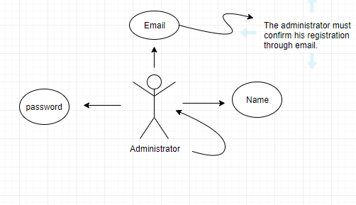

1. Replaceable power source

The Tracker will be able to accept a battery as a power source. The Tracker’s battery compartment shall also be accessible with aid of a tool (screwdriver) to remove the spent power source and subsequently replace it with a new power source. The battery compartment shall also be able to be closed and sealed for completeness of installation of a new power source.

1. Minor damage resistance

The Tracker’s hardware will be encased in a housing to protect the device from damage. The housing will be designed around the Tracker to ensure the least amount of movement of the device while inside of the housing. The housing will be able to open and close for minor maintenance by the user. When closed, the Tracker’s housing will be sealed to prevent the entering of outside particles and fluids into the housing. In addition, the housing will have a rubberized external coating to enhance the shock absorbing quality of the casing to further protect the Tracker’s hardware.