|  |  |
| --- | --- |
| **Group** 27 | Item Tracker |
| **Major:** | **Team members:** |
| CS | Mohammad Aljagthmi |
| EE | Ryan Ly |
| CEG | Jake Manser |
| CS | Donald Taylor |

**System Architecture**

*Blue text (like this) should be removed from your submission. Sketch and describe the overall hardware AND software architectures for your design. These sketches should include interconnected functional blocks sufficient to support the design functionality of your system, and with proper design choices, should have the potential to satisfy all earlier selected requirements, constraints, and standards. Each functional block should be defined and described, and connections between blocks should be identified for later specification (e.g., USB for hardware architecture, data structure for software architecture). It may be simplest to enumerate the blocks for association with their subsequent definitions, and the interconnect between blocks may then be a conjunction of their enumerated values.*

Hardware Architecture

Insert hardware block diagram

Hardware functional block definitions

1. HW block 1 definition and description
2. HW block 2 definition and description
3. HW block 3 definition and description

⁞

⁞

Software Architecture

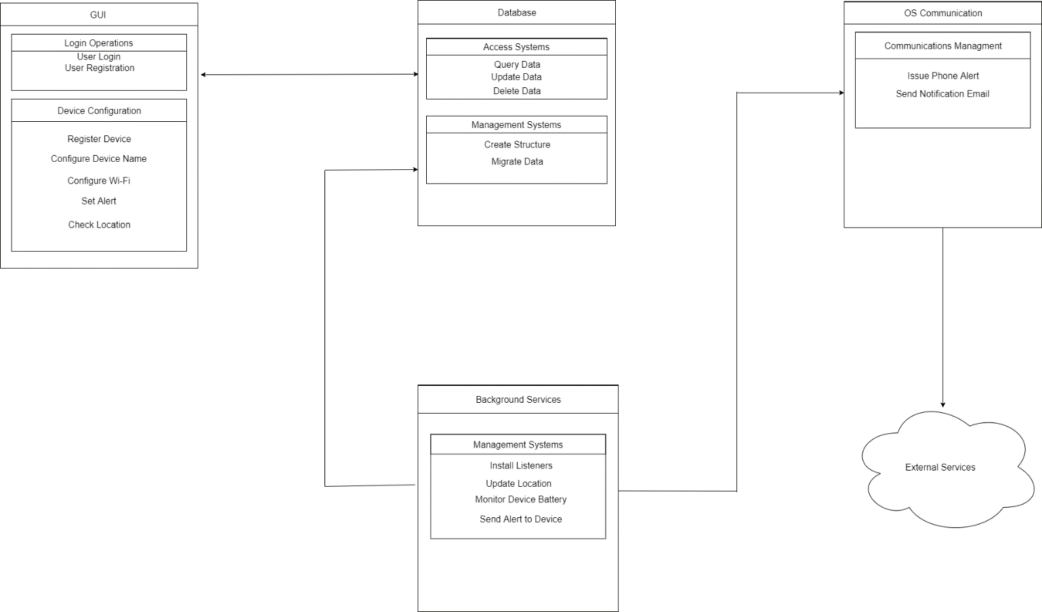

Software functional block definitions

1. GUI – The graphical user interface application designed to allow the user to access and edit data stored in the database. This functional block contains two subsystems:
   1. Login Operations – controls the user access to the application or registration if no user data is found.
   2. Device Configuration – controls the configuration or addition of Trackers to the database for display in the GUI.
2. Database – The storage paradigm for Tracker statistics and configurations. This functional block contains two subsystems:
   1. Access Systems – runs queries against the stored data and returns, updates, or deletes that data according to user defined or system requested inputs.
   2. Managements Systems – controls the database modules construction or migration.
3. Background Services – The subsystems that will need to be launched when the device is started to handle the intermittent communication with the Trackers. This functional block contains one subsystem:
   1. Management Systems – controls the initial setup and controls the behaviors for the listening routes required for intermittent reporting of data by the Tracker.
4. OS Communications – The subsystem to interact with the OS features that allow for external communications from the device. This functional block contains one subsystem:
   1. Communication Management – Issues the mobile alerts, notifications, or email to the user.