BITS PILANI, DUBAI CAMPUS II Semester 2018 – 2019 III Yr. C.S.
Course: CS F363 Compiler Construction
Individual LAB EXERCISE: Total Marks: 10 Weightage: 10 %
Date for Demonstration 04 Feb (Monday Batch) 05 Feb (Tuesday Batch)
Record can be submitted only after successful demonstration.
Date for Record Submission : immediate Next Lab Class
Record should contain LEX Source Code, Input and Output.
Note: Delayed Submission will result in reduction in marks.
Bring LEX / YACC Class Notes for ready reference for Lab Class.
Copying not permissible. Issue Date: 27/01/19
The students are required to work in their individual linux accounts in the linux server.
Use input redirection ( < read data from a file )
and output redirection ( > write results to a file ).
- Write LEX SOURCE, compile and run it for the following problem:
Recognize, Validate (day and month [including Feb].) and Change a date in American Convention to that of British Convention:
INPUT: OUTPUT:
10/05/2004 05/10/2004
06/31/2005 31/06/2005
31/32/03 invalid input
02/30/2005 invalid input
02/28/2005 28/02/2005
- Write LEX SOURCE, compile and run it for the following problem:
Read any C program as INPUT [say: sample.c; you must write a C program as a test case] and list the IDENTIFIERS, CONSTANTS (int, float, char) ARITHMETIC OPERATORS and KEYWORDS (consider at least 5 keywords of your choice: like switch, if etc) as OUTPUT on the screen. Also show the line numbers in the program where these items occur. Suppress spaces / tabs and other symbols in output.

INPUT: use any C program of your first year or second year [say sample.c: take efforts to carefully create a C program which will include at least - 2 identifiers, 2 int constants, 2 float constants, 2 char constants, 2 arithmetic operators and 5 keywords].

SAMPLE OUTPUT:
include keyword line 1
char keyword line 4
a1 identifier line 4
10 integer line 6

PTO

3. Write LEX SOURCE to recognize unsigned numbers. Test your code with many inputs (valid as well as invalid inputs).
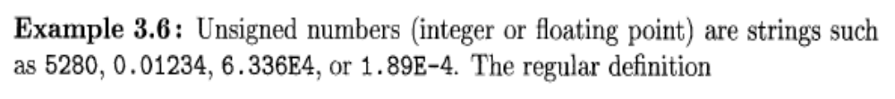
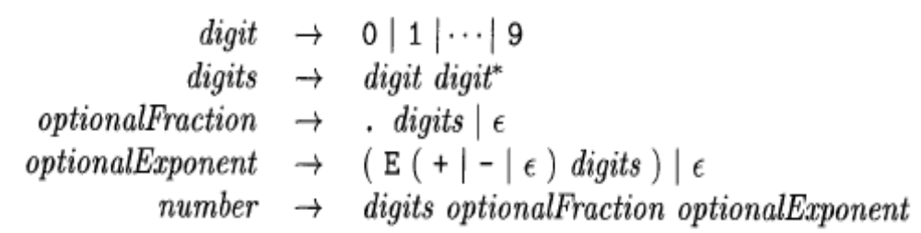

(Note: You must express this regular definition according to LEX syntax)

