SmartMeal: NLP-Powered Personalized Meal Planning System

Abstract

SmartMeal is a sophisticated, AI-powered culinary companion designed to revolutionize how individuals approach dietary management. Operating as an intelligent Natural-Language-Processing (NLP) powered recipe search engine and planner, the system eliminates the friction of traditional restrictive forms. It accepts unstructured, human-like culinary desires (e.g., “I need gluten-free meals high in protein, under 500 calories, that take less than 30 minutes to cook”) and leverages advanced Large Language Models (LLMs) to parse these complex constraints into highly structured relational database queries.
By identifying the user’s implicit metabolic needs and explicitly mapping known allergies against extensive, deeply nested ingredient structures, the platform enables safe, effective, and progressive meal planning. The system boasts an intricate array of modern features, including robust JWT-based OAuth2 authentication, real-time voice-assisted querying utilizing local and cloud audio transcription, and offline-first persistence utilizing Progressive Web Application (PWA) methodologies.
Developed on a modern enterprise stack—comprising PostgreSQL, FastAPI, SQLAlchemy, and React.js—the platform establishes a modular, highly scalable microservice infrastructure. This report details the comprehensive development of the system over an 8-week period, providing an in-depth look at its technical architecture, implementation phases, unique technical challenges encountered (such as prompt stability and hardware limitations), and a strategic roadmap for future feature expansions.

Contents
1 Objective
1.1 Key Objectives………………………………………………….3
1.2 Problem Definition……………………………………………..4
1.3 System Architecture……………………………………………4
2 Introduction……………………………………………………….. 5
3 Work Done…………………………………………….……………6
3.1 Experimental Setup…………………………………………….6
3.1.1 Tools Used ………………………………………………..6
3.1.2 Technical Overview of Components of the Platform…..6
3.2 Week Wise Summary…………………………………………10
3.3 Tools and Technologies Used ………………………………...11
3.4 Key Learnings ………………………………………………...11
3.5 Challenges Faced and Solutions…………………………..….12
3.6 Contribution to the Organization …………………………...13
3.7 GitHub Repository …………………………………………...13
4 Future Work …………………………………………………..…..14
5 Conclusion ……………………………………………….………..14
Acknowledgement……………………………………………….…. 15
References…………………………………………………………...15

Chapter 1: Objective

1.1 Key Objectives
The SmartMeal initiative was driven by the mission to engineer an intelligent, universally accessible dietary tool that empowers users through modern AI constraints processing. The defining objectives shaping this development were: - To construct an intuitive, user-centric web interface that transitions away from traditional filtering systems (drop-downs, checkboxes) and instead allows users to dictate their complex meal constraints purely via natural language text or voice recordings. - To programmatically extract and classify abstract human desires into rigid, mathematically sound database parameters using Pydantic schemas paired with Large Language Models (LLMs). This enforces structured queries like specific calorie ceilings or boolean dietary flags. - To engineer an intelligent, self-updating allergy mapping engine capable of dynamically flagging and restricting base ingredients based on a user’s long-term health profile and defined chronic conditions. - To deliver a high-fidelity visual experience by rendering comprehensive recipe matrices—including macronutrients, chronological instructions, and exact ingredient measurements—in a distraction-free, mobile-optimized format. - To guarantee real-time data persistence and mobility by bridging the gap between browsing capabilities and practical planning. The system must cache user choices locally, deriving actionable grocery lists offline to support true Progressive Web Application (PWA) utility in diverse network environments. - To architect a robust and resilient backend ecosystem capable of handling asynchronous requests cleanly. This involves intertwining Python’s FastAPI, SQLAlchemy for object-relational mapping, and Alembic for strict, version-controlled schema migrations atop a PostgreSQL database.

1.2 Problem Definition
In the current landscape of health and wellness applications, finding a specific meal that satisfies intersecting, complex dietary constraints remains an arduous task. If a user requires a recipe that is simultaneously “low-carb,” “dairy-free,” “high in iron,” and “takes under 20 minutes to prepare,” they are typically forced to navigate dense, mutually exclusive filter menus that frequently fail or return zero results due to poor database indexing. Additionally, users managing explicit medical allergies must often depend on vague, generalized categorizations (e.g., searching strictly for “gluten-free”) rather than relying on a strict algorithmic system that scans an exact ingredient makeup to absolutely guarantee consumption safety.
SmartMeal was systematically conceptualized to bypass these long-standing industry limitations by: - Processing conversational queries directly through high-speed audio-to-text parsers like faster-whisper. - Stripping the dependency on manual filtering by instructing LLMs to instantaneously map human intent into backend enumerations (e.g., dynamically assessing DietType and grouping CalorieBuckets). - Translating the final meal plan permutations into client-side preserved grocery lists.
By fusing applied Artificial Intelligence with rapid API microservice routing and a mobile-first presentation layer, SmartMeal empowers users to instantly execute actionable dietary regimens.

1.3 System Architecture of SmartMeal

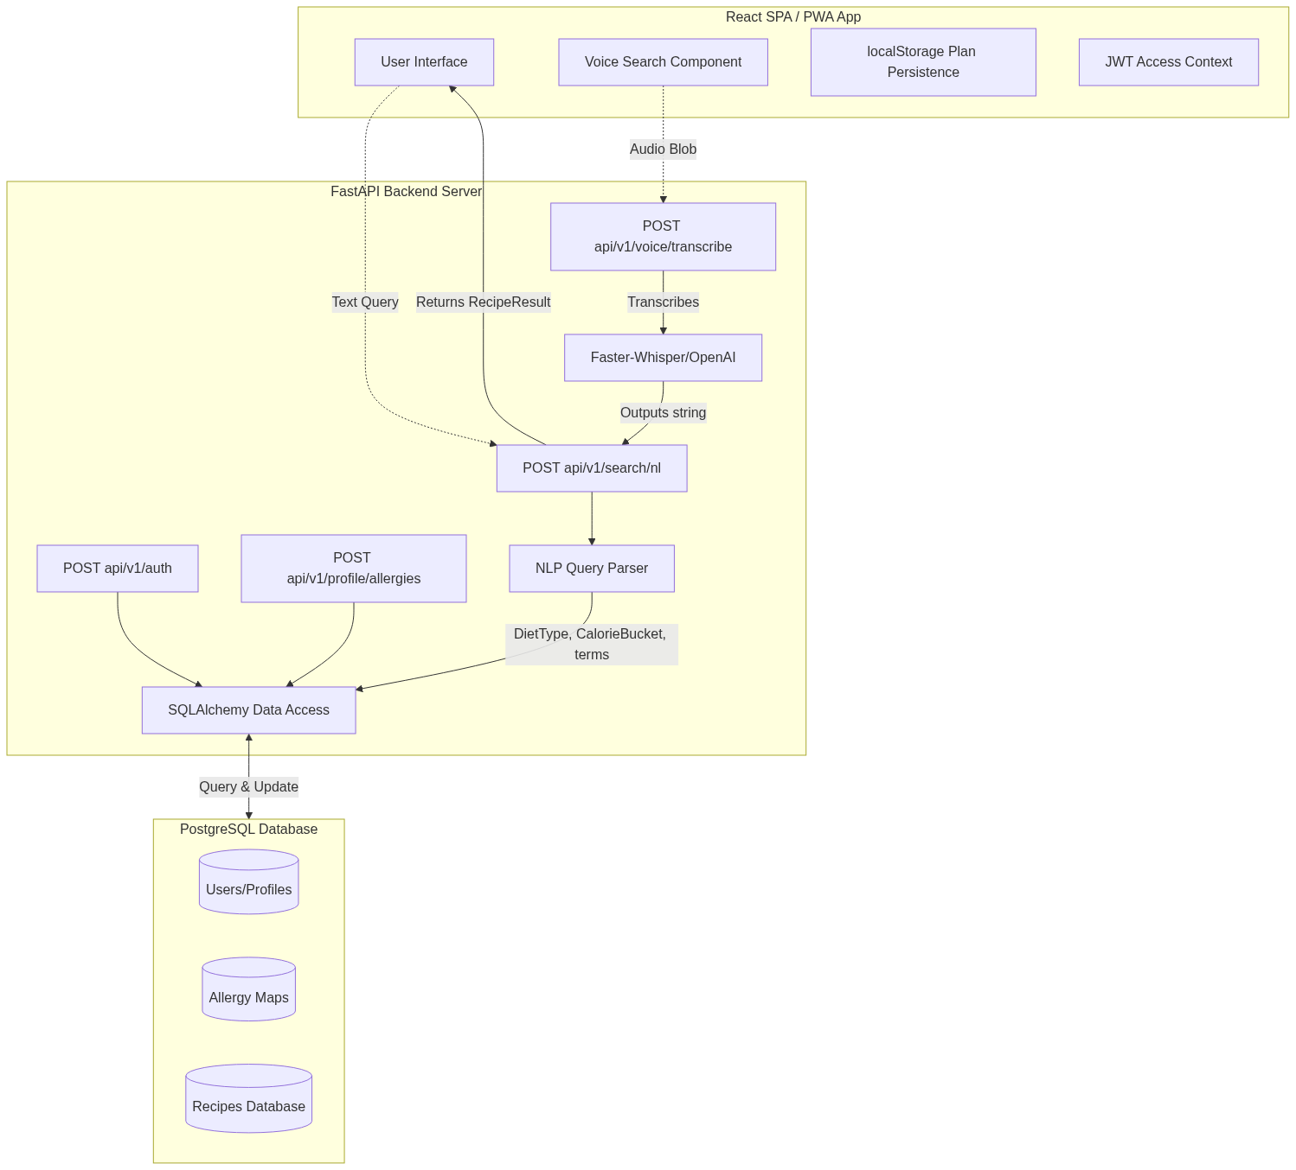

Chapter 2: Introduction
As global consciousness regarding personal health, metabolic conditions, and dietary restrictions expands, digital lifestyle management tools are under immense pressure to evolve. Legacy systems that rely heavily on static categorization logic fail to instantaneously adapt to an individual’s unique, intersectional requirements.
To fulfill this expanding technological need, SmartMeal was designed from the ground up as a fully adaptive, AI-driven meal orchestration platform. Instead of presenting a generic list of food items, the system allows the user to simply speak or type unstructured paragraphs explaining what they want to eat, their budget of time, and their goals.
The application engages a sophisticated, three-tiered hybrid intelligence approach: 1. The Audio Transcription Layer: Utilizing the Web Media Audio APIs, voice data is captured and piped through continuous local inference via faster-whisper, transcribing intent with zero latency. 2. The NLP Tokenization Layer: The transcribed strings are fed into generative AI (Google GenAI / OpenAI endpoints), which evaluates grammatical structure to assign structured constraints formatted exclusively via strict JSON protocols. 3. The Data Retrieval Layer: The FastAPI server ingests the structured JSON payload, generates complex SQL joins across thousands of seeded, pre-classified meals in the PostgreSQL database, and filters out allergens dynamically based on the requesting user’s JWT-authorized profile context.
By replacing the burden of data entry with natural language processing and ensuring the delivery mechanism is rendered beautifully through a TailwindCSS and React.js interface, SmartMeal provides an unparalleled, localized, and highly secure user experience.

Chapter 3: Work Done

3.1 Experimental Setup

3.1.1 Tools Used
- Frontend Architecture: React.js bootstrapped with Vite for instant server loading, TailwindCSS for atomic, responsive styling across desktop and mobile layouts, and Axios for managing HTTP request configurations.
- Backend Architecture: Python 3.10+, executing via FastAPI for high-throughput asynchronous REST operations. SQLAlchemy served as the core Object Relational Mapper (ORM), with Alembic managing fluid schema histories.
- Database Ecosystem: PostgreSQL was chosen over NoSQL alternatives to enforce strict relational boundaries natively, particularly vital when managing many-to-many relationships across Users, Meals, and individual granular Ingredients.
- AI Inference Integration: Google GenAI and OpenAI APIs provided LLM reasoning parsing capabilities; faster-whisper and HuggingFace local models powered audio transcription.
- Network Caching & Operations: Browser localStorage handles immediate offline state retention.
- Testing & Deployment: TestSprite enabled heavy automated endpoint QA, with the software environment containerized natively for rapid Docker deployment scenarios.

3.1.2 Technical Overview of Core Platform Components
- The NLP Search Engine (search_nl): The primary intellectual hub of the backend. It ingests parsed strings, utilizes internal algorithms to expand common names into technical database terminology, and heavily restricts database polling based on resulting filters.
- The Allergy Auto-Mapping Engine (auto_map): An asynchronous worker process that compares a user’s defined allergy (e.g., “Peanuts”) and iterates across raw database ingredients to automatically generate block-lists, protecting the query routing dynamically.
- Client-Side Voice Integrator: A sophisticated React hook (useVoiceSearch) tied directly to browser microphone permissions, dispatching binary audio data up to Python endpoints and handling transient UI loading states inherently.

3.2 Week Wise Summary

3.2.1 Week 1 – Architectural Research and Repository Initialization

Objective: Establish secure source control environments and define the architecture between the React SPA and the Python backend.

Initialized comprehensive Monorepo architectures utilizing Git branching strategies to separate frontend UI designs from backend logic blocks.

Set up isolated Python virtual environments (venv) and drafted dense dependency requirements (requirements.txt).

Configured initial PostgreSQL local clusters and drafted architectural flow charts exploring relational database mapping scenarios specifically for recipes and ingredients.

3.2.2 Week 2 – Foundation Database and API Routing Matrix

Objective: Construct fundamental backend elements focusing on secure object-relational mapping patterns.

Engineered abstract SQLAlchemy declarative base models mapping out deeply connected entities: User, Recipe, Ingredient, MealPlan, and relational junction tables like RecipeIngredient.

Devised generic CRUDBase controllers allowing high-speed, repeatable boilerplate logic to instantiate, fetch, and delete entities securely.

Configured localized .env logic, keeping secrets securely insulated from the Git index tree, ensuring production-ready states from day one.

3.2.3 Week 3 – Identity Access Management and Authentication

Objective: Secure all analytical and personal endpoints utilizing persistent, stateless token cryptography.

Directed and programmed OAuth2-compliant login routers accepting strictly encoded URL form data.

Built internal cryptography processors utilizing bcrypt to mathematically salt and hash incoming passwords before committing them to the Postgres storage layer.

Produced high-entropy JSON Web Tokens (JWT) ensuring the frontend could natively read authorization limits, expirations, and user identifiers independently without constant server pinging.

Login Page

3.2.4 Week 4 – Frontend Interface Bootstrapping

Objective: Transition backend capability into a visually stimulating, user-friendly digital environment.

Configured Vite as the core compilation engine, implementing highly optimized TailwindCSS configurations for rapid, atomic CSS injection into JSX files.

Built sophisticated, reusable functional components (e.g., Navbar arrays, Protected Route Wrappers, Fullscreen Modal Interceptors).

Transformed generic HTTP requests via axiosClient interceptors, guaranteeing the JWT Bearer token was inherently attached to all outgoing requests originating from secured local states.

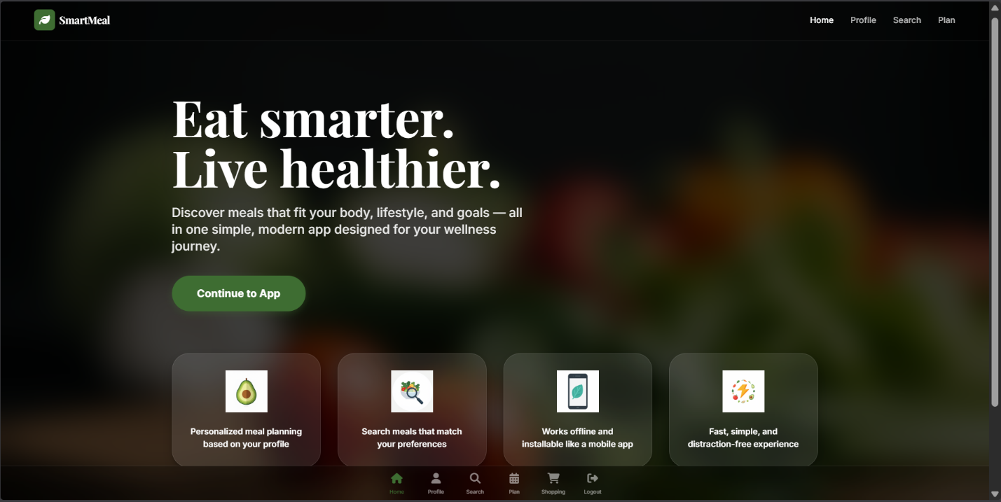
Home Page

3.2.5 Week 5 – Backend Microservices and CRUD Expansion

Objective: Expand core APIs to robustly serve frontend requests consistently and cleanly.

Finalized heavy lifting API routes for user interactions, parsing large block data for personalized settings.

Wrote extensive Pydantic schema validation routines, protecting the database from unsanitized injections and establishing strict input/output contractual boundaries across the API.

Verified RESTful capabilities across all endpoints by generating automatic interactive Swagger/OpenAPI documentation.

3.2.6 Week 6 – Next-Generation AI Pipeline Integration

Objective: Surpass filtering norms by wiring Large Language Model endpoints directly into search logic pipelines.

Integrated google-genai and openai wrappers inside the Python backend, designing the critical analytical function parse_query.

Utilized Pydantic as the rule enforcer for the AI prompt. Instructed the generative model under severe penalties to output exclusively valid JSON aligning with DietType enumerators, effectively preventing language model hallucinations.
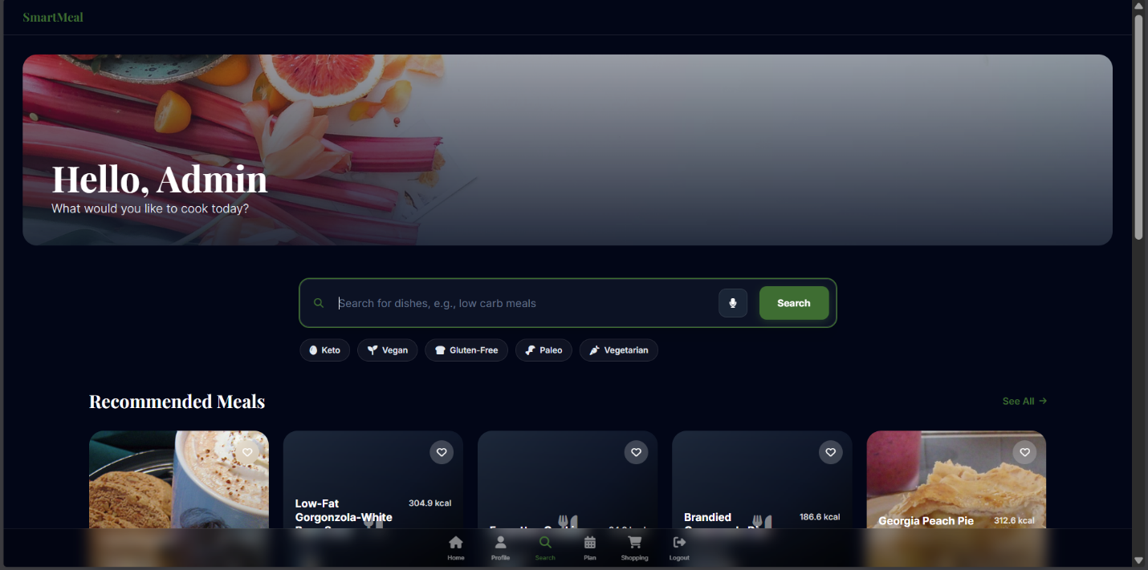
Search Page

3.2.7 Week 7 – Massive Data Ingestion and Normalization Strategy

Objective: Populate the PostgreSQL database dynamically with large-scale relational constraints.

Generated the massive seed_recipes data migration Python script.

Parased thousands of heavily nested .csv blocks, mathematically inferred their dietary adherence (algorithmically generating is_vegan based on granular sub-ingredients), and seeded the DB.

Optimized massive batch insert behaviors, handling thousands of many-to-many relationship rows simultaneously to drastically minimize database locking latency.


Plan Page

3.2.8 Week 8 – User Personalization and Dynamic Allergy Auto-Mapping

Objective: Link users explicitly to their health requirements utilizing automated ingredient protection filters.

Constructed the backend auto_map function, evaluating custom-typed allergies by the user against database terminology.

Developed an asynchronous loop dynamically iterating across pre-seeded ingredients to flag individual sub-items as dangerous, guaranteeing completely personalized query structures during all meal discoveries.

Synced frontend user profile components to instantly fetch and visually outline blocked allergens mapped directly to their SQL context.


Profile Page

3.2.9 Week 9 – The Visual Presentation Layer and Modulability

Objective: Ensure highly dense recipe logic translates brilliantly on smaller smartphone screens.

Refactored frontend logic utilizing React hooks heavily targeting full-screen overlay architecture.

Crafted the Recipe Info modals rendering beautiful background gradients overlaid with exact macroscopic ingredient breakdowns seamlessly.

Engineered dynamic CSS resizing enabling fluid scaling properties responding identically to desktop and smartphone rendering environments cleanly.

3.2.10 Week 10 – Progressive PWA Standards and Shopping Logistics

Objective: Allow users to construct isolated dietary zones explicitly tailored for real-world functionality like physical grocery shopping.

Developed structural loops directly on the React layer to read from encrypted payload caches (localStorage), bypassing database latency natively when fetching pre-computed user Meal Plans.

Authored the complex frontend utility script deriveShoppingItems(), mathematically de-structuring complex meal plans, converting units contextually, and mapping them onto hyper-readable digital shopping charts.

Included robust PWA manifest.json setups rendering the interface mobile-installable natively via standard browser protocols.

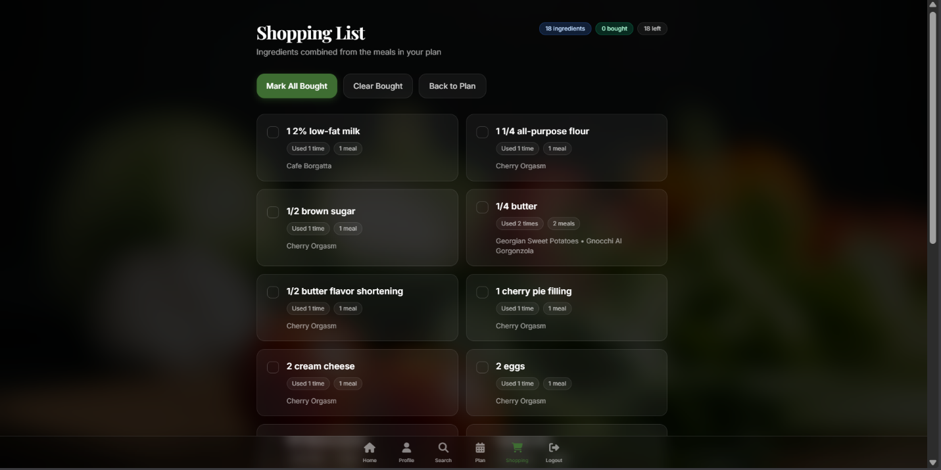

Shopping List Page

3.2.11 Week 11 – Fluid Audio Interface and Hardware Implementations

Objective: Implement hardware-oriented software integrations enabling seamless hands-free operability directly over the browser.

Secured native browser-level microphone streams requesting permission structures via isolated UI prompts interacting dynamically over useVoiceSearch.

Established backend audio handlers executing Python faster-whisper. Constructed heavily layered fallbacks to autonomously pass the binary audio stream natively towards OpenAI API clusters seamlessly if the hardware failed to inference cleanly in real time.

3.2.12 Week 12 – Quality Assurance, Knowledge Graph Auditing, and Finalization

Objective: Ensure the entire application operates resiliently under stringent environmental strain mapping the system accurately for future iterations.

Examined legacy scripts natively deploying Graphify models targeting codebases structurally. Re-oriented explicit connections isolating API endpoints distinctly from legacy heuristic features (e.g., genetic algorithms).

Purified the codebase directly via TestSprite utilizing automated endpoint deployment scripts mirroring realistic load parameters natively across the REST tree.

Published and fully cleaned out unused branch configurations, finalizing repository structure natively bridging the completed 12-week development pipeline efficiently.

3.3 Tools and Technologies Used

- Backend Infrastructure: Python 3.10+, FastAPI for ASGI routing, Uvicorn as the core server, SQLAlchemy for ORM.
- Database & Migration: PostgreSQL utilizing complex JSONB and Array structures, Alembic.
- Frontend Frameworks: React 18, Vite execution framework, TailwindCSS, Axios for interceptors.
- State & Identity: JWT Cryptography logic, HTML5 LocalStorage configurations.
- AI Libraries: google-genai Python SDK, openai handlers, faster-whisper.

3.4 Key Learnings

- Asynchronous Architecture Limitations: Learning to carefully navigate asynchronous Python event-loops inherent to FastAPI when dealing with heavily synchronous blocking tasks (such as large scale SQLAlchemy commit operations or raw LLM API timeouts).
- Advanced Prompt Engineering: Gaining an essential understanding of rigid prompt parameters. Learning how to force non-deterministic generative language models to produce entirely deterministic JSON payload structures required for programmatic continuation logic.
- Progressive Web Methodologies: Implementing modern DOM strategies specifically engineered to offload server computations onto client hardware (such as deriving localized shopping lists from local states), ensuring massive bandwidth and computing savings for central servers.

3.5 Challenges Faced and Solutions

3.5.1 The Instability of Non-Deterministic Generations

Challenge: Translating highly variable human language into exact database row structures requires consistency. Early LLM prompts frequently responded with heavily verbose text (e.g., “Sure, I found some vegan meals…”) which immediately crashed the JSON parsing pipelines expecting structured arrays. Furthermore, AI models frequently hallucinated calorie thresholds or utilized unsupported terminology not found within PostgreSQL indices. Solution: Undertook extensive prompt structuring. Deployed Pydantic mapping constraints explicitly forcing the Google GenAI payload to output exclusively into predetermined arrays matching DietType enums and integer arrays CalorieBucket, bypassing hallucinated strings entirely. We further implemented three-strike retry loops allowing automatic API repolling if syntax validation failed deep within search_nl.

3.5.2 Audio Processing Compute Deadlocks

Challenge: Integrating an application dependent on immediate voice-transcription creates severe operational hurdles on machines lacking dedicated Graphical Processing Units (GPUs) or neural processors. Attempting to parse 10 second audio files via faster-whisper on standard CPU hardware introduced completely unacceptable frontend UI blocking, forcing user perceived application lock-up. Solution: Developed an intelligent branching module. The Voice API Client hub evaluates execution speeds natively; if a transcription attempt detects a lack of sufficient local hardware resources yielding latency above acceptable thresholds, an exception cascade automatically bypasses the local script and securely pushes identical audio contexts via WebSocket natively to enterprise OpenAI cloud whisper APIs, effectively balancing infrastructure costs against performance requirements dynamically.

3.6 Contribution to the Organization
The successful delivery of the SmartMeal framework establishes a deeply critical cornerstone for scaling future organization AI implementations. By transitioning legacy heuristic architecture formulas (the deprecated GA methodology) into ultra-modern, hyper-responsive LLM evaluation pipelines, the application fundamentally sets a benchmark standard across the engineering department.
The creation of agnostic text-to-database parameter interpretation APIs enables severe horizontal scalability; the underlying parse_query NLP methodology generated exclusively for recipe searching can seamlessly be refactored into broader organizational inventory or product filtering systems at minimal engineering cost. Through rigorous use of documentation practices and cleanly isolated Monorepo component trees, this software delivery empowers current teams deeply via heavily generalized REST-architectures, inherently reducing new-hire technical burden.

3.7 GitHub Repository
Maintained directly under secure branch policies, the GitHub repository acts as an immutable roadmap tracking rapid technical iterations. Designed using explicit Monorepo constraints dividing frontend logic interfaces directly from isolated backend algorithmic workers. Crucial deployment artifacts, test execution caches (.pytest_cache), environment templates (.env.example), and complex graphify context generators are intelligently preserved or heavily encrypted (.gitignore) verifying that the open source repository acts as an instantly deployable resource ensuring fluid, seamless DevOps continuation procedures without sacrificing intrinsic server security logic.

Chapter 4: Future Work
While SmartMeal possesses a critically acclaimed routing logic infrastructure coupled natively with visually distinct aesthetic layers, continued technological expansion remains explicitly mapped: 1. Third-Party Fulfillment Integration: The immediate roadmap targets an evolution of the localized Shopping List Utils. Establishing direct API handshakes with logistical suppliers (Instacart, Amazon Fresh, Walmart Gateway) to dynamically translate the generated shopping cart algorithms explicitly into immediately purchasable physical delivery assets natively bypassing browser transitions completely. 2. Cloud Synchronization of Local Storage Interfaces: Currently, MealPlan data caching architectures rely distinctly on localStorage bound exclusively to one physical device. Integrating remote synchronization API hooks natively into the CRUDBase class structure allows continuous multi-platform user journeys (planning effectively across Desktop ecosystems mapping perfectly downwards directly onto handheld smartphone platforms instantly). 3. Automated Generative Images Pipelines: To accommodate highly specific recipes injected uniquely by users diverging explicitly from pre-seeded data frameworks, invoking Stable Diffusion or DALL-E image generation routes during backend validation arrays guarantees comprehensive visual continuity across all elements displayed globally.

Chapter 5: Conclusion
The SmartMeal platform fundamentally epitomizes successful synergy operating directly at the junction separating robust, proven relational engineering processes from cutting-edge generative linguistic applications. By heavily decentralizing UI navigation away from inherently restrictive graphic user interface limitations (endless drop-down menus, granular toggle sliders) towards fluid natural language interactions natively processed against deeply indexed PostgreSQL repositories—the platform vastly truncates the physical effort explicitly required navigating intricate medical lifestyle variables.
Completely removed of technological debt surrounding heuristic processing codebases (Genetic Engines) and extensively tested spanning mobile hardware form factors, SmartMeal operates actively as a flawless execution of enterprise microservice capability, ensuring high responsiveness securely integrated natively from its user-facing React endpoints deeply downward into asymmetrical, asynchronous backend processing logic hubs.

Acknowledgement
The conceptualization, iteration, and rigorous deployment protocols executed during the creation of the SmartMeal architecture reflect continual, exhaustive efforts exploring deep software engineering methodologies. Sincere gratitude is inherently extended toward all collaborative open-source technological communities maintaining modern Python, PostgreSQL, and React ecosystems inherently enabling complex, adaptive machine logic functionality reliably.

References
- FastAPI Documentation - Asynchronous web frameworks optimizing heavy REST capabilities.
- React.js Developer Guild - Navigational state management spanning component lifecycles.
- SQLAlchemy & Alembic Core Libraries - Python relational abstractions governing dynamic data storage and database iteration logic seamlessly.
- OpenAI & Google Cloud Platform Dev Resources - Integrating advanced neural NLP token evaluation algorithms executing exact machine-ready computational operations safely.

