CYBER SECURITY INTERNSHIP
Task 2: Seeing the Unseen — Network Scanning & Enumeration
Submitted by: Donthi Ramya Sri Goud

1. Intern Details
Name | Donthi Ramya Sri Goud
Internship Domain | Cyber Security
Organization | SoftNexis
Task Number | Task 2
Task Title | Seeing the Unseen — Network Scanning & Enumeration
Machine Used | Fawn (Hack The Box — Starting Point)
Date | 16 March 2026

2. Objective
The objective of Task 2 was to use a network scanner to discover devices on a network and identify what services they are running. This is the first step an attacker takes during reconnaissance and it is a critical step for defenders to understand their attack surface. The task involved scanning the target machine using Nmap and connecting to an FTP service to retrieve the flag.

3. Tools Used
Tool | Purpose
Hack The Box (HTB) | Online cybersecurity lab platform with pre-built vulnerable machines
OpenVPN | To create a secure VPN tunnel and connect to the HTB lab network
Nmap | Network scanner used to find open ports and services on the target
FTP Client | Used to connect to the FTP service and download the flag file
Windows PowerShell | Terminal used to run all commands

4. Steps Performed
Step 1 — Connected OpenVPN
- Opened OpenVPN on Windows PC.
- Connected using the .ovpn file downloaded from HTB.
- Waited for confirmation that VPN was successfully connected.
- FIG: Open VPN connection successful:
- 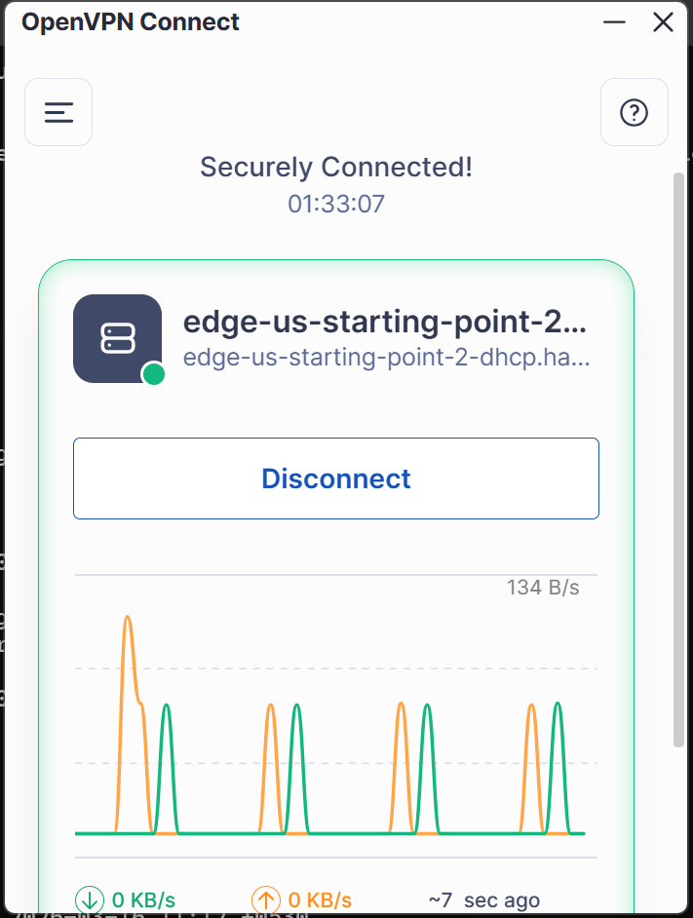

Step 2 — Spawned Fawn Machine on HTB
- Logged into hackthebox.com.
- Navigated to Labs → Starting Point → Fawn machine.
- Clicked Spawn Machine and noted the target IP address.
- Successfully Spawned Fawn Machine on HTB:
- 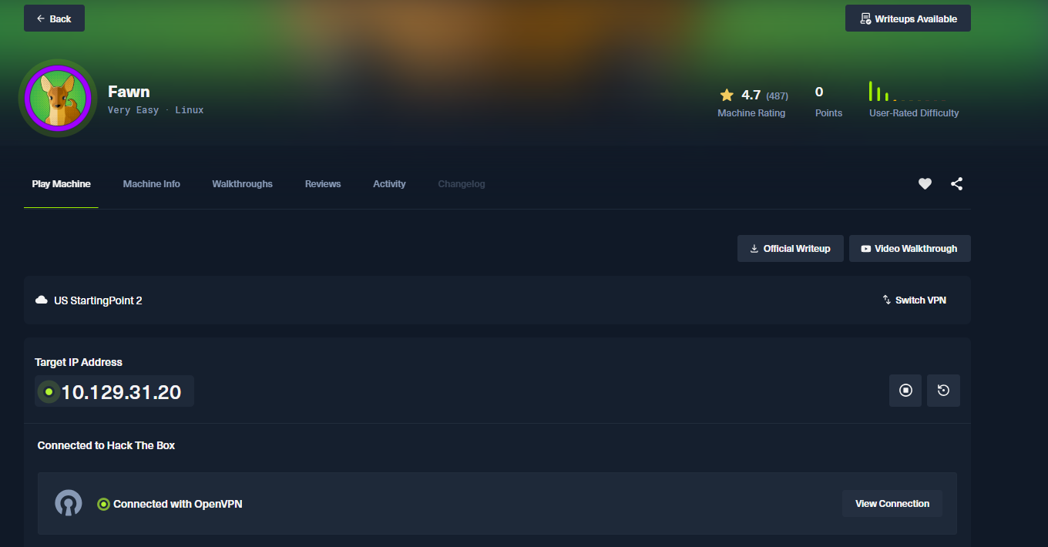

Step 3 — Scanned Target Using Nmap
Command 1 — Basic Scan:
nmap 10.129.30.241
Command 2 — Aggressive Scan:
nmap -A 10.129.30.241
Command 3 — Full Port Scan:
nmap -p- 10.129.30.241
- Nmap scan revealed Port 21/tcp is open running vsFTPd 3.0.3.
- OS type identified as Unix/Linux based on vsFTPd service.
- Anonymous FTP login was found to be allowed — a misconfiguration vulnerability.
- Nmap scan was attempted on the target machine. Port 21/tcp was found open running vsFTPd 3.0.3 service on a Unix/Linux operating system.

Step 4 — Connected to FTP Service
Command used:
ftp 10.129.30.241
- Successfully connected to the FTP service on Port 21.
- FTP banner showed: 220 (vsFTPd 3.0.3)
- FTP connected successfully:
- 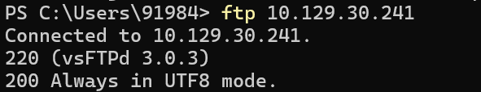

Step 5 — Logged in as Anonymous
Name: anonymous
Password: (blank — just pressed Enter)
- Login was successful — 230 Login successful message received.
- This confirms Anonymous FTP login is enabled — a serious vulnerability.
- Anonymous login successful:

- 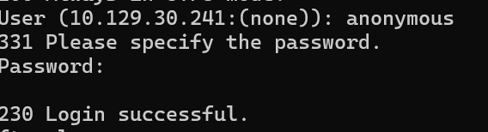

Step 6 — Found and Downloaded the Flag
Commands used:
ls
get flag.txt
- ls command showed flag.txt file present in the directory.
- get flag.txt downloaded the file to local PC successfully.
- Transfer complete message confirmed successful download.
- Flag found and downloaded successfully:
- 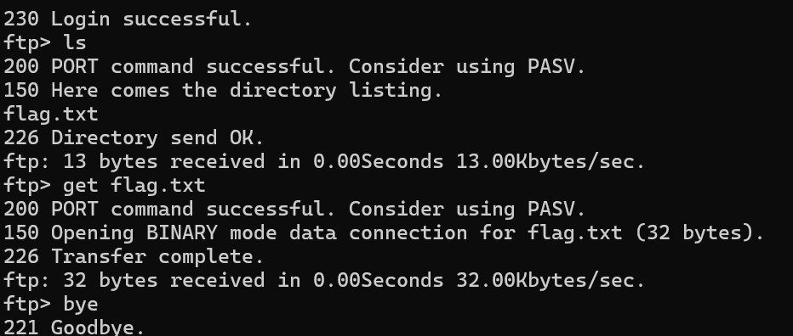

Step 7 — Read the Flag
type flag.txt
- Flag was successfully read and submitted on HTB website.
- Flag read successfully:
- 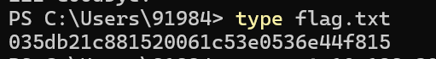
- Flag Submitted:
- 

5. Nmap Scan Results
Port | State | Service | Version
21/tcp | open | ftp | vsFTPd 3.0.3

6. Flag Captured
Machine Name | Fawn
Target IP | 10.129.30.241
Open Port | 21/tcp (FTP)
FTP Software | vsFTPd 3.0.3
OS Type | Unix/Linux
Login Username | anonymous
Password | (blank — no password)
Flag File | flag.txt
Flag Value | 035db21c881520061c53e0536e44f815
Status | ✅ Successfully Submitted on HTB

7. Concepts Learned
- Network Scanning: The process of discovering open ports and services on a target machine.
- Nmap: A powerful tool used to scan networks and identify open ports, services and OS details.
- Port 21 / FTP: File Transfer Protocol used to transfer files between computers.
- vsFTPd: A Unix/Linux FTP server software — its presence identifies the OS as Unix.
- Anonymous FTP Login: A misconfiguration where anyone can login without a password.
- Enumeration: Making a detailed list of services running on a target — first step of hacking.
- Attack Surface: All the possible ways an attacker can get into a system.

8. Conclusion
Task 2 provided hands-on experience with network scanning and enumeration using Nmap. By scanning the Fawn machine on Hack The Box, I was able to identify an open FTP service running vsFTPd 3.0.3 on Port 21. The OS was identified as Unix/Linux. The FTP service was misconfigured to allow anonymous login with no password, which allowed me to connect, browse the directory, download the flag file and submit it successfully. This task demonstrated how attackers discover vulnerabilities through simple network scans.

— End of Report —

