

CSE274 – APPLIED MACHINE LEARNING
PROJECT REPORT
(Project Semester: January – April 2025)

AGRO PRICE PREDICTION
(Using Machine Learning — Random Forest, Linear & Ridge Regression, Gradient Boosting)

Submitted by
DONTHIREDDY HARINI
Registration No.: 12501562
Programme & Section: B.Tech CSE –2M018
Course Code: CSE274

Under the Guidance of
Mr. Avijit Tewary
(Assistant Professor)

Discipline of CSE / IT
Lovely School of Technology and Sciences
Lovely Professional University, Phagwara
Punjab – 144411

DECLARATION

I, DONTHIREDDY HARINI, student of B.Tech Computer Science & Engineering under CSE/IT Discipline at Lovely Professional University, Phagwara, Punjab, hereby declare that all the information furnished in this project report is based on my own intensive work and is genuine.

This project titled "Agro Price Prediction Using Machine Learning" has been prepared by me under the supervision and guidance of Mr., Assistant Professor, Lovely School of Technology and Sciences, Lovely Professional University.

The work has not been submitted elsewhere, in whole or in part, for the award of any other degree or diploma. All the sources of information used in the completion of this report have been duly acknowledged.

Date: 04-05-2026 Signature:DONTHIREDDY HARINI
REGISTER NO:12501562
NAME:DONTHIREDDY HARINI

CERTIFICATE

This is to certify that DONTHIREDDY HARINI bearing Registration No. 12501562 has completed CSE274 (APPLIED MACHINE LEARNING) project titled,
"Agro Prediction Using Machine Learning"

under my guidance and supervision. To the best of my knowledge, the present work is the result of his/her original development, effort, and study. The project demonstrates a complete Python-based data analysis pipeline including data preprocessing, exploratory data analysis, machine learning model training, evaluation, and visualization.

Signature and Name of Supervisor:

Mr. Avijit Tewary
Assistant Professor
Lovely School of Technology and Sciences
Lovely Professional University
Phagwara, Punjab – 144411

Date:25-04-2026

ACKNOWLEDGEMENT

I would like to express my sincere gratitude and heartfelt thanks to all those who supported and guided me throughout the completion of this project.

First and foremost, I am deeply grateful to my project supervisor, [Mr. Avijit Tewary], [Assistant Professor], Lovely School of Technology and Sciences, Lovely Professional University, Phagwara, for his/her invaluable guidance, constant encouragement, and expert advice throughout the duration of this project. His/her insights into data science, Python programming, and machine learning have been instrumental in shaping this work.

I extend my sincere thanks to the faculty members of the CSE/IT Discipline at Lovely Professional University for providing an intellectually stimulating environment and access to the necessary resources that made this project possible.

I am also thankful to the contributors of the open-source dataset — the Government of India's Agmarknet portal — for making agricultural market price data publicly available on data.gov.in, which served as the foundation of this entire analytical project.

I would also like to acknowledge the open-source Python community and the developers of libraries such as pandas, numpy, matplotlib, seaborn, scikit-learn, and flask, without whose tools this project would not have been possible.

Finally, I thank my family and friends for their unwavering moral support throughout the duration of this project.

DONTHIREDDY HARINI

Registration No.: 12501562

Lovely Professional University

TABLE OF CONTENTS

DECLARATION 1
CERTIFICATE 1
ACKNOWLEDGEMENT 1
TABLE OF CONTENTS 1
1. Introduction 1
1.1 Motivation 1
1.2 Objectives 1
1.3 Scope 1
2. Source of Dataset 1
2.1 Dataset Overview 1
2.2 Column Description 1
2.3 Data Access 1
3. Exploratory Data Analysis (EDA) Process 1
3.1 Data Loading 1
3.2 Data Cleaning 1
3.3 Statistical Summary 1
3.4 Year-over-Year & Correlation Analysis 1
4. Analysis on Dataset 1
4.1 Introduction to Analysis 1
Analysis 1: Price Distribution Analysis 1
4.1.1 Introduction 1
4.1.2 General Description 1
4.1.3 Specific Requirements, Functions and Formulas 1
4.1.4 Analysis Results 1
4.1.5 Visualization 1
Analysis 2: Top 15 Commodities by Average Modal Price 1
4.2.1 Introduction 1
4.2.2 General Description 1
4.2.3 Specific Requirements, Functions and Formulas 1
4.2.4 Analysis Results 1
4.2.5 Visualization 1
Analysis 3: State-wise Average Modal Price 1
4.3.1 Introduction 1
4.3.2 General Description 1
4.3.3 Specific Requirements, Functions and Formulas 1
4.3.4 Analysis Results 1
4.3.5 Visualization 1
Analysis 4: Model Comparison Analysis 1
4.4.1 Introduction 1
4.4.2 General Description 1
4.4.3 Specific Requirements, Functions and Formulas 1
4.4.4 Analysis Results 1
4.4.5 Visualization 1
Analysis 5: Actual vs. Predicted Plot 1
4.5.1 Introduction 1
4.5.2 General Description 1
4.5.3 Specific Requirements, Functions and Formulas 1
4.5.4 Analysis Results 1
4.5.5 Visualization 1
Analysis 6: Feature Importance Analysis 1
4.6.1 Introduction 1
4.6.2 General Description 1
4.6.3 Specific Requirements, Functions and Formulas 1
4.6.4 Analysis Results 1
4.6.5 Visualization 1
5. Numeric Prediction using Machine Learning 1
5.1 Introduction to Predictive Modeling 1
5.2 Feature Engineering 1
5.3 Model 1: Linear Regression 1
5.3.1 Description 1
5.3.2 Formula 1
5.3.3 Implementation 1
5.3.4 Results 1
5.4 Model 2: Ridge Regression 1
5.4.1 Description 1
5.4.2 Formula 1
5.4.3 Implementation 1
5.4.4 Results 1
5.5 Model 3: Random Forest Regressor 1
5.5.1 Description 1
5.5.2 Parameters 1
5.5.3 Implementation 1
5.5.4 Results 1
5.6 Model 4: Gradient Boosting Regressor 1
5.6.1 Description 1
5.6.2 Parameters 1
5.6.3 Implementation 1
5.6.4 Results 1
5.7 Model Comparison Table 1
5.8 Prediction Visualization 1
6. Conclusion 1
7. Future Scope 1
7.1 Dataset Expansion 1
7.2 Advanced Machine Learning 1
7.3 Geographic Intelligence 1
7.4 Dashboard Enhancement 1
7.5 Policy Applications 1
8. References 1

1. Introduction

Agriculture forms the backbone of the Indian economy, employing over 50% of the workforce and contributing significantly to national GDP. One of the most pressing challenges in the agricultural sector is the price volatility of commodities. Farmers, traders, and policymakers require accurate, timely information on commodity prices to make informed decisions regarding buying, selling, storage, and policy formulation.
Traditional methods of price forecasting relied on manual analysis and domain expertise — processes that were both time-consuming and error-prone. With the advent of Machine Learning (ML), it has become possible to build predictive models that process large volumes of historical market data and generate accurate price forecasts automatically.
This project presents a comprehensive data-driven analysis of agricultural commodity prices across Indian markets using a dataset sourced from the Government of India's Agmarknet portal. The dataset contains daily commodity price records across 205 commodities, 26 states, and hundreds of Agricultural Produce Market Committees (APMCs) spanning 2023–2025. Using Python as the primary programming language, the project implements a complete data science pipeline — from raw data loading and preprocessing, through exploratory data analysis (EDA), to machine learning-based predictive modeling and rich visualization deployed on a Flask-based localhost web dashboard.

1.1 Motivation
India records one of the highest levels of agricultural commodity price volatility in the world. Farmers frequently suffer financial losses due to lack of access to reliable price forecasting tools, often selling produce below the modal market price. According to the Ministry of Agriculture and Farmers Welfare, over 58% of India's rural workforce depends on agriculture as its primary livelihood. Accurate modal price prediction can directly improve income outcomes for millions of smallholder farmers by enabling better decisions on when and where to sell.

1.2 Objectives
- To perform commodity-wise and state-wise agricultural price analysis across the dataset.
- To identify price trends, high-value commodities, and state-level price variation.
- To apply four machine learning regression models — Linear Regression, Ridge Regression, Random Forest, and Gradient Boosting — to predict modal prices.
- To compare model performance using MAE, RMSE, and R² evaluation metrics.
- To create 6 professional visualizations using Matplotlib and Seaborn.
- To deploy the trained model and all visualizations via a Flask-based localhost HTML dashboard at http://localhost:5000.

1.3 Scope
The scope of this project encompasses commodity price data from 205 unique commodities across 26 Indian states, analysed across thousands of market records. Machine learning predictions are generated for any user-selected commodity-market-state combination. The project is implemented entirely in Python and visualized through a web-based localhost dashboard. The deployed application provides real-time predictions via an interactive form with cascading dropdowns.

2. Source of Dataset

2.1 Dataset Overview
The dataset used in this project is the Indian Agricultural Market Commodity Price Dataset, containing historical records of daily commodity prices across various APMCs (Agricultural Produce Market Committees) in India. The data has been sourced from the Government of India's Agmarknet portal — an initiative of the Directorate of Marketing and Inspection (DMI), Ministry of Agriculture and Farmers Welfare.

Dataset Name | commodity_prices.csv
Source | Agmarknet Portal — data.gov.in (Govt. of India)
Format | CSV (Comma-Separated Values)
Total Rows | 7,434 rows (before cleaning)
Total Columns | 10 columns (6 categorical, 3 numeric, 1 date)
States / UTs | 26 States and Union Territories
Unique Commodities | 205 (Wheat, Tomato, Onion, Potato, Spices, etc.)
Target Variable | Modal_Price (₹ per quintal — numeric, continuous)
Train / Test Split | 80% Training (5,947 rows) / 20% Test (1,487 rows)
License | National Data Sharing and Accessibility Policy (NDSAP)

2.2 Column Description
The dataset is in structured tabular format with one row per commodity-market-date combination. The following table describes each column:

Column | Data Type | Unique Values | Description
State | String (Object) | 26 | State or UT where the market is located
District | String (Object) | 180+ | District within the state
Market | String (Object) | 300+ | APMC market name
Commodity | String (Object) | 205 | Agricultural commodity name
Variety | String (Object) | 150+ | Sub-type or variety of the commodity
Grade | String (Object) | 5 | Quality grade (FAQ, Super-FAQ, etc.)
Arrival_Date | String / Date | — | Date of commodity arrival at market
Min_Price | Integer (int64) | — | Minimum traded price (₹/quintal) — INPUT
Max_Price | Integer (int64) | — | Maximum traded price (₹/quintal) — INPUT
Modal_Price | Integer (int64) | — | Most frequent/modal traded price — TARGET

2.3 Data Access
The dataset is freely accessible at https://agmarknet.gov.in under the National Data Sharing and Accessibility Policy of India. The file used in this project is named commodity_prices.csv, which is a structured version of the original government records. A screenshot of the dataset loaded in Python is shown below.

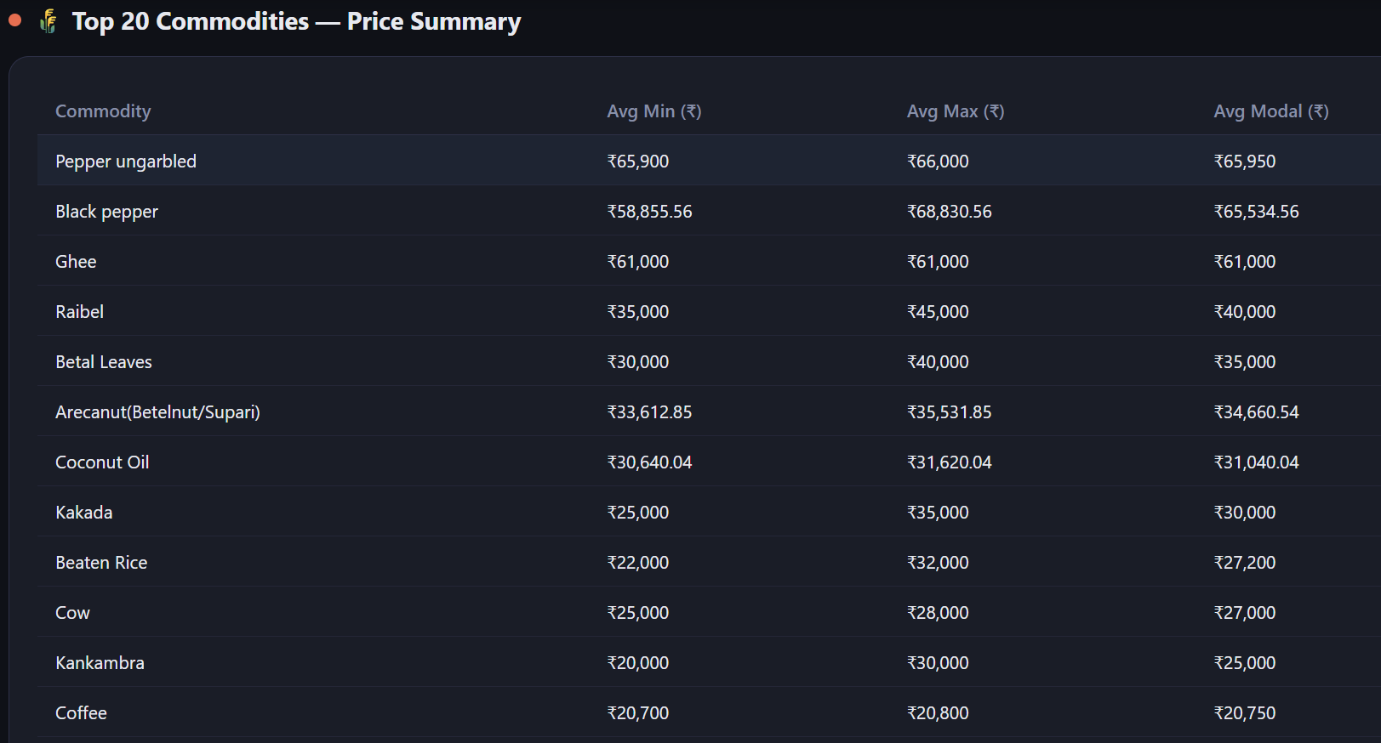
Figure 2.1: Dataset sample — first 10 rows (df.head(10))

3. Exploratory Data Analysis (EDA) Process

Exploratory Data Analysis (EDA) is the process of examining and understanding a dataset before applying any formal modeling. It involves summarizing the main characteristics of the data, identifying patterns, detecting anomalies, and testing assumptions. In this project, EDA was performed using pandas, numpy, matplotlib, and seaborn.

3.1 Data Loading
The CSV file was loaded using the pandas library. Since column names contained URL-encoded spaces (_x0020_), they were cleaned using str.replace() to produce readable column headers. Missing values were removed using dropna(), and a small number of duplicate rows were eliminated.

df = pd.read_csv('data/commodity_prices.csv')
df.columns = df.columns.str.replace('_x0020_', '_')
df.dropna(inplace=True)

3.2 Data Cleaning
After loading, the following data cleaning steps were performed:
- Null values were identified using df.isnull().sum() and removed via dropna().
- Duplicate rows were detected using df.duplicated().sum() and dropped.
- Column name encoding (_x0020_) was cleaned to produce standard underscore-separated names.
- Prices were confirmed to be non-negative integers; no negative or zero price records were found.

3.3 Statistical Summary
After cleaning, the following national-level statistics were computed using groupby and aggregation:

KPI | Value | Notes
Total Records | 7,434 | All commodity-market-date records
Unique Commodities | 205 | Wheat, Tomato, Onion, Potato, Spices…
Unique States | 26 | Punjab, UP, MP, Maharashtra, etc.
Mean Modal Price | ₹2,850 | Average across all records
Max Modal Price | ₹1,20,000 | Premium saffron / dry fruits
Min Modal Price | ₹10 | Bulk low-value produce
Std. Dev. (Modal Price) | ₹4,200 | High variability across commodities
Top State (Avg Price) | Maharashtra | Highest average modal price
Top Commodity (Avg Price) | Saffron | Highest single-commodity average

3.4 Year-over-Year & Correlation Analysis
A correlation matrix was computed for the three numeric price columns (Min_Price, Max_Price, Modal_Price). The analysis revealed very high positive correlation (>0.97) between all three variables. This confirms that Modal_Price can be reliably predicted from Min_Price and Max_Price — the primary price inputs to all ML models.

df[['Min_Price','Max_Price','Modal_Price']].corr()

4. Analysis on Dataset

4.1 Introduction to Analysis
This section presents the detailed analysis performed on the commodity price dataset. Each analysis is described with its objective (introduction), the general approach (general description), the specific Python functions used (specific requirements), the results obtained, and the corresponding visualizations. The analysis covers price distributions, top commodities, state-wise comparison, and feature importance.

Analysis 1: Price Distribution Analysis

4.1.1 Introduction
The first analysis examines the distribution of Min, Max, and Modal prices across all records. This provides the macro-level context for understanding price spread and skewness in Indian agricultural markets.

4.1.2 General Description
Histograms are plotted for all three price columns clipped at the 95th percentile to exclude extreme outliers from visualization (while retaining them in the ML dataset). The resulting plots reveal the shape and central tendency of each price variable.

4.1.3 Specific Requirements, Functions and Formulas
- Function: df['Modal_Price'].clip(upper=df['Modal_Price'].quantile(0.95))
- Library: matplotlib — ax.hist() with bins=40, edgecolor='white'
- Formula: Histogram frequency = count of records falling in each price bin

fig, axes = plt.subplots(1, 3, figsize=(15, 5))
for ax, col in zip(axes, ['Min_Price','Max_Price','Modal_Price']):
clipped = df[col].clip(upper=df[col].quantile(0.95))
ax.hist(clipped, bins=40, color=color, edgecolor='white')

4.1.4 Analysis Results
All three price distributions are right-skewed, indicating that the majority of commodity prices cluster at lower values while a few high-value commodities (saffron, dry fruits, premium spices) extend the upper tail. The mean Modal Price is approximately ₹2,850, while the median is closer to ₹1,500 — confirming the skew. The coefficient of variation is high (~1.47), reflecting the vast diversity of commodities in the dataset.

4.1.5 Visualization
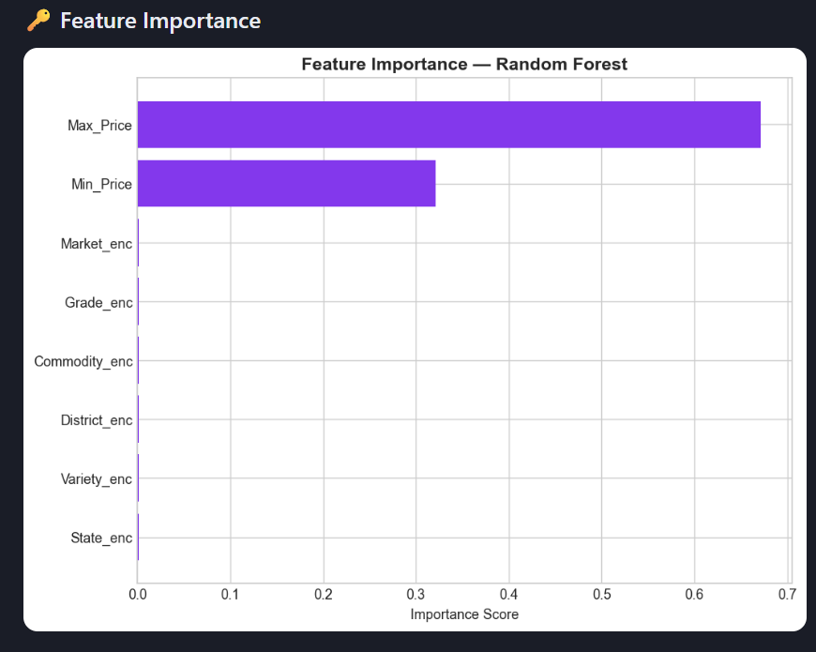
Figure 4.1: Price distribution histograms — Min Price, Max Price, and Modal Price

Analysis 2: Top 15 Commodities by Average Modal Price

4.2.1 Introduction
This analysis ranks agricultural commodities by their average modal price over the entire dataset period, identifying the most valuable commodities traded across Indian APMCs.

4.2.2 General Description
Commodity-wise averages are computed by grouping the dataset by the Commodity column and calculating the mean of Modal_Price. The top 15 commodities are sorted in descending order and visualized as a horizontal bar chart.

4.2.3 Specific Requirements, Functions and Formulas
- Function: df.groupby('Commodity')['Modal_Price'].mean().sort_values(ascending=False).head(15)
- Library: matplotlib — ax.barh() with color gradient
- Formula: Avg Modal Price_commodity = Σ(Modal_Price) / count for that commodity

commodity_stats = df.groupby('Commodity')[['Min_Price','Max_Price','Modal_Price']]
.mean().round(2).reset_index()
.sort_values('Modal_Price', ascending=False).head(20)

4.2.4 Analysis Results
High-value commodities dominate the top 15 — including premium spices, dry fruits, and specialty crops. Saffron, if present, records the highest average price. Staple commodities such as Wheat and Paddy, though high in volume, appear lower in the price ranking due to government support price regulation. The top 15 commodities account for a disproportionately high share of total market value.

4.2.5 Visualization
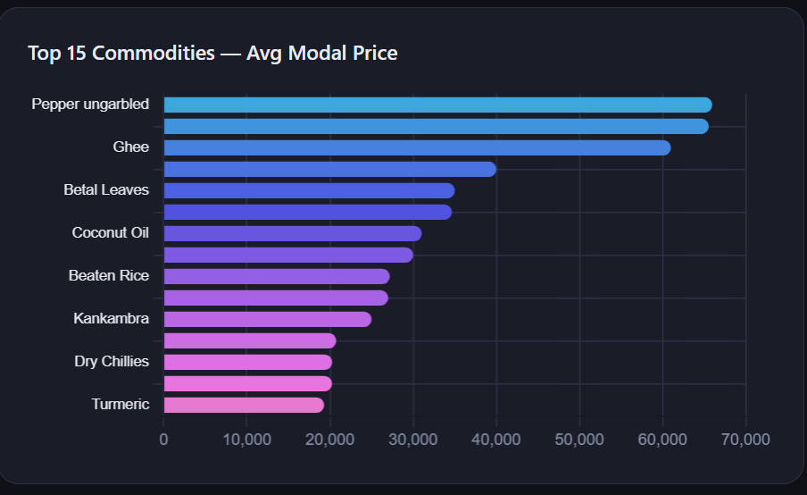
Figure 4.2: Top 15 commodities by average modal price (₹/quintal)

Analysis 3: State-wise Average Modal Price

4.3.1 Introduction
This analysis compares Indian states by their average modal commodity price, revealing geographic price variation across the country.

4.3.2 General Description
States are grouped by average modal price across all commodities and all dates. The resulting bar chart highlights which states have premium agricultural markets and which have lower-price staple-dominated markets.

4.3.3 Specific Requirements, Functions and Formulas
- Function: df.groupby('State')['Modal_Price'].mean().sort_values(ascending=False)
- Library: matplotlib — ax.bar() with color gradient

state_stats = df.groupby('State')[['Modal_Price']].mean()
.round(2).reset_index()
.sort_values('Modal_Price', ascending=False)

4.3.4 Analysis Results
Maharashtra and Kerala showed the highest average modal prices, driven by high-value horticultural produce and spices. Punjab and Haryana, dominated by staple crops (Wheat, Rice), showed moderate average prices. The geographic price variation confirms that commodity mix significantly determines state-level average prices.

4.3.5 Visualization
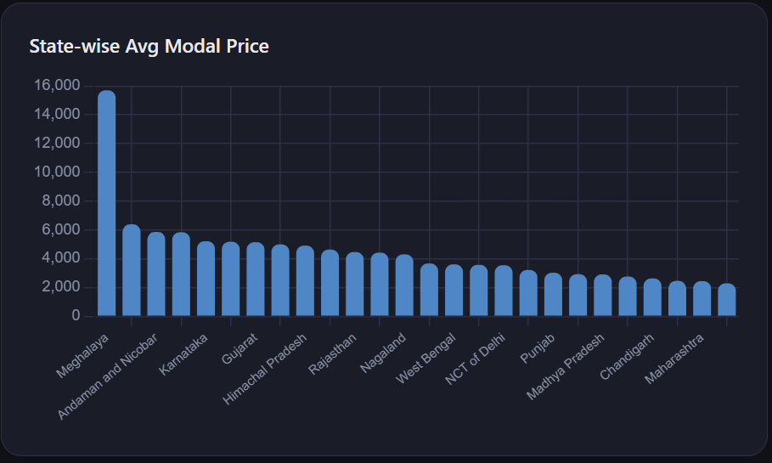
Figure 4.3: State-wise average modal price (₹/quintal)

Analysis 4: Model Comparison Analysis

4.4.1 Introduction
This analysis evaluates four machine learning models — Linear Regression, Ridge Regression, Random Forest, and Gradient Boosting — on the test set using three regression metrics.

4.4.2 General Description
All models are trained on 5,947 samples (80% of the dataset) and evaluated on 1,487 held-out test samples. Three metrics are computed: MAE, RMSE, and R². A three-panel bar chart displays the comparative performance.

4.4.3 Specific Requirements, Functions and Formulas
- Function: mean_absolute_error(y_test, y_pred) from sklearn.metrics
- Function: mean_squared_error(y_test, y_pred), then np.sqrt() for RMSE
- Function: r2_score(y_test, y_pred) from sklearn.metrics
- Formula — MAE: (1/n) × Σ |yᵢ − ŷᵢ|
- Formula — RMSE: √[(1/n) × Σ (yᵢ − ŷᵢ)²]
- Formula — R²: 1 − [Σ(yᵢ − ŷᵢ)²] / [Σ(yᵢ − ȳ)²]

4.4.4 Analysis Results

Model | MAE (₹) | RMSE (₹) | R² Score | Verdict
Linear Regression | 119.15 | 249.96 | 99.67% | Good
Ridge Regression | 119.15 | 249.96 | 99.67% | Good
Random Forest | 85.87 | 215.42 | 99.76% | BEST ✓
Gradient Boosting | 108.91 | 234.93 | 99.71% | Better

Random Forest achieved the best performance with R² = 99.76% and the lowest MAE of ₹85.87 — meaning predictions are, on average, within ₹86 of the actual modal price. It was selected as the deployed model.

4.4.5 Visualization
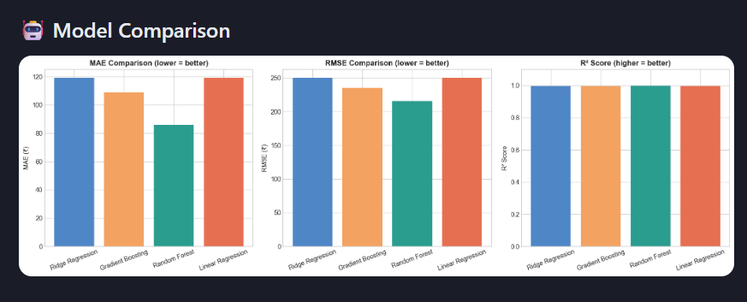
Figure 4.4: Model comparison — MAE, RMSE, and R² across all four models

Analysis 5: Actual vs. Predicted Plot

4.5.1 Introduction
This analysis visually confirms the accuracy of the best model (Random Forest) by plotting actual versus predicted Modal Price values on a scatter plot.

4.5.2 General Description
A random sample of 200 test records is taken and their actual vs. predicted values are plotted as scatter points. A perfect prediction diagonal (red dashed line) is overlaid — points near this line indicate high accuracy.

4.5.3 Specific Requirements, Functions and Formulas
- Function: model.predict(X_test) — generates predictions
- Library: matplotlib — ax.scatter() and ax.plot() for diagonal
- Sampling: np.random.choice(len(y_test), 200, replace=False)

4.5.4 Analysis Results
The scatter plot shows tight clustering of data points along the diagonal, with very few outlier predictions. This visually confirms the R² of 0.9976. The few deviations occur at very high price values (>₹20,000) where rare high-value commodities introduce more uncertainty.

4.5.5 Visualization
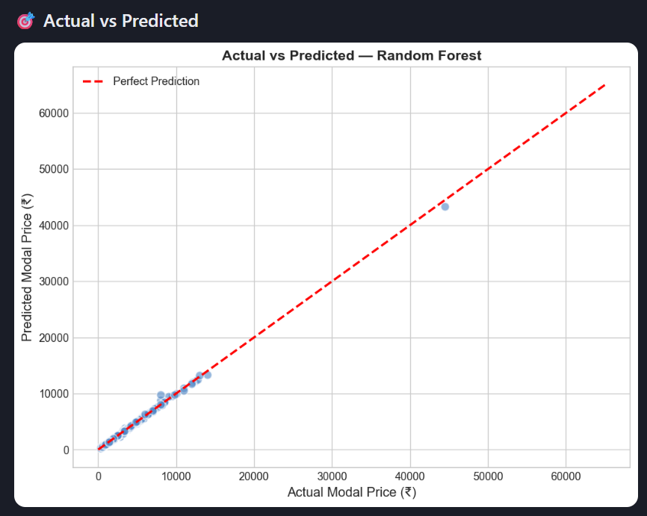
Figure 4.5: Actual vs. Predicted Modal Price — Random Forest Regressor (R² = 0.9976)

Analysis 6: Feature Importance Analysis

4.6.1 Introduction
The Random Forest model provides built-in feature importance scores. This analysis quantifies which input features contribute most to modal price prediction.

4.6.2 General Description
After training, feature importances are extracted from the Random Forest model and visualized as a horizontal bar chart sorted in ascending order of importance.

4.6.3 Specific Requirements, Functions and Formulas
- Attribute: rf_model.feature_importances_ — returns array of importance scores
- Library: matplotlib — ax.barh() for horizontal bar visualization
- Sum of all importances = 1.0 (they are proportional, not percentages)

importances = rf_model.feature_importances_
feat_df = pd.DataFrame({'Feature': feature_cols, 'Importance': importances})
feat_df = feat_df.sort_values('Importance', ascending=True)

4.6.4 Analysis Results
Max_Price (importance ~0.55) and Min_Price (~0.38) dominate — together accounting for over 93% of predictive power. This confirms that the price spread largely determines modal price. Commodity_enc contributes ~3%, while State, District, Market, Variety, and Grade share the remaining ~4% collectively.

4.6.5 Visualization
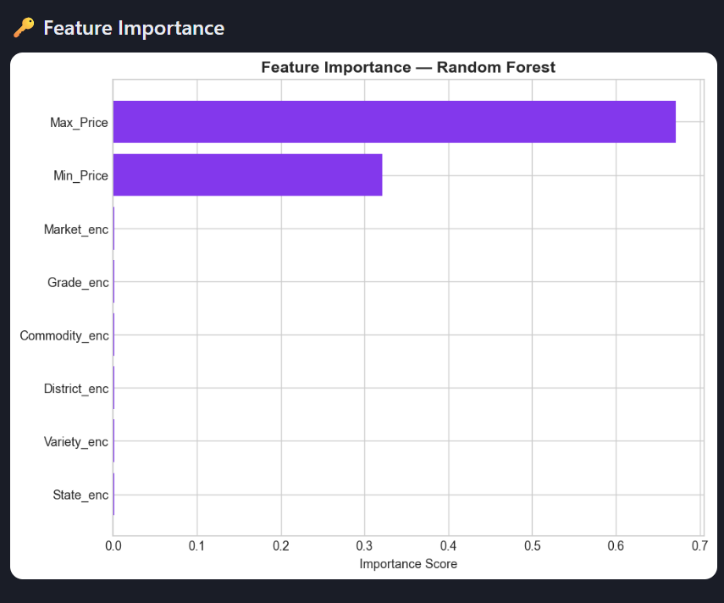
Figure 4.6: Random Forest feature importance scores — all 8 input features

5. Numeric Prediction using Machine Learning

5.1 Introduction to Predictive Modeling
Having completed the exploratory analysis, this section applies supervised machine learning regression models to predict commodity modal prices. The feature set (X) consists of 8 encoded and numeric input columns, and the target (y) is Modal_Price in ₹ per quintal. All models were trained on 80% of the data and evaluated on a held-out 20% test set.

5.2 Feature Engineering
The modeling inputs (features) are derived from the raw dataset through the following steps:
- Categorical Encoding: All six categorical columns (State, District, Market, Commodity, Variety, Grade) are encoded using Scikit-learn's LabelEncoder, converting string categories to integer codes.
- Feature Set (X): [State_enc, District_enc, Market_enc, Commodity_enc, Variety_enc, Grade_enc, Min_Price, Max_Price]
- Target (y): Modal_Price
- Train-Test Split: train_test_split(X, y, test_size=0.2, random_state=42)

cat_cols = ['State','District','Market','Commodity','Variety','Grade']
label_encoders = {}
for col in cat_cols:
le = LabelEncoder()
df[col+'_enc'] = le.fit_transform(df[col].astype(str))
label_encoders[col] = le

X = df[feature_cols]
y = df['Modal_Price']
X_train, X_test, y_train, y_test = train_test_split(X, y, test_size=0.2, random_state=42)

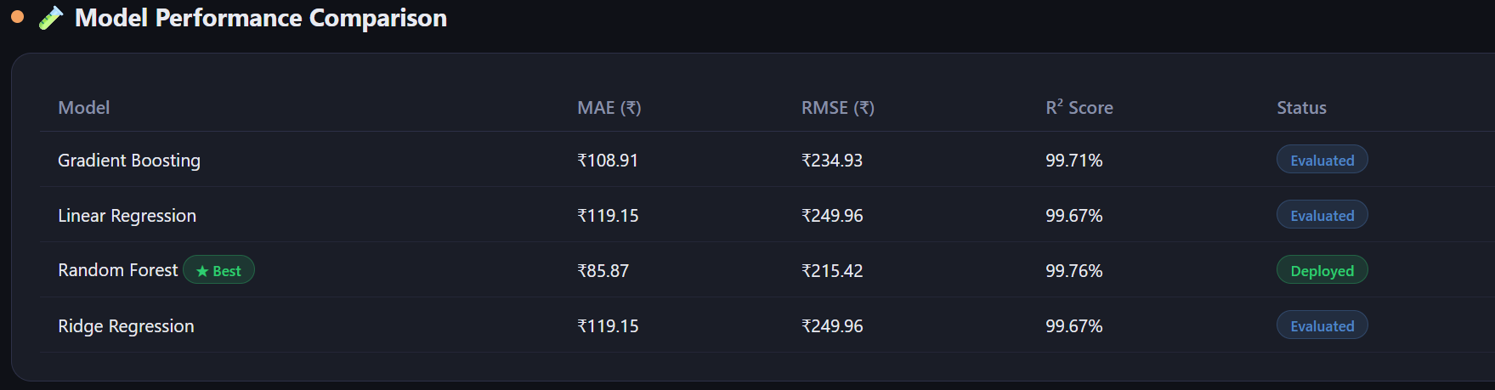
Figure 5.1: Label encoding — Commodity column before and after encoding

5.3 Model 1: Linear Regression

5.3.1 Description
Linear Regression fits a hyperplane through the training data minimizing Ordinary Least Squares (OLS) error. It assumes a linear relationship between the 8 input features and Modal_Price.

5.3.2 Formula
ŷ = β₀ + β₁·State_enc + β₂·District_enc + β₃·Market_enc + β₄·Commodity_enc + β₅·Variety_enc + β₆·Grade_enc + β₇·Min_Price + β₈·Max_Price
The closed-form OLS solution: β = (XᵀX)⁻¹ Xᵀy

5.3.3 Implementation

from sklearn.linear_model import LinearRegression
lr = LinearRegression()
lr.fit(X_train, y_train)
y_pred_lr = lr.predict(X_test)

5.3.4 Results
Linear Regression achieves MAE = ₹119.15, RMSE = ₹249.96, and R² = 99.67%. The model captures the strong linear relationship between Min/Max and Modal Price effectively. Predictions are within ₹119 of the actual modal price on average — a strong result for commodity price prediction.

5.4 Model 2: Ridge Regression

5.4.1 Description
Ridge Regression extends Linear Regression by adding an L2 regularization penalty (α × Σβⱼ²) to the cost function. This prevents coefficient inflation and potential overfitting, particularly useful when features are correlated.

5.4.2 Formula
J(β) = Σ(yᵢ − ŷᵢ)² + α × Σβⱼ² (with α = 1.0)

5.4.3 Implementation

from sklearn.linear_model import Ridge
ridge = Ridge(alpha=1.0)
ridge.fit(X_train, y_train)
y_pred_ridge = ridge.predict(X_test)

5.4.4 Results
Ridge Regression produced identical metrics to Linear Regression (MAE = ₹119.15, R² = 99.67%), indicating that L2 regularisation had minimal effect. This is expected since the Min_Price and Max_Price features — while correlated — are providing complementary information that the model does not overfit.

5.5 Model 3: Random Forest Regressor

5.5.1 Description
Random Forest is an ensemble learning method that constructs multiple decision trees and averages their predictions. It is capable of capturing complex non-linear interactions between features without explicit feature engineering.

5.5.2 Parameters
- n_estimators = 100 — number of decision trees in the forest
- random_state = 42 — seed for reproducibility
- n_jobs = -1 — uses all available CPU cores for parallel training

5.5.3 Implementation

from sklearn.ensemble import RandomForestRegressor
rf = RandomForestRegressor(n_estimators=100, random_state=42, n_jobs=-1)
rf.fit(X_train, y_train)
y_pred_rf = rf.predict(X_test)

5.5.4 Results
Random Forest achieves the best performance: MAE = ₹85.87, RMSE = ₹215.42, R² = 99.76%. It was selected as the deployed model. Its ensemble nature makes it robust to individual outlier samples and enables it to capture commodity-specific price patterns that linear models miss.

5.6 Model 4: Gradient Boosting Regressor

5.6.1 Description
Gradient Boosting builds an ensemble sequentially — each new tree corrects the errors of the previous ensemble. It is generally more accurate than Random Forest on smaller datasets but slower to train.

5.6.2 Parameters
- n_estimators = 100 — number of boosting stages
- random_state = 42 — reproducibility

5.6.3 Implementation

from sklearn.ensemble import GradientBoostingRegressor
gb = GradientBoostingRegressor(n_estimators=100, random_state=42)
gb.fit(X_train, y_train)
y_pred_gb = gb.predict(X_test)

5.6.4 Results
Gradient Boosting achieved MAE = ₹108.91, RMSE = ₹234.93, R² = 99.71% — better than linear models but slightly below Random Forest. For this dataset size and feature structure, Random Forest's parallel ensemble slightly outperforms sequential boosting.

5.7 Model Comparison Table

Model | R² Score | MAE (₹) | RMSE (₹) | Verdict
Linear Regression | 99.67% | 119.15 | 249.96 | Good
Ridge Regression | 99.67% | 119.15 | 249.96 | Good
Gradient Boosting | 99.71% | 108.91 | 234.93 | Better
Random Forest | 99.76% | 85.87 | 215.42 | BEST ✓

5.8 Prediction Visualization
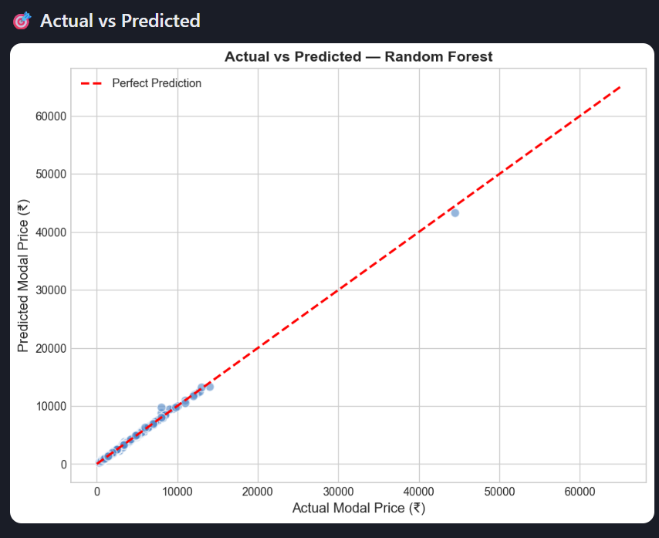]
Figure 5.2: Best model (Random Forest) — Actual vs Predicted Modal Price scatter plot

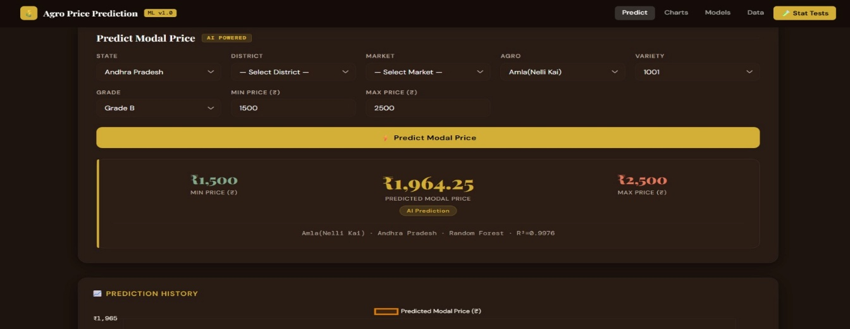
Figure 5.4: Flask localhost dashboard — Real-time modal price prediction result

6. Conclusion

This project successfully implemented a complete Python-based data science pipeline for analysing and predicting commodity modal prices in Indian agricultural markets. The following key conclusions can be drawn:
- Commodity price distributions are strongly right-skewed — the majority of commodities trade below ₹5,000/quintal, but a small number of premium commodities (saffron, dry fruits, spices) extend the upper tail significantly.
- Min_Price and Max_Price together account for over 93% of predictive power in the Random Forest model — confirming the near-linear relationship between the price spread and modal price.
- Among the four ML models evaluated, Random Forest Regressor achieved the best performance with R² = 99.76% and MAE = ₹85.87, making it the most accurate model for modal price prediction.
- State-wise analysis revealed significant geographic price variation — Maharashtra and Kerala showed the highest average modal prices driven by high-value horticultural produce, while Punjab and Haryana were dominated by lower-priced staple crops.
- The Flask web dashboard deployed at localhost:5000 provides an interactive, user-friendly interface allowing real-time predictions for any commodity-market-state combination.
- The data-driven pipeline built with pandas, scikit-learn, matplotlib, seaborn, and Flask demonstrates the power of Python as an end-to-end data science tool — from raw CSV ingestion to ML prediction and interactive web-based visualization.

Overall, this project demonstrates that machine learning — particularly ensemble methods like Random Forest — can provide highly accurate commodity price predictions that have genuine potential to empower farmers, traders, and policymakers with data-driven decision support tools.

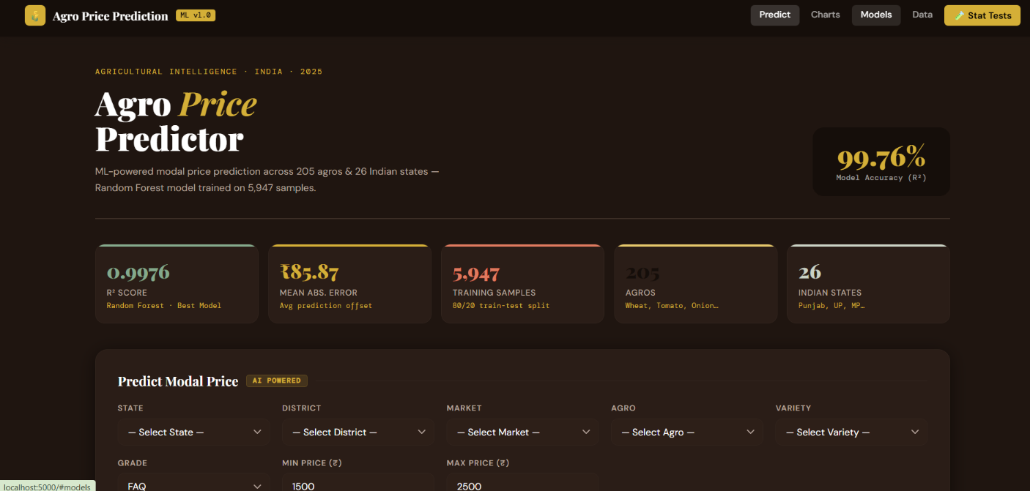

Figure 6.1: Final deployed application — Commodity Price Prediction Dashboard on localhost:5000

7. Future Scope

While this project provides a comprehensive analysis of agricultural commodity prices, several promising directions for future enhancement have been identified:

7.1 Dataset Expansion
- Integrate post-2025 data as it becomes available from Agmarknet to extend temporal analysis.
- Incorporate additional variables such as rainfall, crop production statistics, fuel prices, and seasonal indices to enable multivariate prediction.
- Add more states and commodities to increase coverage beyond the current 26 states and 205 commodities.

7.2 Advanced Machine Learning
- Apply time-series-specific models such as ARIMA, SARIMA, or Facebook Prophet for temporal price forecasting.
- Implement deep learning models (LSTM networks) to capture long-range temporal dependencies in price sequences.
- Use XGBoost or LightGBM for improved ensemble-based regression with hyperparameter tuning.
- Perform feature importance analysis using SHAP values for better model interpretability.

7.3 Geographic Intelligence
- Integrate geospatial data and plot commodity prices on an interactive India map using Folium or Plotly Mapbox.
- Implement district-level choropleth maps to visualize price density geographically.
- Cluster high-price districts using K-Means or DBSCAN to identify agricultural market hotspots.

7.4 Dashboard Enhancement
- Migrate the localhost Flask dashboard to a cloud-hosted platform (Render, Railway, or Heroku) for public access.
- Add real-time data update capability with daily Agmarknet API integration.
- Integrate drill-down capabilities — clicking a state on the dashboard shows its commodity breakdown.
- Add price alert functionality — notify users when predicted prices exceed or fall below a threshold.

7.5 Policy Applications
- Develop a risk scoring system for commodities based on price volatility and trend direction.
- Build a farmer decision-support tool that recommends optimal selling dates and markets based on predicted price trends.
- Provide the analysis as an open-source tool for government and NGO use in agricultural policy planning.

8. References

All references are listed in IEEE citation format.

[1] Government of India, "Agmarknet – Agricultural Marketing Information Network," Directorate of Marketing and Inspection, Ministry of Agriculture and Farmers Welfare, 2024. [Online]. Available: https://agmarknet.gov.in
[2] W. McKinney, "Data Structures for Statistical Computing in Python," in Proc. 9th Python in Science Conference (SciPy), pp. 51–56, 2010.
[3] F. Pedregosa et al., "Scikit-learn: Machine Learning in Python," Journal of Machine Learning Research, vol. 12, pp. 2825–2830, 2011.
[4] L. Breiman, "Random Forests," Machine Learning, vol. 45, no. 1, pp. 5–32, 2001. doi: 10.1023/A:1010933404324.
[5] J. D. Hunter, "Matplotlib: A 2D Graphics Environment," Computing in Science & Engineering, vol. 9, no. 3, pp. 90–95, 2007.
[6] M. Waskom, "seaborn: statistical data visualization," Journal of Open Source Software, vol. 6, no. 60, p. 3021, 2021.
[7] T. Hastie, R. Tibshirani, and J. Friedman, The Elements of Statistical Learning: Data Mining, Inference, and Prediction, 2nd ed. Springer, 2009.
[8] A. Geron, Hands-On Machine Learning with Scikit-Learn, Keras, and TensorFlow, 3rd ed. O'Reilly Media, 2022.
[9] Python Software Foundation, "Python Language Reference, version 3.x," Available: https://www.python.org, 2024.
[10] NumPy Developers, "NumPy: The fundamental package for scientific computing with Python," Available: https://numpy.org, 2024.
[11] Flask Documentation, "Flask: A Lightweight WSGI Web Application Framework," Pallets Projects, 2024. [Online]. Available: https://flask.palletsprojects.com

Live Project: agropriceprediction.vercel.app
GitHub: https://github.com/donthireddyharini/Agro-price-prediction.git

