211 Cambridge Science Park

Cambridge, CB4 0WA

|  |
| --- |
| Qlik Sense Training Manual |

|  |
| --- |
| Version 0.1 – Initial Draft |

|  |
| --- |
| Chris Johnson  Business Intelligence  Prometic Life Sciences Inc.  19th September 2016 |

# Training Breakdown

* Qlik Sense Navigation
  + What’s a sheet?
  + What’s a chart?
  + Chart controls/Exporting charts
  + Making Selections
  + Removing Selections
  + Making Bookmarks
  + Making Stories

Home Screen

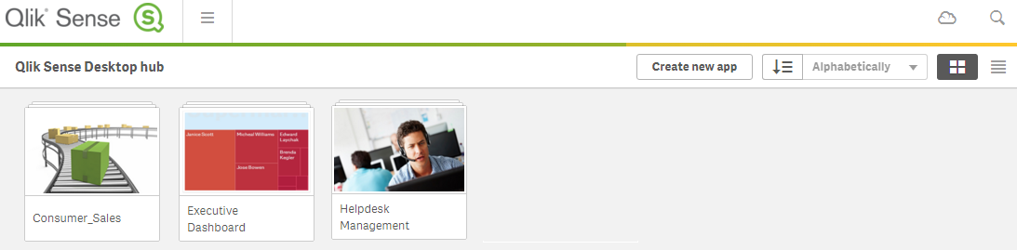

Navigation 1

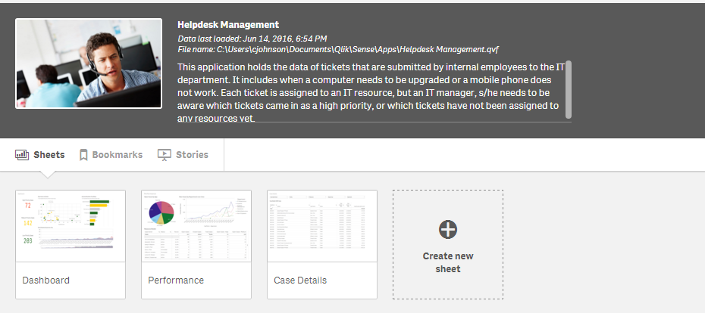

Navigation 2

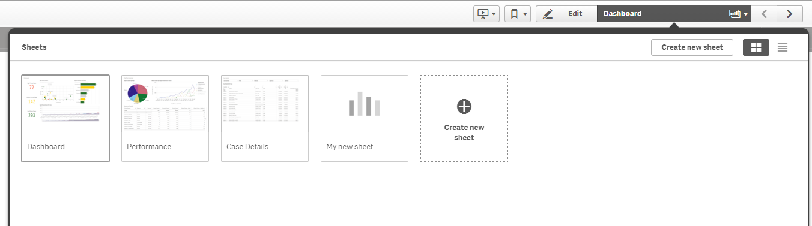

Navigation 3

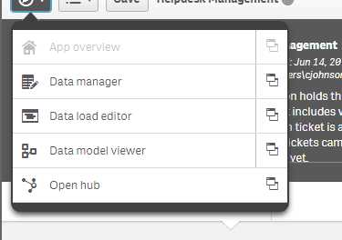

Chart Controls 1

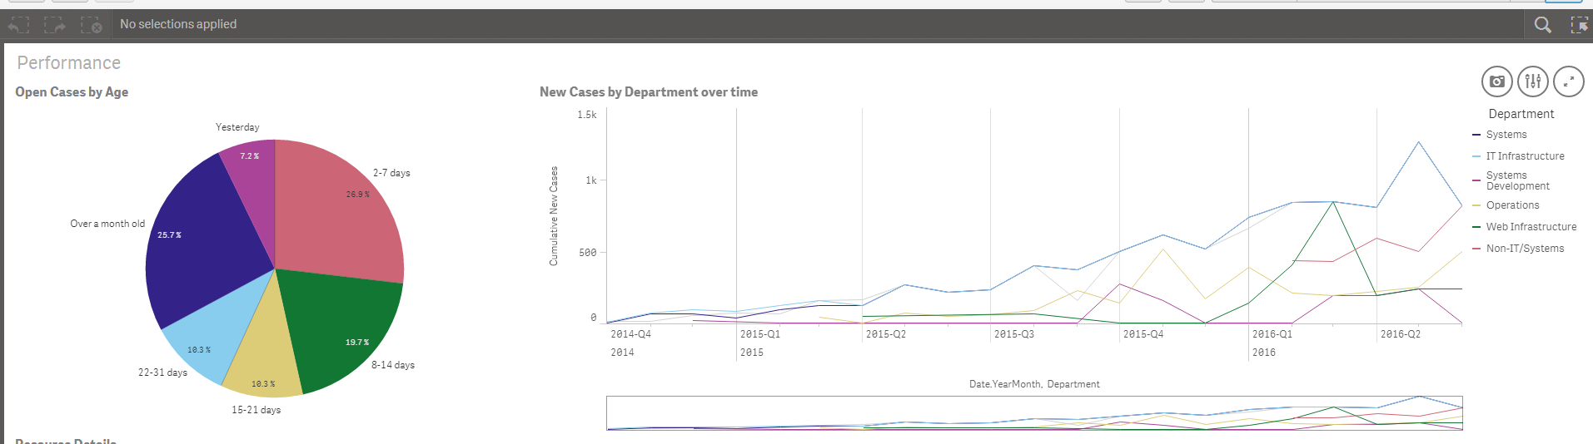

Chart Controls 2

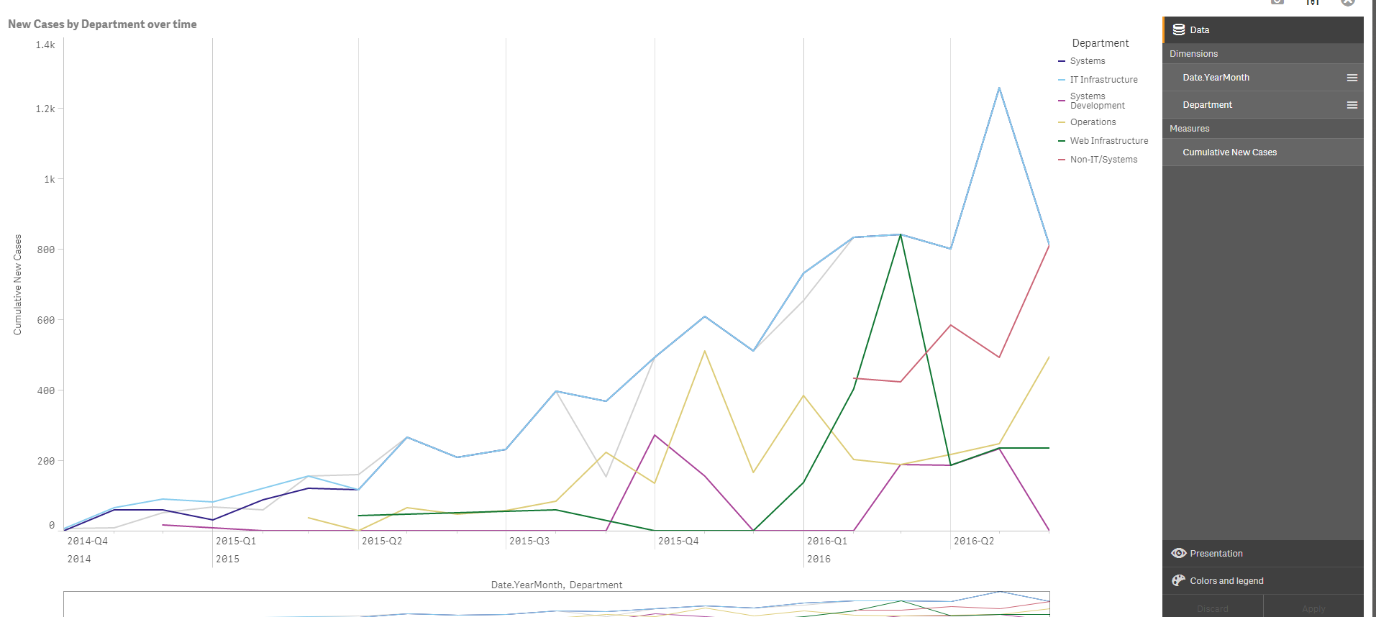

Selections

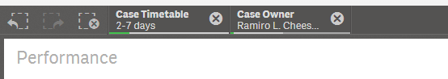

Bookmarks

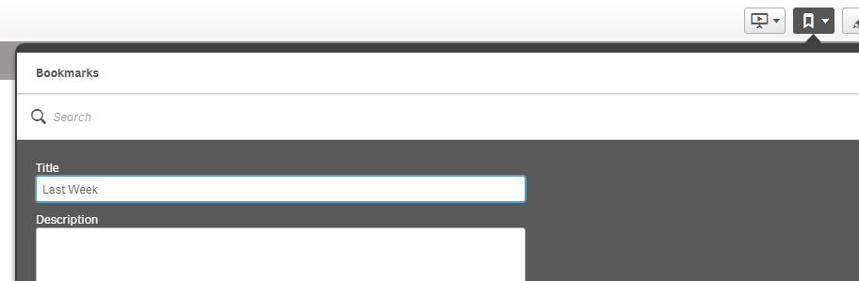

Story 1

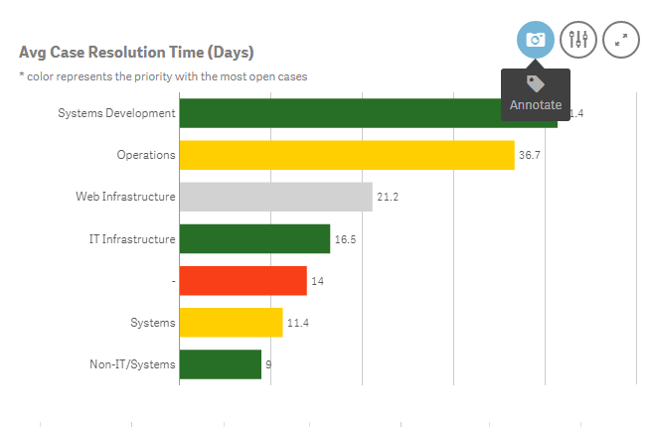

Story 2

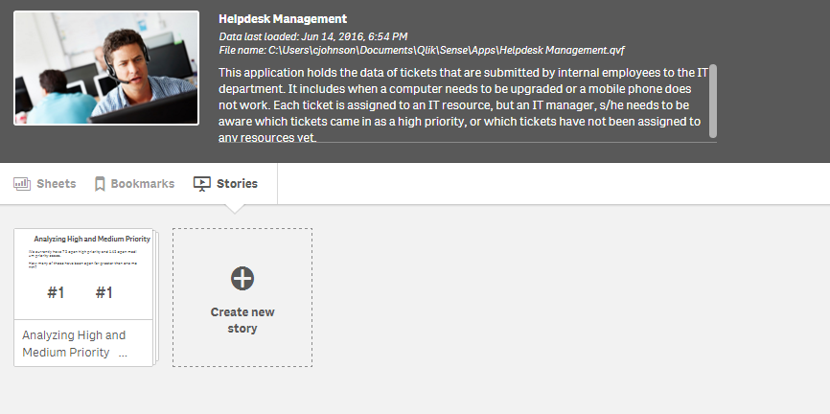

Story 3

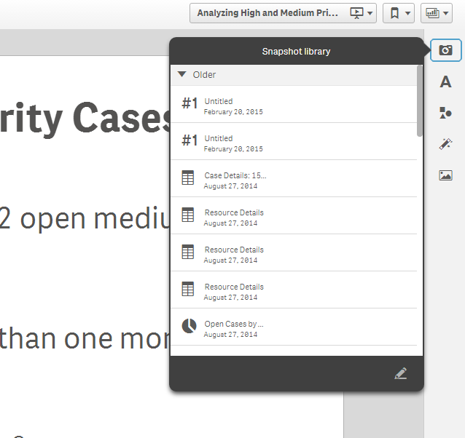

* Qlik Sense Editing
  + Introduction to Data Models
  + Master Charts
  + Creating/editing sheets using Master Charts
  + Master Dimensions and Measures
  + Creating/editing charts using Master Dimensions and Measures

Navigation 1



Data Models 1

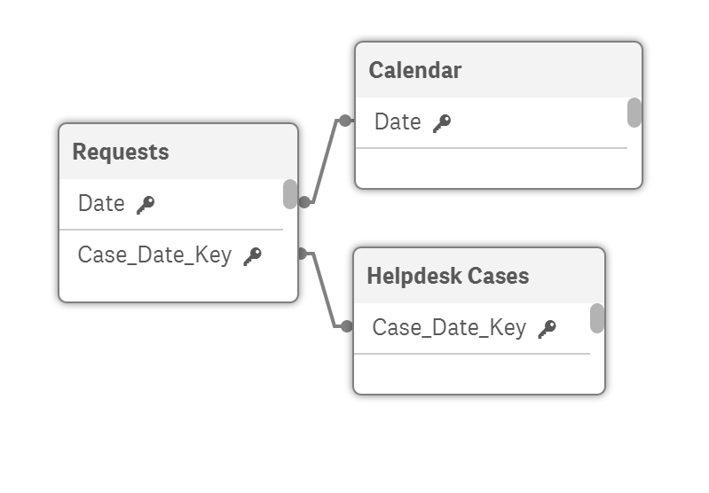

Data Models 2

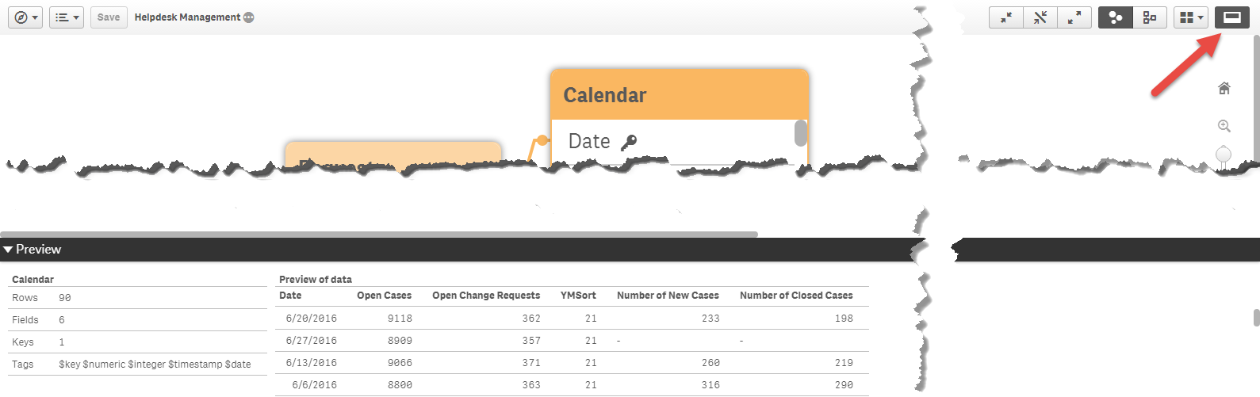

* Qlik Sense Formulae
  + Create a chart with a custom measure
  + Create Master Dimensions and Measures
  + Further reading on formulae and help resources

Edit 1

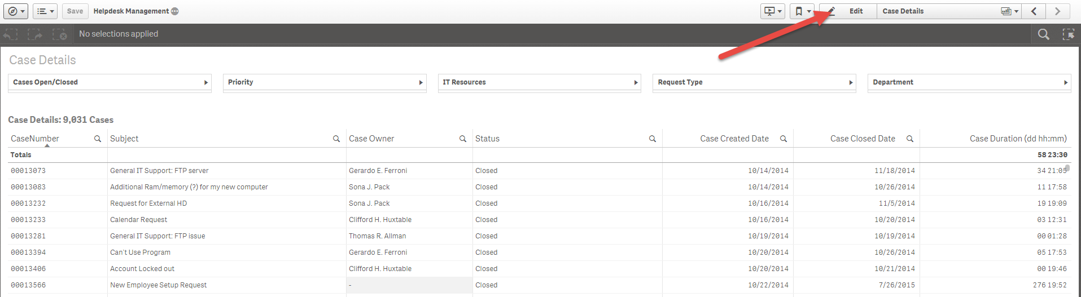

Edit 2

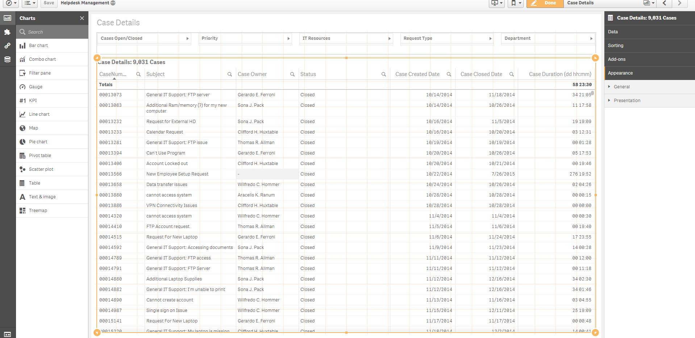

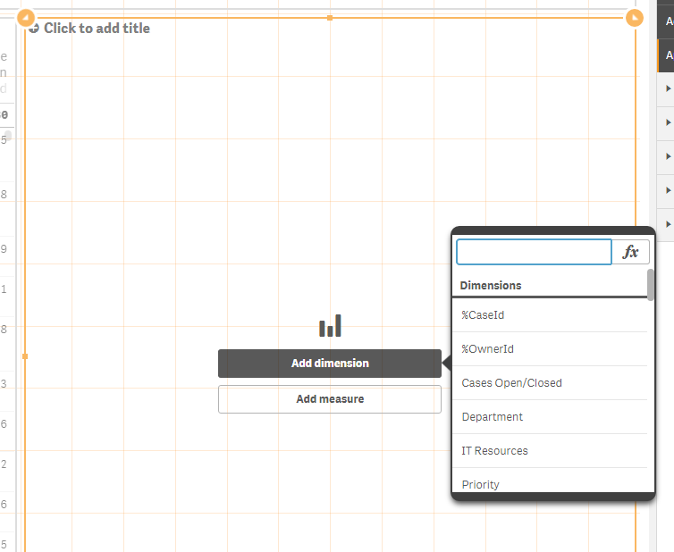Add a bar chart, Select Department as dimension

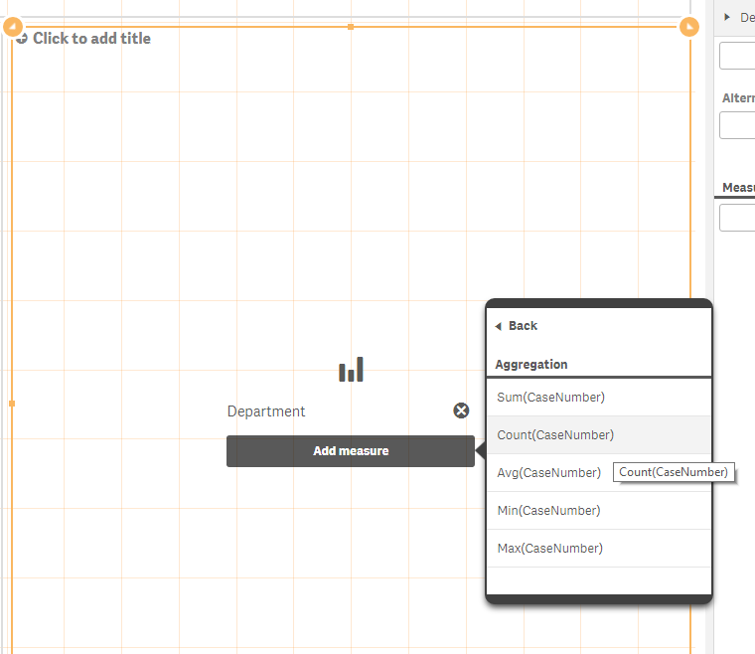Add Case Number, Count as measure

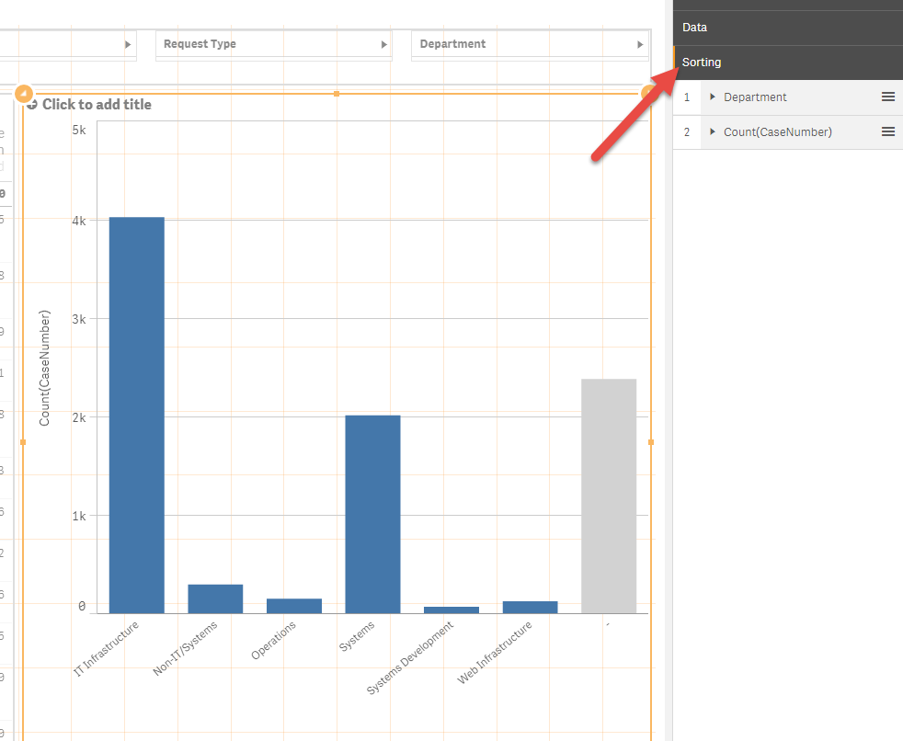Change the sort by dragging count above dept.

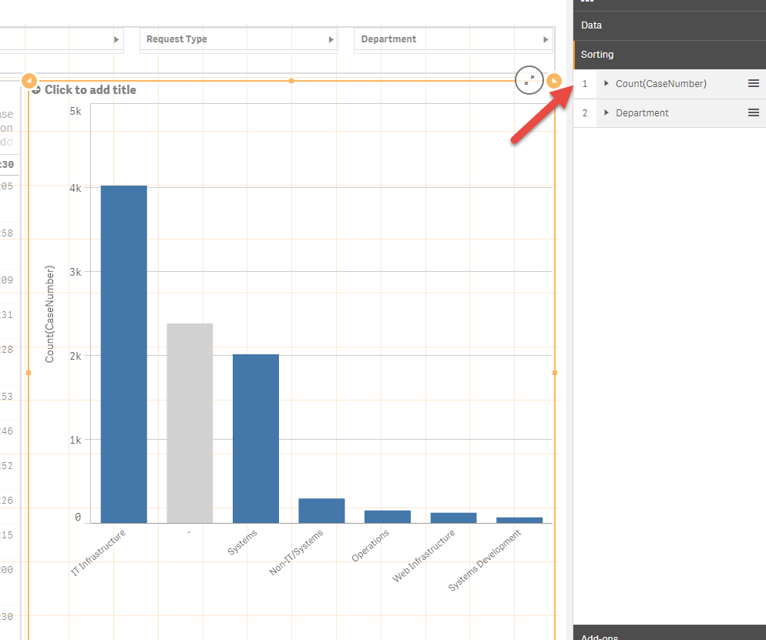

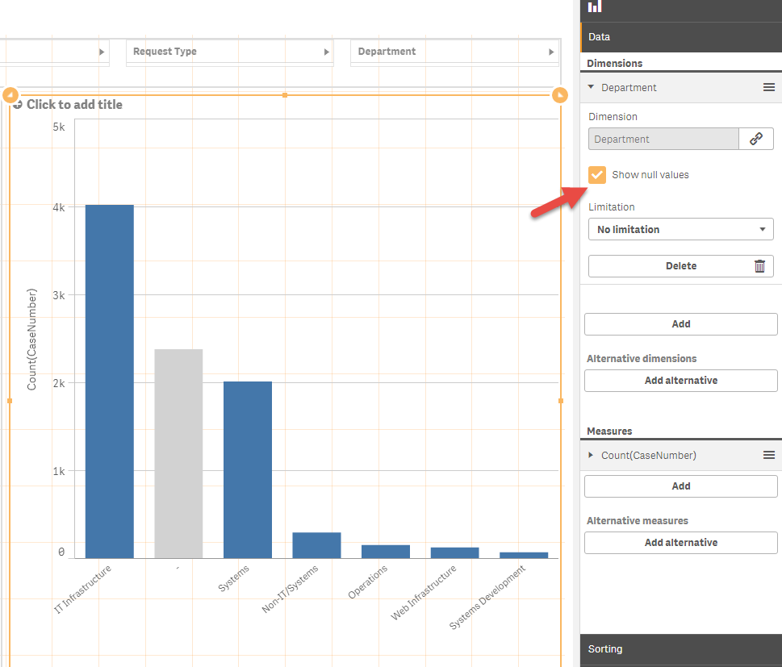

Remove null values from Department Dimension

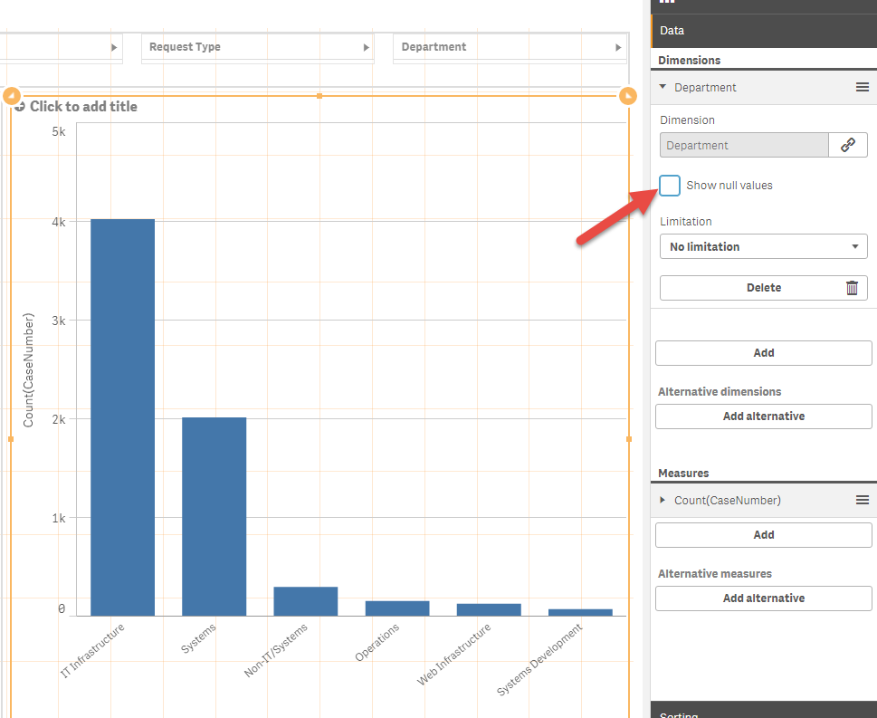

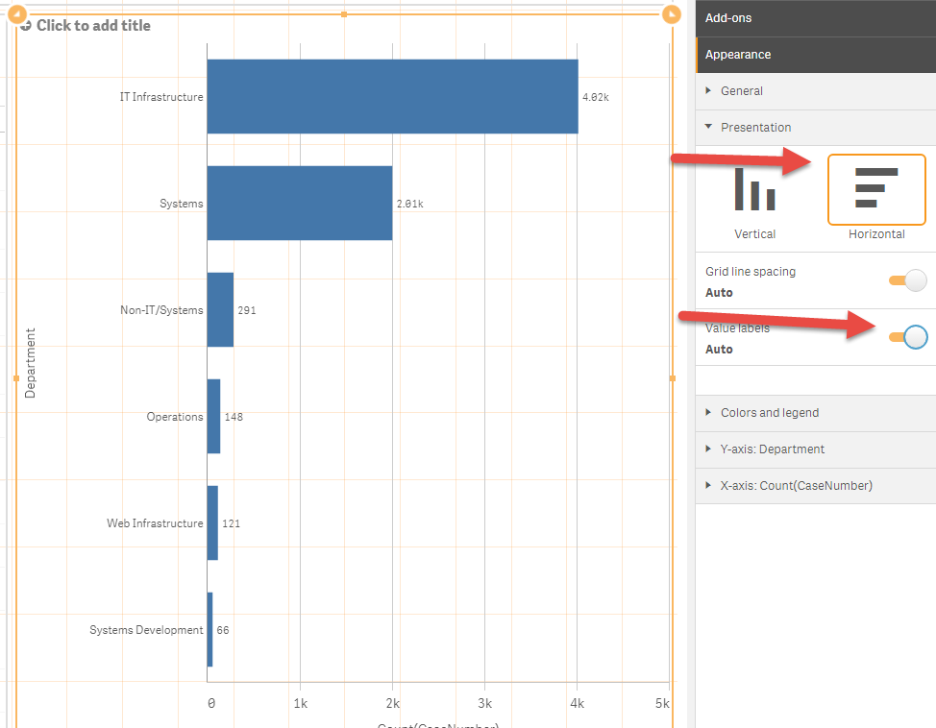Change to horizontal bars, add value labels

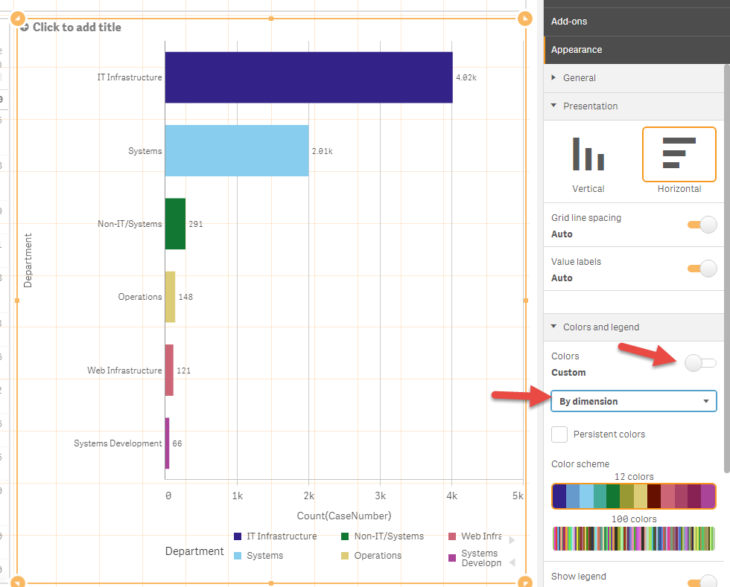Change colours to be by dimension

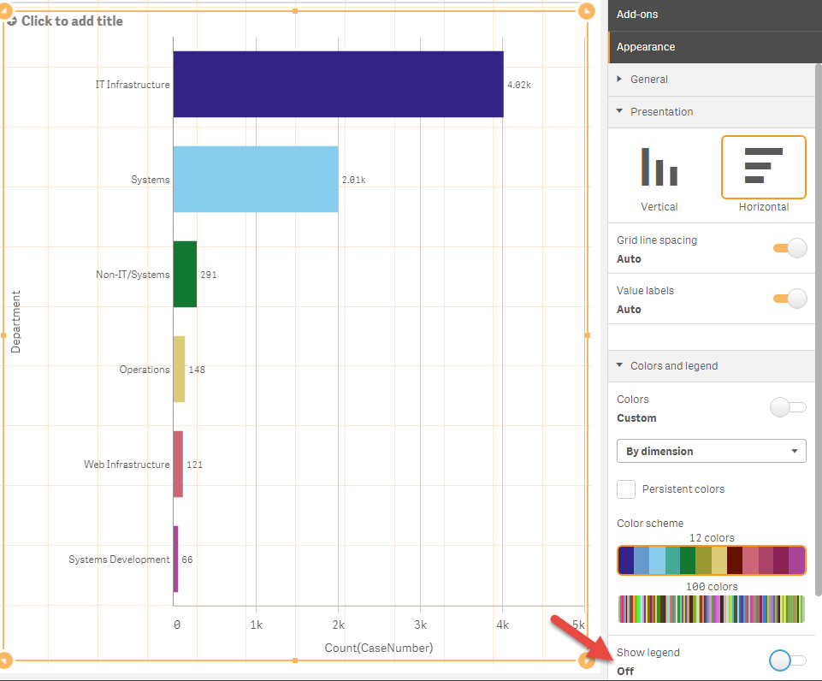Turn off show legend

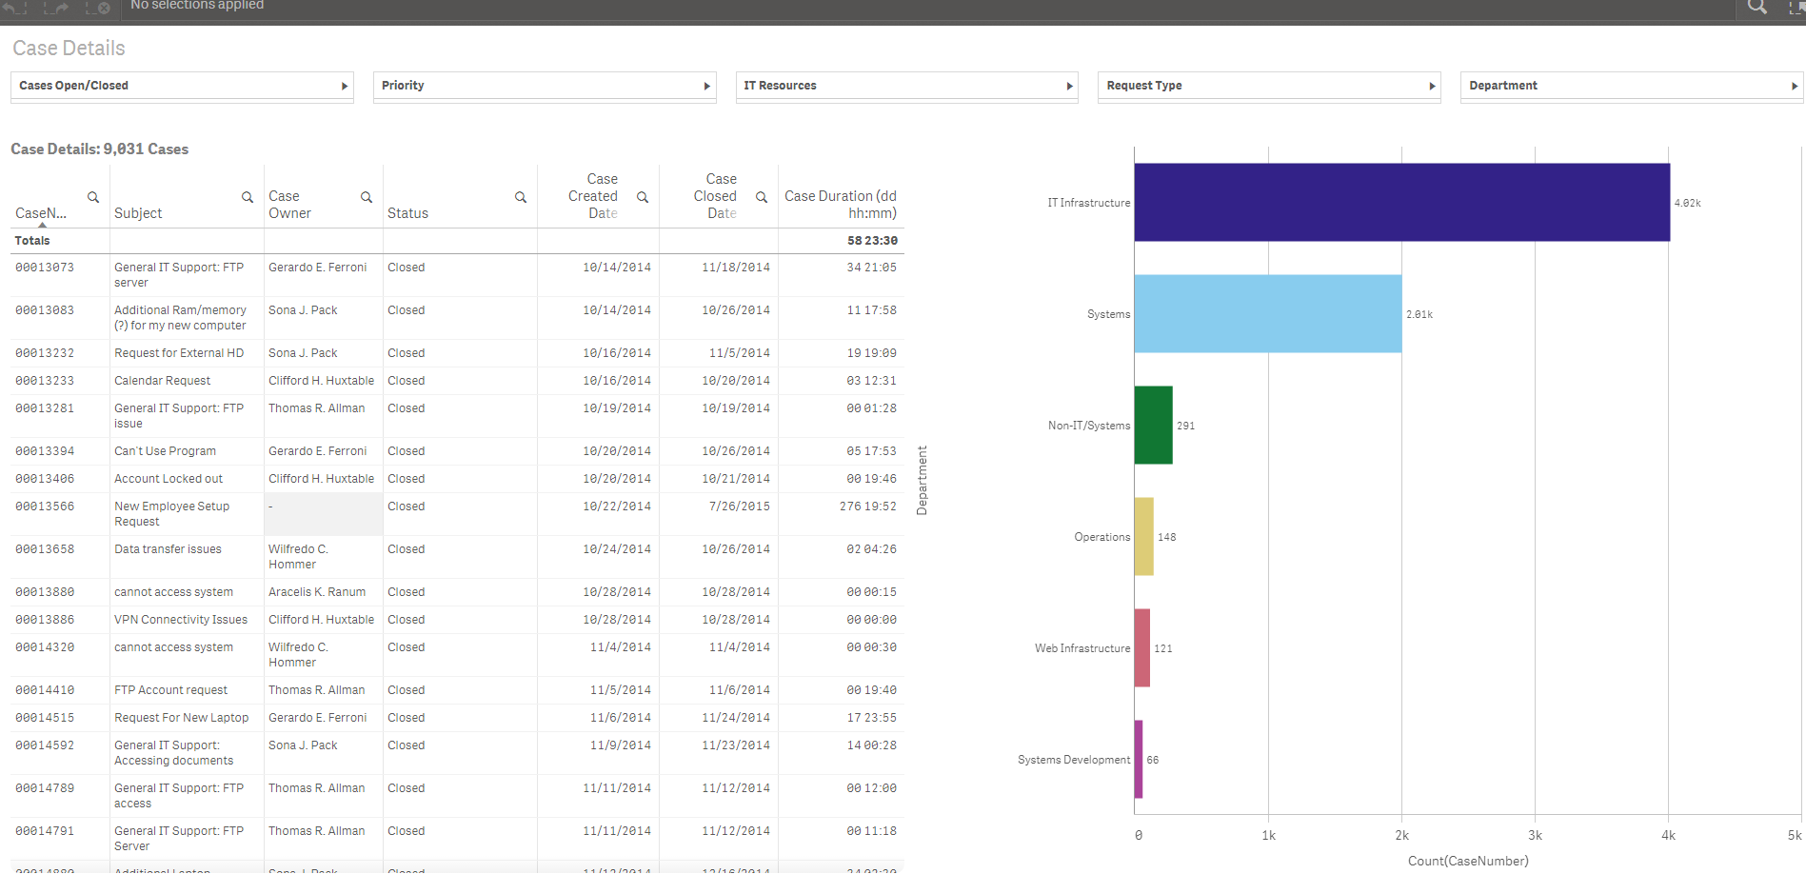Check out the format

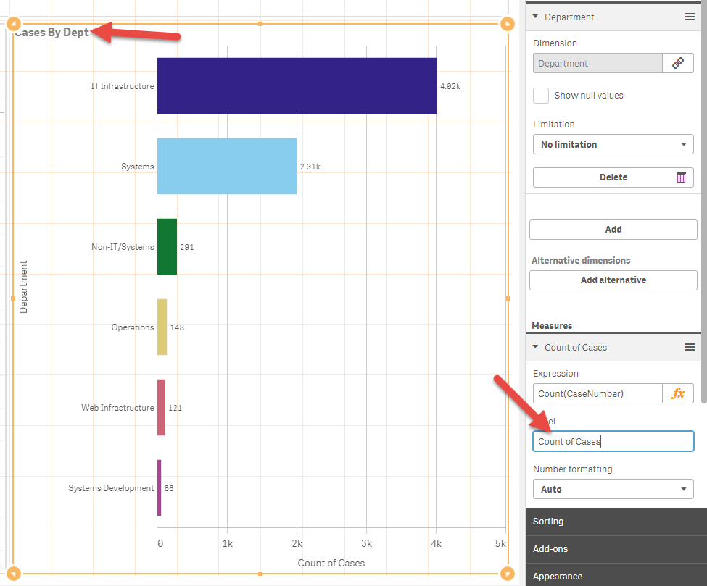Re-edit

Name the measure

Name the chart

* Additional Topics
  + Load data into Qlik Sense from files
  + Creating a drilldown dimension for use in charts
  + How to limit charts using an amount
  + Creating a histogram

Data Location

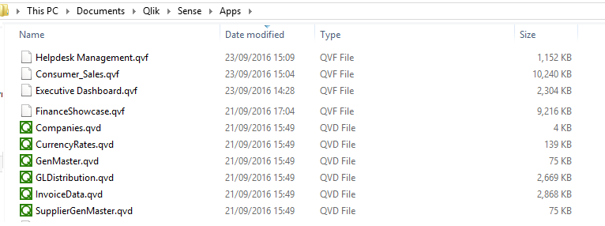

Report now shows on the hub

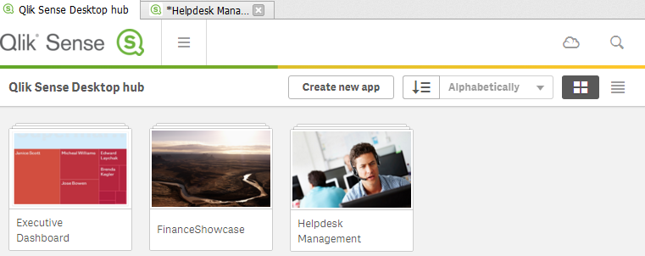

Drilldown and histogram example

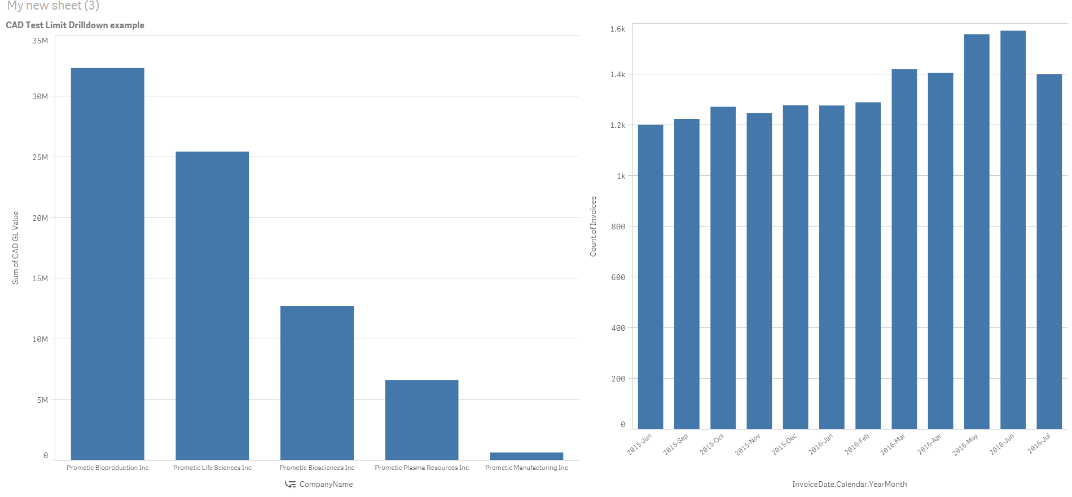

**Qlik Sense Navigation**

Aim of Session: By the end of the session, attendees should be able to

* identify the different parts of a Qlik Sense application
* navigate between different sheets
* Expand, print and alter charts
* Exporting information from charts into images, pdfs and excel
* make, view and remove selections on data
* make, view and remove bookmarks
* make, view and remove stories

**Qlik Sense Editing**

Aim of Session: By the end of the session, attendees should be able to

* Load a document into the Qlik Sense Hub
* view a data model in Qlik Sense, understand connections between tables and browse data
* create a new sheet and add Master Charts to the sheet
* Create charts using Master Dimensions and Measures

**Qlik Sense Formulae**

Aim of Session: By the end of the session, attendees should be able to

* Describe the difference between a dimension and a measure
* Describe the following functions
  + Sum
  + Max
  + MaxString
  + Min
  + Count
  + Distinct
  + Today
  + if
* Demonstrate the different types of charts available
* Create a chart with
  + Alternate measures
  + Alternative Dimensions
* Explain the benefits of using Master Dimensions and Measures and be able to create them

**Additional Topics**

Aim of Session: By the end of the session, attendees should be able to

* Be able to import a Qlik Sense document in Qlik Sense Desktop
* load data into Qlik Sense from provided files
* Creating a drilldown dimension and implement it in a chart
* Demonstrate how to limit charts using top and a fixed amount and explain when to use the “Others” feature
* Create a basic histogram using automatically generated values

**Reload Process**