Table of Contents

Review of Reports Guide and Notes 2

Background 2

Screenshot of Report 2

Components 3

Companies without names 3

Tables not updated in the last 35 minutes 3

Currency Status 3

Lookup records that are duplicated 4

Report Stats 4

Top 10 Reports – All Time 4

Top 10 Stored Procedures – All Time 4

Development Reports Run in Last Month 5

Report System Troubleshooting 5

Step 1: Try executing the “Report System Refresh” crystal report in Syspro 5

Step 2: Run the load controller using SSMS 5

Step 3: Identify and run the update procedure for the individual tables. 6

# Review of Reports Guide and Notes

## Background

This report provides details on the status and usage of the reports that are being accessed through Syspro. It is used to identify problems with the reports system before they are noticed by users.

## Screenshot of Report

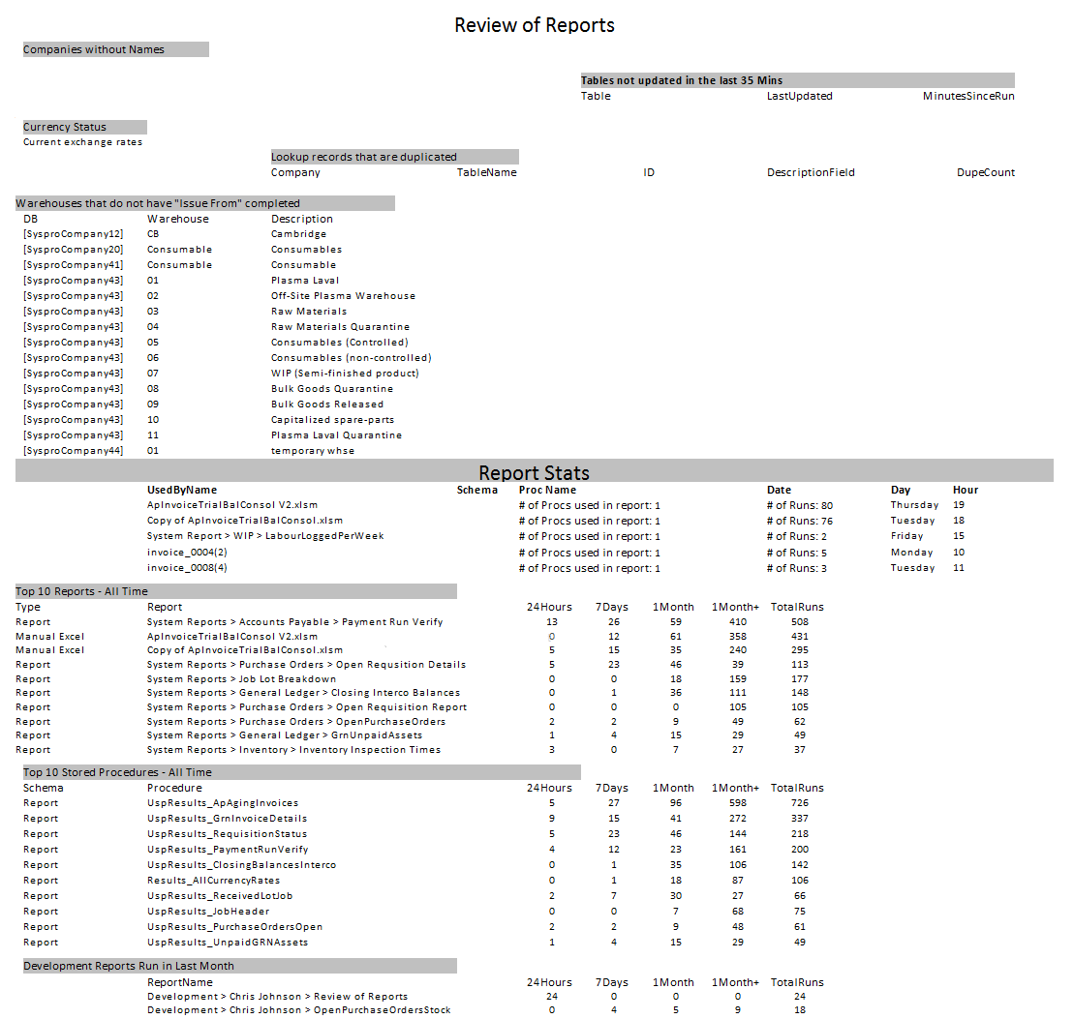

## Components

### Companies without names

* What does this mean?

The table [Lookups].[CompanyNames] contains a list of all the Syspro companies that are live, this check highlights where a live Syspro Company (determined by the company reference being a number instead of a character) is not found in this table.

* Why is this important?

Without an entry in this table, the reports that are in the mentioned company will not work.

* How this can be resolved?

The stored procedure [Process].[UspUpdate_CompanyNames] must be amended to include the new company name.

### Tables not updated in the last 35 minutes

* What does this mean?

The static data behind the reporting systems is populated every 30 minutes, this check determines if the data in any of the affected tables has not been updated in this time frame.

* Why is this important?

Reports on changes to the system rely on this information to be as up to date as possible.

* How this can be resolved?

See Report System Troubleshooting

### Currency Status

* What does this mean?

The table [Lookups].[CurrencyRates] contains the exchange rates used to convert between different currencies. This check ensures that there is a rate that is in place for today.

* Why is this important?

If a rate for today is not present, this means that’s any conversion of currency will not work and cause reports to fail.

* How this can be resolved?

See Report System Troubleshooting

### Lookup records that are duplicated

* What does this mean?

Tables that belong to the Schema Lookups are used as references when generating reports, this is due to the data not being available in Syspro. This check looks for where this information has been duplicated which can happen in the event of report system losing connectivity.

* Why is this important?

If there are duplicates in the tables, this leads to information in the reports generated being duplicated. Causing figures to be inaccurate.

* How this can be resolved?

See Report System Troubleshooting

### Report Stats

This provides details of how often a report has been run in the time period selected when running the report, it also provides details of how many stored procedures each report requires to run. This can be used to identify when to review reports and their efficiency (when they are being used frequently), which reports may have caused an issue within a specific time frame and which reports may not be required (through lack of use)

*\* This section does not take into account reports in Development*

### Top 10 Reports – All Time

This provides a top 10 list of all the reports, sorted by the number of times they have been run. There is a weighting applied to the figures dependent on how long ago a report run happened.

* Run in last 24 hours – weighting * 4
* Run in last 7 days – weighting * 3
* Run in last month – weighting * 2
* Run later than last month – weighting * 1

*\* This section does not take into account reports in Development*

### Top 10 Stored Procedures – All Time

This provides a top 10 list of all the stored procedures that have been run on the server, sorted by the number of times they have been run. This is because the same procedure can be run for different reports. There is a weighting applied to the figures dependent on how long ago a run happened.

* Run in last 24 hours – weighting * 4
* Run in last 7 days – weighting * 3
* Run in last month – weighting * 2
* Run later than last month – weighting * 1

### Development Reports Run in Last Month

This provides a list of all the report testing that has happened in the last month. This can be used to validate that the level of testing required has been met.

## Report System Troubleshooting

### Step 1: Try executing the “Report System Refresh” crystal report in Syspro

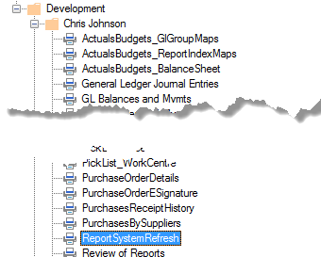

The exec parameter should be set to 1

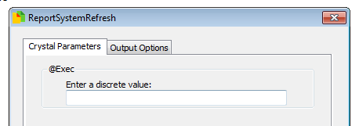

If this report runs correctly, re-run the “Review of Reports” report and check if this has resolved the issue. If the issue is unresolved, move to step 2.

### Step 2: Run the load controller using SSMS

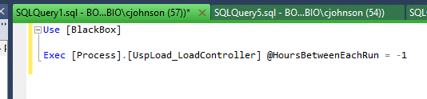

If there are no errors, re-run the “Review of Reports” report and check if this has resolved the issue. If the issue is unresolved, move to step 3.

### Step 3: Identify and run the update procedure for the individual tables.

Run the below code to identify which stored procedure is needed for the table(s) that haven’t been updated. The ProcName following the “UspUpdate_” should enable you to identify the table.

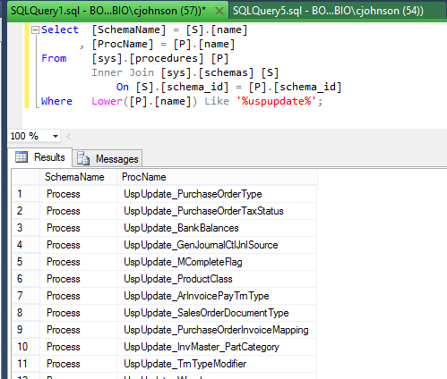

Execute the procedures with the parameters completed as below.

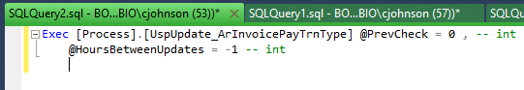

This will enable you to identify issues in the procedures, correct them and deploy them to live. Once this is corrected, re-run the “Review of Reports” Report to validate the correction.