Project 1 instructions:

Todos:
Create 2 matlab functions w specified names P1a_name1_name2.m and P1b_name1_name2.m.
P1a_name1_name2:
Animate 3 cycles of inverted slider crank mechanism, given specified link
For this project, you will create two Matlab functions, called P1a_name1_name2.m and P1b_name1_name2.m.

P1a:
Name: P1a_name1_name2(r1,r2,r3,speed),

Plot 1:
- Animate 3 cycles of inverted slider crank mechanism
- Takes: specified link lengths r1, r2, r3, (no offset)
  - R1 is the length of a fixed horizontal ground link
  - R2 is the crank length
  - r3 is the rocker length
  - speed is the crank speed in rad/s.
- must print error message if r3 is too short
- must work correctly for crank rocker and drag link (aka when r1 < r2 )
- must start with all links horizontal and directed to the right of round
“Your animation does not have to look exactly the same in terms style, but it should have the same starting position shown in the video file.”
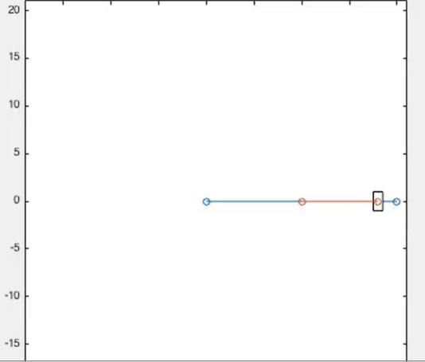
Ideally, test function with inputs (10, 8, 20, 1)

Plot 2:
- plot rocker angle against time

P1b:
Goal: modify P1A to to create a quick return planing machine
Function form: P1b_name1_name2(r1,r2,r3,r4,r5,speed),
Sample test inputs: P1b_name1_name2(5,4,13,6,10,1)
Input guide:
  - R1 is the length of a fixed horizontal ground link
  - R2 is the crank length
  - r3 is the rocker length
  - r4 is the length of the rod connecting the new slider to the rocker of the inverted slider crank
  - r5 is the horizontal distance from the rocker pin joint to the vertical path of the second slider's pin joint.
  - speed is the crank speed in rad/s.

P1B: reuse same code but modify to have the following:
- offset
- link that connects the output rocker to a second slider that reciprocates vertically
- No need to plot rocker angle against time for P1B, so only one output plot needed

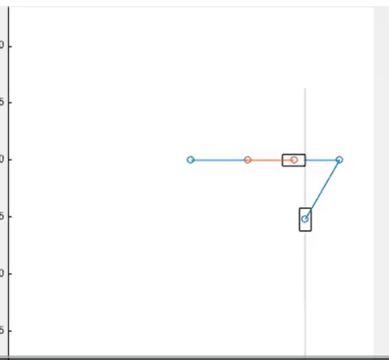
Initial P1b position shown:

Important Notes:
You will notice that in the slider-crank sample code, the slider was represented using the rectangle command. However, rectangles made using the rectangle command cannot be rotated. For the rotating slider, you will need to use the 'patch' or 'fill' commands instead.

Both P1A and P1B
Your plots should have appropriate titles and axis labels.
Each group must submit their own code (with detailed comments) and demonstrate it at a tutorial.

Full D2L text:
For this project, you will create two Matlab functions, called P1a_name1_name2.m and P1b_name1_name2.m.
P1a_name1_name2 will animate 3 cycles of an inverted slider-crank mechanism, given specified link lengths with no offset, and plot the rocker angle against time in a separate plot. P1b_name1_name2 will be the same code but modified to include a link that connects the output rocker to a second slider that reciprocates vertically. P1b need not include the plot of rocker angle versus time.
The first function has the form P1a_name1_name2(r1,r2,r3,speed), where r1 is the length of a fixed horizontal ground link, r2 is the crank length, r3 is the rocker length, and speed is the crank speed in rad/s. Your code should print an error message if r3 is too short to support the slider over a full rotation of the crank. The code should work correctly for both the crank rocker-case and the drag-link case (i.e. when r1 < r2).
Below is a video showing the result of calling P1a_name1_name2(10,8,20,1). Your animation does not have to look exactly the same in terms style, but it should have the same starting position shown in the video file.
The goal of P1b is to add a connecting rod and vertical slider to the arm in your first assignment to create a quick-return planing machine. This function should have the form P1b_name1_name2(r1,r2,r3,r4,r5,speed), where r4 is the length of the rod connecting the new slider to the rocker of the inverted slider crank and r5 is the horizontal distance from the rocker pin joint to the vertical path of the second slider's pin joint.
The second video below shows the result of calling P1b_name1_name2(5,4,13,6,10,1).
Important Notes:
- You will notice that in the slider-crank sample code, the slider was represented using the rectangle command. However, rectangles made using the rectangle command cannot be rotated. For the rotating slider, you will need to use the 'patch' or 'fill' commands instead.
- Your plots should have appropriate titles and axis labels.
- Each group must submit their own code (with detailed comments) and demonstrate it at a tutorial.

  - Sample project:
This sample project shows how Matlab can be used to animate a mechanism and plot output variables versus time. The project was to animate 3 cycles of a slider crank and then plot the slider position and speed versus time. The function defined in the m-file called P1_Sample.m takes the link lengths and crank speed as inputs. Read the comments in the m-file to understand what it does and how. It generates 3 plots: the plot of the animated mechanism, a plot of slider position versus time, and a plot of speed versus time. The speed plot contains 2 subplots: one is the slider speed calculated from a formula, and the other is the same speed calculated numerically from the position data.
Try running the function P1_Sample(r1,r2,r3,speed) by calling it with with different inputs, such as P1_Sample(1,2,5,2). Note that the 3 generated plots hide each other, so you will need to drag them apart with your mouse to view all 3.

