Environment:

1. Machine: Nvidia GeForce GTX 1060 (6GB RAM)
2. System: Windows 10
3. Python 3.6
4. Tensorflow 1.15.0

Procedures:

1. Git clone the repo;

>>> git clone https://github.com/wangershi/AlphaZero_Gomoku.git

1. Install Python 3.6 environment (use Anaconda or other tools);
2. Install CUDA and cuDNN;

You can refer this blog: <https://blog.csdn.net/fengxinzioo/article/details/105646969>);

1. Install Tensorflow

>>> conda install tensorflow-gpu==1.15.0

Train:

1. Start training with a 6 * 6 board and 4 in a row. Time: 22:11, Mar 22nd, 2021;

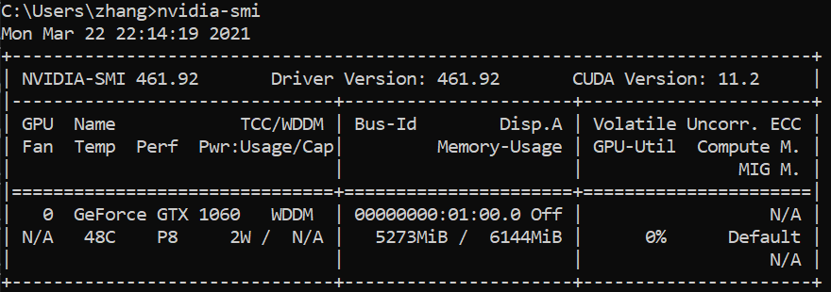

1. Use about 7.5 hours to finish training (1500 epochs);



1. Epoch 1500 is not the best policy model;

From the created time of best_policy.model, we can infer that the model get the best score after training about 700 epochs;

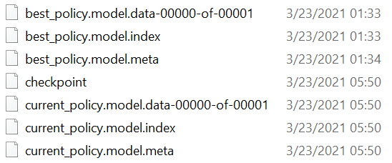

Inference:

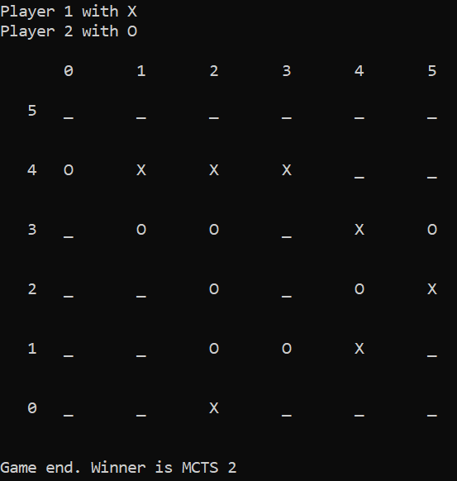

Section 2: Submit training jobs to ITP MS-Shared cluster group using phillytools

1. Installing phillytools

<https://phillytools.azurewebsites.net/master/get_started/2_installation.html#id1>

1. Git clone the repo;

>>> git clone https://github.com/wangershi/AlphaZero_Gomoku.git

1. Organize the project locally

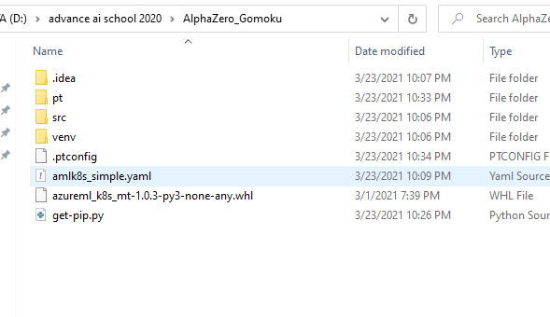

4. amlk8_simple.yaml

description: Tensorflow MNIST example

target:

service: amlk8s

# run "pt target list amlk8s" to list the names of available AMLK8s targets

environment:

image: tensorflow/tensorflow:1.15.2-gpu-py3

code:

# upload the code

local_dir: $CONFIG_DIR/src/

data:

# You need to run "python src/download_data.py" beforehand

# to generate the dataset to be uploaded

# don't forget to run with --upload-data

local_dir: $CONFIG_DIR/data/

# The data will be uploaded to your default storage.

# Check ``multi_storage.yaml'' for more flexibility.

remote_dir: data/mnist_tensorflow

# schedule two simple jobs, names for each job should be different:

jobs:

- name: alphazero_gomoku_train_job

sku: G1

command:

- python train.py

1. Submit training job to ITP MS-Shared cluster group

>> pt run amlk8s_simple.yaml AlphaZero_Gomoku -t ms-shared-v100 --pre

Notes: ms-shared-v100 can be replaced by ms-shared-p100, ms-shared-a100, ms-shared-p40.