Foxtrot Game Manual.

**WHERE DO I DOWNLOAD THE GAME?**

Hop on over to my GitHub and download the latest version of my game to try out. The link is provided here: <https://github.com/dontrunmk/FoxtrotGame>

**SURVEY LINK**

**https://forms.gle/4ZgLpfbtzASBjXMEA**

**HOW DO I INSTALL THE GAME?**

Go to my GitHub. Click on the green button called “Clone or Download” and press “Download ZIP”. After that, extract the files/folders to a destination, preferably the Desktop. The Folder should be called “FoxtrotGame-Master”. After that navigate through the folders and find the latest version folder (as of writing this, it should be V2.1. Lastly, double click on the Foxtrot.exe application and run the game!

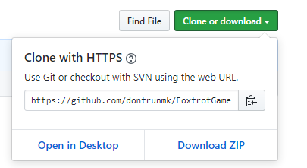

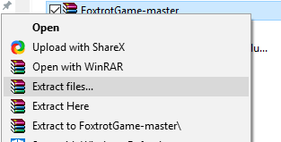

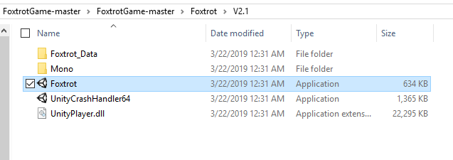

**WHAT DO YOU EXPECT FROM ME?**

For you to have fun, and document it! With your help, I can improve my game even more, such as adding features you want to see, fix some bugs I did not find, and much more. The google survey should be everything that I want from the players. Please answer honestly and try to not leave one word comments/replies too much please!

**WHAT DO I GET FOR HELPING YOU?**

My Eternal gratitude. Just kidding. The emails I ask of you in the survey will be used for a random drawing for a gift card. Something like a $20 gift card (Itunes or something) sent electronically to you. The winner will be announced sometime near the middle-end of April.

The emails will be used only for the random gift card drawing, and to send out a mass email update on a version update of my game for a second round of testing.

Hi there player, this is Adam Sulayman, the creator of this game you are about to play, called Foxtrot. This game is my Project II and one of my assignments is player testing and feedback! That’s where you, the player comes in. All you need to do is play my game! And report back on any bugs and feedback that you have.

This game is far from perfect, I know that, but part of the development cycle of the game is playtesting your game right?! There are some bugs and glitches in my game, some that I know, some that I don’t, hopefully after all is said and done, those bugs won’t be there anymore!

Once again, thanks for helping me with my game and my Project II.

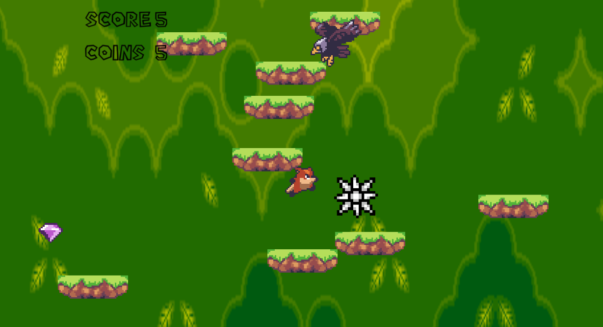

Here is a brief tutorial on how to play the game.

The character you control is the brown fox. He jumps on every green platform he steps on. Your score is determined by how far you can make it before dying. There are some obstacles along the way. Some of them are pictured here. A spiky ball and an eagle.

You die when you touch an enemy, obstacle, or go off the screen.

There are also collectibles too. You can collect Gems. There are also different platforms as well; some help or hinder you depending on what it is.

You move around with the “A” and “D” keys.

If you die, it is not over, just press the “R” key to retry again. If you need to pee or take a break, hit the Spacebar to bring up the pause menu.