**Foxtrot Game Manual**

**A WORD FROM THE DEV**

Hi there player, this is Adam Sulayman, the creator of this game you are about to play, called Foxtrot. This game is my Project II and one of my assignments is player testing and feedback! That’s where you, the player comes in. All you need to do is play my game! And report back on any bugs and feedback that you have.

This game is far from perfect, I know that, but part of the development cycle of the game is playtesting your game, right?! There are some bugs and glitches in my game, some that I know, some that I don’t, hopefully after all is said and done, those bugs won’t be there anymore!

Once again, thanks for helping me with my game and my Project II.

**WHERE DO I DOWNLOAD THE GAME?**

I have an installer on my GitHub page. <https://github.com/dontrunmk/FoxtrotGame>

Please read the README file before doing anything else!

**SURVEY LINK**

[**https://forms.gle/2iUwe6cKe5EBi8Jm6**](https://forms.gle/2iUwe6cKe5EBi8Jm6)

**HOW DO I INSTALL THE GAME?**

Go to my GitHub, click on the “Foxtrot Setup(x86).exe file and hit the Download button. Afterwards, wait and click on the downloaded exe file and run the installer. Follow the installers prompts and make sure you create a desktop shortcut. Click on it and enjoy the game! I have pictures to help with the installation process down below.

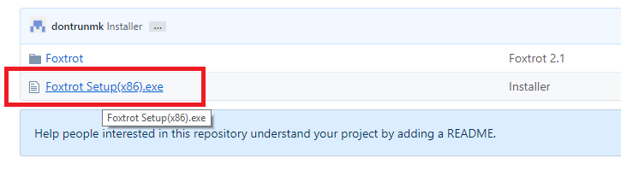

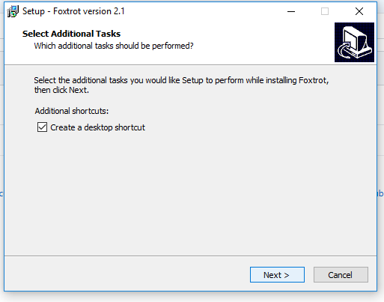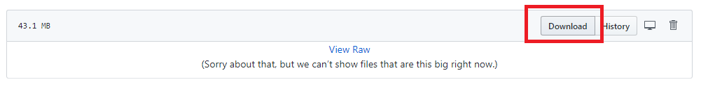

**WHAT DO YOU EXPECT FROM ME?**

For you to have fun, and document it! With your help, I can improve my game even more, such as adding features you want to see, fix some bugs I did not find, and much more. The google survey should be everything that I want from the players. Please answer honestly and try to not leave one word comments/replies too much please!

**WHAT DO I GET FOR HELPING YOU?**

My Eternal gratitude. Just kidding. The emails I ask of you in the survey will be used for a random drawing for a gift card. Something like a $20 gift card (Itunes or something) sent electronically to you. The winner will be announced sometime near the middle-end of April.

The emails will be used only for the random gift card drawing, and to send out a mass email update on a version update of my game for a second round of testing.

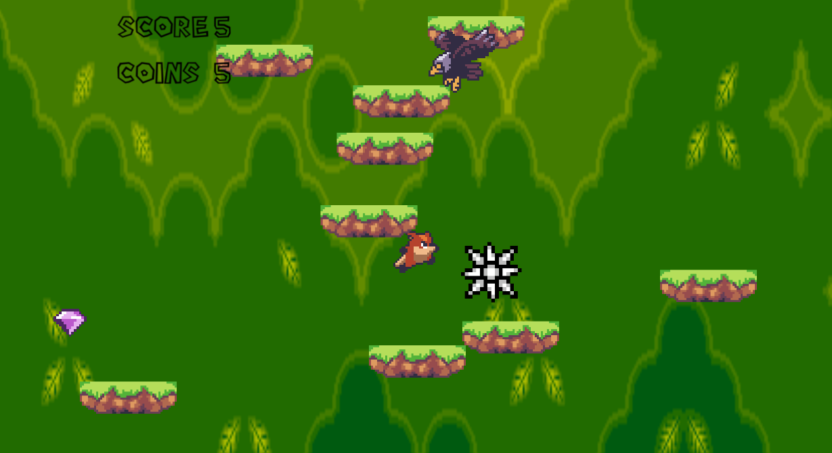**TUTORIAL**

Inputs: A (move left), D (move right), R (retry) Spacebar (bring up pause menu)

The character you control is the brown fox. He jumps on every green platform he steps on. Your score is determined by how far you can make it before dying. There are some obstacles along the way. Some of them are pictured here. A spiky ball and an eagle.

**You die when you touch an enemy, obstacle, or go off the screen.**

There are also **collectibles** too. You can collect **Gems**. There are also different platforms as well; some help or hinder you depending on what it is.

If you die, it is not over, **just press the “R” key to retry again**. If you need to pee or take a break, hit the **Spacebar to bring up the pause menu**.