MID TERM REPORT
Computational Physics Project
Topic : Spherical Caps in Cell Polarization
By Anamika Garg

Abstract
Many models of cell polarity study how certain proteins move and react on the surface of a cell. Because a cell membrane is not flat but curved and closed, these models need to work on a spherical surface instead of a flat one. This means we must solve reaction diffusion equations on a sphere.
The aim of this project is to reproduce an existing cell polarity model by building a numerical setup that works on a spherical surface. The main focus is on understanding the geometry of the sphere, explaining why spherical meshes are needed, and starting the numerical implementation. So far, this includes generating points on a sphere and describing how a Voronoi-based discretization can be used.
This report explains the basic theory behind the model, outlines what has been completed so far.

Introduction
Cell polarity refers to spontaneous breaking of symmertry in spatial distribution of proteins on a cell membrane. Proteins can bind to the membrane, unbind back into the cytoplasm, and diffuse along the membrane. Under certain conditions, this uniform state becomes unstable and a polarized pattern emerges. Cell polarity is described using nonlinear partial differential equations that are defined on the surface of a sphere, which represents the cell membrane. Unlike a flat surface, a sphere has no edges and is curved everywhere. This curvature affects how proteins spread and how patterns form on the membrane. Because of this, the spherical surface must be discretized carefully before running any time-dependent numerical simulations.

Spherical Geometry
Protein concentriation are constrained to the cell membrane, which is topologically equivalent to a sphere. Modelling this system on a square grid introduces artificial boundaries or periodic conditions that do not exist physically.
On a sphere:
- There are no edges or corners.
- Diffusion is governed by the Laplace–Beltrami operator rather than the standard Laplacian.
- Curvature influences the allowed spatial modes and the mechanism of symmetry breaking.

Model from Paper
Paper models cell polarity as coupled reaction diffusion system. Describes exchange of proteins between cytoplasm and cell membrane. Cell = sphere of radius R, membrane = 2d curved surface, cytoplasm = 3d enclosed volume.
Let B(θ, φ, t) denote the concentration of membrane-bound protein, defined on the spherical surface. Its temporal evolution is governed by a surface reaction diffusion equation of the form:
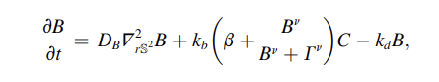
The cytoplasmic protein concentration, denoted by C(r, t), evolves according to a standard diffusion equation:
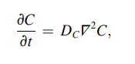
The membrane and cytoplasm are coupled through a boundary condition at the cell surface. Conservation of protein mass requires that the normal diffusive flux of cytoplasmic proteins at the membrane balances attachment and detachment processes:
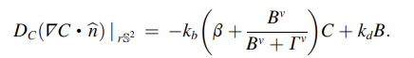
Due to the fast cytoplasmic diffusion, the cytoplasmic concentration can be approximated as spatially uniform. Under this assumption, C becomes a global variable determined by the total amount of membrane-bound protein:
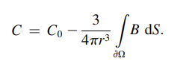
Substituting this expression into the membrane equation yields a closed nonlinear partial differential equation defined entirely on the spherical surface. After nondimensionalization, the governing equation takes the generic form:
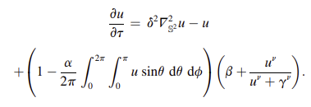
This equation captures the essential physics of cell polarity: diffusion on a curved surface, nonlinear local feedback, and global mass conservation. Accurate numerical solution of this equation requires careful discretization of the spherical surface and the Laplace Beltrami operator
Geometry Formation Algorithm
- Fix the sphere radius to $R=1$.
- Generate $N$approximately uniformly distributed points on the sphere using Fibonacci sampling.
- Construct a spherical Voronoi tessellation from these points.
- Use the resulting cells as finite surface elements for numerical discretization.

Mesh Generation
Fibonacci Point Sampling - For numerical diffusion to be stable, the points used to discretize the surface should be spread out as evenly as possible. Common latitude longitude grids do not satisfy this requirement, since many points get crowded near the poles. This leads to cells of very different sizes and makes the numerical calculations unstable.
To avoid this problem, the points are placed on the sphere using a Fibonacci point set. It uses the special properties of the golden ratio to distribute points almost uniformly over the spherical surface. For a chosen number of points $N$, each point is assigned a vertical coordinate $z$that is evenly spaced between −1 and 1, along with an angular coordinate $θ$ that advances by an irrational fraction of $2π$. This prevents points from lining up or repeating patterns.
When these coordinates are converted to Cartesian form, all points lie exactly on the surface of the sphere and are distributed very evenly, even for relatively small values of $N$.

Spherical Voronoi Tessellation
After placing points on the sphere, a spherical Voronoi tessellation is created. In this construction, each Voronoi cell is the part of the spherical surface that is closest to one point compared to all other points, where distance is measured along the surface of the sphere. Spherical Voronoi cells are curved polygons that lie directly on the surface of the sphere. The tessellation is generated numerically using SciPy’s SphericalVoronoi tool, which correctly accounts for the curved geometry of the sphere and produces reliable cell shapes and neighbour relationships.

CODE SNIPPET FOR MESH
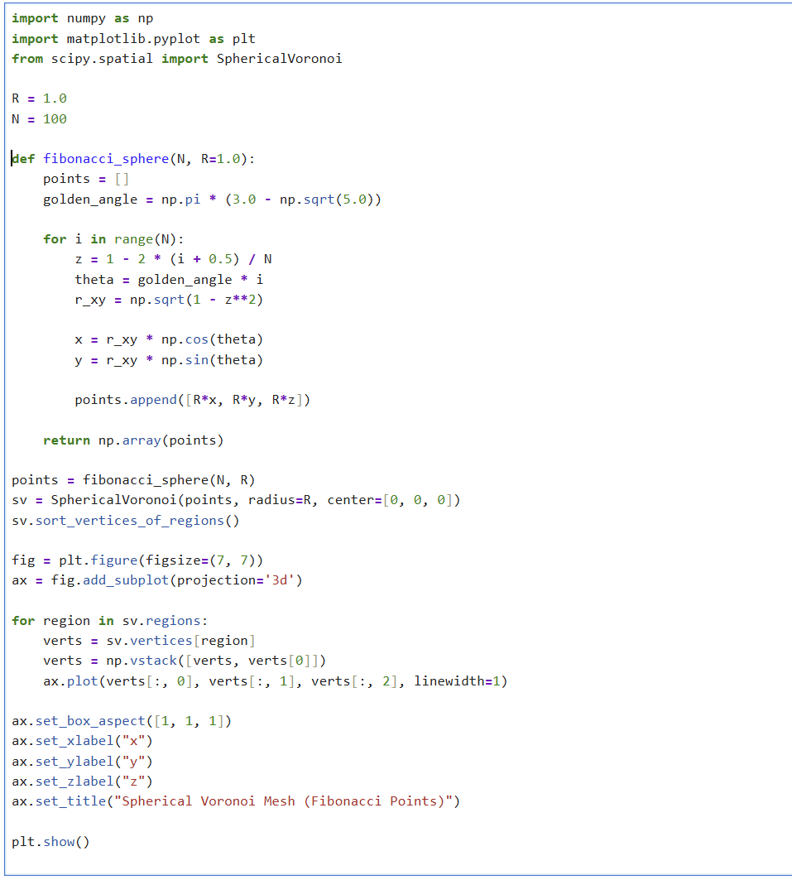
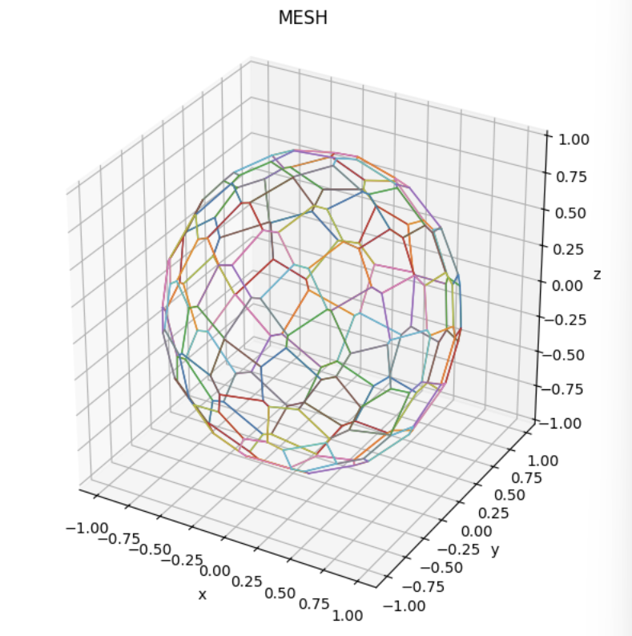
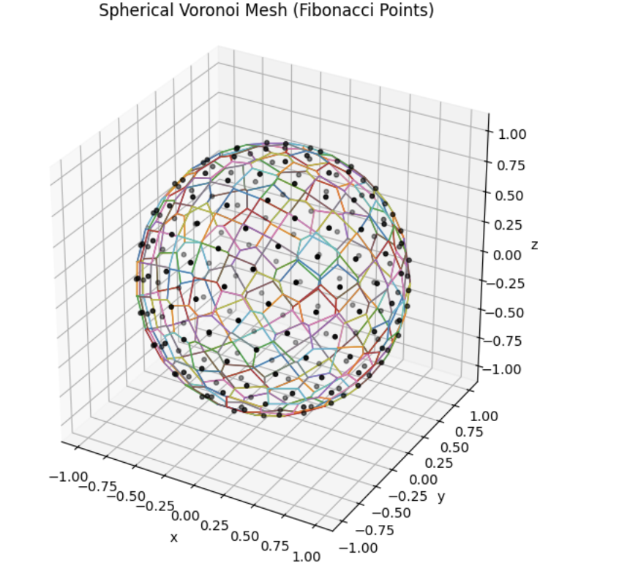
Spherical Voronoi tessellation constructed from Fibonacci-sampled points. Each polygon represents a surface control volume for numerical discretization.
The present work completes the geometric and meshing components of the project as specified. Dynamical simulations will be implemented in the next phase.

