END TERM REPORT
Computational Physics Project
Topic : Spherical Caps in Cell Polarization
By Anamika Garg
Abstract
In the midterm part of this project the spherical geometry was set up. Points were placed on a unit sphere using Fibonacci sampling and a spherical Voronoi tessellation was built on top of them, so that each Voronoi cell could act as a small surface element. That work stopped at the mesh, no time evolution was done.
This report covers the remaining part. The reaction diffusion equation for the membrane bound protein is now solved on that mesh in time, and a stable spherical cap is obtained starting from a random initial condition. Along with this the steady cap profiles are also computed analytically using Legendre functions, and the two answers are compared. Finally the effect of a cortical flow is added, which shows that a cap can be pushed to a chosen place on the membrane instead of appearing at a random spot.
What is being solved
After assuming fast cytoplasmic diffusion, the cytoplasm concentration becomes a single number instead of a field, and the whole model collapses to one equation on the sphere for the dimensionless membrane concentration u(theta, phi, tau):
du/dtau = delta^2 * Lap(u) - u + ( 1 - (alpha/2pi) * integral of u dS ) * ( beta + u^nu/(u^nu + gamma^nu) )
The three pieces of this equation are quite different from each other. The first term is diffusion along the curved membrane and it uses the Laplace Beltrami operator, not the flat Laplacian. The last bracket is a local nonlinearity, it is a Hill function which is basically a smooth switch, it is close to 0 when u is below gamma and close to 1 when u is above gamma. The middle bracket is the interesting one, it is an integral over the whole sphere, so every point on the membrane feels every other point. This is the mass conservation, the protein sitting on the membrane is protein that is no longer available in the cytoplasm.
The parameters used are the same as the ones in the paper, alpha = 1, beta = 0.1, gamma = 0.3, delta^2 = 0.05 and nu = 20.
Discretization on the Voronoi mesh
The mesh from the midterm is reused directly. Each Voronoi cell is treated as a control volume and u is stored as one value per cell, so u is a vector of length N.
For the diffusion term a finite volume approach is used. If two cells i and j are neighbours, they share an edge on the sphere. Integrating the Laplacian over cell i and using the divergence theorem turns the term into a sum of fluxes through the edges of that cell. Each flux is approximated as the difference of u across the edge, multiplied by the length of the shared edge and divided by the distance between the two generating points. So
Lap(u)_i = (1/A_i) * sum over neighbours j of ( L_ij / d_ij ) * ( u_j - u_i )
Here A_i is the area of the Voronoi cell, L_ij is the length of the shared edge and d_ij is the geodesic distance between the two points. Both L_ij and d_ij are measured as arcs on the sphere and not as straight lines, this is where the curvature actually enters the code. The nice thing about this form is that curvature never has to be written down explicitly, it comes in automatically through the geometry of the cells.
Two cells are treated as neighbours if their Voronoi regions share two vertices, that is an edge. This is found by walking around every region and collecting its edges into a dictionary, an edge that shows up in exactly two regions gives one neighbour pair.
This scheme is conservative by construction, whatever leaves cell i through an edge enters cell j through the same edge, so the total amount of u only changes because of the reaction terms and not because of the diffusion. That is a useful check since the model is supposed to conserve mass.
The global coupling term is much easier, the integral is just the sum of u_i times A_i over all cells. Time stepping is done with classical RK4 with dt = 0.002.
Formation of the cap
The initial condition is a smooth random field made by adding a few random exponential bumps on the sphere and then rescaling so that the mean stays below 1/(2*alpha), otherwise the global term would already be negative at t = 0. A pure white noise initial condition was tried first but it does not work, the noise amplitude is too small to cross the threshold gamma anywhere and the solution just relaxes back to the uniform off state.
The evolution is shown below. At early times the field is patchy and there are several regions above threshold. These regions then compete, they merge and the smaller ones die out, and by tau = 10 only one connected patch is left. After that it stops changing and settles into a single cap.
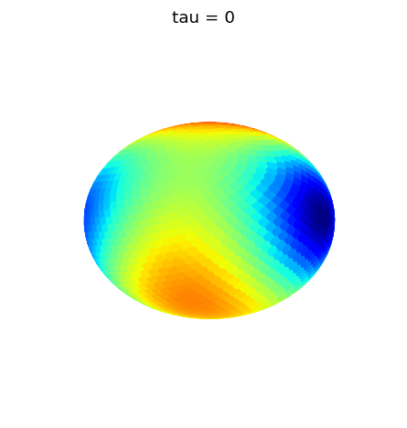
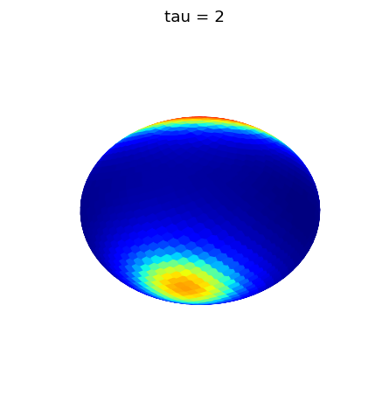
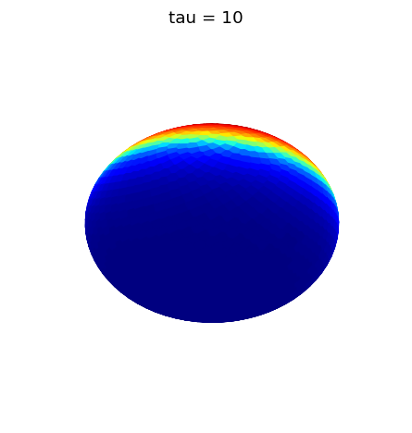
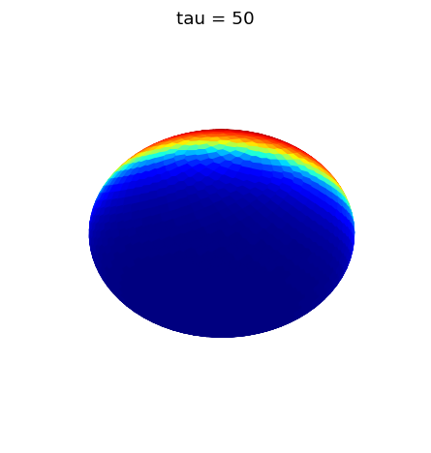
Membrane concentration at tau = 0, 2, 10 and 50. The initial patchy field coarsens into one spherical cap.
At the end u goes from about 0.052 in the blue region to about 0.564 in the red region. These are close to the two uniform steady states of the model, u_minus = beta/(1 + 2*alpha*beta) = 0.083 and u_plus = (1+beta)/(1 + 2*alpha*(1+beta)) = 0.355, but not equal to them, which is expected because the cap solution is not uniform and the global term sees a different average.
The cap can appear anywhere depending on the random seed, since nothing in the equation prefers any direction. This is exactly the symmetry breaking, the equation is invariant under rotations but the solution is not.
Steady states from Legendre functions
The cap is axially symmetric so the problem can also be done by hand. Putting the cap at the pole and using eta = -cos(theta), u depends on eta only, and for large nu the Hill function can be replaced by a step function. The equation then becomes piecewise linear and can be solved on each side of the point eta_c where u crosses gamma. The solution is written using the Legendre function P_mu with mu = (1/2)(sqrt(1 - 4/delta^2) - 1).
One problem here is that for delta < 2 the order mu is complex, and scipy will not evaluate the hypergeometric function with a complex first argument. But if the power series for P_mu is written out, the terms only ever contain the combination 1/delta^2 + l + l^2, which is real. So the series is summed directly instead of calling a special function, and everything stays real. The series converges quickly for eta strictly inside (-1, 1).
Matching the value and the derivative at eta_c and using the conservation law gives one implicit equation relating gamma to eta_c, which is Eq. 11 of the paper. Plotting the right hand side against eta_c shows how many caps exist for a given gamma.
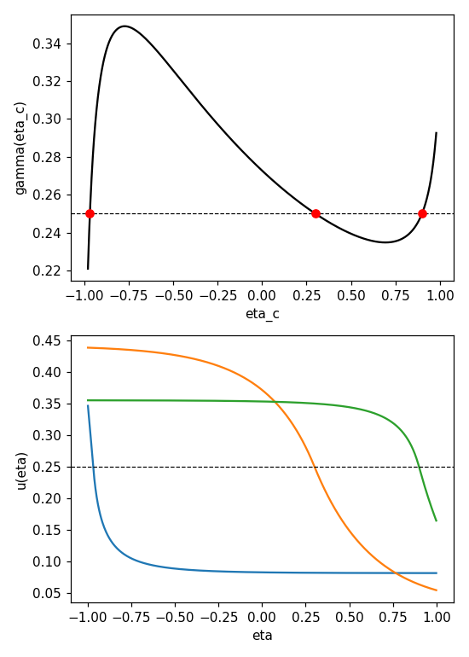
Top: gamma as a function of eta_c for alpha = 1, beta = 0.1, delta = 0.3. The dashed line is gamma = 0.25 and it cuts the curve three times. Bottom: the three profiles belonging to those three roots.
For gamma = 0.25 there are three roots, at eta_c = -0.969, 0.300 and 0.900. These give three different steady states. The middle one is the large cap, and the outer two are small caps, one is a tiny patch of high concentration and the other is a tiny patch of low concentration. The paper shows using a stability analysis that only the large cap is stable, and that agrees with the simulation, the time stepping only ever ends up on a large cap and never on the small ones.
A simple way to see which branch is stable is to look at the slope. If gamma is the threshold for switching on, then raising gamma should make it harder to recruit protein and the cap should get smaller. So a physically sensible branch must have gamma decreasing with cap size, that is the decreasing part of the curve. The increasing parts correspond to the unstable solutions.
Using this, the boundary of the region where caps can exist is where the curve stops being monotonic, that is where its local maximum and local minimum appear. Tracking those two turning points as delta is varied gives the cusp shaped regions below.
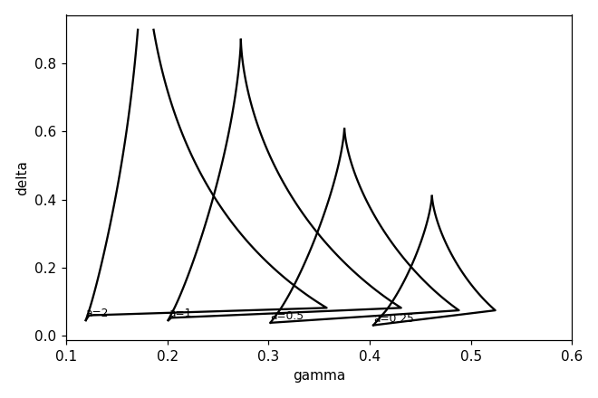
Region of the (gamma, delta) plane where stable caps exist, for beta = 0.1 and four values of alpha. Above the tip of each cusp the curve is monotonic and no stable cap is possible.
Each cusp has a tip at some maximum delta. Since delta goes like 1/R, a large delta means a small cell, so this says that a cell which is too small cannot polarize, the surface diffusion smears the pattern out faster than the recruitment can build it. The cusps also shift to the left as alpha grows, so the amount of global coupling decides which thresholds gamma are usable.
Directing the cap using a flow
So far the cap forms wherever the noise happens to be biggest. In a real cell that is not good enough, the polarity has to point somewhere specific. The paper models this using a cortical flow, which is an extra advection term added to the membrane equation. The flow used is v_theta = eps * sin(theta) and v_phi = 0, so it is strongest at the equator and dies at the poles, and it drags material from the south pole to the north pole.
This adds a divergence of (u*v) to the equation, which is again done with finite volumes. The flux through an edge is the normal component of the velocity times u times the edge length, and u at the edge is taken with upwinding, that is u is taken from whichever of the two cells the flow is coming from. Using a plain average instead of upwinding was tried first and it gave oscillations near the sharp front of the cap, so upwinding is needed here.
The flow is only kept on for a short window, tau from 0 to 2, and after that it is switched off. Here gamma = 0.35 is used, following the paper.
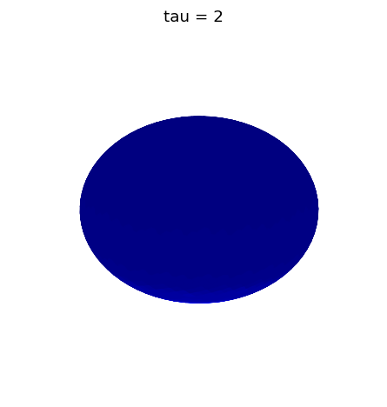
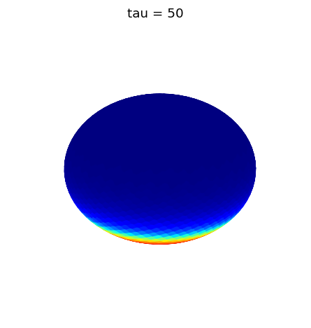
Left: tau = 2, just as the flow is switched off. Right: tau = 50, long after the flow is gone. The cap stays at the north pole.
The run starts from the uniform off state, u = 0.083 everywhere, which on its own would stay like that forever. The flow sweeps protein towards the north pole and the concentration there goes up until it crosses gamma, which switches on the autocatalytic recruitment. At tau = 2 the peak value is around 3.0, which is much higher than any steady state of the model, because the flow is still actively piling material up. Once the flow is turned off this peak relaxes back down and the solution settles onto a proper cap with u between about 0.063 and 0.668, and it then just sits there.
The value 3.0 looked wrong at first so the run was repeated with dt reduced by a factor of four, and the peak came out as 3.0385 instead of 3.0389, so it is not a time stepping artefact, it is really what the flow does.
The point of this run is that the flow is only a trigger. It does not have to be maintained, it only has to last long enough to push the concentration over the threshold once. After that the nonlinearity holds the pattern in place by itself. So the cell can decide where the cap goes using a transient flow and then stop spending energy on it.
Conclusion
The mesh built in the midterm has now been used to actually solve the model. A stable spherical cap forms from random initial data, and the same caps are also obtained analytically with Legendre functions, with the two methods agreeing on which solution survives. The region in parameter space where caps are possible has been mapped and it turns out that only an intermediate range of cell sizes works. Adding a transient flow shows that the position of the cap can be controlled, which is what happens in the C. elegans embryo.
The main thing that could be improved is the time stepping. RK4 with an explicit step is fine for these parameters but the step size is limited by the diffusion term and by delta being small, so a finer mesh would get slow very quickly. An implicit explicit scheme, where the diffusion is treated implicitly and the reaction explicitly, would fix that. The nu = 20 Hill function is also quite sharp and the cap front is only resolved by a few cells, so the mesh could be refined near the front instead of being uniform.

