
Companion Integration
Design Specification
Bridging real-time feedback detection with live mixer EQ control
March 2026 — MVP Design
Target: Behringer Wing (Compact + Rack) via OSC/UDP

Problem Statement
At a live gig, feedback detection and EQ correction are separate workflows. The engineer looks at the laptop to identify the feedback frequency, then walks to the mixer or switches apps to apply the EQ cut. This context switch costs 5-15 seconds per feedback event — an eternity during a live performance.

Solution
Connect the feedback detection app to Bitfocus Companion so detections appear as actionable buttons on a Stream Deck. The engineer sees the problem and pushes the EQ cut from the same control surface, without touching the laptop or switching apps.

In Scope (MVP)
- WebSocket API for Companion to connect to
- Companion module with feedback status + manual EQ push
- Direct OSC to Behringer Wing for PEQ band control
- Local network only (laptop at the venue)
- Manual confirm mode only (no auto-engage)

Not in Scope
- Auto-engage mode (future)
- Cloud WebSocket relay
- Licensing or tiered pricing
- dbx DriveRack support
- Reading current Wing EQ state

System Architecture
The system has four components communicating over the local venue network. The browser app detects feedback, the server relays state via WebSocket, the Companion module translates advisories into Stream Deck buttons, and OSC commands are sent directly to the Wing mixer for EQ control.
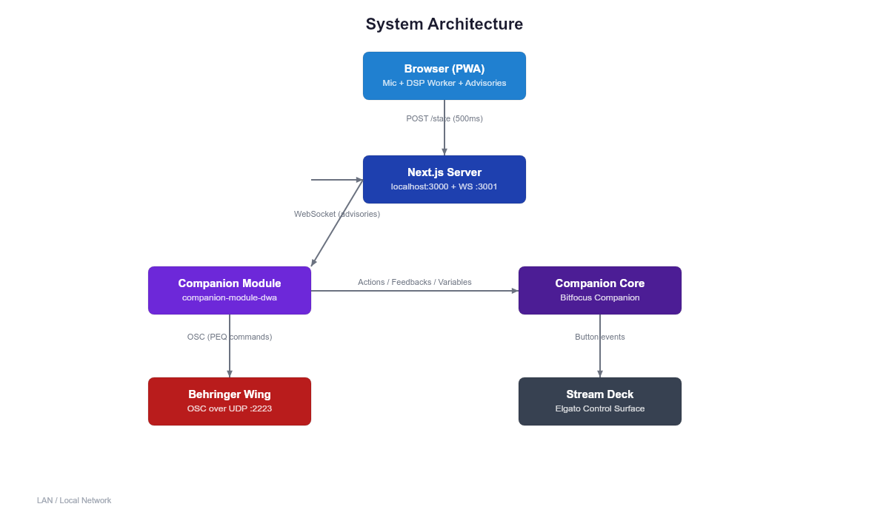

Why Direct OSC?
The existing Wing Companion module does not expose PEQ band parameter actions (frequency, gain, Q). It only supports EQ on/off and model selection. Rather than depending on upstream changes, the DWA module sends OSC commands directly to the Wing. The Wing only supports one active OSC subscription, so the DWA module does NOT subscribe — it only sends commands (fire-and-forget), avoiding conflicts with the Wing module.

Wing OSC Protocol
EQ band parameters are set via OSC messages over UDP. The paths below are confirmed from the official Wing Remote Protocols documentation.
Parameter | OSC Path | Type | Range
EQ Enable | /ch/{n}/eq/on | int | 0 | 1
Band Gain | /ch/{n}/eq/{b}g | float | -15 to +15 dB
Band Frequency | /ch/{n}/eq/{b}f | float | 20 to 20000 Hz
Band Q | /ch/{n}/eq/{b}q | float | 0.44 to 10
EQ Model | /ch/{n}/eq/mdl | string | STD, SOUL, etc.
Low Shelf Gain | /ch/{n}/eq/lg | float | -15 to +15 dB
High Shelf Gain | /ch/{n}/eq/hg | float | -15 to +15 dB
Node paths: /ch/{n} (channels 1-40), /bus/{n} (buses 1-16), /main/{n} (mains 1-4), /mtx/{n} (matrices 1-8). All 1-based indexing. Bands 1-4 are parametric; low shelf (l) and high shelf (h) also available.

Two-Press EQ Cut Workflow
Pressing a CUT button does not immediately send OSC. Instead, it enters targeting mode to prevent accidentally cutting the wrong channel.
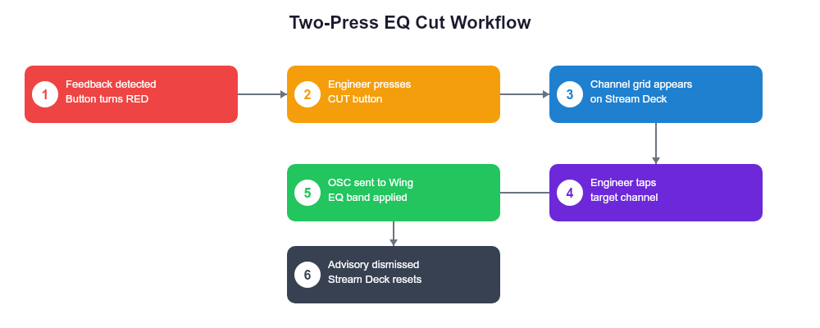

Press 1: Select the Cut
Engineer presses a CUT button showing the detected frequency and recommended cut. The Stream Deck page switches to a channel grid showing available targets.

Press 2: Select the Target
Engineer taps the channel, bus, or main where the cut should be applied. Four OSC messages are sent (EQ on, frequency, gain, Q), the advisory is dismissed, and the Stream Deck returns to the main page.

Safety Guardrails
These limits prevent the system from damaging a live mix. All values are configurable but ship with safe defaults.
Guardrail | Default | Rationale
Max Cut Depth | -12 dB | Deeper cuts audibly damage the mix quality
Max Active Notches | 4 per ch | Wing channel EQ has 4 parametric bands
Min Advisory Age | 3 seconds | Prevents cutting transient false positives
Confidence Floor | 60% | Below 60%, button shows info but will not send OSC
Rate Limit | 1 cut / 2s | Prevents rapid-fire cascading cuts
Undo Stack | 16 deep | Can restore the last 16 EQ cuts
Band Range | Bands 3-4 | Protects engineer's manual EQ in bands 1-2

Stream Deck Layout
Suggested 8-button layout for an Elgato Stream Deck. Top row: control buttons. Bottom row: advisory cut buttons that update dynamically with detected feedback frequencies.
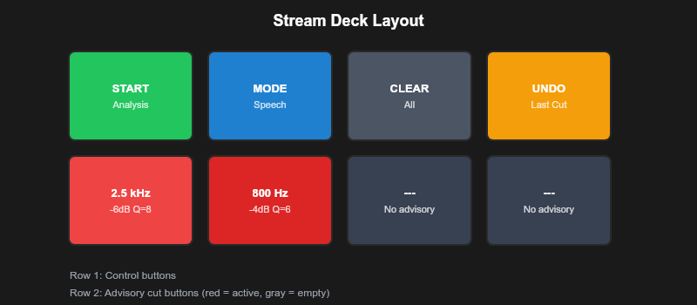

Implementation Timeline
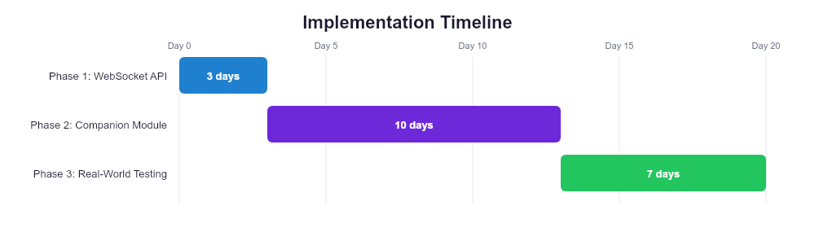

Phase 1: WebSocket API (2-3 days)
- POST state endpoint + WebSocket relay on port 3001
- Browser sync hook (useCompanionSync)
- Settings UI: enable toggle, auth token, connection indicator
- Protocol tests

Phase 2: Companion Module (1-2 weeks)
- Scaffold with Companion module SDK (TypeScript, yarn)
- WebSocket client connection to app server
- Actions: start/stop, apply cut, undo, clear, set mode
- Feedbacks: running, feedback detected, critical, connected
- Variables: frequency, note, cut depth, Q, severity for each advisory
- OSC sender for Wing PEQ band commands
- Test with Companion + Stream Deck hardware

Phase 3: Real-World Testing (1 week)
- Test at a live gig with the Behringer Wing
- Verify OSC PEQ paths against actual mixer behavior
- Tune safety guardrails based on real feedback scenarios
- Adjust timing, confidence thresholds, and band allocation

Companion Module Specification

Actions
Action ID | Name | Description
start_analysis | Start Analysis | Begin feedback detection in the app
stop_analysis | Stop Analysis | Stop feedback detection
apply_cut | Apply EQ Cut | Enter targeting mode, then send PEQ to Wing
undo_last | Undo Last Cut | Restore previous EQ band to 0 dB
clear_all | Clear Advisories | Dismiss all active advisories
set_mode | Set Detection Mode | Switch between speech, worship, music, etc.

Feedbacks
Feedback ID | Name | Type | Color
status_running | Analysis Running | boolean | Green
feedback_detected | Feedback Detected | boolean | Red
critical_feedback | Critical Feedback | boolean | Flash Red
connected | Connected to App | boolean | Blue

Variables
Variable ID | Name | Example
$(dwa:status) | Analysis Status | running
$(dwa:mode) | Detection Mode | speech
$(dwa:advisory_count) | Active Advisory Count | 3
$(dwa:a1_freq) | Advisory 1 Frequency | 2.5 kHz
$(dwa:a1_note) | Advisory 1 Note | D#7
$(dwa:a1_cut) | Advisory 1 Cut | -6 dB
$(dwa:a1_q) | Advisory 1 Q | 8
$(dwa:a1_severity) | Advisory 1 Severity | high

