BLE communication integration for automotive systems using esp32.
- What is Bluetooth Low Energy (BLE) ~ Bluetooth Smart?
BLE is a wireless technology for short-range communication, developed by the Bluetooth Special Interest Group (Bluetooth SIG). Its main goal is to use much less power and cost less than Classic Bluetooth, while maintaining a similar communication range.
BLE remains in a deep sleep state, waking up only briefly to transmit small "bursts" of data, and then returning immediately to sleep.

- BLE vs classic :
Bluetooth is a wireless technology standard used for exchanging data over short distances. We have 2 types of Bluetooth:
Classic Bluetooth:
Classic Bluetooth is designed for continuous, high-speed data streaming, such as playing music on wireless headphones. It offers high data rates (1–3 Mbit/s) and strong performance, but this comes at the cost of high power consumption (~1 W, used as the reference point).
BLE (Bluetooth Low Energy):
BLE is designed specifically for IoT applications. Instead of streaming data continuously, it sends short bursts of data (ranges across 125 kbit/s, 500 kbit/s, 1 Mbit/s, and 2 Mbit/s depending on the mode used), which allows it to consume extremely low power (0.01–0.50 W). This makes it ideal for battery-operated devices.
It has a lower latency rate, even though Bluetooth has a higher transfer rate; so while Classic Bluetooth transmits data faster, but responds to input slower (100 ms wake latency); BLE transmits data slower, but responds to input faster(6 ms wake latency).
Both types have a similar maximum range of up to 100 m.
Conclusion:
Overall, BLE is the clear winner in terms of energy efficiency, since it can keep devices running for months or even years on a single battery (1–2 years on a 1,000 mAh per cell) making it the better choice for low-power, IoT-oriented automotive application, etc.
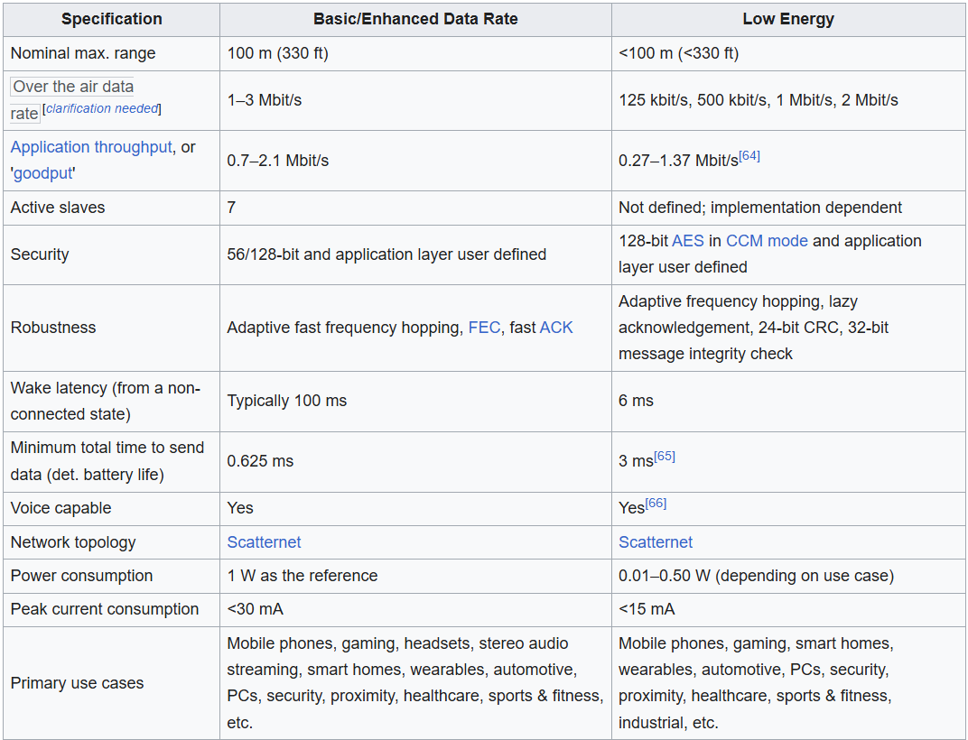
- battery consumption
- Data rate
- Latency time
Now let’s dive more deeply into BLE.
How does it work? (BLE Services and Characteristics):
BLE stack architecture:
The BLE stack implements the core BLE functionality. It is included as a precompiled library, embedded inside the BLE Component.
The BLE protocol implements a layered architecture:

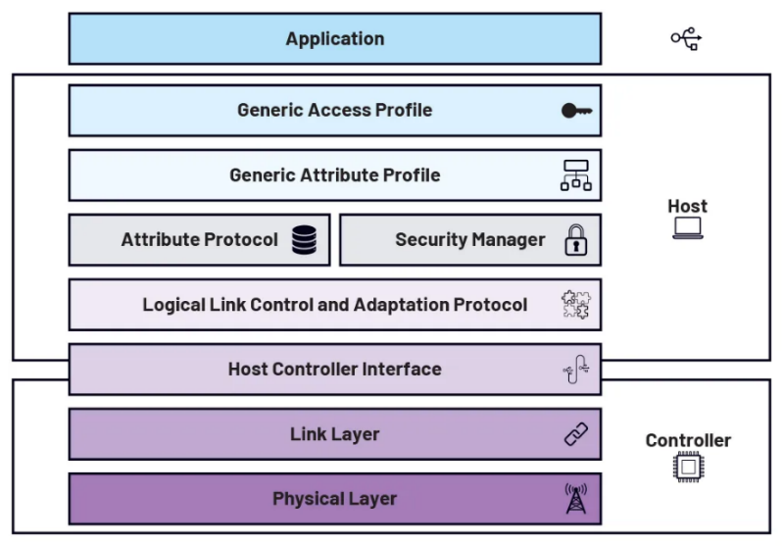
1. The Controller layer
This layer is responsible for controlling the hardware that transmits and receives radio waves, and it maps connection requests from the higher layers down to the physical layer. It's made up of two parts:
- PHY: responsible for the actual transmission over the air via radio waves.
- LL: a combination of hardware and software responsible for scanning, and for creating and maintaining connections.
2. HCI This sits between the Controller and the Host layers. It provides a standardized communication interface between the two, allowing them to exchange data and commands.
3. The Host layer
This layer handles pushing in and pulling out the data of the device. It includes:
- L2CAP: it provides data encapsulation services to the upper layers and ensures data integrity. Thus, if a packet doesn’t reach the destination, this layer handles its retransmission.
- SM: As the name implies, this one provides a secure connection and a secure exchange between 2 devices.
- ATT: defines a basic data structure called attribute (service, characteristics, ..) and data access methods based on the server/client architecture.
- GATT: defines what data exists on the device and how it can be read/ written. It is based on Client-Server architecture and it has 2 main roles:
- GATT server: stores and exposes sensor data (ESP32).
- GATT client: initiates commands and requests to the GATT Server (the smartphone)
- GAP: manages device connections and advertising and defines the roles of devices in Bluetooth communication. It defines 2 primary roles : central/ peripheral.

4. The Application layer
Finally, this is where developers define attributes and configure BLE behavior, using the APIs provided by the Host layer.

Server/ client architecture:
A device can implement multiple profiles (a profile describes how two devices connect and communicate with each other). Most application profiles are based on the GATT Profile, which sets the rules for sending and receiving small pieces of data over a Low Energy connection.
Data in GATT is organized in a standardized structure:
- Client: a device that initiates requests and receives responses (a smartphone).
- Server: a device that receives requests and sends back responses (a temperature sensor).
- Service: a collection of related characteristics that work together to perform a particular function (the Health Thermometer Service).
- Characteristic: the basic unit of data exchange, encapsulating a specific data value. A complete characteristic includes:
* Value: The actual stored data.
* Properties: Define the operations a client can perform on the "Value"
* Declaration: Contains the characteristic's properties, UUID, and location within the service.
- Descriptor: an optional parameter attached to a characteristic that provides extra information about it (a Temperature Unit descriptor).
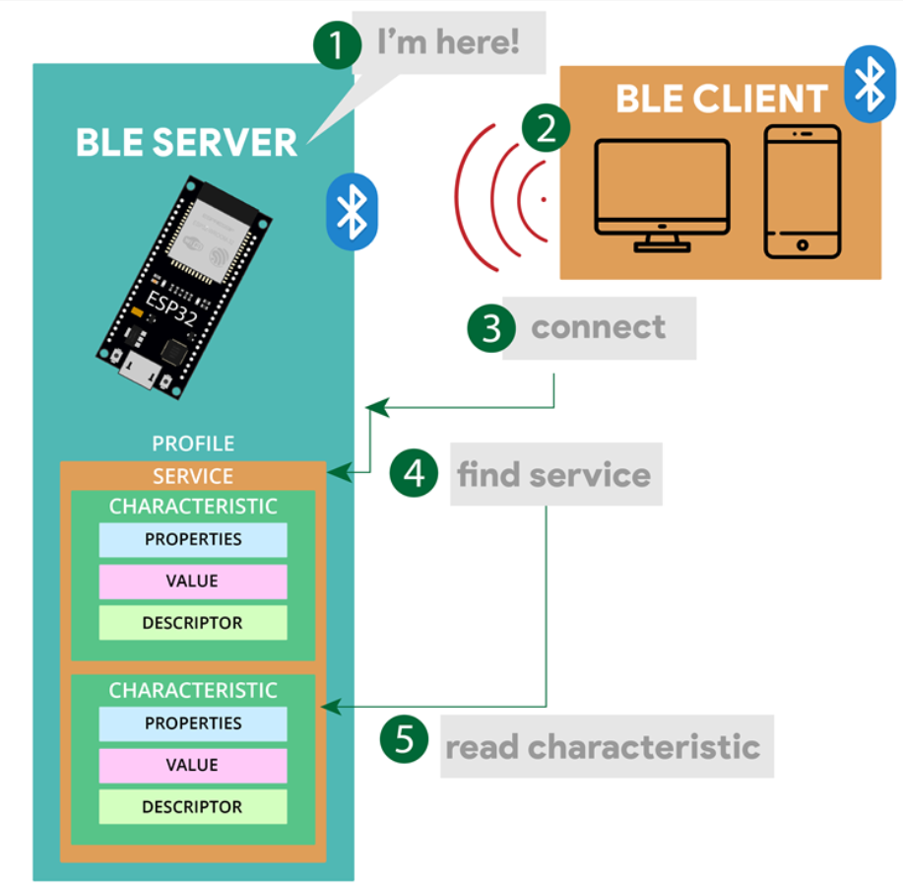
Services, characteristics, and descriptors are collectively called attributes, and each one is identified by a UUID (Universally Unique Identifier), so devices know exactly what data they're reading or writing.

- Central and Peripheral roles:
BLE has 2 main roles.
First, The Central device:
Central is a device with powerful and rich resources. It's the one that initiates the connection request and that by scanning for nearby peripherals and connecting to them, then processes the data they send.
Because of this, it is often referred to as a “Master.” A good example is a smartphone, which can connect to several peripherals at the same time, collecting and processing data from each one.
On the other hand, The peripheral device:
is usually a small, low-power device that just provides data. It advertises its presence to nearby devices and waits for one of them to connect.
Since it mostly just sits there until someone connects to it, it's also called the "Slave." We can take as an example a smartwatch, a temperature sensor, etc.

- How to choose between master and slave BLE modules :
Energy Efficiency Priority: Determine if energy conservation is a top priority for your device. If so, opting for a BLE module acting as a slave may be advantageous, because it operates in a low-power mode.
Data Role: Assess whether your device primarily generates data for consumption by other devices or needs to collect and process data from peripherals. Devices that generate data are better embedded by slave BLE modules, while those that collect data are more apt as masters.
Multi-Device Connectivity: Consider whether our device needs to connect with multiple other devices. If so, functioning as a master device would be more effective in managing multiple connections.
Other examples: Resource Allocation: Evaluate the processing power and resources available on your device. (if limited, slave).

BLE operations:
Read, Write, indicates and Notify are the core (GATT) operations used to exchange data between a client and a Server.
- Read: is an on-demand request initiated by the Client to retrieve the current value of a specific characteristic hosted on the Server.
. How it works: The Client sends a request packet specifying the characteristics. The Server pulls the requested value from its database and replies with a packet containing the data.

- Write: is initiated by the Client to modify or send data to a characteristic on the Server.
. Write Request: The Client sends a read request. The Server processes the data and sends back confirmation.
+/-: the application layer knows the data arrived safely, but it features lower throughput (the actual rate of useful data transferred over the air per second) because the Client must wait for the acknowledgment before sending the next packet

. Write Command: The Client sends a write command. The Server accepts the data but sends absolutely no confirmation package back.
+/-: fast with maximum data throughput but lacks application-layer verification if a packet drops.
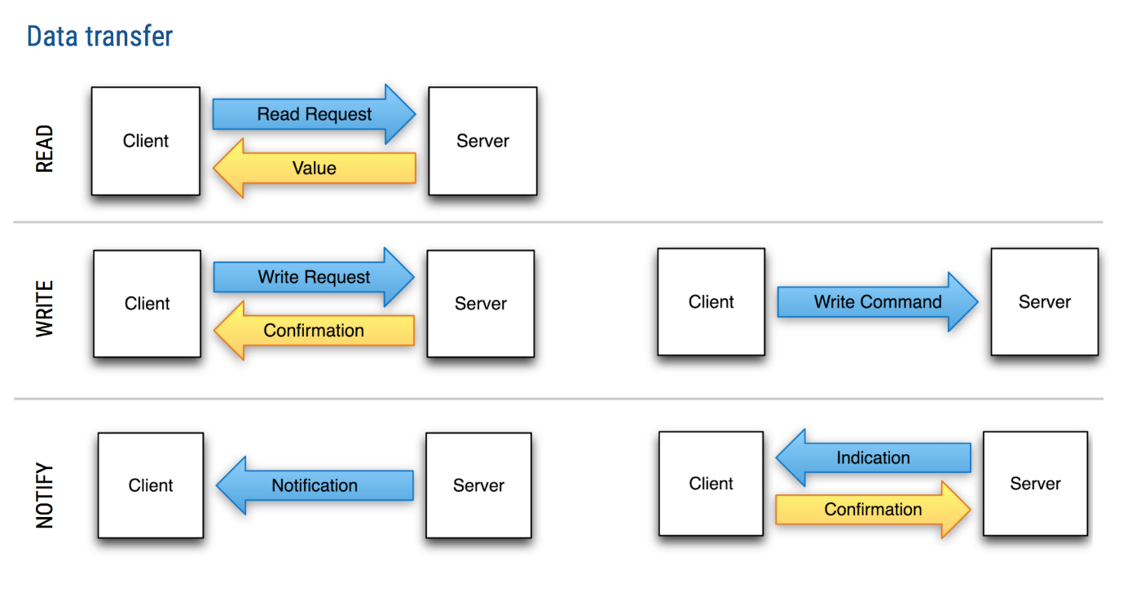
- Notify: A Notify operation is a Server-initiated data push that asynchronously streams data to the Client whenever a characteristic value changes.

. How it works: 1. The Client must first "subscribe" to notifications. It does this by writing a specific flag to the characteristic's Client Characteristic Configuration Descriptor (CCCD),
2. Once enabled, the Server pushes a notification packet to the Client whenever the data updates.

. If your application needs acknowledged server, we use Indication instead since it requires the Client to respond with a confirmation packet before the next update can be pushed.
ESP32 BLE capabilities:
all standard ESP32 microcontrollers feature integrated Bluetooth Classic and Bluetooth Low Energy (BLE).
Features:
- Flexible role: Can act as a Central, a Peripheral, or even both at once.
- Supports GATT Profiles: Handles multiple services and characteristics in one application.
- Low cost, low power: Ideal for battery-powered IoT and embedded projects.

BLE communication flow using ESP32:
- Initialization and Advertising (GAP):
The communication flow starts with device setup and discovery.
Server setup: The ESP32 initializes its BLE stack, sets a device name, and creates a GATT hierarchy: it defines one or more Services (identified by UUIDs) and Characteristics.
Advertising (GAP): The ESP32 broadcasts advertising packets containing its name and Service UUIDs, so nearby devices can discover it. It then enters a listening state, waiting for a client to request a connection.
Scanning: The Client (a smartphone) scans for these advertising packets until it finds the specific server it wants to connect to, then sends a connection request.
- Connection and GATT Discovery:
Once the client finds the advertising server, communication can begin.
The connection is established using GAP. The ESP32 handles connection state changes (connect/disconnect) through callback functions.
Upon connecting, the client performs GATT discovery to find the services and characteristics exposed by the server.
- Data Exchange
Once connected, data is transmitted using GATT commands, following the properties defined for each characteristic:
Read: the client requests the current value of a characteristic, and the ESP32 responds with the requested data.
Write: the client sends new data to a characteristic (for example, an ON/OFF command for an LED ) which the ESP32 processes through a write callback.
Notify / Indicate: the ESP32 pushes data to the client whenever a value changes.

- Disconnection:
When communication is no longer needed, either the client or the server can terminate the connection.
Once disconnected, the ESP32's callbacks are triggered, and standard code is usually written to resume advertising, so the device can be found and reconnected in the future.

To build or test this, most developers use mobile debugging apps like nRF Connect or LightBlue to act as the BLE client while configuring the ESP32 as the server. For example code, the official ESP32 BLE Arduino repository provides templates for defining services and characteristics.

