BLE communication integration for automotive systems using esp32.

Connections and roles:
- Dual-Topology Connections:
A BLE role is not a fixed hardware property . It describes how a device is behaving in a given connection, and this can change. Some devices use Dual Topology connections: a device can be simultaneously in a central and a peripheral role and it can also connect to multiple central devices at the same time.
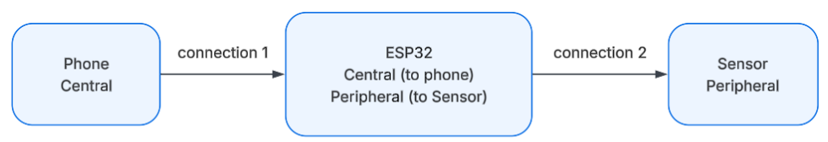

Sources:
https://docs.silabs.com/bluetooth/3.3/bluetooth-general-connections/
https://docs.silabs.com/bluetooth/latest/bluetooth-fundamentals-connections/dual-topology

- Multi-Central / Multi-Peripheral Topology:
- Multi-Central : A peripheral device can connect to multiple centrals:
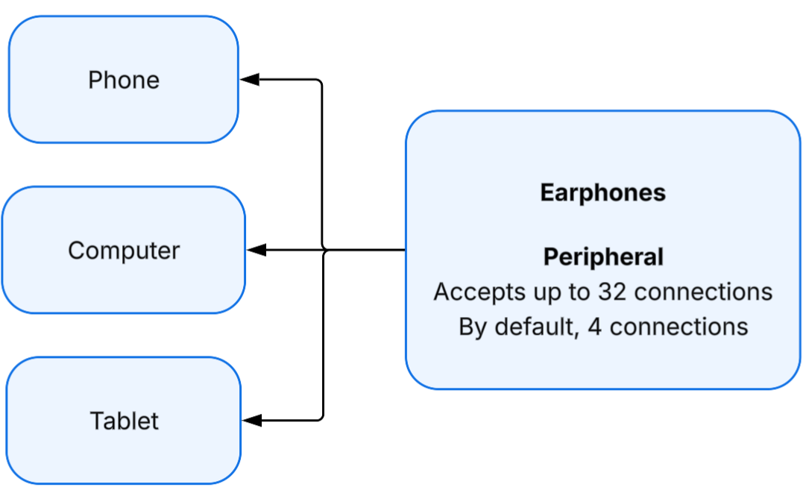

- Multi-Peripheral: A central device can connect to multiple peripherals:
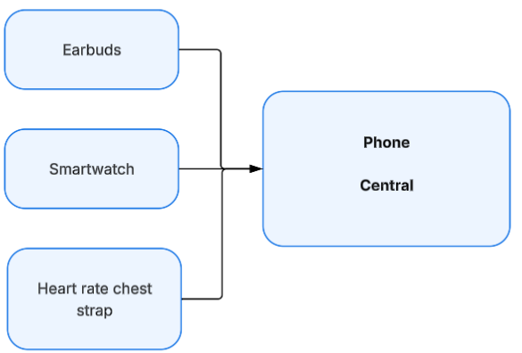
- Timing of Parallel Connections:

Bluetooth connections use small connection windows to exchange data in every connection interval. At least an empty packet is sent in every connection interval, first by the central, then by the peripheral, and if there is data to send, the packets are extended. This ensures that no continuous receiving is needed.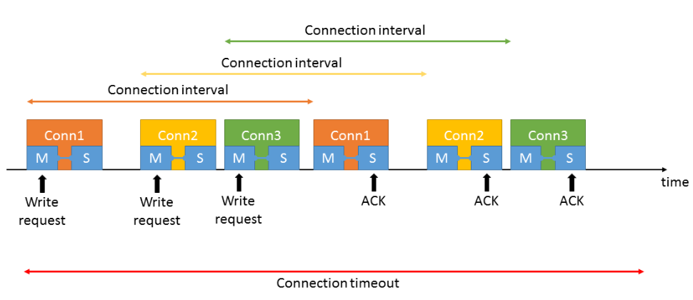
Sources:
https://docs.silabs.com/bluetooth/latest/bluetooth-fundamentals-connections/multi-central-topology#multi-central-topology
https://docs.silabs.com/bluetooth/latest/bluetooth-fundamentals-connections/multi-peripheral-topology

Host Layer Architecture:
- How do the Host layer's sub-layers communicate with each other?
Inside the Host, the sub-layers don’t communicate directly. Everything routes through L2CAP, which acts as an internal "messaging service." And protocol multiplexer between them and assigns unique Channel IDs (CIDs). This allows the upper layers protocols to share a single connection:
- GATT/ATT → channel 0x0004: GATT relies on ATT to structure the format data.
- SM (pairing/security) → channel 0x0006
- LE Signaling channel → channel 0x0005 : updating connection parameters (interval, latency, timeout) after a connection is already active.
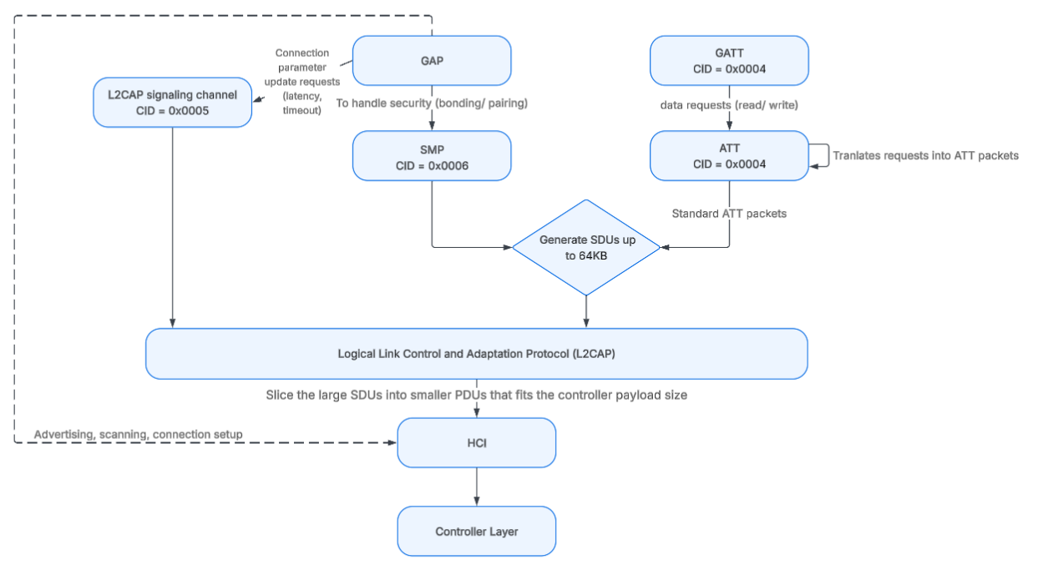
SDUs: Service Data Units, PDUs : Protocol Data Units
Upper layers can generate Service Data Units (SDUs) up to 64KB. L2CAP slices these large packets into smaller Protocol Data Units (PDUs) that fit the controller's payload size.
- Can developers control these layers, or only the Application layer?
In practice, developers configure the system entirely through APIs exposed to the Application layer , the Host's sub-layers (L2CAP, ATT, SMP) are not meant to be touched directly; they are handled automatically by the stack.
What developers can configure through the Application layer's APIs:
- GAP: device name, advertising data, connection parameters, scanning behavior
- GATT: custom Services and Characteristics (UUIDs, properties, values). This is where the Digital Key's data structure lives
- SM: security policy — whether to require bonding, MITM protection, passkey entry, etc.
What developers cannot directly manipulate: the raw ATT protocol frames, L2CAP packet framing/segmentation, or internal SMP key-exchange messages. These are fixed and standardized inside the Host stack.
Sources:
https://www.analog.com/en/resources/technical-articles/understanding-architecture-bluetooth-low-energy-stack.html
https://software-dl.ti.com/simplelink/esd/simplelink_cc2640r2_sdk/3.40.00.10/exports/docs/blestack/ble_user_guide/html/ble-stack-common/l2cap.html
GAP roles:
GAP is a set of rules that control how Bluetooth Low Energy (BLE) devices discover, connect, and communicate with each other.
- Central (connection-oriented): initiates connections.
- Peripheral (connection-oriented): accepts connections.
- Broadcaster (connection-less): Sends out information but can’t be connected to. (ex: In a mall, phones can receive discount offers but cannot connect to the beacon (small, wireless transmitter that uses BLE to broadcast small packets of data)).
- Observer (connection-less): Listens for Bluetooth advertisements but cannot connect to other devices.
For example, a smartphone app scans for beacons to detect nearby stores but does not connect to them.
Sources:
https://esp32.implrust.com/bluetooth/ble/gap.html

Advertising behavior:
Advertising is used either to announce the device’s existence or to transfer data.
- When and for how long does the server advertise ?
When a BLE peripheral device is in advertising mode, advertising packets are sent periodically on each advertising channel. The time interval (sleep time) between packet set has both a fixed interval (from 20ms to 10.24 s) and a random delay (jitter), which is a pseudo-random value from 0ms to 10ms that is automatically added.
This randomness helps reduce the possibility of collisions between advertisements of different devices.
The advertising keeps repeating until the application stops it or until a connection is established.
- Which radio channels are used for advertising ?
BLE uses 3 dedicated primary advertising channels (37, 38 and 39) and the other 37 secondary channels are used for active data transfer once the connection is established between the devices.
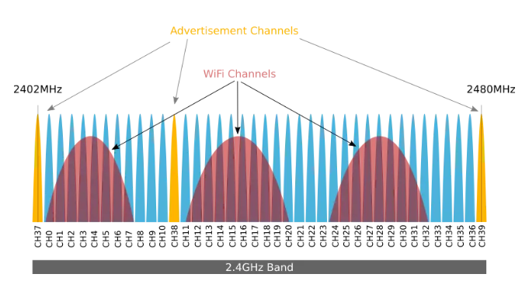
Despite the wide range of advertising interval, most products use the following as a guideline:
- Less than 100ms: for very aggressive connections and usually for short periods of time
- 100ms to 500ms: normal fast advertising for most devices
- 1s to 2s: slow advertising for devices that connect to gateways and where latency is not critical

- Does the server keep advertising while already connected?
In general, once a Central connects, the Peripheral typically stops advertising and enters the connected state instead. Advertising only resumes automatically after a disconnection.
If the Peripheral is designed to accept multiple simultaneous connections, the developer must configure it to keep advertising while already connected to one Central. This is entirely a design decision, it can happen right after disconnecting/connecting, on a timer, on a button press, etc.
- When does the peripheral sleep, and when does it wake up?

Two loops, connected by a handoff:
Before connection: Wake (~1–3 ms, broadcasts + listens) ↔ Sleep (waits the advertising interval, 20 ms–10.24 s). This repeats until a central connects.
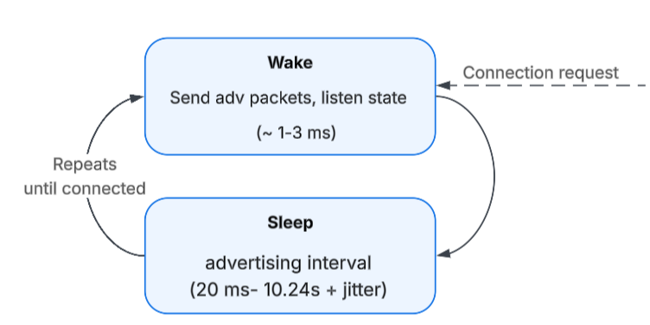
Once connected: the rhythm switches to the connection interval (7.5 ms–4 s) — Wake (exchange packets) ↔ Sleep, repeating every interval.
Two special cases branch off the connected loop:
- Peripheral latency — skip several sleep cycles in a row if there's nothing to send (saves even more power).
- Wake on demand — urgent data (like a button press) breaks the wait early and gets sent at the very next connection event, instead of waiting for the scheduled wake-up.
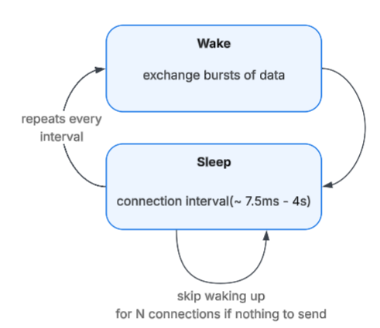
Scanning behavior:

Passive scanning:
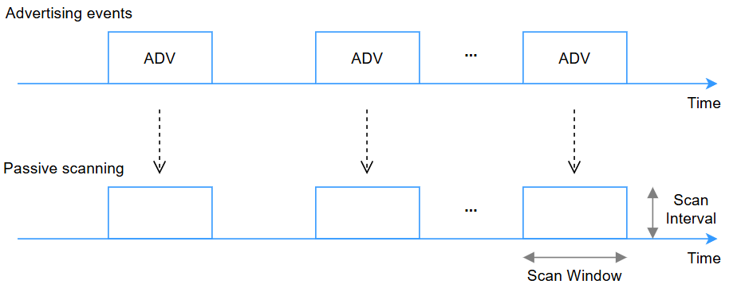
Active scanning:
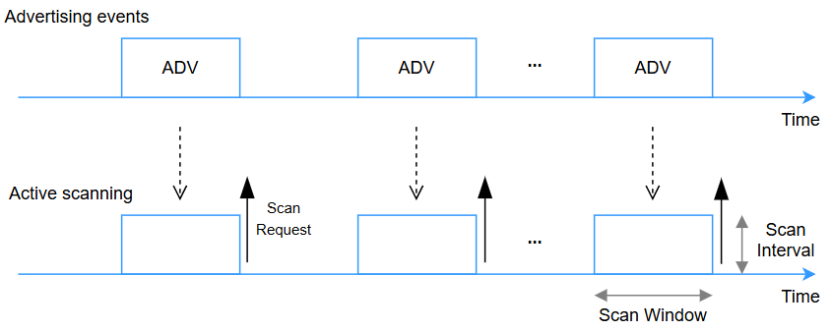
Sources:
https://people.eecs.berkeley.edu/~prabal/pubs/papers/zachariah22reliable.pdf
https://hubble.com/community/guides/esp32-power-consumption-in-ble-mode-what-to-expect-from-advertising-scanning-and-connected-states/
https://argenox.com/library/bluetooth-low-energy/ble-advertising-primer
https://punchthrough.com/ble-connection-parameters-guide/
https://academy.nordicsemi.com/courses/bluetooth-low-energy-fundamentals/lessons/lesson-2-bluetooth-le-advertising/

Data Access and Security:
- Who can write to a characteristic, and under what conditions?
By default, any connected Client can attempt a write request to the Server. Whether that write is actually accepted depends on two deliberately separate layers of control:
- Characteristic Properties (what the server advertises it supports) — tell the client which operations are conceivable at all: Read, Write, Write Without Response, Notify, etc. This is visible to the client during GATT discovery.
- Attribute Permissions (the server's real access control, hidden from the client) — a combination of access, encryption, authentication, and authorization requirements. The client cannot see these rules in advance; it only finds out by trying:
  - No write permission at all → "Write Not Permitted"
  - Write requires encryption, link is unencrypted → "Insufficient Encryption"
  - Write requires authentication, pairing wasn't authenticated → "Insufficient Authentication"
Worked example — an UnlockCommand characteristic:
- Step 1 (Property): Write = Yes — set by the developer; means writing is possible in principle.
- Step 2 (Permission): configured as "Write requires encryption + authentication" — enforced automatically by the BLE stack before the write ever reaches the application.
- Step 3 (Authorization): an optional, application-level check inside the onWrite() callback — e.g. validating a signed challenge-response — confirming the app itself trusts this specific write, even though the link already passed the stack's security checks.
In short: Properties answer "can this be written to, in general?" (visible, developer-set). Permissions answer "does this link meet the required security bar?" (invisible to the client, enforced automatically). Authorization answers "do I, the application, actually trust this particular write?" (custom logic, fully up to the developer).

Sources:
Infineon — Handling GATT Attribute Security Permissions in Bluetooth LE
Texas Instruments — Generic Attribute Profile (GATT), BLE-Stack User's Guide
- Security modes
The two Security Modes
BLE defines two independent modes, and they solve different problems:
- Security Mode 1: This is the standard mode used by the majority of modern BLE applications. It controls link encryption and device identity verification.
- Security Mode 2: is used when data is not encrypted, but packets must be cryptographically signed to prevent tampering.
Security Mode 1 — the 4 levels
Level 1: Requirement: no security, no encryption, no authentication.
Protects against: nothing, appropriate for non-sensitive data.
Level 2: Requirement: unauthenticated pairing with encryption.
Protects against: passive eavesdropping.
Pairing via: Just works (no MITM protection).
Level 3: Requirement: authenticated pairing with encryption.
Protects against: active eavesdropping (MITM).
Pairing via: methods that proves identity (passkey, OOB)
Level 4: Requirement: authenticated LE secure connections pairing with encryption.
Pairing via: only Passkey entry, numeric comparison or secure OOB.

Using Legacy Pairing or LE Secure Connections with "Just Works" only brings the connection to Level 2 — since Just Works never authenticates identity, it can't reach Level 3 or above. To reach Level 3+, a method with real MITM protection is required (Passkey, Numeric Comparison, or OOB). Level 4 additionally requires both devices to support LE Secure Connections specifically (not the older Legacy pairing).
The 4 association models (chosen based on I/O capability):
- Just Works — no user interaction; keys generated in the clear; no MITM protection
- Passkey Entry — a 6-digit code is displayed on one device and typed into the other; protects against MITM
- Numeric Comparison — (LE Secure Connections only) both devices display the same number; the user confirms they match
- Out of Band (OOB) — key material exchanged via another channel entirely (e.g. NFC); protects against MITM

Security Mode 2 — the 2 levels
Level 1: Unauthenticated data signing using a signature resolving key (CSRK).
Level 2: Authenticated data signing with a verified CSRK ( secret key used to verify data integrity without requiring full encryption).

Connection Data Signing Procedure
The connection data signing procedure is a security guard for the integrity and authenticity of data transmitted between devices, even when encryption isn't used. The procedure can be summarized in the following steps:
- Key Generation: During pairing, devices share a Connection Signature Resolving Key (CSRK).
- Signature Creation: Device A makes a data packet to send to Device B. At the same time, Device A uses the CSRK and the packet's details to create a signature. The signature comprises a Message Authentication Code (MAC), made by a special Signing Algorithm and a counter value. The counter value increases every time a new data packet is sent. This makes sure that every signature is unique, even for data packets that are the same.
- Data Transmission: The signature is appended to the data packet, forming a convoy that travels together over the communication link from Device A to Device B.
- Signature Verification: Upon receipt, Device B uses its copy of the CSRK to recreate the signature. It does this based on the received data packet and the counter value. If the newly recreated signature aligns with the one that came with the data packet, Device B can trust the data's authenticity and that no tampering occurred during its journey.
- Counter Synchronization: The counter value also helps Device B keep track of the data packets' sequence. If there's a mismatch in the counter value, Device B can identify that a replay attack is happening.

The Pairing Procedure (how a connection climbs these levels)
Pairing happens in 3 phases:
- Phase 1 — Feature exchange: the two devices exchange a Pairing Request/Response, sharing their I/O capabilities, OOB availability, and authentication requirements. This determines which pairing method (association model) is even possible.
- Phase 2 — Key generation & authentication: using one of the association models below, the devices generate a shared key — a Short Term Key (STK) in Legacy Pairing, or a Long Term Key (LTK) directly in LE Secure Connections (via an Elliptic-Curve Diffie-Hellman exchange).
- Phase 3 — Key distribution: additional keys are distributed over the now-encrypted link — the LTK (if not already generated), the IRK (for private address resolution), and the CSRK (for signed data in Mode 2).
Sources:
https://www.allaboutcircuits.com/technical-articles/bluetooth-le-security-modes-and-procedures-explained/
https://www.allaboutcircuits.com/technical-articles/understanding-bluetooth-le-pairingstep-by-step/
UUID:
a Universally Unique IDentifier used in BLE communication for services and characteristics. It defines how Bluetooth devices organize and exchange data between devices such as smartphones, gateways, embedded systems, and IoT controllers.
Types:

- 16-bit UUID: standardized Bluetooth SIG assigned identifiers commonly used for official BLE services and characteristics (0x180F).
- 32-bit UUID: provide extended identification space and are less commonly used compared to 16-bit and 128-bit UUIDs (0x12345678).
- 128-bit UUID: custom UUIDs generally used by manufacturers, industrial systems, and private BLE applications (550e8400-e29b-41d4-a716-446655440000).
Sources:
https://www.nextgeniiot.com/tools/ble-uuid-lookup

ESP32 BLE libraries:
1. Core Architecture :
These headers form the backbone of nearly every standard BLE project.
- Arduino.h: The foundational header for all standard Arduino framework operations.
- BLEDevice.h: Initializes the Bluetooth radio, sets the global device name, and serves as the factory for generating servers or clients.
- BLEServer.h: Configures the ESP32 as a peripheral device. It manages active connections, tracks when clients connect or disconnect, and hosts the data services.
- BLEService.h: A missing essential. It groups related data points together under a single UUID (e.g., creating a "Heart Rate Service").
- BLECharacteristic.h: The workhorse of BLE. It holds the actual data payloads, handles read/write requests, and triggers data pushes to clients.
- BLEAdvertising.h: Broadcasts the ESP32’s presence and Service UUIDs into the air so smartphones and other clients can discover it.

2. Scanning & Client Operations
You need these when the ESP32 acts as a "Central" device connecting to other sensors, rather than serving data itself.
- BLEClient.h: Configures the ESP32 to actively connect to remote BLE servers, request their characteristics, and register for notifications.
- BLEScan.h: Scans the environment to discover nearby advertising BLE devices.
- BLEAdvertisedDevice.h: Represents a single device found during a scan, containing its MAC address, signal strength (RSSI), and advertised data payloads.

3. Data Utilities
These libraries handle formatting, conversions, and addressing.
- BLEUtils.h: Provides helper functions for logging and converting raw byte arrays or native ESP-IDF structures into Arduino-friendly strings.
- BLEUUID.h: Manages the 16-bit, 32-bit, and 128-bit Universally Unique Identifiers that label every service and characteristic.
- BLEAddress.h: Handles public and random Bluetooth MAC addresses, allowing you to parse hardware addresses or initiate direct connection requests.

4. Security & Metadata (Project Dependent)
Used when you need to secure the connection or provide context to the data being sent.
- BLESecurity.h: Manages cryptographic pairings, passkeys, and bonding. It configures security protocols ranging from standard LE Legacy Pairing to LE Secure Connections, and generates the Connection Signature Resolving Key (CSRK) for encrypted data exchanges.
- BLE2902.h: The standard Client Characteristic Configuration Descriptor (CCCD). You must attach this to a characteristic if you want the ESP32 to automatically push data "Notifications" or "Indications."
- BLEDescriptor.h: The base class for defining custom metadata attached to a characteristic (such as explicitly defining the measurement units as Celsius or Fahrenheit).
- BLE2901.h: The Characteristic User Description Descriptor. It attaches a human-readable text string (like "Living Room Temperature") directly to a data point.

5. System Hooks (Framework Essentials)
These are not BLE-specific, but they are required to support underlying hardware features.
- nvs_flash.h: Initializes the Non-Volatile Storage on the ESP32. The BLE stack requires this to save bonded device keys and pairing information across reboots. (Note: This was listed twice in your snippet).
- esp_sleep.h: Manages power states. It is heavily used in battery-powered BLE projects to configure deep sleep or light sleep while maintaining or dropping connections.

6. Specialized Protocols
These are only included if you are building very specific types of devices.
- BLEHIDDevice.h: Configures the ESP32 to emulate a Human Interface Device over GATT (HOGP). You use this to turn the ESP32 into a wireless keyboard, mouse, or presentation clicker.
- BLEBeacon.h: The foundational class for creating unidirectional, connectionless broadcasting devices (like Apple iBeacons).
- BLEEddystoneURL.h: Implements Google's Eddystone protocol to broadcast a physical web URL directly to nearby smartphones.
- BLEEddystoneTLM.h: Implements the Eddystone Telemetry protocol to broadcast unencrypted device health data, such as battery voltage and internal temperature.

