BLE communication integration for automotive systems using esp32.
ESP32 Server – PC Client :

1. Introduction
Bluetooth Low Energy (BLE) is a wireless communication technology designed for low-power communication between electronic devices. It is widely used in embedded and automotive applications where devices need to exchange small amounts of data efficiently.
The objective of this project is to establish BLE communication between an ESP32 board and a PC, with the ESP32 configured as a BLE Server and the PC acting as the BLE Client.

2. BLE Environment Setup

2.1 Required Hardware
- ESP32 development board
- USB cable
- Two LEDs
- 2 Resistors
- Button
- PC

2.2 Installing ESP32 Board Support
The ESP32 board support package was installed in the Arduino IDE to allow the ESP32 to be programmed and configured. 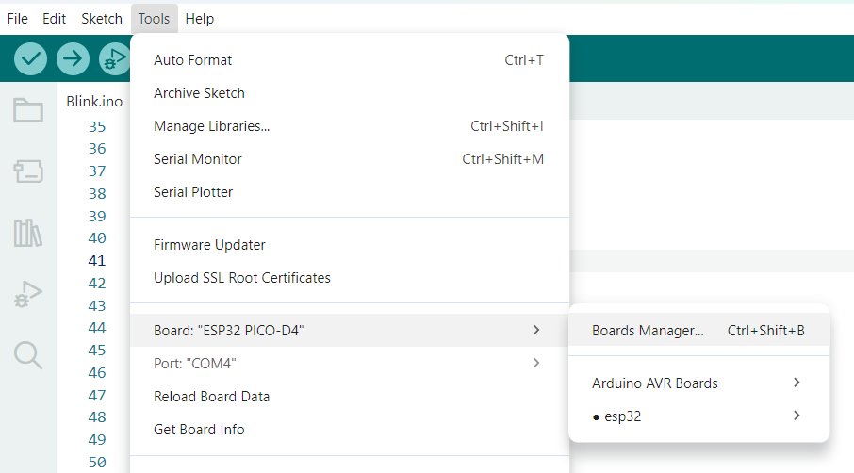
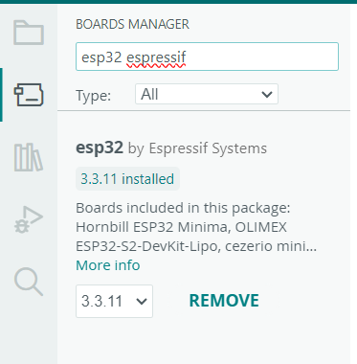

2.3 Selecting the Board and Port
The appropriate ESP32 board was selected in the Arduino IDE, together with the corresponding serial communication port.
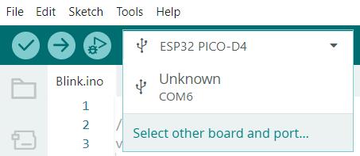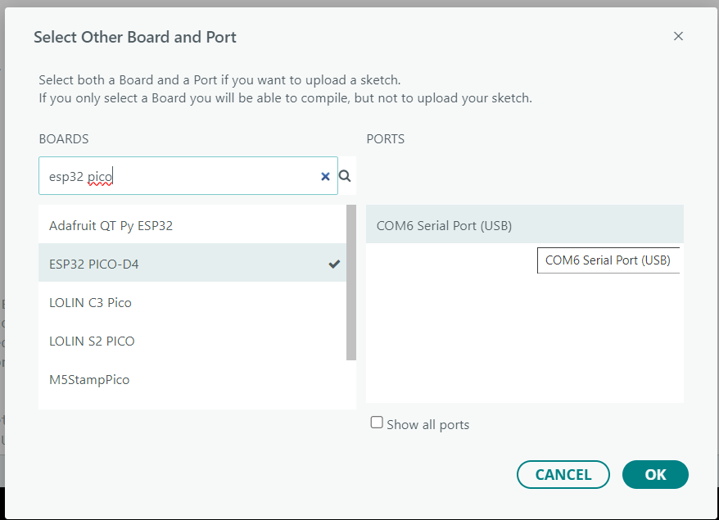

2.4 Testing the ESP32
Before implementing BLE communication, the ESP32 was tested to verify that the board could be successfully programmed and that communication through the Serial Monitor was working correctly.
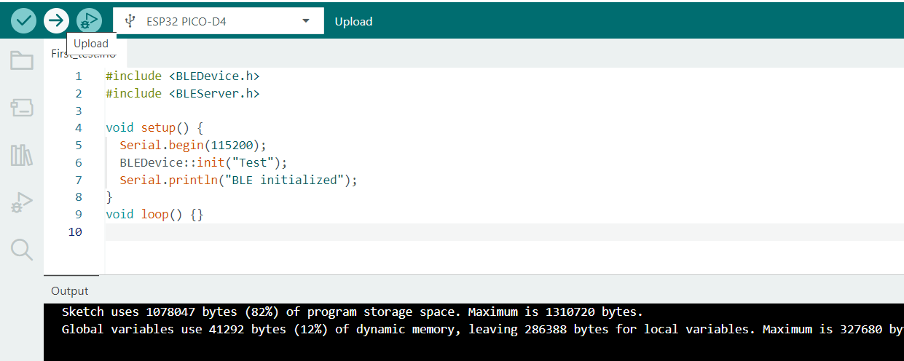
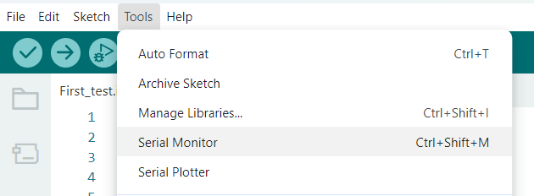
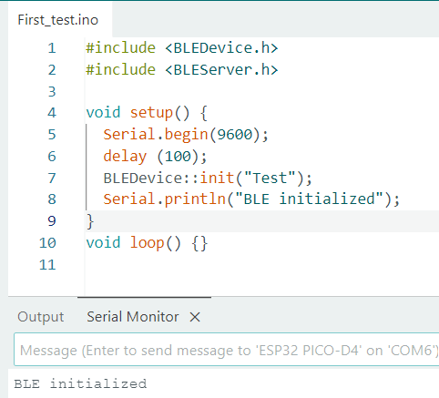

3. Configuring the ESP32 as a BLE Server
The ESP32 is configured as a BLE Server. The server provides BLE services and characteristics that can be accessed by a connected BLE client.
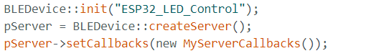

3.1 Connection Handling
When a client connects to the ESP32, the onConnect() callback is automatically executed. The first LED is switched ON to indicate that a BLE connection has been established.
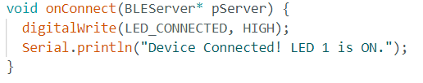

3.2 Disconnection Handling
When the client disconnects, the onDisconnect() callback is executed. The implementation switches both LEDs OFF and restarts advertising so that another device can connect.

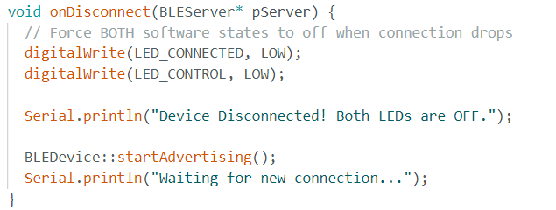
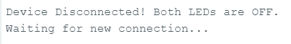

4. BLE Services and Characteristics
BLE communication at the application level is organized using services and characteristics. A service groups related functionality, while characteristics contain the actual data exchanged between the BLE Server and Client.

4.1 Custom Service/ Characteristic UUIDs
Create custom service UUID + characteristic UUID using UUID generator (https://www.uuidgenerator.net/ )
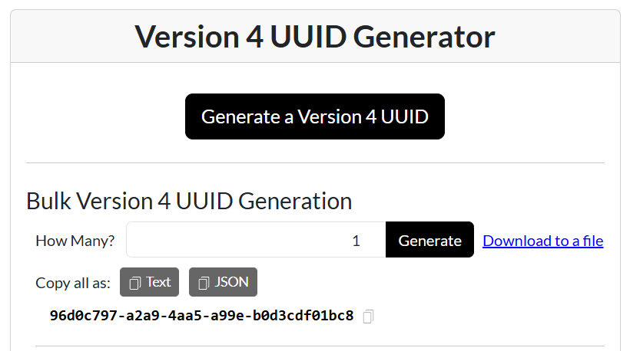
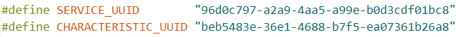

BLE Service
Although only one custom service was explicitly created in the Arduino code, three services were observed from the PC during service discovery: the Generic Access Service, the Generic Attribute Service, and the custom application service.
Generic Access Service: provides fundamental information about the BLE device, including information such as the device name.
Generic Attribute Service: a mandatory service related to the organization and management of the device's GATT structure.
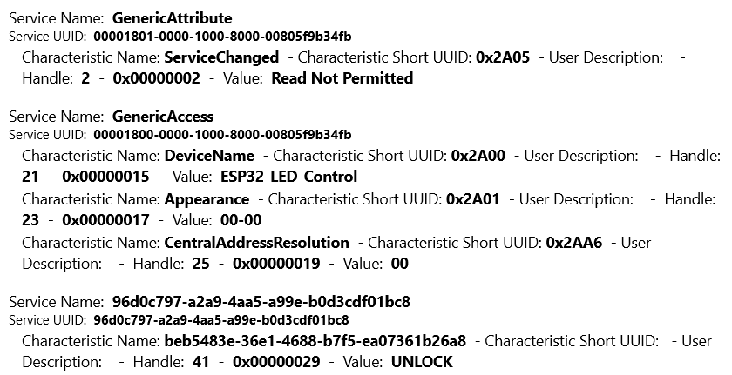

4.3 BLE Characteristic
A custom characteristic was created inside the custom service.
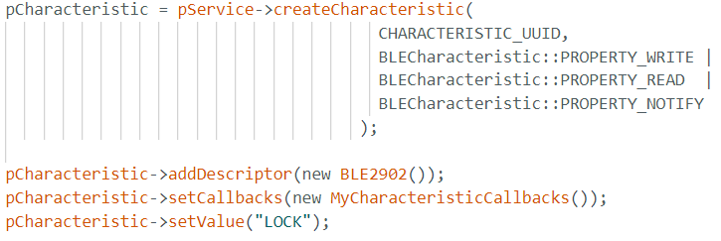


5. BLE Advertising
BLE advertising allows the ESP32 to make its presence known to nearby BLE devices before a connection is established.
The custom service UUID is included in the advertising data, scan response is enabled, and advertising is then started.
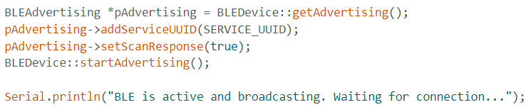
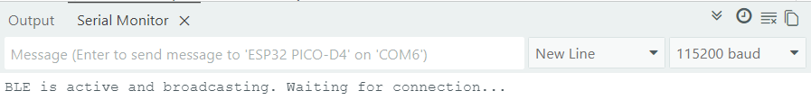

6. Discovering the ESP32 from the PC
After advertising is enabled, the ESP32 can be discovered from the PC. The device appears with the BLE name ESP32_LED_Control.
During testing, the BLE device information was explored from the application “Bluetooth LE Explorer”
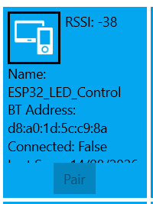

8. Characteristic Read / Write / Notify Operation
When the PC writes data to the characteristic, the onWrite() callback is executed.
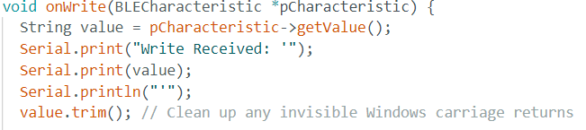If the received character is '1', LED 2 is switched ON, the value to be read is “UNLOCK”. If the received character is '0', LED 2 is switched OFF, the value to be read is “LOCK”.
For both cases, the user will receive a notification either “LOCK” or “UNLOCK”.
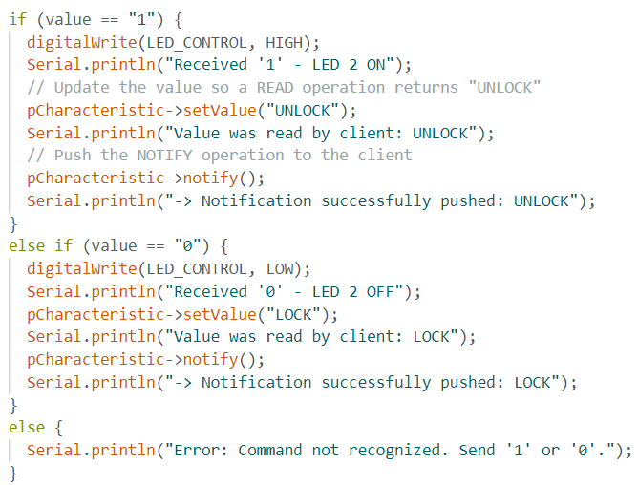
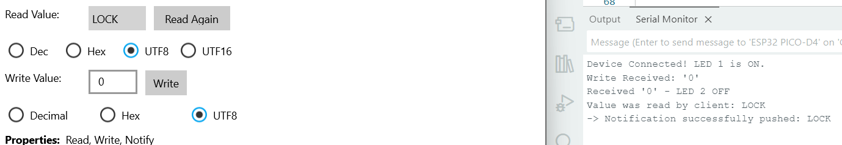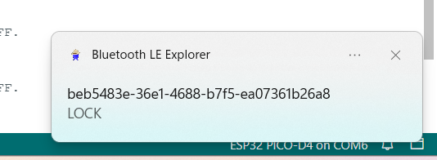

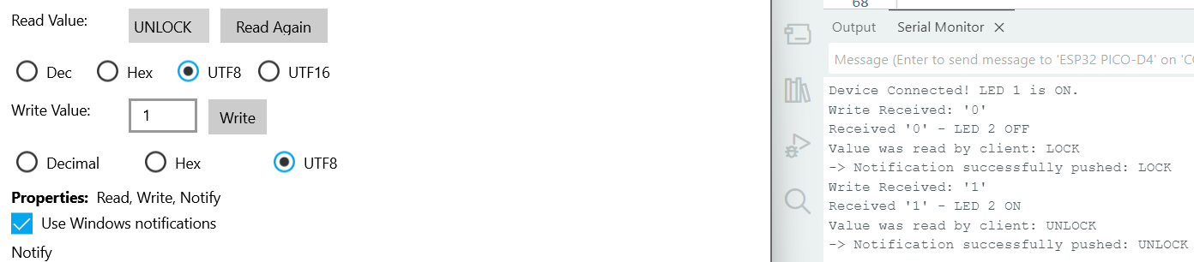
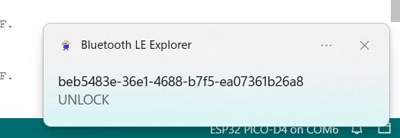

9. Security (Passkey Entry)
