BLE communication integration for automotive systems using esp32.
PC Server – ESP32 Client :

1. Introduction
Bluetooth Low Energy (BLE) is a wireless communication technology designed for low-power communication between electronic devices. It is widely used in embedded and automotive applications where devices need to exchange small amounts of data efficiently.
The objective of this phase is to establish BLE communication between a PC and an ESP32, with the PC configured as a BLE Server and the ESP32 as the BLE Client.

2. BLE Environment Setup

2.1 Required Hardware
- ESP32 development board
- USB cable
- LED
- Resistor
- Push button
- PC

2.2 ESP32 Software Setup
The ESP32 board support package was installed in the Arduino IDE to allow the ESP32 to be programmed and configured. 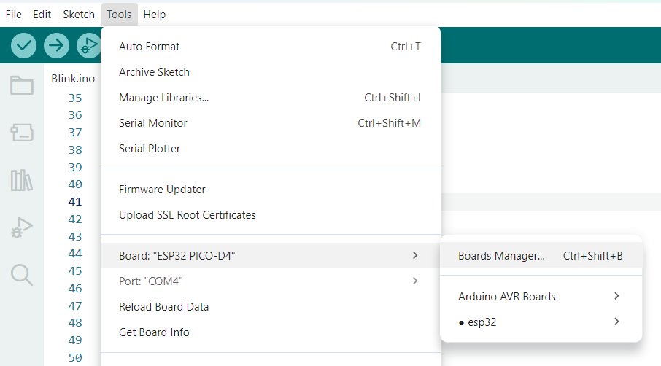
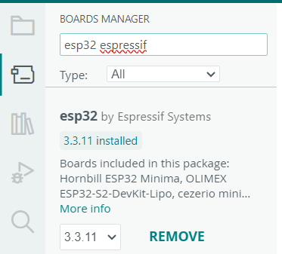
The appropriate ESP32 board was selected in the Arduino IDE, together with the corresponding serial communication port.
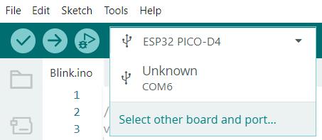
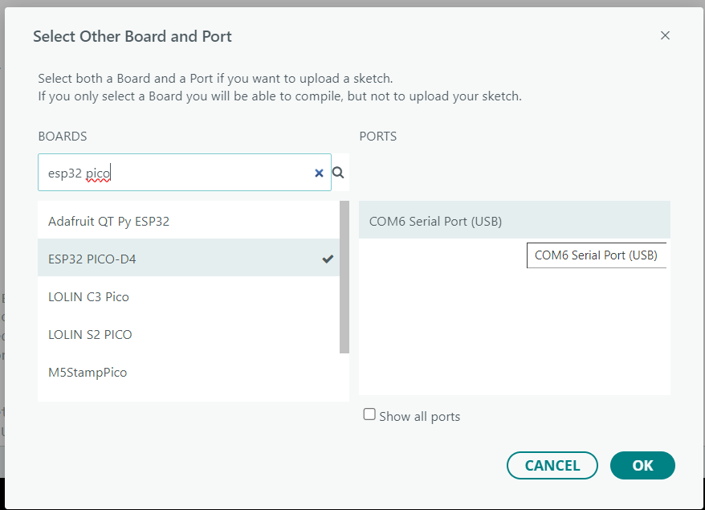

2.3 PC Software Setup
The PC Server is implemented in Python using the Bless (Bluetooth Low Energy Server Supplement) BLE library.
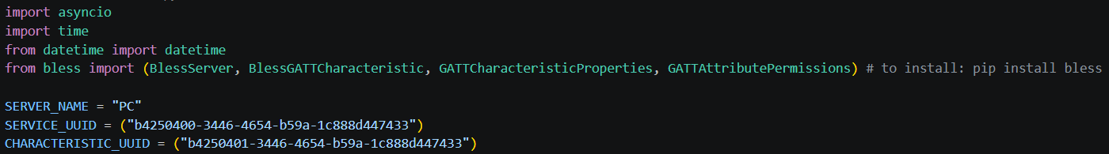

3. Configuring the PC as a BLE Server
The PC uses BlessServer to create the BLE Server.
my_server.start() starts the BLE server.

3.1 Connection Handling
When the server receives its first relevant request, connection_established() verifies whether a connection has already been established.
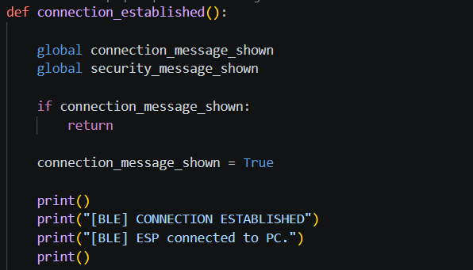

3.2 Disconnection Handling
The ESP32 sends 0x00 every 2 seconds while connected. If the PC receives no packet for more than 5 seconds, its watchdog reports a supervision timeout and restarts the advertising simulation. The PC restarts advertising after disconnection.

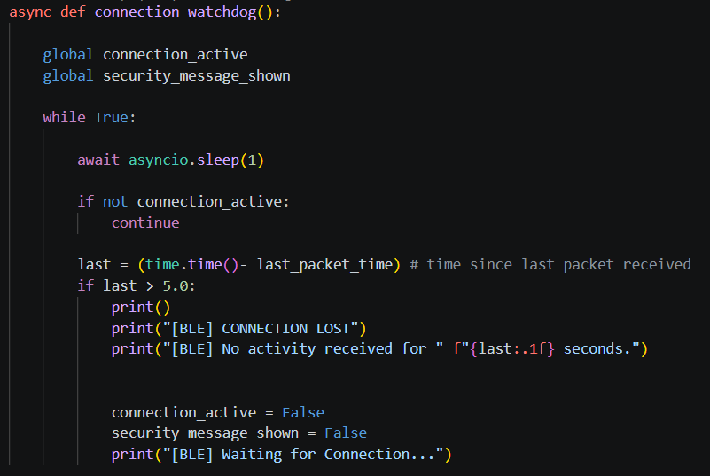

4. BLE Advertising
The advertising() represents the advertising phase of the PC Server. While no connection has been established, the application repeatedly generates an ADV_IND log entry identifying the PC as a server.
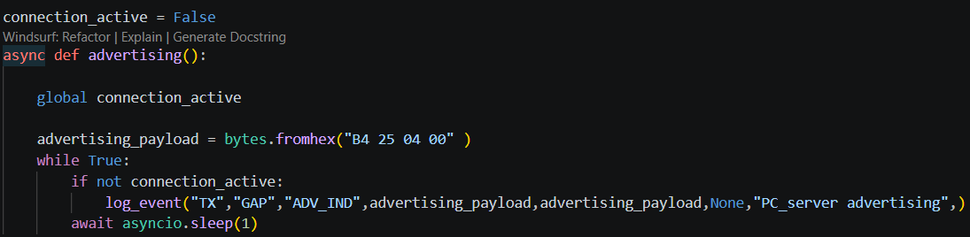

5. BLE Services and Characteristics
The PC uses Bless to create custom services, and custom characteristics.

5.1 Custom Service/ Characteristic UUIDs
Create custom service UUID + characteristic UUID using UUID generator (https://www.uuidgenerator.net/ )

5.2 BLE Service

5.3 BLE Characteristic
A custom characteristic was created inside the custom service. It supports three operations: Read, Write, and Notify.

6. Characteristic Read Operation
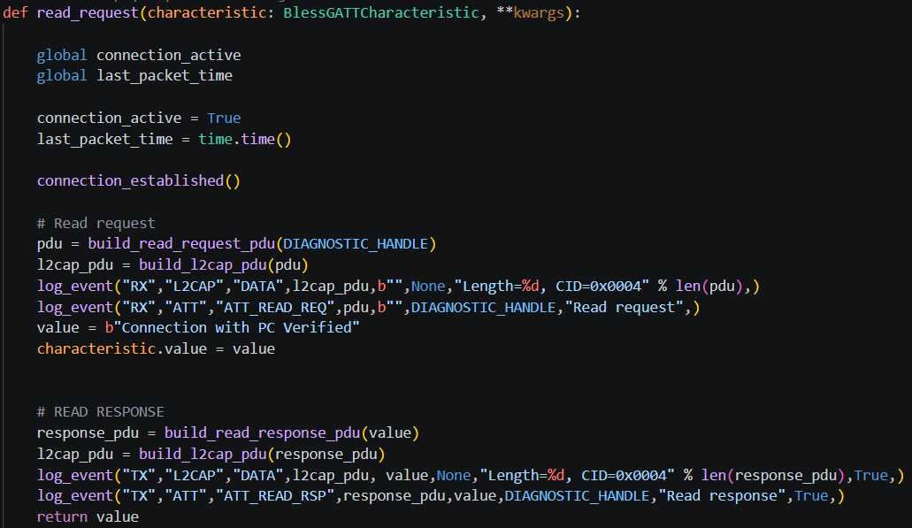
ESP32
│ ATT_READ_REQ (0x0A)
│ Handle 0x002A
▼
PC Server
│ Search characteristic
│ Search value
▼
ATT_READ_RSP (0x0B)
│ Return value = "Connection with PC Verified"
▼
ESP32

7. Characteristic Write Operation
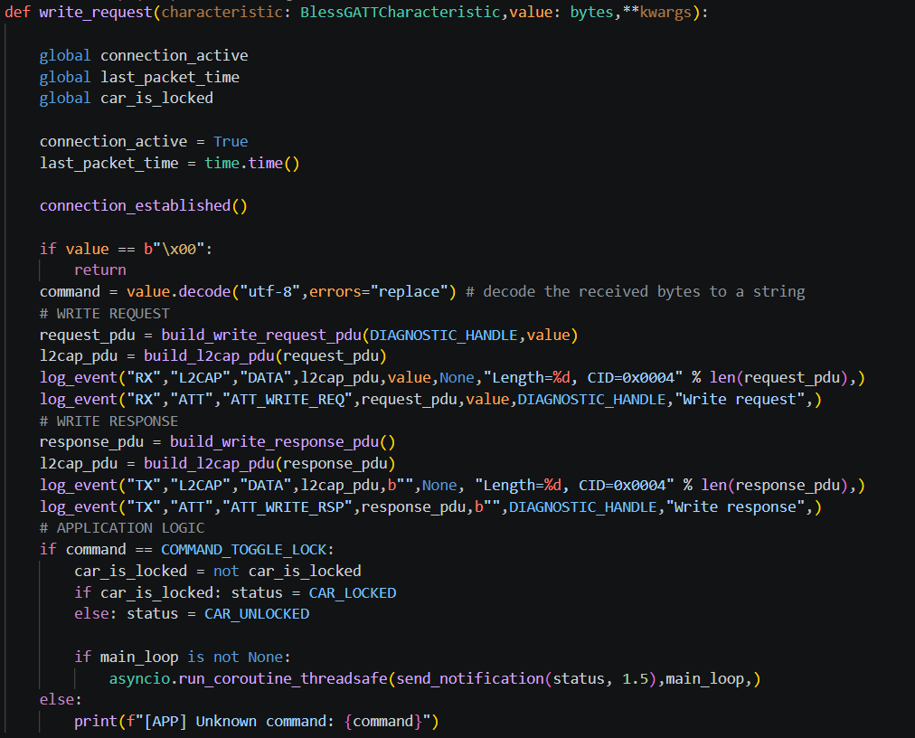
Initially: car_is_locked = True
TOGGLE_LOCK  ↓  car_is_locked = False  ↓  Car Unlocked | TOGGLE_LOCK  ↓  car_is_locked = True  ↓  Car Locked

8. Characteristic Notify Operation
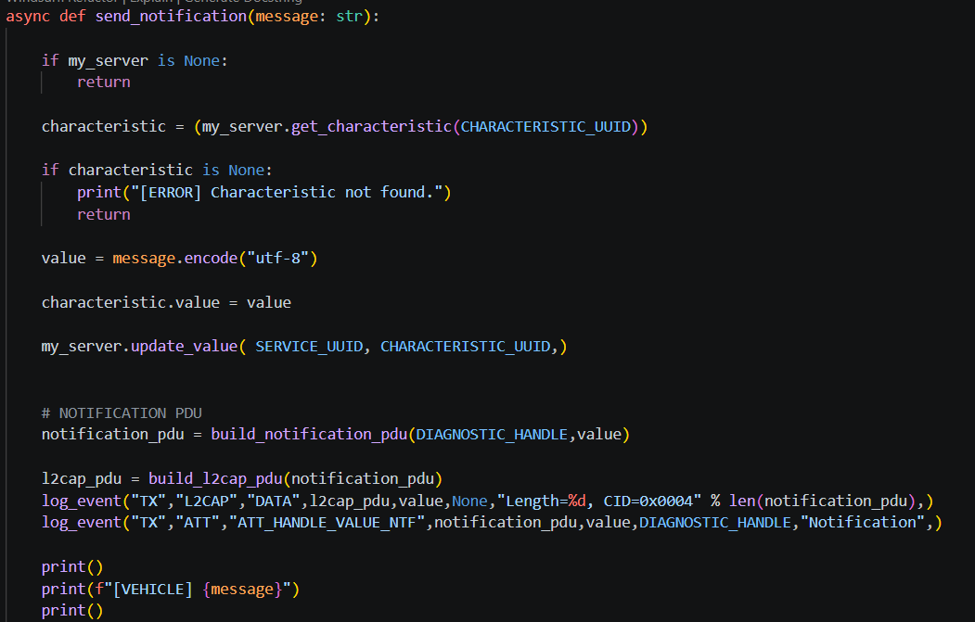
TOGGLE_LOCK -> Change car_is_locked ("Car Locked" / "Car Unlocked") -> Update characteristic value -> Update_value() -> Notification -> ESP32 Client.

9. Security (Passkey Entry)
Because the Windows/Bless side does not expose the raw SMP authentication-complete callback, the current code uses notification subscription as the operational point and displays the authentication result
The ESP32 configures passkey-based BLE security with MITM protection and secure connections enabled in the current firmware.
