1. {"courseId": 79,"professorId": 1,"TAId": 1,"department": "IS","boardId": 1}

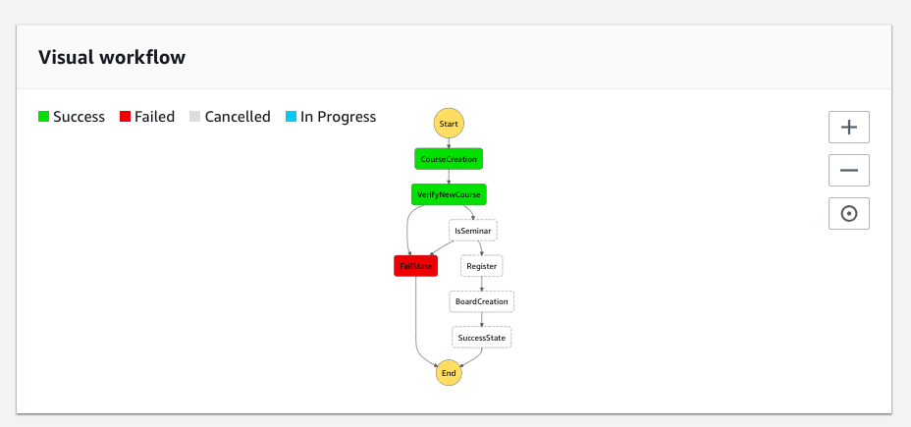

1. {"courseId": 78,"professorId": 1,"TAId": 1,"department": "Seminars"}

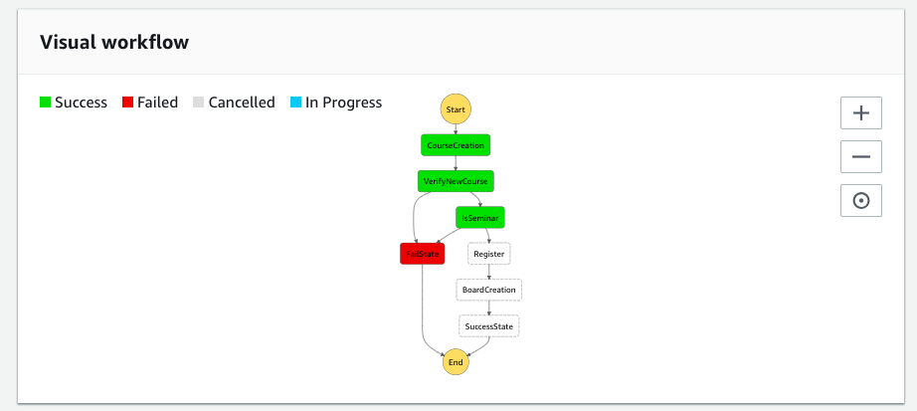

1. {"courseId": 79,"professorId": 1,"TAId": 1,"department": "IS"}

