Invoice Extraction Checker
Documentation
Version 1.0.0

15th June 2019
Table of Contents
1 Introduction 3
1.1 Templates 3
1.2 Installing the application 3
1.3 Running the application 4
2 Writing a template 5
2.1 Naming the template 6
2.2 Keywords – Applying a template 6
2.3 Fields – Picking values for a given name 7
2.3.1 Name 7
2.3.2 Location 8
2.3.2.1 Right 8
2.3.2.2 Second-right 9
2.3.2.3 Bottom 9
2.3.2.4 Regex 10
2.3.2.5 Regex right 10
2.3.3 Identifier 11
2.3.4 Ordinal 12
2.4 Picking Line Items 13
2.4.1 Table Line Items 13
2.4.1.1 Both Horizontal and Vertical Lines 14
2.4.1.2 Vertical Lines but no Horizontal Lines 16
2.4.1.3 Horizontal Lines but no Vertical Lines 18
2.4.1.4 No Vertical Lines or Horizontal Lines 20
2.4.2 Regex Line Items 22
2.5 Checking extracted values 23
3 Customization using plugins 26

Introduction

This project is based on invoice2data which extracts data from invoice pdf files using user written regular expressions. It is observed that quite some invoices cannot be extracted just using the regular expression approach since pdf text is organized not as lines of text rather as boxes with co-ordinates. Field values are placed at locations like to the right, bottom of a field so on. Line items can also placed in tables. This solution tries to use other techniques along with regular expressions to solve the problem.

The solution is written in python and provides the following capabilities
- Extract Field values (Based on regex or location based - right, bottom ...)
- Table based line item extraction (regex, vertical or horizontal table lines ...)
- Check if the extracted line item Total values matches the Sum Total.

Templates

Templates which are in json format are used to tell the application how to pick field values (regex, top, bottom of field name) and also how line items are present in the invoice (With or Without Horizontal Vertical Lines, Line item columns…).

Installing the application

- Install python 2.7 (Anaconda)
- pip/conda install the following libraries json, re, deepcopy, configparser, logging, pdfminer, argparse, sortedcontainers, sets

Running the application

From the src folder run,
python Main.py --dump <Dump file name> --template <Template Folder> --file <PDF file name> --output <Output JSON file>

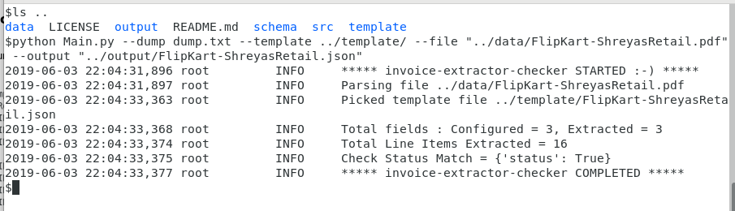

Writing a template

Template is written in json format and contains the name of the template, keywords that would be used to match the given template with a invoice pdf, field names and information on how to pick the corresponding field values, the columns in line items.
Before writing the template, it is a must that two files are held as reference. The first one being the invoice pdf itself, which would be used to identify the location of fields, columns of the line items so on. The second one that would come handy is a dump of the pdf that is created by this application. Text is represented as text boxes with x & y coordinates and the dump contains the location of the different text boxes in the given pdf.

Below you see the start of the first page dump, followed by a text box at location y 548.59 and location starting and ending at x0 and x1 respectively.

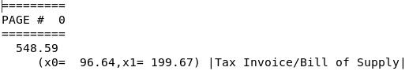

Below you can see 4 text boxes aligned horizontal next to each other.

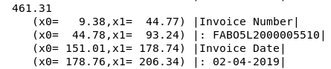

Naming the template

Name of this template must be unique across all the templates that are part of the system.

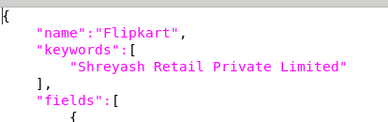

Keywords – Applying a template

A list of all the text that would exist in the pdf. If all matches, apply this template i.e., use the fields cum line item definition to extract information from the pdf.

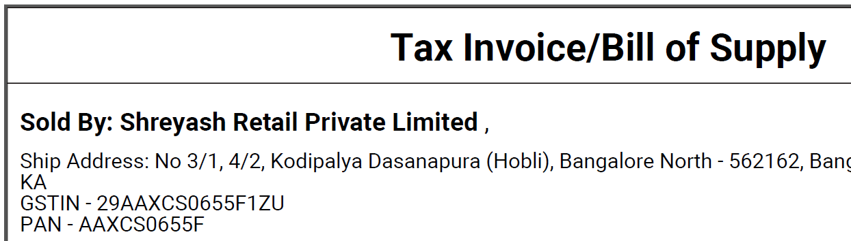
Template
PDF

Fields – Picking values for a given name

A list of all the fields that need to be extracted along with information about how to extract them.

Template | 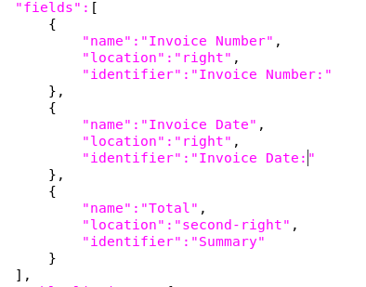

In the above example, there are 3 fields to be extracted. The name of field that would be extracted, the location of the field’s value and information on how to identify the field in the pdf.

Name

Name of the field. The same name would be used in the output extracted json file.

Location

Provide the location detail for the particular field. The following values are possible

Right
Template | {  "name":"Invoice Number",  "location":"right",  }
PDF | 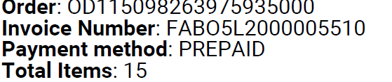
Dump | 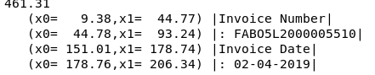
Extraction | {  "fields": {  "Invoice Number": ": FABO5L2000005510",  ...

Template | {  "name":"Invoice Number",  "location":"right",  }
PDF | 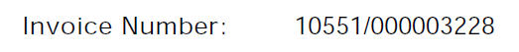
Dump | 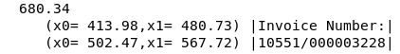
Extraction | {  "fields": {  "Invoice Number": "10551/000003228", , ...

Second-right
Template | {  "name":"Tax",  "location":"second-right",  "identifier":"TOTAL:"  },
PDF
Dump | 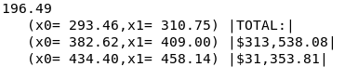
Extraction | {  "fields": {  ...  "Tax": "$31,353.81",  ...

Bottom
Template | {  "name":"Subtotal",  "location":"bottom",  "identifier":"Net"  },
PDF | 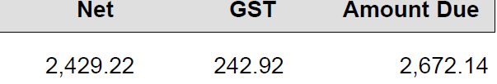
Dump | 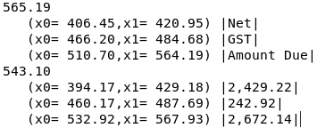
Extraction | "Tax": "242.92",  "Total": "2,672.14",  Subtotal": "2,429.22"

Regex
Template | {  "name":"Invoice Number",  "location":"regex",  }
PDF | 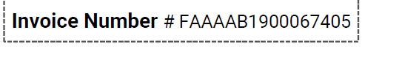
Dump
Extraction | {  "fields": {  "Invoice Number": "FAAAAB1900067405",  ...

Regex right
Template | {  "name":"Total",  "location":"regex-right",  "identifier":"Total Current Charges - Due .*"  }
PDF
Dump
Extraction | "fields": {  ...  "Total": "2,167.88",  ...

The other possibilities could be regex bottom, regex second-right

Identifier

This text tells how to identify the field in the pdf. Matching text could be Text “as is” or a regular expression match.

“as is”
Template | {  "name":"Subtotal",  "location":"bottom",  "identifier":"Net"  },
PDF

“regular expression”
Template | {  "name":"Total",  "location":"regex-right",  "identifier":"Total Current Charges - Due .*"  }
PDF

Ordinal

Optional. Default first (1). Sometimes the identifier given could occur at multiple locations in the pdf file. Ordinal is used to tell the application the field value needs to be picked from what ordinal.

Template | 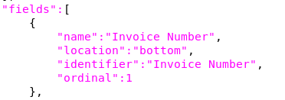
PDF | First occurrence  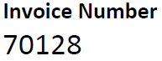  Second occurrence  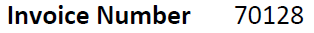

Picking Line Items

Line items can either be of tabular format or simple lines which can be extracted using regular expressions.

Table Line Items

To extract line items we need to specify the list of all the columns in the line item, the alignment of text under each column, what all columns constitutes a start of a line item and whether line items have vertical and horizontal guide lines.

Both Horizontal and Vertical Lines

Template | 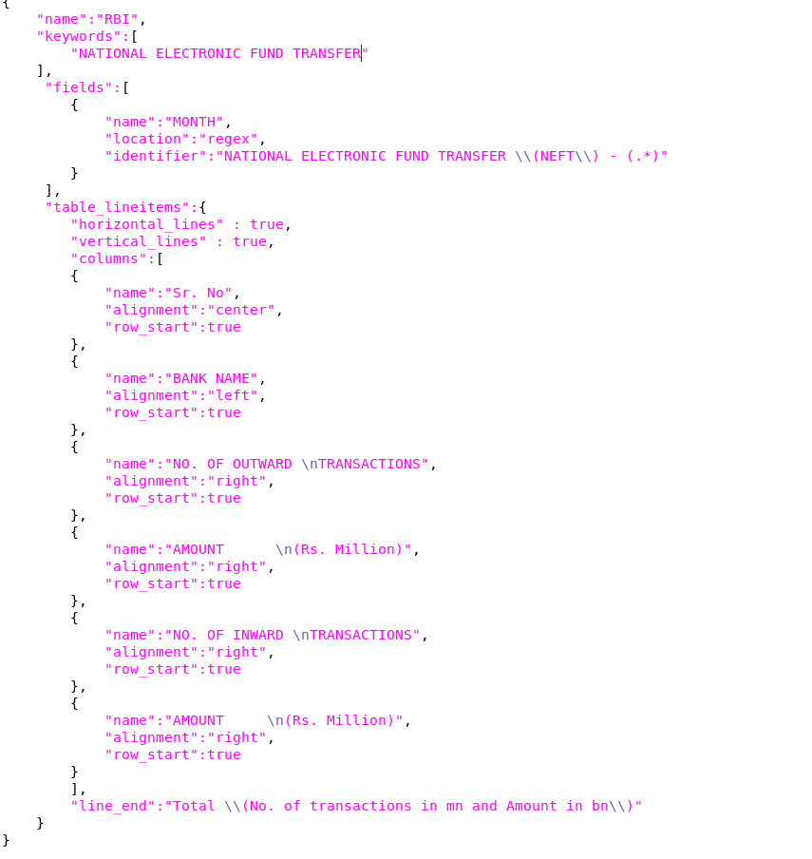
PDF | 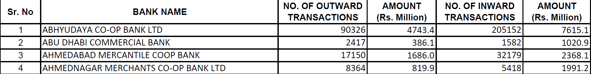
Dump | 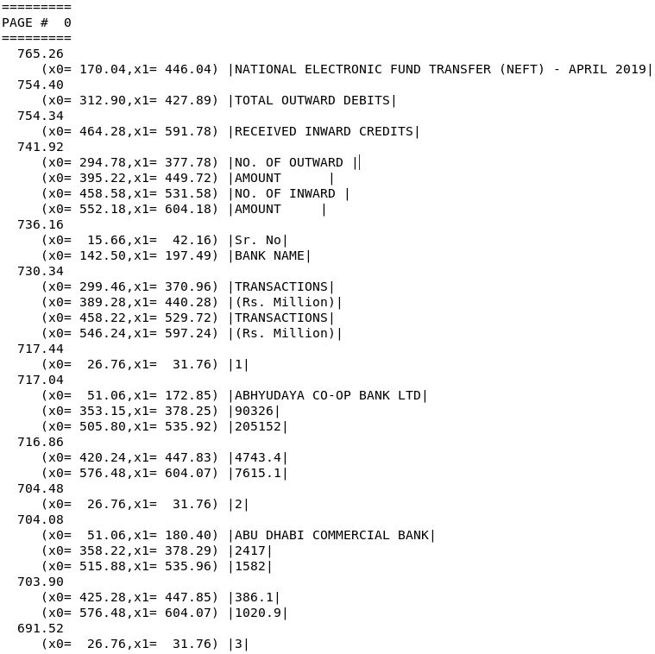
Extraction | 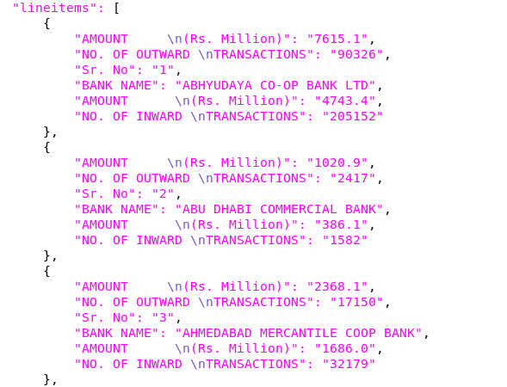

Vertical Lines but no Horizontal Lines

Template | 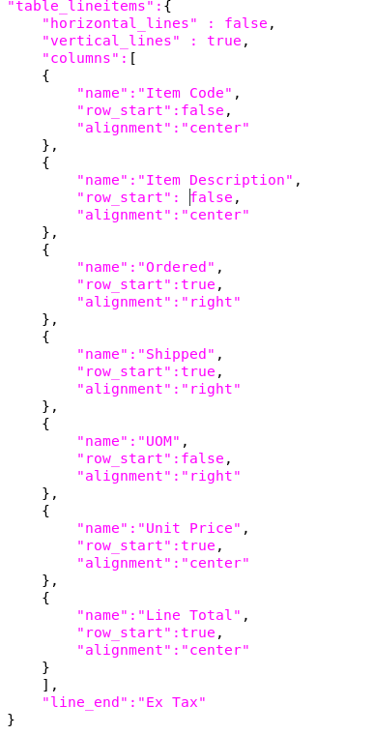
PDF | 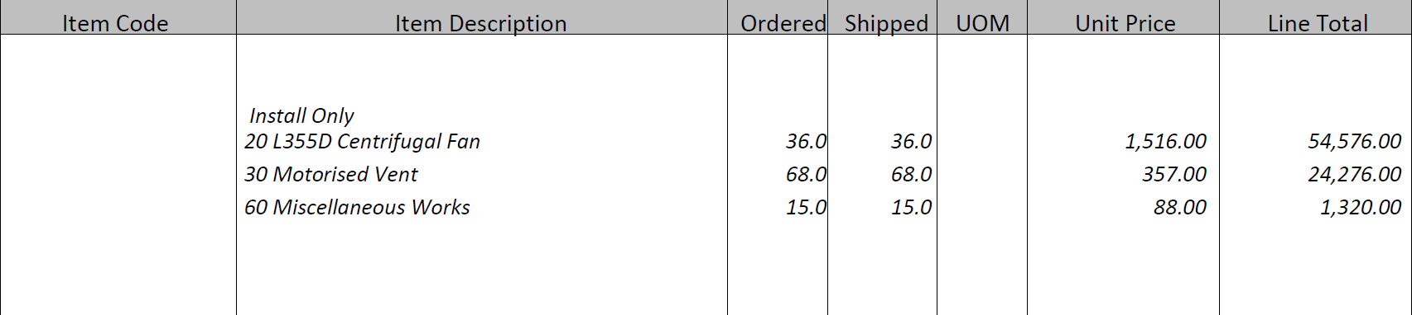
Dump | 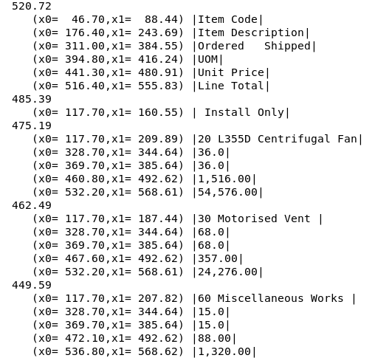
Extraction | 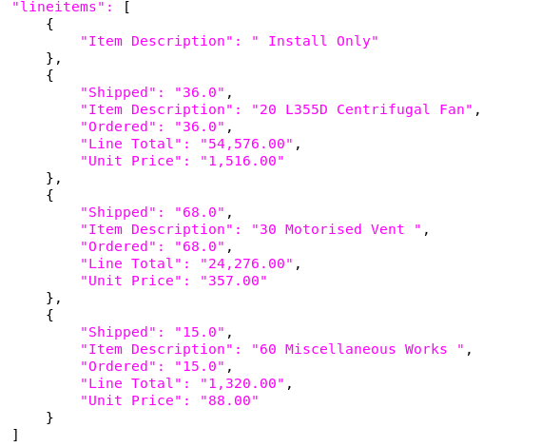

Horizontal Lines but no Vertical Lines

Template | 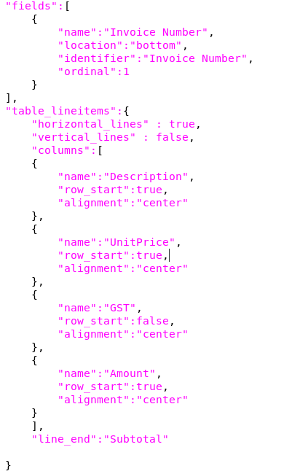
PDF | 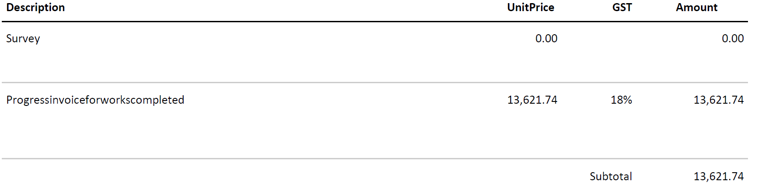
Dump | 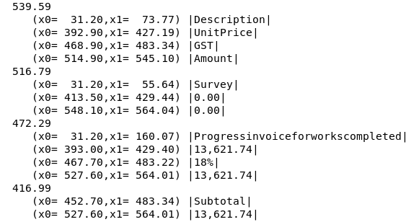
Extraction | 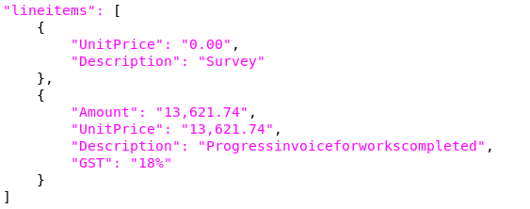

No Vertical Lines or Horizontal Lines

Template | 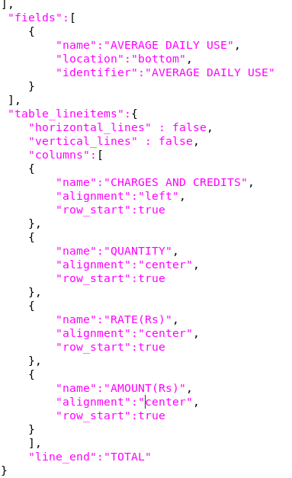
PDF | 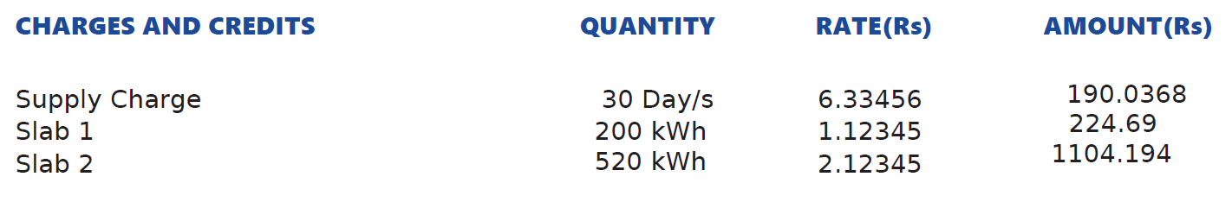
Dump | 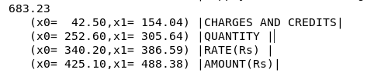
Extraction | 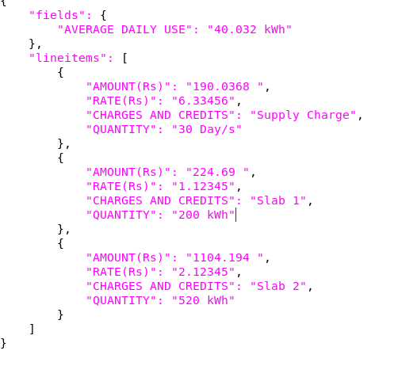

Regex Line Items

Template | "regex_lineitems":{  "line_start" : "Line\\s+Code\\s+Description\\s+Qty\\s+Total",  "line_end" : "Total before GST",  "lines":[  "^(?P<Line>\\d+)\\s+(?P<Code>\\d*)\\s+(?P<Description>.+)\\s+(?P<Qty>\\d+(,\\d+)*(\\.\\d+)?)\\s+(?P<Total>\\d+(,\\d+)*(\\.\\d+)?)$"  ],  "columns":[  "Line",  "Code",  "Description",  "Qty",  "Total"  ]  }
PDF
Extraction | 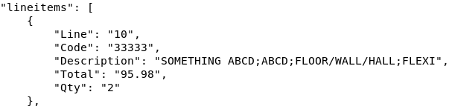

Checking extracted values

Checker is used to check if the Total value provided in the invoice and the sum of all the Amount columns in the line items match.

A field name which contains the extracted Total and the Line Item column name needs to be provided in the template. Regular expressions can also be provided to extract only the numeric value from the field/line item values. The result indicating the check status (matches, did not match for a particular reason…) shows up in the output json.

Template | 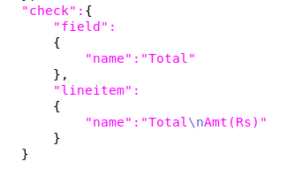

Sample showcasing picking a part of a field/line item value using regular expression for further extraction validation.

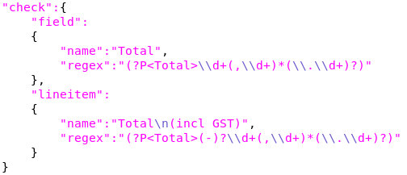
Template

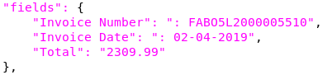
PDF content (Line Item column with values, Field Total value – Only few rows showcased)
PDF | 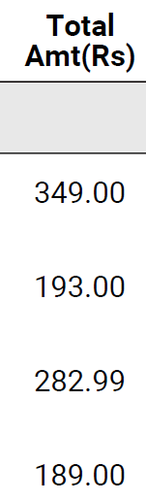
Extracted (fields) | 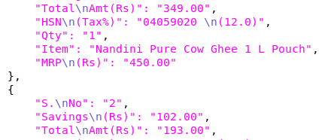
Extracted (Status) | 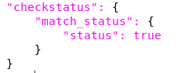

Match failure samples

Conversion Errors when the data in either line item columns or field value are not floating point numbers.

Extracted (Status) | 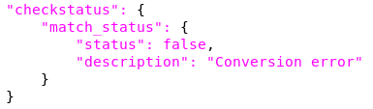

When either wrong or missing extractions occur,

Extracted (Status) | 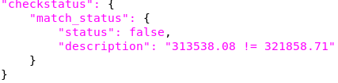

Customization using plugins

Plugins allow you to customize the extraction. Mainly you can transform the field and line item contents based on the specific invoice. You can also access the text data page wise and extract invoice specific data.

To write a plugin, you need to write a new python file and drop it under src/plugin. You should specify the name of the plugin in the invoice template file.
Template | 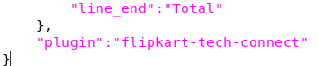
Plugin Python | #!/usr/bin/env python  def transform(_type, type_name, type_value):  print _type, ' ', type_name, ' ', type_value  return type_value  def transform_line_item(index, type_name, type_value):  print index, ' ', type_name, ' ', type_value  return '|' + type_value + '|'  def post_processor(extracted_data, container_instance):  print len(container_instance.pagewise_rows_of_y0_textboxes)  return extracted_data

Three methods need to be implemented
transform | Method is called for every field.  type_name is the name of the field  type_value is the extracted value of the field name  Either the transformed value or the original value needs to be returned.
transform_line_item | Method is called for every field.  type_name is the name of the column  type_value is the extracted value of the column name  Either the transformed value or the original value needs to be returned.
post_processor | Refer ObjectLayoutContainer.py for the methods that provide you access to the text boxes and their data.

