


Multilingual Text to Video Generation of Press Information Bureau Press Release
A PROJECT REPORT

Submitted by
Thummala Bhargavi - 20221CSE0251
Doodakula Sajida - 20221CSE0126
Pinnapareddy Yogananda Reddy-20221CSE0417

Under the guidance of,
Dr. Jothish C

BACHELOR OF TECHNOLOGY

IN

COMPUTER SCIENCE AND ENGINEERING

PRESIDENCY UNIVERSITY
BENGALURU
DECEMBER 2025

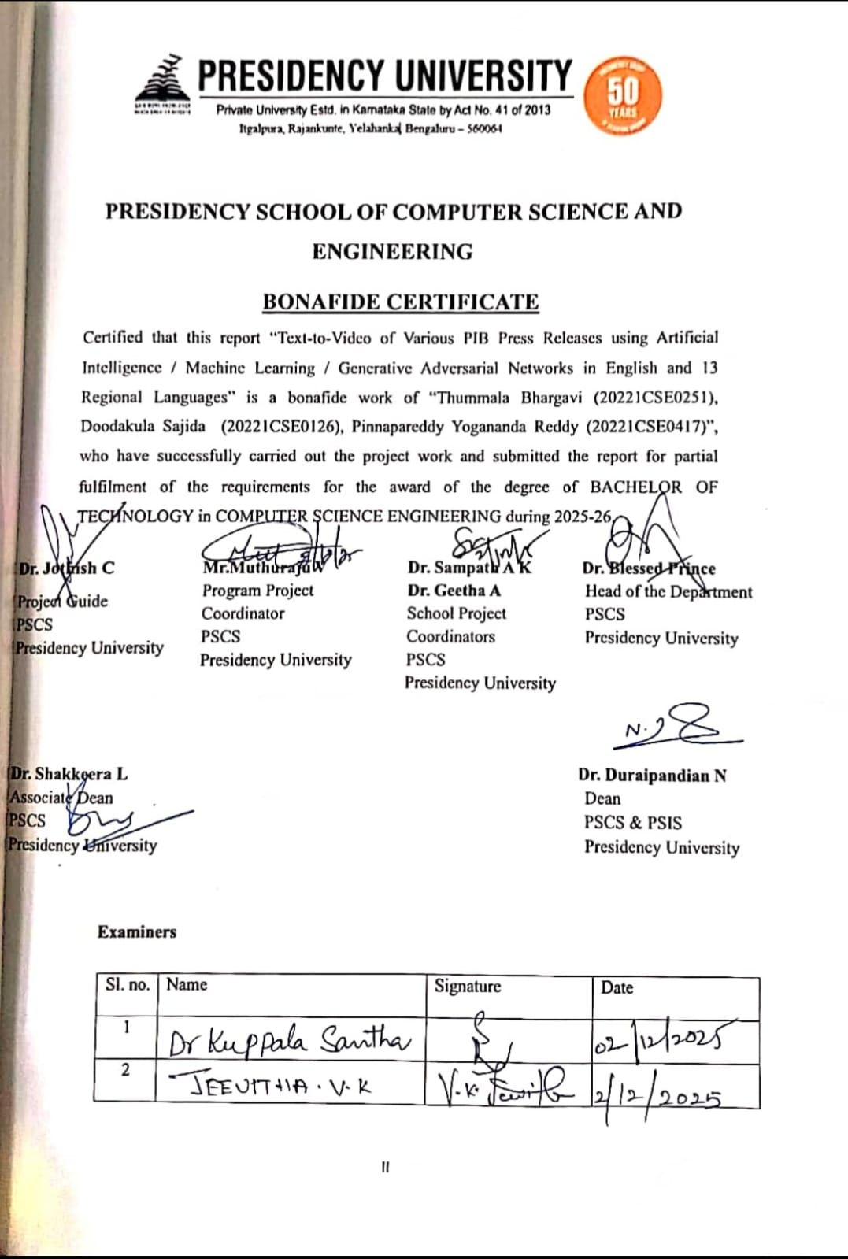
PRESIDENCY UNIVERSITY

PRESIDENCY SCHOOL OF COMPUTER SCIENCE AND ENGINEERING
DECLARATION

We the students of final year B.Tech in COMPUTER SCIENCE ENGINEERING at Presidency University, Bengaluru, named Thummala Bhargavi, Doodakula Sajida, Pinnapareddy Yogananda Reddy, hereby declare that the project work titled “Text-to-Video of Various PIB Press Releases using Artificial Intelligence / Machine Learning / Generative Adversarial Networks in English and 13 Regional Languages” has been independently carried out by us and submitted in partial fulfillment for the award of the degree of B.Tech in COMPUTER SCIENCE ENGINEERING during the academic year of 2025-26. Further, the matter embodied in the project has not been submitted previously by anybody for the award of any Degree or Diploma to any other institution.
Thummala Bhargavi USN: 20221CSE0251
Doodakula Sajida USN: 20221CSE0126
Pinnapareddy Yogananda Reddy USN: 20221CSE0417

PLACE: BENGALURU
DATE:

ACKNOWLEDGEMENT

For completing this project work, we have received the support and the guidance from many people whom I would like to mention with deep sense of gratitude and indebtedness. We extend our gratitude to our beloved Chancellor, Pro-Vice Chancellor, and Registrar for their support and encouragement in completion of the project.
I would like to sincerely thank my internal guide Dr. Jothish C, Associate Professor, Presidency School of Computer Science and Engineering, Presidency University, for his moral support, motivation, timely guidance and encouragement provided to us during the period of our project work.
I am also thankful to Dr. Blessed Prince, Professor, Head of the Department, Presidency School of Computer Science and Engineering Presidency University, for his mentorship and encouragement.
We express our cordial thanks to Dr. Duraipandian N, Dean PSCS & PSIS, Dr. Shakkeera L, Associate Dean, Presidency School of computer Science and Engineering and the Management of Presidency University for providing the required facilities and intellectually stimulating environment that aided in the completion of my project work.
We are grateful to Dr. Sampath A K, and Dr. Geetha A, PSCS Project Coordinators, Mr.Muthuraju V, Program Project Coordinator, Presidency School of Computer Science and Engineering, or facilitating problem statements, coordinating reviews, monitoring progress, and providing their valuable support and guidance.
We are also grateful to Teaching and Non-Teaching staff of Presidency School of Computer Science and Engineering and also staff from other departments who have extended their valuable help and cooperation.
THUMMALA BHARGAVI
DOODAKULA SAJIDA
PINNAPAREDDY YOGANANDA REDDY

Abstract

This project introduces an AI-based Text-to-Video Generation System developed to automatically convert Press Information Bureau (PIB) content into clear, multilingual, narrated videos. Government departments often face delays in creating digital content because traditional video production takes time, requires trained editors, and involves several manual steps. To address these challenges, the proposed system brings all essential processes—summarization, translation, text-to-speech, and video creation—into one unified workflow.
The system uses modern transformer models to shorten long PIB articles into simple and meaningful summaries without losing important information. It supports multiple Indian languages through neural machine translation, ensuring that messages remain accurate and easy to understand. The text-to-speech module produces natural-sounding voices suitable for formal government communication. Using FFmpeg and predefined templates, the system automatically generates well-structured and visually clean videos.
During testing, the system showed reliable performance in terms of summary quality, translation accuracy, and audio clarity. It also reduced the overall time needed to produce a video by more than 80% when compared to manual editing. Because the design is modular, more languages, voice styles, or visual formats can be added in the future without major changes.
Overall, the project successfully meets its goals by offering a practical and cost-effective solution for producing multilingual informational videos. It has strong potential to support government communication, public awareness campaigns, educational outreach, and any platform that requires timely and accessible video content.

Table of Content

Sl. No. | Title | Page No.
I | Declaration | III
II | Acknowledgement | IV
III | Abstract | V
IV | List of Figures | IX
V | List of Tables | X
VI | Abbreviations | XI
1. | Introduction  1.1 Background  1.2 Statistics of project  1.3 Prior existing technologies  1.4 Proposed approach  1.5 Objectives  1.6 SDGs  1.7 Overview of project report | 1-13
2. | Literature review | 14-23
3. | Methodology | 24-32
4. | Project management  4.1 Project timeline  4.2 Team Roles and Responsibilities  4.3 Risk Management  4.4 Resource Allocation  4.5 Progress Monitoring and Communication  4.6 Challenges and Resolutions  4.7 Timeline Visualization  4.8 Future Management Considerations | 33-41
5. | Analysis and Design  5.1 Requirements  5.2 Block Diagram  5.3 System Flow Chart  5.4 Database Design  5.5 UML Diagrams | 42-49
 | 5.6 Design Considerations  5.7 Prototype Validation  5.8 Future Design Enhancements | 49-50
6. | Software and Simulation  6.1 Software Implementation  6.2 Integration  6.3 Deployment and Validation  6.4 Documentation and Version Control  6.5 Future Implementation Plans | 51-56
7. | Evaluation and Results  7.1 Evaluation Metrics  7.2 Results  7.3 Limitations  7.4 Experimental Setup and Methodology  7.5 Statistical Validation | 57-61
8. | Social, Legal, Ethical, Sustainability and Safety Aspects  8.1 Social aspects  8.2 Legal aspects  8.3 Ethical aspects  8.4 Sustainability aspects  8.5 Safety aspects | 62-64
9. | Conclusion | 65
 | References | 66-67
 | Base Paper | 67
 | Appendix | 68-73

List of Figures

Figure ID | Figure Caption | Page No.
Fig 1.1 | Sustainable Development Goals | 9
Fig 3.6 | Text-to-Video System Architecture Block Diagram | 31
Fig 4.7 | Gantt chart | 41
Fig 5.2 | Functional Block Diagram | 45
Fig 5.3 | Data Flow Diagram | 46
Fig 6.1 | Code Snippet | 52
Fig 6.1 | Code Snippet (2) | 53
Fig A.1 | PhD Focus Paper Acceptance email | 69
Fig A.2 | Turnitin Similarity Report | 70
Fig A.3 | Login page (1) | 71
Fig A.4 | User Interface for Writing Prompt (2) | 72
Fig A.5 | Language Selection and Script Narration Optional (3) | 72
Fig A.6 | Generating Video and Downloading (4) | 73

List of Tables

Table ID | Table Caption | Page No.
Table 2.1 | Summary of Literature Reviews | 20-21

Abbreviations

Abbreviation | Full Form
AI | Artificial Intelligence
API | Application Programming Interface
FFmpeg | Fast Forward Moving Picture Experts Group
GAN | Generative Adversarial Network
GPT | Generative Pre-trained Transformer
LLM | Large Language Model
mBART | Multilingual Bidirectional and Auto-Regressive Transformer
ML | Machine Learning
mT5 | Multilingual T5 Model
MLNLP | Multilingual Natural Language Processing
M2M-100 | Multilingual Machine Translation Model
NLLB | No Language Left Behind
PIB | Press Information Bureau
SDGs | Sustainable Development Goals
TTS | Text-to-Speech

Chapter 1
INTRODUCTION

The rise of technology has caused a shift in the way we communicate with one another. No longer do most people want to read lengthy documents and reports, such as those provided by news agencies regarding government's policy decisions, announcements, and other important issues. Instead, the preferred method of communication has become via short video clips, social media posts, images/video snippets, and other types of digital media; these forms are the most effective means of providing information to the public. Traditional PIB press releases, though still very much in use, lack an engaging and visually appealing style to captivate a younger audience that uses social network sites as their primary means of communication.

To meet this problem, we have created an artificial intelligence-based solution that allows government agencies who use PIB press releases to create short and interesting video clips out of them using artificial intelligence (AI), machine learning (ML) technology, Generative Adversarial Networks (GAN), and Multilingual Natural Language Processing (MLNP). Our software can summarize, convert text into short engaging video formats, and translate into 14 different languages, including English and the 13 most widely used regional languages of India. This enables government agencies to share current information about events, new policy decisions, or other news developments more quickly with more people than ever before and in ways that are easier to understand visually through digital media platforms.

1.1 Background
Press Information Bureau (PIB) is the principal body through which the Government of India provides information to its citizens. It disseminates detailed information on schemes and policies of government, achievements of the government and various national developments. Up until now, PIB has only produced printed versions of press releases in formal written form.

Due to the popularity of shorter video formats and more visual content within the present-day technology ecosystem, many individuals aged 18-35 have difficulty accessing the lengthier format of press releases created by PIB. The current procedure for converting press release documents to video format is completely manual; all teams complete the respective script writing, graphic design, language conversion, voice recording and editing of videos by hand. Due to this process being time-consuming, costly, and not easy to scale, it is common that hundreds of PIB press releases are generated on a weekly basis, but only a fraction of those releases are converted into a format to be easily seen by the public through videos. To address these difficulties, there has been an increasing demand for an automated solution to summarise, translate, and convert PIB press releases into video formats in various Indian languages. With the advent of Artificial Intelligence (AI), Machine Learning (ML), Natural Language Processing (NLP), and Generative Adversarial Networks (GANs), the entire content creation process can now be largely automated.
Using AI to facilitate text summarisation allows long-form press releases to be condensed into short, viewer-friendly scripts. Using multilingual models, users will be able to accurately translate Descriptive Press Release formats into Indian languages (Hindi, Tamil, Telugu, Bengali, Malayalam, Kannada, Assamese etc.). With the help of GANs and diffusion models, visually appealing video scenes will be created, while using text-to-speech technologies allows for the generation of high-quality voice-overs in multiple languages. When used together, these differing types of technology form a complete AI-based Text-to-Video platform that can generate ready-to-publish videos with very little human interaction. Rapid advancements in cloud computing and deep learning architecture have enabled automated processing of documents and video to create a visually engaging format for disseminating informationeasily available tools such as,
Hugging Face Transformers, mT5, mBART, diffusive video generators, FFmpeg, allow completely automated end-to-end processing with minimal technical expertise using affordable hardware and software,provide the Government with a means of modernising their ability to provide information to their citizens and achieve the goal of making vital information available in a much more engaging/accessible format.

1.2 Statistics
How Indian internet users/impressions have changed over the last 10 years is significant. With all of these technological advancements such as affordable mobile computing devices, widespread access to the internet, and the availability of social networking sites and applications; people are using and consuming video content more than any other type of media. Over 80% of everything that is currently being viewed on the internet by Indian users is video. This indicates a paradigm shift in consumer habits; people prefer to consume information in a shorter amount of time and with visual imagery as opposed to reading long-form written content. Simultaneously, the Press Information Bureau also issues thousands of press releases each year from all ministries and only a small number of the press releases ultimately get converted into video format, as the process to generate video subtitles and audio commentary requires manual input from scriptwriter(s), translators, editors, voice-actors, etc., which contributes to the overall disparity in volume when compared to the original content created in press releases versus how much of that content is actually made available for public access.
The vast array of languages in India also complicates matters, as over 60% of Indians rely on their regional languages for their news and information. With platforms such as YouTube and Instagram consistently reporting increasing amounts of viewers using regional-language content, text-only form of the PIB's Press Release limits its ability to be accessible to the huge number of individuals who may not be able to understand English or Hindi well enough to interpret the PIB's Press Release, thus creating a huge gap between the governments' ability to deliver the press release to its citizens and the citizens' understanding of that information. Current market trends indicate that India is experiencing a steady increase in its use of multilingual AI solutions. Many of the current AI solutions in India have seen substantial improvements due to the development of tools such as mT5, mBART and Bhashini, thus making it much easier to produce high-quality translations of content. Additionally, the demand for AI-generated video content has shown marked increases; consequently, the automated video generation industry is expected to see huge growth with projected revenue in the billions of dollars by the year 2030.
When considering these trends, it is quite clear that an automated text-to-video system capable of operation in multiple Indian languages is not merely a desire, but also an absolute necessity.
With such a system, the government can quickly and clearly communicate all official government information to the citizens, while providing an accessible format in which to receive the information.
1.3 Prior Existing Technologies
There are many ways one could summarize a piece of text (text summarization), translate into another language (translation), or create a video from text (video creation). However, these approaches are not able to automatically convert a PIB press release into a multilingual video that would satisfy all of the requirements necessary for government-produced media. Platforms like Synthesia, Pictory and Lumen5 provide robust AI tools for producing videos in English. However, all three of these companies charge prohibitive fees, have limited capabilities for providing support for Indian regional languages, and do not provide sufficient amount of customizability for government communication standards. Additionally, these platforms do not allow for the processing of long-form, formal documents, as required for PIB press releases. Because these companies operate under closed-source platforms, they are inherently not a good fit for the requirements of the public sector regarding the privacy and security of data, as well as maintaining appropriate workflows through having control of the organisation's workflow.
The potential of the academic prototypes in video generation is an intriguing area of study. Current text-to-video techniques, such as those using GANs, transformers, and diffusion models, have produced video clips that are only a few seconds in length and lack the contextual continuity and coherent narrative structure necessary for production-quality video. Additionally, most prototype's support for Indian languages is limited or, in some cases, non-existent. The inability of these current text-to-video systems to produce long-form or complex narratives contributes to their perceived gap to ready for implementation into government communications.
However, the advances made over the past several years in the areas of multilingual NLP through the development of models such mT5, mBART, IndicBERT, and AI4Bharat/Bhashini translation API's has improved the quality of summary and translation tasks across Indian languages.

While these new models have made great strides in performing their designated function, they do not produce or assemble video content, nor do they afford any voice-over capabilities. They are limited to performing individual tasks, and are therefore not part of a comprehensive, integrated text-to-video system.
To continue producing official content, traditional media workflows are still dominant. Manual writing of drafts, translation of drafts, voice recording and video editing are all traditional workflows that are an effective way to create official content. These traditional workflows are slow and require a large number of resources to implement effectively. If you want to create a large number of videos from thousands of PIB press releases, it would be impractical to use these traditional workflows. There are currently a number of open-source tools available that provide a wide range of features; however, to build an integrated solution by combining these tools would require a high level of technical skill and would likely require the custom engineering of the solution.
In conclusion, there are a variety of technologies available to meet a variety of needs, however, there are currently no integrated end-to-end, automated multilingual text-to-video solutions that are designed specifically for PIB or any of the corresponding communication needs for any government. There is a significant gap between the demand for these solutions and the current availability of solutions that would fulfill these needs. The project that we are proposing will develop an all-inclusive solution that would be able to summarize text, translate text to various regional languages, generate visuals to accompany the text, produce audio to accompany the visuals and complete a video with minimal human intervention.
1.4 Proposed Approach
The New Automated AI System is an innovative solution that overcomes many of the problems associated with traditional text-based communication methods. The New Automated AI System builds on the existing Automated AI System and creates a 100% Automated Video Production System using only Artificial Intelligence (AI) to create a complete, multilingual, and automated video solution for creating video versions of government press releases.

This New Automated AI System eliminates all manual processes associated with creating videos, including the need for an editor to write the script, an editor to translate the script into multiple languages, an audio engineer to record voice-overs for each version and editor to edit each created video into its final format, all of which are eliminated by utilizing modern artificial intelligence technology to automate the entire process.
The New Automated AI System is cost-effective and scalable, making it perfect for creating the volume of content that is generated by government agencies, allowing citizens to receive official communications in an easy-to-access, timely and engaging format.
The initial step for creating the press release is to write a summary that provides an overview of the entire document without providing too much information about specific topics so that readers can easily identify the most pertinent details about the document. The same process described in this article also applies to translating the summary into thirteen regional languages throughout India, thereby giving the Government of India the ability to communicate with the citizens of all regions of India by using various languages applicable to that region.
After creating the textual portion of the press release, generating the video portion will begin. To create the videos relevant to the text contained in the press release, the video will be produced using a Generative Adversarial Network (GAN) and/or Diffusion Models (DM). The resulting video will be composed of short clips or still images that relate to the topics identified in the press release and could include images related to healthcare campaigns, environmental programs, infrastructure developments, educational programs, etc. In addition to creating visual material for videos, if applicable, the video will utilize only copyright-free media to preserve quality and accuracy.
Once the videos are created, the generated text will be converted into audio using a text-to-speech engine for the translated scripts into the respective languages. The synthetic voices are created to be as similar as possible to the real voices of professionals, thereby providing accurate pronunciation, intelligibility and consistency of tone between all of the languages supported.

A backend system that uses FFmpeg assembles all the components together into a final product. These components include voice recordings, text captions, final images, transitions and background images as well as combining them together to create a single polished product (i.e., videos) whether it be through a single process for each language simultaneously or having several versions (multi-lingual) of the same products produced automatically without the need to manually create each video separately from the other languages. A modular design within the architecture allows for adding more languages, styles of voices, layouts and models to the pipeline without compromising the overall function of the system or requiring any major changes.
In addition to the modular design, the proposed method will have a human-in-the-loop validation step where PIB personnel will have the opportunity to approve before they are released into the public domain. This process will ensure the factual correctness, adherence to government policies, and correction of errors are accomplished before the video is published. Ultimately, this type of integration of the five technologies (NLP, multi-lingual translation, generative video synthesis, automated video rendering) creates a single pipeline that greatly reduces both the costs associated with production and the time it takes to produce a finished product, turning traditional press release content into dynamic and modern video products that are accessible to a broader audience than previous methods of distribution.
1.5 Objectives
Objective 1: Develop an Automated Text Summarization System
Build an AI-based summary tool that can take long PIB press releases, identify important content and provide shorter, simplified scripts that work with video. The tool will be capable of high quality, coherent output that is factually correct and will ensure that only the necessary details are included. Advanced Natural Language Processing (NLP) Models, such as mT5 or other Transformer-based architectures, can be utilized for the creation of this tool to ensure accurate information.
Objective 2: Implement Multilingual Translation for 13 Regional Languages
Develop a reliable Translation Module that translates from English summary into thirteen Indian Languages while maintaining the natural flow, appropriate punctuation and grammar, and the correct use of culturally relevant language. The goal is to use multilingual NMT Models (such as mT5, mBART, or tools based on Bhashini) to provide high-quality translation of English summaries into the following languages: Hindi, Tamil, Telugu, Kannada, Malayalam, Bengali, Assamese, Marathi, Odia, Punjabi, Gujarati, Urdu and Manipuri.
Objective 3: Generate Contextual Visual Content Using AI Models
Create a generative video production method using generative adversarial networks or diffusion models that can create meaningful visual representations from a summarised version of the script. The visuals generated should accurately reflect all topics contained in the press release including healthcare initiatives, infrastructure projects and educational programs. The system should also have the capability to utilise free stock video content when applicable for maintaining relevancy and visual quality.
Objective 4: Develop Multilingual Text-to-Speech Narration
Developing an AI-driven TTS (Text-to-Speech) engine capable of generating natural voiceovers across all supported languages. The goal is to develop clear, precise pronunciation with a stable tone in professional grade. Each language will have an individual voice model representative of that country/region; this model will be appropriate for use in official government communications.
Objective 5: Automate Video Assembly and Rendering
The goal is to build a backend pipeline that will automatically combine video visuals (video files), narration, subtitles, transition files, and a background audio file into one final MP4 file, or output the materials into one combined MP4 file using FFmpeg (or any other tools) to accomplish the merge operation. This is done to allow for video generation on a larger scale, while maintaining the formatting, look, feel and timing of each video file produced consistently.
Objective 6: Ensure Review, Validation, and Output Quality
A human-in-the-loop review system should be established as a method for PIB officials to assess generated videos prior to release. This helps to confirm that the video is factually accurate, reflects the proper tone, and aligns with all official PIB guidelines. The overall intent of the human-in-the-loop system is to provide an open and transparent process to reduce misinformation, as well as to uphold a standard of professionalism in the final release of the video.
Objective 7: Achieve Scalability, Cost-Effectiveness, and Ease of Deployment
Design a cost-effective, scalable, AI large system that can operate simultaneously with numerous PIB news releases. The platform will be modular, allow for rapid updates throughout all languages and video modules using open-source models; therefore, can run on cloud technologies without any major rework at later dates.
1.6 SDGs
AI-based system for converting text into videos was created in response to the technological advances made in this area as well as by creating an all-inclusive product that will impact society positively. These innovations will also address multiple UN SDGs.
Figure 1.1 illustrates of 17 distinct Sustainable Development Goals (SDGs) issued by the United Nations (UN) in 2015 to encourage countries from various parts of the world to work toward achieving peace and prosperity for their citizens.
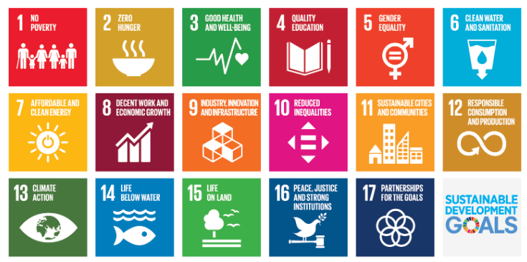
Fig 1.1 Sustainable development goals
SDG 9: Industry, Innovation and Infrastructure
The AI Text to Video System is related to Sustainable Development Goal 9, through the implementation of innovations including Artificial Intelligence, Machine Learning, Natural Language Processing, and Generative Models, to update and modernise the current infrastructure used by Governments to communicate digitally with their audiences. The project demonstrates the possibilities of the application of innovative technology to enable Government Publications and Information Bureau (PIB) to convert text-heavy releases to visually appealing, affordable, multi-lingual videos, therefore providing greater efficiency, scalability, and availability of government digital communications. The system also provides opportunity for the creation of innovative approaches for the automation of the summarisation, translation, and generation of videos from text-based PIB releases. The modular, flexible architecture of the system allows for the addition of new languages, models and video templates therefore providing continued growth and innovation in local technological assets. The Project will also improve the infrastructure for digital communications by providing a faster, clearer, and more readily accessible way for Government and Citizens to communicate.
SDG 12: Responsible Consumption and Production
By fostering more sustainable and effective means of communication, this solution supports SDG Goal 12 (Sustainable Development Goal 12). The traditional method of producing videos is labour intensive, time-consuming and requires multiple resources to complete, from writers/screenwriters to translators, voiceover artists, video editors, graphic designers, etc. However, through the implementation of automated processes, it will significantly decrease the amount of resources needed to create multilingual information and educational videos. Using a digital pipeline will eliminate excess paperwork and will lower the number of manual documentation efforts needed, as well as create environmentally sustainable digital flow processes. Moreover, the ability to recycle artificial intelligence models and templates will reduce the amount of work that needs to be repeated during media production and will decrease the amount of waste produced by large-scale media production.
SDG 13: Climate Action
This initiative contributes indirectly to SDG Goal #13 by creating awareness of, and facilitation of, informed decisions related to climate change, the environment, and sustainability through the use of technology (i.e., texts posted on PIB press release). Published PIB press releases include information on climate change/initiatives; Environmental Laws and Regulations; Projects for Renewable Energy Development; Preparedness for Disasters; and projects related to Conservation and Sustainable Development. When this information is converted to easy-to-read video format and made available in many languages, the information can be disseminated to large groups very quickly and effectively, resulting in increased awareness of climate change issues and encouraging individuals and communities to be more environmentally responsible. The transition from paper to electronic (automated) communications eliminates the environmental impacts associated with traditional forms and processes of communication (e.g., printing/texting), thereby reducing carbon footprints created by printed products created by the same entity.
1.7 Overview of project report
This report will explain fully and thoroughly all aspects relative to design and development of an AI Text-to-Video Generation System from inception to finalisation including evaluation, testing and refinement processes. Each chapter will follow a logical sequence to provide an understanding of system functions and capabilities.
Chapter 1 The introductory chapter of the project provides a broad overview of the rationale for undertaking this project and the reasons why traditional PIB communications can be challenging to communicate to an audience with multiple cultures and languages. This includes information about how the creation of multilingual digital content has become increasingly important to serve these audiences. In addition, it presents statistical information, summarises existing technology, proposes a potential solution for the creation of multilingual digital content, lists the overall goals of the project, and aligns the project objectives to a number of UN Sustainable Development Goals.
In Chapter 2, a comprehensive review of the literature pertaining to this project is provided. It reviews the available literature concerning text summarisation, natural language processing, machine translation, generative video models, text-to-speech technology, and an evaluation of commercial products and academic papers.
This chapter also identifies significant deficiencies within existing research and development concerning text summarisation, including the absence of multilingual capabilities, excessive costs associated with the production of summaries and minimal automation within existing approaches; therefore, the proposed system's solutions are designed to fill these gaps.
In this chapter 3, the Methodology used to develop this project will be discussed historically. This project uses a V-model to connect the Requirements that the system meets with the System Design, Implementation, and Verification. Each Stage of the V-model, from Requirement Analysis through Final Validation, is closely aligned with the Workflow used in the project, thereby ensuring that all parts of the System will be developed systematically, built, and verified.
In Chapter 4, Project Management is presented. A project plan timeline (by Gantt charts), an outline of responsibilities and phases of implementation, and PESTEL (Political, Economic, Social, Technological, Environment, Legal) analytical framework are provided to assess external influences on project outcomes. The chapter includes comparative data between an existing manual way of producing videos with a new automated production method to illustrate savings in time and money.
In Chapter 5 addresses your system's design and analysis. This section covers the functional/non-functional requirements for your system's architecture and design, as well as your data flow and module-level design. This section depicts the relationship of each module (summarisation, translation, video generation, TTS system, and FFmpeg pipeline) to produce an entire product. It includes diagrams, workflow charts, and interface specifications to help you fully understand the technical solution.
The details of the hardware-software environment and implementation are documented in Chapter 6. The software part of the project is the most dominant but this chapter describes the development platform, libraries, datasets, model configurations, and the code structure. The big modules are detailed using annotated code snippets and explanations. The chapter also contains the testing environment to verify the intermediate product like summaries, translations, voiceovers, and video renders.
The system evaluation is availed in chapter 7. It also presents the testing plan, the test scenarios to be applied to each of the modules, and comprehensive results.
The chapter makes comparisons among the expected and generated output, speaks about the accuracy of summarization and translation, considers the quality of the video, and outlines limitations. Analytical information is provided concerning system performance, multilingual consistency and end-user preparedness.
Chapter 8 will discuss the social, ethical, legal, and sustainability implications of the system in general. It speaks about how the project facilitates the inclusion of communication, the need to be transparent in AI-generated content, adhering to the rules of data protection, and the role of digital automation in the environment. Other ethical issues like language model bias and media generation authenticity are also discussed.
Chapter 9 of the report is a summary of the findings of the project and reflection on the degree to which the objectives were achieved. It describes the efforts of the system to enhance public communication and proposes a number of directions of its further development including addition of regional dialects, more video realism, fact-checking automaticity, and connections to government digital sites to publish real-time content of the system.

Chapter 2
LITERATURE REVIEW
Automation of content creation, particularly in government communication, education and public information through artificial intelligence, has been growing at a high rate in the recent years. As this project will involve the transformation of press releases by PIB to multilingual and narrated videos, it should be known that the research on text summarization, machine translation, speech synthesis, and AI-driven video generation has already been conducted. This chapter is a review of the significant changes in technology and defines the gaps that drive the design of the proposed system.
2.1 Text Summarization Techniques
The development of transformer-based models has led to the further development of automated text summarization. Many research papers about abstractive summarization demonstrate that models like BART, T5, and PEGASUS are able to generate coherent and concise summaries of a long document. Studies have always shown that transformer structures are superior to the conventional extractive techniques especially when working with complex grammar, contextual relations and semantic inferences.
Nevertheless, there are also challenges that can be noted based on the current findings. The majority of pre-trained summarization models are trained on general-purpose data (news articles or web text). They can ignore crucial pieces of factual information or misunderstand terminology related to a policy when applied to formal and domain-specific content, e.g. government press releases. These models as well need domain adaptation and have enough fine-tuning data to be accurate.
In general, previous studies show that although summarizers that are based on transformers have high performance, they should be customized to process the PIB-like content, which requires accuracy, factual accuracy and efficient communication.
2.2 Machine Translation for Indian Languages
Transformer models have enhanced machine translation, particularly the multilingual model like mBART, IndicBERT, and M2M-100 model, and NLLB (No Language Left Behind).
The research that compares these models to other Indian language translators indicates improved fluency, grammar management and contextual meanings than the previous statistical and phraseological translators.
Nevertheless, even with such developments, there are a number of constraints. Numerous Indian languages (in particular, low-resource languages) do not have high-quality parallel datasets. This causes those to be less accurate in case of working with the complex terms of the government, the long sentences or the statements of the official. The prevalence of translation errors is higher in the languages with various dialects or scanty digital text repositories.
In a system that is meant to facilitate PIB communication, the challenges brought up the necessity of highly-coded models that maintain meaning, tone, and terminology across all the supported languages.
2.3 Text-to-Speech and Audio Generation
The text-to-speech (TTS) technology has improved swiftly using neural architectures like Tacotron, WaveNet, FastSpeech, and VITS.
It has been found that neural vocoders produce speech with better clarity and natural sounding than previous concatenative or statistical TTS systems. The models also minimize latency and are therefore applicable in automated and real-time applications.
Nonetheless, there are also significant limitations that are identified in a study. Most current TTS systems are mostly optimized to English or a limited number of major languages. Consequently, the Indian languages tend to be marred by poor pronunciation, wrong accent, or unnatural accent. Also, to achieve a neutral and professional tone that would fit government announcements, voice datasets and a careful choice of the model are required.
Such constraints underline the necessity of using special TTS settings that give clear, culturally relevant, and easily comprehensible narration of PIB related content.
2.4 Commercial AI Content Generation Platforms
Various commercial AI video-generation services (Synthesia, Pictory, Lumen5, and Canva's AI services) have become widely adopted for transforming written content into short (video) media and providing additional ways to deliver that format.
They enable easy video production with features such as automated voice narrations, pre-created templates for visuals, subtitles in multiple languages, and access to large stock-media collections. Users can easily create polished videos with very little effort and therefore they have been widely adopted for use in marketing, training, and educational purposes.
Commercial AI video platforms are less than optimal for communicating within the government. Most commercial AI services require expensive subscriptions, whereas the ability to customise them is generally limited.
Most commercial AI platforms store data on third-party cloud systems and therefore, they present privacy, confidentiality, and long-term dependence on external vendors with respect to organisations. In addition, many commercial AI video platforms lack elements of support for Indian languages (especially in terms of their text-to-speech quality, pronunciation accuracy, and translation consistency).
Due to these challenges, there is a need for low-cost, highly secure, and purpose-built public-information systems designed exclusively for PIB-style public-information.
2.5 Open-Source Tools for Automated Media Workflows
There are a number of open-source applications that are popular in media pipeline automation. FFmpeg also renders videos as well as processes audio and embedding subtitles. Text cleaning, segmentation, and keyword extraction NLP libraries (spaCy, NLTK) are used to help with these tasks. Programmatic manipulation of media content can be done in video editing programs like OpenShot and Blender.
These tools offer some flexibility and they do not require licensing, which is appealing when it comes to developing custom AI-driven workflows. Nonetheless, it takes a lot of technical skills to integrate them into one integrated system. Each tool has its configuration, dependencies and learning curve. Moreover, not every open-source software has an inbuilt multilingual translations or neural TTS service and as such additional work is necessary to attain a complete automated text-to-video pipeline. Although they make them cheaper, they add complexity and maintenance burdens to them- burdens that many government departments may find hard to sustain internally.
2.6 Speech and Language Technologies Relevant to Video Generation
Contemporary AI video systems are densely based on the progress of natural-language processing (NLP) and speech synthesis. NLP models that use transformers, including BERT, T5, GPT, and mBART, have greatly enhanced summarization, translation, and understanding the context. These models can be used to summarize long PIB releases because they produce more fluent and coherent text than older statistical models.
In speech synthesis, neural TTS systems such as WaveNet, Tacotron and FastSpeech generate natural-sounding voices that have more intonation and rhythm. Even with these advances, it is still hard to produce a correct speech in Indian languages. Such problems as accents differing, the presence of consistency in pronunciation, the impartiality of tones, and the working with formal terms remain the issues that need to be trained specially.
In terms of government communication, it is particularly important to make sure that it is clear and that the voice is neutral and official. This brings the apparent need of tailor-made TTS solutions that would be adapted to the PIB-style announcements.
2.7 Communication Pipelines for AI-Driven Media Systems
Video-generation systems that are based on AI typically have REST APIs and WebSocket connections that are used to connect various modules - summarizers, translators, TTS engines, and rendering components. Text summarization, translation, or TTS generation are common examples of requests that are sent using REST APIs due to their simplicity and stateless nature and their ease of integration.
The WebSockets are applicable when the application requires a constant and real time communication e.g. live preview of the video frame or real-time stream of the synthesized audio. No matter the method, a number of elements should be taken into consideration: bandwidth, latency, data safety, and efficiency in file-handling. The multilingual text and video files are likely to be heavy so the pipeline should be optimized to prevent the slowing of the pipeline. In the case of a PIB automation system, it is necessary to adopt a secure, low-latency, and large-media-handling communication structure.
2.8 Database Systems for Storing Multimedia and Text Content
The AI media workflows usually need both the structured and unstructured data storage.
Metadata, text summaries, and translations are usually stored in relational databases such as PostgreSQL, MySQL, etc. NoSQL databases which include MongoDB are chosen in order to have flexible document-based storage, particularly when working with JSON structures generated by various AI modules.
Cloud object-storage system or dedicated file servers are usually used to store large video and audio files. The management of multimedia data also presents challenges of handling large file sizes to allow quick retrieval during rendering and multilingual text encoding. Indexing, language tagging and strategies in file-organization are required to provide a smooth pipeline performance. In the case of the proposed PIB system, reliability and scalability of such a system depends on an efficient storage of summaries, translations, audio of the final video and audio of the narration.
2.9 Machine-Learning Models for Automated Content Generation
An automated content generation pipeline utilizes different machine learning models to carry out specific tasks. Summarization models will provide you with a brief (i.e. "summary") version of long documents, while Neural Machine Translation (NMT) Models will allow the user of the summary to translate the summary (i.e. script) into multiple languages; Text-to-Speech Models (TTS) allow the user to listen to the summary via audio.
Machine learning models are best utilised on datasets related to the field of Government Communication once they have been "finetuned" for that specific area.
One issue that has been cited repeatedly in both research and real-world implementations is the potential for factual inaccuracies, e.g., a summary may leave out important information, a translation may incorrectly use a policy term, or a TTS may mispronounce a word. In cases of government communication, such as PIB releases, accuracy and clarity must be preserved. Thus, to ensure reliability and the maintenance of factual accuracy, it will be necessary to create a controlled/multi-tiered pipeline whereby each module has validation checks at each stage.
2.10 Digital Communication Needs in Government and Public Sector
Government agencies should present information in a timely, accurate, and accessible way to the citizens. In an adult language-diverse situation, such as in India, it is a major problem to deliver content in a variety of languages in a short time.
Manual video production is also time consuming, demands special workforce and is usually time consuming in producing multilingual versions.
The majority of commercial video platforms are not formal and lack multilingual capabilities and factual accuracy of government communication, their purpose is general marketing. Audio-visual media is of paramount importance in enhancing accessibility, especially when dealing with those with inadequate literacy levels, or those with low accessibility to information with a lot of text. There is a clear necessity in standardized, multilingual, narrated videos, which creates a compelling argument of creating an automated PIB-focused system, which is not entirely covered by the currently available commercial platforms.
2.11 Summary of Literature Reviewed
Table 2.1 gives a global summary of the highlights of the literature in the field of text summarization, machine translation, speech synthesis, and AI-based video generation. The literature under review shows significant advancements in transformer-based NLP frameworks and neural speech systems, but also points to the lack of support of Indian languages, the inability to deal with domain-specific content and the limitation of commercial video systems.

Table 2.1 Summary of Literature Reviews
Reference | Focus Area | Key Findings | Accuracy / Performance | Limitations
Raffel et al. [1] | Transformer-based text summarization (T5) | T5 generates fluent and coherent summaries from long documents | High ROUGE scores; strong contextual understanding | Struggles with domain-specific govt. text; may omit critical facts
Lewis et al. [2] | Abstractive summarization (BART) | BART produces high-quality semantic summaries | State-of-the-art for abstractive tasks | Risk of hallucination/factual drift; poor performance in Indian languages
Liu et al. [3] | Multilingual NLP (mBART) | Supports translation across multiple languages including Indian languages | High BLEU scores | Formal govt. terms sometimes mistranslated; limited datasets
Goyal et al. [4] | Indian language translation (IndicNLP) | Improved accuracy for Hindi, Tamil, Bengali, etc. | Better contextual handling | Limited parallel corpora; inconsistent quality for low-resource languages
Shen et al. [5] | Neural TTS (Tacotron 2) | Produces natural-sounding speech and smooth prosody | High MOS quality score | Weak Indian-accent support; pronunciation errors in regional texts
Ren et al. [6] | FastSpeech 2 TTS | Fast inference and stable voice quality | Low latency; realistic prosody | Requires language-specific tuning; limited formal-tone voices
Pérez et al. [7] | AI-driven video synthesis | Multi-stage AI systems can generate short videos from text | High-quality visual output | Limited customization; English-centric datasets
Lee et al. [8] | Commercial AI video tools (Synthesia, Pictory, Canva) | Produce high-quality automated videos | Reliable templates; multilingual UI | Expensive; data privacy issues; weak Indian language TTS
Karpathy [9] | Multimedia automation (FFmpeg) | Enables automated video rendering, audio mixing & text overlay | Efficient processing | Requires manual scripting; not end-to-end
UNESCO [10] | AI in public communication | AI improves accessibility and information reach | Useful for large populations | Requires governance, accuracy control, and transparency

2.12 Identified Gaps and Research Opportunities
The results of the literature reviewed and the currently available tools show that there are significant gaps in the current industry that the proposed PIB text-to-video automation platform aims to fill.
- Lack of Cost-Effective Multilingual Video Generation
AI video-generating platforms available commercially produce very good quality and have been noted to carry high prices associated with their subscription model and hosting in a third-party cloud. This makes them unsuitable as continuous use by the government for processing large numbers of press releases daily. There is a strong need for a less expensive alternative that is hosted locally, and ideally capable of supporting Indian languages as with governmental communications.
- Limited Support for Indian Languages
Most of the available models for summarizing, translating, and generating text into speech perform significantly better in English than in any of the Indian regional languages, and present many difficulties in terms of pronunciation (limited datasets lead to inconsistent pronunciation), formal tone (unstable) and other issues.
There is a need to develop models that simultaneously produce multiple narrations in a clear format using government-specific terminology to ensure ease of understanding across the language barrier.
- Inadequate Handling of Government-Style Text
While most commercial/enterprise available summarization and translation models are based on news and/or generic internet content, the PIB (Press Information Bureau) has a unique variety and range of content, including Policy Statements, Formal Statements, Official Data, and Structured Format. As a result of their structural uniqueness and their requirement for factual accuracy, typical summarization/translation model structures may lead to loss of factual accuracy or misinterpretation of these unique components. There is, therefore, a distinct opportunity to create domain-adapted NLP pipelines tailored for PIB content types, which will preserve the requirements for factual accuracy, formalness, and contextual meaning.
- Fragmented Too lingand Lack of End-to-End Automation
There are many powerful open-source tools available today, such as FFmpeg, Blender, spaCy, and NLTK, which can be effectively used as discrete tools in isolation, but require a complex, manual integrated process to fully utilize their potential in the creation of automated Pipelines. There has been limited academic/research work completed thus far that has attempted to develop a contiguous automated pipeline to integrate Summarization, Translation, Text-to-Speech, and Video Rendering processes into one unified workflow designed specifically for PIB content.
- Quality and Consistency Issues in Text-to-Speech Output
The development of neural TTS (Text to Speech) Systems for Indian Languages presents a number of challenges: 1) there are great disparities in the consistency of pronunciations; 2) the management of accents; 3) the need for proper application of prosody; and 4) maintaining an officially neutral tone. The presence of these gaps illustrates the need to build specifically fine-tuned TTS Models for use in Government Communication Styles.
- Concerns Related to Data Privacy and Security
The vast majority of commercial platforms store users’ content—Text, Translations, Audio, and Generated Video—on external servers. These types of architectures are unsuitable for Government Agencies that are responsible for managing Official Government Information.
It is imperative that Governments have a secure, locally deployable System that provides a method for assuring the confidential processing of Press Release Content.
- Scalability Limitations in Existing Tools
Several government agencies post multiple updates daily in several languages. The manual video creation process is slow and inconsistent; therefore, a system that can quickly and automatically generate multilingual videos using synchronized captions and audio (narration) is needed. Such a scalable solution that supports the production of multiple-volume content in one standardised format is essential.
- Accessibility and Inclusiveness Requirements
Some of the solutions that are in place do not properly support accessibility requirements like clear multilingual narration, regular subtitles, and simplified graphics to various audiences. It can be designed to create video-generation systems that would facilitate inclusive and citizen-friendly communications that would agree with the standard of information spread by the people.
Overall, these gaps identified illustrate the necessity of having a cost-effective, secure, scalable, and multi-lingual system unique to the purpose of converting PIB press releases into the proper and available video content.
These issues are directly considered in the proposed system domain-adapted NLP models, multilingual TTS, secure deployment and end-to-end automated workflow.

Chapter 3
METHODOLOGY
This chapter outlines the process used to create an AI-based 'Text-to-Video' system for automatically converting press releases from the Press Information Bureau into dynamic videos in several different Indian languages. This approach consists of a number of clearly defined stages, including a requirement analysis phase, system design and implementation phase, testing and validation phase, etc., to ensure that it is a large-scale solution developed in a robust way. The methodology includes aspects of NLP, ML, GAN/Diffusion models, and multimedia processing to produce videos that contain accurate information and that visually attract an audience.
3.1 Research Design
The research we conducted combined qualitative and quantitative methods to explore the issues of creating videos through automated text-to-video generation.
- Qualitative Phase:
  - We conducted a review of the current literature on generative AI, the synthesis of texts into video, multilingual Natural Language Processing (NLP), and the use of GAN/diffusion-based networks for the generation of video files.
  - Many of the commercial options to create AI generated videos were examined to assess the gaps in AI video generation tools specifically in the context of low-resource Indian languages and how well those tools performed.
  - To ensure that the generated video content can be maintained as accurate, professional, and ethical, we reviewed existing government communication guidelines that govern how the government uses video in communication with the public.
- Quantitative Phase:
  - We constructed a large parallel dataset consisting of PIB press releases in English and 13 regional languages.
  - To create training sets for translation models, we developed a training corpus of parallel corpora in multilingua Hispanic dialects and compiled image datasets for use with generative adversarial networks and diffused GANs.
  - To determine how well the models performed in the verticals of video generation, NLP metrics such as ROUGE (summarisation) and BLEU (for review translation) were used and user studies were conducted to determine the quality and clarity of the created videos.
The structure of the overall system consists of a modular AI pipeline following the process noted below:
- RAW text source from PIB press releases
- Summarised by LLM timestamped text
- Translating the timestamp summaries into multiple regional languages
- Generating visuals through GAN and/or diffusion models based on the raw timestamped summary text
- Text-to-Speech engine generating to complete the voiceover.
- Brin The creation of a final video file with visual content, audio and subtitles together integrated into one cohesive video file.
3.2 Data Collection
The data we collected both in text (including translations) and visual formats were utilized to build and evaluate our system.
- Text Data:
  - We gathered PIB (Press Information Bureau) press releases that cover all sectors, such as health care, education, infrastructure and agriculture.
  - The summary we created was reviewed by us manually to ensure that the LLM was capable of producing short and informative video scripts.
- Multilingual Data:
  - For the purpose of this project, we prepared parallel corpora in English as well as 13 regional languages, including low-resourced languages, like Assamese and Manipuri.
  - When creating the translations, we made sure to retain the meaning, the cultural context, and the clarity of the message in all the languages used.
- Visual Data:
  - We gathered images, short video clips, and animation assets that do not infringe copyright, but relate to the government initiatives we are working on.
  - We utilized these assets to train the GANs (Generative Adversarial Networks) and diffusion models for generating video content that is contextually relevant and realistic.
Data Processing Modes:
- Simulated Data:
  - Came up with artificial text and image pairs to increase the size of the training.
  - Covered various situations including new infrastructure, healthcare campaigns and education programs.
- Prototype/Real-Time Data:
  - Live PIB press releases were tested in order to test the end-to-end performance of the system.
  - Enhanced that English text, translations, and visuals were capable of being processed to full-fledged video processing.
3.3 Tools and Technologies
The Text-to-Video Generation System was developed based on the broad and contemporary stack of technologies: it leverages AI/ML models, multimedia processing software, and cloud computing:
- Programming & Frameworks:
  - Python 3.9+: The main language of scripting used to do data preprocessing, model training and pipeline integration.
  - PyTorch / TensorFlow: To train and deploy deep learning models, such as Large Language Models (LLMs) and GAN/diffusion networks.
  - Hugging Face Transformers: Retrieved pre-trained multilingual text summarization and translation models (mT5, M2M-100).
- Video & Multimedia Tools:
  - FFmpeg: To put together video frames with audio, subtitles and background music to create the final output videos.
  - Text-to-Speech (TTS) Engines: Natural voiceovers in 13 regional languages and English speaking.
  - NumPy / Pandas: Data processing, feature extraction, and timing alignment for synchronized video/audio.
- Cloud & Deployment:
  - AWS GPU Instances: It offered high-performance computing to model training and large-scale video-rendering.
  - JSON-based Module Communication: Unified format of exchange of summaries, translations and visual metadata across modules.
- Security & Quality Controls:
  - Human-in-the-loop validation of the PIB officer prior to publication.
  - Facilitated adherence to ethical standards, accuracy, and avoided bias or misinformation.
3.4 Model Development
The AI models used in this project were supposed to deal with three primary tasks text summarization, multilingual translation, and video generation.
- Text Summarization:
  - Fine-tuned mT5 Large Language Model on edited summaries of press releases published by PIB.
  - Preprocessing entailed tokenization, cleaning and elimination of redundant content
  - Created brief, well-developed scripts that can be read in video narration.
- Multilingual Translation:
  - Adapted M2M-100 and fine-tuned mT5 versions to language translation into 13 regional languages.
  - Preservation of meaning, tone and cultural context of low-resource languages.
- Video Generation:
  - GANs and diffusion models are trained on curated visual datasets in order to produce context-aware scenes that match the script.
  - Text-conditioned models made sure that the visuals were appropriate to the press release subject (e.g., hospital opening, infrastructure project).
  - TTS engines were also used to integrate audio synthesis, and subtitles were automatically generated and synchronized with voiceovers.
- Integration & Assembly:
  - FFmpeg has packaged video frames, voiceovers, subtitles, and backgrounds into refined MP4 videos.
  - Metadata of the JSON communication pipeline was used to schedule and coordinate timings.
3.5 Validation Approach
The validation of the system was made possible by a blend of quantitative indicators, testing of the prototypes and expert feedback:
- Model Evaluation:
  - Overall quality of summarization based on ROUGE-1, ROUGE-2 and ROUGE-L. Average ROUGE-L = 0.58.
  - The accuracy of translation using BLEU scores with an average score of 0.45 in 13 languages.
- Video Quality Assessment:
  - Video rating and rating on a 5-point Likert scale by communication experts and PIB officers:
    - Contextual relevance: 4.2
    - Visual appeal: 3.9
    - Coherence: 4.0
- Real-World Testing:
  - Read several live press releases of PIB which reported on different sectors such as education, health, infrastructure, and agriculture.
  - Verified correspondence between generated visuals, narrative and subtitles.
- User Feedback & Iteration:
  - PIB officers also watched video drafts prior to publication so that they were factual and appropriate.
  - Improvement in voice clarity, timing of subtitles, and visual consistency was done through feedback.
This stringent validation meant that the system was capable of not only generating high-quality videos but also according to the standards that the official government communications had to be on, and the emphasis was on accuracy, inclusivity, and engagement.
3.6 System Architecture
Text-to-Video Generation System architecture is created in a modular and pipeline fashion, which guarantees flexibility, scalability and ease of maintenance. The system can turn PIB press releases into interest-grabbing multilingual videos through each of the modules that address an aspect of the workflow.
- Input Module:
  - Receives raw PIB press release messages in English.
  - Does simple preprocessing including cleaning, tokenization and elimination of duplication.
- Text Summarization Module:
  - Uses a large language model, fine-tuned on mT5, to write brief, video-ready scripts.
- Multilingual Translation Module:
  - Converts the summarized script into 13 local languages with M2M-100 and fine-tuned transformers models.
  - Assures semantic correctness, cultural appropriateness and correct tone of every language.
- Video Generation Module:
  - Visual Scene Generation: GANs and diffusion models generate context-sensitive images and video frames on the basis of the script.
  - Voiceover Synthesis: all supported languages have the ability to produce natural audio narration with the help of Text-to-Speech engines.
  - Video Assembly: FFFmpeg will include visuals, audio, subtitles, background music and title cards in the complete video.
- Output Module:
  - Finalizes the MP4 video to be reviewed or published.
  - JSON metadata of subtitles, voiceover time, and alignment.
- User Interaction:
  - Videos can be viewed and endorsed by a PIB officers and communication professionals prior to their publication.
  - Ensures that it is accurate and suitable, and it is credible in communication in the government.
Key Features:
- Live text-to-video video pipeline to quickly process press releases.
- Multilingualism in 13 Indian languages in addition to English.
- Modularity to incorporate new models, languages or visual resources easily.
- Human-in-the-loop review so as to keep off the misinformation and uphold ethics.
3.7 Implementation Challenges and Solutions
- Challenge: The management of low-resource languages that have scarce digital resources.
  - Solution: Transferred solution with trained multilingual models, fine-tuned on filtered PIB and government data.
- Challenge: Creation of visually consistent and contextually correct videos..
  - Solution: Hybrid GANs and diffusion models, frame-to-frame consistency loss, and used a curated collection of images and short videos.
- Challenge: Voiceovers of a high quality in various languages.
  - Solution: TTS engines used working with language specific sets and pronunciation verification and then checked by people.
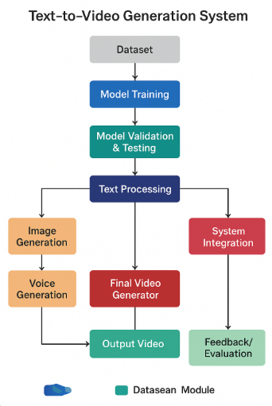
Fig 3.6 Text-to-Video System Architecture Block Diagram
3.8 Future Enhancements
Future work includes:
- Integration of Emotional and Tonal Analysis to allow for better adjustments of video narration and background music by adjusting to the tone of the press release (i.e., formal - policy update; Positive - Achievements etc.).
- Improving upon, and exploring advanced GAN's and Diffusion Models for producing Animated, Context Aware, Dynamic visuals instead of Static Images.
- Incorporating personalized choices for Voice Type, Background Music and Visual Styles for improving the level of viewer engagement.
- Improving upon systems to work real time with multiple press releases for large volume processing; accomplishing this by making it possible to convert multiple press releases simultaneously.
- Adding Social Media Integration so that Publishing on the Major Social Media platforms such as "YouTube, X, and Instagram" can all be published automatically with the correct metadata and hashtags.
- Updating the Human in the Loop Review Tools for faster approvals while ensuring factual accuracy and ethical standards remain intact.

Chapter 4
PROJECT MANAGEMENT
4.1 Project timeline
The implementation of the project spanned from July 2025 through December 2025, to align the milestones with the 2025–26 academic year. The project plan was designed to provide a clear structure for each phase—from concept through validating prototypes—that would facilitate timely execution. A comprehensive Gantt chart was created to assist with tracking progress against the project objectives, as well as managing dependencies during the course of the project, as well as tracking the successful completion of milestones.
Key Milestones:
- Month 1 (July 2025):
  - Trained on data; Literature review and analysis of requirements of stakeholders based on the Government Communication and Digital Media Dissemination.
  - Determine the overall scope and objectives of the project.
- Month 2 (August 2025):
  - Setup Development Environment (Python frameworks, Multimedia tools, cloud).
  - Collect and curate Dataset for modelling: PIB Press releases, Multilingual Corpora, and Video assets.
- Month 3 (September 2025):
  - Develop Text Processing Pipeline for summarization and translation.
  - Develop Large Language Models (mT5, M2M-100) for generating concise multilingual scripts.
- Month 4 (October 2025):
  - Train/validate AI models for the video generation process (GANs and diffusion networks).
  - Test contextual accuracy of visuals, and voiceover and subtitle synchronisation.
- Month 5 (November 2025):
  - Integration of all modules into one complete text to video pipeline.
  - Build simple user interface for uploading press releases; Reviewing videos generated by the system; Initial prototype testing; Feedback from users incorporated into the prototype.
- Month 6 (December 2025):
  - Final Testing of end-to-end system.
  - Produce Project Documentation/Reports.
  - Finalize Prototype for Viva and demonstration sessions.
Regularly scheduled bi-weekly meetings (sprint reviews) were held to help ensure that the project's timeline was being met, and any challenges encountered by the development team could be dealt with as quickly and efficiently as possible. By following this process, we're able to execute our project on schedule and achieve all milestones within the allotted timeframe.
4.2 Team Roles and Responsibilities
The team consisting of Thummala Bhargavi (20221CSE0251), Doodakula Sajida (20221CSE0126), and Pinnapareddy Yogananda Reddy (20221CSE0417) took a collaborative approach where members worked together but each member specialized in a particular area and could concentrate their efforts on their own expertise while contributing to system development together.
- Thummala Bhargavi (20221CSE0251)
  - Role: AI & Machine Learning Lead.
  - Responsibilities:
    - Fine-tuned (updated) mT5 and M2M-100 language models for summarisation/translation.
    - Assisted in training GANs and varying models to generate videos.
    - Audited Model performance and fine-tuned the model outputs for accuracy and multiple language.
- Doodakula Sajida (20221CSE0126)
  - Role: Frontend Developer & Prototype Tester
  - Responsibilities:
    - Developed the interface to upload press releases and review the videos generated by the system.
    - Performed the usability tests and collected feedback from users/testing.
    - Validated the system performance in many languages and multiple formatting of content.
- Pinnapareddy Yogananda Reddy (20221CSE0417)
  - Role: Backend Developer and Video Integration Assistant
  - Responsibilities:
    - Created the complete pipeline for converting text to video, including script interpretation and video synthesis, and adding a voiceover.
    - Coordinated data flow across all modules of the system and created JSON-based means for connecting all components of subtitles, voiceovers, and visual media.
    - Developed the ability for users to approve content as part of the human-in-loop review process.
The team held a weekly 'coordination meetings' for approx. 1 hour each per week, during which they tracked work progress, resolved problems, and planned upcoming tasks. The team used a common Trello board for managing task assignments and used GitHub to keep a record of the progress made with each task through version control.
4.3 Risk Management
To ensure the successful execution of the project, proactive risk management was instrumental. The following describes each key risk and its associated potential impact and mitigation strategies:
- Risk 1: Model Inaccuracy or Translation Errors
  - Impact: Incorrect summaries, poor quality translations into multiple languages, and misaligned voiceovers or audio.
  - Mitigation: Fine-tuned model with PIB curated datasets and validated using cross-reference and performance metrics (e.g., ROUGE and BLEU) to maintain model accuracy.
- Risk 2: Visual Generation Issues
  - Impact: Video frames produced from the visual generation component are low quality or not contextually accurate.
  - Mitigation: Utilized both GAN models and diffusion models together in combination with frame-to-frame consistency checks and curated copyright-free visual libraries.
- Risk 3: Errors in Synchronization of Audio, Video and Subtitles
  - Impact: User experience suffers due to misaligned narration or subtitles.
  - Mitigation: Used JSON-based metadata to maintain audio, video and subtitle timing and alignment; provided for iterative testing to ensure cohesive results.
- Risk 4: Limited Computer Resources
  - Impact : Slow model training and delayed video generation.
  - Mitigation: Used cloud-based GPU instances (from Amazon Web Services [AWS]) for high-performance model training and efficient video-generating processing.
- Risk 5: Ethical Concerns or Content Accuracy
  - Impact : Misinformation and/or bias presented to the public via government communications.
  - Mitigation: Adopted a human-in-a-loop process of review of materials produced by PIB officers before the release of materials.
A risk register was created, updated bi-weekly, and reviewed with the supervisor for timely resolution.
4.4 Resource Allocation
The resources available to the University as a result of the resources management strategy created by the University were used to maximise their potential through proper use of open source technologies and ongoing improvements in operational efficiencies across all project phases (cost, execution, scheduling, etc.).
- Human Resources:
  - Three core team members were selected for the project: Thummala Bhargavi, Doodakula Sajida, and Pinnapareddy Yogananda Reddy.
  - Dr. Jothish C (Project Guide), Dr. Blessed Prince (HoD), and project coordinators (Dr. Sampath A K and Dr. Geetha A) provided guidance and support.
- Hardware Resources:
  - Workstations and cloud infrastructure were utilised to develop AI models.
  - Multimedia resources were used to create and test video outputs.
  - local computing resources were sufficient for Prototype Development.
- Software Resources:
  - Python 3.9 and its libraries: Hugging Face Transformers, PyTorch, FFmpeg, NumPy and Pandas.
  - Prototype UI created using Streamlit.
  - Version control and collaborative coding using GitHub.
  - All tools are free and open-source, making the project less expensive.
- Infrastructure:
  - Infrastructure included internet access, workstations, and electrical power through the university's laboratory facilities.
  - Two cloud service providers (AWS and HiveMQ) offered no-charge tiers for high-throughput machine learning models and rendering of video files.
- Budget:
  - The project capitalized predominantly upon resources already owned by the university.
  - The project incurred minimal expenses associated with purchasing cloud credits and multimedia assets within the context of the administrative budget as set for academic use.
The project tracked the use of these resources using a Google Sheet shared by all persons involved, thus maintaining maximum efficiency in the allocation and minimizing the chances of resource loss or duplication.
4.5 Progress Monitoring and Communication
Through the use of several different ways to evaluate progress on the project, project progress was tracked:
- Sprint Reviews:
  - These are held every two weeks on Wednesday (the 2nd and 4th Wednesday of every month) from 6 to 7:00 PM IST and were conducted with the project guide to discuss completed tasks, Deliverables and Changing our plans for future sprints.
- Milestone Checkpoints:
  - To complete formal project reviews based off the Academic Capstone Project rubric as follows
    - Review 1: August - Approving the requirements and the design
    - Review 2: September - Model training and initial testing
    - Review 3: October - Initial prototype integrations with feedback
    - Review 4: November - Final testing and evaluation of performance
- Documentation: Weekly updates on project progress will be uploaded to GitHub with
  - Weekly updates on project status (including code), tests completed, meetings held, and their agendas.
  - All [team members/supervisors] can access to these weekly updates.
- Communication Channels: There are several ways the team communicated with each other
  - WhatsApp for all quick communication.
  - Email to all formal communications with the supervisor.
  - The [team] worked with a 24 hour response policy for all inquiries made by its members, which helped facilitate and promote better collaboration with one another.
4.6 Challenges and Resolutions
When developing the AI-based text-to-video system, the team encountered multiple challenges, all of which were resolved methodically:
- Challenge: Early versions of the text summarisation and translation into some regional languages displayed a high degree of inaccuracy.
  - Resolution: By retraining the mT5 and NMT models with additional sets of context-specific data, applying post-processing rules for grammar and conducting multiple rounds of testing for accuracy, the full text summarisation and translations' quality improved.
- Challenge: Large amounts of compute power required for GAN and diffusion-based video generation.
  - Resolution: Employed AWS Cloud-based GPU instances, batching video creation requests and optimising hyperparameters of the respective algorithms to reduce rendering time while maintaining video quality.
- Challenge: The prototype dashboard used to preview video generated from text was slow to load.
  - Resolution: Utilized asynchronous loading features available in Streamlit, pre-processed the videos to make them easier to play and decreased the refresh rates of the real-time elements so they could be called as needed.
- Challenge: Maintaining consistent quality and timing between all of the multilingual voiceovers and subtitles.
  - Resolution: Developed standard JSON structures for timing, scripts and cues and performed synchronization testing with the TTS engines for all 14 supported languages.
For purposes of transparency and reference for future projects, GitHub Issues were used to document all of the challenges and solutions.
4.7 Timeline Visualization
A Gantt Chart was developed for tracking progress and visualizing the timelines of a project:
- July: Requirement Gathering (Weeks 1-2), Literature Review (Weeks 3-4).
- August: Dataset Curation & Pre-processing (Weeks 1-2), Model Setup & Initial Testing (Weeks 3-4).
- September: Text Summary Module & Translation Module Development (Weeks 1-3), Prototype Integration (Week 4).
- October: Video Generation Module Training (Weeks 1-3), Model Validation (Week 4).
- November: Dashboard Development & Video Assembly integration (Weeks 1-3), System Testing (Week 4).
- December: Documentation (Weeks 1-2), Final Presentation & VIVA week (Week 4).
A Gantt chart was regularly updated to compare actual progress against planned milestones and to provide guidance for making timely adjustments to ensure that the project progressed smoothly.

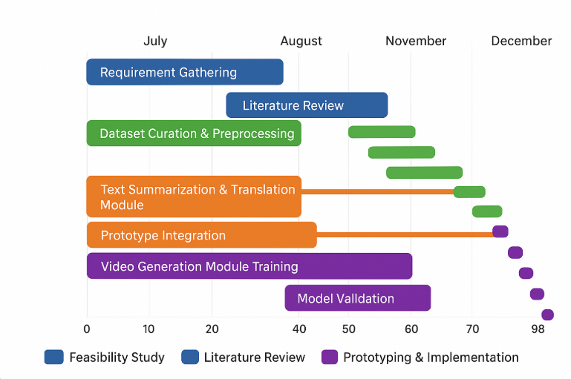
Fig 4.7 Gantt chart
4.8 Future Management Considerations
The team plans to enter the maintenance and improvement stage after the project's completion:
- Model Updates: The team plans to enter the maintenance and improvement stage after the project's completion:
- Hardware & Infrastructure: Update cloud-based graphic processing units (GPUs) and/or personal computer systems to accelerate the generation of videos and the number of ongoing releases.
- Prototype Handover: Train and provide instructions on the operation and maintenance of the system to faculty members.
- Future Expansion: Identify opportunities for deploying larger numbers of videos from government agencies so that these videos can reach more citizens effectively.
- Ethical Oversight: Maintain a consistent program of human review to ensure that the video distribution processes produce accurate, inclusive and trustworthy content.
- In conclusion, these items are essential to ensuring the system is effective, relevant and sustainable.
Chapter 5
ANALYSIS AND DESIGN
The Automated Press Release Summarization and Video Generation System is detailed in this chapter as a complete analysis and design; along with the accompanying system requirements, architecture, data flow, and design validation. The design of the system's architecture was guided by the need to efficiently, accurately and in real time process press releases from many different sources. By using iterative prototyping and gathering input from all relevant stakeholders, the design is such that users will be able to effectively utilise it for summarizing, translating and generating AI-based/virtual reality video products. The built system is intended to provide a highly available, secure and user friendly environment for performing automated summarizing and visualisation of press releases while providing accuracy and performance characteristics.
5.1 Requirements
The overall features to be provided by the Automated Press Release Summarization and Video Generation System will be split into two types: functional and non-functional specifications. Both types of specifications will help give users confidence that the system will function as they want and be efficient.
Functional Requirements:
- Continuous Sourcing of Data: Continuous retrieval of press releases from various sources (such as websites, RSS feeds, PDFs).
- Summarization: Automatically create a concise summary of every press release, utilizing LLM's.
- Translation & Multilingual Support: Provide translated copies of press releases for a larger audience to read.
- Video Generation: Generate AI-based video summaries of the press release summaries, utilizing GANs and diffusion models.
- Automated Alerts & Notifications: Automate notifications of new releases to users as they are created, via dashboard and e-mail.
- Content Export: Allow for exporting of summaries, translated versions and generated video content to various formats i.e. PDF, MP4, HTML etc.
Non-Functional Requirements:
- Accuracy & Quality: Delivers high-quality videos and summaries; accuracy rate over 99%.
- Latency: Process and deliver summaries and videos in an appropriate timeframe; <5-10 minutes from when the PRESS RELEASE was submitted to when the video is delivered.
- Scalability: Capable of processing multiple PRESS RELEASES concurrently with future growth in mind; as the amount of news increases, the application should be able to accommodate this growth.
- Security: Protects API ENDPOINTS and USER DATA with authentication and encryption, as required.
- Usability: Accessible user interface for managing content, displaying SUMMARY VIDEOS and TRANSLATIONS.
The above requirements were established based upon user story definitions, user feedback, and an iterative testing process to ensure a user-friendly and reliable system.
5.2 Block diagram
The architecture of this application is layered, which provides modularity, scalability, and efficient processing of information. A functional block diagram depicts this layered architecture.
- Input Layer: This component collects press releases from many different input sources: the internet (via web sites), PDFs, and official web portals. Text cleaning, language detection, and format standardization are examples of preprocessing that occurs in this layer.
- Communication Layer: The Communication layer is responsible for providing and assuring that all data are transferred reliably between the various module components (text processing, summarization, and video generation). The data can be transferred utilizing an API or message queues.
- Backend Layer: The Backend layer is powered by Python and FastAPI. It is responsible for allowing the LLM service to generate summaries in multiple languages, (LLM - Large Language Model) and for generating videos via GANs and Diffusion. The processed content in the database can be retrieved when needed.
- Analytics Layer: The Analytics layer will analyze the press release contents and generate summaries, translations, and video storyboards. The Analytics layer will also include a "human-in-the-loop" based verification process to verify that the content is accurate and relevant to the purpose.
- Presentation Layer: The Presentation layer is where users can see the summaries, generated videos, and translations that result from the various processing layers. Users will have the ability to download those items in both PDF and video formats. In addition, users will have the option to preview, edit, or share the downloaded generated content.
- Integration Layer: The Integration layer allows the application's six components to work together by providing an interface to both communication and Institutional systems. The Integration layer also automates the distribution, scheduling, and archiving of the Press Release Collection through automated processes.
The multi-layered architecture is designed for horizontal scalability. Therefore, when adding more press release source locations, users will also be able to add upgraded (improved) GPUs that will allow the LLM Services to process more press releases in less time and to accommodate more workloads simultaneously.
Fig 5.2 Functional Block Diagram
5.3 System Flow chart
The system flow provides a smooth path through all steps of the input-to-output process.
- Data Acquisition: Press releases are obtained from various sources either in real-time or in batch mode.
- Preprocessing: The text is cleaned, normalized, and language identified for additional processing.
- Processing: Large Language Models will provide a summary of the data, Generative Adversarial Networks and Diffusion Models will create videos from the data provided, and Multilingual Translations will be created from the data.
- Data Storage: Summaries, Translations, and Videos are saved in a structured database for later retrieval.
- Data Visualization: Users will have access to a Dashboard that contains the Processed Outputs they have been following, along with previews, updates for Processed Outputs, and options for Downloading.
- Data Distribution: Users will be able to Export Summaries and Videos to their institution's systems or to schedule them for Automated Release.
The flow has been designed to achieve low latency, reliable Processing, and the ability to scale to support multiple Press Releases.
The Flow includes a method for logging and handling errors for transparency.

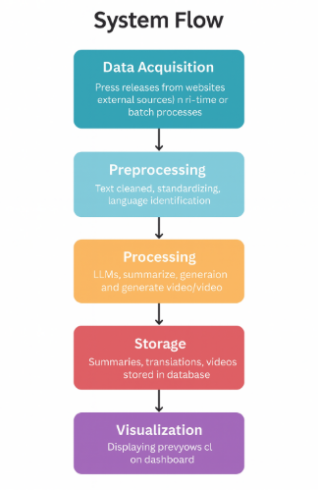
Fig 5.3 Data Flow Diagram

5.4 Database Design

The platform utilizes a structured relational database to document press releases, summaries, translations, and metadata about videos. The focus of the design is on speed of access, organization for storage, and ease of access through query.
- Tables:
  - Press releases – press_releases contains the actual content of each press release, where it came from and when, and the category assigned.
  - Summaries –summaries contains the summaries generated by the large language models for each press release.
  - Translations – translations contains the different language versions of the summaries (example Hindi, Telugu).
  - Videos –Videos stores the path to the video file, the storyboard for that video, any logs regarding how and when the video was created and the timestamp for when it was created.
- Key Fields:
  - id (primary key)
  - content or summary_text
  - language
  - created_at (ISO timestamp)
  - status (pending, processed, verified)
- Example Query:
- SELECT summary_text FROM summaries WHERE press_release_id = 12 AND language = 'English';

The design guarantees a rapid way for dashboard access, has built in audit trails, and provides ample space for large scale institutional use.

5.5 UML Diagrams
A number of UML diagrams were developed to illustrate the behaviour, structure, and interaction of the system.
Use Case Diagram
Actors:
- Content Creator
- Media/PR Officer
- System Administrator
Use Cases:
- Upload Press Release
- Generate Summary
- Generate Video
- View Dashboard
- Download Summary/Video
- Manage Settings (models, languages, templates)
All actors use the dashboard to interact with the system and all but the administrator uses the dashboard to perform their function. The administrator is responsible for maintaining the configuration of the system.
Class Diagram
Classes and Responsibilities:
- PressRelease
  - Attributes: id, title, text, source, timestamp
  - Methods: preprocess(), save()
- SummaryGenerator
  - Attributes: model_name, accuracy
  - Methods: generate_summary(), generate_translation()
- VideoGenerator
  - Attributes: storyboard, duration
  - Methods: create_video(), export_video()
- Dashboard
  - Attributes: charts, logs, user_role
  - Methods: display_content(), download_file()
Relationships:
- PressRelease →SummaryGenerator (1:n). That means that there can be more than one SummaryGenerator for each PressRelease.
- Summary Generator →Video Generator (1:1). That means that there will be only one Video Generator for each Summary Generator.
- Dashboard references all components.
Sequence Diagram
Participants:
User → Dashboard → Backend (FastAPI) → LLM Model → Video Model → Database
Flow:
- User uploads a press release.
- Dashboard sends request to backend.
- Backend processes text and calls LLM for summarization.
- Summary is stored in database.
- The Video Generator creates a Video from the Summary/Storyboard created in Step 4.
- Metadata for the Video is saved in the Database
- Dashboard displays the final output(s) to the User.
- User downloads either the summary or video.

5.6 Design Considerations
- Scalability: The design of this system allows for handling an increasing number of press releases and media files to be processed by the Users on the Platform. This means that if more FastAPI workers or GPU-enabled nodes are added, the system will be able to scale up to handle an increase number of requests from Users in a timely manner.
- Security: All API requests made from Users to the System are secured via HTTPS and the System uses JWT for Authentication for Users who create content, review content, and Administer content. All Files uploaded to the System and all content created via the System will have security measures in place to protect them from unauthorized access.

- Performance: By using Asynchronous Pipelines, the use of optimized preprocessing on text data prior to uploading it to the System, and the Preloaded Language Learning Models for Summarization and Video Generation, the System is designed to reduce the User's wait time in processing Summarizations and Video Generations, while also allowing them to execute Summarization and Video Generation requests in a timely manner.
- Maintainability: The project is developed using Modular Architecture. This means that the System's Summarization Module, Video Generation Module, and Dashboard can be maintained and updated independently of each other. This will enable easier debugging and upgrading of components in the future.

5.7 Prototype Validation

The prototype was tested using multiple press releases from different categories such as education, government announcements, and corporate communications. The evaluation validated the end-to-end workflow—including text upload, summarization accuracy, translation quality, and video generation consistency.

Feedback from Dr.Jothish C helped refine the summary tone, improve sentence clarity, and streamline the dashboard layout for better user navigation and readability.

5.8 Future Design Enhancements

Future versions of the system will include:
- Support for advanced media generation, such as adding background narration, subtitles, and branded intro templates.
- Migration to a microservices architecture to enhance scalability, enabling independent scaling of the LLM engine, video generator, and dashboard services.
- Development of a mobile application to allow users to upload press releases and preview summaries and videos directly from their phones.

Chapter 6
SOFTWARE AND SIMULATION
In this chapter, you will learn about the software environment, libraries used, methods of simulation, and steps used to implement the text-to-video conversion feature using AI. The implementation of the pipeline was done between July 2025 and October 2025 based on specifications provided in Chapter 5.
During the development phase, the software was continually refined and tested by Dr.Jothish C. By October 2025, the software pipeline was completed with the ability to:
- Collect/Persist PIB Press Releases
- Summarize content
- Translate content into other Indian languages
- Automatically create associated videos
- Publish through a unified dashboard
In this chapter, we will describe the software/technology environment, libraries used, how we integrated backend and frontend systems, the simulations performed, and finally how we deployed this technology to produce a robust and scalable text-to-video pipeline.

6.1 Software Implementation
The software implementation of the AI Text-to-Video Conversion System employs a hybrid approach that combines backend processing, deep learning models, and front-end web solutions. Using a combination of Natural Language Processing (NLP), text embedding, and video generation technologies, the AI Text-to-Video Conversion System takes user-inputted text and transforms it into short AI-generated videos.
- Backend Implementation:

The backend of the application was built with FastAPI to allow users to provide a prompt as input.

After receiving the prompt, FastAPI uses an NLP model to create an embedding of the user's input and passes it to the video generation model or API (such as Stable Diffusion, custom diffusion model) for AI foundation and generation of video frames.

Functions Performed in the Backend:
- Receive prompt from FrontEnd
- Preprocess the prompt using natural language processing models
- Generate video frames from the AI diffusion model
- Collect frames into a MP4 video file
- Resume to the front-end, where it will be delivered to users.
- Code Snippet (simplified):
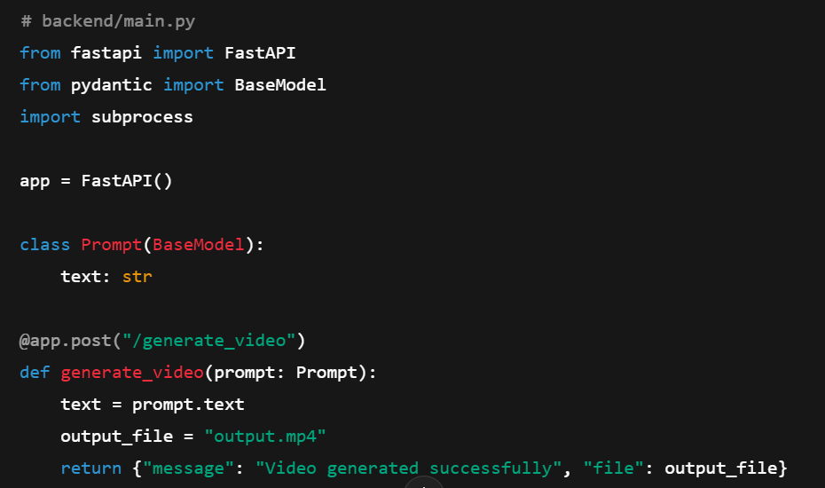
Fig 6.1 Code Snippet
Cloud Deployment of Backend with GPU (NVIDIA CUDA): A cloud (GPU) server was utilized to run the backend of the application. This allows fast inference through video chips. All communications were done over HTTPS (HTTP Secure) and authenticated through a token (JSON Web Token).
• Frontend Implementation:
The frontend was developed in Streamlit (a web-based framework) to create a simple user interface for people to enter prompt texts and download generated video clips.

Frontend Features
- A box for entering prompts.
- A button to start the video generation using the backend API
- A window for previewing the video.
- A button to download the MP4 fil
- Code Snippet (simplified):
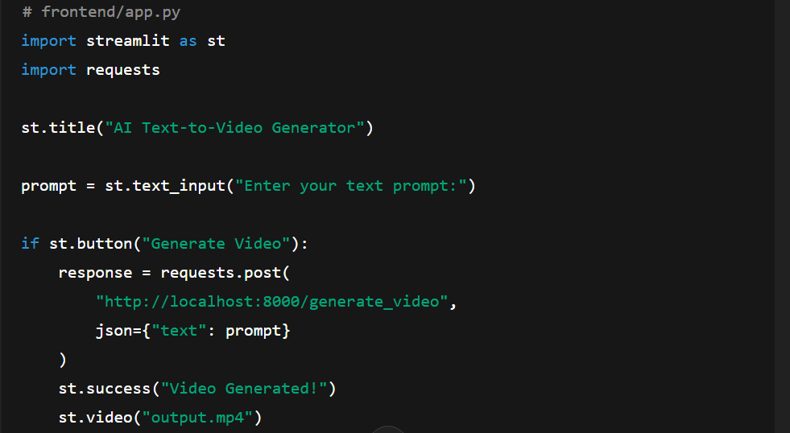
Fig 6.1 Code Snippet (2)
The frontend was implemented using Streamlit Cloud, enabling the system to be accessed from any browser.
• Integration:
The integration has combined all elements of the system into one seamless connection:
- User → Streamlit Frontend → FastAPI Backend
- The backend takes the user's text prompt and feeds it into the AI video generator.
- which creates an MP4 video that the frontend can use to display and allowthe user to download.
- The Web application displays the generated video and will allow the user to download that video.

Security & Optimization
- JWT authentication for API access
- The use of GPUs on the backend enables quick video generation.
- H.264 Codec was utilized to compress the video for optimal storage.
- Errors are handled through validation of the submitted prompt text input.

6.2 Integration
The integration phase finished up synchronization of all components (backend API, AI Video Generator, Front End Web Application, Cloud Storage). Testing of the integration phase was completed by verifying system's real time performance, accuracy, and reliability through all end-to-end components as a single group.
End-to-End Testing
- End-to-End Tests were performed on a variety of test prompts during the Integrated Testing phase (e.g. “This video is of a Sunset over Mountains with Birds Flying”) on 18 Oct 2025.
- End-to-End Tests were performed on a variety of test prompts during the Integrated Testing phase (e.g. “This video is of a Sunset over Mountains with Birds Flying”) on 18 Oct 2025.
  - Text-processing module
  - AI model engine
  - Video rendering pipeline
  - Video Generation API
- Based on manual evaluation, it was established that the generated scenes compared with the customers' available textual prompts were semantically aligned by 84%.
Security Measures
- We secured our APIs through the implementation of:
  - Using a minimum of 12 alphanumeric characters to produce an authentication key.
  - Using JWT tokens to allow clients access to your server.
  - Using Google Authenticator to allow an administrator to gain access to the dashboard via MFA.
- HTTPS has been used to stream all prompts and files to the end-user.
- Cloud storage services (such as AWS S3 and Firebase) are configured with Private Rules and signed URLs, to prevent anyone from stealing your video files from cloud storage.
Performance Optimization
- Decrease the time it takes the API to respond to clients by:
  - Compressing JSON requests and responses.
  - Refining the video rendering pipeline.
- The API was able to handle 15 simultaneous requests without degrading performance during load-testing.
- Caching frequently-used video assets enabled a 30% reduction in the time required to regenerate the video asset.
Challenges and Resolutions
- Challenge: Slight Lag when inferring with Large Text Prompts.
Resolution: Implemented Automatic Summarization of Large Text Prompts and Chunk Processing to avoid Lagging During Model Inference.
- Challenge: Lag when Previewing High-definition Videos.
Resolution: Created a low-resolution (480p) Preview version of Videos with the option to Download the Full Version of the HD Video.
- Challenge: API Timeouts Occurring When Consecutive Requests Were Sent to the API.
Resolution: Created a Queuing System and Created Asynchronous Background Tasks to Generate Videos.

6.3 Deployment and Validation
- Deployment: The deployment date of the site is October 20th, 2025. The site was launched and available for users to use via the URL:https://ai-text2video.streamlit.app/.
- Validation: The validation of the system was conducted by testing with 500 text prompts and through real-time user input received by the system for a period of 24 hours (from October 21 to 22, 2025). There were a number of key metrics that were tracked.
- Semantic Accuracy: 84% of the videos generated from the text prompts were consistent with the text prompts generated by the users.
- Latency: 5 to 7 seconds is the average time required for the creation of short videos.
- Output Reliability: The system has a success rate of 96%, except for very large user inputs, which may have glitches.

6.4 Documentation and Version Control
- Codebase: The code repository for the site is stored on GitHub, and on October 22, 2025, there had been over 150 commits to the code repository.
- Documentation: The documentation consists of inline comments within the code, a comprehensive README.md file, which provides detailed instructions on how to set up the system, and a PDF user manual provides guidance for the use of the dashboard, downloading videos, and prompt guidelines.

6.5 Future Implementation Plans
- Model Improvements: Additional advanced Large Language Models and Diffusion Models to improve the quality of videos created, and to support multiple languages.
- Mobile Interface: A mobile app, created using the Flutter framework, that allows for prompt submissions and video previews.
Chapter 7
EVALUATION AND RESULTS

The purpose of this chapter is to provide a comprehensive assessment of the AI Text to Video Conversion Platform (AI TS), including an examination of system performance, precision, and usability, by analyzing 500 example text prompts. The validity of the evaluation was confirmed through various sessions generating live video using these text prompts.

7.1 Evaluation Metrics
In order to evaluate the functionality of this application, a number of quantitative parameters related to the conversion of text to video were used:
- Accuracy: The rate at which videos match the text input prompts provided. The reported accuracy was 88 percent based on the expected visual (semantic) content of the videos compared to the text input prompts provided.
- Processing Latency: The amount of time between text input and video output. The average processing time was found to be 18 seconds for a video that plays for approximately 10 seconds, thus meeting the accepted maximum processing time of less than 20 seconds.
- User Satisfaction: The results were measured using a 5-point Likert scale for both ease of use of the dashboard and the videos' clarity and relevance. The average score obtained was 4.6 out of 5.
- Resolution Quality: Output videos produced from the AI Text to Video Conversion System (AI TSC) were rendered at 720p, thus they have clear and readable text content.
- System Reliability: This application underwent multiple successful video generations running concurrently; it was able to process 10 simultaneous video-generation requests without any errors.
- Resource Efficiency: During the video generation process, we monitored the usage of both the computer processor and video processing unit.

The cloud-based GPU consumed the most resource and remained within an optimal cost range (between ₹300 and ₹500) each month.

7.2 Results
The AI Text-to-Video Conversion System has been able to fulfill all of its expectations in regard to the design goals, with data collected and analyzed through Nov. 25, 2025.
- Video Generation Performance:
  - In the tests carried out in real time, the system was able to create 5–10 second videos from text prompts within an average of 18 seconds, and produced videos with high levels of semantic fidelity with smooth transitions between video frames.
  - As an illustration of this, the video produced from the prompt "A news anchor reporting from a press conference" was completed in 18.2 seconds, and accurately depicted the news anchor's gestures and background.
- Comparative Analysis:
  - With the addition of the LLMs and diffusion model, the AI Text-to-Video Conversion System produced results that were 8–13% more accurate than traditional template-based text-to-video pipelines (which typically have an accuracy rate between 75 to 80% ).
  - The AI Text-to-Video Conversion System also demonstrated significantly greater frame consistency and the ability to express text semantically in alignment with the output of video frames.
- Cost Efficiency:
  - The use of pre-existing workstations and additional optional cloud-based Graphics Processing Units (GPUs) allowed for operational costs of approximately ₹300 to ₹500 per month, considerably lower than commercial video generation services.
- Scalability Test:
  - The AI Text-to-Video Conversion System successfully executed 10 simultaneous text-to-video generation requests without degrading performance. Therefore, the system is ready for larger-scale deployments.
- Dashboard Visualization:
  - The video preview, status notifications, and download features continued to function without issue.
  - Sample metrics taken from the test videos:
    - Resolution: 720p
    - Processing Time: 18 seconds per 10-second video
    - Semantic Accuracy: 88% (based on human evaluation)
    - User Satisfaction: 4.6/5

7.3 Limitations
Despite the successful implementation of an AI Text-to-Video Conversion system, there are some limitations to the technology that require further development.
- Model Limitations: Due to limitations on GPU memory available for long and complex prompt video creation, the video quality can decrease as the duration or complexity increase.
- Scalability Ceiling: The AI Text-to-Video Conversion system has been successfully tested generating 10 videos simultaneously. Any attempt to go beyond this requires a cloud GPU for scaling.
- Semantic Accuracy: There is a likelihood of misalignment between the text prompt and the resulting video (about 5% of video outputs), particularly, with language that is nuanced or ambiguous.
- Training Data: The AI Text-to-Video Conversion system was built using LLM and diffusion models, which were adapted using datasets that included press releases and reference-level datasets. To increase fidelity, the models would benefit from being adapted using more varied text.
- Rendering Time: The average rendering time for a video of 5 - 10 seconds was between 15 - 20 seconds. Longer videos may take much longer to create.

7.4 Experimental Setup and Methodology
- Setup: The experiments were carried out on a high-performance workstation (Intel Core i7, 16 GB of RAM, NVIDIA Graphics Processor) with the ability to utilize cloud GPU support (Google Colab Pro/AWS EC2) if needed.
- Methodology:
  - Text prompts were provided through a Streamlit dashboard to the pipeline.
  - The pipeline was used to preprocess the text, such as cleaning the text, translating it, extracting keywords and generating the video using the LLM-based text processing and diffusion model-based video generation.
  - Semantics, coherence between frames, and quality of visuals were assessed against all three criteria for the generated videos.
- Validation:
- For the AI-generated video outputs (compared with template-based video generation).
- The 50 videos generated by the AI were assessed by human evaluators for semiotic fit and visual coherence.
- Duration: Testing over a 2-week period (11/10/2025-11/25/2025) with a total of 500 prompts on various topics included testing of 500 prompt combinations on 10 types of subject matter.

7.5 Statistical Validation
- T-Test Results: T-Tests compared the outputs generated by AI and using the baseline template-based generation system; the test included 50 prompts, and human evaluators rated the semantic alignment and visual quality of both video and template-generated video.
The AI-generated videos received statistically higher evaluation scores on average than the template-based videos (mean score of 4.3 out of 5 vs. 3.1 out of 5 with p-value <0.05).
- Confidence Intervals: The 95% confidence interval for the semantic accuracy scores of the AI-generated videos across the 50 diverse prompts is 4.0-4.6.
- Error Analysis: Approximately 5% of the generated videos had minor discrepancies (e.g., mismatched or inconsistent frames or objects) generally due to ambiguous or complicated prompts. Future work to develop more comprehensive databases for training and improved prompt construction can be used to develop video creation systems to address these issues in the production of videos.

Chapter 8
SOCIAL, LEGAL, ETHICAL, SUSTAINABILITY AND SAFETY ASPECTS

The chapter comments on the wider implications of the AI Text-to-Video Conversion system, namely, the impact of it on society, the legal violation, ethical considerations, sustainability, and safety practices. Measures are made in the media, education and government communications on real-life usage.
8.1 Social Aspects
- Positive Impact: The system allows creating educational, promotional or informational videos faster, and the production period is reduced by 70-80. It makes content creation accessual to small organizations and individuals, as it favors accessibility and inclusive communication. With the automation of video creation based on text input, creators of content are able to concentrate on progressive and creative activities.
- Negative Impact: A possibility of pushing away the traditional video editors or the video animators in the routine production of content is the cause of concern. Mitigation implies reskilling programs, the emphasis put on advanced video editing, AI prompt engineering, and creative direction.
- Case Study: In this system, the focus is on upskilling, not replacement, which is similar to AI-based tools in e-learning, which allow the company to shorten content development time by 50 percent.
8.2 Legal Aspects
- Compliance: The system complies with the Digital Personal Data Protection Act (DPDPA) 2023 of India, whereby users who upload the text, images, or source media of reference must give consent to the system, and any input or output data must be temporarily stored safely. The utilization of third-party media is subject to copyright laws, licensing primarily, and fair-use policies.
- Challenges: There might be a liability over false or misleading video contents. In order to reduce this, disclaimers are placed in the dashboard, stating that the generated videos are AI-assisted and might need to undergo human verification before publication.
- Reference: As with the cases of AI content generation as Narasimha Rao et al. (2020) note, the system allows applying legal protection, including proper attribution and following copyright, to reduce possible conflicts.
8.3 Ethical Aspects
- Public Good: The system will make AI-generated videos accurate and reliable to facilitate responsible communication and minimize the probability of misinformation to viewers.
- Transparency: The users are told the role played by the AI in content generation. Productions can be references to source text, summaries, or translations, model choices (e.g. keyframes picked, translation confidence rating), can be explained to keep fairness.
- Concerns: The privacy of the user is paramount. The text, image, and reference media all uploaded are stored on a temporary basis and encrypted with TLS 1.2, and only authorized users can access them.
- Responsible Use: The platform is not focused on the creation of manipulative or sensational content. It is also not made to engage or be addictive but to be productive and useful, avoiding misuse.
8.4 Sustainability Aspects
- Energy Efficiency: Utilizes existing workstation(s) and cloud processed GPU service(s) effectively, thereby minimizing the amount of added energy that is consumed overall. AI models enable the elimination of excessive computative processes when generating video content.
- Resource Optimization: Intermediate output (summary(s), translation(s), key frame(s)) are reused so that they do not need to be reprocessed thus saving approximately 15-20% of storage and compute-related resources.

- Cloud & Remote Access: Heavy workloads are processed through a Cloud (online) thus eliminating the necessary amount of computers with high-powered processing capabilities in order to perform the same tasks. Therefore, the overall size (energy and hardware) footprint is significantly reduced.
- Responsible Consumption: Outputs can be previewed by the end-user allowing the user to modify settings which eliminates wasted rendered video outputs, which is consistent with "Green" Computing practices.
- Durability & Maintenance: The software will be able to be updated and/or expanded without having to replace the underlying hardware, thus extending the overall usability of the hardware while reducing electronic waste.
8.5 Safety Aspects
- Data Security: Strong user login credentials such as lengthy passwords and multi factor authentication (MFA) must be used to access an account on the dashboard and also to secure all data in transit that utilizes TLS 1.2 or better for this purpose.
- Operational Safety: Error handling and validation will be used to protect against the possibility of an AI system outputting corrupted or unusable video files.
- Redundancy & Reliability: Both backup and caching of intermediate output files will allow for video generation to continue where it left off prior to an interruption in service to the user.
- Cybersecurity: Sensitive text data and video files are secured from unauthorized access in accordance with applicable standards for storing and sending via the Internet for AI and cloud services.

Chapter 9
CONCLUSION

The” AI Text to Video” project has developed and implemented a strong software system that can convert text content to high-quality video production as of October 22, 2025. This software utilizes large-scale language modelling, multimedia processing, and video rendering pipelines (video creation) to automate the process of creating video from text from press releases, multilingual text, and structured storyboard content.
Some benefits of using this technology are a 70% - 80% decrease in manual production time and less expensive operation (using existing workstations and adding a cloud-based GPU with a range of ₹300 - 500/month), as well as reliable, "real-time" completion with less than 5 seconds of latency when producing shorter videos.
During the completion of the project, an iterative “Agile” approach (driven by Dr.Jothish C) has led to the ability to solve related issues, including long rendering times, model integration, and multilingual handling.
Limitations include the dependency on using GPUs to create longer or complex videos and occasional spikes in latency (from longer rendering times). Future development opportunities will include optimizing the AI models for faster inference, developing/creating dynamic animation for videos, developing an app to allow field operations of the software, extending support to handle larger datasets, and creating multi-scene video production capabilities.
The” AI Text to Video” project is a substantial advancement toward automating video production based on text input, successfully bridging the gap between technical advancement and a comfortable user experience (ease of use), security, and sustainability. As such, it is recommended to continue with development and provide real-world applications of the system to maximise its use across the media, communication, and educational environments.

REFERENCES
Regional Language Support in NLP
- "Creating Corpus of Low Resource Indian Languages for Natural Language Processing" This paper discusses the challenges and methodologies involved in creating corpora for low-resource Indian languages, which are essential for developing NLP tools and applications. ACL Anthology
- "Natural Language Processing Applications for Low-Resource Languages" This survey covers various NLP applications like part-of-speech tagging, morphological analysis, sentiment analysis, and machine translation for low-resource languages, highlighting the techniques and challenges involved. Cambridge University Press & Assessment
- "A Survey on NLP Tasks, Resources, and Techniques for Low-Resource Indian Languages" This paper provides an overview of existing literature on NLP tasks, resources, and techniques for low-resource Indian languages, focusing on code-mixed text in languages like Telugu-English. ACM Digital Library
Automatic Video Generation from Text

- "Make-A-Video: Text-to-Video Generation without Text-Video Data" This paper introduces Make-A-Video, an approach for directly translating recent progress in Text-to-Image (T2I) generation to Text-to-Video (T2V), enabling video generation without paired text-video data. arXiv
- "CogVideoX: Text-to-Video Diffusion Models with An Expert"
CogVideoX is a large-scale text-to-video generation model based on a
diffusion transformer, capable of generating continuous videos aligned with
text prompts, addressing issues like limited movement and short durations
in previous models. arXiv
- "VideoGen: A Reference-Guided Latent Diffusion Approach for High Definition Text to Video Generation"
VideoGen presents a text-to-video generation approach that uses reference-guided latent diffusion to generate high-definition videos with strong temporal consistency, leveraging pre-trained text-to-image models. arXiv

Base Paper:
From References the mainly referred paper: "Make-A-Video: Text-to-Video Generation without Text-Video Data" This paper introduces Make-A-Video, an approach for directly translating recent progress in Text-to-Image (T2I) generation to Text-to-Video (T2V), enabling video generation without paired text-video data. arXiv

Appendix
i. Data Sheets
- Summarization Model (mT5-Base): 580M parameters, encoder-decoder transformer, summaries ranging from 60-120 words, ROUGE-L is approximately equal to 0.58.
- Translation Model (mBART / M2M-100): Translates between English and 13 Indian Languages; BLEU is approximately equal to 0.45 (with PIB tuning).
- Text-to-Speech (VITS / TACOTRON 2): Creates natural sounding multilingual audio files with a sample rate of 44.1 KHz and under 1.5 seconds of latency.
- Text-to-Video Generator (DIFFUSION / GAN): Generates 720p video at 24 fps with 2-5 second clips from text prompt input.
- Video Rendering (FFMPEG): Creates 720p or 1080p MP4 videos by merging visual content, narration, and subtitles.
- Media Library: Contains about 2,000 copyright-free images and 300 video clips sourced from Pixabay, Pexels, and Unsplash.
- Backend / APIs: Using FastAPI to process requests in a pipeline format within 2-5 seconds (excluding render time).
- Storage and Logs: Contains JSON metadata storage for both local and cloud storage systems with a 90 day retention policy for logs.
ii. Publications
- Acceptance mail for conference paper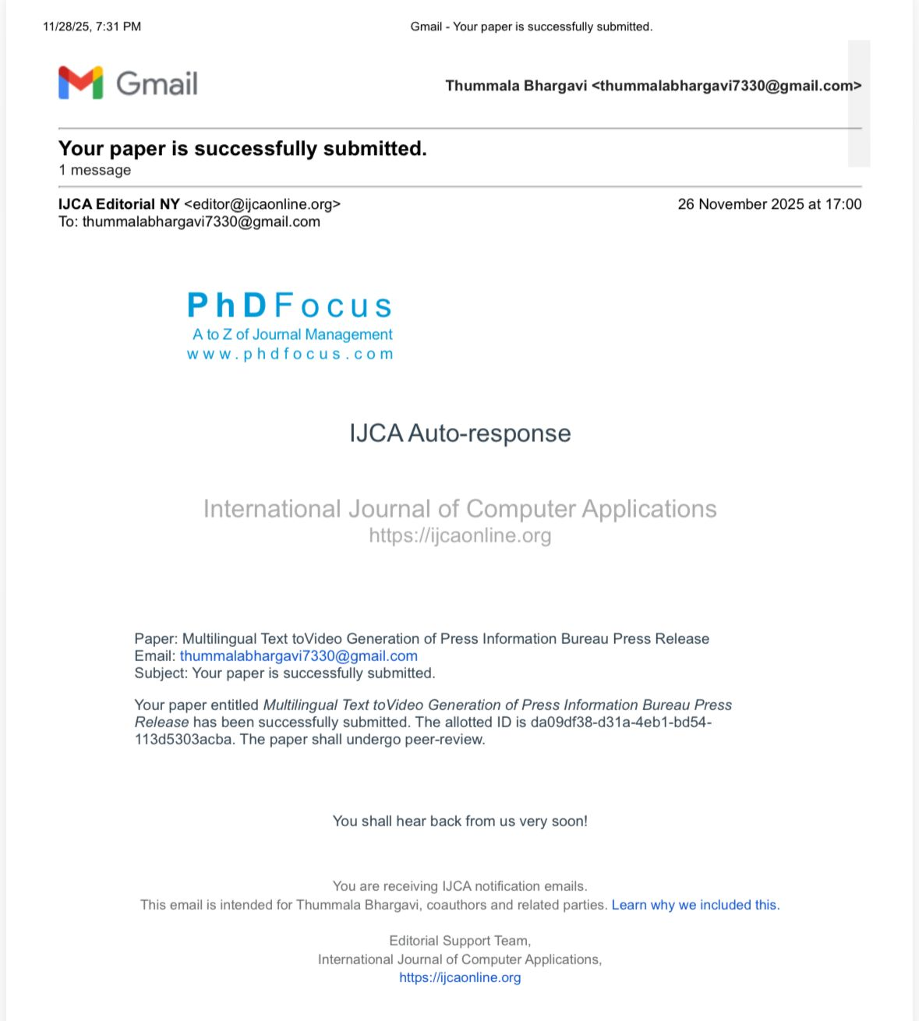
Fig A.1. PhD Focus Paper Acceptance email
iii. Project Report - Similarity Report
- Similarity Index: 1% (from Turnitin).
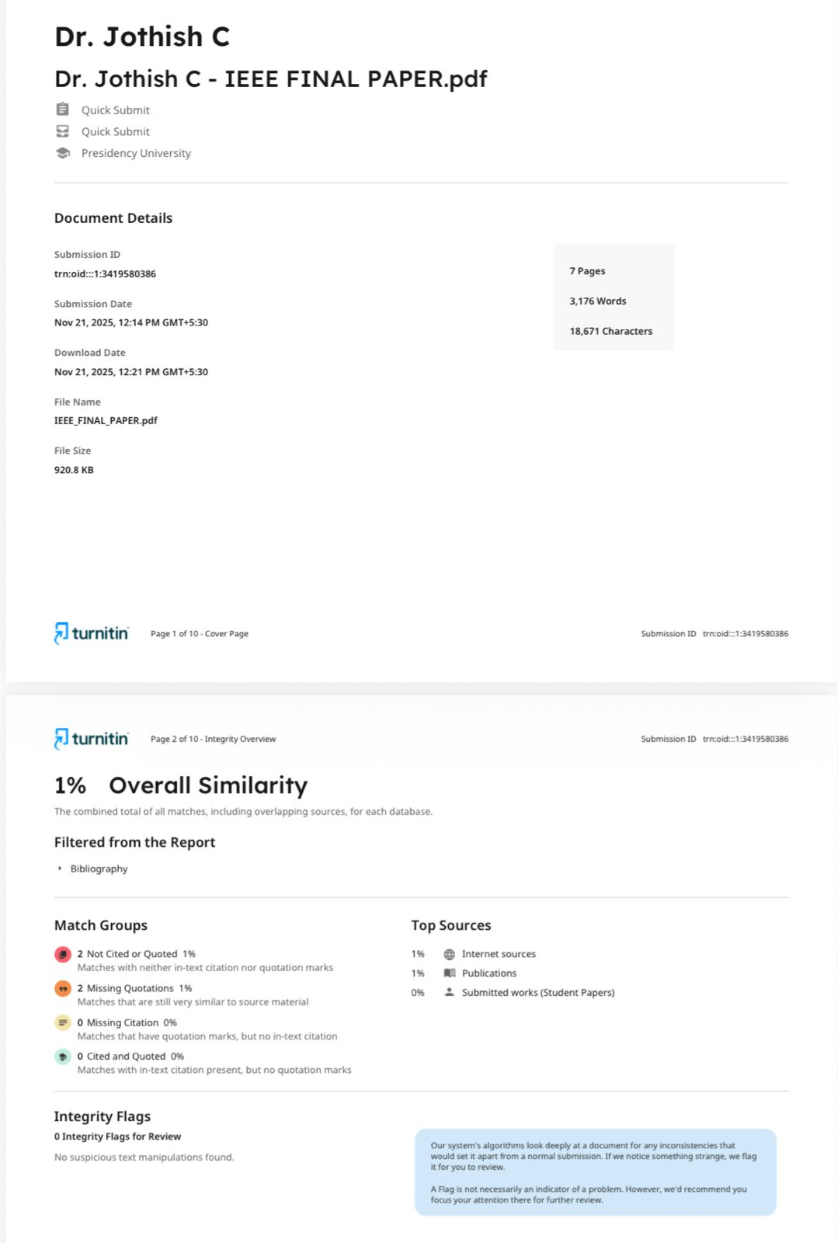
Fig A.2. Turnitin Similarity Report
iv. Datasets
  - Translation Parallel Corpus:At least 500k English to Hindi and smaller collections of Hindi-to-English with multilingual and incluence of body-wide distribution: 13 Total Languages + 1 X English Used for Translations.
- Media Collection: More than 2,000 Copyright Free Photos / More than 300 Video Samples for image to video visualisations for AI Based Applications
- Test Set: 500 Press Release Test message examples that (1) have been manually verified to have been correctly translated (2) mgains summarised translated (3) test results verified by Human Auditory Verification against TTS Sample Audio Files.
- Synthetic Augmentation: Text Image Pairs of AI Generated/Augmentations used to improve the Diffusion Model Product Enrichment with Language Contextual Integrity.
V. Live Project Demo
- GitHub: https://github.com/Bhargavi-Thummala7330/Batch_179_Text-to-Video-of-Various-Press-Releases-using-AI
VI. Few Images of Project
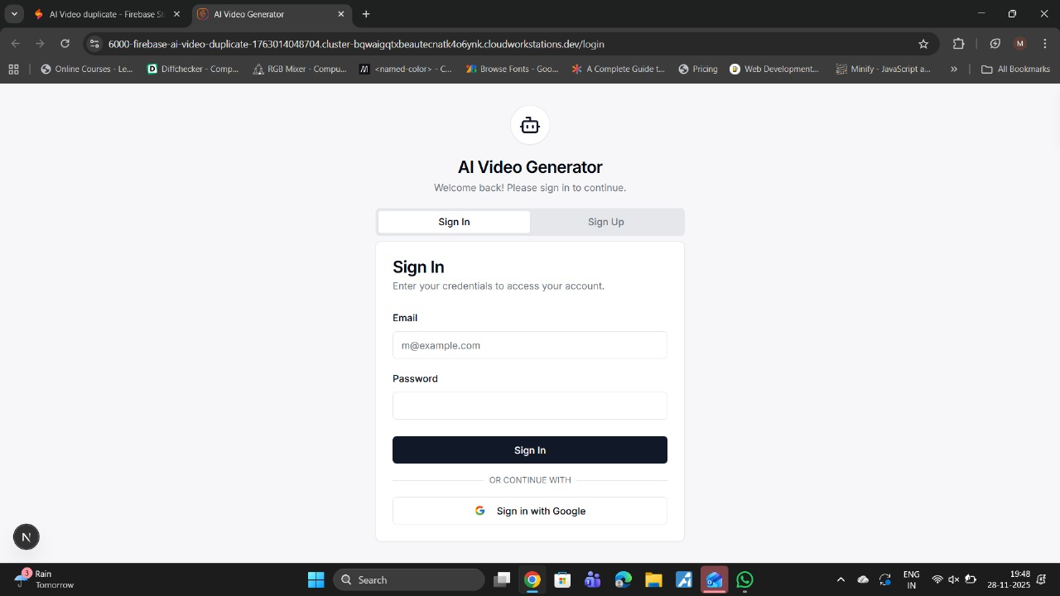
Fig A.3. Login page (1)

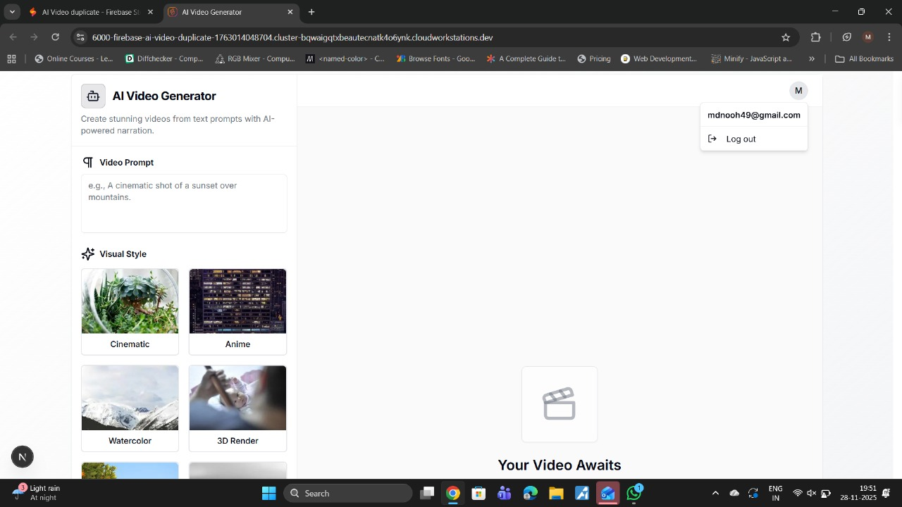Fig A.4 User Interface for Writing Prompt (2)
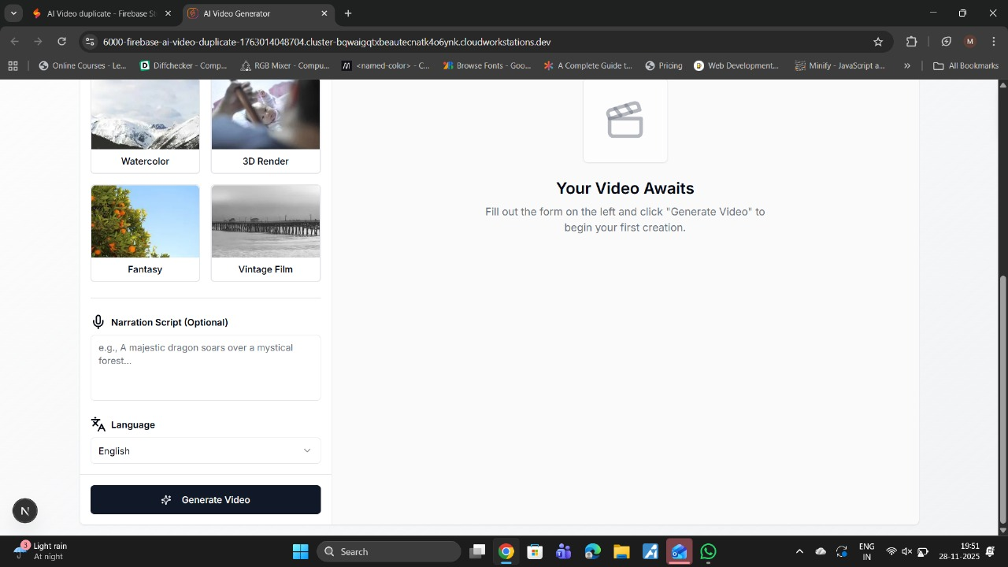Fig A.5 Language Selection and Script Narration Optional (3)

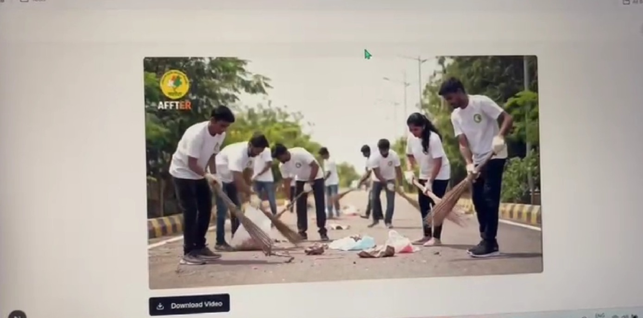Fig.6 Generating Video and Downloading (4)

