|  |  |  |  |
| --- | --- | --- | --- |
| Tree | Insert (ms) | Delete (ms) | Search (ms) |
| BinarySearchTree | 0 | 0 | 0 |
| Tree | 0 | 0 | 0 |
| HashDouble | 0 | 0 | 0 |
| HashChain | 0 | 0 | 0 |

BinaryTree

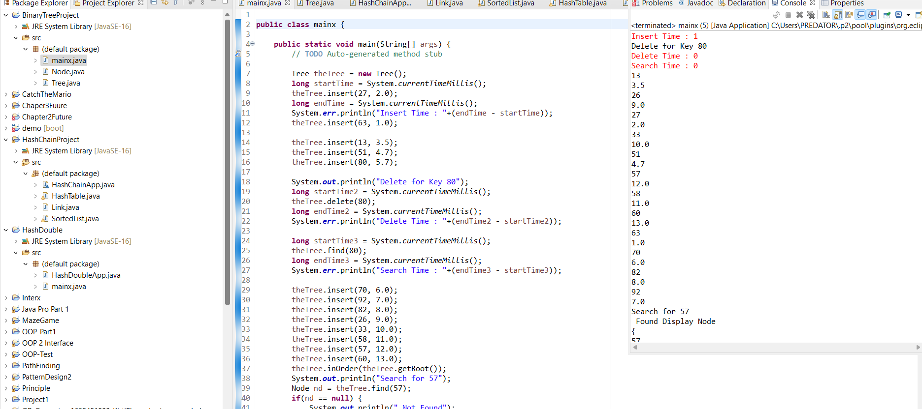

HashDouble

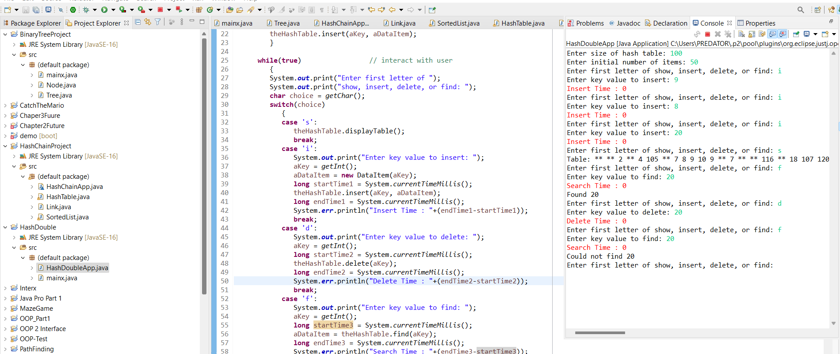

HashChain

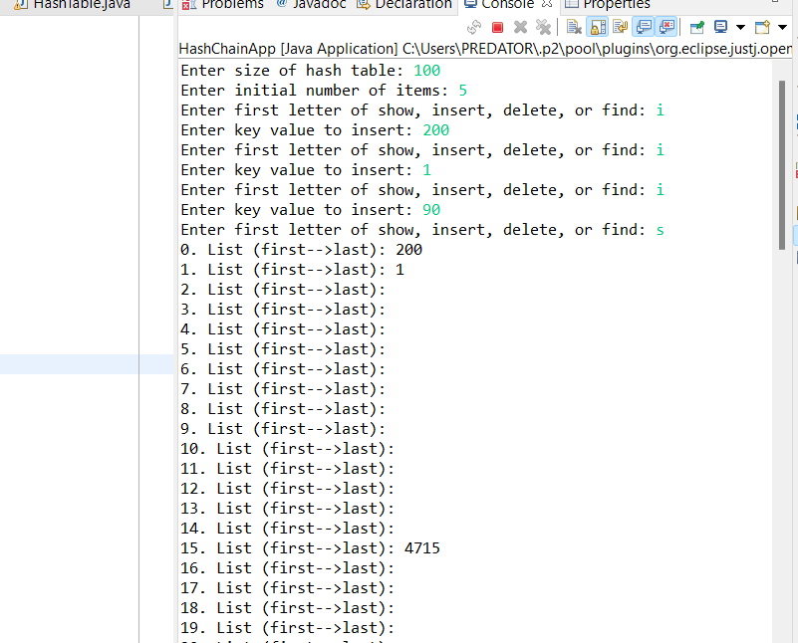

Tree

