1. Subscribe Product Api

Url - <http://doodhvale.in/dev/doodhvale/api/web/v1/subscriptions/add>

Parameters

user_id -> String

product_id - > String

start_date - > String (Date format should be YYYY-mm-dd)

type - > String( type = “Daily” for fresh milk and type =”One Time” for other )

quantity -> String

UI for Subscribing product

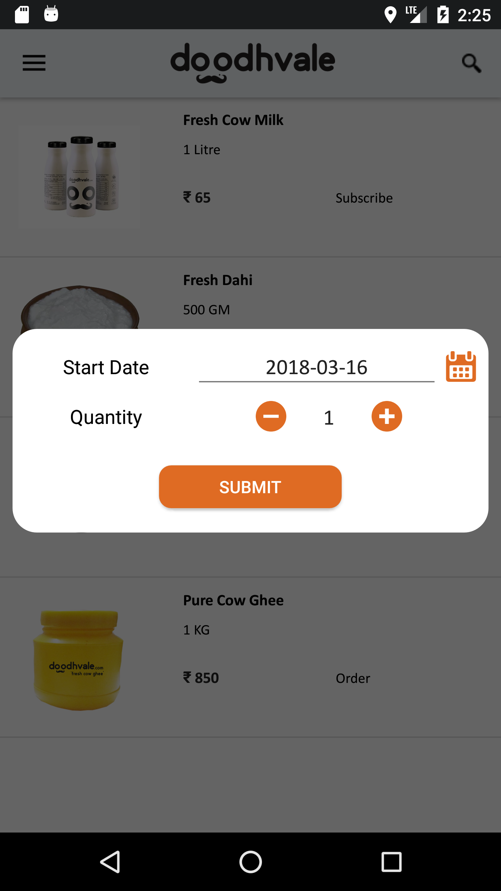

2. Unsubsribe Product Api

Url - <http://doodhvale.in/dev/doodhvale/api/web/v1/subscriptions/unsubscribe>

Parameters

subscription_id - > String

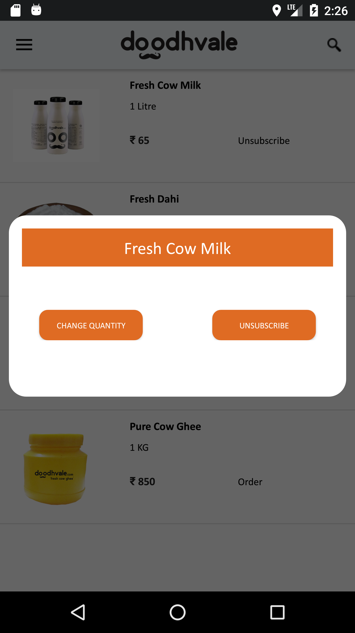

3. Pause Subscription Api

Url – <http://doodhvale.in/dev/doodhvale/api/web/v1/subscriptions/pause-subscription>

Parameters

user_id -> String

start_date - > String (Date format should be YYYY-mm-dd)

end_date - > String

4. Change Subscription Api

Url – <http://doodhvale.in/dev/doodhvale/api/web/v1/subscriptions/change-quantity>

Parameters

user_id -> String

subscription_id - > String

quantity -> String

