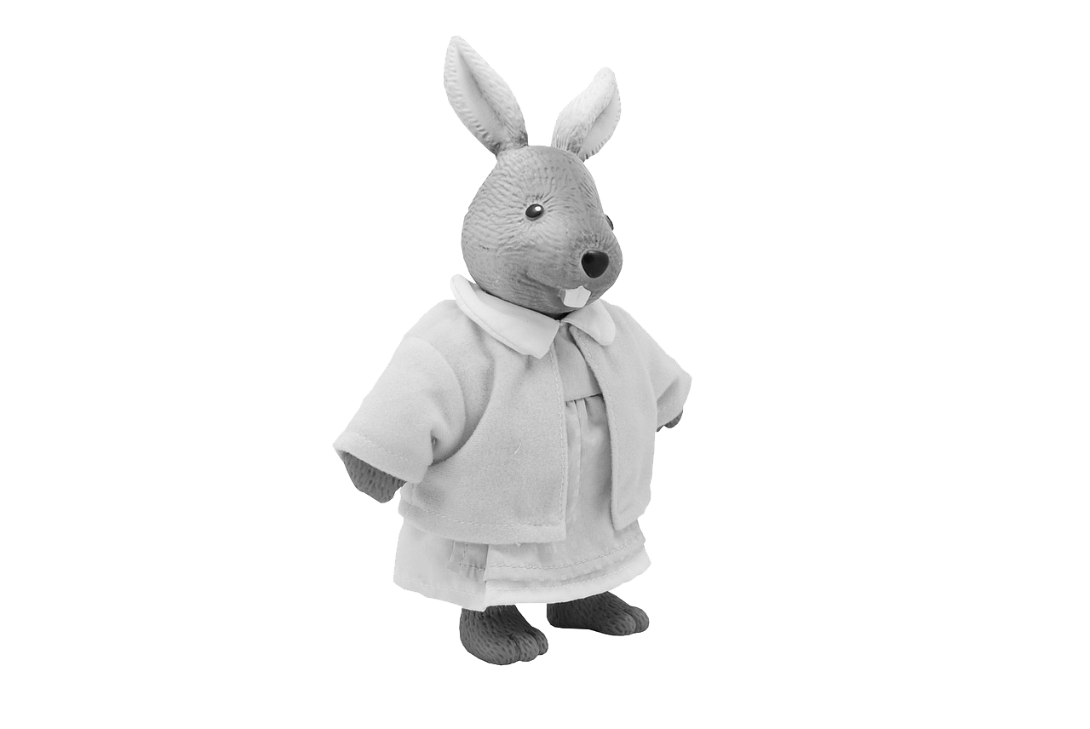

ON _/_/__, BRING A TOY TO SCHOOL!

Your student participates in the Doodles Academy art program at _____________ Elementary. On _____/_____ we will be starting a new project in which they will be using their favorite toy as artistic inspiration! Please have them bring their toy, labeled with their name, to school on this day.

Sincerely,

*your name*

ON _/_/__, BRING A TOY TO SCHOOL!

Your student participates in the Doodles Academy art program at _____________ Elementary. On _____/_____ we will be starting a new project in which they will be using their favorite toy as artistic inspiration! Please have them bring their toy, labeled with their name, to school on this day.

Sincerely,

*your name*

ON _/_/__, BRING A TOY TO SCHOOL!

Your student participates in the Doodles Academy art program at _____________ Elementary. On _____/_____ we will be starting a new project in which they will be using their favorite toy as artistic inspiration! Please have them bring their toy, labeled with their name, to school on this day.

Sincerely,

*your name*

ON _/_/__, BRING A TOY TO SCHOOL!

Your student participates in the Doodles Academy art program at _____________ Elementary. On _____/_____ we will be starting a new project in which they will be using their favorite toy as artistic inspiration! Please have them bring their toy, labeled with their name, to school on this day.

Sincerely,

*your name*