Doofinder for Magento 2…

**Overview 2**

Support 2

Pre-requisites 2

**Installation 3**

Installation via Magento Marketplace 3

Installation via Composer 3

Post-Installation 4

**Module Configuration 4**

Read First 4

Configuration Flow 6

Configuration 11

Index Settings 17

**Troubleshooting 18**

**Overview**

This module provides integration between Magento 2.2+ and the [Doofinder](http://www.doofinder.com) search service to enhance the overall search experience in your site.

To do that, the module replaces the default search engine of Magento. This means your product data is indexed in Doofinder servers and updated whenever a product is changed. When a search occurs, the module asks Doofinder for the right results and serves them to Magento.

Additionally, you can use our front-end Javascript layers to enhance the user search experience with faster results.

Support

* For technical support, get in touch from your [Doofinder Account](https://app.doofinder.com/admin) or drop us an email at [support@doofinder.com](mailto:support@doofinder.com).
* If you’re a developer, you can file an issue or contribution request in our public code repository at Github: <https://github.com/doofinder/doofinder-magento2>.

Pre-requisites

* This module requires Magento 2.2 or greater.
* Hardware and software requirements are the same as for Magento 2. Check Magento 2 technical requirements for more information.
* This module is heavily based on Cron. Magento 2 requires Cron to properly work, so you must have Cron up and running in your server for the module to work.
* To use the Doofinder module you need an active Doofinder account. Doofinder is a paid service but you can try it 30 days for free and benefit from the *freemium* plan if you have a small store. If you don’t have an account yet you can sign up at:   
    
  <https://www.doofinder.com/signup>  
    
  Plans and pricing are available at:  
    
  <https://www.doofinder.com/price>
* Doofinder module is a free purchase so you have to pay nothing to use it. The only cost for you is the price of the Doofinder service once the trial period has ended.

**Installation**

Doofinder can be installed via Component Manager as a *free* purchase done in Magento Marketplace, or via Composer, the *the-facto* PHP package manager, if you feel at home working from the command line directly in your server.

**WARNING:** **Do not install this module via FTP or direct upload** to your server’s filesystem. This module has external software dependencies that Component Manager and Composer know how to deal with. If you try to install the module by any other way than recommended you may experience errors in your system.

**From the official Magento documentation:**

*Installing an extension from the Admin is a three-step process that should take place during off-peak hours. Before the extension is installed, your store is put into maintenance mode, checked for readiness, and backed up. After the extension is installed, it must be configured for your store according to the developer’s instructions.*

*As a best practice, an extension should be installed and tested in a development environment before it is pushed to production.*

Installation via Magento Marketplace

For up-to-date instructions refer to the [official Magento documentation](https://docs.magento.com/m2/ce/user_guide/system/web-setup-extension-manager.html).

Installation via Composer

1. Log into your Magento 2 server via SSH.
2. Go to Magento 2 installation path, for instance:$ cd /var/www/domains/shop.example.com
3. Execute:$ composer require doofinder/doofinder-magento2 $ php bin/magento setup:upgrade…

Post-Installation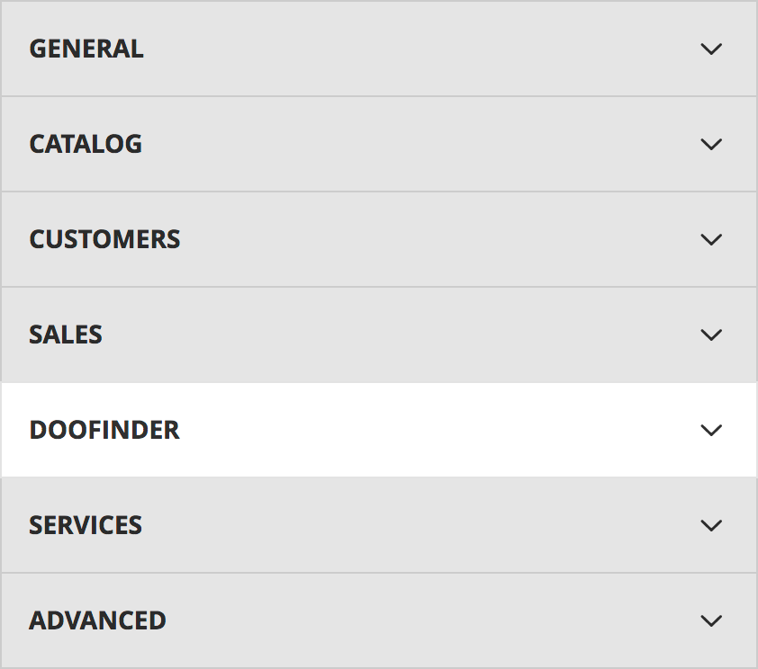

After installing the module, a new *“Doofinder”* menu should have been added to *“Stores > Configuration”*.

There you will find all the module configuration options.

**Module Configuration**

Read First

As you will probably know, Magento 2 can be conﬁgured at different levels; you can set up default values and be more speciﬁc for each store view.

This module makes use of that conﬁguration scheme but not all settings are available at all levels, some will be at the default level and some others will be speciﬁc for each store view. You must pay attention so the module is properly conﬁgured.

Before conﬁguring the module we should clarify some concepts:

* From Magento’s point of view, Dooﬁnder is a search engine. This concept clashes with Dooﬁnder’s concept of search engine. In Magento 2 the search engine is the system you use for search and you can use only one. MySQL is Magento’s default search engine but you can use Dooﬁnder instead.
* In Dooﬁnder’s slang a search engine is a single container where you can put documents you want to search. You can have multiple search engines in the same account, each with a different unique ID which is called a Hash ID. When you set up search in Magento 2 with the Dooﬁnder module, you associate each store view with its own search engine by using different Hash ID values.

Module conﬁguration is structured in two submenus:

1. **Conﬁguration:** General conﬁguration of the module, like authentication, search engine identiﬁcators or whether to use the Dooﬁnder Layer in the frontend or not.
2. **Index Settings:** Conﬁguration about the data being exported.

Almost all module your configuration will take place inside those two sections. To make the most of the module there are some considerations to take into account first so reading the next section is recommended.

Configuration Flow

These are the recommended steps to have Doofinder up and running in the shortest time.

1. Sign up for a Doofinder account.
2. Create your search engines in Doofinder.
3. Configure the module.
4. Enable Doofinder as Magento’s search engine.

1. Sign up for a Doofinder account

If you already have a Doofinder account you can omit this step.

Visit: <https://www.doofinder.com/signup> in your web browser to create a new account.

2. Create your search engines in Doofinder

If you created your Doofinder account in the previous step or you don’t have any search engine yet, you will automatically start the installation wizard. Otherwise, in the list of search engines in your account you will find a button to create a new search engine (*New Search Engi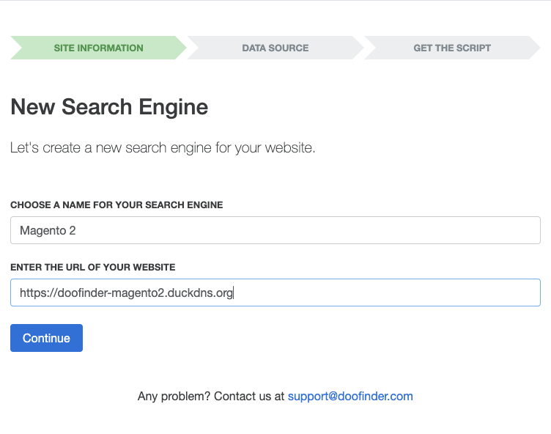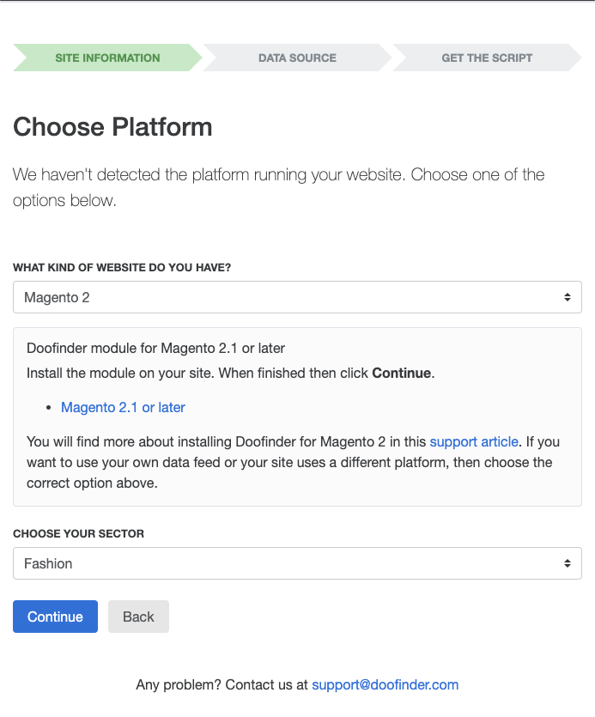ne*).

The search engine creation wizard consists of three steps:

**Site Information**

In this screen you will have to enter:

* A name for your search engine to easily distinguish it from other search engines in your account.
* The web address of your site’s home page.

Once available, click the *Continue* button.

**Choose Platform**

The application should have detected that your site is using Magento 2. If that’s not the case choose *Magento 2*.

From now on, Doofinder will assume the Magento 2 module is installed. If you have not installed it yet, please, do it now.

Once done, click *Continue*. Doofinder will try to read the configuration from your site. If you get an error message, check that you’ve installed the plugin properly.

If everything went as expected you will be asked if you want Doofinder to generate a search engine for each store view in your site or if you want to create only one search engine.

The default action (generate all search engines) is recommended.

Once done click the *Continue* button.

Doofinder will create a single search engine or, in case you followed the recommended action, as many search engines as store views in your site, and you will be presented a summary with the data required to configure the plugin.

Annotate all information (copy and paste into a text file should work fine) and continue.

**Doofinder Layer Script**

This step is optional at this stage of the installation process. If you want to configure the script now, click the *Yes, let’s go!* button and follow the instructions of the wizard. Otherwise click the *Skip this step and* finish button.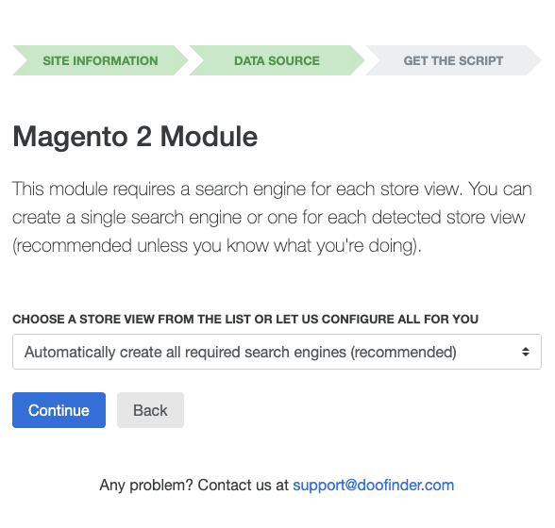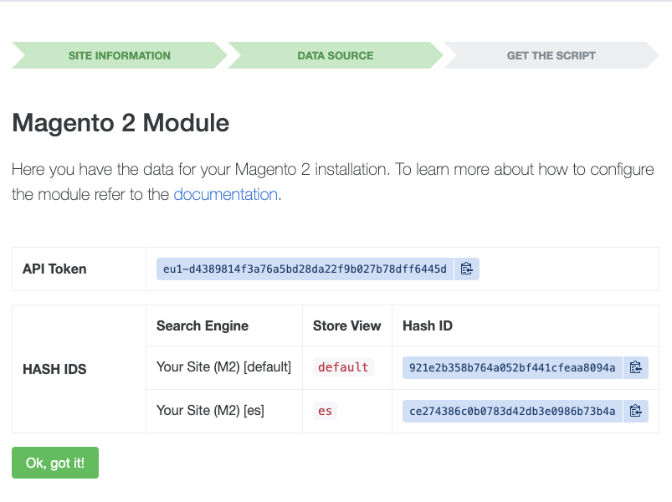

You will be able to configure the layer later by accessing your search engine and going to *Setup > Search Layers > Setup*.

3. Configure the module

Once you have all *hashids* and the *API Key* you can configure the Doofinder module.

Enter your Magento admin and go to *Stores > Configuration > Doofinder > Configuration* in the default configuration scope and **set the API Key first**. Then save the configuration.

Then change the configuration scope to one of your site’s store view and **set the hash id** and save. Repeat for each store view in your site. Make sure you’re not repeating hash ids between different store views.

After the basic configuration is done **you’re ready to enable Doofinder** as Magento’s search engine.

**NOTICE:** It’s recommended to take some time to configure the module before enabling Doofinder as Magento’s search engine.

4. Enable Doofinder as Magento’s search engine

Once you configured the module, it’s time to set Doofinder as Magento’s search engine. That’s done at *Stores > Configuration > Catalog > Catalog > Catalog Search* .

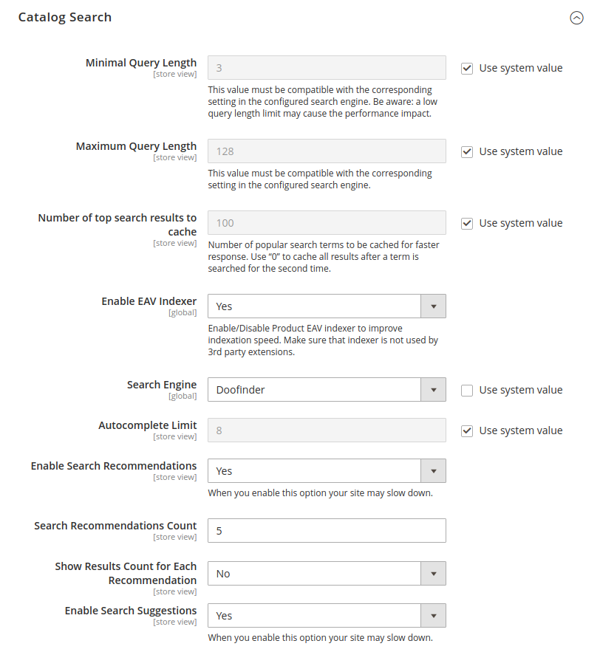

Here are some things to consider first…

**Doofinder as Magento’s search engine**

The module replaces the default search engine (MySQL) and indexes all your products in the Doofinder servers. After the initial import, **the recommended search catalog index mode is *Update On Save*** so only changes in products are sent to Doofinder. If you set the search catalog index to *Update By Schedule* your catalog will be completely erased and reindexed too frequently, unnecessarily increasing the consumption of requests in the Doofinder service. Instead, it’s better to let the module take care of the updates by setting the catalog index mode to *Update On Save*.

**NOTICE:** If you change the search catalog index mode to *Update By Schedule* you may experience problems with search because your data will be erased and re-indexed in Doofinder based on that schedule.

**Prevent indexing wrong image URLs**

Due to some well known bugs in Magento 2, it may occur that images are indexed in Doofinder with wrong paths, resulting in errors when they’re displayed.

To fix this, ensure you explicitly set media URLs:

* On the Admin Panel, go to `Stores > Settings > Configuration`.
* On the left panel, under `General`, select `Web`.
* Open the `Base URLs` section.
* Make sure you have configured *Base URL for User Media Files* and *Secure Base URL for User Media Files* so they point to the right place (usually, they are not configured by default).
* For *Base URLs (Secure)*: Fix *Secure Base URL* and *Secure Base Link URL* first, because they may have the value **0/** and the form won't validate on submit. In a local development environment you can use the same protocol (http://) as for Base URLs.

**Recommended Catalog Search Settings**

Once you select Doofinder as Magento’s search engine, you may have questions about what to do with the other settings that appear next to the *Search Engine* selector. These are our recommendations:

* **Enable EAV Indexer:** From Doofinder’s point of view there’s no recommended setting. For a shop with a big number of products, you can try to enable it and see if it performs faster. If it doesn't, and you don’t have a plugin that uses it, it can remain disabled.
* **Autocomplete limit:** Doofinder does not use it, so it can be ignored.
* **Enable Search Recommendations:** Switching this option on may slow down searching a bit, but you can enable it if you want this feature.
* **Enable Search Suggestions:** It’s not used so it can be switched off.

Configuration

It’s time to set Doofinder as Magento’s configuration. That’s done at *Doofinder > Configuration*. It must be taken into account that depending on the selected scope the options are different.

For Scope *Default Config* settings for Account and Doofinder Layer are shown below.

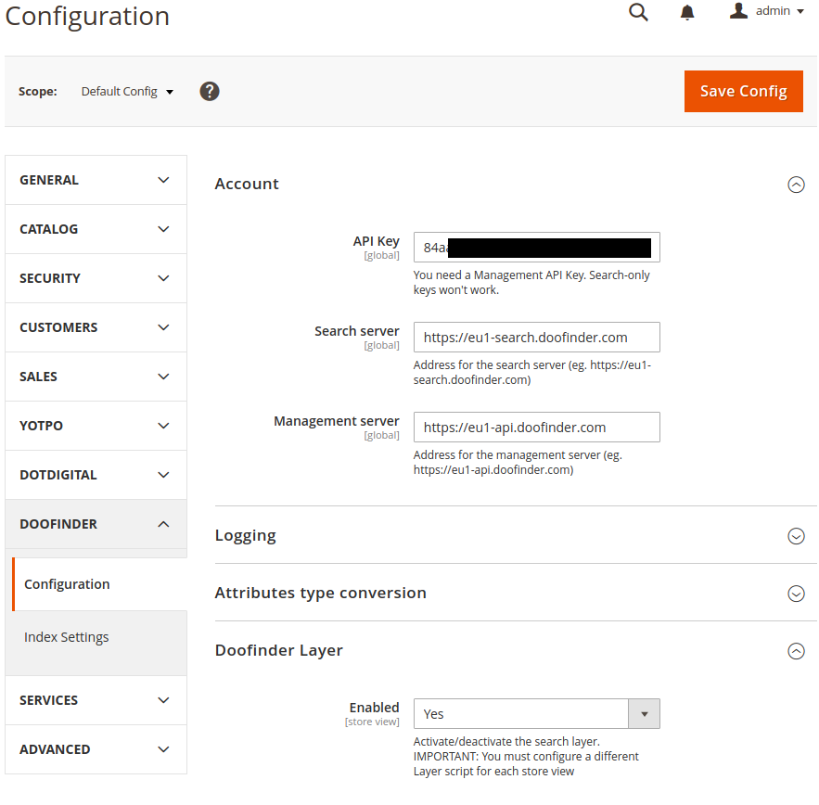

For Scope *Default Store View* settings for Account and Doofinder Layer are shown below.

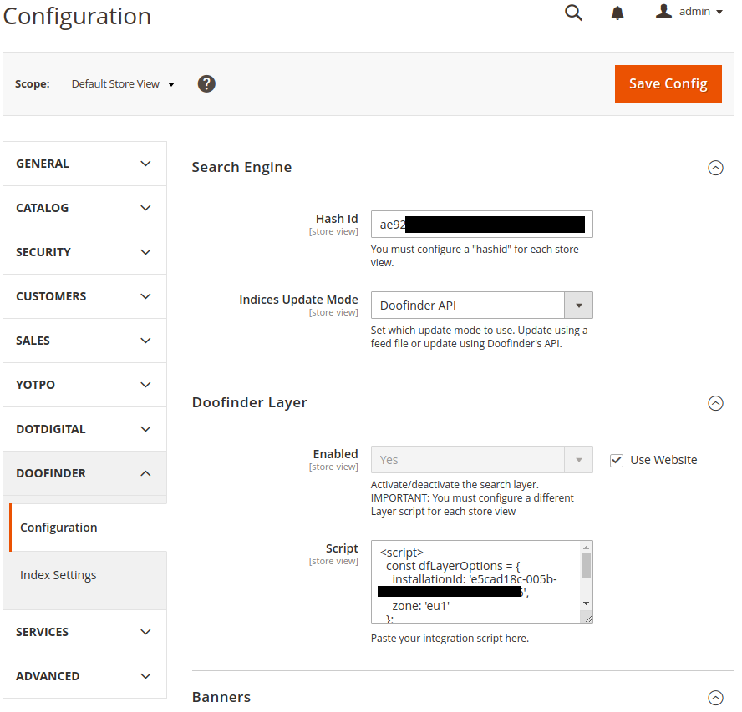

Account

| **API Key**  Global | If you plan to use Doofinder as your Magento 2 search engine instead of the default (MySQL), or you plan to use only the *Atomic Updates* feature (see *Index Settings* later) you will need an API Key to properly authenticate requests done from your server against Doofinder servers.  **WARNING:** Doofinder offers two different types of API Keys depending on the use. Remember to configure a *Management API Key* so your Magento 2 can perform indexing operations in Doofinder.  **WARNING:** This setting must be configured BEFORE selecting Doofinder as Magento 2 search engine or enabling the *Atomic Updates* feature.  If you don’t have an API Key:   * Log into your Doofinder account. * In the top menu press your account’s email to open the menu and go to *API Keys*. * Press *New API Key*. * Enter a name for your API Key so you know where you’re using it and check *I will use this API Key with the management API*. * Press *Create API Key*. |
| --- | --- |

| **Management server**  Global | Address of management server. It depends on the region and it must use https protocol.  The format is https://{region}-api.doofinder.com. e.g. https://eu1-api.doofinder.com |
| --- | --- |

| **Management server**  Global | Address of management server. It depends on the region and it must use https protocol.  The format is https://{region}-api.doofinder.com. e.g. https://eu1-api.doofinder.com |
| --- | --- |

Search Engine

| **Use Doofinder for Internal Search**  Global | This is actually a shortcut to configure Doofinder as the Magento 2 search engine. If the link doesn’t work you only have to go to *Stores > Configuration > Catalog > Catalog* and, under *Catalog Search* uncheck *Use System Value* for *Search Engine* and choose *Doofinder* instead.  **WARNING:** When you choose Doofinder as Magento’s search engine the catalog index will require a reindex. |
| --- | --- |

| **Hash ID**  Store View | This is the unique ID of a search engine in Doofinder. It’s a 32-character long string. You can get it from the list of search engines that appears when you access your Doofinder account.  **WARNING:** This setting must be configured BEFORE selecting Doofinder as Magento 2 search engine or enabling the *Atomic Updates* feature. |
| --- | --- |

| **Indices Update Mode**  Store View | Set which update mode to use. Two options are available. Update using Doofinder’s API or a Feed File. |
| --- | --- |
|  |  |

Doofinder Layer

Doofinder provides some Javascript layers to easily integrate search with any website. You can also use those layers in your Magento 2 website and this section provides a place to paste the necessary Javascript code to make them work.

To generate a layer for your website:

1. Log into your Doofinder account.
2. Access the search engine you want to configure.
3. Go to *Setup > Search Layers > Setup*.
4. Press *Setup Wizard*.
5. Follow the wizard steps.

**WARNING:** Magento 2 uses RequireJS to load Javascript dependencies. When creating your script you must change the type of script. The recommended value to paste the script in this section is *RequireJS (HTML script tag, easy)*.

| **Enabled**  Global, Store View | Enable or disable the layer globally or per store view. |
| --- | --- |
| **Script**  Store View | This is the place where you have to paste the layer script. |

Index Settings

Settings

| **Export Product Prices**  Global, Store View | Choose whether to export prices or not. |
| --- | --- |
| **Price Export Mode**  Global, Store View | Choose *Auto* (default) to export prices the same way as they’re displayed in your store. If your store displays prices with and without taxes included you will want to choose an specific mode: *With Taxes* or *Without Taxes*. |
| **Image Size**  Global, Store View | Export product images at the given width. Leave empty to export at the original size.  **WARNING:** Take into account that, if the images don’t exist at the specified size, they will have to be generated, which is a high time and resources consuming process. It is recommended to leave it empty and use the default size of the selected image attribute. |
| **Export only categories present in navigation menus**  Global, Store View | The module exports only active categories. This option will limit them to categories used for navigation purposes. |

Attributes

For each product, the module indexes a default set of attributes in Doofinder.

You can change some of them or add your own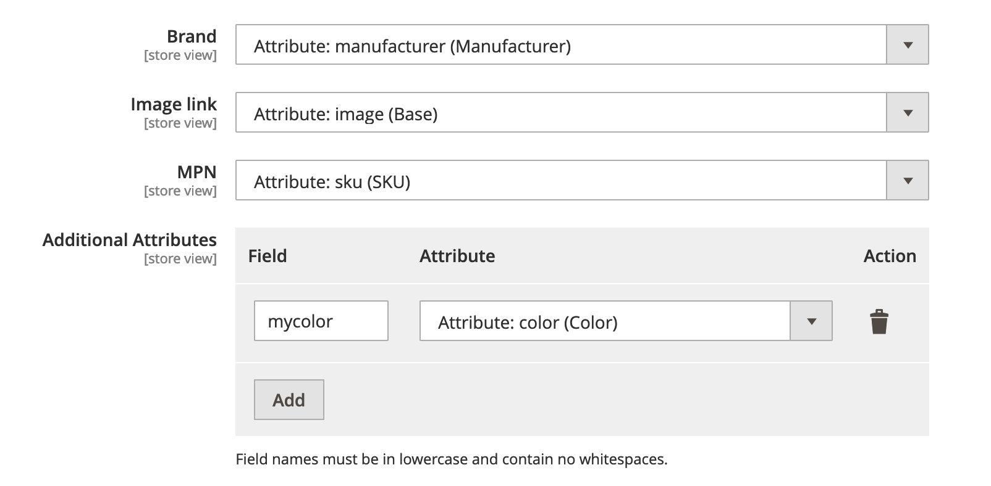 custom attributes.

**IMPORTANT:** Don't use names that may clash with internal Magento attribute names. It’s a good practice to use a prefix like **my_** or **custom_**.

**Troubleshooting**

| **Q:** | **Right after installing the module, trying to save the module conﬁguration I get an error:**  Warning: array_merge(): Argument #1 is not an array in /var/www/html/ vendor/doofinder/doofinder-magento2/Helper/Indexer.php on line XX |
| --- | --- |
| **A:** | Right after the installation of the module, Magento doesn't know about the default settings, which can trigger this error. The solution usually is to clean the cache after installing the module.  You can execute this in the CLI:  $ php bin/magento setup:upgrade  $ php bin/magento setup:di:compile  $ php bin/magento cache:flush  Or go to *System > Cache Management* and choose Flush Magento Cache. |
| **Q:** | **I have my indexes conﬁgured to be updated on save: when will the items be indexed?** |
| **A:** | They should be indexed after a while, assuming cron works properly - indexes are revalidated in case of invalidation in cron no matter of index mode. |
| **Q:** | **I can’t change the Update Products on Save conﬁguration in Index Settings** |
| **A:** | When Dooﬁnder is conﬁgured to be Magento’s search engine, atomic updates conﬁguration is forced. When your indexed are conﬁgured to be updated on save, atomic updates are enabled. When they are conﬁgured to be updated by schedule, atomic updates are disabled.  If you don’t use Dooﬁnder as Magento’s search engine (for instance, you only use the Javascript layers), you can conﬁgure atomic updates yourself. |
| **Q:** | **Some products are being indexed with a wrong link, they point to the *backoffice* instead of the correct frontend store view.** |
| **A:** | Unfortunately at the time of writing this, there’s a bug in Magento 2 which produces wrong URLs in certain conditions:  <https://github.com/magento/magento2/issues/4247>  To prevent this, make sure every product has a URL key set. |